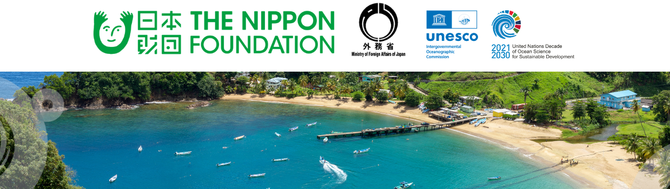

Island States Ocean Summit: Sustainable Ocean Action for Resilient Islands - Input Request for Background Booklet

Information—Please read it entirely before proceeding with your submission

In preparation for the Island States Ocean Summit (Tokyo, 3–4 June 2026), we are collecting inputs on the current state of play of Sustainable Ocean Planning and Management (SOPM) from country delegations and partners.

Your input will help us to:

- highlight ongoing initiatives and experiences
- identify common challenges, priority needs and opportunities for action
- inform Summit discussions and outcome documents
Responses will be synthesized into a high-level background document to be shared with all Summit participants ahead of the event.
Important Information:
- Estimated response time: 8–10 minutes.
- The deadline for submission of this form is 15 May 2026 23:59 UTC.
- You can find the PDF and Word versions of the form here. Please note that these are for your use only, e.g. to help prepare your submission. Only submissions sent via the online form will be accepted.
For any questions, please contact al.londono-ramirez@unesco.org with “Input Request – ISOS: Background Document” in the subject line.
* Indicates required question

SECTION 1 — RESPONDENT INFORMATION
(All ﬁelds are required unless stated.)

Country / Organisation name *

Type of respondent *

Mark only one.

 Government

 Regional organisation  International organisation  NGO / Civil society
 Research / academic institution  Private sector
Other:

- Contact person (name and title) *

Email address *

SECTION 2 — CURRENT INITIATIVES LINKED TO SOPM
What are countries and partners doing?

Please brieﬂy describe current SOPM-related initiatives from your country / * organization to be highlighted (e.g. policies, plans, programmes, projects).
Please indicate the geographical scope of these initiatives (national, subnational, regional or global)

(Max.150–200 ords)

Can you highlight some key achievements or milestones in this process?

(optional, up to 3)

What are some of the key lessons learned or success factors from the execution of these initiatives?

(optional, up to 3)

SECTION 3 — CHALLENGES & OPPORTUNITIES

What are the main challenges or barriers to advancing SOPM? *

(multiple options are accepted)
 Data and knowledge gaps Technical capacity
Institutional coordination
Financing
Stakeholder engagement Policy / legal frameworks
Other:

Please brieﬂy elaborate on priority challenges

(optional)

What types of support would be most useful?

(multiple options are accepted)
Technical assistance Data / science support Capacity development Financing / investment
Partnerships / coordination Policy / legal support
Other:

What are the priority needs to advance SOPM?

(optional, max 150 ords)

SECTION 4 — ADDITIONAL INPUTS

Do you have any additional comments?

(optional)

Please share links to any relevant reports, strategies, or materials you may like to share with us (optional)

THANK YOU

Thank you very much for your time and contribution. Your inputs will directly feed into the Summit background documents, helping to shape Summit discussions. We look forward to welcoming you in Tokyo this June!

Sincerely,
The Island States Ocean Summit Organizing team

For any questions, please contact:
Ana Lucia Londoño Ramirez, Associate Project Oﬃcer, Intergovernmental Oceanographic Commission of UNESCO via email: al.londono-ramirez@unesco.org, with “Input Request – ISOS: Background Document” in the subject line.

