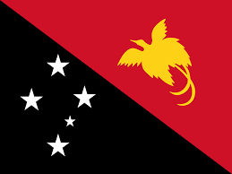
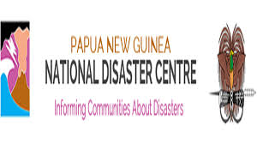

PNG TSUNAMI EVACUATION PLANNING STATUES, CHALLENGES, SUCCESS AND CASE STUDIES

13th -17th April 2026, Tanoa International Hotel, Nadi, Fiji

- Introduction
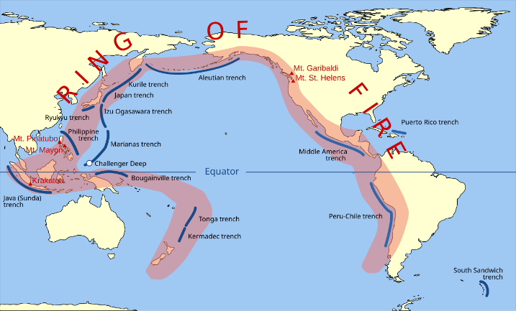
Papua New Guinea (PNG) is located along the Pacific “Ring of Fire,” making it highly vulnerable to earthquakes and tsunami hazards. Coastal communities—especially along the northern coastline—face, are significant risk due to proximity to active tectonic zones.
Tsunamis in PNG are often locally generated, meaning they can strike within minutes, leaving very little time for warning and evacuation.

2. Purpose of the Presentation
- Status of the tsunami evacuation planning in PNG
- To assess past tsunami events and lessons learned
- To identify challenges and gaps
- To propose future strategies and way forward

3.Overview of Tsunami Risk in PNG

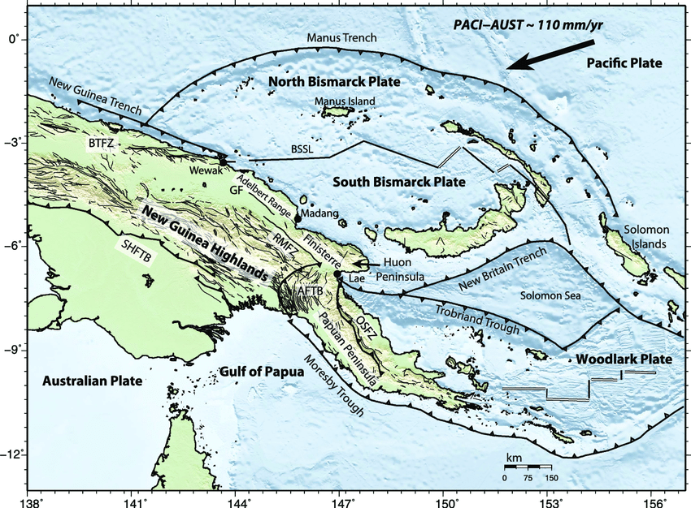
- PNG lies near active plate boundaries (Australian & Pacific Plates)
- Frequent seismic activity in:
  - Bismarck Sea
  - New Guinea Trench
  - Solomon Sea
- Coastal communities are:
  - Low-lying
  - Densely populated
  - Dependent on marine resources

4. Concept of Tsunami Evacuation Planning
Tsunami evacuation planning involves:
- Early warning systems
- Community awareness and preparedness
- Identification of safe evacuation routes
- Designation of evacuation centers
- Coordination among agencies
- Mounting of tsunami signage along the tsunami prone areas
5.Case Study 1: 17 July 1998 – Aitape Tsunami (Sandaun Province)

Event Summary
- Magnitude 7.0 earthquake triggered tsunami
- Waves reached 10–15 meters high
- Over 1,600–2,000 deaths
- Entire villages destroyed along Sissano Lagoon in sanduan province

Key Observations
- It’s was an local source tsunami event
- Tsunami arrived within 10–20 minutes time
- No warning system in place
- Communities unaware and tsunami awareness were limited

Evacuation Status
- No structured evacuation planning in place
- People moved randomly causing many deaths and destroyed properties

Lessons Learned
- Need for community awareness
- Importance of natural warning signs (earthquake + sea withdrawal)
- Critical need for early warning systems
- Need for continuous awareness on regular basis

6. Case Study 2: 16 November 2000 – Bismarck Sea (New Ireland Province)

Event Summary
- Offshore earthquake generated tsunami
- It happened during the day
- Less destructive compared to 1998
- Parcel Tsunami warning was issued from Port Moresby Geophysical Observatory

Observations
- Some coastal communities within the epicentral area experienced tsunami
- Many were able to evacuate to the higher grounds
- Some areas were evacuated, Misima island and woodlark Islands

Lesson learned
- People were aware of the tsunami signs and evacuated to higher grounds

7. Case Study 3: Japan, 11th March 2011 – East Sepik Province

Event Summary
- Tsunami from a distant source, Tohoku Japan, Magnitude 9.1
- It’s was an distant source tsunami
- Tsunami damage observed in North Coast, Mainland of PNG, Wewak

Observations
- Timely tsunami information received from Pacific Tsunami Warning Centre (PTWC) and North West Pacific Tsunami Advisory Centre (NWPTAC)
- Major damages were observed (Considerable damage to hospital facility in Wewak)
- Timely information was discriminated, from NDC and Pom Geophysical Observatory

Lesson learned
- Effective tsunami early warning information was issued
- Orderly evacuation was carried out
- No life lost

8. Current Status of Tsunami Evacuation Planning in PNG

Remarks
- From past case studies, we have been working on a head-off basis
- No effective evacuation planning for the tsunami prone areas
- There are some draft documents for tsunami response planning buts needs review and expand on it

9. Key Challenges

1. Limited Early Warning Coverage
- Remote coastal communities lack communication systems
- For local tsunami, challenge for effective response

2. Geographic Constraints
- Mountainous terrain limits evacuation routes
- Isolated islands and villages

3. Low Community Awareness
- Many communities unaware of tsunami signs
- Traditional beliefs may influence response

4. Infrastructure Limitations
- Lack of:
  - Evacuation shelters
  - Signage
  - Safe routes

5. Coordination Issues
- Lack integration between agencies
- Limited provincial capacity

10. Some Successes and Improvements
- Increased awareness after 1998 tsunami
- Integration with regional tsunami warning systems
- Growing involvement of:
  - Provincial Disaster Offices and line agencies
  - NGOs and partners
- Some community-based disaster risk reduction programs (CBRDM), for example, IOM

11. Future Tsunami Evacuation Planning (Way Forward)

1. Strengthen Early Warning Systems
- Expand communication networks and evacuation route modeling to coastal communities (radio, SMS alerts, wattsup messages, emails)
- Improve last-mile connectivity

2. Community-Based Evacuation Planning
- Develop Community-level evacuation maps plans
- Identify safe high-ground areas
- Conduct regular tsunami drills

3. Capacity Building
- Train Provincial Disaster Coordinators and Managers
- Increase manpower capacity
- Capacity building training, eg. Similar training like this is needed
- Strengthen inter-agency collaboration

12. Conclusion
Papua New Guinea has experienced devastating tsunami events, particularly the 1998 Aitape tsunami, which highlighted the nation’s vulnerability.
While progress has been made, significant gaps remain in evacuation planning, awareness, and infrastructure.
Therefore, Local generated tsunami events are always a challenge for effective response, while for regional event, there is enough time for appropriate response.
A coordinated, community-focused, and science-based approach is essential to strengthen tsunami resilience and protect lives in coastal islands and communities of PNG.

Thank you Tumas

