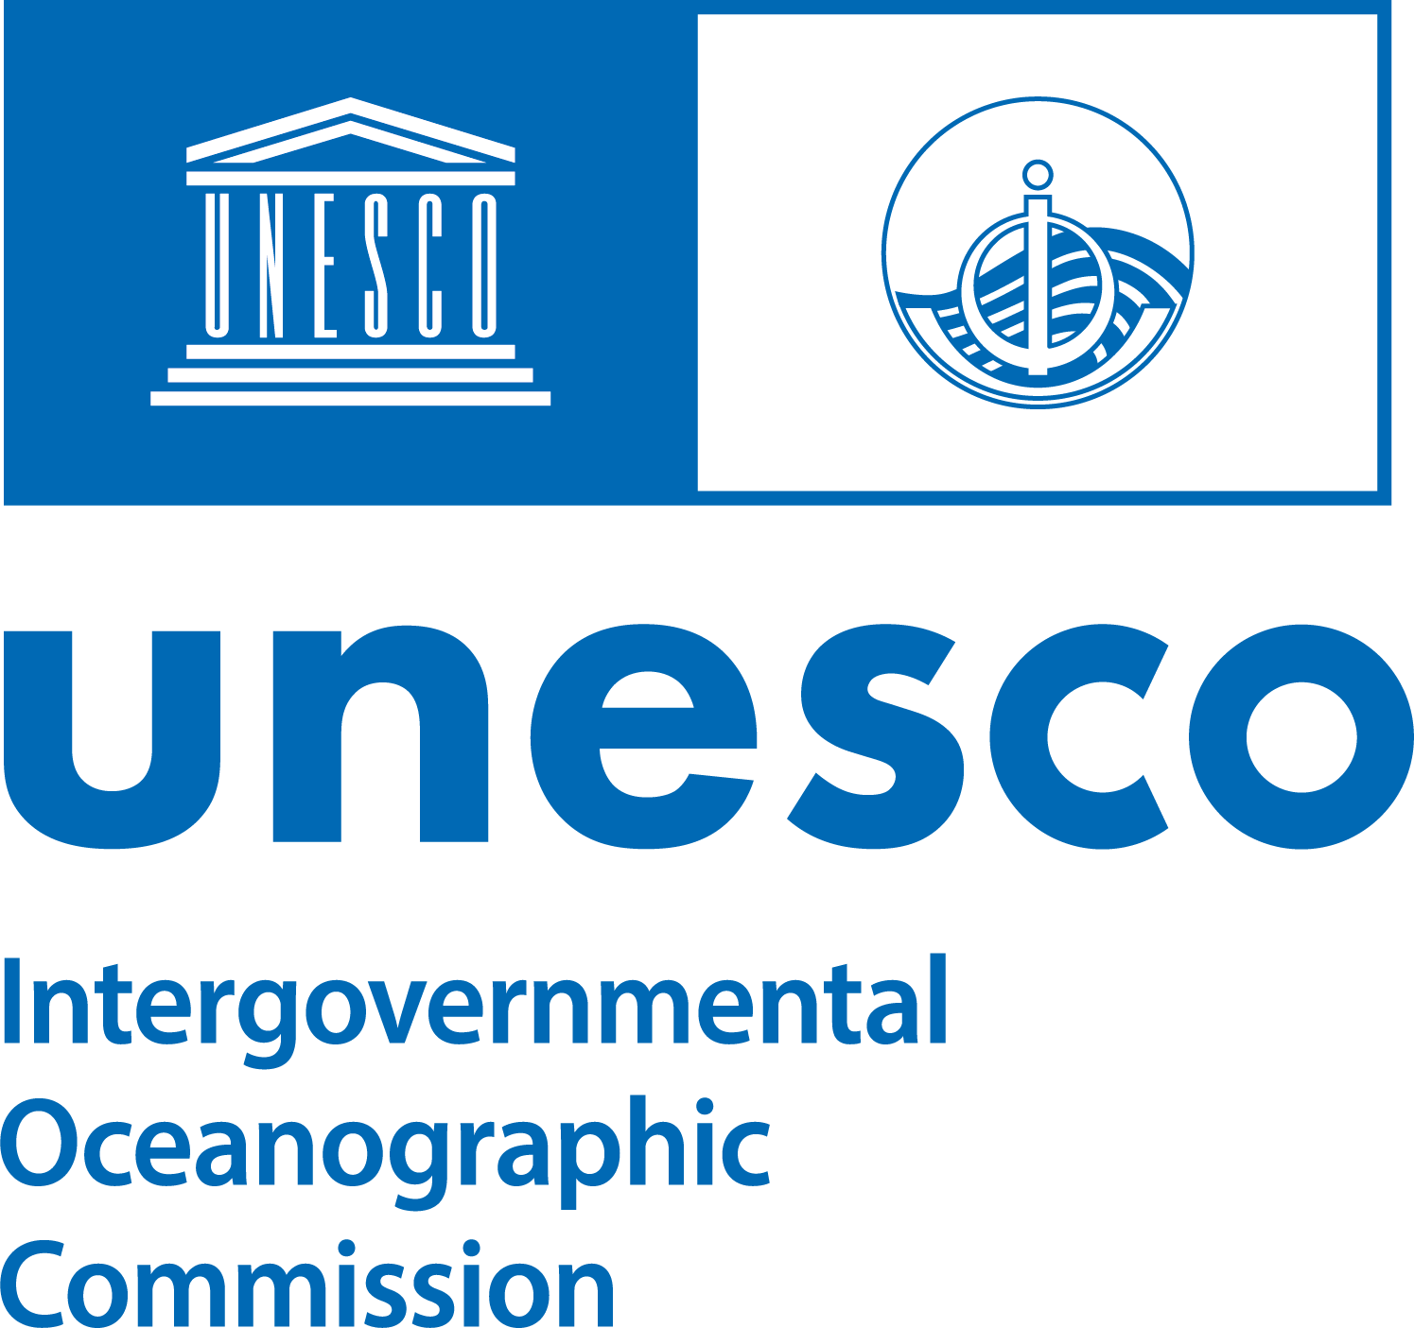
2026 IOC Ocean Traineeship
https://oceanexpert.org/event/4988

Reference documents to capacity development needs and priorities identified by IOC Governing Bodies, IOC Programmes, and IOC Regional Sub Commissions, globally and regionally:

IOC Assembly:

Summary Report of the 33rd Session of the IOC Assembly (25 June-3 July 2025, UNESCO, Paris): https://oceanexpert.org/document/37067

IOC Medium-term Strategy (2022-2029): https://unesdoc.unesco.org/ark:/48223/pf0000381388

- IOC Sub-Commissions:
IOC Sub-Commission for Africa and Adjacent Island States (IOCAFRICA):
Eighth Session of the Intergovernmental Oceanographic Commission, Sub-commission for Africa and the Adjacent Island States, documents and summary report: https://oceanexpert.org/event/4677#documents

Summarized information, by priority theme, provided by the Head of the IOCAFRICA Secretariat, Mr. Ibukun Adewumi:

- Coastal Hazard Early Warning Systems,
particularly strengthening expertise in hazard modelling, forecasting, and multi-hazard risk dissemination.
- Marine Spatial Planning (MSP),
with strong demand for technical training on GIS, participatory planning approaches, and transboundary MSP cooperation.
- Bioecology and e-DNA,
including capacity for e-DNA sampling, molecular analysis, and biodiversity monitoring.
- Ocean Acidification and Blue Carbon Assessments,
where access to monitoring technologies, standard methodologies, and data-sharing platforms remains a major gap.

- Pollution Monitoring,
especially chemical and microplastic pollution, where African Laboratories require analytical capacity, sensors, and data-integration tools.
- Deep-sea Research,
including training, regional coordination, and engagement in emerging global frameworks

IOC Sub-Commission for the Central Indian Ocean (IOCINDIO):
First Intergovernmental Session of the IOC Sub-Commission for the Central Indian Ocean (IOCINDIO-1), summary report: https://oceanexpert.org/document/36681
IOC Sub-Commission for the Caribbean and Adjacent Regions (IOCARIBE):
Eighteenth Intergovernmental Session of the Unesco-IOC Sub- Commission for the Caribbean and Adjacent Regions, meeting report https://oceanexpert.org/document/36725
IOC Sub-Commission for the Western Pacific (WESTPAC):
Fifteenth Intergovernmental Session of the IOC Sub-Commission for the Western Pacific (WESTPAC-XV): https://oceanexpert.org/event/4632

- IOC Programmes by section:

IOC Ocean Observations and Services Section (IOC/OOS):
Global Ocean Observing System (GOOS) Virtual Steering Committee Meeting Report: https://oceanexpert.org/document/37485
IOC Ocean Science Section:
- Building regional capacity:
  - for designing and implementing early warning systems for harmful algal blooms
  - in marine monitoring for ocean acidification, deoxygenation including hypoxia and pollution including eutrophication
  - conservation and restoration of blue carbon ecosystems, including assessment and accounting
- See also:
  - IOCARIBE: ocean acidification
  - IOAFRICA: Ocean acidification, blue carbon, marine hazard early warning systems, pollution
  - IPHAB: early warning systems for HABs, HAB taxonomy
IOC Marine Policy and Regional Coordination Section (IOC/MPR):
Marine Spatial Planning:
Summarized information and guidance, by priority theme and task teams, provided by the MSPGlobal Secretariat:
- IOCARIBE: Marine Spatial Planning Task Team (MSP-TT)
  - UN to UN Agreement with United Nations Office for Project Services (UNOPS) to implement MSP activities of the UNDP/GEF/UNOPS Procaribe+ Project, including:
    - National MSP processes in Colombia and Dominican Republic.
    - Capacity Development activities on MSP.
  - IOCARIBE established a Marine Spatial Planning Task Team (MSP-TT) as part of IOCARIBE’s Working Group on Capacity Development (composed of 19 IOCARIBE Member States and 5 organizations).
    - Exchange best practices and knowledge on MSP; facilitate implementation of MSP in the region; and act as a steering committee or advisory group for the implementation of UNDP/GEF/UNOPS Procaribe+ Project activities.

- IOCAFRICA: Marine Spatial Planning Technical Expert Group for the Atlantic Coast of West, Central and Southern Africa region (MSP-TEG-ACA)- https://www.mspglobal2030.org/msp-global/pilot-project-atlantic-coast-of-africa/

- WESTPAC: Group of Experts of Marine Spatial Planning (GoE-MSP)- https://ioc-westpac.org/MSP/Document/FINAL_Action%20Framework%20design_29Aug2025_s.pdf

Potential MSP tasks for a hosted intern:
- Support to regional MSP working groups
- Support the development of regional technical reports on MSP
- Support regional and national trainings and events on MSP
- Support the implementation of the MSPglobal Rapid Assessment Methodology at national level

IOC Tsunami Resilience Section (IOC/TRS):
[to come]
- IOC Technical Subsidiary Bodies

International Oceanographic Data and Information Exchange (IODE):
28th session of the International Oceanographic Data and Information Exchange Committee, meeting report and documents https://oceanexpert.org/document/36666

Ocean Biodiversity Information System (OBIS):

13th Session of the IODE Steering Group for OBIS, meeting report: https://oceanexpert.org/document/37512
Summarized information, by priority theme, provided by the Head of OBIS, Mr. Ward Appeltans: https://oceanexpert.org/document/38134
Sub-Unit of the Decade Coordination Unit hosted at IODE: Decade Coordination Office for Ocean Data Sharing:
https://oceanexpert.org/event/4988
IOC-FAO Intergovernmental Panel on Harmful Algal Blooms (IPHAB):
The Seventeenth Session of the IOC-FAO Intergovernmental Panel on Harmful Algal Blooms (IPHAB-XVII) was held on 18-20 March 2025 at UNESCO Headquarters in Paris. https://oceanexpert.org/document/36439.

- Cross cutting:

IOC Capacity Development
IOC Capacity Development Strategy (2023-2030): https://oceanexpert.org/document/35897
IOC Capacity Development Implementation Plan: https://oceanexpert.org/document/28303
IOC Ocean Literacy Action Plan: https://oceanexpert.org/document/37392
Ocean Teacher Global Academy (OTGA):
5th Session of the IODE Steering Group for OceanTeacher Global Academy, documents and report: https://oceanexpert.org/event/4852
Ocean Decade Coordination Unit
Capacity Development Facility: [to come]
Platforms and resources: https://oceandecade.org/capacity-development-facility/

