Guideline for Community Summary for Web Page

A. Outline, brief information on:
1. The community / village
2. Tsunami history, hazard, risk, and disaster risk reduction of the village
3. The tsunami ready effort and/or accomplishment

B. Specification, limit the information to:
- Paragraph: 3-4 Paragraphs
- Words: 300 – 400 words
- Characters: 1500 - 3000 Characters
- Include 1 photo representing Tsunami Ready activity in the community

C. Example 1:
In 2024, Adhuan (Adia) Village, India received recognition as Tsunami Ready under the Tsunami Ready Recognition Programme being developed by UNESCO-IOC.
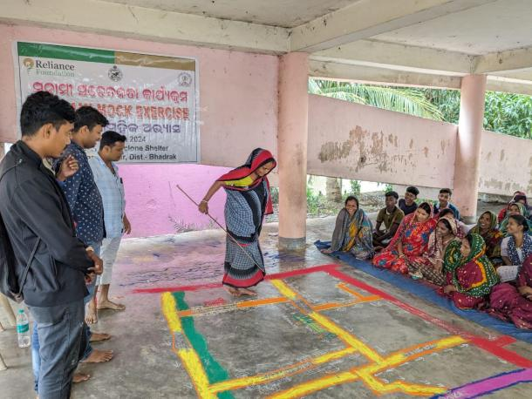

Adhuan (Adia) is a small village in Basudevpur Tahasil, Bhadrak District, Odisha, located 45 kilometers east of Bhadrak and 12 kilometers from Basudevpur. This coastal village is bordered by the Bay of Bengal to the east, Gavari River and Sasubhuasuni village to the south, Coast Canal to the west, and Eram village to the north. With its proximity to the coast, only 1.5 kilometers away, Adhuan faces significant vulnerability to natural hazards, including tsunamis, cyclones, and coastal flooding.
The village has experienced inundation during past disasters, underlining its high vulnerability. A Red Cross cyclone shelter is available in the village, reflecting the community's proactive approach to disaster preparedness. Historical tsunami hazard maps from the Indian National Centre for Ocean Information Services (INCOIS) indicate low inundation risk along the Odisha coast; however, the region has faced severe impacts from Oceano genic hazards, such as cyclones and storm surges.
Feedback from local residents and assessments of the coastal terrain have identified the area within 1.5 kilometres of the coast as a tsunami hazard zone, leading to the generation of relevant hazard maps. The demographic details of the community have been collected and approved by the Sarapanch (Head) of the Panchayat, ensuring that local knowledge is integrated into disaster risk management efforts.

Example 2:
In 2024, Lam Kruet, Indonesia received recognition as Tsunami Ready under the Tsunami Ready Recognition Programme being developed by UNESCO-IOC.
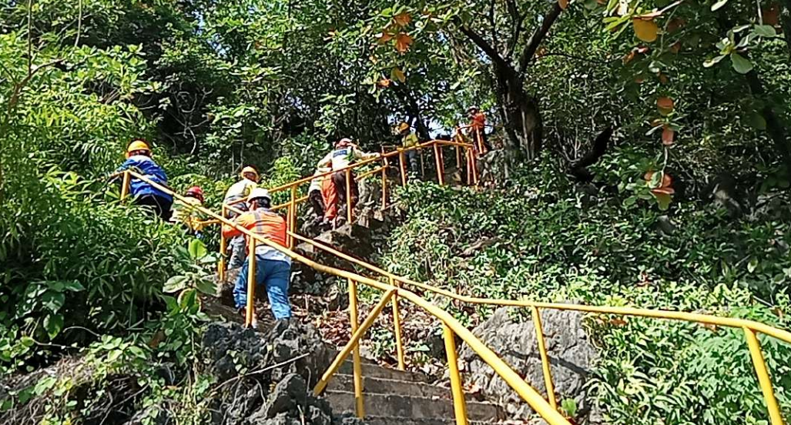
On December 26, 2004, a 9.1-magnitude earthquake struck off the coast of Aceh, Indonesia. The catastrophic event generated a massive tsunami that devastated the Indian Ocean region, claiming more than 227,000 lives and causing unprecedented destruction. With waves reaching over 35 meters in height, it remains one of the deadliest tsunamis in recorded history. Indonesia was the hardest-hit country, with 167,540 people dead or missing and economic losses exceeding USD 4.45 billion.

Lam Kruet Village, located in the Lhoknga sub-district of Aceh Besar District, less than one kilometer from the shoreline, was among the most severely affected communities. The tsunami obliterated the village, reducing its population by more than 95%. Lam Kruet endured catastrophic devastation but, despite the overwhelming loss, its community remained determined to recover and rebuild.

Today, Lam Kruet stands as a symbol of resilience. Its residents are deeply committed to restoring and strengthening their community while recognizing the vital importance of disaster preparedness in a hazard-prone region. The village’s dedication to recovery has transformed it into a model of adaptation and resilience in the aftermath of disaster.

Local government and support agencies, including the Aceh Besar District Disaster Management Agency (BPBD), have been instrumental in guiding Lam Kruet’s recovery. A cornerstone of this effort is the Lam Kruet Village Disaster Preparedness Team, which delivers disaster education, community guidance, and emergency response training. In collaboration with key partners such as the BMKG Aceh Besar Geophysical Station, BPBD Aceh District, and PT Solusi Bangun Andalas (SBA) through its Corporate Social Responsibility (CSR) program, the village has implemented a range of disaster risk management initiatives, with a strong emphasis on tsunami preparedness. Regular outreach and training activities have helped foster a culture of awareness and readiness.

Through these sustained efforts, Lam Kruet Village aspires to achieve UNESCO-IOC recognition as a Tsunami Ready Community. By strengthening contingency planning, deepening community engagement, and working closely with disaster management partners, the village seeks not only to safeguard its people but also to serve as an example of resilience and preparedness for other coastal communities in Aceh and beyond. These initiatives honour the memory of those lost while building a legacy of safety and strength for future generations.

