Logistics note for Cascais, Portugal

UNESCO-IOC EU DG-ECHO CoastWAVE National to Local Level Standard Operating Procedures (SOP) Workshop
Organized by UNESCO-IOC and hosted by Municipality of Cascais Civil Protection Agency
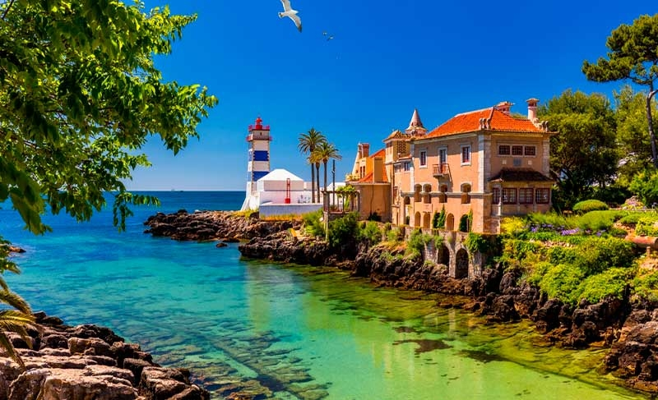

Welcome to Cascais!
We are delighted to welcome you to Cascais, one of Portugal’s most beautiful coastal towns. This brochure provides essential information to support your participation in the CoastWAVE SOP Workshop.
This workshop, held within the framework of the UNESCO-IOC CoastWAVE 2.0 Project, will bring together participants from across the North-eastern Atlantic, Mediterranean and connected seas region to strengthen tsunami preparedness through the development and harmonization of Standard Operating Procedures (SOPs).

🌍 About Cascais
Nestled between the Atlantic Ocean and Sintra mountains, Cascais is a charming and elegant town known for its beaches, historical heritage and laid-back lifestyle. Just 30 minutes away from Lisbon, it offers the perfect mix of tradition, culture and modern comforts.
Historically a fishing village, Cascais became a royal retreat in the 19th century and remains a top destination in Portugal for visitors looking for sun, sea and sophistication.

📅 Date: 27–30 October 2025
📅 Event Info & Contacts
- Workshop Location:
Casa de Santa Maria
Rua do Farol de Santa Marta 2750-341 Cascais, Portugal
(https://maps.app.goo.gl/X8S9ZyuA9AJGKE6T6)

The venue is located within a 20-minutes walking distance of Cascais train station.
The closest bus stop is Igreja Matriz (served by bus line M27), just 7-minutes’ walk to the event location.
Other nearby stops include:
- Cascais Train Station (served by M04, M05, M09, M15, M43);
- Cascais Bus Terminal (served by M02, M06, M07, M08, M11, M12, M13, M14, M17, M18, M22), which is approximately 22 minutes on foot from the venue.

- Contact Information:
Ms. Derya Dilmen Vennin at d.dilmen-vennin@unesco.org or +33 767 30 42 06
Mr. Rui Ângelo at rui.angelo@cm-cascais.pt or +351 924 102 526

💡 Practical Information
- Currency: Euro (€)
- Credit Cards: Widely accepted; cash is useful for small shops or cafés.
- ATMs: Available throughout Cascais; look for “MB” (Multibanco).
- Time Zone: Western European Time (WET / UTC+0)
- Portugal country code: +351

🚗 Transportation
From Lisbon Airport (Humberto Delgado – LIS):
- By public transport: Metro red line to Alameda → change to green line (direction Cais do Sodré) → train from Cais do Sodré to Cascais (Linha de Cascais, approx. 40 minutes).
- By taxi or ride-hailing service (Uber/Bolt): 30–40 minutes.
- Contact your hotel for pre-arranged transfers if needed.

Ground Transportation:
- Taxis & Ride-hailing apps: Widely available
- Bus: Cascais is served by several MobiCascais bus lines connecting the town center, train station, and surrounding areas. To plan a route using the city’s public transportation, please use the MobiCascais mobile app (https://mobi.cascais.pt/geral/aplicacao-mobicascais ).
Transport tickets can be purchased at major bus stops, at the Cascais train station, or via the MobiCascais app. It's important to note that only cash payments are accepted on board.
- Train: Lisbon–Cascais line (Cais do Sodré – Cascais). Information: https://www.cp.pt/passageiros/en
- Walking: The town center and venue are easily walkable
🏨 Accommodation
Hotel Name | Category | Contact | Website
Farol Hotel | 5★ | +351 214 823 490 | https://farol.com.pt/en/
Hotel Baía | 4★ | +351 214 831 033 | https://www.hotelbaia.com/
Vila Galé Cascais | 4★ | +351 214 826 000 | https://www.vilagale.com/
Westlight Cascais Chalet | 4★ | +351 214 842 174 | https://www.westlightcascaischalet.pt/en/
Pestana Cascais | 4★ | +351 214 825 900 | https://www.pestana.com/en/hotel/pestana-cascais
Cascais City & Beach Hotel | 3★ | +351 211 164 330 | https://www.cascaiscbhotel.com/
Cascais Hotel | 3★ | +351 215 897 370 | https://cascaishotel.mydirectstay.com/
Kavia Hotel do Largo | 3★ | +351 210 545 770 | https://www.hoteldolargo.pt/en/
Hotel Londres Estoril / Cascais | 3★ | +351 214 648 300 | https://hotelondres.com/en/

📱 Mobile & Internet
- Wi-Fi: Free Wi-Fi is available in most hotels, cafés and public areas.
- SIM Cards: Local prepaid SIMs (Vodafone, MEO, NOS) can be bought at the airport or stores.
- Roaming: EU roaming applies to most European mobile plans.

🥘 Where to Eat
Cascais offers a wide range of restaurants—from traditional Portuguese cuisine to international options.
Don't miss trying the pastry delicacies Pastel de Nata, Areias and Nozes de Cascais, or local gastronomic specialties like fresh grilled fish and seafood.

🌅 What to See & Do
In Cascais:
- Boca do Inferno – dramatic cliffs and crashing waves
- Cascais Marina – walk, dine and watch the boats
- Condes de Castro Guimarães Museum – history & art in a palace
- Parque Marechal Carmona – peaceful gardens in the town center
- Praia da Rainha & Praia do Guincho – from cozy coves to surfing waves
- Casa das Histórias Paula Rego – museum dedicated to the famous artist

🌄 Day Trips & Nearby Attractions
- Sintra (25 min): Palácio da Pena, Quinta da Regaleira, historic village
- Lisbon (30–40 min): Belém, Baixa-Chiado, Bairro Alto, Alfama
- Cabo da Roca: The westernmost point of continental Europe
🛡️ Safety and Security
- Cascais is generally safe but use standard precautions in crowded places
- Keep your valuables secure and be cautious of pickpockets
- In case of emergency contact local services listed below

📞 Emergency Contacts
- Emergency (Police/Fire/Ambulance): 112
- Police (PSP Cascais): 219 022 120
- Firefighters (non-emergency): 214 828 400
- Cascais Civil Protection Agency: 214 607 610

🌐 Useful Links
- Visit Cascais – Official Tourism Site (Visit Cascais )
- CP (Trains) – Schedules (Check train Times Online | CP - Comboios de Portugal )
- Lisbon Airport Info (https://www.lisbonairport.pt/en/lis/home)
- Weather in Cascais (https://www.accuweather.com/)

