

Draft:
User’s Guide for the South China Sea Tsunami Advisory Center (SCSTAC) products for the South China Sea Tsunami Warning and Mitigation System

TABLE OF CONTENT

1. OVERVIEW 1
1.1. BACKGROUND 1
1.2. AREA OF SERVICE 2
1.3. EARTHQUAKE SOURCE ZONE 2
1.4. TSUNAMI HAZARD 3
2. OPERATIONS 4
2.1. TSP FACILITY 4
2.1.1. SCSTAC 4
2.1.2. BACKUP SOUTH CHINA SEA TSUNAMI ADVISORY CENTER (Hong Kong) (BSCSTAC) 4
2.2. OPERATIONAL TOOLS AND PROCEDURES 4
2.2.1. Tsunami Source Detection and Characterization 4
2.2.2. Tsunami Wave Observations 5
2.2.3. Tsunami Forecasting 6
2.2.4. Decision Support 6
2.2.5. Product Creation and Dissemination 7
2.2.6. Timeline 8
3. PRODUCTS 9
3.1. PRODUCT TYPES AND CRITERIA 9
3.1.1. Informational 10
3.1.2. Threat 11
3.2. PRODUCT CONTENT 12
3.2.1. Text Products 12
3.2.2. Graphical Products 13
4. DISSEMINATION 14
4.1. METHODOLOGIES 14
4.1.1. Products 14
4.1.2. Customer Decision Support 15
4.2. COMMUNICATION TESTING 15
4.3. CONTACT INFORMATION 16
ANNEXS 17
ANNEX I PRODUCT TEMPLATES 17
A1. TSUNAMI INFORMATION (NO TSUNAMI THREAT) IN THE ESZ: 17
B1. TSUNAMI THREAT MESSAGE IN THE ESZ: 22
C1. TSUNAMI THREAT MESSAGE FROM EARTHQUAKE OUTSIDE THE ESZ: 28
A2. SUPPLEMENTARY TSUNAMI INFORMATION IN THE ESZ 30
B2. SUPPLEMENTARY TSUNAMI THREAT MESSAGE IN THE ESZ 34
C2. SUPPLEMENTARY TSUNAMI THREAT MESSAGE FROM OUTSIDE THE ESZ: 41
ANNEX II FORECAST POINTS 45
ANNEX III OBSERVATION SITES 47

OVERVIEW

BACKGROUND
The South China Sea Tsunami Advisory Center (SCSTAC), hosted by the National Marine Environmental Forecasting Center of China, has been authorized to commence full operation on 5 November 2019 by the Intergovernmental Coordination Group for Pacific Tsunami Warning and Mitigation System (ICG/PTWS). The interim tsunami advisory services from Northwest Pacific Tsunami Advisory Center (NWPTAC) for the South China Sea region were discontinued at the same time. The SCSTAC provides tsunami advisory services to 9 Member States of ICG/PTWS in the South China Sea (SCS) region and its adjoining basins Sulu Sea and Celebes Sea, which are identified as tsunami-prone areas due to high level of seismicity.
The ICG/PTWS-XXV Session in Vladivostok, Russia, approved the proposal of the South China Sea Tsunami Warning and Mitigation System submitted by SCS Regional Working Group (WG-SCS), and decided to further establish a Task Team on the Establishment of a South China Sea Tsunami Advisory Center (TT-SCSTAC). The 1st TT-SCSTAC Meeting, and the 3rd Session of WG-SCS that immediately followed, were both hosted by the Hong Kong Observatory on 7-9 April 2014. The WG-SCS adopted the recommendations of the TT-SCSTAC that the SCSTAC advisory products should comprise a suite of text and graphical products to keep pace with the PTWC New Enhanced Products, and the design of the SCSTAC advisory products should be accomplished and submitted for consideration to the 4th Session of WG-SCS. During the 4th WG-SCS Session hosted by BMKG in Jakarta, Indonesia the WG-SCS instructed TT-SCSTAC to continue its work on the draft SCS advisory products, and submit to the 5th WG-SCS Session for approval. The WG-SCS at its 5th Session in Manila, the Philippines requested the Intergovernmental Oceanographic Commission (IOC) Secretariat to circulate the document on ”Tsunami Advisory Products for the South China Sea Regional Tsunami Warning and Mitigation System” to all WG-SCS Member States for final comments with a time limit of one month, and finalize the SCS tsunami advisory products accordingly. As approved by the PTWS Steering Committee in July 2016, the SCSTAC advisory products were tested during the PacWave17 Tsunami Exercise among the SCS Member States, and the post-exercise survey was conducted and reported to the 6th WG-SCS Meeting (1-3 March 2017, Shanghai, China) and the ICG/PTWS 27th Session (31 March to 3 April 2017, Tahiti, French Polynesia). The 7th Session of WG-SCS (6-8 March 2018, Hanoi, Vietnam) requested the Member States to further review the technical document “Tsunami Advisory Products for the South China Sea Tsunami Warning and Mitigation System” and provide comments by the end of May 2018. WG-SCS agreed to accept the document “Tsunami Advisory Products for the South China Sea Tsunami Warning and Mitigation System” as an official publication within the IOC Technical Series upon endorsement of the IOC Assembly at the 8th Regional Working Group Meeting (4-6 March 2019, Jakarta, Indonesia). The 28th Session of ICG/PTWS (2-5 April 2019, Montelimar, Nicaragua) acknowledged that all the individual TSP user’s guides have similar categories of information regarding their services but organized in different ways, decided the existing and emerging TSPs should create or revise their current individual TSP user guides with a similar structure and scope of content. User’s Guide for SCSTAC products was published in September 2019 following the IOC Circular letter No 2777, which informed full operation of the South China Sea Tsunami Advisory Center (SCSTAC) on 5 November 2019. The 30th Session of ICG/PTWS (11-15 September 2023, Nuku’alofa, Tonga) reviewed and agreed on the proposed common Table of Contents proposed by the WG2 Task Team of TSPs. The 12th Session of WG-SCS (7-8 November 2024, Jakarta, Indonesia) requested SCSTAC to make ready the draft revised User’s Guide by December 2024 for the Chair of the WG-SCS to circulate it to Member State for review by January 2025. During the 31st Session of ICG/PTWS (7-11 April 2025, Beijing, China), it was noted that SCSTAC was continuing to revise its own User’s Guide and would finalize a draft version before the 13th Session of WG-SCS.
The provision of the SCS tsunami advisory products aims at allowing the recipient countries to take appropriate actions against tsunami threats, in collaboration with the Pacific Ocean-wide service provided by PTWC. The advisory products that account for regional features and particular requirements of the SCS Member States are crucial for an effective regional tsunami warning and mitigation system. In this regard, an in-depth and continuous involvement of all Member States in the optimization of products of the SCSTAC is of great importance.

AREA OF SERVICE
The Area of Service (AoS) for the SCSTAC includes the main body of the SCS, the Sulu Sea and the Celebes Sea located within the range of 99 - 128°E and 5°S - 24°N (Figure 1). Through the framework of the IOC of UNESCO, Member States in the region include Brunei, Cambodia, China, Indonesia, Malaysia, the Philippines, Singapore, Thailand and Vietnam. For major earthquakes that occur outside the SCS region but may pose threat to AoS, SCSTAC will issue tsunami advisory products by following the epicenter information identified by PTWC or NWPTAC.
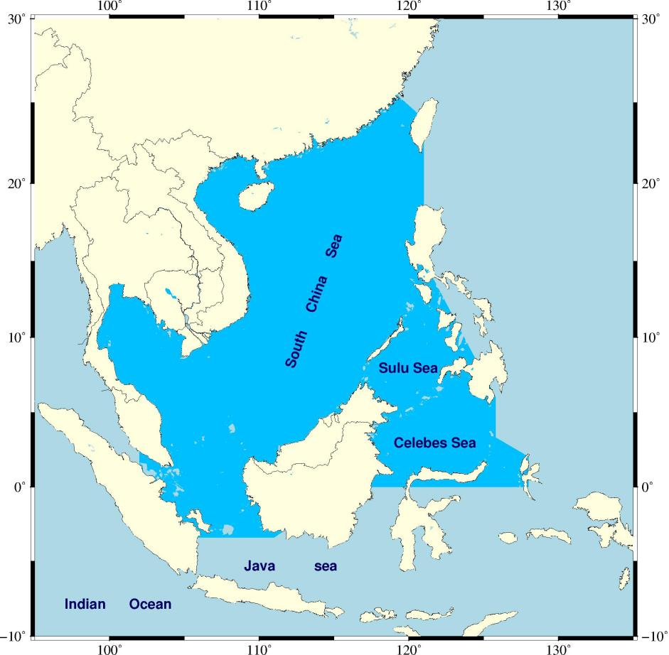
Figure 1. SCSTAC AoS.

EARTHQUAKE SOURCE ZONE (ESZ)
The SCS and its surrounding areas are situated at the boundaries of three major plates, namely the Eurasian, the Pacific and the Indo-Australian Plates. The convergence of these plates has resulted in frequent occurrence of complex tectonic activities in the region such as earthquakes, volcanic eruptions and tsunamis. When a catastrophic tsunami occurs, it could pose great threat to the coastal areas of the neighboring countries in the region.
The Earthquake Source Zone of SCS covers not only the SCS but also its adjacent basins, Sulu Sea and Celebes Sea (Sulawesi Sea), and is characterized as one of the most vulnerable regions to major tsunamigenic earthquakes due to the high seismicity of the Manila Trench, Cotabato and Negros Trench, and North Sulawesi Trench (Li et al. 2018; Mardi et al. 2017) (Figure 2).
In case an earthquake occurs near any common boundary of the PTWC Area of Earthquake Responsibility (AER), SCSTAC AoS or NWPTAC AER, the SCSTAC will promptly use its own earthquake parameters for issuance of tsunami bulletins to avoid possible scenario that no TSPs consider the epicenter falling within their area of responsibility. These areas are called buffer zones with a slightly extended boundary of the earthquake source zone and the TSPs can use their own earthquake parameters.
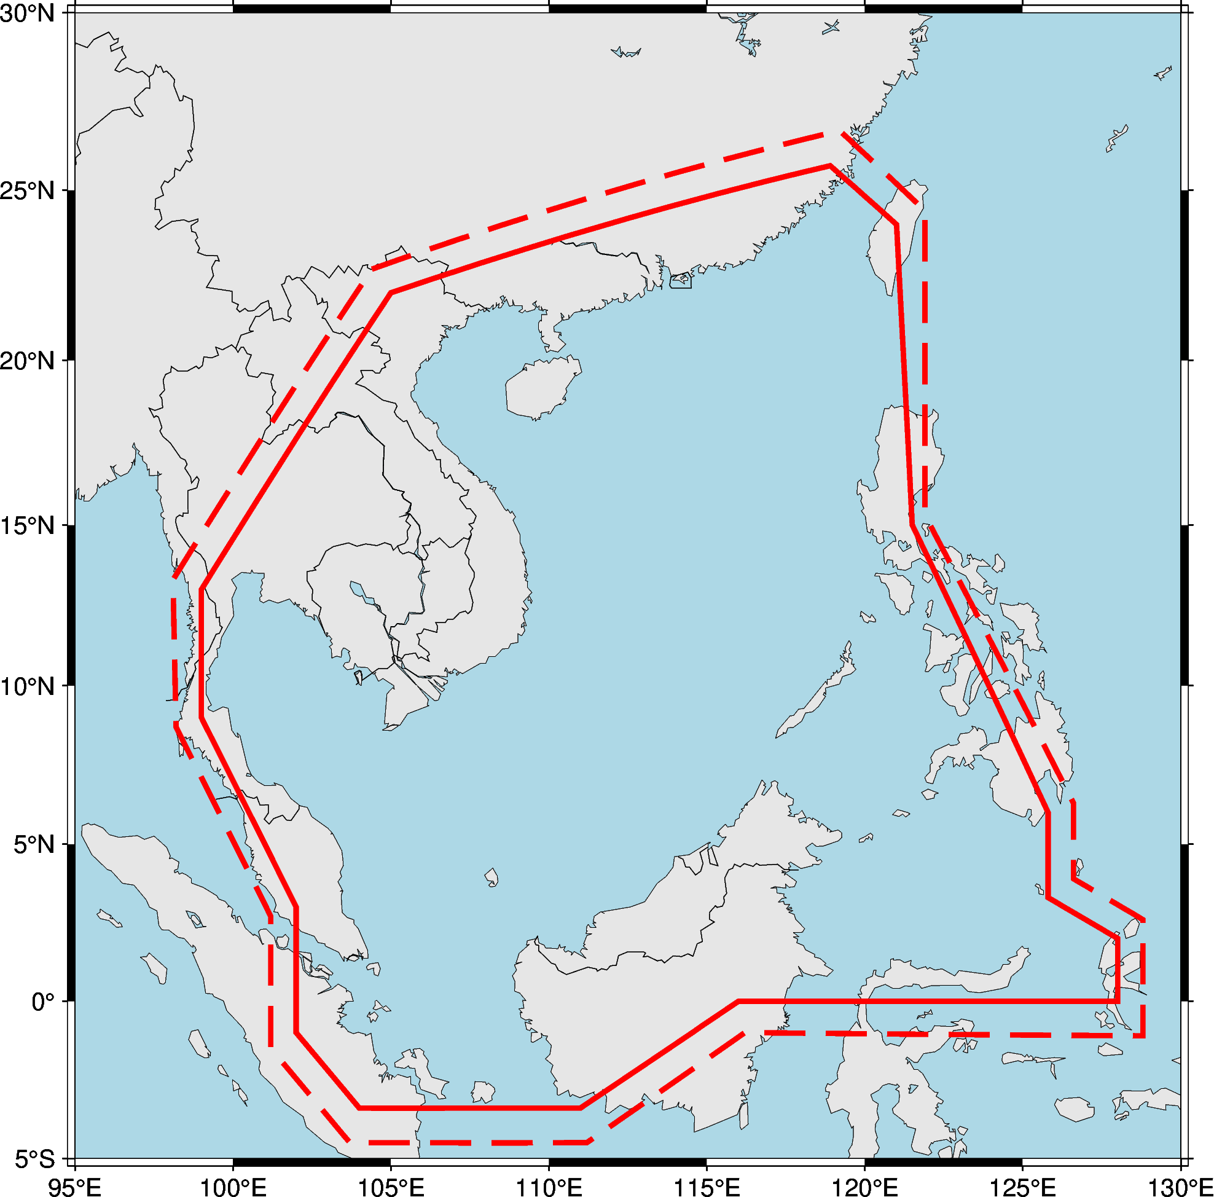
Figure 2. Earthquake source zone(red solid line) of SCSTAC with buffer zones(red dotted lines)

TSUNAMI HAZARD
Historical events have demonstrated the devastating impact of these hazards, not only in terms of human loss, but also in the disruption of livelihoods, infrastructure, and regional stability.In 2018, a M_{w}7.5 earthquake struck Sulawesi Island, Indonesia, triggering a tsunami and resulting in more than 2,000 4000 deaths. The M_{w}9.0 (Harvard CMT) earthquake that occurred in the southwestern waters of Sumatra Island, Indonesia on 26 December 2004, triggered an extremely rare transoceanic seismic tsunami, causing more than 283,100 deaths in the countries around the Indian Ocean and devastating damage to the coastal areas. In 1976, a M_{w}8.0 earthquake struck the Sea of Sulawesi and triggered a tsunami, causing nearly 8,000 deaths or missing in the Philippines and triggering a local tsunami with waves exceeding 4 to 5 meters.
After the Indian Ocean tsunami incident occurred, it attracted the attention of governments and the public all over the world, including China. How to prevent and mitigate earthquake and tsunami disasters and establish an effective tsunami early warning system have become the focus of attention from all sectors of society. The South China Sea region is located at the confluence of the Eurasian Plate, the Pacific Plate and the Indo-Australian Plate. Due to the influence of subduction of multiple plates, volcanic, seismic and tsunami activities are frequent in the junction areas of various plates. Subduction zones such as the Manila Trench, the Sulu Trench and the Sulawesi Trench have developed along the eastern margins of the South China Sea, the Sulu Sea and the Sulawesi Sea, which are internationally recognized as potential sites for tsunami sources. If a large-scale tsunami occurs, it will pose great threat to the coastal areas of the countries around the South China Sea.

OPERATIONS

TSP FACILITY

SCSTAC
The SCSTAC is located at 8 Dahuisi Road, Haidian District, Beijing, China, operated by the National Marine Environmental Forecasting Center (NMEFC) of China, and supported by the China Earthquake Administration (CEA). The SCSTAC provides 24-hour all-weather earthquake and tsunami monitoring and early warning services for the Member States around the SCS. There are two staff on duty respectively serving as the primary and standby watch-standers in each shift, switching positions at 6:00 PM.

BACKUP SOUTH CHINA SEA TSUNAMI ADVISORY CENTER (Hong Kong) (BSCSTAC)
The BSCSTAC, located at the Central Forecasting Office of the Hong Kong Observatory (HKO), was officially put into operation on 29 March 2023, after a year of trial operation. All operating systems of the BSCSTAC are in hot standby mode on normal days. An HKO’s watch-stander provides round-the-clock tsunami monitoring and BSCSTAC is ready to support the SCSTAC in providing a tsunami alert advisory service for the South China Sea region as and when necessary.

OPERATIONAL TOOLS AND PROCEDURES

Tsunami Source Detection and Characterization
Hypocenter and magnitude of earthquake are important parameters for tsunami warning. Rapid estimation of magnitude with optimal accuracy is particularly important in tsunami forecasting. Therefore, SCSTAC utilizes automatic monitoring systems to assess earthquakes as they occur. When certain criteria are met, manual analysis of the event is commenced.
The data used for the calculation of earthquake parameters include those from around 20 seismic broadband stations of the Ministry of Natural Resources (MNR) of China, more than 50 seismic broadband stations of CEA, and other national and regional networks around the world (Figure 3).
The earthquake monitoring and processing systems, including SeisComP and Antelope, were set up in the SCSTAC to monitor, detect and rapidly identify possible tsunamigenic earthquakes within the AoS for tsunami warning, involving widespread data collection, data quality control, data archiving, real-time data transfer protocol, automated and interactive data processing procedures to determine the origin time, location, depth and various types of magnitude. Mwp is calculated using band-pass filtered data from seismic broadband stations within global seismological networks and seismic stations of China (Xu et al., 2021). In addition, W-phase Centroid Moment Tensor (WCMT) analysis (Dziewonski et al., 1981; Kawakatsu, 1989), which is typically available about 10-20 minutes after the earthquake is also used to run the tsunami model.

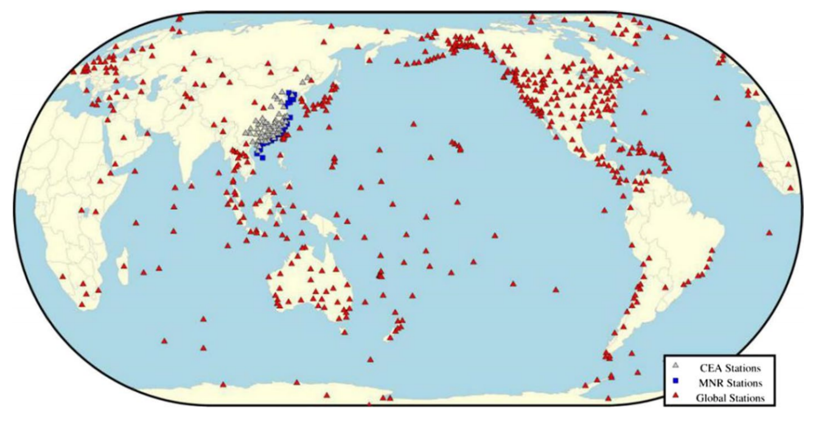
Figure 3. Seismic stations (grey: stations of CEA, blue: stations of MNR, red: global stations) used to determine hypocenters and magnitude of earthquakes and for CMT analysis by SCSTAC (as of 31 July 2025)

Tsunami Wave Observations
The SCSTAC acquires real-time sea-level data though the NOAA GTS Server and GTS Server of China Meteorological Administration. Two sea-level decoding software, the self-developed one and the Tide tool, are running to back up each other. SCSTAC determines the tsunami amplitude relative to the normal sea level (i.e. above the astronomical tide level) as a common measure of tsunamis. Amplitude is measured as (1) the absolute difference between a particular peak or trough of the tsunami and the sea level at that time, or (2) half the difference between an adjacent trough and peak.
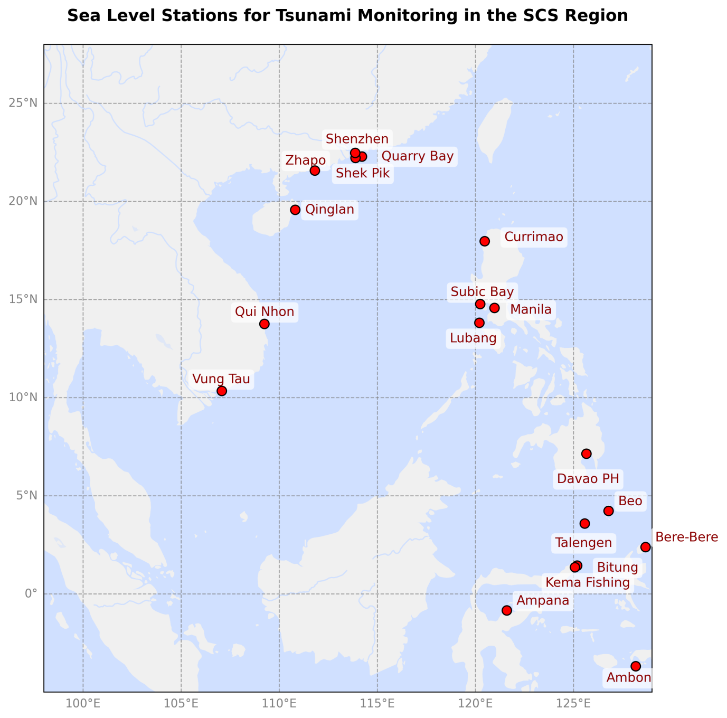
Figure 4. Sea level gauges for tsunami monitoring in the SCS Region

Tsunami Forecasting
Two sets of tsunami numerical forecasting model are in operation now at the SCSTAC. The first forecasting method is based on a pre-computed scenario database, which covers the Northwest Pacific Ocean. The second one is real-time tsunami forecast based on a GPU & OpenMP hybrid parallelized tsunami model - CTSU.
The computation domains include the SCS, NW Pacific and the whole Pacific with a resolution of 2, 4 and 5 arc-minute respectively. The linear shallow water equation was adopted as the governing equation and the minimum water depth of 10 meters was set. For the focal mechanism input, the initial forecast can start when earthquake location and magnitude are available, while the strike, slip and dip angles are chosen based on the Harvard Global CMT catalog in a conservative manner. When the W-phase CMT solution becomes available, the model can be re-run to generate a more accurate forecast. A 15-hr forecast for the SCS region model domain at 2-arc-min resolution can be produced within 10 seconds, a 15-hr forecast for the NW Pacific model domain at 4-arc-min resolution can be obtained within 8 seconds, and a 30-hr forecast for the entire Pacific region can be produced in less than 80 seconds.

Decision Support
A state-of-the-art decision support system (DSS) called Smart Tsunami Information Processing System (STIPS) tailored for the SCSTAC has been put into operation since February 2023. The DSS was self-developed by watchstanders of SCSTAC using Python. It was designed for watchstanders to make decisions following the Standard Operating Procedures and the warning criteria. The SCSTAC text bulletins and graphical products can be finally generated through a series of functional modules including: Seismic module, tsunami observation module, tsunami scenario database and tsunami modeling modules, coastal impact assessment modules and bulletin production & dissemination modules (Figure 5).
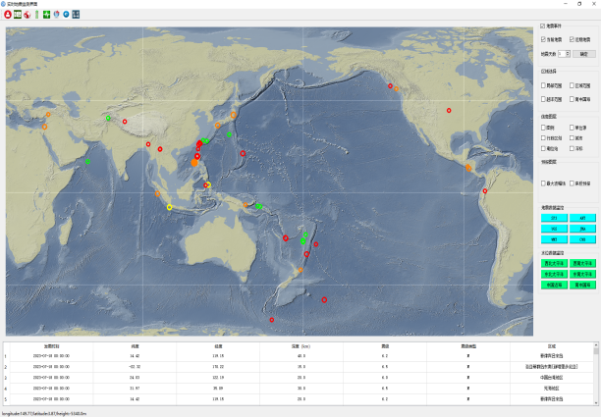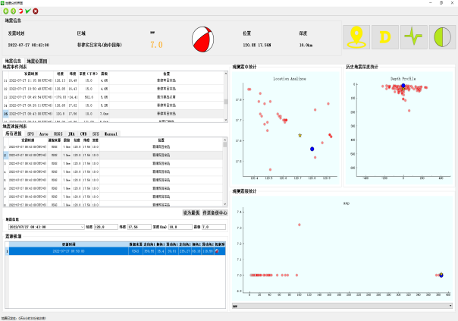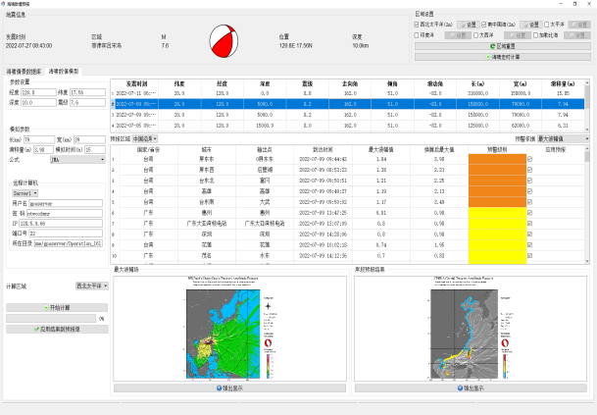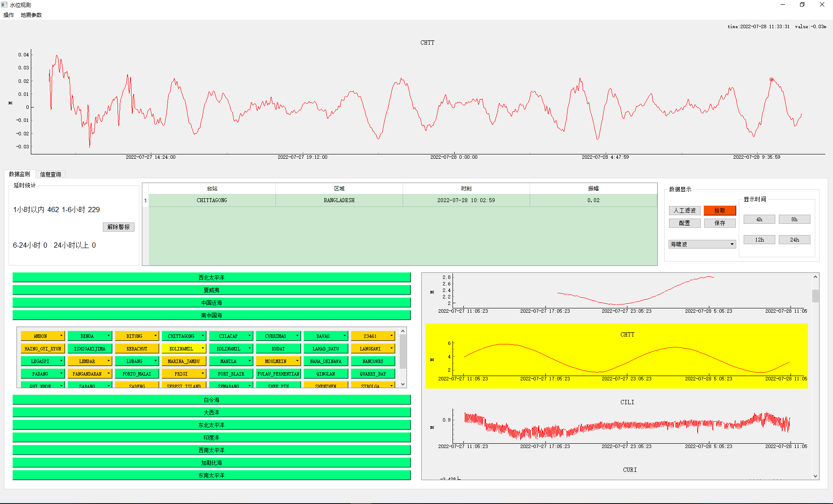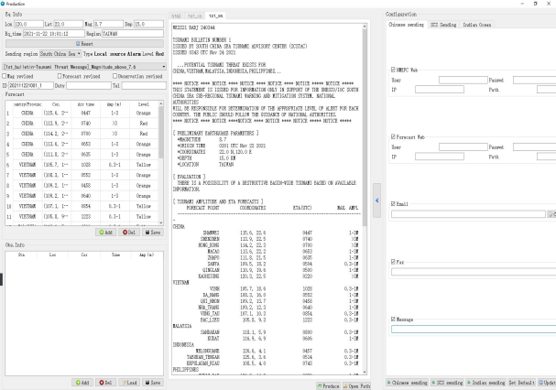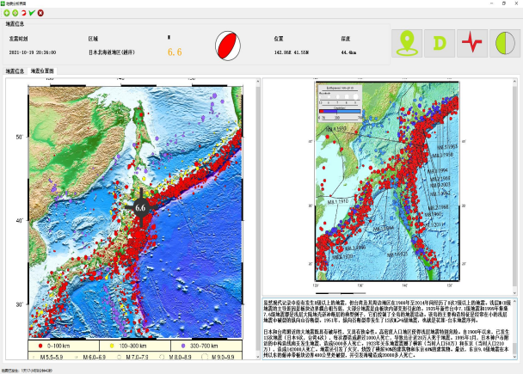
(f)
(e)
(d)
(c)
(a)
(b)
Figure 5. Decision support system for SCSTAC containing (a) Information display module; (b)-(c) Seismic module; (d) Tsunami Scenario database and TTT module; (e) Tsunami observation module; and (f) Bulletin production and dissemination module.

Product Creation and Dissemination
SCSTAC products in both textual and graphical formats are created and disseminated by the decision support system when an earthquake of magnitude 6.0 or above is detected in the SCSTAC earthquake source zone (Figure 2). The first product is text product containing information on the earthquake location, depth and magnitude, along with a qualitative tsunami evaluation for a submarine earthquake of magnitude ranging from 6.0 to 7.0 occurs with a depth less than 100 km. If the earthquake magnitude is 7.1 or above, tsunami forecast will be generated by using tsunami database or real-time numerical model. Therefore, the first product may consist of both text and graphical products, with information on the estimated arrival time and the maximum amplitude forecast. The second and subsequent products may be issued depending on the updated earthquake parameters, quantitative results and tsunami observations. The graphical products of the second and subsequent advisories are provided only when tsunami amplitudes of 0.3 m or more are expected for any forecast points or coastal points defined by SCSTAC. The details and dissemination of text and graphical products are described in Section 3.2 and Section 4 respectively.

Timeline
The typical timeline in Table 1 shows the events that occur within the AoS during the process necessitating the issuance of advisory products by SCSTAC. The times shown are only approximate values which may represent typical values.

Table 1. General Timeline of events for SCSTAC Products

Time | Events
00h00m | An earthquake of magnitude 6.0 or above occurs within the AoS of SCSTAC.
00h03m | Seismic waves from the earthquake reach seismic stations near the epicenter, triggering event alarms with preliminary seismic parameters available at SCSTAC. The watchstander begins to analyze the event.
00h06m | Rapid calculations of tsunami amplitude forecast are performed using GPU models or tsunami scenario database.
00h08m | Tsunami forecast is produced and tsunami hazard is analyzed based on the numerical results.
00h10m | The first informational or threat message is issued according to the criteria listed in Table 2 and 3 based on seismic parameters and numerical results.
00h30m  to 03h00m | The second informational or threat message is issued with updated seismic parameters and tsunami observations.
Beyond  03h00m | Subsequent informational or threat messages are issued with updated seismic parameters and tsunami observations. The watchstander continuously updates seismic parameters and tsunami observations as situation warrants, and incorporates this information to enhance forecast accuracy. A final bulletin is issued when there is no longer a significant tsunami threat.

PRODUCTS
The SCSTAC is committed to ensuring all National Tsunami Warning Centers (NTWCs) and Tsunami Warning Focal Points (TWFPs) can receive, understand and respond appropriately to tsunami advisory products. In general, the SCS advisory products should be informative, intuitive and comprehensive, and more importantly, be compatible with PTWC’s New Enhanced products so as to avoid possible confusion and facilitate usage.

PRODUCT TYPES AND CRITERIA
At the 25th Session of the ICG/PTWS held on 11-13 September 2013, all Member States agreed on a changeover to the PTWC New enhanced Products suite since 1 October 2014. As each Member State is sovereign and thus responsible for taking actions to ensure the safety of its own population, the PTWC New Enhanced Products no longer use levels of alert (i.e., watch and warning) to define the tsunami bulletins, and instead provide levels of threat based on numerical modeling. The levels of threat currently are provided as expected maximum tsunami wave amplitudes relative to the tide within four categories which are: (i) less than 0.3 m, (ii) 0.3 to less than 1 m, (iii) 1 m to 3 m, and (iv) greater than 3 m.
The SCS Tsunami Advisory Products follow the PTWC and NWPTAC’s practice to provide quantitative tsunami threat to recipients, rather than warning levels that are more meaningful and useful for local warnings. According to numerical studies in the SCS region, the basin-wide tsunami triggered by the Manila Trench will strike the Philippines within an hour and reach China, Vietnam, Malaysia and Brunei in 1-4 hours, thus there is not much time left for emergency response. Basically, SCSTAC will send out the initial bulletin as soon as possible mainly based on the preliminary earthquake parameters including location, magnitude and focal depth. Whether a Member State will be put into‘threat area’depends on the relatively conservative outputs of the tsunami forecast.
In Tsunami Informational or Tsunami Threat Message, the tsunamigenic potential is provided based on preliminary earthquake parameters and tsunami forecasts as follows:
Table 2. Tsunamigenic potential adopted by SCSTAC
Magnitude(Mw) | Tsunami Forecast | Tsunami Potential Description
6.0 ≤ Mw ≤ 7.0 | NONE | There is no tsunami threat from this earthquake
7.1 ≤ Mw ≤ 7.5 | Available if amplitude < 0.3m | There is no tsunami threat but minor waves are expected
7.1 ≤ Mw ≤ 7.5 | Available if amplitude >= 0.3m | Possibility of a destructive local tsunami confined to 100-300 km of the epicenter
7.6 ≤ Mw ≤ 7.9 | Available | Possibility of a destructive regional tsunami confined to 1000 km of the epicenter
Mw ≥ 8.0 | Available | Possibility of a destructive basin-wide tsunami

Informational
Table 3. Informational criteria adopted by SCSTAC
Bulletin type |  | Criteria | Content | Timeline
Tsunami  Information for EQ occurs in the ESZ  (A1) | Only one  bulletin  unless minor  waves  observed  and should  be reported | EQ inland or  depth≥100km | Preliminary EQ parameters and statement of ‘No tsunami threat’ | Less than 10 min
Tsunami  Information for EQ occurs in the ESZ  (A1) |  | Submarine EQ with magnitude 6.0-6.4 & depth<100km |  | Less than 10 min
Tsunami  Information for EQ occurs in the ESZ  (A1) |  | Submarine EQ with magnitude 6.5-7.0 & depth<100km | Preliminary EQ parameters and statement of ‘No tsunami threat’ but minor waves may be expected | Less than 10 min
Tsunami  Information for EQ occurs in the ESZ  (A1) |  | Submarine EQ with magnitude 7.1-7.5 & depth<100km  & no tsunami forecast amplitude 0.3m or above |  | Less than 10 min
Tsunami  Information  for EQ occurs in the ESZ  (A2) | Waves  Observation recorded or upgraded | Observed amplitude  less than 0.3 m | EQ parameters, and statement of ‘No tsunami threat’, and/or Observed amplitude
Tsunami  Information  for EQ occurs in the ESZ  (A2) | Downgrade from threat message according to wave observation or forecast | Observed amplitude  less than 0.3 m; or EQ parameter or tsunami  forecasts falling into the informational criteria

Threat
Table 4. Threat criteria adopted by SCSTAC
Bulletin type |  | Criteria | Content | Timeline
Tsunami  Threat  Message for EQ occurs in the ESZ  (B1) | Supplementary or final bulletin will follow with persistently updated wave observations | Submarine EQ with magnitude 7.1-7.5 & depth<100km  & tsunami forecast amplitude 0.3m or above | Preliminary EQ parameters, and Member States under potential threat and quantitative tsunami forecasts (Estimated Time of Arrival and Amplitude) | Less than 15 min
Tsunami  Threat  Message for EQ occurs in the ESZ  (B1) |  | Submarine EQ with Magnitude no less than 7.6 & depth<100km |  | Less than 15 min
Tsunami Threat Message for EQ occurs outside the ESZ  (C1) | Supplementary or final bulletin will follow with persistently updated wave observations | Submarine EQ with magnitude no less than 7.6 & depth<100km & outside the ESZ but in the Pacific Ocean | Preliminary EQ parameters and Member States under potential threat and quantitative tsunami forecasts (Estimated Time of Arrival and Amplitude) | Less than 15 min
Tsunami  Threat  Message for EQ occurs in the ESZ  (B2) | Waves  observation  recorded or updated | Observed amplitude 0.3 m or above | EQ parameters and Member States under potential threat and  quantitative tsunami forecasts (Estimated Time of Arrival and Amplitude) and/or Observed amplitude
Tsunami  Threat  Message for EQ occurs in the ESZ  (B2) | Upgrade from the information according to wave observation or forecast | Observed amplitude 0.3 m or above; or EQ parameter  or tsunami  forecasts falling into the threat criteria
Tsunami  Threat  Message for EQ occurs in the ESZ  (B2) | Final bulletin for threat message | Less than 0.3m of wave amplitude recorded for 2h | Statement of ‘No  tsunami confirmed or  threat passed’
Tsunami  Threat Message for EQ occurs outside the ESZ but poses potential threat to AOS  (C2) | Waves  observation  recorded or updated | Observed amplitude 0.3m or above | EQ parameters and Member States under potential threat and quantitative tsunami forecasts (Estimated Time of Arrival and Amplitude) and/or Observed amplitude
 | Final bulletin for threat message | Less than 0.3m of wave amplitude recorded for 2h | Statement of ‘No  tsunami confirmed or  threat passed’

PRODUCT CONTENT

Text Products
Text message is available to the public, NTWCs and TWFPs. Typically the SCSTAC text product contains earthquake parameters, tsunamigenic potential, tsunami amplitude and ETA forecasts for each Coastal Forecast Point, tsunami observations, and recommended actions. The earthquake parameters for major earthquakes need to be coordinated and consistent with those of the PTWC or/and NWPTAC bulletin (refer to Appendix I for bulletin templates)

3.2.1.1 Informational message
The tsunami informational message means all forecast points in the SCS region are estimated less than 0.3 meter based on the current earthquake parameters and tsunami data.
- Product Heading - WESS31 BABJ or WESS31 VHHH
- Product Title - TSUNAMI INFORMATION
- Earthquake Parameters -
[ PRELIMINARY EARTHQUAKE PARAMETERS ]
*MAGNITUDE
*ORIGIN TIME
*COORDINATES
*DEPTH
*LOCATION
- Current State of the Tsunami Evaluation - [ EVALUATION ]
- Tsunami Observations -
[ TSUNAMI OBSERVATIONS ]
GAUGE NAME REGION COORDINATES TIME (UTC) MAX. AMPL
BITUNG INDONESIA 1.4N, 125.2E 1100 0.13 M
DAVAO PHILIPPINES 7.1N, 125.6E 1310 0.08 M
- Recommended Actions - [ RECOMMENDED ACTIONS ]
- Update - [ UPDATES ]
- Other Information - [ ADDITIONAL INFORMATION]

3.2.1.2 Threat message
Compared to the informational message, quantitative forecasts are added for coastal forecast points. Tsunami amplitude and arrival time are provided for each coastal forecast point in the SCS region. These coastal forecast points were agreed-upon points chosen by the SCS Member States during the 3rd ,4th and 5th WG-SCS Meeting in Hong Kong, Jakarta and Manila, respectively. They correspond to important coastal populated cities and sea-level gauges. In order to keep consistent, now majority of these coastal forecast points come from PTWC and NWPTAC’s forecast points for ETA and amplitude (refer to Appendix II). In the tsunami threat message, all forecast points with maximum amplitude greater than 0.3 meter are listed in groups that are entitled as Member States.
- Product Heading - WESS21 BABJ or WESS21 VHHH
- Product Title - POTENTIAL TSUNAMI THREAT EXISTS FOR ...
- Earthquake Parameters -
[ PRELIMINARY EARTHQUAKE PARAMETERS ]
*MAGNITUDE
*ORIGIN TIME
*COORDINATES
*DEPTH
*LOCATION
- Current State of the Tsunami Evaluation - [ EVALUATION ]
- Threatened Coastal Areas & Forecast Arrival Times & Forecast Amplitudes -
[ TSUNAMI AMPLITUDE AND ETA FORECASTS ]
FORECAST POINT COORDINATES ETA (UTC) MAX. AMPL
--------------------------------------------------------------------------------------------------------
PHILIPPINES
CURRIMAO 18.0N, 120.5E 0330 0.3-1 M
--------------------------------------------------------------------------------------------------------
- Tsunami Observations -
[ TSUNAMI OBSERVATIONS ]
GAUGE NAME REGION COORDINATES TIME (UTC) MAX. AMPL
BITUNG INDONESIA 1.4N, 125.2E 1100 0.13 M
DAVAO PHILIPPINES 7.1N, 125.6E 1310 0.08 M
- Recommended Actions - [ RECOMMENDED ACTIONS ]
- Update - [ UPDATES ]
- Other Information - [ ADDITIONAL INFORMATION]
.

Graphical Products
Graphical products are exclusive to the NTWCs and TWFPs, including tsunami energy map and coastal forecast map.

      - Tsunami Energy Map
The tsunami energy map shows the color-filled distribution of maximum tsunami amplitude in the SCS region. Direction of tsunami energy beam and the threatened areas can be easily identified by different color scale. The contour map of Tsunami Travel Time (TTT) is shown in light-gray lines and overlapped on tsunami energy map.
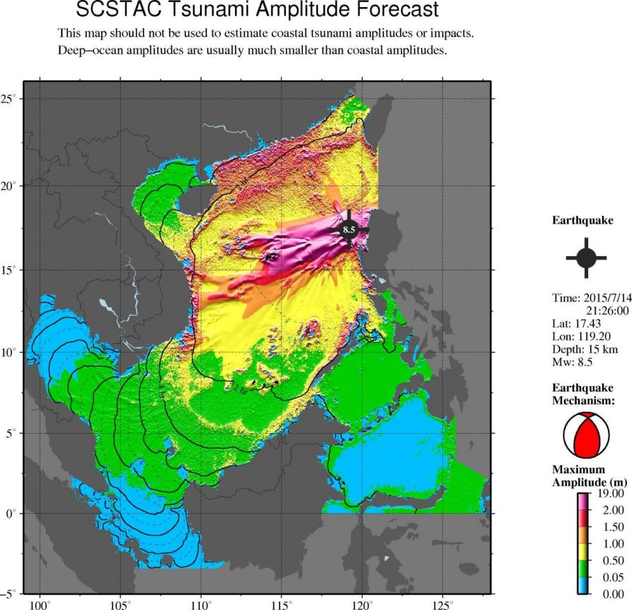
Figure 6. Tsunami Energy Map.

      - COASTAL FORECAST MAP
The coastal forecast map provides a detailed view of tsunami threat to the coasts in the SCS region. It divides the SCS coastlines into a number of Model Output Points (MOP). Each MOP is colored according to the tsunami amplitude of the model grid points closest to the point. The tsunami energy map is also overlapped in gray-shading style with illuminated effect and further have TTT contour lines on top.
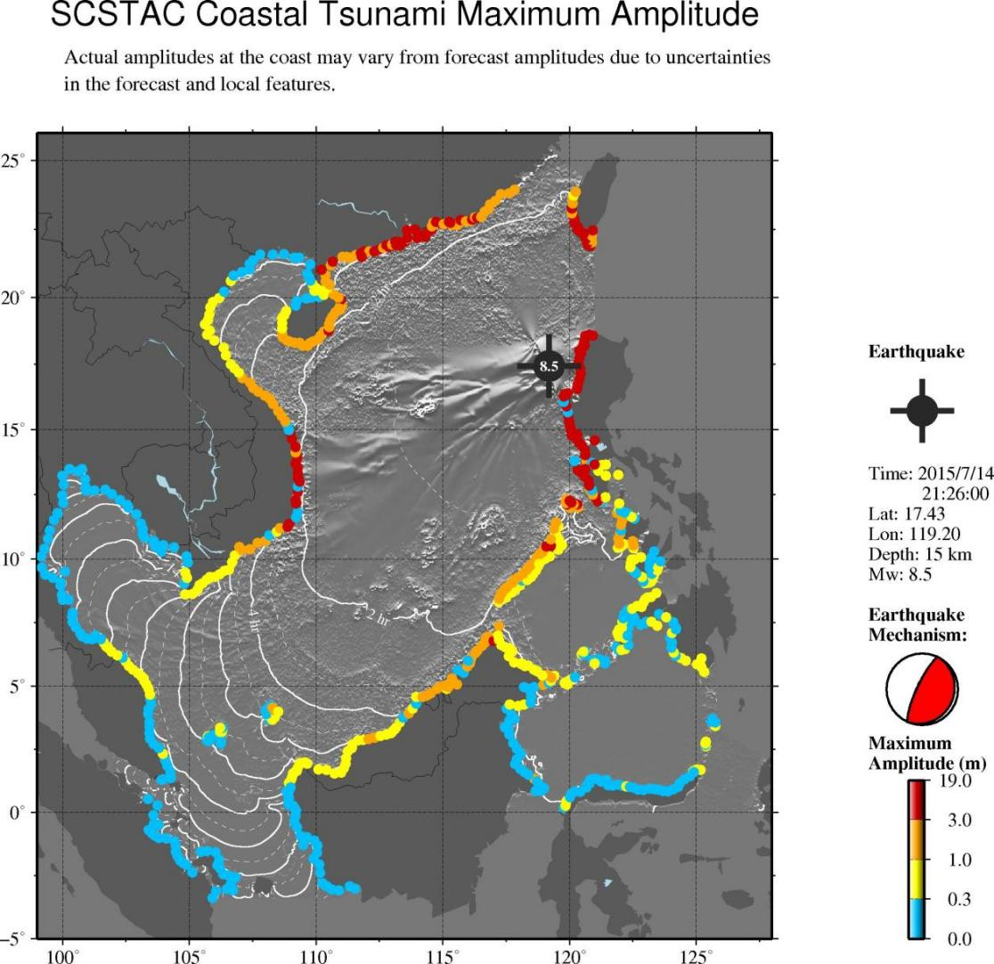
Figure 7. Coastal Forecast Map.

DISSEMINATION

METHODOLOGIES

Products
According to experience adopted by PTWS, text message should be available to the NTWCs via WMO Global Telecommunication System (GTS), email and website, while scientifically more complex graphical products should only be accessible to NTWCs and TWFPs via exclusive channels such as email in order to minimize public confusion and misunderstanding. A public and NTWC accessible website is developed to facilitate the dissemination of tsunami advisories. The website is SCSTAC.OCEANGUIDE.ORG.CN maintained by NMEFC, and BSCSTAC.HKO.GOV.HK maintained by HKO.

Table 5. Products dissemination approaches
Approach | Services
GTS | Text Message
Website | Text Message for public
Email | Text and Graphical products for NTWCs and TWFPs

Customer Decision Support
SCSTAC products support decisions on tsunami warning/alert issuance by recipient countries. If no information is issued by the SCSTAC in an emergency, user countries should take appropriate actions with reference to the advisories from PTWC and NWPTAC. In the event of any difference in tsunami threat evaluation among PTWC, NWPTAC and SCSTAC, the most extreme one should be considered to be adopted for conservative sake. Alerts should be officially issued and lifted by the authorities of the countries concerned, as tsunami characteristics depend on coastal terrain and bathymetry as well.
For a giant earthquake (M>8.0), the first product tends to underestimate the moment magnitude in a very short time, and supplementary products are supposed to follow up. According to the current criterion herein, threat type messages should be followed by the last one indicating that the threat has passed, or no destructive tsunami is confirmed. However, the current information type message may be the final issuance unless threat conclusion is made based on the updated information, or tsunami waves reported.

COMMUNICATION TESTING
Typically, SCSTAC conducts communication tests every three months to check whether its communication connections with tsunami warning receiving organizations in the South China Sea countries and regions are normal. Before each test, SCSTAC will notify the user countries in advance via email. The test file is named "SCSTAC COMMUNICATIONS TEST" to distinguish it from the content of other products. The user countries should promptly provide feedback on the communication test situation to SCSTAC via email. Table 5 presents examples of test messages.
Table 5. SCSTAC communication test example
------------------------------------------------------------------------------------------------
SCSTAC COMMUNICATIONS TEST

ISSUED BY SOUTH CHINA SEA TSUNAMI ADVISORY CENTER (SCSTAC)

ISSUED AT 0600Z 06 JUN 2025

THIS IS A TEST BULLETIN

THIS IS A TEST TO VERIFY COMMUNICATION LINKS AND DETERMINE

TRANSMISSION TIMES INVOLVED IN THE DISSEMINATION OF OPERATIONAL

TSUNAMI ADVICE PRODUCTS FROM THE SOUTH CHINA SEA TSUNAMI ADVISORY

CENTER TO DESIGNATED 24-HOUR TSUNAMI WARNING FOCAL POINTS OF THE SOUTH

CHINA SEA TSUNAMI WARNING SYSTEM.

RECIPIENTS ARE REQUESTED TO PLEASE RESPOND BACK TO THE SOUTH CHINA SEA

TSUNAMI ADVISORY CENTER.

PLEASE RESPOND VIA ONE OF THE FOLLOWING MEANS

*TEL:+86-10-62104561

*EMAIL:TSU@NMEFC.CN

*FAX:+86-10-62173638

THANK YOU FOR YOUR PARTICIPATION IN THIS COMMUNICATION TEST

NNN
-----------------------------------------------------------------------------------------------

CONTACT INFORMATION
Address: National Marine Environmental Forecasting Center /MNR of P. R. China
National Tsunami Warning Center /MNR of P. R. China
No.8, Dahuisi Rd., Haidian District
Beijing, 100081
E-mail: tsu@nmefc.cn
Facsimile: +86 10 6217 3638
URL: http://scstac.oceanguide.org.cn/index.htm

ANNEXS

ANNEX I PRODUCT TEMPLATES

A1. TSUNAMI INFORMATION (NO TSUNAMI THREAT) IN THE ESZ:

A1-1 Sample Message of [ONE BULLETIN] Earthquake of Mw >=6.0 inland but not far away from coastlines (100KM) - Information

WESS31 BABJ 100906 (NMEFC) OR
WESS31 VHHH 100906 (HKO)

TSUNAMI BULLETIN NUMBER 01
ISSUED BY SOUTH CHINA SEA TSUNAMI ADVISORY CENTER (SCSTAC)
ISSUED AT 0905 UTC JUL 10 2014

... TSUNAMI INFORMATION ...

****NOTICE****NOTICE****NOTICE****NOTICE****NOTICE*****NOTICE*****
THIS STATEMENT IS ISSUED FOR INFORMATION ONLY IN SUPPORT OF THE UNESCO/IOC SOUTH CHINA SEA SUB-REGIONAL TSUNAMI WARNING AND MITIGATION SYSTEM. NATIONAL AUTHORITIES WILL BE RESPONSIBLE FOR DETERMINATION OF THE APPROPRIATE LEVEL OF ALERT FOR EACH COUNTRY. THE PUBLIC SHOULD FOLLOW THE GUIDANCE OF NATIONAL AUTHORITIES.
**** NOTICE **** NOTICE ****NOTICE **** NOTICE **** NOTICE *****NOTICE*****

[ PRELIMINARY EARTHQUAKE PARAMETERS ]
*MAGNITUDE 6.5
*ORIGIN TIME 0900 UTC JUL 10 2014
*COORDINATES 17.5N, 121.2E
*DEPTH 30 KM
*LOCATION LUZON, PHILIPPINES

[ EVALUATION ]
THERE IS NO TSUNAMI THREAT FROM THIS EARTHQUAKE BASED ON PRELIMINARY EARTHQUAKE PARAMETERS.

[ RECOMMENDED ACTIONS ]
NO ACTION IS REQUIRED.

[ UPDATES ]
THIS WILL BE THE ONLY BULLETIN REGARDING THIS EVENT UNLESS MAJOR REVISION ON EARTHQUAKE PARAMETERS BECOME AVAILABLE OR TSUNAMI WAVES ARE CONFIRMED.

[ ADDITIONAL INFORMATION ]
* MORE DETAILED INFORMATION CAN BE FOUND AT WEBSITE SCSTAC.OCEANGUIDE.ORG.CN OR BSCSTAC.HKO.GOV.HK
* TSUNAMI BULLETIN REGARDING THIS EVENT MAY BE ISSUED BY PACIFIC TSUNAMI WARNING CENTER. IN CASE OF CONFLICTING INFORMATION, MORE CONSERVATIVE INFORMATION SHOULD BE ADOPTED.

* EMAIL: TSU@NMEFC.CN OR
* EMAIL: INFO-BSCSTAC@HKO.GOV.HK

---------------------------------------------END OF BULLETIN ---------------------------------------------

A1-2 Sample Message of [ONE BULLETIN] Earthquake of Mw >=6.0 at a depth of 100 km or more, undersea or very near to coastlines - Information

WESS31 BABJ 020526 (NMEFC) OR
WESS31 VHHH 020526 (HKO)

TSUNAMI BULLETIN NUMBER 01
ISSUED BY SOUTH CHINA SEA TSUNAMI ADVISORY CENTER (SCSTAC)
ISSUED AT 0525 UTC DEC 02 2014

... TSUNAMI INFORMATION ...

****NOTICE****NOTICE****NOTICE****NOTICE****NOTICE*****NOTICE*****
THIS STATEMENT IS ISSUED FOR INFORMATION ONLY IN SUPPORT OF THEUNESCO/IOC SOUTH CHINA SEA SUB-REGIONAL TSUNAMI WARNING AND MITIGATION SYSTEM. NATIONAL AUTHORITIES WILL BE RESPONSIBLE FOR DETERMINATION OF THE APPROPRIATE LEVEL OF ALERT FOR EACH COUNTRY. THE PUBLIC SHOULD FOLLOW THE GUIDANCE OF NATIONAL AUTHORITIES.
**** NOTICE **** NOTICE ****NOTICE **** NOTICE **** NOTICE *****NOTICE*****

[ PRELIMINARY EARTHQUAKE PARAMETERS ]
*MAGNITUDE 6.6
*ORIGIN TIME 0511 UTC DEC 02 2014
*COORDINATES 6.2N, 123.1E
*DEPTH 614 KM
*LOCATION MORO GULF, PHILIPPINES

[ EVALUATION ]
THERE IS NO TSUNAMI THREAT FROM THIS EARTHQUAKE BASED ON PRELIMINARY EARTHQUAKE PARAMETERS.

[ RECOMMENDED ACTIONS ]
NO ACTION IS REQUIRED.

[ UPDATES ]
THIS WILL BE THE ONLY BULLETIN REGARDING THIS EVENT UNLESS MAJOR REVISION ON EARTHQUAKE PARAMETERS BECOME AVAILABLE OR TSUNAMI WAVES ARE CONFIRMED.

[ ADDITIONAL INFORMATION ]
* MORE DETAILED INFORMATION CAN BE FOUND AT WEBSITE SCSTAC.OCEANGUIDE.ORG.CN OR BSCSTAC.HKO.GOV.HK
* TSUNAMI BULLETIN REGARDING THIS EVENT MAY BE ISSUED BY PACIFIC TSUNAMI WARNING CENTER. IN CASE OF CONFLICTING INFORMATION, MORE CONSERVATIVE INFORMATION SHOULD BE ADOPTED.

* EMAIL: TSU@NMEFC.CN OR
* EMAIL: INFO-BSCSTAC@HKO.GOV.HK

---------------------------------------------END OF BULLETIN ---------------------------------------------

A1-3 Sample Message of [ONE BULLETIN] Earthquake of Mw 6.0-6.4 with focal depth < 100 km undersea or very near to coastlines - Information

WESS31 BABJ 020526 (NMEFC) OR
WESS31 VHHH 020526 (HKO)

TSUNAMI BULLETIN NUMBER 01
ISSUED BY SOUTH CHINA SEA TSUNAMI ADVISORY CENTER (SCSTAC)
ISSUED AT 0525 UTC DEC 02 2014

... TSUNAMI INFORMATION ...

****NOTICE****NOTICE****NOTICE****NOTICE****NOTICE*****NOTICE*****
THIS STATEMENT IS ISSUED FOR INFORMATION ONLY IN SUPPORT OF THEUNESCO/IOC SOUTH CHINA SEA SUB-REGIONAL TSUNAMI WARNING AND MITIGATION SYSTEM. NATIONAL AUTHORITIES WILL BE RESPONSIBLE FOR DETERMINATION OF THE APPROPRIATE LEVEL OF ALERT FOR EACH COUNTRY. THE PUBLIC SHOULD FOLLOW THE GUIDANCE OF NATIONAL AUTHORITIES.
**** NOTICE **** NOTICE ****NOTICE **** NOTICE **** NOTICE *****NOTICE*****

[ PRELIMINARY EARTHQUAKE PARAMETERS ]
*MAGNITUDE 6.3
*ORIGIN TIME 0511 UTC DEC 02 2014
*COORDINATES 6.2N, 123.1E
*DEPTH 15 KM
*LOCATION MORO GULF, PHILIPPINES

[ EVALUATION ]
THERE IS NO TSUNAMI THREAT FROM THIS EARTHQUAKE BASED ON PRELIMINARY EARTHQUAKE PARAMETERS.

[ RECOMMENDED ACTIONS ]
NO ACTION IS REQUIRED.

[ UPDATES ]
THIS WILL BE THE ONLY BULLETIN REGARDING THIS EVENT UNLESS MAJOR REVISION ON EARTHQUAKE PARAMETERS BECOME AVAILABLE OR TSUNAMI WAVES ARE CONFIRMED.

[ ADDITIONAL INFORMATION ]
* MORE DETAILED INFORMATION CAN BE FOUND AT WEBSITE SCSTAC.OCEANGUIDE.ORG.CN OR BSCSTAC.HKO.GOV.HK
* TSUNAMI BULLETIN REGARDING THIS EVENT MAY BE ISSUED BY PACIFIC TSUNAMI WARNING CENTER. IN CASE OF CONFLICTING INFORMATION, MORE CONSERVATIVE INFORMATION SHOULD BE ADOPTED.

* EMAIL: TSU@NMEFC.CN OR
* EMAIL: INFO-BSCSTAC@HKO.GOV.HK

---------------------------------------------END OF BULLETIN ---------------------------------------------

A1-4 Sample Message of [ONE BULLETIN EXCEPT MAJOR REVISION] Earthquake of Mw 6.5-7.0 with focal depth < 100 km undersea or very near to coastlines - Information

WESS31 BABJ 020526 (NMEFC) OR
WESS31 VHHH 020526 (HKO)

TSUNAMI BULLETIN NUMBER 01
ISSUED BY SOUTH CHINA SEA TSUNAMI ADVISORY CENTER (SCSTAC)
ISSUED AT 0525 UTC DEC 02 2014

... TSUNAMI INFORMATION ...

****NOTICE****NOTICE****NOTICE****NOTICE****NOTICE*****NOTICE*****
THIS STATEMENT IS ISSUED FOR INFORMATION ONLY IN SUPPORT OF THEUNESCO/IOC SOUTH CHINA SEA SUB-REGIONAL TSUNAMI WARNING AND MITIGATION SYSTEM. NATIONAL AUTHORITIES WILL BE RESPONSIBLE FOR DETERMINATION OF THE APPROPRIATE LEVEL OF ALERT FOR EACH COUNTRY. THE PUBLIC SHOULD FOLLOW THE GUIDANCE OF NATIONAL AUTHORITIES.
**** NOTICE **** NOTICE ****NOTICE **** NOTICE **** NOTICE *****NOTICE*****

[ PRELIMINARY EARTHQUAKE PARAMETERS ]
*MAGNITUDE 6.9
*ORIGIN TIME 1010 UTC NOV 21 2014
*COORDINATES 2.1N, 127.0E
*DEPTH 10 KM
*LOCATION HALMAHERA INDONESIA

[ EVALUATION ]
THERE IS NO TSUNAMI THREAT FROM THIS EARTHQUAKE BASED ON HISTORICAL EARTHQUAKE AND TSUNAMI DATA.

HOWEVER, NON-DESTRUCTIVE SEA LEVEL FLUCTUATIONS MAY BE GENERATED ALONG COASTS NEAR THE EPICENTER.

[ RECOMMENDED ACTIONS ]
PERSONS ALONG COASTAL AREAS NEAR THE EPICENTER SHOULD BE AWARE OF POSSIBILITY OF MINOR TSUNAMI WAVES AND UNUSUAL CURRENT. NO OTHER ACTION IS REQUIRED.

[ UPDATES ]
THIS WILL BE THE ONLY BULLETIN REGARDING THIS EVENT UNLESS MAJOR REVISION ON EARTHQUAKE PARAMETERS BECOME AVAILABLE OR TSUNAMI WAVES ARE CONFIRMED.

[ ADDITIONAL INFORMATION ]
* MORE DETAILED INFORMATION CAN BE FOUND AT WEBSITE SCSTAC.OCEANGUIDE.ORG.CN OR BSCSTAC.HKO.GOV.HK
* TSUNAMI BULLETIN REGARDING THIS EVENT MAY BE ISSUED BY PACIFIC TSUNAMI WARNING CENTER. IN CASE OF CONFLICTING INFORMATION, MORE CONSERVATIVE INFORMATION SHOULD BE ADOPTED.

* EMAIL: TSU@NMEFC.CN OR
* EMAIL: INFO-BSCSTAC@HKO.GOV.HK

---------------------------------------------END OF BULLETIN ---------------------------------------------

A1-5 Sample Message of [1st BULLETIN - TSUNAMI FORECAST < 0.3M] Earthquake of Mw 7.1-7.5 with focal depth < 100 km undersea or very near to coastlines - Information

WESS31 BABJ 020525 (NMEFC) OR
WESS31 VHHH 020525 (HKO)

TSUNAMI BULLETIN NUMBER 01
ISSUED BY SOUTH CHINA SEA TSUNAMI ADVISORY CENTER (SCSTAC)
ISSUED AT 0525 UTC DEC 02 2014

... TSUNAMI INFORMATION ...

****NOTICE****NOTICE****NOTICE****NOTICE****NOTICE*****NOTICE*****
THIS STATEMENT IS ISSUED FOR INFORMATION ONLY IN SUPPORT OF THEUNESCO/IOC SOUTH CHINA SEA SUB-REGIONAL TSUNAMI WARNING AND MITIGATION SYSTEM. NATIONAL AUTHORITIES WILL BE RESPONSIBLE FOR DETERMINATION OF THE APPROPRIATE LEVEL OF ALERT FOR EACH COUNTRY. THE PUBLIC SHOULD FOLLOW THE GUIDANCE OF NATIONAL AUTHORITIES.
**** NOTICE **** NOTICE ****NOTICE **** NOTICE **** NOTICE *****NOTICE*****

[ PRELIMINARY EARTHQUAKE PARAMETERS ]
*MAGNITUDE 7.1
*ORIGIN TIME 0232 UTC NOV 15 2014
*COORDINATES 18.4N, 119.3E
*DEPTH 25 KM
*LOCATION LUZON, PHILIPPINES

[ EVALUATION ]
THERE IS NO TSUNAMI THREAT FROM THIS EARTHQUAKE BASED ON HISTORICAL EARTHQUAKE AND TSUNAMI DATA.

HOWEVER, NON-DESTRUCTIVE SEA LEVEL FLUCTUATIONS MAY BE GENERATED ALONG COASTS NEAR THE EPICENTER.

[ RECOMMENDED ACTIONS ]
PERSONS ALONG COASTAL AREAS NEAR THE EPICENTER SHOULD BE AWARE OF POSSIBILITY OF MINOR TSUNAMI WAVES AND UNUSUAL CURRENT. NO OTHER ACTION IS REQUIRED.

[ UPDATES ]
THE NEXT BULLETIN WILL BE ISSUED AS MORE INFORMATION BECOMES AVAILABLE.

[ ADDITIONAL INFORMATION ]
* MORE DETAILED INFORMATION CAN BE FOUND AT WEBSITE SCSTAC.OCEANGUIDE.ORG.CN OR BSCSTAC.HKO.GOV.HK
* TSUNAMI BULLETIN REGARDING THIS EVENT MAY BE ISSUED BY PACIFIC TSUNAMI WARNING CENTER. IN CASE OF CONFLICTING INFORMATION, MORE CONSERVATIVE INFORMATION SHOULD BE ADOPTED.

* EMAIL: TSU@NMEFC.CN OR
* EMAIL: INFO-BSCSTAC@HKO.GOV.HK

---------------------------------------------END OF BULLETIN ---------------------------------------------

B1. TSUNAMI THREAT MESSAGE IN THE ESZ:

B1-1 Sample Message of [1st BULLETIN - TSUNAMI FORECAST > 0.3M - LOCAL TSUNAMI] Earthquake of Mw 7.1-7.5 with focal depth < 100 km undersea or very near to coastlines - Threat

WESS21 BABJ 020526 (NMEFC) OR
WESS21 VHHH 020526 (HKO)

TSUNAMI BULLETIN NUMBER 01
ISSUED BY SOUTH CHINA SEA TSUNAMI ADVISORY CENTER (SCSTAC)
ISSUED AT 0525 UTC DEC 02 2014

... POTENTIAL TSUNAMI THREAT EXISTS FOR PHILIPPINES ...

****NOTICE****NOTICE****NOTICE****NOTICE****NOTICE*****NOTICE*****
THIS STATEMENT IS ISSUED FOR INFORMATION ONLY IN SUPPORT OF THEUNESCO/IOC SOUTH CHINA SEA SUB-REGIONAL TSUNAMI WARNING AND MITIGATION SYSTEM. NATIONAL AUTHORITIES WILL BE RESPONSIBLE FOR DETERMINATION OF THE APPROPRIATE LEVEL OF ALERT FOR EACH COUNTRY. THE PUBLIC SHOULD FOLLOW THE GUIDANCE OF NATIONAL AUTHORITIES.
**** NOTICE **** NOTICE ****NOTICE **** NOTICE **** NOTICE *****NOTICE*****

[ PRELIMINARY EARTHQUAKE PARAMETERS ]
*MAGNITUDE 7.4
*ORIGIN TIME 0232 UTC NOV 15 2014
*COORDINATES 18.4N, 119.3E
*DEPTH 25 KM
*LOCATION LUZON, PHILIPPINES

[ EVALUATION ]
THERE IS A POSSIBILITY OF A DESTRUCTIVE LOCAL TSUNAMI CONFINED TO 100-300 KM OF THE EPICENTER BASED ON AVAILABEL INFORMATION.

HAZARDOUS TSUNAMI WAVES ARE FORECAST FOR THE COASTS.

[ TSUNAMI AMPLITUDE AND ETA FORECASTS ]
FORECAST POINT COORDINATES ETA (UTC) MAX. AMPL
----------------------------------------------------------------------------------------
PHILIPPINES
CURRIMAO 18.0N, 120.5E 0330 0.3-1 M
----------------------------------------------------------------------------------------
* THIS LIST IS GROUPED BY COUNTRIES, AND COUNTRY NAMES ARE ORDERED ACCORDING TO THREAT LEVELS.
* ETA - ESTIMATED TIME OF ARRIVAL FOR INITIAL WAVE. NOTING THAT IN SOME COASTAL AREA TSUNAMI WAVES MAY ARRIVE EARLIER THAN OUR ESTIMATE DUE TO COARSE BATHYMETRY USED BY MODEL.
* MAX. AMPL - MAXIMUM WAVE HEIGHT RELATIVE TO NORMAL SEA LEVEL, WHICH ARE EXTRACTED FROM MODEL RESULTS AND GROUPED INTO FOUR BINS OF '<0.3 M; 0.3 TO 1 M; 1 TO 3 M and ABOVE 3 M'. NOTING THAT THE INITIAL WAVE MAY NOT NECESSARILY THE LARGEST, AND WAVE ACTIVITIES MAY VARY SIGNIFICANTLY ALONG COASTS DUE TO LOCAL FEATURES.

[ RECOMMENDED ACTIONS ]
* LOCAL AUTHORITIES SHOULD PAY CLOSE ATTENTION ON THEIR NATIONAL TSUNAMI WARNING CENTER’S EVALUATION ON TSUNAMI HAZARD, AND TAKE APPROPRIATE ACTIONS IN RESPONSE TO THIS POTENTIAL HAZARD.
* PERSONS LOCATED IN THREATENED COASTAL AREAS SHOULD KEEP ALERT FOR WARNING INFORMATION AND FOLLOW INSTRUCTIONS FROM LOCAL AUTHORITIES.

[ UPDATES ]
THE NEXT BULLETIN WILL BE ISSUED AS MORE INFORMATION BECOMES AVAILABLE.

[ ADDITIONAL INFORMATION ]
* MORE DETAILED INFORMATION CAN BE FOUND AT WEBSITE SCSTAC.OCEANGUIDE.ORG.CN OR BSCSTAC.HKO.GOV.HK
* TSUNAMI BULLETIN REGARDING THIS EVENT MAY BE ISSUED BY PACIFIC TSUNAMI WARNING CENTER. IN CASE OF CONFLICTING INFORMATION, MORE CONSERVATIVE INFORMATION SHOULD BE ADOPTED.

* EMAIL: TSU@NMEFC.CN OR
* EMAIL: INFO-BSCSTAC@HKO.GOV.HK

---------------------------------------------END OF BULLETIN ---------------------------------------------

B1-2 Sample Message of [1st BULLETIN - REGIONAL TSUNAMI] Earthquake of Mw 7.6-7.9 with focal depth < 100 km undersea or very near to coastlines - Threat

WESS21 BABJ 020525 (NMEFC) OR
WESS21 VHHH 020525 (HKO)

TSUNAMI BULLETIN NUMBER 01
ISSUED BY SOUTH CHINA SEA TSUNAMI ADVISORY CENTER (SCSTAC)
ISSUED AT 0525 UTC DEC 02 2014

... POTENTIAL TSUNAMI THREAT EXISTS FOR PHILIPPINES ...

****NOTICE****NOTICE****NOTICE****NOTICE****NOTICE*****NOTICE*****
THIS STATEMENT IS ISSUED FOR INFORMATION ONLY IN SUPPORT OF THEUNESCO/IOC SOUTH CHINA SEA SUB-REGIONAL TSUNAMI WARNING AND MITIGATION SYSTEM. NATIONAL AUTHORITIES WILL BE RESPONSIBLE FOR DETERMINATION OF THE APPROPRIATE LEVEL OF ALERT FOR EACH COUNTRY. THE PUBLIC SHOULD FOLLOW THE GUIDANCE OF NATIONAL AUTHORITIES.
**** NOTICE **** NOTICE ****NOTICE **** NOTICE **** NOTICE *****NOTICE*****

[ PRELIMINARY EARTHQUAKE PARAMETERS ]
*MAGNITUDE 7.6
*ORIGIN TIME 0232 UTC NOV 15 2014
*COORDINATES 18.4N, 119.3E
*DEPTH 25 KM
*LOCATION LUZON, PHILIPPINES

[ EVALUATION ]
THERE IS A POSSIBILITY OF A DESTRUCTIVE REGIONAL TSUNAMI CONFINED TO 1000 KM OF THE EPICENTER BASED ON AVAILABEL INFORMATION.

HAZARDOUS TSUNAMI WAVES ARE FORECAST FOR THE COASTS.

[ TSUNAMI AMPLITUDE AND ETA FORECASTS ]
FORECAST POINT COORDINATES ETA (UTC) MAX. AMPL
----------------------------------------------------------------------------------------
PHILIPPINES
CURRIMAO 18.0N, 120.5E 0330 1.0-3.0 M
CHINA
KAOHSIUNG-TAIWAN 22.5N, 120.3E 0430 0.3-1.0 M
HONG_KONG 22.3N, 114.2E 0530 0.3-1.0 M
SHANWEI 22.75N,115.3E 0530 0.3-1.0 M
----------------------------------------------------------------------------------------
* THIS LIST IS GROUPED BY COUNTRIES, AND COUNTRY NAMES ARE ORDERED ACCORDING TO THREAT LEVELS.
* ETA - ESTIMATED TIME OF ARRIVAL FOR INITIAL WAVE. NOTING THAT IN SOME COASTAL AREA TSUNAMI WAVES MAY ARRIVE EARLIER THAN OUR ESTIMATE DUE TO COARSE BATHYMETRY USED BY MODEL.
* MAX. AMPL - MAXIMUM WAVE HEIGHT RELATIVE TO NORMAL SEA LEVEL, WHICH ARE EXTRACTED FROM MODEL RESULTS AND GROUPED INTO FOUR BINS OF '<0.3 M; 0.3 TO 1 M; 1 TO 3 M and ABOVE 3 M'. NOTING THAT THE INITIAL WAVE MAY NOT NECESSARILY THE LARGEST, AND WAVE ACTIVITIES MAY VARY SIGNIFICANTLY ALONG COASTS DUE TO LOCAL FEATURES.

[ RECOMMENDED ACTIONS ]
* LOCAL AUTHORITIES SHOULD PAY CLOSE ATTENTION ON THEIR NATIONAL TSUNAMI WARNING CENTER’S EVALUATION ON TSUNAMI HAZARD, AND TAKE APPROPRIATE ACTIONS IN RESPONSE TO THIS POTENTIAL HAZARD.
* PERSONS LOCATED IN THREATENED COASTAL AREAS SHOULD KEEP ALERT FOR WARNING INFORMATION AND FOLLOW INSTRUCTIONS FROM LOCAL AUTHORITIES.

[ UPDATES ]
THE NEXT BULLETIN WILL BE ISSUED AS MORE INFORMATION BECOMES AVAILABLE.

[ ADDITIONAL INFORMATION ]
* MORE DETAILED INFORMATION CAN BE FOUND AT WEBSITE SCSTAC.OCEANGUIDE.ORG.CN OR BSCSTAC.HKO.GOV.HK
* TSUNAMI BULLETIN REGARDING THIS EVENT MAY BE ISSUED BY PACIFIC TSUNAMI WARNING CENTER. IN CASE OF CONFLICTING INFORMATION, MORE CONSERVATIVE INFORMATION SHOULD BE ADOPTED.

* EMAIL: TSU@NMEFC.CN OR
* EMAIL: INFO-BSCSTAC@HKO.GOV.HK

---------------------------------------------END OF BULLETIN ---------------------------------------------

B1-3 Sample Message of [1st BULLETIN - Basin-wide TSUNAMI] Earthquake of Mw >=8.0 with focal depth < 100 km undersea or very near to coastlines - Threat

WESS21 BABJ 150249 (NMEFC) OR
WESS21 VHHH 150249 (HKO)

TSUNAMI BULLETIN NUMBER 01
ISSUED BY SOUTH CHINA SEA TSUNAMI ADVISORY CENTER (SCSTAC)
ISSUED AT 0248 UTC NOV 15 2014

... POTENTIAL TSUNAMI THREAT EXISTS FOR PHILIPPINES, CHINA, VIETNAM, MALAYSIA, BRUNEI...

****NOTICE****NOTICE****NOTICE****NOTICE****NOTICE*****NOTICE*****
THIS STATEMENT IS ISSUED FOR INFORMATION ONLY IN SUPPORT OF THEUNESCO/IOC SOUTH CHINA SEA SUB-REGIONAL TSUNAMI WARNING AND MITIGATION SYSTEM. NATIONAL AUTHORITIES WILL BE RESPONSIBLE FOR DETERMINATION OF THE APPROPRIATE LEVEL OF ALERT FOR EACH COUNTRY. THE PUBLIC SHOULD FOLLOW THE GUIDANCE OF NATIONAL AUTHORITIES.
**** NOTICE **** NOTICE ****NOTICE **** NOTICE **** NOTICE *****NOTICE*****

[ PRELIMINARY EARTHQUAKE PARAMETERS (REVISION) ]
*MAGNITUDE 8.8
*ORIGIN TIME 0232 UTC NOV15 2014
*COORDINATES 18.4N, 119.3E
*DEPTH 25 KM
*LOCATION LUZON, PHILIPPINES

[ EVALUATION ]
THERE IS A POSSIBILITY OF A DESTRUCTIVE BASIN-WIDE TSUNAMI BASED ON AVAILABLE INFORMATION.

HAZARDOUS TSUNAMI WAVES ARE FORECAST FOR THE COASTS.

[ TSUNAMI AMPLITUDE AND ETA FORECASTS (REVISION) ]
FORECAST POINT COORDINATES ETA (UTC) MAX. AMPL
----------------------------------------------------------------------------------------
PHILIPPINES
CURRIMAO 18.0N, 120.5E 0310 >3 M
SUBIC_BAY 14.8N, 120.3E 0330 >3 M
LUBANG 13.8N, 120.2E 0350 1-3 M
CHINA
QINGLAN 19.6N, 110.8E 0435 >3 M
HONG_KONG 22.3N, 114.3E 0510 >3 M
SHENZHEN 22.5N, 113.9E 0540 >3 M
VIETNAM
QUI_NHON 13.8N, 109.3E 0440 1-3 M
VUNG_TAU 10.3N, 107.1E 0520 0.3-1 M
MALAYSIA
PAPAR 5.7N, 115.9E 0510 0.3-1 M
BRUNEI
JERUDONG 5.0N, 114.8E 0522 0.3-1 M
----------------------------------------------------------------------------------------
* THIS LIST IS GROUPED BY COUNTRIES, AND COUNTRY NAMES ARE ORDERED ACCORDING TO THREAT LEVELS.
* ETA - ESTIMATED TIME OF ARRIVAL FOR INITIAL WAVE. NOTING THAT IN SOME COASTAL AREA TSUNAMI WAVES MAY ARRIVE EARLIER THAN OUR ESTIMATE DUE TO COARSE BATHYMETRY USED BY MODEL.
* MAX. AMPL - MAXIMUM WAVE HEIGHT RELATIVE TO NORMAL SEA LEVEL, WHICH ARE EXTRACTED FROM MODEL RESULTS AND GROUPED INTO FOUR BINS OF '<0.3 M; 0.3 TO 1 M; 1 TO 3 M and ABOVE 3 M'. NOTING THAT THE INITIAL WAVE MAY NOT NECESSARILY THE LARGEST, AND WAVE ACTIVITIES MAY VARY SIGNIFICANTLY ALONG COASTS DUE TO LOCAL FEATURES.

[ RECOMMENDED ACTIONS ]
* LOCAL AUTHORITIES SHOULD PAY CLOSE ATTENTION ON THEIR NATIONAL TSUNAMI WARNING CENTER’S EVALUATION ON TSUNAMI HAZARD, AND TAKE APPROPRIATE ACTIONS IN RESPONSE TO THIS POTENTIAL HAZARD.
* PERSONS LOCATED IN THREATENED COASTAL AREAS SHOULD KEEP ALERT FOR WARNING INFORMATION AND FOLLOW INSTRUCTIONS FROM LOCAL AUTHORITIES.

[ UPDATES ]
THE NEXT BULLETIN WILL BE ISSUED AS MORE INFORMATION BECOMES AVAILABLE.

[ ADDITIONAL INFORMATION ]
* MORE DETAILED INFORMATION CAN BE FOUND AT WEBSITE SCSTAC.OCEANGUIDE.ORG.CN OR BSCSTAC.HKO.GOV.HK.
* TSUNAMI BULLETIN REGARDING THIS EVENT MAY BE ISSUED BY PACIFIC TSUNAMI WARNING CENTER. IN CASE OF CONFLICTING INFORMATION, MORE CONSERVATIVE INFORMATION SHOULD BE ADOPTED.

* EMAIL: TSU@NMEFC.CN OR
* EMAIL: INFO-BSCSTAC@HKO.GOV.HK

---------------------------------------------END OF BULLETIN ---------------------------------------------

C1. TSUNAMI THREAT MESSAGE FROM EARTHQUAKE OUTSIDE THE ESZ:

C1 Sample Message of [1st BULLETIN - Tsunami threat from EQ. of Mw >= 7.6 OUTSIDE THE ESZ] undersea or very near to coastlines

WESS21 BABJ 240240 (NMEFC) OR
WESS21 VHHH 240240 (HKO)

TSUNAMI BULLETIN NUMBER 1
ISSUED BY SOUTH CHINA SEA TSUNAMI ADVISORY CENTER (SCSTAC)
ISSUED AT 0239 UTC Jul 24 2025

...POTENTIAL TSUNAMI THREAT EXISTS FOR CHINA,INDONESIA,PHILIPPINES...

**** NOTICE **** NOTICE **** NOTICE **** NOTICE **** NOTICE **** NOTICE ****
THIS STATEMENT IS ISSUED FOR INFORMATION ONLY IN SUPPORT OF THE UNESCO/IOC SOUTH CHINA SEA SUB-REGIONAL TSUNAMI WARNING AND MITIGATION SYSTEM. NATIONAL AUTHORITIES WILL BE RESPONSIBLE FOR DETERMINATION OF THE APPROPRIATE LEVEL OF ALERT FOR EACH COUNTRY. THE PUBLIC SHOULD FOLLOW THE GUIDANCE OF NATIONAL AUTHORITIES.
**** NOTICE **** NOTICE **** NOTICE **** NOTICE **** NOTICE **** NOTICE ****

[ PRELIMINARY EARTHQUAKE PARAMETERS ]
*MAGNITUDE 8.6
*ORIGIN TIME 0231 UTC Jul 24 2025
*COORDINATES 33.0 N,135.0 E (OUTSIDE THE AOS)
*DEPTH 20 KM
*LOCATION NEAR S. COAST OF WESTERN HONSHU

[ EVALUATION ]
THERE IS A POSSIBILITY OF A DESTRUCTIVE TSUNAMI BASED ON AVAILABLE INFORMATION.

HAZARDOUS TSUNAMI WAVES ARE FORECAST FOR THE COASTS.

[ TSUNAMI AMPLITUDE AND ETA FORECASTS ]
FORECAST POINT COORDINATES ETA(UTC) MAX. AMPL
--------------------------------------------------------------------------------
CHINA
KAOHSIUNG 120.3, 22.5 0528 0.3-1M
HONG_KONG 114.2, 22.3 0846 0.3-1M
INDONESIA
MELONGUANE 126.6, 4.1 0640 0.3-1M
TABUKAN_TENGAH 125.6, 3.6 0658 0.3-1M
JAILOLO 127.5, 1.1 0721 0.3-1M
MANADO 124.9, 1.6 0729 0.3-1M
TOLI-TOLI 120.7, 1.1 0749 0.3-1M
TARAKAN 117.6, 3.3 0927 0.3-1M
PHILIPPINES
LAOAG 120.6, 18.2 0531 0.3-1M
CURRIMAO 120.4, 18.0 0533 0.3-1M
GENERAL_SANTOS 125.2, 6.1 0701 0.3-1M
ZAMBOANGA 122.3, 7.0 0741 0.3-1M

* THIS LIST IS GROUPED BY COUNTRIES, AND COUNTRY NAMES ARE ORDERED ACCORDING TO THREAT LEVELS.
* ETA - ESTIMATED TIME OF ARRIVAL OF THE INITIAL TSUNAMI WAVE. NOTING THAT IN SOME COASTAL AREAS TSUNAMI WAVES MAY ARRIVE EARLIER THAN OUR ESTIMATE DUE TO COARSE BATHYMETRY USED BY MODEL.
* MAX. AMPL - MAXIMUM WAVE HEIGHT RELATIVE TO NORMAL SEA LEVEL EXTRACTED
FROM MODEL RESULTS AND GROUPED INTO FOUR BINS OF <0.3 M, 0.3 TO 1 M, 1 TO 3 M and ABOVE 3 M. NOTING THAT THE INITIAL WAVE MAY NOT NECESSARILY BE THE LARGEST, AND WAVE ACTIVITIES MAY VARY SIGNIFICANTLY ALONG COASTS DUE TO LOCAL FEATURES.

[ RECOMMENDED ACTIONS ]
* LOCAL AUTHORITIES SHOULD PAY CLOSE ATTENTION TO THE EVALUATION OF THEIR NATIONAL TSUNAMI WARNING CENTERS ON TSUNAMI HAZARD, AND TAKE APPROPRIATE ACTIONS IN RESPONSE TO THIS POTENTIAL HAZARD.
* PERSONS LOCATED IN THREATENED COASTAL AREAS SHOULD KEEP ALERT FOR WARNING INFORMATION AND FOLLOW INSTRUCTIONS FROM LOCAL AUTHORITIES.

[ UPDATES ]
THE NEXT BULLETIN WILL BE ISSUED AS MORE INFORMATION BECOMES AVAILABLE.

[ ADDITIONAL INFORMATION ]
* MORE DETAILED INFORMATION CAN BE FOUND AT WEBSITE SCSTAC.OCEANGUIDE.ORG.CN OR BSCSTAC.HKO.GOV.HK.
* TSUNAMI BULLETIN REGARDING THIS EVENT MAY BE ISSUED BY PACIFIC TSUNAMI WARNING CENTER. IN CASE OF CONFLICTING INFORMATION, MORE CONSERVATIVE INFORMATION SHOULD BE ADOPTED.

* EMAIL: TSU@NMEFC.CN OR
* EMAIL: INFO-BSCSTAC@HKO.GOV.HK

--------------------------------------------- END OF BULLETIN ---------------------------------------------

A2. SUPPLEMENTARY TSUNAMI INFORMATION IN THE ESZ

A2-1 Sample Message of [2nd Bulletin-Tsunami Information] WITH MINOR TSUNAMI OBSERVATION (Amp.<0.3M)

WESS31 BABJ 211025 (NMEFC) OR
WESS31 VHHH 211025 (HKO)

TSUNAMI BULLETIN NUMBER 02
ISSUED BY SOUTH CHINA SEA TSUNAMI ADVISORY CENTER (SCSTAC)
ISSUED AT 1024 UTC NOV 21 2014

... TSUNAMI INFORMATION SUPPLEMENT ...

****NOTICE****NOTICE****NOTICE****NOTICE****NOTICE*****NOTICE*****
THIS STATEMENT IS ISSUED FOR INFORMATION ONLY IN SUPPORT OF THEUNESCO/IOC SOUTH CHINA SEA SUB-REGIONAL TSUNAMI WARNING AND MITIGATION SYSTEM. NATIONAL AUTHORITIES WILL BE RESPONSIBLE FOR DETERMINATION OF THE APPROPRIATE LEVEL OF ALERT FOR EACH COUNTRY. THE PUBLIC SHOULD FOLLOW THE GUIDANCE OF NATIONAL AUTHORITIES.
**** NOTICE **** NOTICE ****NOTICE **** NOTICE **** NOTICE *****NOTICE*****

[ PRELIMINARY EARTHQUAKE PARAMETERS ]
*MAGNITUDE 6.9
*ORIGIN TIME 1010 UTC NOV21 2014
*COORDINATES 2.1N, 127.0E
*DEPTH 10 KM
*LOCATION HALMAHERA INDONESIA

[ TSUNAMI OBSERVATIONS ]
GAUGE NAME REGION COORDINATES TIME (UTC) MAX. AMPL
BITUNG INDONESIA 1.4N, 125.2E 1100 0.13 M
DAVAO PHILIPPINES 7.1N, 125.6E 1310 0.08 M
* MAX. AMPL - TSUNAMI AMPLITUDE MEASURED RELATIVE TO NORMAL SEA LEVEL.

[ EVALUATION ]
ACCORDING TO AVAILABLE SEA LEVEL READINGS, THERE IS NO TSUNAMI THREAT FROM THIS EARTHQUAKE.

TSUNAMI OBSERVATIONS INDICATE MINOR TSUNAMI WAVES WERE ACTUALLY GENERATED BY THE EARTHQUAKE. TSUNAMI AMPLITUDES MAY VARY ALONG COASTS DUE TO LOCAL FEATURES.

[ RECOMMENDED ACTIONS ]
PERSONS ALONG COASTAL AREAS NEAR THE EPICENTER SHOULD BE AWARE OF POSSIBILITY OF MINOR TSUNAMI WAVES AND UNUSUAL CURRENT. NO OTHER ACTION IS REQUIRED.

[ UPDATES ]
THIS WILL BE THE FINAL BULLETIN REGARDING THIS EVENT UNLESS FURTHER INFORMATION BECOMES AVAILABLE.

[ ADDITIONAL INFORMATION ]
* MORE DETAILED INFORMATION CAN BE FOUND AT WEBSITE SCSTAC.OCEANGUIDE.ORG.CN OR BSCSTAC.HKO.GOV.HK.
* TSUNAMI BULLETIN REGARDING THIS EVENT MAY BE ISSUED BY PACIFIC TSUNAMI WARNING CENTER. IN CASE OF CONFLICTING INFORMATION, MORE CONSERVATIVE INFORMATION SHOULD BE ADOPTED.

* EMAIL: TSU@NMEFC.CN OR
* EMAIL: INFO-BSCSTAC@HKO.GOV.HK

---------------------------------------------END OF BULLETIN ---------------------------------------------

A2-2 Sample Message of [2nd Bulletin-Tsunami Information] Downgrading from threat message according to wave observation (Amp.<0.3M)

WESS31 BABJ 211025 (NMEFC) OR
WESS31 VHHH 211025 (HKO)

TSUNAMI BULLETIN NUMBER 02
ISSUED BY SOUTH CHINA SEA TSUNAMI ADVISORY CENTER (SCSTAC)
ISSUED AT 1024 UTC NOV 21 2014

... TSUNAMI ADVISORY UPDATED: FROM THREAT TO INFORMATION ...

****NOTICE****NOTICE****NOTICE****NOTICE****NOTICE*****NOTICE*****
THIS STATEMENT IS ISSUED FOR INFORMATION ONLY IN SUPPORT OF THEUNESCO/IOC SOUTH CHINA SEA SUB-REGIONAL TSUNAMI WARNING AND MITIGATION SYSTEM. NATIONAL AUTHORITIES WILL BE RESPONSIBLE FOR DETERMINATION OF THE APPROPRIATE LEVEL OF ALERT FOR EACH COUNTRY. THE PUBLIC SHOULD FOLLOW THE GUIDANCE OF NATIONAL AUTHORITIES.
**** NOTICE **** NOTICE ****NOTICE **** NOTICE **** NOTICE *****NOTICE*****

[ PRELIMINARY EARTHQUAKE PARAMETERS ]
*MAGNITUDE 7.2
*ORIGIN TIME 1010 UTC NOV21 2014
*COORDINATES 2.1N, 127.0E
*DEPTH 10 KM
*LOCATION HALMAHERA INDONESIA

[ TSUNAMI OBSERVATIONS ]
GAUGE NAME REGION COORDINATES TIME (UTC) MAX. AMPL
BITUNG INDONESIA 1.4N, 125.2E 1100 0.13 M
DAVAO PHILIPPINES 7.1N, 125.6E 1310 0.08 M
* MAX. AMPL - TSUNAMI AMPLITUDE MEASURED RELATIVE TO NORMAL SEA LEVEL.

[ EVALUATION ]
ACCORDING TO AVAILABLE SEA LEVEL READINGS, THERE IS NO TSUNAMI THREAT FROM THIS EARTHQUAKE.

* TSUNAMI OBSERVATIONS INDICATE MINOR TSUNAMI WAVES WERE ACTUALLY GENERATED BY THE EARTHQUAKE. TSUNAMI AMPLITUDES MAY VARY ALONG COASTS DUE TO LOCAL FEATURES.

[ RECOMMENDED ACTIONS ]
PERSONS ALONG COASTAL AREAS NEAR THE EPICENTER SHOULD BE AWARE OF POSSIBILITY OF MINOR TSUNAMI WAVES AND UNUSUAL CURRENT. NO OTHER ACTION IS REQUIRED.

[ UPDATES ]
THIS WILL BE THE FINAL BULLETIN REGARDING THIS EVENT UNLESS FURTHER INFORMATION BECOMES AVAILABLE.

[ ADDITIONAL INFORMATION ]
* MORE DETAILED INFORMATION CAN BE FOUND AT WEBSITE SCSTAC.OCEANGUIDE.ORG.CN OR BSCSTAC.HKO.GOV.HK.
* TSUNAMI BULLETIN REGARDING THIS EVENT MAY BE ISSUED BY PACIFIC TSUNAMI WARNING CENTER. IN CASE OF CONFLICTING INFORMATION, MORE CONSERVATIVE INFORMATION SHOULD BE ADOPTED.

* EMAIL: TSU@NMEFC.CN OR
* EMAIL: INFO-BSCSTAC@HKO.GOV.HK

---------------------------------------------END OF BULLETIN ---------------------------------------------

A2-3 Sample Message of [2nd Bulletin-Tsunami Information] Downgrading from threat message according to forecast (Amp.<0.3M)

WESS31 BABJ 020526 (NMEFC) OR
WESS31 VHHH 020526 (HKO)

TSUNAMI BULLETIN NUMBER 02
ISSUED BY SOUTH CHINA SEA TSUNAMI ADVISORY CENTER (SCSTAC)
ISSUED AT 0525 UTC DEC 02 2014

... TSUNAMI ADVISORY UPDATED: FROM THREAT TO INFORMATION ...

****NOTICE****NOTICE****NOTICE****NOTICE****NOTICE*****NOTICE*****
THIS STATEMENT IS ISSUED FOR INFORMATION ONLY IN SUPPORT OF THEUNESCO/IOC SOUTH CHINA SEA SUB-REGIONAL TSUNAMI WARNING AND MITIGATION SYSTEM. NATIONAL AUTHORITIES WILL BE RESPONSIBLE FOR DETERMINATION OF THE APPROPRIATE LEVEL OF ALERT FOR EACH COUNTRY. THE PUBLIC SHOULD FOLLOW THE GUIDANCE OF NATIONAL AUTHORITIES.
**** NOTICE **** NOTICE ****NOTICE **** NOTICE **** NOTICE *****NOTICE*****

[ PRELIMINARY EARTHQUAKE PARAMETERS (REVISION)]
*MAGNITUDE 7.2
*ORIGIN TIME 1010 UTC NOV 21 2014
*COORDINATES 2.1N, 127.0E
*DEPTH 10 KM
*LOCATION HALMAHERA INDONESIA

[ EVALUATION ]
THERE IS NO TSUNAMI THREAT FROM THIS EARTHQUAKE BASED ON HISTORICAL EARTHQUAKE AND TSUNAMI DATA.

HOWEVER, NON-DESTRUCTIVE SEA LEVEL FLUCTUATIONS MAY BE GENERATED ALONG COASTS NEAR THE EPICENTER.

[ RECOMMENDED ACTIONS ]
PERSONS ALONG COASTAL AREAS NEAR THE EPICENTER SHOULD BE AWARE OF POSSIBILITY OF MINOR TSUNAMI WAVES AND UNUSUAL CURRENT. NO OTHER ACTION IS REQUIRED.

[ UPDATES ]
THIS WILL BE THE ONLY BULLETIN REGARDING THIS EVENT UNLESS MAJOR REVISION ON EARTHQUAKE PARAMETERS BECOME AVAILABLE OR TSUNAMI WAVES ARE CONFIRMED.

[ ADDITIONAL INFORMATION ]
* MORE DETAILED INFORMATION CAN BE FOUND AT WEBSITE SCSTAC.OCEANGUIDE.ORG.CN OR BSCSTAC.HKO.GOV.HK
* TSUNAMI BULLETIN REGARDING THIS EVENT MAY BE ISSUED BY PACIFIC TSUNAMI WARNING CENTER. IN CASE OF CONFLICTING INFORMATION, MORE CONSERVATIVE INFORMATION SHOULD BE ADOPTED.

* EMAIL: TSU@NMEFC.CN OR
* EMAIL: INFO-BSCSTAC@HKO.GOV.HK

---------------------------------------------END OF BULLETIN ---------------------------------------------

B2. SUPPLEMENTARY TSUNAMI THREAT MESSAGE IN THE ESZ

B2-1 Sample Message of [2nd Bulletin to Nth -Tsunami Threat] WITH TSUNAMI OBSERVATIONS

WESS21 BABJ 150450 (NMEFC) OR
WESS21 VHHH 150450 (HKO)

TSUNAMI BULLETIN NUMBER 02
ISSUED BY SOUTH CHINA SEA TSUNAMI ADVISORY CENTER (SCSTAC)
ISSUED AT 0450 UTC NOV 15 2014

... POTENTIAL TSUNAMI THREAT EXISTS FOR PHILIPPINES, CHINA, VIETNAM, MALAYSIA, BRUNEI...

****NOTICE****NOTICE****NOTICE****NOTICE****NOTICE*****NOTICE*****
THIS STATEMENT IS ISSUED FOR INFORMATION ONLY IN SUPPORT OF THEUNESCO/IOC SOUTH CHINA SEA SUB-REGIONAL TSUNAMI WARNING AND MITIGATION SYSTEM. NATIONAL AUTHORITIES WILL BE RESPONSIBLE FOR DETERMINATION OF THE APPROPRIATE LEVEL OF ALERT FOR EACH COUNTRY. THE PUBLIC SHOULD FOLLOW THE GUIDANCE OF NATIONAL AUTHORITIES.
**** NOTICE **** NOTICE ****NOTICE **** NOTICE **** NOTICE *****NOTICE*****

[ PRELIMINARY EARTHQUAKE PARAMETERS ]
*MAGNITUDE 8.8
*ORIGIN TIME 0232 UTC NOV 15 2014
*COORDINATES 18.4N, 119.3E
*DEPTH 25 KM
*LOCATION LUZON, PHILIPPINES

[ TSUNAMI OBSERVATIONS ]
GAUGE NAME REGION COORDINATES TIME (UTC) MAX. AMPL
CURRIMAO PHILIPPINES 18.0N, 120.5E 0313 6.9 M
SUBIC_BAY PHILIPPINES 14.8N, 120.3E 0330 4.2 M
QINGLAN CHINA 19.6N, 110.8E 0445 3.2 M

[ EVALUATION ]
THERE IS A POSSIBILITY OF A DESTRUCTIVE BASIN-WIDE TSUNAMI BASED ON AVAILABLE INFORMATION.

* TSUNAMI OBSERVATIONS INDICATE TSUNAMI WAVES WERE ACTUALLY GENERATED BY THE EARTHQUAKE. TSUNAMI AMPLITUDES MAY VARY ALONG COASTS DUE TO LOCAL FEATURES.

TSUNAMI THREAT STILL EXISTS BASED ON AVAILABLE INFORMATION.

HAZARDOUS TSUNAMI WAVES ARE FORECAST FOR THE COASTS.

[ TSUNAMI AMPLITUDE AND ETA FORECASTS ]
FORECAST POINT COORDINATES ETA (UTC) MAX. AMPL
----------------------------------------------------------------------------------------
PHILIPPINES
CURRIMAO 18.0N, 120.5E 0310 >3 M
SUBIC_BAY 14.8N, 120.3E 0330 >3 M
LUBANG 13.8N, 120.2E 0350 1-3 M
CHINA
QINGLAN 19.6N, 110.8E 0435 >3 M
SHENZHEN 22.5N, 113.9E 0540 >3 M
HONG KONG 22.3N, 114.3E 0510 >3 M
VIETNAM
QUI_NHON 13.8N, 109.3E 0440 1-3 M
VUNG_TAU 10.3N, 107.1E 0520 0.3-1 M
MALAYSIA
PAPAR 5.7N, 115.9E 0510 0.3-1 M
BRUNEI
JERUDONG 5.0N, 114.8E 0522 0.3-1 M
----------------------------------------------------------------------------------------
* THIS LIST IS GROUPED BY COUNTRIES, AND COUNTRY NAMES ARE ORDERED ACCORDING TO THREAT LEVELS.
* ETA - ESTIMATED TIME OF ARRIVAL FOR INITIAL WAVE. NOTING THAT IN SOME COASTAL AREA TSUNAMI WAVES MAY ARRIVE EARLIER THAN OUR ESTIMATE DUE TO COARSE BATHYMETRY USED BY MODEL.
* MAX. AMPL - MAXIMUM WAVE HEIGHT RELATIVE TO NORMAL SEA LEVEL, WHICH ARE EXTRACTED FROM MODEL RESULTS AND GROUPED INTO FOUR BINS OF '<0.3 M; 0.3 TO 1 M; 1 TO 3 M and ABOVE 3 M'. NOTING THAT THE INITIAL WAVE MAY NOT NECESSARILY THE LARGEST, AND WAVE ACTIVITIES MAY VARY SIGNIFICANTLY ALONG COASTS DUE TO LOCAL FEATURES.

[ RECOMMENDED ACTIONS ]
* LOCAL AUTHORITIES SHOULD PAY CLOSE ATTENTION ON THEIR NATIONAL TSUNAMI WARNING CENTER’S EVALUATION ON TSUNAMI HAZARD, AND TAKE APPROPRIATE ACTIONS IN RESPONSE TO THIS POTENTIAL HAZARD.
* PERSONS LOCATED IN THREATENED COASTAL AREAS SHOULD KEEP ALERT FOR WARNING INFORMATION AND FOLLOW INSTRUCTIONS FROM LOCAL AUTHORITIES.

[ UPDATES ]
THE NEXT BULLETIN WILL BE ISSUED AS MORE INFORMATION BECOMES AVAILABLE.

[ ADDITIONAL INFORMATION ]
* MORE DETAILED INFORMATION CAN BE FOUND AT WEBSITE SCSTAC.OCEANGUIDE.ORG.CN OR BSCSTAC.HKO.GOV.HK.
* TSUNAMI BULLETIN REGARDING THIS EVENT MAY BE ISSUED BY PACIFIC TSUNAMI WARNING CENTER. IN CASE OF CONFLICTING INFORMATION, MORE CONSERVATIVE INFORMATION SHOULD BE ADOPTED.

* EMAIL: TSU@NMEFC.CN OR
* EMAIL: INFO-BSCSTAC@HKO.GOV.HK

---------------------------------------------END OF BULLETIN ---------------------------------------------

B2-2 Sample Message of [2nd Bulletin to Nth -Tsunami Threat Upgraded according to tsunami observations

WESS21 BABJ 150450 (NMEFC) OR
WESS21 VHHH 150450 (HKO)

TSUNAMI BULLETIN NUMBER 02
ISSUED BY SOUTH CHINA SEA TSUNAMI ADVISORY CENTER (SCSTAC)
ISSUED AT 0450 UTC NOV 15 2014

... TSUNAMI ADVISORY UPDATED: FROM INFORMATION TO THREAT ...
... POTENTIAL TSUNAMI THREAT EXISTS FOR PHILIPPINES ...

****NOTICE****NOTICE****NOTICE****NOTICE****NOTICE*****NOTICE*****
THIS STATEMENT IS ISSUED FOR INFORMATION ONLY IN SUPPORT OF THEUNESCO/IOC SOUTH CHINA SEA SUB-REGIONAL TSUNAMI WARNING AND MITIGATION SYSTEM. NATIONAL AUTHORITIES WILL BE RESPONSIBLE FOR DETERMINATION OF THE APPROPRIATE LEVEL OF ALERT FOR EACH COUNTRY. THE PUBLIC SHOULD FOLLOW THE GUIDANCE OF NATIONAL AUTHORITIES.
**** NOTICE **** NOTICE ****NOTICE **** NOTICE **** NOTICE *****NOTICE*****

[ PRELIMINARY EARTHQUAKE PARAMETERS ]
*MAGNITUDE 7.3
*ORIGIN TIME 0232 UTC NOV 15 2014
*COORDINATES 18.4N, 119.3E
*DEPTH 25 KM
*LOCATION LUZON, PHILIPPINES

[ TSUNAMI OBSERVATIONS ]
GAUGE NAME REGION COORDINATES TIME (UTC) MAX. AMPL
CURRIMAO PHILIPPINES 18.0N, 120.5E 0313 1.1 M

[ EVALUATION ]
A TSUNAMI HAS BEEN RECORDED BASED ON AVAILABLE INFORMATION.

THE SEA LEVEL FLUCTUATIONS MAY CONTINUE NEAR THE EARTHQUAKE OVER THE NEXT FEW HOURS.

[ RECOMMENDED ACTIONS ]
* LOCAL AUTHORITIES SHOULD PAY CLOSE ATTENTION ON THEIR NATIONAL TSUNAMI WARNING CENTER’S EVALUATION ON TSUNAMI HAZARD, AND TAKE APPROPRIATE ACTIONS IN RESPONSE TO THIS POTENTIAL HAZARD.
* PERSONS LOCATED IN THREATENED COASTAL AREAS SHOULD KEEP ALERT FOR WARNING INFORMATION AND FOLLOW INSTRUCTIONS FROM LOCAL AUTHORITIES.

[ UPDATES ]
THE NEXT BULLETIN WILL BE ISSUED AS MORE INFORMATION BECOMES AVAILABLE.

[ ADDITIONAL INFORMATION ]
* MORE DETAILED INFORMATION CAN BE FOUND AT WEBSITE SCSTAC.OCEANGUIDE.ORG.CN OR BSCSTAC.HKO.GOV.HK.
* TSUNAMI BULLETIN REGARDING THIS EVENT MAY BE ISSUED BY PACIFIC TSUNAMI WARNING CENTER. IN CASE OF CONFLICTING INFORMATION, MORE CONSERVATIVE INFORMATION SHOULD BE ADOPTED.

* EMAIL: TSU@NMEFC.CN OR
* EMAIL: INFO-BSCSTAC@HKO.GOV.HK

---------------------------------------------END OF BULLETIN ---------------------------------------------

B2-3 Sample Message of [2nd Bulletin to Nth -Tsunami Threat Upgraded according to tsunami forecast]

WESS21 BABJ 020525 (NMEFC) OR
WESS21 VHHH 020525 (HKO)

TSUNAMI BULLETIN NUMBER 02
ISSUED BY SOUTH CHINA SEA TSUNAMI ADVISORY CENTER (SCSTAC)
ISSUED AT 0525 UTC DEC 02 2014

... TSUNAMI ADVISORY UPDATED: FROM INFORMATION TO THREAT...
... POTENTIAL TSUNAMI THREAT EXISTS FOR PHILIPPINES ...

****NOTICE****NOTICE****NOTICE****NOTICE****NOTICE*****NOTICE*****
THIS STATEMENT IS ISSUED FOR INFORMATION ONLY IN SUPPORT OF THEUNESCO/IOC SOUTH CHINA SEA SUB-REGIONAL TSUNAMI WARNING AND MITIGATION SYSTEM. NATIONAL AUTHORITIES WILL BE RESPONSIBLE FOR DETERMINATION OF THE APPROPRIATE LEVEL OF ALERT FOR EACH COUNTRY. THE PUBLIC SHOULD FOLLOW THE GUIDANCE OF NATIONAL AUTHORITIES.
**** NOTICE **** NOTICE ****NOTICE **** NOTICE **** NOTICE *****NOTICE*****

[ PRELIMINARY EARTHQUAKE PARAMETERS(REVISION) ]
*MAGNITUDE 7.4
*ORIGIN TIME 0232 UTC NOV 15 2014
*COORDINATES 18.4N, 119.3E
*DEPTH 25 KM
*LOCATION LUZON, PHILIPPINES

[ EVALUATION ]
THERE IS A POSSIBILITY OF A DESTRUCTIVE LOCAL TSUNAMI CONFINED TO 100-300 KM OF THE EPICENTER BASED ON AVAILABEL INFORMATION.

HAZARDOUS TSUNAMI WAVES ARE FORECAST FOR THE COASTS.

[ TSUNAMI AMPLITUDE AND ETA FORECASTS(REVISION) ]
FORECAST POINT COORDINATES ETA (UTC) MAX. AMPL
----------------------------------------------------------------------------------------
PHILIPPINES
CURRIMAO 18.0N, 120.5E 0330 0.3-1 M
----------------------------------------------------------------------------------------
* THIS LIST IS GROUPED BY COUNTRIES, AND COUNTRY NAMES ARE ORDERED ACCORDING TO THREAT LEVELS.
* ETA - ESTIMATED TIME OF ARRIVAL FOR INITIAL WAVE. NOTING THAT IN SOME COASTAL AREA TSUNAMI WAVES MAY ARRIVE EARLIER THAN OUR ESTIMATE DUE TO COARSE BATHYMETRY USED BY MODEL.
* MAX. AMPL - MAXIMUM WAVE HEIGHT RELATIVE TO NORMAL SEA LEVEL, WHICH ARE EXTRACTED FROM MODEL RESULTS AND GROUPED INTO FOUR BINS OF '<0.3 M; 0.3 TO 1 M; 1 TO 3 M and ABOVE 3 M'. NOTING THAT THE INITIAL WAVE MAY NOT NECESSARILY THE LARGEST, AND WAVE ACTIVITIES MAY VARY SIGNIFICANTLY ALONG COASTS DUE TO LOCAL FEATURES.

[ RECOMMENDED ACTIONS ]
* LOCAL AUTHORITIES SHOULD PAY CLOSE ATTENTION ON THEIR NATIONAL TSUNAMI WARNING CENTER’S EVALUATION ON TSUNAMI HAZARD, AND TAKE APPROPRIATE ACTIONS IN RESPONSE TO THIS POTENTIAL HAZARD.
* PERSONS LOCATED IN THREATENED COASTAL AREAS SHOULD KEEP ALERT FOR WARNING INFORMATION AND FOLLOW INSTRUCTIONS FROM LOCAL AUTHORITIES.

[ UPDATES ]
THE NEXT BULLETIN WILL BE ISSUED AS MORE INFORMATION BECOMES AVAILABLE.

[ ADDITIONAL INFORMATION ]
* MORE DETAILED INFORMATION CAN BE FOUND AT WEBSITE SCSTAC.OCEANGUIDE.ORG.CN OR BSCSTAC.HKO.GOV.HK
* TSUNAMI BULLETIN REGARDING THIS EVENT MAY BE ISSUED BY PACIFIC TSUNAMI WARNING CENTER. IN CASE OF CONFLICTING INFORMATION, MORE CONSERVATIVE INFORMATION SHOULD BE ADOPTED.

* EMAIL: TSU@NMEFC.CN OR
* EMAIL: INFO-BSCSTAC@HKO.GOV.HK

---------------------------------------------END OF BULLETIN ---------------------------------------------

B2-4 Sample Message of [Final bulletin for threat message - Threat passed]

WESS21 BABJ 151250 (NMEFC) OR
WESS21 VHHH 151250 (HKO)

TSUNAMI BULLETIN NUMBER 03
ISSUED BY SOUTH CHINA SEA TSUNAMI ADVISORY CENTER (SCSTAC)
ISSUED AT 1250 UTC NOV 15 2014

... TSUNAMI THREAT HAS PASSED...

****NOTICE****NOTICE****NOTICE****NOTICE****NOTICE*****NOTICE*****
THIS STATEMENT IS ISSUED FOR INFORMATION ONLY IN SUPPORT OF THEUNESCO/IOC SOUTH CHINA SEA SUB-REGIONAL TSUNAMI WARNING AND MITIGATION SYSTEM. NATIONAL AUTHORITIES WILL BE RESPONSIBLE FOR DETERMINATION OF THE APPROPRIATE LEVEL OF ALERT FOR EACH COUNTRY. THE PUBLIC SHOULD FOLLOW THE GUIDANCE OF NATIONAL AUTHORITIES.
**** NOTICE **** NOTICE ****NOTICE **** NOTICE **** NOTICE *****NOTICE*****

[ PRELIMINARY EARTHQUAKE PARAMETERS ]
*MAGNITUDE 8.8
*ORIGIN TIME 0232 UTC NOV15 2014
*COORDINATES 18.4N, 119.3E
*DEPTH 25 KM
*LOCATION LUZON, PHILIPPINES

[ EVALUATION ]
BASED ON ALL AVAILABLE DATA, TSUNAMI THREAT NO LONGER EXISTS.

HOWEVER, DUE TO LOCAL FEATURES SEA LEVEL FLUCTUATIONS MAY CONTINUE.

[ RECOMMENDED ACTIONS ]
* LOCAL AUTHORITIES MAY ASSUME NO TSUNAMI THREAT EXISTS WHEN NO OBVIOUS SEA LEVEL FLUCTUATION OBSERVED FOR TWO HOURS AFTER THE ESTIMATED TIME OF ARRIVAL OR HAZARDOUS WAVES HAVE NOT OCCURED FOR AT LEAST TWO HOURS.
* PERSONS LOCATED IN THREATENED COASTAL AREAS SHOULD KEEP ALERT FOR WARNING INFORMATION AND FOLLOW INSTRUCTIONS FROM LOCAL AUTHORITIES.

[ UPDATES ]
THIS WILL BE THE FINAL BULLETIN REGARDING THIS EVENT UNLESS ADDITIONAL INFORMATION BECOMES AVAILABLE..

[ ADDITIONAL INFORMATION ]
* MORE DETAILED INFORMATION CAN BE FOUND AT WEBSITE SCSTAC.OCEANGUIDE.ORG.CN OR BSCSTAC.HKO.GOV.HK.
* TSUNAMI BULLETIN REGARDING THIS EVENT MAY BE ISSUED BY PACIFIC TSUNAMI WARNING CENTER. IN CASE OF CONFLICTING INFORMATION, MORE CONSERVATIVE INFORMATION SHOULD BE ADOPTED.

* EMAIL: TSU@NMEFC.CN OR
* EMAIL: INFO-BSCSTAC@HKO.GOV.HK

---------------------------------------------END OF BULLETIN ---------------------------------------------

B2-5 Sample Message of [Final bulletin for threat message - No tsunami confirmed] WITH NO OBSERVATION

WESS21 BABJ 150350 (NMEFC) OR
WESS21 VHHH 150350 (HKO)

TSUNAMI BULLETIN NUMBER 02
ISSUED BY SOUTH CHINA SEA TSUNAMI ADVISORY CENTER (SCSTAC)
ISSUED AT 0350 UTC NOV 15 2014

... TSUNAMI THREAT NOT CONFIRMED...

****NOTICE****NOTICE****NOTICE****NOTICE****NOTICE*****NOTICE*****
THIS STATEMENT IS ISSUED FOR INFORMATION ONLY IN SUPPORT OF THEUNESCO/IOC SOUTH CHINA SEA SUB-REGIONAL TSUNAMI WARNING AND MITIGATION SYSTEM. NATIONAL AUTHORITIES WILL BE RESPONSIBLE FOR DETERMINATION OF THE APPROPRIATE LEVEL OF ALERT FOR EACH COUNTRY. THE PUBLIC SHOULD FOLLOW THE GUIDANCE OF NATIONAL AUTHORITIES.
**** NOTICE **** NOTICE ****NOTICE **** NOTICE **** NOTICE *****NOTICE*****

[ PRELIMINARY EARTHQUAKE PARAMETERS ]
*MAGNITUDE 7.4
*ORIGIN TIME 0232 UTC NOV15 2014
*COORDINATES 18.4N, 119.3E
*DEPTH 25 KM
*LOCATION LUZON, PHILIPPINES

[ EVALUATION ]
NO EVIDENCE SHOWED A DESTRUCTIVE TSUNAMI ACTUALLY OCCURED BASED ON ALL AVAILABLE INFORMATION.

HOWEVER, NATIONAL TSUNAMI WARNING CENTERS SHOULD CONTINUOUSLY MONITOR THEIR OWN SEA LEVEL STATIONS DUE TO RELATIVELY SPARSE OBSERVING NETWORKS IN THIS REGION.

[ RECOMMENDED ACTIONS ]
* LOCAL AUTHORITIES MAY ASSUME NO TSUNAMI THREAT EXISTS WHEN NO OBVIOUS SEA LEVEL FLUCTUATION OBSERVED FOR TWO HOURS AFTER THE ESTIMATED TIME OF ARRIVAL.
* PERSONS LOCATED IN THREATENED COASTAL AREAS SHOULD KEEP ALERT FOR WARNING INFORMATION AND FOLLOW INSTRUCTIONS FROM LOCAL AUTHORITIES.

[ UPDATES ]
THIS WILL BE THE FINAL BULLETIN REGARDING THIS EVENT UNLESS ADDITIONAL INFORMATION BECOMES AVAILABLE..

[ ADDITIONAL INFORMATION ]
* MORE DETAILED INFORMATION CAN BE FOUND AT WEBSITE SCSTAC.OCEANGUIDE.ORG.CN OR BSCSTAC.HKO.GOV.HK.
* TSUNAMI BULLETIN REGARDING THIS EVENT MAY BE ISSUED BY PACIFIC TSUNAMI WARNING CENTER. IN CASE OF CONFLICTING INFORMATION, MORE CONSERVATIVE INFORMATION SHOULD BE ADOPTED.

* EMAIL: TSU@NMEFC.CN OR
* EMAIL: INFO-BSCSTAC@HKO.GOV.HK

---------------------------------------------END OF BULLETIN ---------------------------------------------

C2. SUPPLEMENTARY TSUNAMI THREAT MESSAGE FROM OUTSIDE THE ESZ:

C2-1 Sample Message of [2nd Bulletin to Nth -Tsunami Threat] WITH TSUNAMI OBSERVATIONS
WESS21 BABJ 240900 (NMEFC) OR
WESS21 VHHH 240900 (HKO)

TSUNAMI BULLETIN NUMBER 2
ISSUED BY SOUTH CHINA SEA TSUNAMI ADVISORY CENTER (SCSTAC)
ISSUED AT 0900 UTC Jul 24 2025

...POTENTIAL TSUNAMI THREAT EXISTS FOR CHINA,INDONESIA,PHILIPPINES...

**** NOTICE **** NOTICE **** NOTICE **** NOTICE **** NOTICE **** NOTICE ****
THIS STATEMENT IS ISSUED FOR INFORMATION ONLY IN SUPPORT OF THE UNESCO/IOC SOUTH CHINA SEA SUB-REGIONAL TSUNAMI WARNING AND MITIGATION SYSTEM. NATIONAL AUTHORITIES WILL BE RESPONSIBLE FOR DETERMINATION OF THE APPROPRIATE LEVEL OF ALERT FOR EACH COUNTRY. THE PUBLIC SHOULD FOLLOW THE GUIDANCE OF NATIONAL AUTHORITIES.
**** NOTICE **** NOTICE **** NOTICE **** NOTICE **** NOTICE **** NOTICE ****

[ PRELIMINARY EARTHQUAKE PARAMETERS ]
*MAGNITUDE 8.6
*ORIGIN TIME 0231 UTC Jul 24 2025
*COORDINATES 33.0 N,135.0 E (OUTSIDE THE AOS)
*DEPTH 20 KM
*LOCATION NEAR S. COAST OF WESTERN HONSHU

[ TSUNAMI OBSERVATIONS ]
GAUGE NAME REGION COORDINATES TIME (UTC) MAX. AMPL
CURRIMAO PHILIPPINES 18.0N, 120.5E 0530 1.2 M
SUBIC_BAY PHILIPPINES 14.8N, 120.3E 0630 0.9 M
QINGLAN CHINA 19.6N, 110.8E 0840 0.4 M

[ EVALUATION ]
THERE IS A POSSIBILITY OF A DESTRUCTIVE TSUNAMI BASED ON AVAILABLE INFORMATION.

HAZARDOUS TSUNAMI WAVES ARE FORECAST FOR THE COASTS.

[ TSUNAMI AMPLITUDE AND ETA FORECASTS ]
FORECAST POINT COORDINATES ETA(UTC) MAX. AMPL
--------------------------------------------------------------------------------
CHINA
KAOHSIUNG 120.3, 22.5 0528 0.3-1M
HONG_KONG 114.2, 22.3 0846 0.3-1M
INDONESIA
MELONGUANE 126.6, 4.1 0640 0.3-1M
TABUKAN_TENGAH 125.6, 3.6 0658 0.3-1M
JAILOLO 127.5, 1.1 0721 0.3-1M
MANADO 124.9, 1.6 0729 0.3-1M
TOLI-TOLI 120.7, 1.1 0749 0.3-1M
TARAKAN 117.6, 3.3 0927 0.3-1M
PHILIPPINES
LAOAG 120.6, 18.2 0531 0.3-1M
CURRIMAO 120.4, 18.0 0533 0.3-1M
GENERAL_SANTOS 125.2, 6.1 0701 0.3-1M
ZAMBOANGA 122.3, 7.0 0741 0.3-1M

* THIS LIST IS GROUPED BY COUNTRIES, AND COUNTRY NAMES ARE ORDERED ACCORDING TO THREAT LEVELS.
* ETA - ESTIMATED TIME OF ARRIVAL OF THE INITIAL TSUNAMI WAVE. NOTING THAT IN SOME COASTAL AREAS TSUNAMI WAVES MAY ARRIVE EARLIER THAN OUR ESTIMATE DUE TO COARSE BATHYMETRY USED BY MODEL.
* MAX. AMPL - MAXIMUM WAVE HEIGHT RELATIVE TO NORMAL SEA LEVEL EXTRACTED
FROM MODEL RESULTS AND GROUPED INTO FOUR BINS OF <0.3 M, 0.3 TO 1 M,
1 TO 3 M and ABOVE 3 M. NOTING THAT THE INITIAL WAVE MAY NOT NECESSARILY BE THE LARGEST, AND WAVE ACTIVITIES MAY VARY SIGNIFICANTLY ALONG COASTS DUE TO LOCAL FEATURES.

[ RECOMMENDED ACTIONS ]
* LOCAL AUTHORITIES SHOULD PAY CLOSE ATTENTION TO THE EVALUATION OF THEIR NATIONAL TSUNAMI WARNING CENTERS ON TSUNAMI HAZARD, AND TAKE APPROPRIATE ACTIONS IN RESPONSE TO THIS POTENTIAL HAZARD.
* PERSONS LOCATED IN THREATENED COASTAL AREAS SHOULD KEEP ALERT FOR WARNING INFORMATION AND FOLLOW INSTRUCTIONS FROM LOCAL AUTHORITIES.

[ UPDATES ]
THE NEXT BULLETIN WILL BE ISSUED AS MORE INFORMATION BECOMES AVAILABLE.

[ ADDITIONAL INFORMATION ]
* MORE DETAILED INFORMATION CAN BE FOUND AT WEBSITE SCSTAC.OCEANGUIDE.ORG.CN OR BSCSTAC.HKO.GOV.HK.
* TSUNAMI BULLETIN REGARDING THIS EVENT MAY BE ISSUED BY PACIFIC TSUNAMI WARNING CENTER. IN CASE OF CONFLICTING INFORMATION, MORE CONSERVATIVE INFORMATION SHOULD BE ADOPTED.

* EMAIL: TSU@NMEFC.CN OR
* EMAIL: INFO-BSCSTAC@HKO.GOV.HK

--------------------------------------------- END OF BULLETIN ---------------------------------------------

C2-2 Sample Message of [Final bulletin for threat message - Threat passed]

WESS21 BABJ 240900 (NMEFC) OR
WESS21 VHHH 240900 (HKO)

TSUNAMI BULLETIN NUMBER 3
ISSUED BY SOUTH CHINA SEA TSUNAMI ADVISORY CENTER (SCSTAC)
ISSUED AT 0900 UTC Jul 24 2025

... TSUNAMI THREAT HAS PASSED...

**** NOTICE **** NOTICE **** NOTICE **** NOTICE **** NOTICE **** NOTICE ****
THIS STATEMENT IS ISSUED FOR INFORMATION ONLY IN SUPPORT OF THE UNESCO/IOC SOUTH CHINA SEA SUB-REGIONAL TSUNAMI WARNING AND MITIGATION SYSTEM. NATIONAL AUTHORITIES WILL BE RESPONSIBLE FOR DETERMINATION OF THE APPROPRIATE LEVEL OF ALERT FOR EACH COUNTRY. THE PUBLIC SHOULD FOLLOW THE GUIDANCE OF NATIONAL AUTHORITIES.
**** NOTICE **** NOTICE **** NOTICE **** NOTICE **** NOTICE **** NOTICE ****

[ PRELIMINARY EARTHQUAKE PARAMETERS ]
*MAGNITUDE 8.6
*ORIGIN TIME 0231 UTC Jul 24 2025
*COORDINATES 33.0 N,135.0 E (OUTSIDE THE AOS)
*DEPTH 20 KM
*LOCATION NEAR S. COAST OF WESTERN HONSHU

[ EVALUATION ]
BASED ON ALL AVAILABLE DATA, TSUNAMI THREAT NO LONGER EXISTS.

HOWEVER, DUE TO LOCAL FEATURES MINOR SEA LEVEL FLUCTUATIONS MAY CONTINUE FOR HOURS.

[ RECOMMENDED ACTIONS ]
* LOCAL AUTHORITIES MAY ASSUME NO TSUNAMI THREAT EXISTS WHEN NO OBVIOUS SEA LEVEL FLUCTUATION OBSERVED FOR TWO HOURS AFTER THE ESTIMATED TIME OF ARRIVAL OR HAZARDOUS WAVES HAVE NOT OCCURED FOR AT LEAST TWO HOURS.
* PERSONS LOCATED IN THREATENED COASTAL AREAS SHOULD KEEP ALERT FOR WARNING INFORMATION AND FOLLOW INSTRUCTIONS FROM LOCAL AUTHORITIES.

[ UPDATES ]
THIS WILL BE THE FINAL BULLETIN REGARDING THIS EVENT UNLESS ADDITIONAL INFORMATION BECOMES AVAILABLE..

[ ADDITIONAL INFORMATION ]
* MORE DETAILED INFORMATION CAN BE FOUND AT WEBSITE SCSTAC.OCEANGUIDE.ORG.CN OR BSCSTAC.HKO.GOV.HK.
* TSUNAMI BULLETIN REGARDING THIS EVENT MAY BE ISSUED BY PACIFIC TSUNAMI WARNING CENTER. IN CASE OF CONFLICTING INFORMATION, MORE CONSERVATIVE INFORMATION SHOULD BE ADOPTED.

* EMAIL: TSU@NMEFC.CN OR
* EMAIL: INFO-BSCSTAC@HKO.GOV.HK

---------------------------------------------END OF BULLETIN ---------------------------------------------

C2-3 Sample Message of [Final bulletin for threat message - No tsunami confirmed]

WESS21 BABJ 240900 (NMEFC) OR
WESS21 VHHH 240900 (HKO)

TSUNAMI BULLETIN NUMBER 2
ISSUED BY SOUTH CHINA SEA TSUNAMI ADVISORY CENTER (SCSTAC)
ISSUED AT 0900 UTC Jul 24 2025

... TSUNAMI THREAT NOT CONFIRMED...

**** NOTICE **** NOTICE **** NOTICE **** NOTICE **** NOTICE **** NOTICE ****
THIS STATEMENT IS ISSUED FOR INFORMATION ONLY IN SUPPORT OF THE UNESCO/IOC SOUTH CHINA SEA SUB-REGIONAL TSUNAMI WARNING AND MITIGATION SYSTEM. NATIONAL AUTHORITIES WILL BE RESPONSIBLE FOR DETERMINATION OF THE APPROPRIATE LEVEL OF ALERT FOR EACH COUNTRY. THE PUBLIC SHOULD FOLLOW THE GUIDANCE OF NATIONAL AUTHORITIES.
**** NOTICE **** NOTICE **** NOTICE **** NOTICE **** NOTICE **** NOTICE ****

[ PRELIMINARY EARTHQUAKE PARAMETERS ]
*MAGNITUDE 8.6
*ORIGIN TIME 0231 UTC Jul 24 2025
*COORDINATES 33.0 N,135.0 E (OUTSIDE THE AOS)
*DEPTH 20 KM
*LOCATION NEAR S. COAST OF WESTERN HONSHU

[ EVALUATION ]
NO EVIDENCE SHOWED A DESTRUCTIVE TSUNAMI ACTUALLY OCCURED BASED ON ALL AVAILABLE INFORMATION.

HOWEVER, NATIONAL TSUNAMI WARNING CENTERS SHOULD CONTINUOUSLY MONITOR THEIR OWN SEA LEVEL STATIONS DUE TO RELATIVELY SPARSE OBSERVING NETWORKS IN THIS REGION.

[ RECOMMENDED ACTIONS ]
* LOCAL AUTHORITIES MAY ASSUME NO TSUNAMI THREAT EXISTS WHEN NO OBVIOUS SEA LEVEL FLUCTUATION OBSERVED FOR TWO HOURS AFTER THE ESTIMATED TIME OF ARRIVAL.
* PERSONS LOCATED IN THREATENED COASTAL AREAS SHOULD KEEP ALERT FOR WARNING INFORMATION AND FOLLOW INSTRUCTIONS FROM LOCAL AUTHORITIES.

[ UPDATES ]
THIS WILL BE THE FINAL BULLETIN REGARDING THIS EVENT UNLESS ADDITIONAL INFORMATION BECOMES AVAILABLE..

[ ADDITIONAL INFORMATION ]
* MORE DETAILED INFORMATION CAN BE FOUND AT WEBSITE SCSTAC.OCEANGUIDE.ORG.CN OR BSCSTAC.HKO.GOV.HK.
* TSUNAMI BULLETIN REGARDING THIS EVENT MAY BE ISSUED BY PACIFIC TSUNAMI WARNING CENTER. IN CASE OF CONFLICTING INFORMATION, MORE CONSERVATIVE INFORMATION SHOULD BE ADOPTED.

* EMAIL: TSU@NMEFC.CN OR
* EMAIL: INFO-BSCSTAC@HKO.GOV.HK

---------------------------------------------END OF BULLETIN ---------------------------------------------

ANNEX II FORECAST POINTS
Table II.1. List of Coastal Forecasting Points

 | COUNTRY/PLACE | LOCATION | LATITUDE | LONGITUDE
1 | BRUNEI | MUARA | 5.0°N | 115.1°E
2 | CAMBODIA | SIHANOUKVILLE | 10.6°N | 103.6°E
3 | CHINA | SANYA | 18.2°N | 109.5°E
4 | CHINA | SHANWEI | 22.75°N | 115.3°E
5 | CHINA | HONG_KONG | 22.3°N | 114.2°E
6 | CHINA | MACAO | 22.2°N | 113.6°E
7 | CHINA | SHENZHEN | 22.5°N | 113.9°E
8 | CHINA | ZHAPO | 21.5°N | 111.8°E
9 | CHINA | QINGLAN | 19.6°N | 110.9°E
10 | CHINA | KAOHSIUNG, TAIWAN | 22.5°N | 120.3°E
11 | INDONESIA | TABUKAN_TENGAH | 3.6°N | 125.6°E
12 | INDONESIA | PANGKALPINANG | 2.1°S | 106.1°E
13 | INDONESIA | KEPULAUAN_RIAU | 4.0°N | 108.5°E
14 | INDONESIA | KUALA_INDRAGIRI | 0.5°S | 103.8°E
15 | INDONESIA | SINGKAWANG | 1.0°N | 109.0°E
16 | INDONESIA | TARAKAN | 3.3°N | 117.6°E
17 | INDONESIA | MELONGUANE | 4.1°N | 126.6°E
18 | INDONESIA | TOLI-TOLI | 1.1°N | 120.7°E
19 | INDONESIA | GORONTALO | 0.5°N | 123.0°E
20 | INDONESIA | MANADO | 1.6°N | 124.9°E
21 | INDONESIA | JAILOLO | 1.1°N | 127.5°E
22 | MALAYSIA | K_TERENGGANU | 5.3°N | 103.2°E
23 | MALAYSIA | BINTULU | 3.2°N | 113.0°E
24 | MALAYSIA | KOTA_KINABALU | 6.0°N | 116.0°E
25 | MALAYSIA | LAHAD_DATU | 4.9°N | 118.4°E
26 | MALAYSIA | SANDAKAN | 5.9°N | 118.1°E
27 | MALAYSIA | KUDAT | 6.9°N | 116.9°E
28 | PHILIPPINES | LUBANG | 13.8°N | 120.2°E
29 | PHILIPPINES | SUBIC_BAY | 14.82°N | 120.3°E
30 | PHILIPPINES | CURRIMAO | 18.0°N | 120.4°E
31 | PHILIPPINES | LAOAG | 18.2°N | 120.6°E
32 | PHILIPPINES | SAN_FERNANDO | 16.6°N | 120.3°E
33 | PHILIPPINES | MANILA | 14.6°N | 121.0°E
34 | PHILIPPINES | ILOILO | 10.7°N | 122.5°E
35 | PHILIPPINES | PUERTO_PRINCESA | 9.8°N | 118.8°E
36 | PHILIPPINES | ZAMBOANGA | 7.0°N | 122.3°E
37 | PHILIPPINES | MAIMBUNG | 5.9°N | 121.0°E
38 | PHILIPPINES | COTABATO_CITY | 7.3°N | 124.2°E
39 | PHILIPPINES | GENERAL_SANTOS | 6.1°N | 125.2°E
40 | SINGAPORE | SINGAPORE | 1.3°N | 103.9°E
41 | THAILAND | PRACHUAP_KRK | 11.8°N | 99.8°E
42 | THAILAND | PATTAYA | 12.8°N | 100.9°E
43 | THAILAND | NAKHON_SI_TMR | 8.4°N | 100.0°E
44 | THAILAND | NARATHIWAT | 6.5°N | 101.8°E
45 | THAILAND | SONGKHLA | 7.2°N | 100.6°E
46 | THAILAND | SAMUI_ISLAND | 9.5°N | 100.1°E
47 | THAILAND | BANGKOK | 13.4°N | 100.6°E
48 | THAILAND | TRAT | 12.0°N | 102.6°E
49 | VIETNAM | VINH | 18.6°N | 105.7°E
50 | VIETNAM | QUI_NHON | 13.7°N | 109.2°E
51 | VIETNAM | QUANG_NGAI | 15.1°N | 108.9°E
52 | VIETNAM | NHA_TRANG | 12.3°N | 109.2°E
53 | VIETNAM | DA_NANG | 16°N | 108.3°E
54 | VIETNAM | VUNG_TAU | 10.34°N | 107.071°E
55 | VIETNAM | HAI_PHONG | 20.7°N | 106.9°E

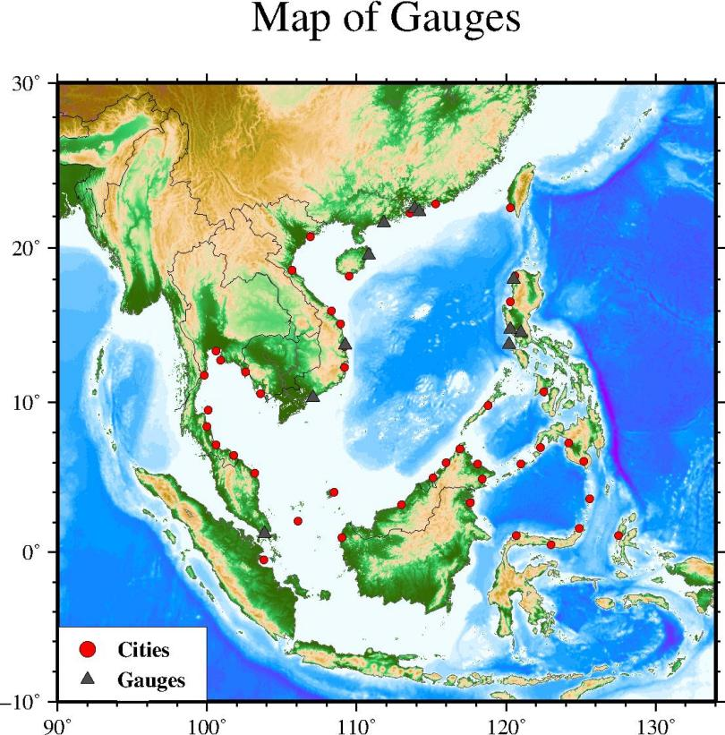
Figure 8. Coastal Forecasting Points for the SCS tsunami advisory products.

ANNEX III OBSERVATION SITES
Table III.1. Tidal stations providing sea level data for tsunami monitoring in the SCS region
Station | Latitude | Longitude | GTS-CODE
Quarry Bay | 22.29 | 114.21 | quar
Shek Pik | 22.22 | 113.89 | shek
Shenzhen | 22.47 | 113.88 | shen
Zhapo | 21.58 | 111.82 | zhap
Qinglan | 19.57 | 110.82 | qing
Ambon | -3.68 | 128.18 | ambon
Bitung | 1.44 | 125.19 | bitu
Currimao | 17.98 | 120.48 | curri
Subic Bay | 14.77 | 120.25 | subi
Manila | 14.58 | 120.97 | mani
Lubang | 13.82 | 120.2 | luba
Davao | 7.15 | 125.66 | davo
Qui Nhon | 13.76 | 109.25 | quin
Vung Tau | 10.34 | 107.07 | vung
Bere-Bere | 2.389 | 128.667 | MRTMI
Beo | 4.230 | 126.788 | BETSI
Talengen | 3.590 | 125.567 | TBSSI
Kema Fishing | 1.358 | 125.077 | KMMSI
Ampana | -0.847 | 121.600 | AMTSI

