Summary
The GEBCO is a joint IHO and IOC Programme, which is guided by the Joint IHO-IOC GEBCO Guiding Committee, made up of representatives from both IHO and IOC and supported by the Technical Sub-Committee on Ocean Mapping (TSCOM), the Sub-Committee on Undersea Feature Names (SCUFN), the Sub-Committee on Regional Undersea Mapping (SCRUM), the Sub-Committee on Communications, Outreach and Public Engagement (SCOPE) and the Sub-Committee on Education and Training (SCET). Additional ad hoc working groups are convened as necessary. Through the work of its organs, GEBCO produces and makes available a range of bathymetric data sets and products, including gridded bathymetric data sets, the GEBCO Digital Atlas, the GEBCO World Map, the GEBCO Gazetteer of Undersea Feature Names and the GEBCO Cook Book. GEBCO maintains a comprehensive website at: http://www.gebco.net. Annex I provides information on the current GEBCO leadership.
The proposed decision(s) is referenced A-33/Dec.4.3 in the Action Paper (document IOC/A-33/2 Prov.) The IOC Assembly is requested to take note of these developments.

Introduction
- GEBCO started in 1903 and will continue after 2030. Whereas the GEBCO programme through its long history and until recently has been referred to as the GEBCO project, it makes sense to start referring to it as the GEBCO programme.
- During the period covered by this report, a continuing and growing interest in the health and status of the oceans by many governments, international and philanthropic organizations and by the public more generally has been maintained. The current heightened awareness and global focus on the ocean and related topics resulting from a number of high profile initiatives, such as UN’s 2030 Agenda for Sustainable Development Goals, The Paris Agreement under the UN Framework Convention on Climate Change, the Sendai Framework for Disaster Risk Reduction 2015–2030, the UN Decade of Ocean Science for Sustainable Development (2021–2030) and most recently, the historic new UN High Seas treaty (BBNJ), have all highlighted the lack of comprehensive global bathymetric coverage, which is recognized as a fundamental element to achieve the goals of these initiatives. The Nippon Foundation-GEBCO Seabed 2030 Project (Seabed 2030), which became operational in February 2018 and is now a UN Decade endorsed programme, has been at the forefront of this focus. Seabed 2030 has created a global movement to search out new datasets to be added to the currently available bathymetry with the IHO Data Centre for Digital Bathymetry being identified as the preferred raw data store. The long-running GEBCO programme, previously rarely mentioned or recognized by the participants in any of the above related activities, has benefited from this raised awareness and focus, which has been further highlighted by the annual updated GEBCO grid. As of June 2024, GEBCO has 26.1 percent coverage of directly measured gridded bathymetric data of the world’s oceans. This means that for almost three quarters of our oceans we lack fundamental knowledge, critical for the sustainable development of our oceans and therefore of our planet.

Meetings of relevant GEBCO bodies

GEBCO Guiding Committee
- The 40th Meeting of the GEBCO Guiding Committee (GGC) was held at the IHO Secretariat, Monaco on 7–10 November 2023. The format reverted to being held over one week meeting with one day of sub-committee meetings, a-two day Map the Gaps Symposium and two days of GGC meeting.
- The GGC received brief reports from its Sub-Committees and Working Groups and endorsed the work which they had undertaken. The GGC also received reports from key personnel performing functions on behalf of GEBCO as well as reports from its parent bodies, IHO and IOC, on activities since the previous meeting.
- Most importantly, the GGC approved the first GEBCO Strategy 2023–2030, which will provide guidance for GEBCO’s Sub-Committees. In addition, the GGC approved the GEBCO Governance Review report as a blueprint of the current, complex and organically grown organization of GEBCO, identifying key areas for improvement.
- A draft discussion paper on potential future organization of the GEBCO Guiding Committee was discussed at the intersessional GGC meeting April 2024 and it was agreed to further develop this paper as part of the implementation of both the GEBCO Strategy and Governance Review.
- The GGC also reviewed its current financial situation in relation to proposed planned projects. The Committee addressed the budget submissions from its subordinate bodies and approved the proposed allocations.
- The GGC participants were reminded that at GGC40, it was noted that Marzia Rovere would finish her 2nd and final term on the GGC in 2024, but would finish her 3-year term on the GGC in 2023. It was agreed at GGC40 that Marzia continue for one further year of a second 3-year term on the GGC until she steps down at GGC41. The GGC thanked Marzia for her dedication and commitment to the GGC.
- The GGC participants were further reminded that at GGC40, it was noted that Evert Flier finished his first 3-year term as Chair of the GGC in 2023, and would complete his first 5-year term as a GGC member in 2024. It was agreed that he be elected as Chair for one further year as the GGC chair until 2024, where he would be nominated for a second 5-year term on the GGC.
- As there were no other nominations, Evert Flier was simultaneously confirmed to serve a second five-year term as a GGC Member, and to continue with his second 3-year term as Chair of the GGC.
- The GGC held an Intersession Meeting via VTC. on the 3 April 2024, where final versions of the GEBCO Strategy and Governance review were approved for submission to the 16th meeting of the IHO Inter-Regional Coordination Committee (IRCC) and the 57th IOC Executive Council.
- The 41st Meeting of the GEBCO Guiding Committee (GGC41) was held at the Tanoa International Hotel, Nadi, Fiji on 4–8 November 2025. The 3-day meeting abridged the 6th Pacific Ocean Mapping meeting which was organized by the Nippon Foundation—GEBCO Seabed 2030 Project. It was the first time for GEBCO to have its meetings on a Pacific Island State and the great amount of interaction between the GEBCO community and representatives of the Pacific Island States, greatly facilitated by the respective regional Seabed 2030 team, was considered to be a great success and of high value for all participants.
- The main focus of the GGC41 was to progress the work on developing an implementation plan for the GEBCO Strategy and Governance Review. To this end, the GGC undertook a detailed SWOT analysis of the 5 pillars of the Strategy and agreed an implementation process. The Chair of the Technical Sub-Committee on Ocean Mapping (TSCOM) was tasked with leading a project team to further refine the plan and to report on progress to the next GGC Intersession meeting in early 2025.
- Again, the GGC also reviewed its current financial situation in relation to proposed planned projects, assessed the budget submissions from its subordinate bodies and approved the proposed allocations. Following this, the 2025 workplan was agreed.
- It was noted that there were now 3 unfilled vacancies on the IOC nominated GGC members. Considering this, it was decided to defer the election of a Vice-Chair until GGC42.
- The GGC held an Intersession Meeting via VTC. on the 10 April 2025. Updates were provided from the Sub-Committees and other stakeholders. The Chair of the Task team on the Strategy implementation updated the GGC on the progress of the plan and presented a timeline for its completion. It was agreed that the 42nd meeting of the GGC will be held in Victoria, BC, Canada. Finally, the reports to the 17th meeting of the IHO Inter-Regional Coordination Committee (IRCC) and the 33rd Session of the IOC Assembly were discussed.
Sub-Committee on Undersea Feature Names (SCUFN)
- SCUFN is tasked with selecting the names of undersea features to appear in the products of the GEBCO programme and on international nautical charts. These names, widely used in scientific publications also, are made available in the GEBCO Gazetteer of Undersea Features Names (www.gebco.net > Data and products > Undersea feature names > view and download).
- In 2023, SCUFN considered a total of 334 undersea feature naming proposals, the majority of which were resubmissions from previous meetings that included corrections or additional data. A large portion of these proposals concerned features located in the South China Sea, which led to strong statements from representatives of Coastal States asserting their naming rights within disputed Exclusive Economic Zones (EEZ) and Extended Continental Shelves (ECS). During the SCUFN35.2 meeting, it was agreed that all decisions would be made solely based on the existing Rules of Procedure and Guidelines, despite their inherent uncertainties. Out of the 334 proposals, 263 names were accepted, some were rejected due to technical reasons, and a few were deferred for further consultation due to overlapping naming claims. For these unresolved cases, SCUFN encouraged the submission of joint proposals at the next meeting. At the end of SCUFN35.2, Chair Dr Hyun-Chul Han stepped down, and Vice Chair Dr Yasuhiko Ohara assumed the role of Acting Chair.
- SCUFN36 took place in November 2023 in Wollongong, Australia, hosted by the Australian Hydrographic Office. During this meeting, the SCUFN Naming 2030 Sub-Group was established to help modernize the naming process. This initiative aimed to develop a new designator model incorporating Geographic Feature Unique Identifiers and enabling multilingual naming attributes for a single feature.
- In March 2024, a new article (2.11) of the SCUFN Terms of Reference and Rules of Procedure was adopted. This amendment introduced a cap on the number of proposals considered at each plenary meeting, limiting them to 250 in total and 25 per country. Additionally, the submission of proposals for undersea features in the South China Sea remained suspended.
- Subsequently, SCUFN37 was held from 24 to 28 June 2024 in Jeju City, Republic of Korea, hosted by the Korea Institute of Geoscience and Mineral Resources (KIGAM) and the Korea Hydrographic and Oceanographic Agency (KHOA). Due to the new limitations and the ongoing freeze on South China Sea proposals, the number of submissions dropped significantly compared to SCUFN36, with only 140 proposals reviewed. Of these, 108 were accepted (some with minor changes to the generic term), four were kept pending pending further information, and 28 were not accepted. The SCUFN Naming 2030 Sub-Group reported notable progress, including establishing its Terms of Reference, forming ties with the International Astronomical Union for benchmarking best practices, and welcoming new members from organizations such as Marine Regions, NOAA, and Canada. The Sub-Group was tasked with developing an S-100 compliant undersea feature name data model to be presented at SCUFN38. Additionally, SCUFN took note of the SCUFN Chair’s signature of the Ocean Decade Canada-GEBCO Project Implementation Plan on the detection of undersea features, initially presented by Canada at SCUFN36.
- Looking ahead, SCUFN welcomed Indonesia’s offer to host SCUFN38 in Bali from 10 to 14 November 2025, with arrangements to be made by the Indonesian Hydrographic Office (Pushidrosal).
Technical Sub-Committee on Ocean Mapping (TSCOM)
- During the last year, TSCOM has held one virtual meeting (TSCOM 41) on 10 September 2024. The 2024–2025 workplan was approved by the members of TSCOM. It was noted during this meeting that the GEBCO grid currently has no official publication reference. This was reported at the GGC41 where it was decided that a study will be conducted to see if the GEBCO grid product specification can be part of S-100 and in particular within the S-300 series reserved for IOC-related products.
- TSCOM is currently, in addition to ongoing supporting activities, conducting the following tasks.
Generic Sensor Format
- TSCOM started a project to Encourage Use of a Common Generic Sensor Format for Bathymetry. Goal of the project is to promote the value of preserving and sharing processed swath data in a generic sensor format data to the archive(s) via technical papers and presentations. It will also facilitate technical discussions to address issues with the existing generic sensor format to ensure validity of existing archived data, and identify and support the development of additional tools and translators to facilitate the conversion of valid data between different formats. An additional budget of 25k has been secured for this work through Seabed 2030 funding.
Discrete Global Grids
- After finalizing the feasibility study for discrete global grids in 2023 the responsible working group continued with the conversion of GEBCO TID grid into the H3 system. The resulting data set was used to calculate coverage statistics which were compared to the annual Seabed2030 statistics. Differences were in the expected range confirming the potential of the H3 gridding system. Next step will be the conversion of the GEBCO grid and integration of the multi resolution grids.
Integration of work items dealing with the Opportunistic Mapping Resources,
Data-Nodata layer and metadata activities.
- TSCOM has integrated the work of the Opportunistic Mapping Resources Working Group into the work items that resulted from the Community Vision (see 2023 report). A detailed project plan is now available for the development of a Global Bathymetric Coverage Metadata Service.
- After issuing the metadata schema, the MetaData implementation WG will now look in how the schema can be used to improve the overall workflow and quality of the bathymetric pipeline to the DCDB in general and the GEBCO grid in particular. Technology will be streamlined and where necessary developed to support this.
Deep ARGO groundings
- The Deep Argo work item is supposed to conclude on the feasibility of using data derived from groundings of Argo floats for calibration of the GEBCO grid. This work is ongoing but for the first time, depth values derived from deep Argo groundings have been used in the GEBCO 2024 digital grid.
Follow up to the 2023 industry day and TSCOM/DCDB workshops
- The industry day and TSCOM/DCDB workshops organized in 2023 resulted in a long list of objectives and actions. In order to structure these into manageable TSCOM work items a meeting was held in Boulder (USA). This meeting has resulted in detailed workplans for the various goals listed in the TSCOM workplan.
Cookbook
- The Cookbook is an official IHO publication and has proven to be difficult to maintain due to a lack of authors. The position of Chair of the editorial board is currently vacant. TSCOM was unable to find a new candidate in 2024. This has led to discussions about the future of the Cookbook and to provide answers to the GGC, TSCOM has appointed an interim chair (Thierry Schmitt, SHOM, France) who will conduct a survey amongst GEBCO stakeholders in 2025.
Chair and Vice-Chair term
- The first term of the current Chair (Mr George Spoelstra, Netherlands) and Vice Chair (Ms Federica Foglini, Italy) ended in 2024. Following the terms of reference of the TSCOM an announcement was made at the 41st TSCOM meeting last September. No nominations for Chair and Vice Chair were received to date. Both current Chair and Vice Chair were willing to continue for the next term (2025–2028) and this was confirmed at GGC41.
Sub-Committee on Regional Undersea Mapping (SCRUM)
- In 2024, the Sub-Committee on Regional Undersea Mapping (SCRUM) continued to strengthen collaboration with Seabed 2030, focusing on building deeper engagement with regional mapping initiatives. A key priority remained the integration of regional compilation efforts into the GEBCO Grid.
- SCRUM actively assisted in coordinated participation in regional IHO and IOC meetings, resulting in GEBCO/Seabed 2030 and/or Crowdsourced Bathymetry (CSB) presentations being delivered at 15 of the 16 Regional Hydrographic Commission (RHC) meetings. SCRUM also worked in close collaboration with the IHO CSBWG to identify Seabed 2030/CSB coordinators for RHCs, with coordinators now confirmed for 15 out of 16 RHCs. Efforts are ongoing to appoint a coordinator for the remaining region.
- Looking ahead to 2025, SCRUM aims to strengthen communication and provide additional support to these coordinators, with the goal of expanding engagement and participation in future RHC meetings. Further, building on the success of CSB coordinators at RHCs, SCRUM is engaging with the IOC and CSBWG to establish similar coordinator roles within IOC regional structures. SCRUM also maintained strong engagement with the CSBWG, attending annual and intersessional meetings.
- The web-based application hosted on the SCRUM webpage continues to remain active, serving as a tool to gather input on mapping priorities and support future planning efforts.
- SCRUM held multiple technical meetings with TSCOM and Seabed 2030 partners to review coordination opportunities and upcoming initiatives. The sub-committee continues to provide scientific and regional expertise, as well as outreach support, to the Seabed 2030 Project Director, the Regional Data Assembly and Coordination Centres (RDACCs), and the Global Data Assembly and Coordination Centre (GDACC). SCRUM appointed Shereen Sharma as Seabed 2030 Coordinator to further strengthen coordination between the groups. SCRUM worked closely with the Seabed 2030 GDACC to ensure updated metrics of mapping completeness and to maintain the SCRUM regional mapping activities webpage, as well as ensuring that the updated statistics were shared with the relevant RHCs.
- SCRUM members contributed to the review of the draft GEBCO 2024 Grid via a web application ahead of its release. In addition, SCRUM coordinated participation by alumni of the Nippon Foundation-GEBCO Training Programme to broaden the global scope of quality control. Feedback was compiled and shared with GDACC to support regional awareness and data improvement.
- In support of greater cross-subcommittee collaboration, SCRUM worked with other GEBCO sub-committees to align reporting practices, coordinate workplans, and avoid duplication of effort. Three meetings were held between chairs and vice-chairs of the various sub-committees to enhance synergies and strategic planning.
- The sub-committee participated in the ongoing review of GEBCO governance and strategy documents through collaboration with the GGC and contributed virtually to the "Executing a GEBCO Community Vision" working meetings.
- The 2024 annual SCRUM meeting was held virtually on 29 October. Following the GEBCO Guiding Committee meeting in Fiji, three new SCRUM members were appointed—two from the Pacific region and one from Europe—bringing additional expertise and regional representation.
- As part of the ongoing transition to a more collaborative digital workspace, SCRUM began migrating its operations to Google Workspace. A dedicated SCRUM mailing list has been created to support internal communications.
- Membership of the sub-committee was reviewed and refreshed in accordance with the SCRUM Terms of Reference. The list of active members has been updated and published on the GEBCO website. Updates to the SCRUM webpages are continuing to ensure current and relevant information is available to the wider community.
Sub-Committee on Communications, Outreach and Public Engagement (SCOPE)
- During the 41st GEBCO Guiding Committee, it was decided to make SCOPE dormant and let the GEBCO strategy implementation process address how best to organize communication, outreach and public engagement for GEBCO in the future.

Sub-Committee on Education and Training (SCET)
- SCET continues to work on the inaugural year workplan, with some minor additions in year two. This includes the work to expand SCET membership beyond that of those already involved in the GEBCO community. SCET continues to attract the attention of mapping professionals outside the GEBCO community with aspirations to further build capacity in educational offerings that meet the goals and objectives of GEBCO. It will be the recruitment of membership and mobilizing the membership to move forward the important work of the subcommittee; overarching goals of identifying, building, and promoting global capacity in ocean mapping education will serve well the goals of GEBCO. The development of an inventory of the various International and national groups undertaking seabed mapping capability-building programmes and performing a gap analysis to identify the role that GEBCO and SCET can take in promoting these programmes.
- In our 2024 work, SCET will look to contribute to GEBCO publications and promote those publications' use and uptake by educational institutions as core curriculum documents that will inform and promote the Goals and Objectives of GEBCO.
- While SCET is still a new subcommittee, there is significant work to do to unwrap and integrate it with the work of other subcommittees of GEBCO.
- The following is a report on the UNH NF GEBCO training programme. There are initial discussions on a governance review of the programme within GEBCO and a framework that could see expanded programme inclusion. Developing a governance structure and cooperation ToR between SCET and the Nippon Foundation—GEBCO Training Programme at the University of New Hampshire (UNH) is high on SCET's priority list this year.
GEBCO Training Programme (now part of SCET WP)
- The Training Programme is in its 20th year. Including the 7 students currently at UNH, 120 alumni from 50 Coastal States have been through the course. The Training Program has returned to pre-COVID in person classes and labs, although the increase to 7 students this year reflects COVID era delays in acquiring student visas and a required deferral due to late visa processing.
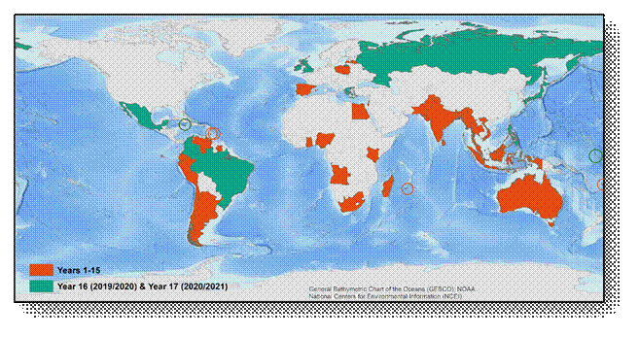Distribution of Alumni of the Nippon Foundation / GEBCO Training Program (Year 1 to 19)

Operation of IHO Data Centre for Digital Bathymetry
- Since its inception, the IHO Data Centre for Digital Bathymetry (DCDB) has become a prominent repository of digital oceanic bathymetry and is used by IHO Member States and other ocean science communities. The IHO DCDB facility is generously hosted by the National Oceanic and Atmospheric Administration (USA) on behalf of the IHO Member States.
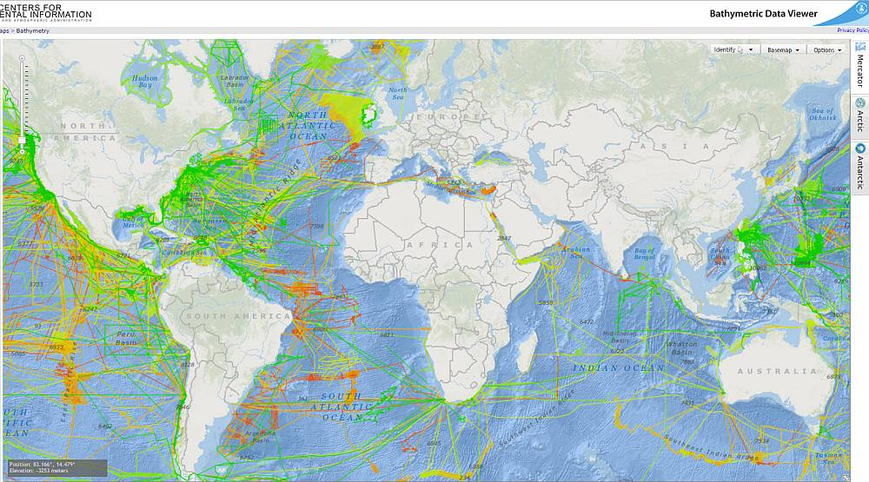
IHO DCDB Web Map Interface
- The IHO DCDB data store contains oceanic soundings that have been acquired by hydrographic, oceanographic and other vessels during surveys or while on passage. These data are used for the production of improved and more comprehensive bathymetric maps and grids, particularly in support of the GEBCO programme. Bathymetric data located at the IHO DCDB can be viewed/filtered via a web map interface, and freely downloaded. The map interface can be accessed from: https://maps.ngdc.noaa.gov/viewers/iho_dcdb/.
Contribution of bathymetric data to the IHO DCDB
- The GEBCO Ocean mapping programme is dependent upon the availability of bathymetric data. In order to achieve its goals, GEBCO actively encourages data contributions from the bathymetric community. In 2020, GEBCO, in collaboration with the DCDB, stood up a new Data Contribution webpage (gebco.net/about_us/contributing_data/) to simplify the answer to the often-asked question, “how can I contribute data?” GEBCO has also worked towards improving its participation in regional mapping activities by attending most IHO Regional Hydrographic Commission (RHC) meetings.
- Traditionally GEBCO has focused on areas deeper than 200 m, however, its focus has expanded to data gathering in shallow water areas to support activities such as coastal zone management and the mitigation of seaborne disasters such as storm surges and tsunami inundation. IHO Member States are encouraged to contribute bathymetric data in shallower coastal areas to support the production of higher resolution gridded data products and to complete the GEBCO grid coverage.

Seabed 2030 Project
- The Nippon Foundation – GEBCO Seabed 2030 Project (SB2030) is now in its 8th year of operation. The project is split into 5 work packages, with key developments summarized below (to 11 April 2025):
WP1 – Data. The GEBCO_2024 grid was released in June 2024 and mapping coverage stood at 26.1% with some 4.34 million km² of new data added between 2023 and 2024. This equates to an area a little more than the size of the European Union. Work is underway on the next release of the GEBCO Grid scheduled for June 2025. IBCAO v5.0 for the Arctic was published, and together with GMRT4.2.1 have been included in the Grid. IBCSO 2.0 for the Southern Ocean was updated and released in December 2034 and will be included in the 2025 GEBCO compilation. Extensive engagement with data donors continues apace as does work with the IHO Data Centre for Digital Bathymetry (DCDB) and IHO’s Crowd Sourced Bathymetry Working Group (CSBWG). Overall, the number of ocean mapping supporters and contributors is growing. The Project has also been supporting GEBCO’s TSCOM in work to access bathymetry from grounded Argo floats.
WP2 – Systems and tools. Significant improvements have been made for the storing and handling of metadata, not only for the Arctic region, but also for global data sets used during statistical calculations. The latter is now derived from a fully automated algorithm at Amazon Web Services. There has been refinement of the viewer and hosting facility for the GEBCO Grid; a Web Map Service (WMS) has been developed to deliver imagery based on the GEBCO_2024 release, and work is progressing on delivery of the multi-resolution grid. The improvement of existing and development of new GEBCO web services and applications for the user community continued across the Centers. Work also included the creation of the “Understanding TID” Story Map available on the GEBCO website in both English and Spanish.
WP3 – Technology Innovation. One of the SB2030 Center hosts has been deeply engaged in the DriX uncrewed vessel trials and upgrade, with a compact midwater MBES. In conjunction with the E/V Nautilus, successful field mapping was achieved. Again, a blend of Seabed 2030 and other agency activity funding has delivered benefit to the wider ocean mapping community. New/updated applications include: GEBCO Globe Web App; Meso-American & Caribbean Hydrographic Commission Web App; Regional Gap Analysis Web App; Regional Unmapped Ocean Web App; and West Indian Ocean Bathymetry Web App. A PhD project at the Arctic Center focusing on developing methods for using super-resolution algorithms as a means to accurately predict seafloor topography at particularly high resolutions is continuing at a good pace, and some results for its use in our mapping projects are expected in the near future.
WP4 – Mapping activities. SB2030 continues to operate a Trusted Node for Crowdsourced Bathymetry (CSB). Hosted at the Global Center, this process is incoming crowd sourced data, providing support and feedback to Regional Centers and data collectors, and liaising closely with DCDB on data submission. SB2030-related CSB activities are ongoing in South Africa, Greenland, Palau and in the Pacific and the Project has a very close relationship with the International Seakeepers Society which is also running CSB activity through its wide membership network. There have been generous contributions of Satellited Derived Bathymetry (SDB) compilations from the Caladan Oceanic/Greenwater Foundation initiative and similar may be expected in the future from Copernicus Marine SDB initiative being implemented by Mercator Ocean International. Many traditional and new contributors, from all sectors, are generously donating bathymetry; and work is ongoing with the RNZN to develop best practice procedures for collection of bathymetry in transit without experts. SB2030 has also been providing technical support to two separately funded Nippon Foundation Alumni projects that contribute to the GEBCO Grid, namely:
WIOBathy: Collation and compilation of Multi-Scale and Multi-Resolution Bathymetric Data in the Western Indian Ocean.
MARUM: Sharing MARUM bathymetric data and open-source processing software (MB-System) workflows
WP5 – Management. Seabed 2030 continues as a flagship programme of the UN Ocean Decade and has also been selected as one of ten global projects for the esteemed Paris Peace Forum (PPF) 2025 Scale Up programme, having previously been a PPF selected project in 2022.
- The ongoing SB2030 Wind in the Sails activity delivered a compendium of 12 Use Cases for ocean mapping. Published on the SB2030 website, these are designed to be high-level readable documents for senior decision makers within the wide ocean community but also have utility for a much wider group of users/readers. Much positive feedback has been received from the user community thus far.
- A very successful SB2030 6th Pacific Community Mapping meeting took place in Fiji in early November. Co-located with the GEBCO Guiding Committee Meeting, this was hosted by the Fiji Navy and sponsored by a number of key partners. This brought together many from across the Pacific Islands and Americas and included a data processing workshop in addition to more formal presentations from the community and supporters from industry, academia and government.
- The Project Team also participated in the 2025 Economist World Ocean Summit and sponsored a session on how to shape global standards for blue data, technology and capacity building. The event was very well attended and provided an extensive engagement opportunities amongst a high-level audience of decision makers across all sectors of society. More widely Seabed 2030 was represented at a broad range of gatherings, both in-person and through virtual attendance. There are too many to list here but, in addition to the above, noteworthy international events include: the Nippon Foundation Alumni Seminar (Japan); The Ocean Collective Summit (Singapore); COP28 (UAE); Our Ocean Conference (Greece); GIS Day at US Library of Congress (USA); BBNJ Symposium (Singapore). In addition to regular, ongoing engagement with the Ocean Decade Corporate Data Group, the Seabed 2030 Team also attended a large number of IHO and IOC events.
- SB2030 has extended its reach across an increasing number of stakeholders during the year. At the time of writing the Project has 74 MOUs in place: 14 added in Year 7 (August 2023 - July 2024) and a further 11 added in Y8 to date (from August 2024). A new process has been implemented to ensure each arrangement can be serviced effectively. Whilst every MOU is important, the very notable, and arguably the most complex, signing since the last report was with the 5 Member States of the Nordic Hydrographic Commission: progress here was facilitated greatly by the GGC Chair NF Alumni Engagement has continued throughout the period: Two alumni kindly offer their time to SB2030 on an on-call remote basis to provide technical support to CSB volunteers.
- Other activities include the WIOBathy and MARUM projects as described above.
- Building on the progress of previous years, the SB2030 has seen a continued period of growth and outreach. Seabed 2030. There has been a continued rise in global media coverage, enhanced collaboration with strategic partners, and a notable expansion of the project's presence across multiple digital platforms including a very successful podcast series. Regular updates, live event coverage, and collaborative content with partners helped drive interaction and expand SB2030’s digital presence. In the period August 2024 to July 2025 the Project had some 495 media hits. At the time of writing, over 344 media hits have been recorded in the period August 2024 to April 2025 alone.

Bathymetric publications
B-4 – Information concerning recent bathymetric data
- Since 1990, the IHO DCDB is a recognized international repository for all deep ocean bathymetric data (greater than 100 m) collected by hydrographic, oceanographic and other vessels. For the last several years, the DCDB has also become the international repository for crowdsourced bathymetric data (CSB). CSB is defined as the collection of depth measurements from vessels, using standard navigation instruments, while engaged in routine maritime operations. CSB can be used to supplement the more rigorous and scientific bathymetric coverage done by hydrographic offices, industry, and researchers around the world.
- These data can be viewed and accessed from: maps.ngdc.noaa.gov/viewers/iho_dcdb/.
- The DCDB data are publicly available and used for the production of improved and more comprehensive bathymetric maps and grids, particularly in support of the GEBCO Ocean Mapping Programme.
B-6 – Standardization of undersea feature names
- The latest edition 4.2.0 of Publication B-6 was published in October 2019. Work is currently underway to update this publication with a decision as to whether this will be by way of a Revision or new Edition to be decided.
B-8 – GEBCO Gazetteer of Undersea Feature Names
- During SCUFN-37, NOAA/NCEI provided a comprehensive status report explaining updating the GEBCO Gazetteer of Undersea Feature Names to its version 5. This version includes various enhancements and bug fixes that were made after SCUFN-36. SCUFN commended these continuous maintenance efforts on the gazetteer by NOAA/NCEI.B-9 – GEBCO Digital Atlas.
- IHO publication B-9 – GEBCO Digital Atlas (GDA) is currently outdated and will be replaced by a new publication describing the GEBCO global gridded product and the GEBCO Grid Web Map Services.
B-11/IOC Manuals and Guides, 63 – GEBCO Cookbook
- Work on the GEBCO Cookbook has been temporarily stopped due to personnel changes.
GEBCO Website
- GEBCO’s web site (https://www.gebco.net) is maintained and updated at BODC. News items, meeting information and ad hoc page updates are added to the web site when requested.
- The GEBCO web site has been migrated to a new management platform (Drupal). The new platform allows GEBCO colleagues, external to BODC, to manage sections of the site and it gives more options for future development of the site.
- This migration work was directly funded through an additional budget line provided through TSCOM. The analysis of visits to the GEBCO Website since 2009 shows a general increase in traffic (Figure 1).
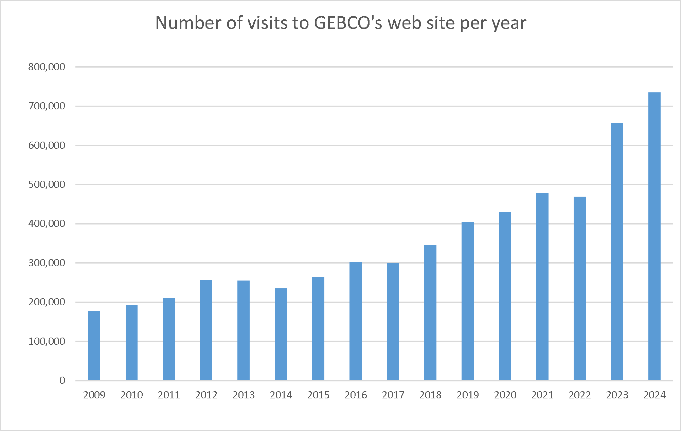
Figure 1. Access to GEBCO’s web site since 2009

Access to GEBCO’s bathymetric grids
- GEBCO’s gridded bathymetric data sets are made available for direct download via GEBCO’s web site (https://www.gebco.net/data-products/gridded-bathymetry-data) either as global grid files or for user-defined geographic areas. During 2024, there were over 268,000 downloads of GEBCO’s data sets.
- Figure 2 shows the number of downloads for each of GEBCO’s data sets and if these are downloads of the global grid file or for user-defined sub-sections of the global grids.
Figure 2. The number of downloads of GEBCO’s gridded data sets in 2024
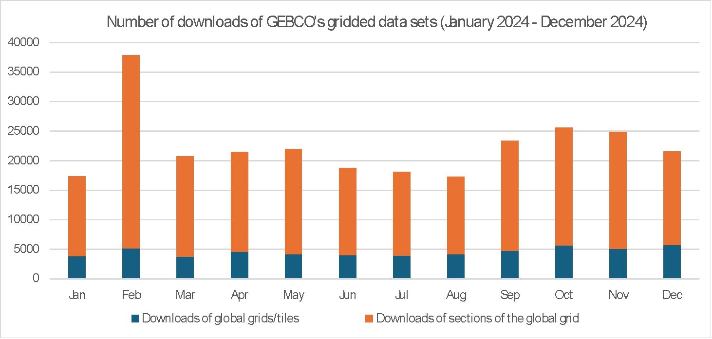

Multi-resolution gridded bathymetry data
- The GEBCO grid is currently made available as a global 15 arc-second interval grid. However, in some regions, it is based on data at higher resolutions. To accommodate users who want access to higher resolution gridded bathymetry data, where it is available, a test multi-resolution grid product has been developed.
- A new application has been developed to give access to data from GEBCO’s global grids and new multi-resolution grids: https://www.gebco.net/data-products/gridded-bathymetry-data/multi-res.
Web services
- A dedicated Web Map Service (WMS) is created for each release of the GEBCO grid. The WMS can be accessed from GEBCO’s web site (https://www.gebco.net/data-products/gebco-web-services/web-map-service). The WMS includes a number of pre-processed layers:
- Shaded relief imagery coloured for elevation
- Imagery showing ice surface and sub-ice topography
- Type Identifier (TID) grid colour coded for TID value
- Layer showing areas based on measured data or pre-generated grids

ANNEX I

GEBCO leadership (2025)

GEBCO Guiding Committee:

Chair - Mr Evert Flier (Norway – IHO) from January 2021
Vice-Chair – vacant from December 2024
Secretary - Mr Sam Harper (IHO)

Sub-Committee on Undersea Feature Names (SCUFN):

Chair – Dr Yasuhiko Ohara (Japan – IHO)
Vice-Chair – First Admiral Dr Najhan Md SAID (Malaysia – IHO)

Technical Sub-Committee on Ocean Mapping (TSCOM):

Chair – Mr. George Spoelstra (Netherlands)
Vice-Chair - Ms Federica Foglini (Italy)

Sub-Committee on Regional Undersea Mapping (SCRUM):

Chair - Ms Aileen Bohan (Ireland)
Vice-Chair – Mr.Hugo Montero (Peru)

Sub-Committee on Communications, Outreach and Public Engagement (SCOPE), currently dormant:

Chair – Vacant
Vice-Chair - Vacant

Sub-Committee on Education and Training (SCET):

Chair – Dr Paul Brett (Canada)
Vice-Chair – Dr Rochelle Wigley (South Africa)

