Summary

This document presents a strategic proposal to establish a Rolling Plan for Ocean Capacity Development in Africa. The initiative is designed to provide an adaptive, evidence-based, and regionally coordinated framework to strengthen human, institutional, and systemic capacity across IOCAFRICA Member States. Rooted in the IOC Capacity Development Strategy (2023–2030), and drawing inspiration from the ocean capacity empowerment concept, this Rolling Plan seeks to move beyond fragmented training to long-term empowerment and transformation. It is intended to serve as the principal framework guiding IOCAFRICA’s work on capacity development for the 2025–2030 period, consolidating past efforts into a coherent and sustainable approach. The plan is aligned with Agenda 2063, the Africa Blue Economy Strategy, the IOCAFRICA Strategic Plan 2023–2030, and the UN Ocean Decade, and aims to foster equity, innovation, and sustainable ocean governance.
Financial implications: Implementation will have financial implications linked to technical assistance, infrastructure development, training, and strategic partnerships. These should be reflected in IOCAFRICA’s budget and work plan. Member States are encouraged to leverage the Rolling Plan in engaging with development partners.
Decision proposed: The Session is invited to consider the draft decision referenced as Dec. IOCAFRICA-VIII/4.11 in the Provisional Action Paper.

Introduction
- Africa’s ocean space represents a vital frontier for sustainable development, economic opportunity, and environmental resilience. Yet, the continent continues to face systemic capacity gaps in science, technology, infrastructure, and governance that limit its ability to fully harness ocean opportunities. The existing capacity development interventions are often fragmented, donor-driven, or short-term, and insufficiently embedded within national systems and long-term policy frameworks.

- To address these challenges, IOCAFRICA proposes the development of a Rolling Plan for Ocean Capacity Development in Africa. This Plan is grounded in the experience of past IOC initiatives and regional capacity development programmes, and reflects the growing demand for long-term, inclusive, and adaptive approaches. It draws inspiration from the concept of ocean capacity empowerment and aims to transform isolated interventions into coherent, sustained capacity ecosystems—anchored in African knowledge systems, institutions, and leadership.

- The Rolling Plan will serve as IOCAFRICA’s principal framework for guiding, coordinating, and scaling capacity development efforts over the 2025–2030 period. It will act as a dynamic interface linking national priorities with regional and global strategies, including the UN Ocean Decade and Africa’s Blue Economy Agenda. While fully aligned with the IOC Capacity Development Strategy (2023–2030), the Rolling Plan is designed to complement—and not substitute—the forthcoming Implementation Plan of the IOC Strategy currently under development.

- In this regard, it functions as a practical regional pathway for translating global strategic intent into actionable programmes, institutional arrangements, and learning models. Moreover, it provides a platform for piloting approaches and innovations that may inform the global implementation framework and strengthen IOC’s understanding of how capacity development can be delivered effectively in a diverse, rapidly evolving context.

Strategic rationale

- The Rolling Plan addresses the need for a coherent, demand-driven, and regionally anchored approach to capacity development that mirrors the enabling conditions and impact pathways identified in the IOC Capacity Development Strategy (2023–2030). It recognizes that empowerment is not limited to individual skill-building but must include institutional sustainability, infrastructure, data systems, intergenerational learning, and regional self-reliance.

- Ocean capacity development must be conceived as a long-term investment in Africa’s collective know-how, not as a series of disjointed training events. It should create systems that retain and apply knowledge, support inclusive and resilient institutions, and build linkages between science and society. This includes support to national research systems, indigenous and local knowledge holders, youth and women networks, intellectual property protections, human rights-based approaches, and Africa’s scientific diaspora. These dimensions contribute to socio-ecological resilience, just transitions, and sustainable marine resource use.

- The approach underpinning this Rolling Plan is guided by four key principles and delivered through a combination of strategic actions and collaborative modalities. In addition to IOCAFRICA’s own mandate to implement capacity development under its programme of work, the Plan also provides a mechanism for facilitating external engagement and partnerships—matching Member States’ capacity needs with financial and technical resources from regional and global partners. Implementation will be coordinated with existing IOC frameworks and involve a dynamic mix of online collaboration, joint planning, matchmaking forums, and bilateral follow-up.

- The Plan will function as a living framework, overseen and periodically reviewed by the Sub-Commission, to ensure it remains responsive to evolving priorities. IOCAFRICA will coordinate the development, piloting, and continuous refinement of the Plan, while encouraging external partners—including donors, institutions, and training providers—to register their interest in supporting aligned activities. Regular review processes and collaborative governance will ensure effective tracking of progress and shared accountability.

- As Africa’s ocean economy expands, this Plan will help ensure that capacity development becomes the backbone of investments in fisheries, maritime transport, marine spatial planning, blue carbon, and coastal resilience. It seeks to embed African scientific leadership and nationally owned research agendas within these sectors, while also strengthening institutional capabilities, enabling knowledge retention and application, fostering inclusive participation, and building the resilience of the broader ocean governance ecosystem. It will guide how IOCAFRICA supports Member States to strengthen governance, develop technical capacity, and secure their own marine futures.

Objectives of the Rolling Plan

- The objectives outlined below represent the practical implementation pathway for the Rolling Plan. Rooted in the strategic rationale and enabling principles described earlier, they aim to ensure that capacity development in Africa transitions from fragmented, short-term interventions to sustained, inclusive, and transformative processes that strengthen the continent's scientific, institutional, and community-based systems.

- The proposed Plan aims to deliver on these goals through a flexible and evolving set of objectives. These objectives reflect strategic intent, but are not yet prioritized or translated into specific actions. Further consultations and planning processes with Member States, stakeholders, and partners will shape the final structure, scope, and delivery mechanisms of these objectives.
- Support Member States to assess and articulate national capacity needs and priorities, in line with IOC high-level functions, while emphasizing inclusion, knowledge co-creation, and cultural and ecological relevance.
- Develop rolling, multi-year implementation cycles (e.g., 3-year blocks) with defined outputs, milestones, and adaptive reviews to allow responsive and iterative development.
- Foster national and regional institutional development, including the strengthening of research institutions, National Oceanographic Data Centres (NODCs), marine data infrastructure, and training hubs.
- Support the development of human and community capacity, with targeted programmes addressing youth engagement, gender equity, indigenous knowledge, and protection of intellectual property within ocean science.
- Facilitate access to funding and partnerships, through structured matchmaking between Member States’ needs and available technical and financial support mechanisms, leveraging the IOCAFRICA capacity development forum and other collaborative platforms.
- Promote regional and global collaboration, encouraging shared learning, diaspora engagement, South-South and triangular cooperation, and alignment with the UN Ocean Decade and African Blue Economy frameworks.
4. Guiding principles
- The Rolling Plan is underpinned by a comprehensive set of guiding principles that serve as its ethical, strategic, and operational foundation. These principles reflect a shared commitment to ensure that capacity development efforts across Africa are not only effective, but also just, inclusive, forward-looking, and transformational. They are intended to evolve through dialogue, review, and implementation experience, and will be further refined in collaboration with Member States and stakeholders.
The guiding principles include:
- African ownership and leadership – Efforts should be anchored in African priorities and led by African institutions to ensure contextual relevance, political support, and sustainability.
- Empowerment over dependency – Capacity development should build self-reliance, long-term institutional strength, and local innovation rather than promote external dependence.
- Equity and inclusion – Programmes must ensure the participation of marginalized groups, especially women, youth, and indigenous communities, while addressing historical and structural disparities.
- Science-policy-society interface – Strengthening links between scientific knowledge, policy development, and societal needs is essential to ensure practical relevance and uptake.
- Flexibility and learning orientation – The Rolling Plan should be adaptive to changing contexts, new knowledge, and emergent needs, with mechanisms for continuous learning and revision.
- Shared responsibility and partnership – IOCAFRICA, Member States, partners, and stakeholders share responsibility for results, coordination, and sustained collaboration.
- Needs-driven implementation – Activities should respond directly to capacity needs identified by Member States and aligned with IOC functions, rather than be supply-driven.
- Building for the future – Initiatives should foster intergenerational knowledge exchange, career development, and leadership to sustain ocean science communities over time.
- Leveraging impact – The Plan should coordinate with existing initiatives and foster strategic partnerships to maximize resource use, replication, and scale.
- Quality, learning, and accountability – Robust monitoring, peer learning, and transparent reporting are critical to ensure high standards and guide evidence-informed improvements.
- These principles are consistent with the IOC Capacity Development Strategy (2023–2030) and are designed to support a resilient, self-reinforcing ecosystem of ocean knowledge, capacity, and governance across Africa.
IOCAFRICA’s facilitation framework
- To support the implementation of the Rolling Plan, five potential facilitation structures have been identified through which IOCAFRICA could coordinate and enhance capacity development efforts. These structures draw from existing initiatives and institutional strengths. At this stage, they are presented as foundational components on which the Rolling Plan could build. Specific actions and prioritization have not yet been finalized and will be subject to further consultation and refinement in collaboration with Member States and partners.

- The facilitation framework builds on a collaborative, multi-actor and multi-level approach, enabling IOCAFRICA to work as both a convener and an enabler of capacity development efforts across the continent. Recognizing the diverse ecosystem of actors already engaged in ocean-related capacity-building, the framework is structured to maximize complementarity, align priorities, and mobilize resources.

- IOCAFRICA will work closely with Member States, regional bodies, research institutions, civil society, youth and women-led organizations, and the African scientific diaspora to ensure full representation, ownership, and relevance. The facilitation structure will consist of:
- A Technical Task Group on Capacity Empowerment, appointed by IOCAFRICA, comprising experts and institutional representatives from across Africa, to provide strategic guidance and oversight for the Rolling Plan's development, coordination, and review. This group will liaise with other IOC working groups and task teams as necessary.
- A dedicated technical support unit, hosted within the IOCAFRICA Secretariat, responsible for coordinating implementation support, developing operational toolkits, and maintaining knowledge platforms.
- The IOCAFRICA Capacity Development Forum, serving as a platform for regular engagement between partners, funders, technical providers, and Member States to align strategies, review progress, and facilitate matchmaking. The Forum will convene annually and include open calls for contributions.
- Matchmaking functions, developed progressively through online tools and bilateral channels to link Member States’ expressed capacity needs with offers of technical and financial support. Strategic calls for proposals may be issued through the Rolling Plan and co-convened with regional or global funding agencies.
- Communications and engagement strategy, to ensure continuity of dialogue, dissemination of results, and promotion of success stories. Digital platforms, webinars, and regional workshops will be utilized to foster collaboration and transparency.
- This facilitation framework will evolve through regular review and partner feedback. It will also be coordinated with existing mechanisms under the UN Ocean Decade, the IOC’s Capacity Development Strategy (2023–2030), and relevant African Union and REC frameworks.
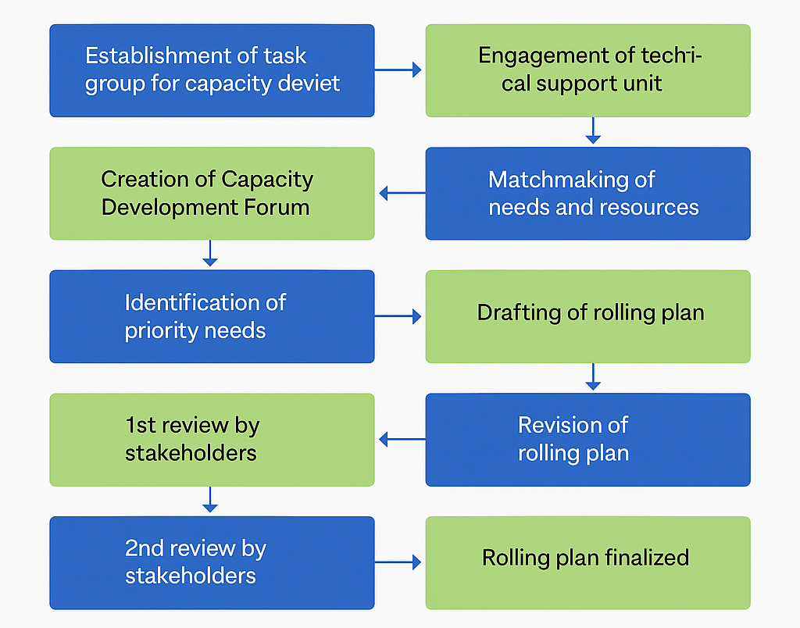
Figure 1: Overview of the process to complete IOCAFRICA Capacity Development Rolling Plan
Anticipated outcomes
- The anticipated outcomes of the Rolling Plan are directly aligned with its guiding principles and objectives, emphasizing long-term empowerment, institutional resilience, inclusivity, and regionally led implementation. By the close of the first implementation cycle (2025–2027), IOCAFRICA expects the following key results:
- Institutional ownership and leadership: At least five Member States will have integrated the Rolling Plan into national capacity frameworks and formalized their own multi-year ocean science and capacity development strategies.
- Empowered institutions and communities: Strengthened National Oceanographic Data Centres (NODCs), training hubs, and academic institutions will demonstrate improved technical and policy support functions, serving both decision-makers and communities.
- Inclusive and equitable capacity engagement: Gender-responsive, youth-focused, and community-based engagement models will be embedded in programme delivery, ensuring that capacity development leaves no one behind.
- Embedded indigenous and traditional knowledge systems: Mechanisms will be in place to recognize, protect, and integrate indigenous knowledge into national capacity frameworks, with attention to intellectual property rights and community consent.
- Knowledge retention and peer learning networks: Professional communities of practice and diaspora-led mentorship programmes will be piloted and scaled, supporting long-term knowledge transfer and regional solidarity.
- Operational and transparent matchmaking system: An initial round of matchmaking calls will be held, connecting Member States’ expressed needs with available expertise, funding, and institutional partnerships.
- Improved application of ocean data and services: National institutions and community users will have demonstrably increased their ability to generate, access, and apply ocean data products for risk reduction, policy development, and sustainable planning.
- Evidence-based monitoring and accountability: The Rolling Plan will be accompanied by a transparent results framework and peer-reviewed progress reporting, informing strategic adjustments and lessons learned.
- These outcomes will collectively reflect IOCAFRICA’s transition toward a holistic, sustainable, and adaptive capacity development model in which African institutions lead, communities participate, and the ocean science-policy interface is continuously strengthened.
Proposed Decision
Recalling the decision of the IOC Assembly to adopt the IOC Capacity Development Strategy (2023–2030) as the principal framework to guide global efforts toward building ocean-related scientific, technical, and institutional capacities;
Recognizing the indispensable role of capacity development in enabling African Member States to achieve the ambitions of the UN Decade of Ocean Science for Sustainable Development, the Africa Blue Economy Strategy, Agenda 2063, and other multilateral environmental and development commitments, including through regional frameworks such as the African Ocean Decade Roadmap and the SEAWARD Africa Programme;
Acknowledging that the proposed Rolling Plan for Ocean Capacity Development in Africa represents a timely, regionally anchored instrument for operationalizing the principles and strategic directions of the IOC Capacity Development Strategy through adaptive, demand-driven, and inclusive programming;
Noting that this Rolling Plan does not seek to replace or pre-empt the IOC global Implementation Plan, which remains under development, but rather complements and strengthens it by providing a continental model for implementation that leverages African experience, innovation, and institutional contexts;
Further noting the convergence between the Rolling Plan and IOCAFRICA’s Strategic Plan (2023–2030), including shared emphasis on gender-responsive action, youth engagement, indigenous and traditional knowledge, and institutional self-reliance;
Highlighting the increasing urgency to address the widening capacity asymmetries between and within African coastal and island nations in the context of climate change, ocean degradation, and the growing digital divide in ocean data and science services;
Affirming the need for IOCAFRICA to lead in fostering a coordinated and proactive regional approach that mobilizes partners, builds communities of practice, and secures long-term investment in people, institutions, and systems;
Recognizing that capacity development is directly proportional to Africa’s ability to achieve sustainable ocean development, and that enduring progress depends on empowering national and regional institutions with the tools, autonomy, and partnerships needed to retain knowledge, generate data, and apply solutions locally;
Emphasizing that the Rolling Plan represents a shift from transactional training to transformative empowerment—placing emphasis on inclusive leadership, knowledge equity, and institutional sustainability as core foundations for achieving ocean-related development goals in Africa;
The Sub-Commission:
Decides to:
- Endorse the development and phased implementation of the Rolling Plan for Ocean Capacity Development in Africa as the regional framework guiding IOCAFRICA’s capacity development actions over the 2025–2030 period;
- Request the IOCAFRICA Secretariat to coordinate an inclusive, consultative process with Member States and partners to prioritize thematic areas, implementation modalities, and monitoring indicators;
- Invite Member States to identify and nominate national focal institutions and technical experts to support the design, piloting, and review of the Rolling Plan;
- Encourage technical and financial partners, including regional institutions, international organizations, philanthropic foundations, and the private sector, to align support with the Rolling Plan and engage through the IOCAFRICA Capacity Development Forum and matchmaking mechanism;
- Request the IOCAFRICA Secretariat to collaborate with the IOC Secretariat to ensure the African experience and innovations inform the global Implementation Plan for the IOC Capacity Development Strategy;
- Request the Secretariat to present a progress report on the Rolling Plan and proposed scale-up actions at the Ninth Session of IOCAFRICA.

