

IOC Manuals and Guides 67

IODE Quality Management Framework for National Oceanographic Data Centres and Associate Data Units
(3rd revised edition)

UNESCO

IOC Manuals and Guides 67

IODE Quality Management Framework for National Oceanographic Data Centres and Associate Data Units
(3rd revised edition)

UNESCO

IOC Manuals and Guides 67 rev. 3
March 2025
English only

For bibliographic purposes this document should be cited as follows:
Paris. Intergovernmental Oceanographic Commission of UNESCO. 2025. IODE Quality Management Framework for National Oceanographic Data Centres and Associate Data Units (3rd Revised edition). (IOC Manuals and Guides 67, 3rd revised edition) 35 pp. (English)
This version revises and replaces IODE Quality Management Framework for National Oceanographic Data Centres and Associate Data Units (2nd Revised edition) published in 2023.
© UNESCO 2025

Table of Contents
1. Introduction 2
2. Terms and Definitions 3
3. IODE Network of Data Centres 3
3.1 National Oceanographic Data Centre 4
3.2 Tasks of an IODE NODC 5
3.3 Associate Data Unit 6
3.4 Standards and Best Practices 7
4. Data Access Policy 7
4.1 IOC Data Policy and Terms of Use (2023) 8
5. IODE Quality Management Framework 8
5.1 IODE and the ISC World Data System 9
5.2 CoreTrustSeal Trustworthy Data Repositories 9
6. A Quality Management System 10
6.1 The ISO 9000 Series of Standards for Quality Management 11
6.2 Principles of Quality Management 12
7. A Quality Management System for IODE Data Centres 14
7.1 Steps to Implement a QMS 15
7.2 Quality System Manual 18
8. Accreditation of IODE Data Centres 19
8.1 NODC/ADU Accreditation Requirements and Report Format 19
8.2 Procedures to Apply for Accreditation 21
8.3 Regular Assessment 21
8.4 Steering Group for the IODE Quality Management Framework 21
9. Capacity Development 22
10. References and Further Reading 23
Annex I. Overview of the ISO 9000 Core Standards 24
Annex II. Outline of a Quality System Manual for an IODE NODC or ADU 26
Annex III. IOC Data Policy and Terms of Use (2023) 28

Introduction
The International Oceanographic Data and Information Exchange (IODE) programme of the Intergovernmental Oceanographic Commission (IOC) of UNESCO maintains a global network of National Oceanographic Data Centres (NODC) and Associate Data Units (ADU) responsible for the collection, quality control, archive, and online publication of many millions of ocean and marine observations which are made available to Member States. In addition, it coordinates a network of marine information (library) managers.
The IODE Committee has long held the view that there is a need for a quality management framework to ensure that NODCs and ADUs are established and operate according to defined principles, including adherence to agreed standards and the requirements of the IOC Data Policy and Terms of Use (2023). This will ensure NODCs and ADUs are able to provide data of known quality to meet the requirements of a broad community of users.
The Twenty-second Session of the IODE Committee (IODE-XXII, 2013) adopted Recommendation IODE-XXII.18 to establish the IODE Quality Management Framework. The IODE Quality Management Framework (IODE-QMF) provides overall strategy, advice and guidance for NODCs and ADUs to design and implement quality management systems (QMS) for the successful delivery of ocean and marine data, products and services. The IODE encourages NODCs and ADUs to implement a QMS and to demonstrate they are in conformity with ISO 9001, the international standard for quality management. Formal ISO 9001 certification is not mandatory however NODCs/ADUs must be able to demonstrate that an effective quality management system has been implemented.
The main objectives of the IODE-QMF are:
- Promote accreditation of NODCs and ADUs according to agreed criteria;
- Provide assistance to NODCs and ADUs to establish organizational quality management systems;
- Initiate and review existing standards and Manuals and Guides with respect to the inclusion of quality management procedures and practices; and
- Provide regular feedback to the IODE Committee.
This document outlines the IODE-QMF that will address the implementation of quality management systems to ensure NODCs and ADUs can demonstrate their capabilities to provide data and services in compliance with established standards and responsibilities that will lead to accreditation.

Terms and Definitions
The following terms and definitions apply to a quality management framework (International Organization for Standardization, 2015).
quality: the degree to which a set of inherent characteristics fulfils requirements. (quality of a product or service refers to the perception of the degree to which it meets the customer's expectations).
quality management: management with regard to quality (quality management can include establishing quality policies and quality objectives, and processes to achieve these quality objectives through quality planning, quality assurance, quality control, and quality improvement).
quality management system (QMS): part of a management system with regard to quality (a set of internal rules that are defined by a collection of policies, processes, documented procedures and records that defines how an organization will achieve the creation and delivery of the product or service they provide to their customers).
quality system manual: specification for the quality management system of an organization (quality system manuals can vary in detail and format to suit the size and complexity of an individual organization).
quality objective: objective related to quality (quality objectives are generally based on the organization's quality policy).
quality planning: part of quality management focused on setting quality objectives and specifying necessary operational processes and related resources to achieve the quality objectives.
quality policy: policy related to quality (a quality policy is consistent with the overall policy of the organization, can be aligned with the organization’s vision and mission and provides a framework for the setting of quality objectives).
top management: person or group of people who directs and controls an organization. (top management has the power to delegate authority and provide resources within an organization)
audit: systematic, independent and documented process for obtaining objective evidence and evaluating it objectively to determine the extent to which the audit criteria are fulfilled (International Organization for Standardization, 2018).

IODE Network of Data Centres
The International Oceanographic Data and Information Exchange Programme (IODE) system of national data facilities was established in 1961 to:
"enhance marine research, exploration, and development by facilitating the exchange of oceanographic data and information between participating Member States, and by meeting the needs of users for data and information products."
The IODE system forms a worldwide service-oriented network consisting of National Oceanographic Data Centres (NODC) and Associate Data Units (ADU). During the past 60 years, IOC Member States have established nearly 100 data centres. This network has been able to collect, control the quality of, and archive millions of ocean and marine observations and make these available to the community.
The objectives of the IODE programme are:
- To facilitate and promote the discovery, exchange of, and access to, marine data and information including metadata, products and information in real-time, near real-time and delayed mode, through the use of international standards, and in compliance with the IOC Data Policy and Terms of Use (2023) for the ocean research and observation community and other stakeholders;
- To encourage the long-term archival, preservation, documentation, management and services of all marine data, data products, and information;
- To develop or use existing best practices for the discovery, management, exchange of, and access to marine data and information, including international standards, quality control and appropriate information technology;
- To assist Member States to acquire the necessary capacity to manage marine research and observation data and information and become partners in the IODE network; and
- To support international scientific and operational marine programmes, including the Framework for Ocean Observing, for the benefit of a wide range of users.

3.1 National Oceanographic Data Centre
Any IOC Member State can establish an NODC according to the steps outlined in IOC Manuals and Guides No. 5 (Guide for Establishing an IODE National Oceanographic Data Centre, IODE Associate Data Unit or IODE Associate Information Unit (3rd revised edition, 2022).
This Guide is intended as a tool for policy makers at the national level to assist them with the decision-making related to the establishment of national facilities for the management of ocean and marine data. It is also intended to be a reference document for national organizations involved in, or planning to be involved in, ocean and marine data management. The Guide provides a step-by-step recommended process to verify the suitability of an institution to become an NODC but there is currently no instrument within IODE to review compliance with this process. As stated in the Guide: “these steps and principles are suggestions for guidance only”. The Guide does not specify a formal process for accreditation of NODCs.
According to Manuals and Guides No. 5 the most important requirement in establishing an NODC is to secure the support and cooperation of the marine, and in some cases meteorological, organizations that collect and use ocean and marine data. Without this cooperation the new centre will have great difficulties in acquiring data and will lose its most natural group of clients, i.e. the data providers. Currently the only formal requirement to be considered an IODE NODC is for the IOC focal point to send an official letter to the IOC Executive Secretary informing him/her of the designation of a particular national institution as an IODE NODC. It is assumed that the NODC will perform the tasks as defined in Manuals and Guides No. 5. The list of IODE National Oceanographic Data Centres as designated by the Member States can be found on the IODE web site.

3.2 Tasks of an IODE NODC
According to IOC Manuals and Guides No.5, the mission of an NODC is:
“to provide access and stewardship for the national resource of oceanographic data. This effort requires the gathering, quality control, processing, summarization, dissemination, and preservation of data generated by national and international agencies”
The range of data management tasks to be carried out by an NODC can be summarized as:
- Receiving data from national, regional and international programmes collecting ocean and marine data;
- Verifying the quality of the data (using agreed upon standards);
- Ensuring the long-term preservation of the data and associated information required for correct interpretation of the data; and
- Making data available, nationally and internationally.

An NODC has responsibilities to both the national and international communities. At the national level a NODC’s responsibilities include:
- Receiving data from the research and observation communities, performing quality control, and archiving;
- Receiving data from buoys, ships and satellites on a daily basis, processing the data in a timely way, and providing outputs to various researchers, forecasters, experiment managers, or to other centres participating in the data management plan for the data in question;
- Reporting the results of quality control directly to data collectors as part of the quality assurance process;
- Participating in the development of data management plans and establishing systems to support major experiments, monitoring systems, fisheries advisory systems, etc.;
- Disseminating data on the Internet and through other means, such as CDROM, DVD, etc.;
- Publishing statistical studies and atlases of ocean and marine variables; and
- Providing indicators for the different types of data being exchanged in order to track progress.
International activities include:
- Participating in the development of international standards and methods for data management through the IODE and other relevant international bodies;
- Participating in international oceanographic data and information exchange through the IODE and other relevant international bodies;
- Assisting with data management aspects of global or regional programmes or pilot projects through IODE and other relevant international bodies in the framework of, inter alia, the IOC’s Strategic Plan for Oceanographic Data and Information Management;
- Operating as a data assembly and quality control centre for part of an international science experiment or programme;
- Operating regional, specialized or ISC World Data System (WDS) centre on behalf of the international science community;
- Contributing to IODE programme components, programme activities and projects, for example, World Ocean Database (WOD), Ocean Biodiversity Information System (OBIS), International Coastal Atlas Network (ICAN), Ocean Data and Information System (ODIS), OceanTeacher Global Academy (OTGA).

3.3 Associate Data Unit
The IODE Associate Data Unit provides an opportunity for the wider ocean and related research and observation communities to become key stakeholders in the IODE network, taking into account the growth of ocean and related research and observation programmes and projects, and the ability of these projects to establish data systems. It is important for these communities to share, provide access to and preserve all ocean and related research and observation data.
Any project, programme, institution or organization can apply to become an ADU by submitting an application to IODE Secretariat. ADU applications are reviewed by the IODE Management Group in consultation with the relevant NODC (if existing) and SG-OBIS (for biodiversity data) or other relevant recognized international programmes. A list of current ADUs can be found on the IODE web site.

3.4 Standards and Best Practices
The diverse data standards and formats that have evolved within the marine community make data exchange complex and the IODE community has recognized standards are critical in defining the way data is managed and exchanged. The IODE, in collaboration with its partners, has established OceanBestPractices (OBP) as a secure, permanent digital repository of OBP documentation that aims to provide a discovery point to search and find community accepted existing ocean best practices. OBP also invites the ocean research, observation and data management communities to submit their own best practice documents to share globally with their colleagues.

Data Access Policy
The exchange of ocean and marine data is central to the mission of IODE and the free and unrestricted exchange of ocean and marine data will ensure the maximum use is made of all available data. Open access to data and derived products contributes to the beneficial public use and protection of the ocean environment, resources, protection of life and property and for the prediction of weather and climate. It also enables the maximum use and reuse of these data.
One of the foremost roles of NODCs and ADUs is to provide long term stewardship of data. Stewardship of ocean and marine data ensures that observations deliver the maximum service to society and good data stewardship is rapidly becoming an essential part of modern science. To facilitate good data stewardship and to promote open science, a broad community of international stakeholders has developed the FAIR Data Principles. The FAIR Data Principles are a set of guiding principles in order to make data findable, accessible, interoperable and reusable. These principles provide guidance for scientific data management and stewardship and are relevant to all stakeholders in the current digital ecosystem. They directly address data producers and data publishers to promote maximum use of research data. The FAIR Data Principles state that data should be:
- Findable: discoverable with metadata, identifiable and locatable by means of a standard identification mechanism;
- Accessible: always available and obtainable; even if the data is restricted, the metadata is open;
- Interoperable: ready to be combined with other datasets by humans or computers, without ambiguities in the meanings of terms and values; and
- Reusable: ready to be used for future research and to be further processed using computational methods. This requires adequate information about how the data were obtained and processed (provenance) and an appropriate license.
The IODE supports the FAIR data principles to make data more findable, accessible, interoperable and reusable.

4.1 IOC Data Policy and Terms of Use (2023)
The IOC Data Policy and Terms of Use (2023), which is a revision of the previous IOC Oceanographic Data Exchange Policy, was adopted at the 32nd Session of the IOC Assembly in 2023. This policy promotes free and open access to data, metadata and products, and aims to maximize the amount of data exchanged without infringing the rights of data originators.
The policy describes the recommended practices and associated institutional arrangements for the exchange of oceanographic data. This policy states that Member States shall provide timely, free and unrestricted access to all data, associated metadata and products generated under the auspices of IOC programs. The Policy aims to maximise the amount of data exchanged and promotes the use of the IODE network of data centres as long-term repositories for data and metadata and encourages capacity building.
Data centres that are part of the IODE network are expected to comply with the IOC Data Policy and Terms of Use (2023) and this Policy should be included as part of the quality management system.
The complete Resolution can be found in Annex III.

IODE Quality Management Framework
At its 20th and 21st Sessions (IODE-XX, 2009 and IODE-XXI, 2011), the IODE Committee considered the need to establish a framework to ensure that the IODE data centres are established and accredited according to defined principles, including adherence to agreed standards and the requirements of IOC Data Policy and Terms of Use (2023). At its 22nd Session (IODE-XXII), the Committee established the IODE Quality Management Framework (IODE-QMF) Project with the following objectives:
- provide the overall strategy, advice and guidance to NODCs to establish organizational quality management systems for the delivery of oceanographic and related data, products and services;
- initiate and review existing standards and Manuals and Guides with respect to the inclusion of quality management procedures and practices; and
- apply the necessary capacity development activities to ensure accreditation of NODCs according to agreed criteria in order to bring all NODCs to a minimum agreed level.
The 24th Session (IODE-XXIV, 2017) revised the Terms of Reference of the IODE-QMF to allow ADUs to be accredited.
The IODE-QMF addresses the implementation of quality management systems by its NODCs and ADUs, as well as providing an overall strategy for IODE to deliver quality ocean and related data, products and services through accreditation. Accreditation of data centres, based on relevant criteria that can be translated into quantitative indicators, will ensure the data centres are able to provide quality data to meet the requirements of a broad community of users.

5.1 IODE and the ISC World Data System
The International Science Council (ISC) established the World Data System (WDS) in October 2008 to create a common globally interoperable distributed data system that incorporates emerging technologies and multidisciplinary scientific data activities. WDS represents a worldwide community of excellence for scientific data that ensures the long-term stewardship and provision of quality-assured data and data services to the international science community.
IODE has collaborated with the World Data Centres (Oceanography) for many years. At its twenty-first Session in 2011, the IODE Committee considered the role of the IODE in the WDS and expressed its strong interest in sharing its network, expertise, data and information with the WDS and agreed to further develop the marine component of the WDS through the application of IODE methodologies and technologies. WDS offers different membership types, including Network Membership which applies to umbrella bodies representing groups of data stewardship organizations, some of which may or may not be WDS Regular Members. Network Members usually serve as coordinating agents for nodes that have common characteristics and mostly common disciplines. IODE has been formally accepted as a network member of the WDS and contributes to the WDS through its network of NODCs.

5.2 CoreTrustSeal Trustworthy Data Repositories
CoreTrustSeal is an international, community based, non-governmental, non-profit organization promoting sustainable and trustworthy data infrastructures. CoreTrustSeal has defined the requirements and offers core level certification for Trustworthy Data Repositories holding data for long-term preservation. The CoreTrustSeal Requirements. describe the characteristics required to be a trustworthy repository for digital data and metadata. The CoreTrustSeal encourages repositories to explore the CoreTrustSeal Trustworthy Data Repositories Requirements and seek certification.
The CoreTrustSeal certification requirements are very similar to the IODE NODC/ADU Accreditation requirements (see Section 8.1), however there are three IODE accreditation requirements which are IODE specific and not covered by CoreTrustSeal, namely:
- IODE criteria 1.5: Provide activity reports to the IODE Committee
- IODE criteria 2.1: Adherence to IODE Standards and Best Practice
- IODE criteria 3.3: Published Data Policy and adherence to the IOC Data Policy and Terms of Use (2023)
Any NODC or ADU that has been certified by CoreTrustSeal will be awarded the status of Accredited IODE National Oceanographic Data Centre or Accredited IODE Associate Data Unit provided they can show evidence of (i) providing activity reports to the IODE Committee, (ii) adherence to IODE Standards and Best Practice and (iii) adherence to the IOC Data Policy and Terms of Use (2023).

A Quality Management System
A Quality Management System (QMS) provides the structure, including documentation and processes, which enables the delivery of products and services to be controlled and managed to meet the specified requirements consistently. The International Organization for Standardization (ISO) has defined a quality management system standard, ISO 9001:2015, that specifies the requirements for a QMS.
A QMS enables an organization to identify risks and opportunities and contains guidance for improvement. A QMS is dynamic and evolves over time through periods of improvement. Every organization has quality management activities, whether they have been formally planned or not. A formal QMS provides a framework for planning, executing, monitoring and improving performance of quality management activities (ISO 9000, 2015). A QMS does not need to be complicated but should accurately reflect the needs of the organization. The general basis for quality management systems is a systematic and cyclic process of defining, planning, controlling, evaluating, changing and improving.
Quality management systems serve many purposes, including:
- Providing consistent and repeatable processes for product or service delivery;
- Improving processes;
- Efficient use of resources;
- Facilitating and identifying training opportunities;
- Engaging staff; and
- Setting organization-wide direction.
Any size organization can benefit from the efficiency of an established QMS as this will help the organization keep customer focus, involve everyone from the top down and drive continual improvement. ISO has defined a good quality management system as process-based. A process-based QMS uses a process approach to manage and control how its quality policy is implemented and how its quality objectives are achieved. A process-based QMS is a network of interrelated and interconnected processes with each process using resources to transform inputs into outputs. Since the output of one process becomes the input of another process, processes interact and are interrelated by means of such input-output relationships. Figure 1 shows the lifecycle model of the ISO 9001:2015 management system standard.
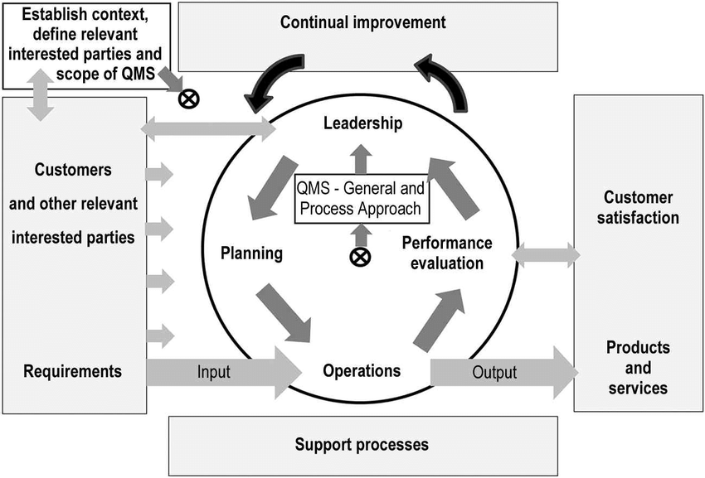
Figure 1. Model of a process-based quality management system (Source: ISO 9001:2015)
The model also recognizes that customers and other relevant interested parties play a key role in defining input requirements. Process management is then implemented to realize the required products or service and the outputs are verified. Satisfaction measurements of customers and other interested parties are used as feedback to evaluate and validate whether customer requirements have been achieved.

6.1 The ISO 9000 Series of Standards for Quality Management
The ISO 9000 series of quality management standards is the generic name given to a family of international standards developed to provide a framework around which a quality management system can effectively be implemented. The standards are published by the International Organization for Standardization (ISO). The ISO 9000 family addresses various aspects of quality management and provides guidance and tools for organizations who want to ensure that their products and services consistently meet customer’s requirements, and that quality is consistently improved. Collectively, these standards provide a model that allows an organization to implement and operate effective quality management systems.
The family of ISO 9000 standards comprises two kinds of quality management standards: requirements and guidelines. The following standards represent international consensus on good quality management practices:
- ISO 9000:2015. Quality management systems – Fundamentals and Vocabulary
- ISO 9001:2015. Quality Management Systems – Requirements
- ISO 9004:2018. Quality management — Quality of an organization — Guidance to achieve sustained success
- ISO 19011:2018. Guidelines for auditing management systems
ISO 9001:2015 is the most recognized and implemented quality management system standard. ISO 9001:2015 specifies the requirements for a QMS that organizations can use to develop their own programs. Other standards related to quality management systems also exist.
An overview of the ISO 9000 series of standards can be found in Annex I.

6.2 Principles of Quality Management
The principles of quality management form the basis for the ISO 9000 series of standards. These principles reflect best practice and are designed to enable continual improvement of the QMS and can be used by top management of an organization, such as an NODC or ADU, as a framework to guide their organization towards improved performance.
A quality management principle is a fundamental rule for leading, operating and developing an organization, with the objective of continually improving performance over the long term through a focused approach to all stakeholders, particularly customers. There are seven principles of QM that provide a sound foundation for achieving goals and objectives.
ISO 9001:2015 is based on these seven quality management principles which are designed to aid performance improvement.
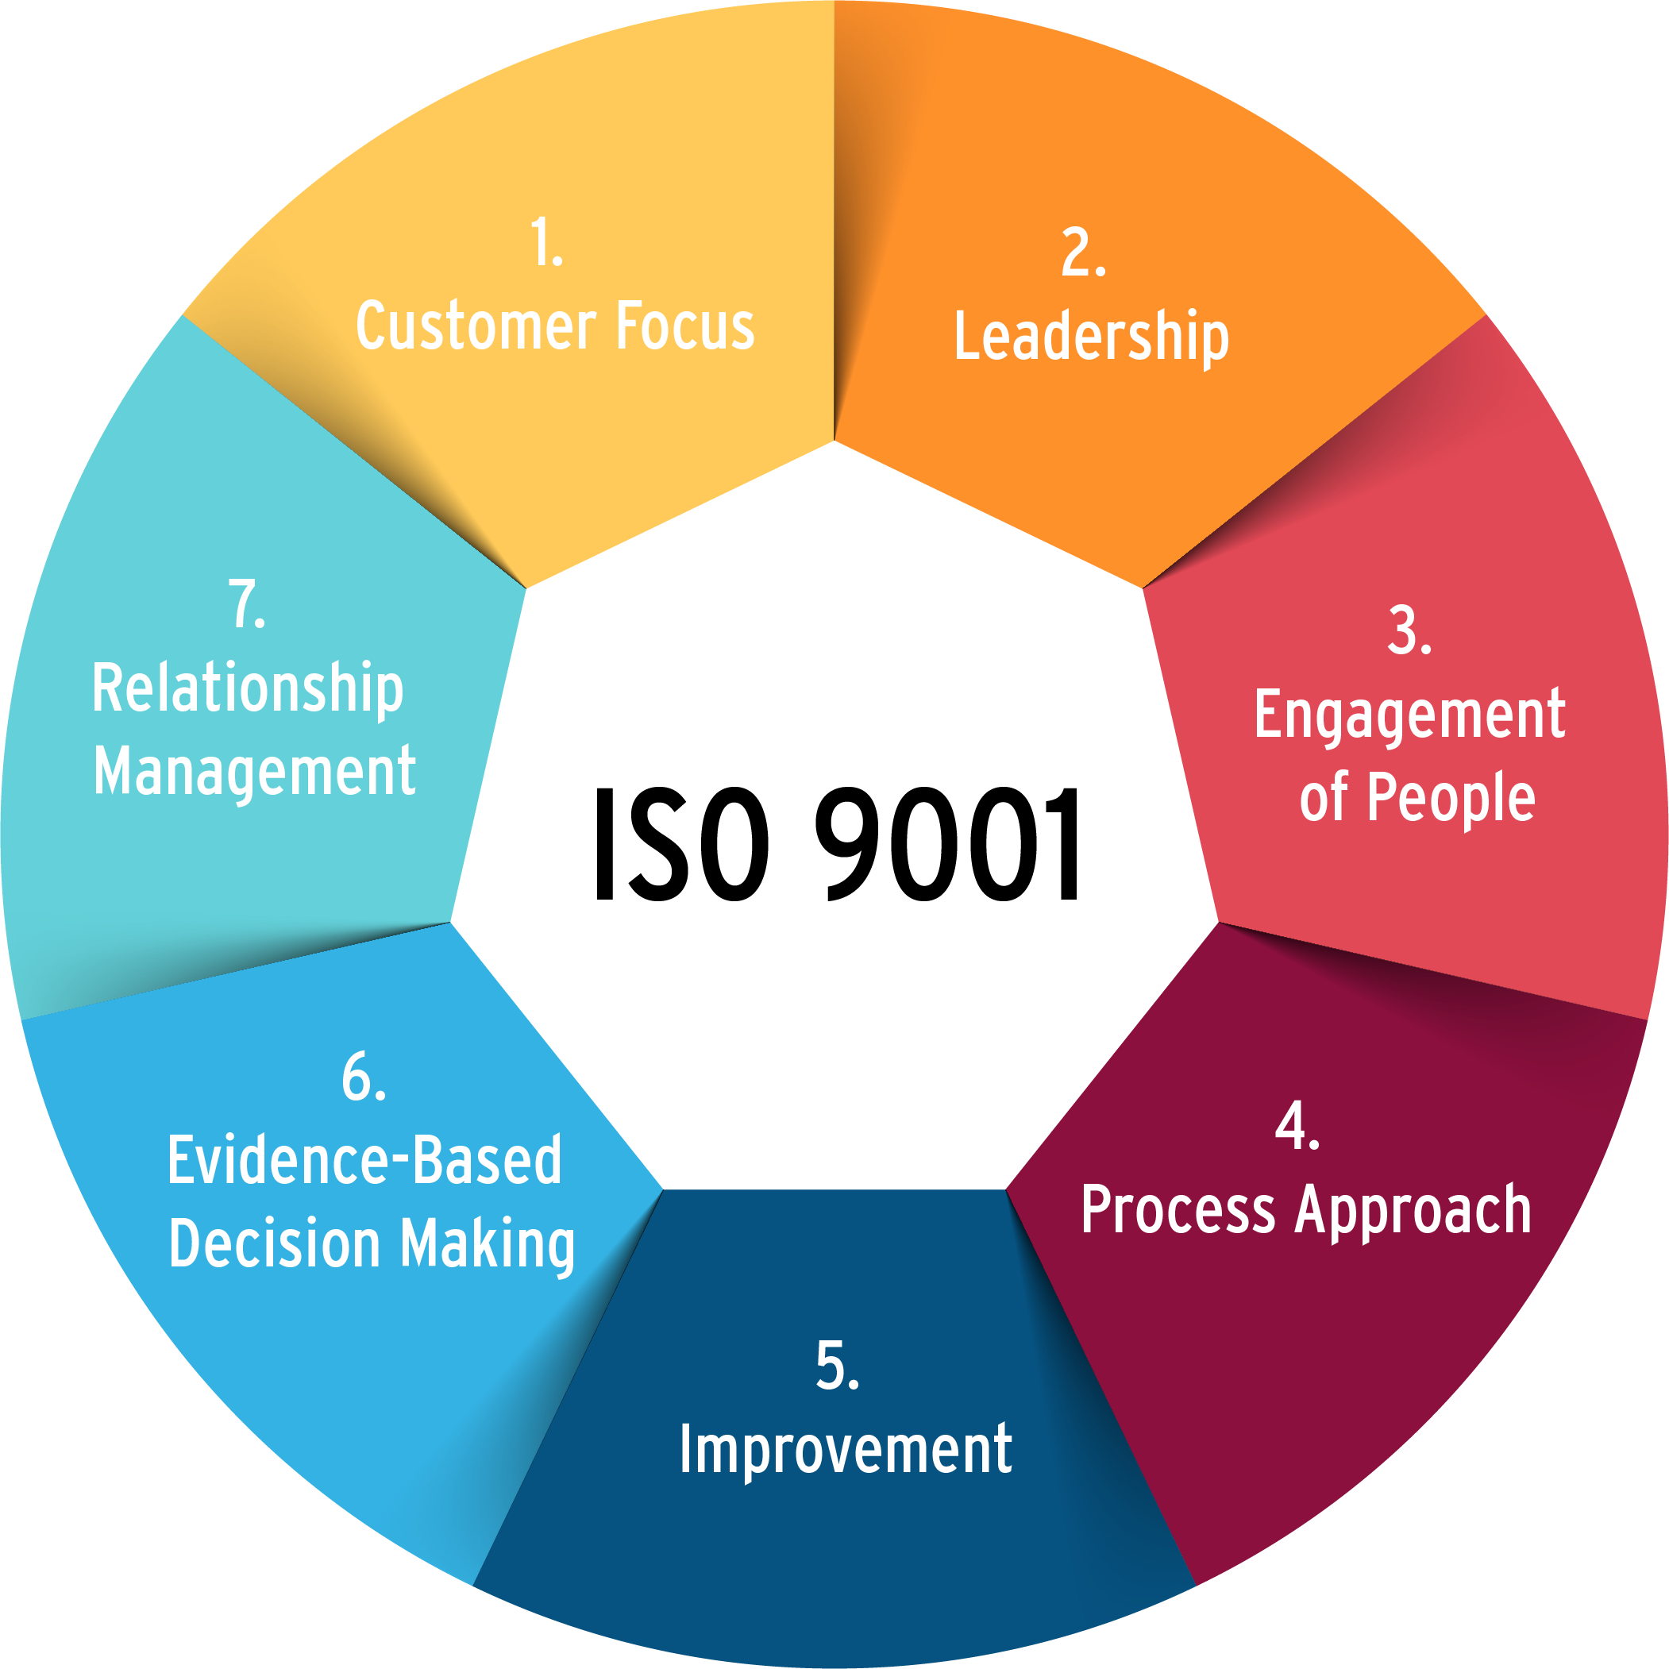
Figure 2. ISO 9001 Quality Management Principles
These principles are:
Principle 1 – Customer focus. The primary focus of quality management is to meet customer requirements and to strive to exceed customer expectations.
Principle 2 – Leadership. Leaders establish unity of purpose and direction of the organization. They should create and maintain the internal environment in which people can become fully involved in achieving the organization's objectives.
Principle 3 – Engagement of people. Competent, empowered and engaged people at all levels throughout the organization are essential to enhance its capability to create and deliver value.
Principle 4 – Process approach. Consistent and predictable results are achieved more effectively and efficiently when activities and related resources are managed as a process.
Principle 5 – Improvement. Improvement of the organization's overall performance should be a permanent objective of the organization.
Principle 6 – Evidence-based decision making. Effective decisions are based on the analysis of data and information.
Principle 7 – Relationship management. For sustained success, an organization manages its relationships with interested parties.
There are many different ways of applying these quality management principles. The nature of the organization and the specific challenges it faces will determine how to implement them. ISO has produced an informative document introducing seven quality management principles (QMPs). It provides for each QMP a Statement (description of the principle), Rationale (explanation of why the principle is important for the organization) Key benefits (examples of benefits associated with the principle), and Actions you can take (examples of typical actions to improve the organization’s performance when applying the principle).
The adoption of these quality management principles will facilitate the efficient and effective management and operation of an NODC or ADU and the implementation of a QMS will support good management practices and enhance confidence in the quality of ocean and marine data, products and services.

A Quality Management System for IODE Data Centres
The IODE NODCs and ADUs must ensure that their responsibilities for ocean and marine data management and delivery of services and products are performed efficiently and effectively. Implementation of quality management systems will assist the NODCs/ADUs in the provision of good management practices and ultimately will enhance confidence in the quality of their data, products and services which will enhance the standing of the NODC/ADU among clients, users and stakeholders. Quality management does not only control the final product, but the entire process.
A QMS addresses on one hand the general management of the NODC/ADU including financial resources, staff, objectives, etc., and on the other hand the technical documentation describing, for example, how data and products are managed and generated. The QMS should be designed specifically for every NODC/ADU. The description of processes and procedures has to be developed by the staff of the NODC/ADU so that it corresponds to the work habits of the organization. However, many processes can be based on commonly used standards and procedures, such as IOC Manuals and Guides and IODE recommended standards and best practices. The full commitment of top management is essential for the implementation of a QMS.
The IODE Committee encourages all NODCs and ADUs to implement a QMS but does not propose a specific standard. The ISO 9001 international standard specifies the basic requirements for a quality management system that can result in certification. Another option is to implement ISO 9004 which provides guidance for the continual improvement of an organization's overall performance, efficiency and effectiveness and does not require formal certification.
There may be a misconception that adopting a quality management approach to the delivery of products and services could be an expensive activity and increase the workload of the organization. However, if well planned properly resourced and efficiently implemented, a quality management system can provide a cost-effective management system that will bring substantial benefits to the organization.
Some NODCs/ADUs may be required to implement the ISO 9001 standard through government policy, requests from customers, the need for competitiveness, etc., or may already have in place systems or practices that address the ISO requirements. In these cases, the NODC/ADU may want to seek ISO 9001 quality management certification. Those NODCs/ADUs that have undergone ISO 9001 certification are urged to share their experience and documentation with other NODCs/ADUs seeking certification.
Achieving ISO 9001 certification through a third party certification body can be an effective way to demonstrate conformity and provides important credibility. Although ISO 9001 certification may be the ideal arrangement, NODCs/ADUs can successfully implement an efficient and effective quality management system without going through formal ISO 9001 certification.

7.1 Steps to Implement a QMS
There are four essential principles to successfully implementing a Quality Management System. These are:
- Keep the system simple and document how you operate your business;
- Ensure strong leadership and management commitment to the process;
- Assign the right person as a system coordinator; and
- Involve all staff in the process.
When developing a system, it is important to keep in mind that there is no need to re-invent the way that a business operates just because you are implementing a Quality Management System.
There are a number of key steps needed to implement a Quality Management System:

Step 1 – Obtain formal endorsement of management
It is essential to ensure that top management fully support the need for a Quality Management System and is committed to supporting the development, implementation, ongoing maintenance and continuous improvement of the system. Management commitment is also critical to ensure that adequate time and resources are allocated. Top Management is defined by ISO as the person or group of people who directs and controls an organization at the highest level. Top management has the following responsibilities and these cannot be delegated:
QMS requirement | Top management responsibility
Customer focus | Demonstrate leadership and commitment
Quality Policy and objectives | Establish, implement, and maintain a Quality Policy
Organizational roles | Assign the responsibility and authority for relevant roles within the organization
Management review | Ensure QMS continuing suitability, adequacy, effectiveness, and alignment with the strategic direction of the organization
Unless formal endorsement and commitment of top management is obtained, and the appropriate level of resources secured, attempting to implement a QMS could be a waste of time and resources.
Step 2 – Assign a quality manager
The role of the quality manager will be key factor to the success of the QMS. This could be a full-time or part time role, depending on the size of the organization. The quality manager will be the driving force behind the QMS and the primary focus for issues pertaining to the QMS. It is essential that the individual appointed has a strong desire for, and interest in, undertaking the challenges associated with developing and implementing a QMS. The quality manager will require a high level of expertise and management skills to manage the broad range of quality management activities, including analysis and assessment of service and product delivery procedures, planning, training, QMS implementation and internal audits.
Step 3 – Provide introductory quality management training
It is important to inform all employees of the plans to implement the QMS, to explain the concept and how it will affect them in order to gain buy‐in and support. An introductory training session for all staff involved in the QMS should be organized to ensure the successful implementation of a QMS by providing sound understanding of the principles and practices of quality management. Training can be provided by an external training organization with expertise in this area, or internally by a staff member who has a sound and demonstrated background in the subject matter. Training should cover:
- The basic concepts of quality systems and accreditation requirements;
- The overall impact on the organization’s strategic goals; and
- The changed work processes and the likely work culture implications of the quality system.
Step 4 – Conduct a gap analysis
A gap analysis is a technique for determining the steps to be taken to move from the current state to a desired future state. A gap analysis is a critical step as it will identify:
- What existing procedures and processes already meet the QMS requirements;
- What existing procedures and processes need to be modified to meet the QMS requirements; and
- What additional procedures and processes need to be created to meet the QMS requirements.
The steps to perform a gap analysis are:
- Review the present operation/process and what already exists;
- Analyze the QMS standard requirements or accreditation requirements to determine what is actually required; and
- Document the gaps.
The gap analysis will identify the requirements that are currently not being fully addressed (or not addressed at all) and to develop remedial actions.
Step 5 – Design and implement
Choose the methodology that suits your organization, list the stakeholders, plan the timelines, develop and revise processes and procedures, and document the system. A phased approach can be used for implementation of the QMS so the effectiveness of the system can be evaluated. The implementation progress should be monitored to ensure that the quality management system is effective and conforms to the design. This includes internal quality audit, corrective action and management review.
Step 6 - Accreditation
Once the quality management system is operational and has stabilized, a formal application for accreditation can be made. Accreditation by the IODE requires that the NODC or ADU fulfil a minimum set of requirements to ensure compliance with IODE standards and to establish a mechanism to regularly monitor and assess the quality of data and services (see section 8).
Step 7 - Continual improvement
Accreditation by IODE should not be the end of the process. A key objective of a Quality Management System is to deliver continuous improvement. It is important to continually seek to improve the effectiveness and suitability of the QMS and the goal is to determine the effectiveness and efficiency of each process toward its objectives, to communicate these findings to the employees, and to develop new best practices and processes based on the data collected during the audit. Steps can be taken to improve the system through the:
- Quality policy;
- Quality objectives;
- Audit results;
- Analysis of data;
- Corrective and preventive actions; and
- Management review.
It is not possible to determine exactly how long it will take an organization to implement a QMS, nor achieve IODE accreditation. WMO (World Meteorological Organization, 2017) suggests there are a number of factors that can impact the time required to implement a QMS. These include
- the size of the organization;
- the extent to which the QMS will be introduced within the organization;
- whether QMS implementation is assisted by a consultant;
- the maturity of the QMS processes and documentation;
- the availability of resources; and
- commitment of top management and staff.
For a small organization or unit within an organization, 12-18 months is an achievable time frame to implement a QMS and apply for accreditation. An incremental approach, where a QMS is developed and implemented for different sections or programme areas, is also a strategy that could be adopted.

7.2 Quality System Manual
A quality system manual forms an important part of the process of building, consolidating and clarifying the quality management framework. A quality system manual details the scope of an organization’s QMS, including references to documented policies and procedures. It provides a "road map" as to how the organization operates. The manual has several uses such as:
- A means to communicate the vision, values, mission, policies and objectives of the organization;
- A means of showing how the system has been designed;
- A means of showing linkages between processes;
- A means of showing who does what;
- An induction tool that describes how the organization operates and the processes associated with achieving its outcomes;
- A tool in the analysis of potential improvements; and
- A means of demonstrating compliance with external standards and regulations.
In developing a quality system manual for an NODC/ADU it helps to look from the perspective of new employees who would use the manual as an induction tool. It should provide them with a clear picture of how the NODC/ADU operates and the processes associated with achieving its outcomes. A quality system manual can also contain additional information about the NODC/ADU such as information about customer service, future strategies, past history, organizational structures and charts as required. It is important that this document is easy to read and understand and reflects the values of the organization.
The format and structure of the quality system manual is a decision for each organization and will depend on the organization’s size, culture and complexity. Some organizations may choose to use the quality system manual for other purposes besides that of simply documenting the QMS. A small organization may find it appropriate to include the description of its entire QMS within a single manual while a large organization may need several manuals and a hierarchy of documentation. A simple outline of a quality system manual for an NODC /ADU is described in Annex II.
Ireland's National Marine Data Centre (hosted by the Marine Institute), an Accredited IODE National Oceanographic Data Centre, has published a document that provides a description of a quality management system, including a Data Management Quality Management model and how it is implemented across the scientific and environmental data producing areas of the Marine Institute, which may be of assistance to NODCs and ADUs establishing their organisational data management quality management systems (Leadbetter et al).

Accreditation of IODE Data Centres
NODCs and ADUs must be able to demonstrate their capability to provide data and services in compliance with established functions and responsibilities and to support the data access requirements of all IOC programme areas as well as to the wider community. The adherence to agreed standards and the requirements of the IOC Data Policy and Terms of Use (2023) must be met and sustained.
To ensure NODCs and ADUs are able to provide quality data to meet the requirements of a broad and varied community of users, an accreditation process has been initiated by IODE. This process is based on compliance to a set of requirements that can be translated into quantitative indicators to set up standard metrics which will be part of a regular review of NODCs and ADUs. Existing NODCs and ADUs are encouraged to apply for accreditation and meet the prescribed accreditation requirements.

8.1 NODC/ADU Accreditation Requirements and Report Format
In order to obtain and maintain accreditation, NODCs and ADUs will need to fulfil a minimum set of requirements to ensure compliance with IODE standards and to establish a mechanism to regularly monitor and assess the quality of data and service. IODE has established accreditation criteria to ensure NODCs and ADUs meet these requirements which are given in Table 1.
Table 1: IODE Accreditation Requirements and Report Format for NODCs and ADUs
Criteria | IODE NODC/ADU accreditation requirement
1 ORGANIZATIONAL FRAMEWORK
1.1 Quality Management System | The NODC/ADU shall establish and maintain a quality management system and document:  - the scope of the quality management system  - procedures established by the quality management system  - a description of the interaction between the processes of the quality management system.  In addition, details of any QMS accreditation attained should be stated.
1.2 Proof of expertise and reputation in the area of ocean and marine data management | The NODC/ADU shall describe the range and length of expertise of both the organization and their staff. Details of datasets and products available from the NODC/ADU should also be provided. Any appropriate affiliations (e.g. national or international bodies, etc.) should be noted.
1.3 Commitment to provide sufficient resources for NODC/ADU operations | The NODC/ADU shall provide evidence that it is hosted by a recognized institution to ensure long-term stability and sustainability. Sufficient funding, including staff resources, IT resources and a budget for attending meetings, should be provided, ideally for a 3 to 5 year period.
1.4 Commitment to return data holdings to originators, or lodging with an alternative repository, if the NODC/ADU becomes unsustainable | A long-term stewardship plan should be available including:  - A statement on how the NODC/ADU is funded and for how long.  - Action to be taken in the event that the NODC/ADU becomes unsustainable
1.5 Provide activity reports to the IODE Committee | The NODC/ADU shall provide a national/activity report to each session of the IODE Committee in accordance with the standard format specified.
2 QUALITY CONTROL AND MAINTENANCE
2.1 Adherence to IODE Standards and Best Practice | The NODC/ADU must provide evidence of adherence to IODE and other recognized standards and best practice to ensure the quality of exchanged data. (OceanBestPractices (OBP) provides a permanent repository of community best practices in ocean-related sciences at https://www.oceanbestpractices.org/)
2.2 Maintain a discovery metadata catalogue | The NODC/ADU shall maintain an online metadata discovery catalogue that provides a description of their data and services. Metadata should be compliant with the ISO 19115 metadata content standard.
2.3 Ensure data are collected according to defined quality principles and accepted procedures | The NODC/ADU should be able to advise on data collection procedures and to direct data collecting organizations to appropriate standards, where these exist. Provide details of guidelines used for the collection of data.
2.4 Description of quality control procedures applied to data | The NODC/ADU should provide descriptions of quality control procedures and algorithms that are used to process data. This should include references to the quality flag system used.
3 USER ACCESS AND COMMUNICATION
3.1 Committed to, and focus on, customer service | The NODC/ADU should be committed to customer service and should provide information on:  - Response times to enquiries for data and information  - Description of aimed service level for responding to user requests (if these not available online).  - Whether an Enquiries or Help Desk is available  - Details of surveys of customer satisfaction undertaken
3.2 Committed to raising awareness of the holdings and promoting the use of the data | The NODC/ADU should provide information on:  - Data products available  - Linkages with other organizations who use the data for generation of products  - Current projects aiming to increase and promote data use  - Statistics/metrics indicating data usage
3.3 Published Data Policy and adherence to the IOC Data Policy and Terms of Use (2023) | The NODC/ADU should have a policy on data access. In general, the NODC/ADU should aim to make data and metadata freely available. Restrictions on access to data may be applied, for example, for national security, commercial confidentiality, and for scientific research to allow the principal investigators to exploit the data.  The data access policy should include the following:  - Details of what data are accessible  - Licensing arrangements  - The format(s) that data can be provided in  - The media used for providing data (if data are not on-line)  - Any costs associated with data provision – including cost of media as well as staff time  Adherence to the IOC Data Policy and Terms of Use (2023)is mandatory for accreditation.
4 TECHNICAL INFRASTRUCTURE
4.1 Description of hardware and software systems used to manage and archive data | The NODC/ADU shall provide documentation on the data centre’s operating environment (hardware, software). This should be appropriate to the services provided to its customers.
4.2 Security Policy outlining the infrastructure for protection of the facility and its data, products and services | The NODC/ADU should have a security policy describing how the data holdings are protected from both malicious and accidental loss. A policy should include the following:  - How the holdings are physically protected (e.g. how access to the building is controlled, how secure the building is, who has access)  - Access to the network – what is the access policy, how is user access limited and by who, whether there is an internet link and details of how the firewall is configured and altered, how machines are patched, which users can log on to particular machines, policy on passwords  - Policy when staff leave the organization or change their role within the organization  - Description of the data archival system including backup and off-site storage procedures.  Note that the security policy should exist but should not be made public as it potentially exposes vulnerabilities.

8.2 Procedures to Apply for Accreditation
The accreditation procedure for NODCs and ADUs is:
- Submission of the accreditation request (including the IODE Accreditation Requirements and Report Format) and associated documentation to the SG-QMF through its Chair;
- Review of the documentation referred to under (i) by the Steering Group within three months after submission;
- If required, clarification or further information may be requested by the Steering Group;
- Formulation of recommendation regarding accreditation for consideration by the IODE Committee (within two months after (ii));
- Decision by the IODE Management Group (as the representative of the IODE Committee); and
- Report the results of the decision back to applicant.
NODCs that meet the accreditation requirements will be awarded the status of Accredited IODE National Oceanographic Data Centre.
ADUs that meet the accreditation requirements will be awarded the status of Accredited IODE Associate Data Unit.
If the advice provided by the Steering Group for accreditation is negative then the NODC/ADU will be given one year to remedy the shortcomings that were reported. After that period (or sooner) the institution can re-apply for accreditation and the same procedure will be followed.

8.3 Regular Assessment
Once accredited, the capability and performance of each NODC/ADU will be reviewed by the SG-QMF every four years. If it is found that compliance to the accreditation requirement has not been met the NODC/ADU will be required to take remedial action within one year. If compliance has not been met after this period accreditation can be withdrawn. If an NODC/ADU loses accreditation it will need to reapply.

8.4 Steering Group for the IODE Quality Management Framework
The QMF Project is overseen by the IODE Steering Group for the IODE Quality Management Framework (SG-QMF). The Steering Group has the following terms of reference:
- prepare and maintain the IODE Quality Management Framework Guidelines;
- receive, through the IODE Secretariat, applications and review the accreditation of NODCs and ADUs; and
- advise the IODE Committee on the accreditation of NODCs and ADUs.
Member States nominate suitably qualified experts with experience in implementing quality management systems for membership of the Steering Group.

Capacity Development
The ISO quality management principles emphasize the importance of human resource management and the need for appropriate training. The International Standard ISO ISO 10015:2019 Quality management — Guidelines for competence management and people development document provides guidance to assist organizations and their personnel when addressing issues related to competence management and people development, including creating learning and training opportunities, and can be applied whenever guidance is required to interpret references to competent/developed people within the ISO 9000 family of quality management systems.
ISO 10015:2019 describes the process to help organizations manage competence and develop their people.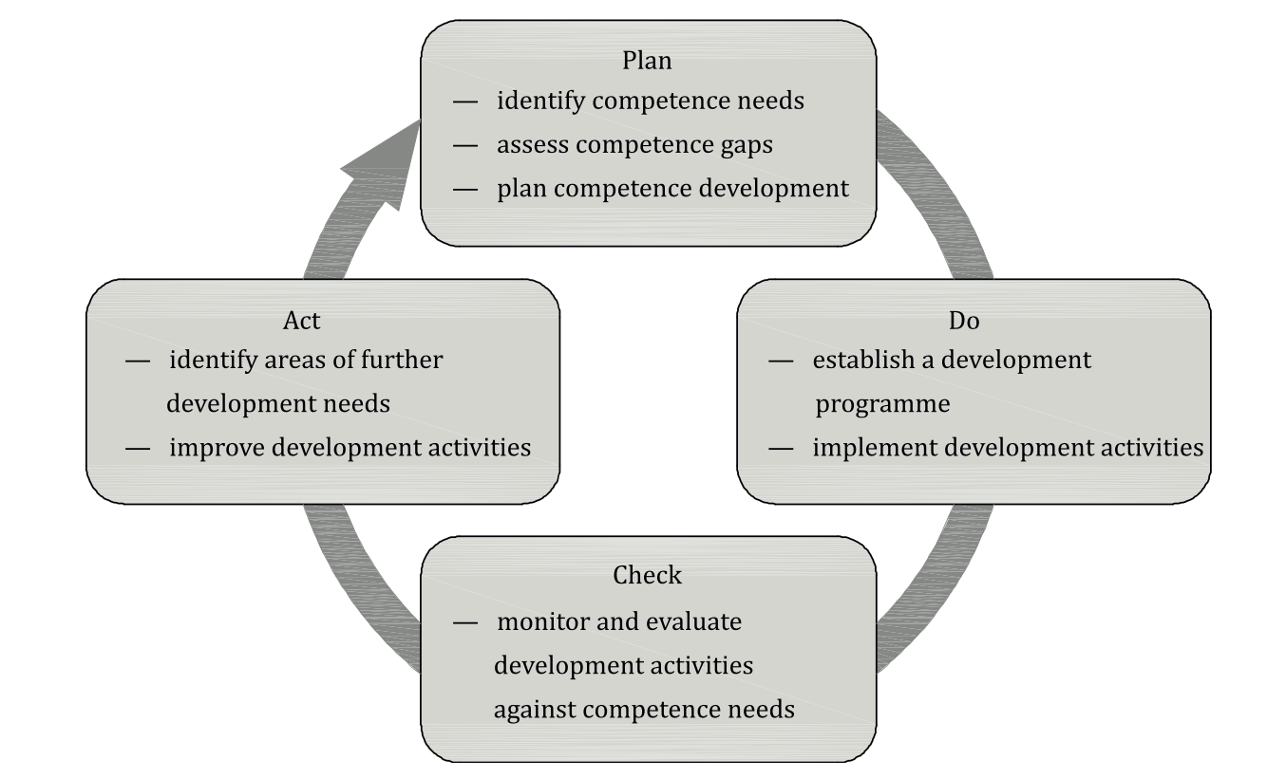
Figure 3. A process for managing competence and developing people (Source: ISO 10015:2019)
Data centre personnel at all levels should be trained to meet their organization's commitment to quality management and the IODE recognizes the importance of appropriate training and continuous education to improve the competence of personnel.
IOC capacity development, centred on the OceanTeacher Global Academy, provides the necessary training so that all NODCs and ADUs can achieve full accreditation. Quality management is included in the OceanTeacher Global Academy Training programme.

References and Further Reading
Intergovernmental Oceanographic Commission of UNESCO. 2022. Guide for Establishing an IODE National Oceanographic Data Centre, IODE Associate Data Unit or IODE Associate Information Unit (3rd revised edition). Paris, UNESCO, 26 pp. (IOC Manuals and Guides, 5, 3rd revised edition)
International Organization for Standardization, 2019. Quality management — Guidelines for competence management and people development. ISO 10015:2019.
International Organization for Standardization, 2015. Quality management systems – Requirements. ISO 9001:2015.
International Organization for Standardization, 2015a. Quality management systems — Fundamentals and vocabulary. ISO 9000:2015.
International Organization for Standardization, 2018. Guidelines for auditing management systems. ISO 9011:2018.
International Organization for Standardization, 2018a. Quality management — Quality of an organization — Guidance to achieve sustained success. ISO 9004:2018.
Leadbetter, A., Carr, R., Flynn, S., Meaney, W., Moran, S., Brophy, L., Lyons, K., Stokes, D., Thomas, R. 2020. Implementing a Data Management Quality Management Framework at the Marine Institute, Ireland. Earth Science Informatics. DOI:10.1007/s12145-019-00432-w
World Meteorological Organization, 2017. Guide to the Implementation of a Quality Management System for National Meteorological and Hydrological Services and Other Relevant Service Providers. WMO-No 1100.

Annex I. Overview of the ISO 9000 Core Standards
ISO 9000:2015. Quality management systems -- Fundamentals and vocabulary. This standard describes the fundamental concepts and principles of quality management which are universally applicable to the following:
- organizations seeking sustained success through the implementation of a quality management system;
- customers seeking confidence in an organization's ability to consistently provide products and services conforming to their requirements;
- organizations seeking confidence in their supply chain that their product and service requirements will be met;
- organizations and interested parties seeking to improve communication through a common understanding of the vocabulary used in quality management;
- organizations performing conformity assessments against the requirements of ISO 9001;
- providers of training, assessment or advice in quality management;
- developers of related standards.
ISO 9000:2015 specifies the terms and definitions that apply to all quality management and quality management system standards.
ISO 9001:2015. Quality management systems -- Requirements. This standard specifies requirements for a quality management system when an organization:
- needs to demonstrate its ability to consistently provide products and services that meet customer and applicable statutory and regulatory requirements;
- aims to enhance customer satisfaction through the effective application of the system, including processes for improvement of the system and the assurance of conformity to customer and applicable statutory and regulatory requirements.
All the requirements of ISO 9001:2015 are generic and are intended to be applicable to any organization, regardless of its type or size, or the products and services it provides.
ISO 9004:2018. Quality management -- Quality of an organization -- Guidance to achieve sustained success. This standard gives guidelines for enhancing an organization's ability to achieve sustained success. This guidance is consistent with the quality management principles given in ISO 9000:2015. ISO 9004:2018 provides a self-assessment tool to review the extent to which the organization has adopted the concepts in this document. ISO 9004:2018 is applicable to any organization, regardless of its size, type and act.
ISO 19011:2018. Guidelines for auditing management systems. This standard provides guidance on auditing management systems, including the principles of auditing, managing an audit programme and conducting management system audits, as well as guidance on the evaluation of competence of individuals involved in the audit process. These activities include the individual(s) managing the audit programme, auditors and audit teams. It is applicable to all organizations that need to plan and conduct internal or external audits of management systems or manage an audit programme. The application of this document to other types of audits is possible, provided that special consideration is given to the specific competence needed.

Annex II. Outline of a Quality System Manual for an IODE NODC or ADU
- Introduction
This section provides an introduction to the quality management system. It should contain a description of the NODC/ADU (stating the name, address, phone, fax, email, etc), explaining what it does and how it does it and summarizes its history and experience. It should describe the organization’s quality policy and objectives and include a statement of the Mission and Vision of the organization. It could also include a flowchart of the organization and provide a list of products and services available to customers. This section should also show who reviewed and approved the manual for distribution and use, identify the manual's version status, including when the current version was approved and issued, describe how manual changes and revisions should be initiated, prepared, approved, and distributed, and indicate whether the manual is for internal use only, or whether it can be distributed to outsiders.
- Scope of the Quality Management System
This section describes the scope of the QMS. The scope can include facilities, products, processes, quality management and standards. The scope will define the area(s) of the organization covered by the management system.
- Responsibility
This section lists the key responsibilities of management, including the Director, the Representative of Quality, the head of Quality Section, Technical Divisions, Administration Division and Heads of regional centres and concerned staff, with respect to the Management System.
- Structure of the QMS
This constitutes the main section of the Quality Management System Manual. It includes a general description the QMS requirements and flowcharts depicting processes. It also includes the description of the following activities:
  - General requirements include the requirements for the organization to establish, document, implement and maintain a quality management system and continually improve its effectiveness.
  - Documentation requirements include quality policy, quality procedures, quality Instructions, guides, records, control of documents and records.
  - Management responsibility, customer focus, quality policy and objectives, planning process, internal communication and the mechanisms for management review.
  - Resource management covers requirements concerning the resources needed for the effective implementation of the quality management system.
  - Product realization covers requirements concerning the production cycle, which involves determining product requirements, designing the product, acquiring the raw materials, manufacturing the product and delivery of the finished product.
  - Measurement, analyses and Improvement addresses requirements for monitoring and measuring the effectiveness of the quality management system of the organization, and conformity of its products, and continual improvement of the quality management system.
The structure of the Quality Management System Manual could follow the ISO 9001:2015 outline:
Section 1 | Scope
Section 2 | Normative references
Section 3 | Terms, definitions, acronyms
Section 4 | Context of the organization
Section 5 | Leadership
Section 6 | Planning
Section 7 | Support
Section 8 | Operation
Section 9 | Performance evaluation
Section 10 | Improvements

Annex III. IOC Data Policy and Terms of Use (2023)
The Assembly,
Recalling that the IOC Oceanographic Data Exchange Policy was published in 2003 (IOC Resolution XXII-6, 2003) and since then has only had one minor change: Clause 5 revised in 2019 by Decision IOC-XXX/7.2.1(II) of the Assembly at its 30th session, Paris, 26 June–4 July 2019,
Recognizing that:
- the timely and unrestricted international exchange of oceanographic data is essential for the efficient acquisition, integration and use of ocean observations gathered by the countries of the world for a wide variety of purposes including the prediction of weather and climate, the operational forecasting of the marine environment, the preservation of life, the mitigation of human-induced changes in the marine and coastal environment, as well as for the advancement of scientific understanding that makes this possible,
- the global digital data, information, and knowledge ecosystem has radically changed since 2003,
- rapidly advancing technologies have altered the Data Stewardship paradigm,
- there is a need to improve interoperability and align the IOC data policy with those at national, regional, and international levels,
- more and more Public-Private Partnerships are being established. To allow the best use of the data in this context as well as in the context of using data in journals from private publishers, the IOC data policy should provide clear guidance for commercial use of data,
Noting that partner and sister organizations are changing their data policies, which can serve as a model for updating the IOC data policy,
Noting also that principles of data sharing and licensing are becoming globally recognized and adopted, e.g., FAIR Principles and Creative Commons licences,
Decides to close the IOC Intersessional Working Group on the Revision of the IOC Oceanographic Data Exchange Policy (2003, 2019) (IWG-DATAPOLICY);
Adopts the IOC Data Policy and Terms of Use (2023) as detailed in Annex to this decision;
Decides to develop guidelines for the development of detailed data and metadata sharing guidelines by all IOC programmes and projects.
Annex to Dec. A-32/4.4
IOC Data Policy and Terms of Use (2023)
Section 1. Preamble
The timely, open and unrestricted international sharing, in both real-time and delayed mode of ocean metadata, data and products is essential for a wide variety of purposes and benefits including scientific research, innovation and decision making, the prediction of weather and climate, the operational forecasting of the marine environment, the preservation of life, economic welfare, safety and security of society, the mitigation of human-induced changes in the marine and coastal environment, as well as for the advancement of scientific understanding that makes this possible. Innovation of specialised products can be stimulated and encouraged by timely, open and unrestricted access to metadata and data. Metadata, data and products should be accessible, interoperable and openly shared with minimum delay and minimum restrictions.
Section 2. Purpose
The purpose of this data policy is to outline the requirements with respect to sharing, access, preservation, and attribution to facilitate the broad use and reuse of metadata, data and products.
Section 3. FAIR & CARE principles
To support knowledge discovery and innovation both by humans and machines and to acknowledge indigenous data governance, data should meet the FAIR Guiding Principles (Findable, Accessible, Interoperable and Reusable)[1] and In the case of indigenous data and information, data should meet the CARE principles (Collective Benefit, Authority to Control, Responsibility, Ethics)[2] to the greatest extent practicable.
Section 4. Conditions of use
Data should be licensed (respecting Section 8) under a minimally restrictive and voluntary common-use licence[3] that grants permission, ensures proper attribution (for example, citable using a persistent identifier) and allows others to copy, distribute and make use of the data.
Section 5. Data Repositories and the IOC ocean data and information system (ODIS)
Data should be quality controlled (using community adopted and documented best practices or standards), accompanied by complete metadata and stored in an openly discoverable and accessible long-term data repository and made available through standards-based data services. Member States shall encourage convergence and interoperability and, where possible, use IODE data centres (National Oceanographic Data Centres or Associate Data Units) or other IOC programme related data centres that share metadata and data using the IOC Ocean Data and Information System (ODIS). ODIS is an interoperability layer and supporting technology, to allow existing and emerging ocean data and information systems to interoperate with one another.
Section 6: Secure long-term data archives
To support long-term and secure archival, data and associated metadata should be submitted, to the best practicable degree, to IODE’s World Ocean Database (WOD), the Ocean Biodiversity Information System (OBIS), Global Sea Level Observing System (GLOSS), other IOC related global data archives, and data centres linked to the World Data System (WDS), their successors or other global data archives.
Section 7. Access restrictions
Data and associated metadata should be made available with minimal restrictions on use unless there are valid reasons to restrict access. Legitimate reasons to restrict access to, and reuse of, data include, inter alia, privacy and confidentiality, protection of species, populations or habitats of concern, and national security.
Section 8. Data sharing policies of Member States
This Policy acknowledges the right of Member States and data owners to determine the terms of metadata, data and products sharing in a manner consistent with national jurisdictions, international conventions, and treaties, where applicable.
Section 9. Data and metadata sharing guidelines
IOC programmes, projects as well as other communities of practice should develop and/or apply, where applicable, detailed metadata, data and products sharing guidelines that are consistent with this IOC Data Policy and Terms of Use.
Section 10. Definitions
‘Data’ is a set of values, symbols or signs (recorded on any type of medium) that represent one or more properties of an entity[4].
‘Metadata’ is 'data about data' describing the content, quality, condition, and other characteristics of data that allows their inventory, discovery, evaluation or use.
‘Timely’ in this context means the distribution of data and/or products, sufficiently rapidly to be of value for a given application.
‘Openly’ means data that can be freely used, re-used and redistributed by anyone - subject only, at most, to the requirement to attribute and share alike.
‘Product’ means a value-added enhancement of data applied to a particular use.
[1] Wilkinson, M., Dumontier, M., Aalbersberg, I. et al. The FAIR Guiding Principles for scientific data management and stewardship. Sci Data 3, 160018 (2016). https://doi.org/10.1038/sdata.2016.18
[2] CARE Principles for Indigenous Data Governance. https://www.gida-global.org/care
[3] For example: the Creative Commons family of licences https://creativecommons.org/about/cclicenses/
[4] Ocean Decade Implementation Plan



Intergovernmental Oceanographic Commission of UNESCO  7 rPlace de Fontenoy  75352 Paris Cedex 07 SP, France  http://ioc.unesco.org |  | UNESCO/IOC Project Office for IODE  InnovOcean Campus  Jacobsenstraat 1  8400 Oostende, Belgium  http://www.iode.org

http://www.iode.org
http://www.ioc.unesco.org
https://unesdoc.unesco.org/ark:/48223/pf0000382882
https://iode.org/nodc
https://iode.org/adu
https://www.oceanbestpractices.org/
https://www.go-fair.org/fair-principles
https://www.coretrustseal.org/why-certification/requirements/
https://www.iso.org/publication/PUB100080.html

