ICG/PTWS Working Group 3 on Disaster Risk Management and Preparedness
Task Team Tsunami Ready
Report to the ICG/PTWS-XXXI
April 2025

Co-Chairs: Laura Kong, International Tsunami Information Centre
Ashleigh Fromont, New Zealand National Emergency Management Agency
This Report covers the intersessional period between the ICG/PTWS-XXX (September 2023) and ICG/PTWS-XXXI (April 2025). The topics to be covered will be
1. Progress of Tsunami Ready Recognition in the Pacific
2. PTWS Tsunami Ready Equivalency Approach
3. Task Team Tsunami Ready Governance

The Task Team was established by the ICG/PTWS-XXX.1 with the following Terms of Reference.
WG3 Task Team Tsunami Ready Terms of Reference
- Develop formal PTWS guidelines following the 'Tsunami Ready Equivalency Approach’ for recognition of tsunami readiness of communities not implementing the IOC Tsunami Ready Recognition Programme,
- Monitor Tsunami Ready campaigns and outcomes, and report results,
- Ensure the advocacy for Tsunami Ready is aligned with other PTWS and IOC documents,
- Advise on the Tsunami Ready workflow as it pertains to the PTWS and regions,
- Support ITIC in its efforts to facilitate the implementation of Tsunami Ready in PTWS Member States,
- Support ITIC’s efforts to develop standardized training supporting Tsunami Ready under the framework of OTGA, such as through feedback on content and helping to test trainings before officially deployed,
- Help to identify sources of funding in support of the implementation of Tsunami Ready,
- Report progress on encouraging the standard text in the UNESCO-IOC Tsunami Ready signage for vertical evacuation, such as “Go to the designated building for vertical evacuation”,
- Report progress toward informing the public on the validity of the recognition, to be indicated on Tsunami Ready signage and on the certificate under the UNESCO-IOC Tsunami Ready logo.

In addition, ICG/PTWS-XXX.5 also
- Encouraged member states to continue to share outcomes and progression towards “100% Tsunami Ready Goal” with WG3, including communities already considered compliant through national standards
- Mandated the ITIC to continue to facilitate implementation and data collection regarding TR in the PTWS
- Noted & endorsed the proposed Tsunami Ready Equivalency Approach that seeks to enable reporting of tsunami preparedness in a manner compatible with the UNESCO/IOC Tsunami Ready Recognition Programme
- Recommends the TT TR to develop formal guidance for the application of this approach, in consultation with the Regional Working Groups.

1. Progress of Tsunami Ready Recognition in the Pacific

The Task Team through the lead of ITIC, continues to promote the implementation and outcomes of Tsunami Ready, and reporting the results to the ICG/PTWS and the TOWS-WG. Please refer to the ITIC report for an overview of Tsunami Ready training and support efforts led by ITIC.

There is a new web page for the UNESCO IOC Tsunami Ready website, now hosted by IOC - https://tsunami.ioc.unesco.org/en/tsunami-ready. The easy-to-remember URL is tsunamiready.org The web pages include links to guidelines and the application process, latest Tsunami Ready Recognition Programme updates and news, and a map viewer with information of recognized communities globally (https://tsunamireadyviewer.ioc-tsunami.org/).

1.1 Global Tsunami Ready Communities Information

As of February 2025, 100 communities in 34 member states, of which 15 are SIDS countries, have been recognized as Tsunami Ready.

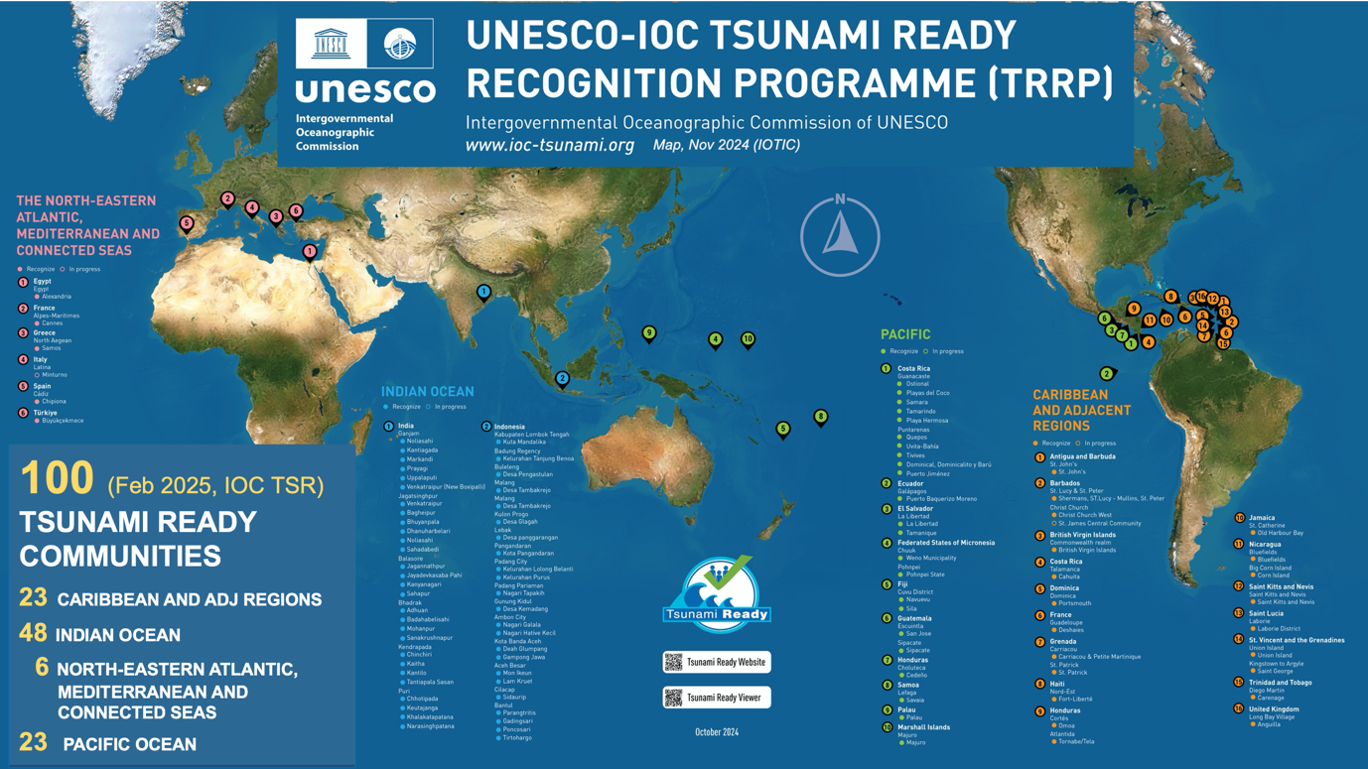

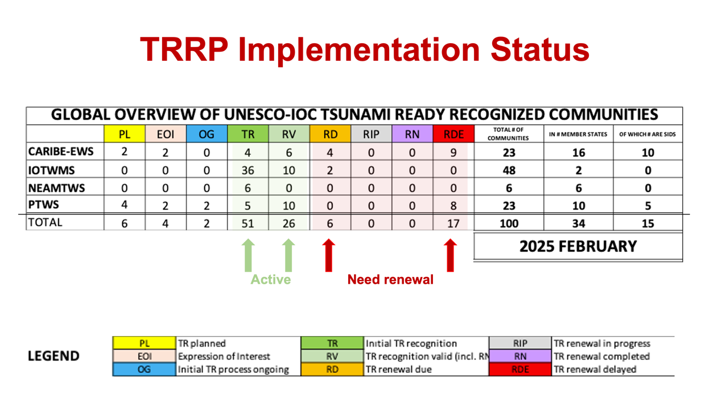

1.2 Pacific Tsunami Ready Communities Information

As of February 2025, 23 communities in 10 member states have been recognized as Tsunami Ready.

Status | Number of Communities
Active Tsunami Ready Recognition | 15
Tsunami Ready Planned | 4
Tsunami Ready process underway | 2
Interested in undertaking Tsunami Ready | 2
Tsunami Ready Renewal Delayed | 8

Year | Tsunami Ready Recognition or Renewal
2017 | Costa Rica (Ostional), Honduras (Cedeno), Samoa (Savaia Lefaga)
2019 | Costa Rica (Playa El Coco), El Salvador (Tamanique, La Libertad ) Guatemala (Sipacate, San Jose Port)
2020
2021 | Costa Rica (Samara, Tamarindo, Uvita-Bahía)
2022 | Costa Rica (Quepos Municipality ,Playa Hermosa, Tivives, Puerto Jiménez, Dominical, Dominicalito y Barú)
2023 | Fiji (Navuevu, Sila)
2024 | Ecuador* (Puerto Baquerizo Moreno), Federated States of Micronesia (Chuuk, Pohnpei), Marshall Islands (Majuro), Palau (Palau)
Underway / Planned | Ecuador* (Puerto Villamil, Puerto Ayora), Federated States of Micronesia (Kosrae, Yap), Nicaragua, Panama (Puerto Armuelles), Solomon Islands (Honiara, Western Provinces), Tonga, Vanuatu (Port Vila, Luganville, Aneiysym), Vietnam, Costa Rica, El Salvador
*The effort to achieve Tsunami Ready cities in Ecuador has been supported by the Permanent Commission of the South Pacific -CPPS.
There are some challenges with reporting the progress of implementation of the Tsunami Ready Recognition Programme (or equivalent) in ICG/PTWS, beyond the Tsunami Ready viewer. Member States are encouraged to share progress with Working Group 3, however, there is no mechanism to do so.
The Task Team considers that there is a need for a regular ICG/PTWS Tsunami Ready survey. This would support monitoring and reporting on Tsunami Ready across the Pacific, and also ensure that Task Team Tsunami Ready activities are representative of the whole Pacific needs. Questions would be to the effect of:
• Intent & progress with implementing the Tsunami Ready Recognition Programme
• Barriers and challenges with Tsunami Ready Recognition implementation
• Whether there is a national programme instead of Tsunami Ready
With the PTWS Capacity Assessment now intended to take place before the next ICG, the Task Team proposes that this will be sufficient, and to avoid survey fatigue, but to make consideration of a regular survey following this.

The WG3 Task Team Tsunami Ready recommends that the ICG/PTWS:

Notes with appreciation the significant role that the International Tsunami Information Centre plays in the facilitation, promotion and application of the Tsunami Ready Recognition Programme across the PTWS.

Notes the challenge in reporting the progress of Tsunami Ready for the PTWS, in particular interest and planning of the programme that may not have been communicated to ITIC or the IOC,

Requests the WG Task Team Tsunami Ready continue to investigate the implementation of a Tsunami Ready survey for the PTWS for implementation prior to the ICG/PTWS-XXXII, to support reporting at that Session.

Encourages member states to continue to share outcomes and progression towards ‘100% Tsunami Ready’ with Working Group Three.

Mandates the International Tsunami Information Centre (ITIC) to continue to facilitate implementation and data collation regarding Tsunami Ready progress in the PTWS.

1.3 Challenges to Tsunami Ready Implementation

The Task Team met in July 2024 with representation from other ICGs and discussed implementation challenges in the Pacific and globally for the TRRP. Similar discussion was had at the 2025 meeting of the TOWS TT-DMP, and is expected to inform future work of the TT-DMP.

Key challenges reported across the ICGs include:
- Hazard assessment, especially inundation modelling and GIS capacity
- A cumbersome / time consuming application process
- Challenges in the definition of community, in that they should not be too small as that uses high levels of administration to roll out across a country but must also be meaningful (not too large)
- Sustainability in effort, expertise and funding
- Awareness & education both in community and government

The lack of inundation modelling presents real difficulties to tsunami preparedness, and Tsunami Ready Recognition.

Accurate inundation modelling requires the availability of high-resolution bathymetry and topography, which often isn't available at every location, or is very expensive to obtain. Advances in satellite-derived bathymetry which, when chart survey data is also available, can be used for inundation modelling. When not available, other options are being considered, including taking offshore wave amplitudes from PTHA tools and extrapolating to the coast using accepted scaling procedures.

The WG3 Task Team Tsunami Ready recommends that the ICG/PTWS:
Notes the barrier that the lack of availability of high-resolution bathymetry and topography for inundation modelling presents to tsunami preparedness and Tsunami Ready Recognition,
Requests Working Group One to consider the collation of existing or creation of new guidance on techniques for inundation modelling where high-resolution bathymetry and topography isn’t available.

1.4 Global Tsunami Ready Coordination

The Tsunami Ready Recognition Programme and its implementation was robustly discussed at the meeting of the TOWS Task Team for Disaster Management and Preparedness. At the meeting, PTWS representatives shared progress on implementation in the Pacific, the key challenges highlighted earlier in this report, and progress on the development of the equivalency guidance.

The Task Team Tsunami Ready notes that there are a number of global efforts underway to support the implementation of Tsunami Ready that will require promotion, alignment and support in the Pacific, not least the continued coordination and sharing of experiences through TOWS TT-DMP.

1.4.1 Tsunami Ready Toolkit

The TICs have developed several toolkits for further consideration by the TOWS-WG XVII:
- Definition and Guidance for Tsunami Ready Communities
- Tsunami Ready Training Tools under the OTGA, covering:
- Tsunami Awareness
- Tsunami Ready
- Toolkits for Tsunami Ready Application, including:
- Application Form
- Submission procedures and recognition workflow ( need for automated tool)
- File naming and file types (file metadata)
- Implementation communications (sample letters and templates), including:
- Letter of Intent
- NTRB/RTRB establishment
- Application submission
- IOC acknowledgement
- Recognition and Appreciation Certificate names
- Community summary for the web page
- Recognition and Appreciation Certificates – sample templates
- Recognition Ceremony – sample agenda
- Recognition Sign – examples with accompanying safety messages
- Renewal Process
Two self-paced training courses are now available in OTGA: Tsunami Awareness and Tsunami Ready. In order to take the Tsunami Ready course, it is required to take and pass the Tsunami Awareness course. The Tsunami Ready course is recommended for primary stakeholders that will be involved in implementing Tsunami Ready.
The toolkit will also provide samples and templates, such as for letters of Intent, NTRB/RTRB establishment, application submission, and IOC acknowledgement of recognition, to facilitate the application process.
A standard format for the folder and file naming for the application of the TRRP has been developed and will be added as the appendix to the MG74.

1.4.2 Tsunami Ready Coalition

As part of the ODTP governance structure, a special Coalition for Tsunami Ready (TRC) was established. The present Chair of the Tsunami Ready Coalition is Dr. Laura Kong, ITIC Director.

During the PTWS intersessional period, the TRC Chair, in consultation with the IOC TRS and supported by a technical consultant with extensive PTWS experience, prepared the Tsunami Ready Coalition Implementation Plan (TRC-IP). The draft TRC-IP was presented to the ODTP-Steering Committee in January 2025 and to the TOWS-WG TT-DMP in February 2025 for comments. The final version was then presented to the TOWS-WG-XVIII in February 2025, and approved.

The mandate for the Tsunami Ready Coalition, derived from the IOC Executive Council (IOC Decision A-31/3.4.1), the TOWS-WG-XV decisions and earlier TOWS Task Team on Disaster Management input, and the ODTP Implementation Plan (IOC Technical Series 180), and approved by the TOWS-WG-XVIII (February 2025) is as follows:

The Tsunami Ready Coalition is a collaboration between global, regional, and national stakeholders to advance and sustain the UNESCO-IOC Tsunami Ready Recognition Programme (TRRP), with a specific view on the UN Ocean Decade Tsunami Programme aim of 100% of communities at risk of tsunami are prepared for and resilient to tsunamis by 2030.

Details on the progress of the TRC are provided in the PTWS-XXXI Report of the WG 3

2. PTWS Tsunami Ready Equivalency Approach

The PTWS Tsunami Ready Equivalency Guidelines (draft March 2025) is available at the ICG/PTWS-XXXI Meeting Site.

At ICG/PTWS-XXX, the ICG directed WG3 to develop formal guidance for ICG/PTWS on the application of the proposed Tsunami Ready Equivalency Approach, led by WG3 TT on Tsunami Ready, in consultation with Regional Working Groups.

In recollection, the purpose of the equivalency is to support reporting to the UN Ocean Decade Tsunami Programme goal of “100% of communities at risk of tsunami prepared for and resilient to tsunamis by 2030 through the implementation of the UNESCO/IOC Tsunami Ready Recognition Programme and other initiatives.”

For the proposed ‘equivalency’ concept, the 12 indicators of the Tsunami Ready Recognition Programme are taken as the definition of ‘prepared and resilient’. The practical goal is to ensure that every country can contribute to progress reporting for the UN Ocean Decade Goal. This process does not require application to IOC/UNESCO for formal TRRP recognition but will support ICG reporting.

The Task Team sought feedback from the PTWS Steering Committee and Regional Working Groups as part of the development process. It was presented to TOWS TT-DMP in February 2025 with no substantial comments received.

The approach has been simplified to three steps:
- Identify / establish national governance
National governance should be in place in order to provide oversight of this process. In many cases an existing governance body may be able to be identified for this purpose to avoid duplication, or a bespoke National Tsunami Ready Board could be established.
The functions of this governance group will be to:
- Provide expert interpretation of the tsunami ready indicators in the country's own context
- Provide expert commentary on the definition of community in the country’s own context
- Approve the implementation of this equivalency process
Should formal Tsunami Ready Recognition appropriately wish to be pursued by any individual community, this governance structure may be able to be utilized for the recognition process as per IOC MG 74.
- Assess tsunami preparedness and resiliency in a manner similar to the Tsunami Ready Recognition Programme
A cross-referencing guide is provided in the documentation, which is intended to be broad enough for multiple contexts, while remaining a high standard of tsunami preparedness. This is based on the checklist included in the Tsunami Ready Recognition Programme.

This process is a self-assessment, and countries are encouraged to apply it accordingly to the principles of the equivalency process. This should be supported by the established governance mechanism, and completed at least once every four years, in alignment with the Tsunami Ready Recognition Programme renewal timeframe.
- Report progress on the UN Ocean Decade (UNOD) Goal to the ICG/PTWS.
This is proposed to be integrated with PTWS national reporting and KPIs and communicated in terms of percentage of communities. While this is not consistent with the current manner of reporting for Tsunami Ready (which is the number of communities) this manner is aligned with the language of the UNOD goal and will better support eventual reporting and reflection on progress in the future. This was reinforced by discussions at the February meeting of TOWS TT-DMP.
It is the view of the Task Team that this guidance needs pilot implementation to test the feasibility of the approach and usability of the guidance. Results from this could be used to inform a final version.
The WG3 Task Team Tsunami Ready recommends that the ICG/PTWS:
Recalling the ICG/PTWS-XXIX.1 recommendation for WG3 to explore ways to recognize communities that choose not to implement the UNESCO IOC Tsunami Ready Recognition Programme as compliant with the Tsunami Ready Indicators,
Recalling the proposed Tsunami Ready Equivalency Approach shared at the Thirtieth session of the ICG/PTWS by Working Group Three, and the establishment of the Task Team Tsunami Ready under PTWS Working Group Three during this Session,
Recalling further the ICG/PTWS-XXX.5 recommendation that WG3 develop formal guidance for ICG/PTWS on the application of the proposed Tsunami Ready Equivalency Approach, led by WG3 Task Team Tsunami Ready, in consultation with Regional Working Groups
Noting the TOWS WG-XVII (2024) appreciation of the progress made by ICG/PTWS concerning exploring mechanisms of how to include national tsunami preparedness and readiness programmes and initiatives in the UN Ocean Decade Programme, and that Tsunami Ready Equivalency Approach framed under other similar initiatives seeks to enable reporting on tsunami preparedness in a manner compatible with the TRRP, using existing national frameworks and requirements.
Noting the progress made in the intersessional period on the development of a Guideline for the PTWS Tsunami Ready Equivalency Framework by ICG/PTWS WG3 TT Tsunami Ready, under the leadership of the New Zealand National Emergency Management Agency and the International Tsunami Information Centre,
Encourages Member States to consider working with the ICG/PTWS WG3 TT Tsunami Ready to contribute to a pilot of the PTWS Tsunami Ready Equivalency Guidance, in order to report back on the feasibility and usability of the approach,
Recommends the ICG/PTWS WG3 TT TR to utilize the results of pilot applications to finalize guidance for approval at the Thirty-second Session of the ICG/PTWS.

3. Governance of Tsunami Ready in the PTWS.

The establishment of a Tsunami Ready Task Team at ICG/PTWS-XXX has worked well to consolidate and focus efforts to support Tsunami Ready in the PTWS, and also provided a clear engagement point for cross-ICG discussion.

The Task Team for this intersessional period has had representation from Chile, China, Ecuador, France, Japan, Malaysia, New Zealand and the USA, and met several times in 2024 to progress activities.

The WG3 Task Team Tsunami Ready recommends that the ICG/PTWS:

Continues the WG3 Task Team Tsunami Ready with revised terms of reference:

- Support the continued development and piloting of PTWS guidelines following the 'Tsunami Ready Equivalency Approach’ for recognition of tsunami readiness of communities not implementing the IOC Tsunami Ready Recognition Programme,
- Monitor Tsunami Ready campaigns and outcomes, and report results,
- Ensure the advocacy for Tsunami Ready is aligned with other PTWS and IOC documents,
- In collaboration with TOWS TT DMP, through the PTWS WG3, support the exchange of experiences and information on Tsunami Ready implementation globally.
- Advise on the Tsunami Ready workflow as it pertains to the PTWS and regions,
- Support ITIC in its efforts to facilitate the implementation of Tsunami Ready in PTWS Member States,
- Support ITIC’s efforts to develop standardized training supporting Tsunami Ready under the framework of OTGA, such as through feedback on content and helping to test trainings before officially deployed,
- Help to identify sources of funding in support of the implementation of Tsunami Ready,
- Report its activities and outcomes to the PTWS WG 3, for sharing with the PTWS, TOWS WG, and globally.

