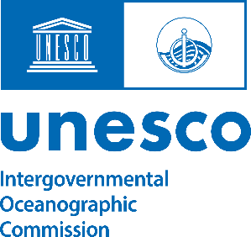

INTERGOVERMENTAL OCEANOGRAPHIC COMMISION OF UNESCO

Meeting of Scientific Committee for the
UN Ocean Decade Tsunami Programme
16-17 January 2025, UNESCO HQs. Paris, France
Meeting Room VII
Progress in Implementing the Ocean Decade Endorsed Actions Related to
Costal Resilience Challenge 6 and ODTP

Summary

This document has been prepared to facilitate discussions during the 5th meeting of the ODTP-SC, focusing on the progress of implementing Ocean Decade Endorsed Actions associated with Coastal Resilience Challenge 6 of relevance to the ODTP (Part of agenda 4)

Prepared by Denis Chang Seng, PhD
Programme Specialist
UNESCO-IOC
The information in this document was provided by the Ocean Decade action leads.

Contents
A: PROGRESS AND ACHIEVEMENTS ACROSS THE ODTP PILLARS. 2
1.0 PROJECTS 2
1.1 PROJECT: COASTWAVE-STRENGTHENING THE RESILIENCE OF COASTAL COMMUNITIES IN THE NORTHEAST ATLANTIC, MEDITERRANEAN REGION TO THE IMPACT OF TSUNAMIS AND OTHER SEA LEVEL-RELATED COASTAL HAZARDS, LINK 3
1.2 PROJECT: GLOBAL REAL-TIME EARLY ALARM FOR TSUNAMI (GREAT), LINK 5
1.3 PROJECT: SEA LEVEL STATION MONITORING FACILITY, LINK 7
1.4 TSUNAMI & CLIMATIC RISK REDUCTION AT PROTECTED AREAS IN COSTA RICA, LINK 8
1.5 INTEGRATING COASTAL HAZARD WARNING SYSTEMS FOR TAC, NORTH ATLANTIC OCEAN/ CARIBBEAN SEA), LINK 9
1.6 OPEN ACCESS TO GTS PROJECT (OPEN-GTS PROJECT), LINK 11
1.7 POTENTIAL COASTAL AREA OF INDONESIA MOUNTAIN ANAK KRAKATAU, BANTEN, SUNDA STRAINT, INDONESIA, LINK 12
2.0 CONTRIBUTIONS 15
2.1 CONTRIBUTION: DECADE COLLABORATIVE CENTRE FOR COASTAL RESILIENCE, LINK 15
2.2 US TSUNAMI CONTRIBUTIONS TO IOC TSUNAMI PT1, LINK 17
2.3 US TSUNAMI CONTRIBUTIONS TO IOC TSUNAMI PT2, LINK 21
2.4 NATIONAL INSTITUTE OF OCEANOGRAPHY AND FISHERIES (NIOF), LINK 23
3.0 GLOBAL (Not covered in this Information Document) 24

A: PROGRESS AND ACHIEVEMENTS ACROSS THE ODTP PILLARS.

nexus (led by the First Institute of Oceanography, Ministry of Natural Resources, 2

1.0 PROJECTS

1.1 PROJECT: COASTWAVE-STRENGTHENING THE RESILIENCE OF COASTAL COMMUNITIES IN THE NORTHEAST ATLANTIC, MEDITERRANEAN REGION TO THE IMPACT OF TSUNAMIS AND OTHER SEA LEVEL-RELATED COASTAL HAZARDS, LINK

Challenge: Coastal Resilience
Institution: IOC
Host: UN31. The Ocean Decade Tsunami Programme
Lead: Denis Chang Seng
Country: France
Start and End: 1 Sep- June 2024
Basin: NEAM

SUMMARY
The project seeks to build resilient communities through awareness and preparedness strategies that will protect life, livelihoods, and property from tsunamis in different regions. It will sustainably strengthen in-country community response capacity and preparedness and local alerting systems to act against coastal multi-hazards with its community-based actions in 7 countries of NEAM region. The project aims to do this by establishing guidelines to mitigate, prepare for and respond to tsunamis and working with the communities to help them meet the guidelines and ultimately become recognized as Tsunami ready by IOC.

KEY PROGRESS AND ACHIEVEMENTS ACROSS THE ODTP PILLARS.

Project was implemented in 7 countries. Cyprus, Egypt, Greece, Malta, Morocco, Spain, and Türkiye.
.
HAZARD RISK KNOWLEDGE:

Perception studies on sea level related hazards completed in 7 project countries

Tsunami inundation and evacuation maps have been successfully developed for all seven project countries.

Notably, the Probabilistic Tsunami Hazard Assessment (PTHA) methodology was employed, making Larnaca the first location in the North-Eastern Atlantic, Mediterranean, and connected seas (NEAM) region to use high-resolution simulations at a local scale for evacuation planning.

These evacuation maps have been validated and approved by local authorities, becoming an integral part of risk preparedness and response efforts.

MONITORING AND DETECTION:
The project supplied spare parts and maintained a network of low-cost sea level stations (IDSL) previously installed by the JRC in the NEAM region.
Additionally, it installed five new affordable sea level devices and five seismic devices.
WARNING AND DISSEMINATION:

The project has deployed 10 long-range sirens across five project countries.

PREPAREDNESS AND RESPONSE:

Standard Operating Procedures (SOPs) for tsunamis have been developed and incorporated into Emergency Operation Plans across all project countries.

The project has also established four UNESCO-IOC Tsunami Ready Recognized communities, with three additional countries in the final stages of recognition, pending the formation of their National Tsunami Ready Boards.

In 2023, tsunami exercises were conducted for the first time within the NEAMWave23 exercise at the local community level. These exercises involved nine communities, including some from non-project countries, across CoastWAVE project nations—Cyprus, Egypt, Greece, Malta, Spain, and Türkiye—to commemorate World Tsunami Awareness Day (WTAD) and raise tsunami awareness.

PARTNERSHIPS, COLLABORATIONS AND ENGAGEMENTS

The project successfully developed partnerships across 8 Government Organizations of which 5 were research institutions (4 public and1 private).

A positive development is the closer engagement and collaboration with Civil Protection Agencies which was considered a major weakness in NEAM. 30 workshops, and 2 major international Ocean Decade related side events attracted three city majors (e.g. Alexandria, Cannes) or their highest representative. It also facilitated 21 educational activities.

KNOWLEDGE PRODUCTS

- Seven National Project Reports were completed, with a final project report scheduled for release in November 2024.

- One peer-reviewed paper (project country).

- Four technical documents—including studies on risk perception and experiences with implementing the Tsunami Ready program—are currently being prepared or finalized.

- The project also shared over 90 social media posts, reaching the tsunami and ocean communities, policymakers, and the public.

Phase II of CoastWAVE Project (CoastWAVE 2.0)
Duration: July 2024-July 2026

Main thrust:

- Targeting additional TR communities in existing and new countries. Twinning of communities. Cities in TR
- Combining TR in exiting Resilient Cities initiative, Portugal
- Enhance detection and monitoring (sea level) rolling out affordable sea level devices based on the recommendations of the Evaluation Report
- Creating Dialogues on HILP in the context of MHEWS-co-design activities with other projects (INGV, DG ECHO project)
- Strengthen Partnership and collaboration
- Engage actively / direct participation of CPA -Broadening the stakeholders
- Stronger connection with OD and ODTP
- Strengthen ICG/NEAMTWS Community of Practice

1.2 PROJECT: GLOBAL REAL-TIME EARLY ALARM FOR TSUNAMI (GREAT), LINK
Challenge 6: Coastal Resilience
Challenge 7: Ocean Observations
Institution: Cardiff University
Host: UN31. The Ocean Decade Tsunami Programme
Lead: Usama Kadri
Country: United Kingdom of Great Britain and Northern Ireland (UK)
Start and End: 09/01/2013 -31/12/2030
Basin: North Atlantic Ocean, South Atlantic Ocean, North Pacific Ocean, South Pacific Ocean, Indian Ocean, Southern Ocean, Mediterranean Sea
SUMMARY:
Tsunami warning relies on seismic measurements causing false alarms. which result in financial loss due to evacuation and business shutdown. Moreover. people’s confidence reduces due to repeating false alarms leading to increased number of casualties in real tsunami. Reducing false alarms is an intergovernmental priority led by the UNESCO in accordance with SDG’s Goal 11 to make cities inclusive. safe. resilient and sustainable. Therefore. we developed a real-time early tsunami warning technology based on analyzing fast travelling sound signals that carry information on tsunamis. The technology will be deployed in two NTWCs for operational validation. then it will be deployed in more centres to provide tsunami emergency response. The technology is built on years of research in the field bridging cutting-edge deep-sea observations to inverse modelling. AI and numerical modelling. Such a technology is complimentary and inclusive with
the conventional tsunami detection techniques.

KEY PROGRESS AND ACHIEVEMENTS

Main milestones achieved:
- Completion of the operational software GREAT v1.0 ready for deployment in TWCs.
- Deployment of the software at IPMA for testing and evaluation (May 2024).
- Gained access to CTBTO real-time hydroacoustic data via IPMA.
- Software is running in real-time since June 2024 – requires manual operation.
- Improved analytical models – computation time in real-time stands at a few seconds to tens of seconds at most, for a global assessment.
- Introduced a new AI model that is capable to assess tsunami size globally from acoustic data.

Main objectives achieved:
- Conducted a comprehensive analysis of historical events to improve an AI model and assess earthquake properties in real-time.
- Implemented latest algorithms to enhance the software performance.
- Conducted rigorous testing/validation of the software for the real-time to evaluate effectiveness in reducing false alarms.
- Addressed and fixed operational bugs that arose during testing/validation.
- Met with ONC and currently evaluating adapting our system to their observations.
- Plugging a trigger from USGS for tsunamigenic earthquakes is also an achievement.
General:
- Submitted a paper on the technology: GREAT v1.0: Global Real-time Early Assessment of Tsunamis, https://gmd.copernicus.org/preprints/gmd-2024-139/gmd-2024-139.pdf
- Attended and presented at the South China Sea Tsunami Workshop (SCSTW-13), Zhuhai, China. https://gs.sysu.edu.cn/scstw13/about/index.htm
- Shortlisted for the Times Higher Education award in STEM category (1 of 6 in all of the UK): https://the-awards.co.uk/2024/en/page/shortlist
- Attended and presented at the 57th Session of the UNESCO-IOC Executive Council, Paris, France 2024.
- Presented at the National Oceanography Centre (NOC), SLOC meeting, Southampton, UK, 2024.
- Hired an animation company that will produce a 1-minute video disseminating the technology worldwide.

Funding:

- Funding is one of the main challenges the project encounters. The main source of funding is the Impact Acceleration Award (IAA) which allows hiring a software engineer and pays for some travelling and miscellaneous expenses. The funding ends in January 2025.
- I applied for the next IAA award grant, which if granted should allow a continued funding until September 2025 at most. A third follow programme might allow further continuation.
- Currently, attention is focused on securing a large grant to keep the project running.

Next Challenges
- Develop an automated operational version of the software – no need for manual operation
- Refine and optimise the software based on user feedback; test results to ensure seamless integration into existing warning systems.
- Integrate real-time data from additional devices provided by External Partners.
- Deploy the software at more TWCs.
- License the software to TWCs and Tsunami Service Providers (TSPs).
- Add new remote sensing data such as satellite data and GPS stations for surface waves and seismic data for acoustics to the system. It requires some training for the AI.

1.3 PROJECT: SEA LEVEL STATION MONITORING FACILITY, LINK
Challenge 6: Coastal Resilience
Challenge 7: Ocean Observations
Institution: Flanders Marine Institute (VLIZ)
Host: UN31. The Ocean Decade Tsunami Programme
Lead: Francisco Hernandez
Country: Belgium
Start and End: 01/01/2023 -31/12/2026
Basin: North Atlantic Ocean, South Atlantic Ocean, North Pacific Ocean, South Pacific Ocean, Indian Ocean, Arctic Ocean, Southern Ocean, Mediterranean Sea, Black Sea
SUMMARY:
The Sea Level Station Monitoring Facility (SLSMF) is an information and display service connecting 1034 real-time sea-level stations in a global and regional network (ioc-sealevelmonitoring.org) of 170 global data providers. The SLSMF provides a free online service for quick inspection of the raw data stream from individual sea level stations. This data is crucial for the provision of early warning of rapid onset sea-level hazards. Additionally. we will support capacity building opportunities to ensure equal warning capabilities and support resilience of coastal and maritime communities. The stations are part of IOC programmes i.e. (i) the Global Sea Level Observing System Core Network and (ii) the networks under the regional tsunami warning systems in the Indian Ocean (IOTWS). Northeast Atlantic & Mediterranean (NEAMTWS). Pacific (PTWS) and the Caribbean (CARIBE-EWS)
KEY PROGRESS AND ACHIEVEMENTS

- Steady increased of usage and stations in 2023 https://www.ioc-sealevelmonitoring.org/news.php?p=show&id=9286
- 80 new stations added in 2024
- New type (DART buoys) added (158 buoys, including historic data) https://www.ioc-sealevelmonitoring.org/news.php?p=show&id=9219
- Implemented the first version of an automated real-time QC procedure, to be able to provide research quality data (via the Geo-INQUIRE project)
- Beta version of the new API (including research quality data) launched in Oct 2024
- Attended GLOSS Steering Group meeting, St. Petersburg, Tampa, Florida, USA (30 Jan - 1 Feb 2024)
Next steps & challenges:
- Improved QC, validated by experts
- New API public
- Filling geographical gaps of stations in Africa
- Unified GLOSS data access portal

1.4 TSUNAMI & CLIMATIC RISK REDUCTION AT PROTECTED AREAS IN COSTA RICA, LINK
Challenge 5: Unlock ocean-based solutions to climate change
Challenge 6: Coastal Resilience
Challenge 8: Create a digital representation of the Ocean
Institution: National University Costa Rica (UNA) – Costa Rica
Host: SINAMOT Program
Lead: Silvia Chacon-Barrantes
Country: Costa Rica
Start and End: 01/01/2022 -31/12/2024
Basin: North Pacific Ocean, and Caribbean Sea
Summary:
The goal is to enhance tsunami and climatic preparedness on Wildlife Protected Areas (WPAs) through the interdisciplinary construction of tsunami inundation and evacuation maps; preparedness and response plans and action plans to decrease climatic and psychosocial vulnerability. The team at the National University is working closely with the National Emergency Commission on Risk Prevention and Emergency Response and the National System of Conservation Areas.
KEY PROGRESS AND ACHIEVEMENTS ACROSS THE ODTP PILLARS.

HAZARD RISK KNOWLEDGE: The project has made measurements to understand the tsunami hazard on the Pacific and Caribbean coasts. Specifically, hazard analyses were conducted in the communities of Cabuya, Isla del Caño and Isla del Coco, in the Pacific, and Tortuguero, in the Caribbean.
MONITORING AND DETECTION: The development of capacities for understanding tsunami risk and its detection in the communities that are part of the project has continued. Likewise, the tsunami risk information generated during this period has been disseminated in the participating communities and has been made accessible to the general population through the SINAMOT networks and the resources of the local and national emergency commissions. With respect to real-time risk communication, the SINAMOT team continues to work 24/7 for the attention and dissemination of alerts, in coordination with the national governing body.
WARNING AND DISSEMINATION: Evacuation and tsunami risk preparedness and response plans have continued to be developed in the communities that are part of the project. The planning includes the definition of means of receiving and disseminating the warning, defined by the community, in coordination with the available means with the collaboration of community organizations, local public institutions, and related to the verified means at the national level. Planning includes the consideration of disaster preparedness and response processes in the communities and achieving the scope of warning dissemination to the entire community, through different means: sound alarms, messages, radio, mobile application, and others, depending on the characteristics and resources of the community.
PREPAREDNESS AND RESPONSE: During the process of preparing the preparedness and response plans, training and capacity building activities were developed for community emergency committees to understand and educate them about the tsunami risk. Likewise, work continues with local governments to expand the scope of tsunami risk preparedness and response capacity in the coastal communities under their influence. Tsunami Ready status was achieved for one of the communities that are part of the project, and progress was made in achieving the requirements for two more of them.
PARTNERSHIPS, COLLABORATIONS AND ENGAGEMENTS: Negotiations were held with the national risk management governing body, and a commitment was made to renew the collaboration agreements for the next five years. The commitment is in the process of being signed by the authorities at this time. Collaboration with Costa Rica's National System of Conservation Areas and the local governments of the communities that are part of the project is also being maintained.
KNOWLEDGE PRODUCTS: In addition to the flood and evacuation maps, and the preparedness and response plans for the communities that are part of the project, presentations have been made at international conferences, a book chapter has been published, and another book chapter is pending publication.

1.5 INTEGRATING COASTAL HAZARD WARNING SYSTEMS FOR TAC, NORTH ATLANTIC OCEAN/ CARIBBEAN SEA), LINK
Challenge 6: Enhance multi-hazard early warning services for all geophysical, ecological, biological, weather, climate and anthropogenic related ocean and coastal hazards, and mainstream community preparedness and resilience.
Challenge 7: Ensure a sustainable ocean observing system across all ocean basins that delivers accessible, timely, and actionable data and information to all users.
Challenge 10: Ensure that the multiple values and services of the ocean for human wellbeing, culture, and sustainable development are widely understood, and identify and overcome barriers to behaviour change required for a step change in humanity’s relationship with the ocean.
Institution: IOCARIBE
Lead: Dr. Lorna Inniss, Head of IOCARIBE (l.inniss@unesco.org).
Country: N/A
Start and End: 2022-2030
Basin: Caribbean Sea, Tropical Western Atlantic and Eastern Pacific
Progress

The Integrating Coastal Hazards Warning System for the Tropical Americas and Caribbean was endorsed as an Ocean Decade Project in June 2022. The proposal was developed through a co-design process with the engagement of over 80 ocean and disaster risk reduction professionals. The focus of this project is the Co-Design, Co-Production and Co-Delivery of Integrated Multiple Coastal Hazard Early Warning System and Services for the Tropical Americas and Caribbean (TAC) considering Monitoring and Warning, Risk Knowledge, Warning Dissemination and Communication, and Response Capabilities, underpinned by capacity development. Linkages to regional and international efforts and national and local priorities would be maximized and strengthened. One of the ocean-related hazards and their impacts to be considered was Tsunami.

The project was placed under the Coast Predict Ocean Program. Two pilot sites have been identified by IOCARIBE for the Global Coast Experiment. Noting climate change vulnerabilities and coastal resilience challenges are not bounded by national borders and oceanographic characteristics and physical processes across state borders, one of the efforts will focus on developing an integrated regional system and capacity, supported by multiple nations. Such structures exist in the weather, tsunami and ocean communities, however it will be important to involve the range of partners that will carry this forward beyond the lifespan of the project and to consider the future governance of such a system. With CARICOOS (Caribbean Integrated Ocean Observing System) based in Puerto Rico the idea is to develop a decision support tool focusing on coastal inundation. This tool would consider all sources of coastal inundation, including tsunamis over a broad temporal range, including real time variabilities.

In December 2024 the IOCARIBE document Building a Roadmap for the implementation of the Ocean Decade in the Tropical Americas and Caribbean (TAC) Region was presented at the Latin American and Caribbean Open Science Forum in San Andres, Colombia. One of the main priorities is the implementation of Decision support tools for the resilience of coastal communities. These tools are to underpin adaptive governance and management systems and decision support tools for the assessment of vulnerability and risk to coastal communities and marine industries. With the establishment of the Roadmap it is expected that the iCHEWS project and related efforts will be facilitated and resourced.

Engaging key partners include IOCARIBE; National Research Institutes in the countries, National entities in charge of Disaster Risk Reduction in the countries, partners in the regions with existing capabilities and expertise who will benefit from capacity enhancement for longer term sustainability of activities, IOC-UNESCO Global Ocean Observing System - GOOS; CoastPredict UN Ocean Decade programme international core partners; Committee on Earth Observation Satellites-CEOS-COAST

1.6 OPEN ACCESS TO GTS PROJECT (OPEN-GTS PROJECT), LINK
Challenge 6: Coastal Resilience
Challenge 8: Digital Representation of the Ocean
Challenge 9: Capacity Development
Institution: NOAA Pacific Marine Environmental Lab
Host: Not yet defined
Lead: Kevin O'Brien
Country: USA
Start and End: 01/03/2022 -01/03/2030
Basin: North Atlantic Ocean, South Atlantic Ocean
SUMMARY:
The Open Access to GTS (Open-GTS) project aims to ease the exchange of marine data and increase the amount of data available for real-time forecasts. The ability of Open-GTS to accept multiple data format types is significant and promising. The application of the Open-GTS workflow will increase the exchange of marine data while retaining data quality and integrity, and its framework will increase transparency and encourage participation from other marine interests, including the commercial shipping industry.
KEY PROGRESS AND ACHIEVEMENTS
Uncrewed Surface Vehicle (USV) data exchange
- Data from 100+ missions to the GTS
- Most recently 12 USVs involved in 2024 hurricane season
- Developed WMO-approved BUFR template for USV data TM-3-15-011)

Science RoCS data exchange
- Support pilot with Science Research on Commercial Ships to exchange weather data on GTS
- Data from commercial ship Xaymaca going to GTS
Non-traditional ship data exchange
- Working with OceanSync to pilot exchange of weather data from commercial chips
- 1 vessel at this time
- Focus on Non-VOS ships only
Fishing Vessel Observing Network (FVON) data exchange
- New Global Ocean Observing System (GOOS) Observations Coordination Group (OCG) emerging network
- Place data from 45 fishing vessels onto the GTS
- Temperature profile data from fishing tows and traps

Challenges
The key challenge continues to be resourcing to scale up operations. We recently were able to scale our harvesting process to grow from supporting a dozen platforms to over 65 platforms that are, or recently have been, exchanging data with the GTS.
Next Steps
We will continue to exchange data on the GTS with the above partners while also remaining vigilant about potential new partnerships. In addition, we will be focusing on developing a pilot project to exchange data on WIS2.0 using Open-GTS processes. See Figure 1 below.
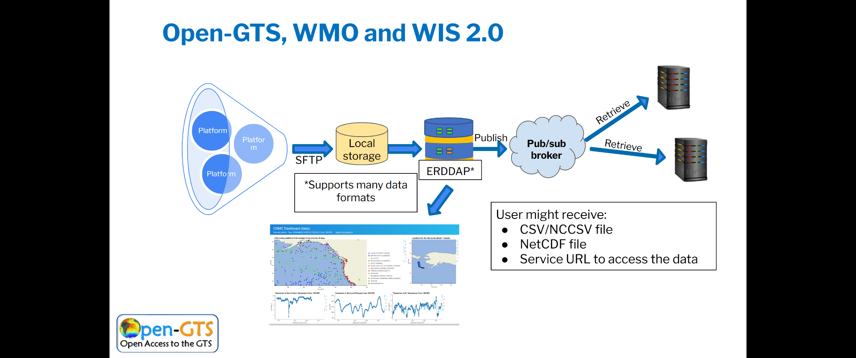
Figure 1. Schematic showing integration of Open-GTS services with WIS 2.0 exchange protocol

1.7 POTENTIAL COASTAL AREA OF INDONESIA MOUNTAIN ANAK KRAKATAU, BANTEN, SUNDA STRAINT, INDONESIA, LINK

Challenge: Challenge 6 Coastal Resilience
Institution: Agency of Meteorology, Climatology, and Geophysics
Host: Not known yet
Lead: Sugeng Pribadi
Country: Indonesia
Start and End: 01/03/2021-30/11/2021
Basin: Indian Ocean
SUMMARY

Historically, the Sunda Strait has experienced tsunamis due to the volcanic, eruption, earthquake tectonics and underwater landslides which have the potential for future recurrences. The most recent event was the Sunda Strait Tsunami, 22 December 2018. Although there have been several writings on Mount Anak Krakatau (GAK) but the results are not satisfactory. Therefore, this study proposes that tsunami modeling be carried out based on bathymetric survey data so that the source and impact of the tsunami due to the 2018 GAK can be reconstructed so as to help mitigation efforts in the Banten and Lampung areas in the future.

KEY PROGRESS AND ACHIEVEMENTS ACROSS THE ODTP PILLARS.

Table below summarizes key activities, progress and remarks.
N  o | Activities program | Held | Date | Remarks
1 | Survey of bathymetry and topography | No | No | Field survey activities were not carried out due to the lack of budget support from national institutions. The purpose of the survey is to obtain local field data that has not yet been created. As a result, whatever model results are carried out will not be close to reality.
2 | Tsunami evacuation maps | Yes | 29-09-2023 | The evacuation map was made independently covering the coastal area of western Banten with the scenario of the eruption of Mount Anak Krakatau generating a tsunami. The base map was created by integrating national bathymetric and topographic data to produce medium resolution (11 meters).  The maps produced are still on a small scale, namely sub-district. What is desired is a large scale in the form of sub-districts accompanied by details with signs, evacuation routes and refugee shelter locations.
3 | Awareness training | Yes | 14/05/2024  22/11/2024 | Awareness training activities have often been carried out previously in this area through the BMKG, BPBD, factory industry and tsunami preparedness communities. This activity requires very large costs. Therefore, we held a small technical training for BMKG employees regarding destructive tsunami surveys using GPS measuring equipment, laser height and sea level measuring equipment.  We collaborate with the STMKG campus to carry out continuous sea level monitoring measurements as study material and scientific analysis for the disciplines of oceanography, geodesy, instrumentation, geophysics and meteorology.
4 | Soft campaign | Yes |  | Campaigns to build citizen awareness can be carried out through scientific (proceeding) publications where we describe areas with a high level of danger with the maximum tsunami height in the Carita area, Labuan and the fastest arrival time in Sumur, Tanjung Lesung. For the Anyer and Cilegon areas, even though the tsunami was low and quite far away, you still have to be alert because they have many chemical, oil and gas industrial factories and vital sectors of the country. In the future, if field data more accurately supports high resolution maps, publication can be done through scientific journals with adequate funding support.
5 | Agent of change | No | No | At this stage, program activities have not yet involved key stakeholders to build awareness of tsunami disaster mitigation. This requires complete coordination and a continuous process so that agents of change will emerge from local government and preparedness communities.

Results
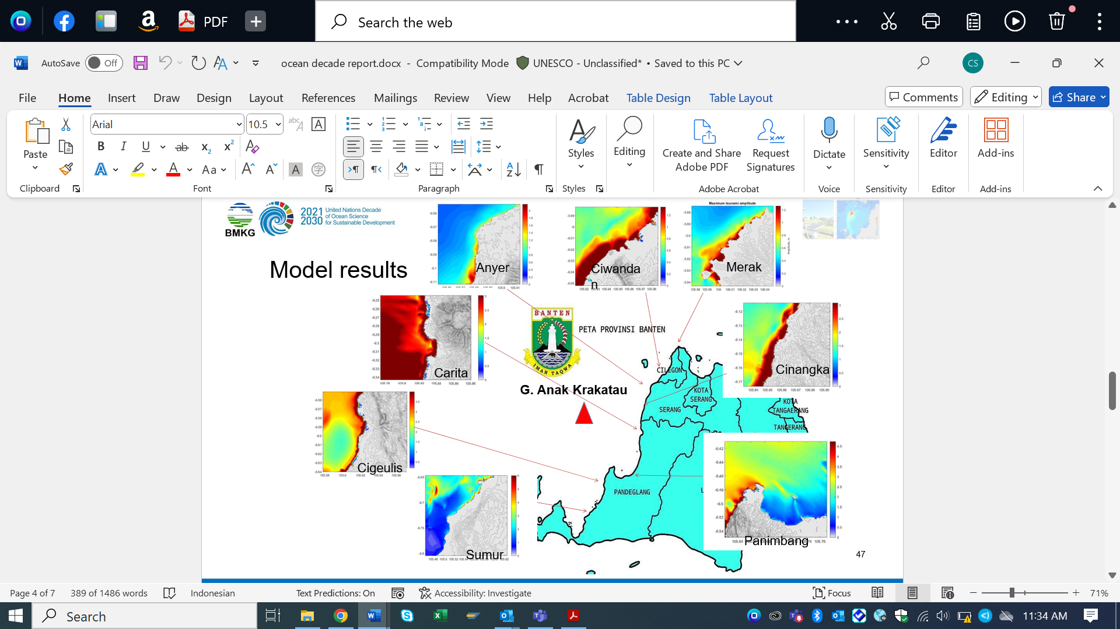

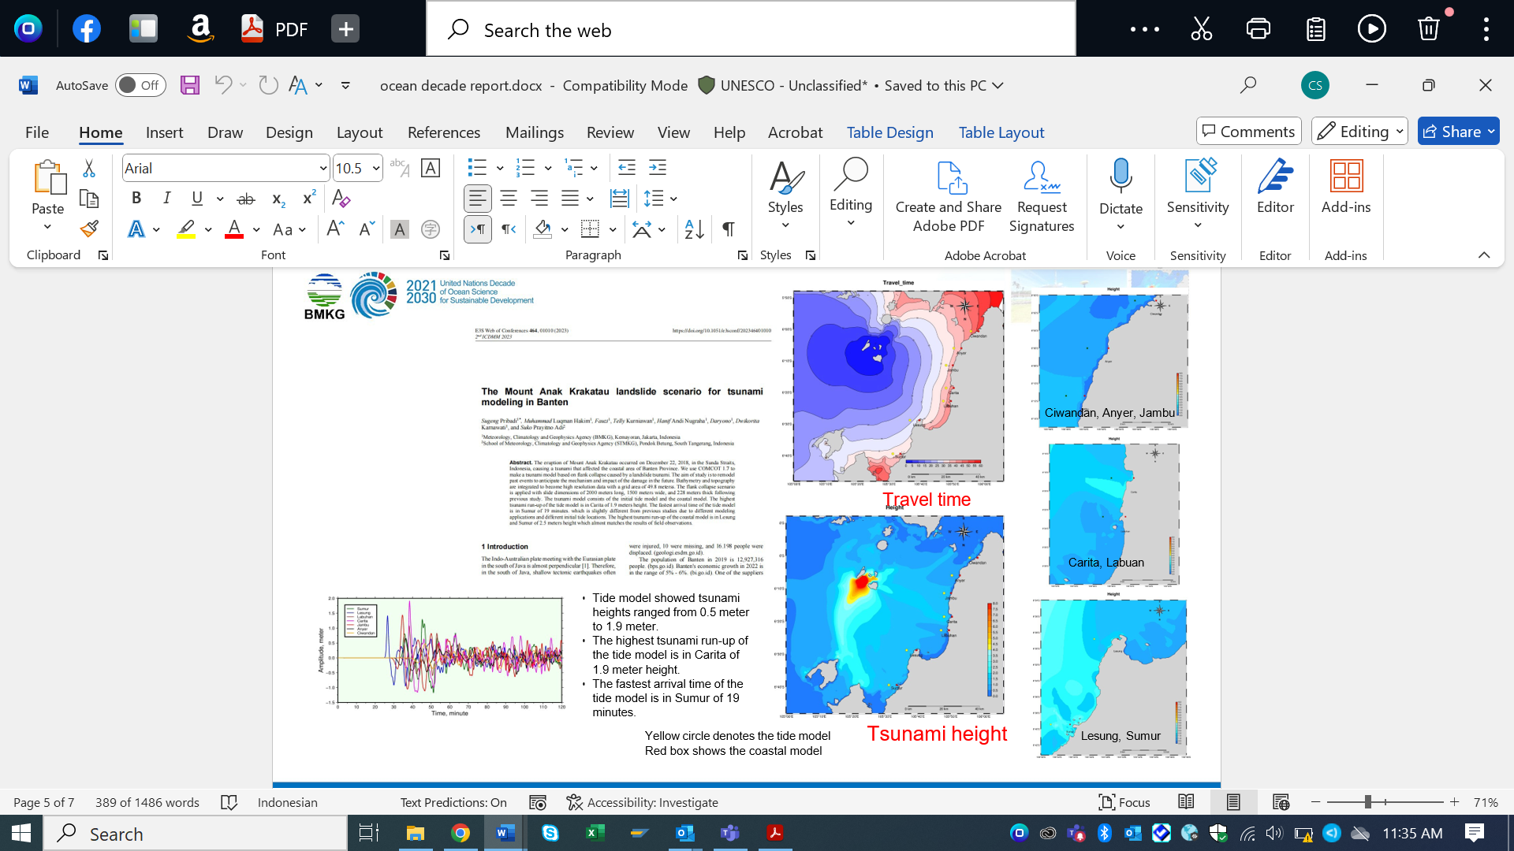
Technical training for BMKG employees regarding tsunami surveys using GPS measuring equipment, laser height and ses level measuring equipment.
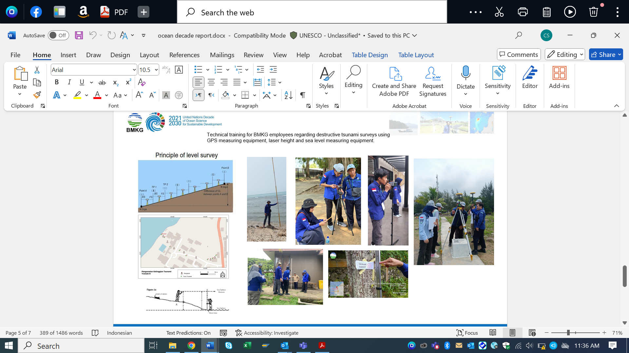

2.0 CONTRIBUTIONS

2.1 CONTRIBUTION: DECADE COLLABORATIVE CENTRE FOR COASTAL RESILIENCE, LINK
Contribution (1): Decade Collaborative Centre for Coastal Resilience
Challenge: Coastal Resilience
Institution: University of Bologna
Host: N/A
Lead:Nadia Pinardi
Country: N/A
Start and End: N/A
Basin: N/AN/A

SUMMARY

Coastal regions encompass the land bordering the ocean, intertidal areas, and much of the continental shelf. They are dynamic, densely populated and highly productive in both human economic and natural systems’ terms, yet are vulnerable to many factors including geohazards, pollution, climate change and sea level rise. Resilience can have many definitions, but broadly refers to capacity of the systems in question to recover following a disturbance, such as a tsunami. The international community of ocean resilience practitioners has worked for some years to raise awareness of, share lessons learned, and address the science challenges of the coastal resilience community. As part of the Ocean Decade, the Decade.

Short Summary DCC-CR 2023-2024 achievements
The main mission of the DCC-CR is to strengthen the connection between the new science and technology development in the Ocean Decade and coastal stakeholders, implementing innovative co-design practices for coastal resilience.In order to operationalize its mission, the DCC-CR has set out four strategic objectives:
• SI – Improve science information for all
• SE – Enhance stakeholder engagement
• EE – Promote equitable education
• EJ – Uphold environmental justice for coastal communities
In addition to the specific strategic objectives, several cross-cutting activities are envisaged both at the explicit request of the DCU and from the initial work of the DCC- CR.
- GLOBAL SOUTH COASTS
- COMMUNITY OF PRACTICE ON COASTAL ECOSYSTEM AND COMMUNITY RESILIENCE
- CITIES WITH THE OCEAN
- GLOBALCOAST EXPERIMENT

During the reporting period of 2023–2024, the Decade Collaborative Centre for Coastal Resilience (DCC-CR) successfully delivered on strategic objectives. Below is a detailed summary of the achievements for this period:
Improve scientific information for all (SI)
- DCC-CR has co-led the writing of the Vision 2030 white paper on coastal resilience: Pinardi, N. et al. (2024). Ocean Decade Vision 2030 White Papers – Challenge 6: Increase Community Resilience to Ocean Hazards. Paris, UNESCO-IOC. (The Ocean Decade Series, 51.6.). https://doi.org/10.25607/smm1-nq79

- DCC-CR has co-lead the writing of the First European Assessment Report on Sea Level Rise: https://oceandecade.org/publications/first-european-assessment-report-on-sea-level-rise/

Stakeholder Engagement (SE):
2023 - 2 workshops on Coastal resilience
2023 - co-designed with CoastPredict the mapping of stakeholders for GlobalCoast
2024 - Ocean Sciences Town Hall meeting “A Dialogue on Coastal Cities and Coastal Community Resilience”
2024 - Events at the Ocean Decade Conference in Barcelona
- Satellite event “Coastal Futures: Charting Priorities for Resilience”
- Challenge 6 Parallel Session 3: Science and Solutions for a Safe and Predicted Ocean
- Participation DCC-IOC Satellite Event: Bridging Billions to Barcelona
2024 - Ecomondo Exhibition 4-Days workshops: “The power of science for coastal communities: better informed, better prepared”, Rimini
2024 - DCC-CR Affiliated Actions Networking Meeting
Equitable Education (EE):
2023 and 2024 - webinar series (7 webinars) in collaboration with CMCC

2024 - Developed and implemented the Coastal Resilience School and its first course (Jan 27-April 4, 2025) titled “Sustainable Coastal Growth and Resilience (Co-Growth)” on the OTGA platform.

2024 - Developed the concept of the first high school Training Course with Rimini Blue Lab “Clima e Oceanografia”

2024 - Contributed to the CoastPredict training course “Coastal modeling for protection and conservation of natural resources in the Philippines” (COMPASS-Philipppines) on ocean modeling and AI for coastal physical and biogeochemical characterisation and increased resilience in the Philippine
Environmental Justice (EJ):
2024 - Completed a literature review on environmental justice, laying the groundwork for actionable insights and informed decision-making.
Cross-Cutting Activities:
- 2023 and 2024 Organised 10 Community of Practice
- Actively engaged in the Cities with the Ocean working group
- Shaping of the Memorandum of Understanding for the GlobalCoast Network
- Activily engaged in Ocean Rise and Resilience Coalition
- Activily enganed in Sustainable Ocean Planning Initiative (SOP)

2.2 US TSUNAMI CONTRIBUTIONS TO IOC TSUNAMI PT1, LINK

Challenge 5: Unlock ocean-based solutions to climate change
Challenge 6: Coastal Resilience
Challenge 7: Expand the Global Ocean Observing System
Institution: National Oceanic and Atmospheric Administration (NOAA)
Host: Not defined
Lead: Mike Angove
Country: USA
Start and End: 23/03/2021 -31/12/2030
Basin: Arctic Ocean, Indian Ocean, Mediterranean Sea, North Atlantic Ocean, North Pacific Ocean, South Atlantic Ocean, South Pacific Ocean, Southern Ocean
PROJECT SUMMARY:
NOAA commits to supporting the UN Decade of Ocean Science’s goal of reducing the time required to detect, measure, and characterize tsunamis. NOAA will: (1) Assist in drafting the UN Decade IOC Tsunami Programme’s 10-year Research, Development and Implementation Plan; (2) Share advanced tsunami source detection and measurement capabilities, including seismic and GNSS applications; (3) Promote collaboration with industry and research institutions to access critical, real-time observational data (e.g., SMART); (4) Continue to develop and deploy advanced tsunameters (e.g., DART system); and (5) support capacity building of Small Island and Least Developed States to use new data streams in their decision-making and for data interpretation and inversion to correctly characterize sources.

KEY PROGRESS AND ACHIEVEMENTS ACROSS THE ODTP PILLARS.
ODTP Pillars:
- HAZARD RISK KNOWLEDGE
  - This is covered in the Part II of this endorsed action.
- MONITORING AND DETECTION
NOAA Updates for advanced tsunami source detection:
  - Successful testing of the USGS Geodetic First Approximation of Size and Time (GFAST) Global Navigation Satellite System (GNSS) algorithm.
    - The tsunami research team at the NOAA Office of Atmospheric Research (OAR) Pacific Marine Environmental Laboratory (PMEL) performed this test for rapid Peak Ground Displayment and moment-tensor source characterization
    - in use in the USGS’s ShakeAlert earthquake early warning system.
  - The GFAST system was connected to the operational tsunami inundation forecast system and deployed at the NOAA Tsunami Warning Centers in Honolulu, Hawaii and Palmer, Alaska, and is currently undergoing operational review.
NOAA Updates for DART upgrades summarized from this article:
- In May 2024, the U.S. Department of Commerce and NOAA announced $30 million to modernize and replace the equipment on the Deep-ocean Assessment and Reporting of Tsunamis (DART) Ocean Observing System as part of President Biden’s Investing in America agenda. The contract, funded by the Bipartisan Infrastructure Law (BIL), was awarded to the Science Applications International Corporation (SAIC) to develop equipment to support improved tsunami detection and warning.
- This investment will modernize NOAA’s DART network to improve real-time tsunami forecasts and alerts in order to save lives and keep coastal communities safe.
- The DART system was developed to detect tsunamis and forecast their impact along vulnerable coastlines. NOAA owns and operates an array of 39 DART buoys in the Pacific and Atlantic ocean basins, including the Gulf of Mexico and Caribbean basins.
- SAIC will develop more modern equipment to replace the existing equipment on the DART buoys, which is 20 years old. The new systems will make the data used to detect tsunamis more available and reliable, and improve the forecast of tsunami intensity and arrival times, as well as the predictions for how tsunami wave inundation would affect coastal communities.
- Replacement of the equipment is expected to begin in 2025 and conclude in 2028.
- The project is managed by NOAA’s National Data Buoy Center — a division of NOAA’s National Weather Service.

SMART Cable Initiative
The following is a listing of the known NOAA/NWS supporters of SMART cable research or exploration through the University of Hawaii (Bruce Howe and Ceci Cruz).
- Kevin O'Brien, GOOS Vice-Chair for Data participates actively in the Data Management Committee as vice-chair.
- Chris Moore, OAR PMEL’s NOAA Center for Tsunami Research (NCTR) Director, provided support for the effort in an IOC workshop in Vanuatu (2024), the Pacific Tsunami Warning System (PTWS) Joint WG2-TT-ISN and TT-FOO meeting, DBCP ITP, as well as being part of a panel in the AGU Townhall: “Observing the Ocean and Earth: Present and Future.”
- Christine Zinkann, coordination with Univ. of Hawaii as an Emerging Network of the Global Ocean Observing System Observations (GOOS) Coordination Group (OceanOPS).
- Stuart Weinstein, PTWC Science and Operations Officer (SOO) supports connections to tsunami models.
- ITIC funded to provide tsunami warning center capacity building/training to Vanuatu Meteorological and Geo-Hazards Dept(VMGD) at part of Vanuatu-New Caledonia SMART Cable Project
- Laura Kong, ITIC Director, supports connecting us with the right people in South America and Pacific Islands as well as presenting SMART Cables in some of her talks. She is co-chair of the JTF Science and Society Committee.
- NOAA has described a possible future application in the GoM/Caribe/NAtlantic, monitoring for storms/hurricanes.
NOAA update on landslide generated tsunami monitoring summarized from this website:
- NOAA”s National Tsunami Warning Center (NTWC) operates a local sea level monitoring system designed to detect a tsunami generated by a failure of the Barry Arm landslide, in Alaska. These data are a crucial piece in the chain of monitoring and warning. For now, the sea level monitoring network at Barry Arm is still experimental in nature, and several tests and robustness requirements still need to be passed prior to the instrumentation network being considered an operational emergency warning system.
- While this instrumentation is only for one location with the potential to generate a landslide generated tsunami the technology and best practices learned from this can apply to other locations with an identified landslide generated tsunami hazard.
- WARNING AND DISSEMINATION

  - NOAA/NWS continues to work on the technical changes necessary to operationally align the two NWS Tsunami Warning Centers (TWC) (one in Palmer, AK and one in Honolulu, HI). In 2024, the TWCs installed an operating platform that has technical enterprise support, the AWIPS Tsunami Operations Messaging System (ATOMS). This allows both TWCs to issue products and services with similar text-based messaging formats and perform these actions in a redundant manner, backing up one another, if needed. The technical implementation is anticipated to be completed in 2026.
  - One of the three NTHMP subcommittees is the “Warning Coordination Subcommittee" (WCS) with the goal of helping improve U.S. tsunami warning system effectiveness. The WCS provides NTHMP partners a means to exchange experiences and discuss improvements related to operational product dissemination.
- PREPAREDNESS AND RESPONSE
  - With a focus on the Pacific Island Countries, ITIC is supporting the strengthening the capacities of Tsunami Warning Centers to analyze, detect and forecast tsunamis. The Pacific (PTWS) has approved National Tsunami Warning Center Minimum Staff Competency Framework, and ITIC has taken the lead to develop tsunami warning center staff core competency (TWC-MSC) training as a Pilot for Pacific SIDS. It will be under the Ocean Teachers Global Academy - to date, Australia, Chile, New Zealand, and USA have contributed national materials. The training initiative is being reported to the TOWS WG TT with an interest in global harmonization.
  - Other preparedness and response contributions are covered in the Part II of this endorsed action.
- PARTNERSHIPS, COLLABORATIONS AND ENGAGEMENTS
  - Funding provided by the United States Agency for International Development (USAID) for TWC-MSC in the Pacific
- KNOWLEDGE PRODUCTS
  - This is covered in the Part II of this endorsed action.
NB:- Corina Allen has now replaced Mike Angove as the Tsunami Program Manager for NOAA National Weather Service and is now the lead for Pt.1, Science and Technology. Her email address is corina.allen@noaa.gov for your records.

2.3 US TSUNAMI CONTRIBUTIONS TO IOC TSUNAMI PT2, LINK
Challenge 5: Unlock ocean-based solutions to climate change
Challenge 6: Coastal Resilience
Institution: National Oceanic and Atmospheric Administration (NOAA)
Host: Not defined
Lead: Laura Kong
Country: USA
Start and End: 01/03/2021 -31/12/2030
Basin: Indian Ocean, North Atlantic Ocean, North Pacific Ocean, South Atlantic Ocean, South Pacific Ocean
SUMMARY:
NOAA commits to supporting the UN Ocean Decade goal to make 100% of communities at risk from tsunamis prepared and resilient by 2030. NOAA will: (1) Participate in the Tsunami Ready (TR) Coalition (2) Provide capacity building and serve as OceanTeacher. To do this NOAA will: 1) Participate in the Tsunami Ready (TR) Coalition; (2) Provide capacity building and serve as Ocean Teacher Global Academy (OTGA) Specialized Training Center for tsunamis; (3) Facilitate Tsunami Ready recognition as an IOC Tsunami Information Center (ITIC) and provide administrative support to the TR Programme; (4) Facilitate implementation of TR indicators in support of NWS Weather Ready Nations with support from USAID; (5) Serve on National and Regional TR recognition boards.
KEY PROGRESS AND ACHIEVEMENTS ACROSS THE ODTP PILLARS.
ODTP Pillars:
- HAZARD RISK KNOWLEDGE
  - National Tsunami Hazard Assessments were completed and delivered for Caribbean SIDS (Antigua and Barbuda, Barbados, Cayman Islands, Dominica and Saint Lucia)
  - Tsunami Inundation Studies were conducted in the Pacific (Fiji - Coral Coast; Micronesia - Weno Island, Chuuk; Pohnpei, Kosrae, Yap; Palau; Republic of Marshall Islands - Majuro).
  - Additional assessments to be conducted in Honduras, Saint Lucia in the Caribbean and Kiribati - Tarawa, Samoa (Upolu, Savaii), Solomon Islands (parts), and Vanuatu (parts) in the Pacific.
  - Additional assessments proposed for some ASEAN member states
  - NOAA, USGS and US states and territories have been collaborating to develop national tsunami hazard data to deliver to FEMA for use in their National Risk Index which combines various natural hazard data sets with social vulnerability to map risk at a national level. This process could be considered by other member states.

- MONITORING AND DETECTION
  - this is not relevant to this contribution

- WARNING AND DISSEMINATION
  - Training, technical assistance and materials and supplies have been provided to Caribbean and Pacific SIDS to improve capabilities for tsunami warning and dissemination. Proposed for ASEAN member states

- PREPAREDNESS AND RESPONSE
  - National and Regional Training and Technical Assistance is being provided in the Caribbean and Pacific Islands for the development of Tsunami Evacuation maps.
  - In support of Tsunami Ready recognitions provided training, technical guidance and materials and supplies for evacuation mapping, signage, education and outreach, exercises and response planning in the Caribbean (Christ Church West, Barbados; Portsmouth, Dominica; Laborie, Saint Lucia; Saint George, Saint Vincent and the Grenadines) and Pacific (Fiji (Sila, Naevuevu), Micronesia - Weno Island, Chuuk; Pohnpei, Kosrae, Yap; Palau; Republic of Marshall Islands - Majuro). Proposed for some ASEAN Member States
  - Supporting Preparedness and Response activities as part of Tsunami Ready efforts in the Caribbean (Barbuda, Antigua and Barbuda; Belize City, Belize; Northern and Northeastern Districts, Dominica; Omoa and Tornaba/Tela, Honduras; Choisel, Saint Lucia) and Pacific (Fiji (Sila, Naevuevu), Micronesia - Weno Island, Chuuk; Pohnpei, Kosrae, Yap; Palau; Republic of Marshall Islands - Majuro). Proposed for some ASEAN Member States
  - Development and global distribution of Tsunami Rules flyer in Braille

- PARTNERSHIPS, COLLABORATIONS AND ENGAGEMENTS
  - Participate and chair the Tsunami Ready Coalition
  - Funding provided by the United States Agency for International Development (USAID) for Tsunami Ready implementation in the Pacific and Caribbean
  - Organization and Support for Tsunami Ready Regional Workshops or Summitts
    - ASEAN
    - Caribbean

- KNOWLEDGE PRODUCTS
  - Published and Printed Poster on Historical Tsunami Effects from the 2004 Indian Ocean Tsunami (ITIC with NOAA/NCEI)
  - OTGA Tsunami Awareness course developed by ITIC provides a basic understanding of the tsunami phenomenon, tsunami hazards and risks, tsunami warning systems, and tsunami preparedness.
  - OTGA Tsunami Ready course developed by ITIC with the Indian Ocean Tsunami Information Center provides an understanding of the UNESCO-IOC Tsunami Ready Programme, the indicators and implementation process.

2.4 NATIONAL INSTITUTE OF OCEANOGRAPHY AND FISHERIES (NIOF), LINK
Challenge 1: Understand and beat marine pollution
Challenge 3: Sustainably feed the global population
Challenge 6: Coastal Resilience
Institution: National Institute of Oceanography and Fisheries (NIOF)
Host: Not defined
Lead: Amr Hamouda
Country: Egypt
Start and End: N/A
Basin: Mediterranean and Red Sea
SUMMARY:
The NIOF will provide support in relation to capacity-building, marine scientific research, and international cooperation for the development of marine technology, as well as the implementation of the strategic directions identified in the framework of the Ocean Decade.
KEY PROGRESS AND ACHIEVEMENTS
No information provided yet.

3.0 GLOBAL (Not covered in this Information Document)

- Promote Seabed 2030 and Ocean Mapping(Project)
- SMART Subsea Cables (Project)
- The Nippon Foundation-GEBCO Seabed 2030 (Programme)

