

Application

to join the International Oceanographic Data and Information Exchange (IODE) of the Intergovernmental Oceanographic Commission of UNESCO (IOC) as an

IODE Associate Data Unit (ADU)
revised version 17/9/2024
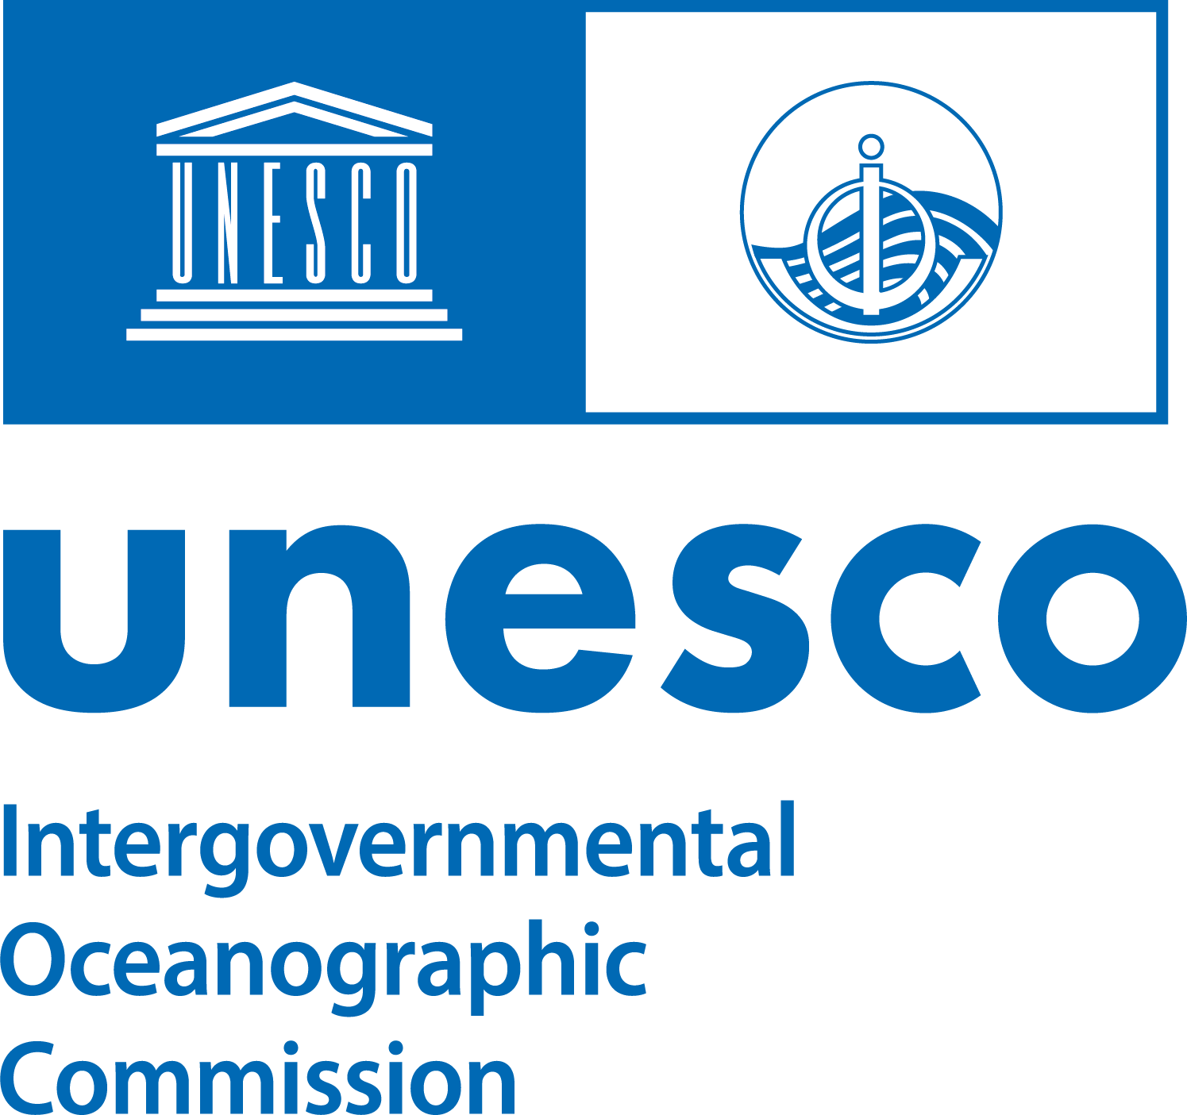
Through this document your project, programme, institution or organization expresses its desire to join the International Oceanographic Data and Information Exchange (IODE) programme of the Intergovernmental Oceanographic Commission as an IODE Associate Data Unit (ADU) as described below.

Procedure: Applications for IODE ADU membership shall be reviewed by the IODE Management Group (see https://oceanexpert.org/group/371) in consultation with (and in the case of national projects, programmes, institutions or organization, subject to approval by) the relevant NODC (see https://oceanexpert.org/group/488) (if existing), or with the IODE Steering Group for OBIS (for biogeographic information) (see https://obis.org/) or other relevant recognized international programme.

Subsequent to the revision applicants will be contacted in writing (by email) through the contact email of the person signing the application. Applications should be submitted by email and sent to Peter Pissierssens, IODE Programme Coordinator, p.pissierssens@unesco.org. If the application was approved, then information on the new ADU will be posted on the IODE web site.

PREAMBLE

The objectives of the IODE Programme are:

- To facilitate and promote the discovery, exchange of, and access to, marine data and information including metadata, products and information in real-time, near real time and delayed mode, through the use of international standards, and in compliance with the IOC Oceanographic Data Exchange Policy for the ocean research and observation community and other stakeholders;
- To encourage the long term archival, preservation, documentation, management and services of all marine data, data products, and information;
- To develop or use existing best practices for the discovery, management, exchange of, and access to marine data and information, including international standards, quality control and appropriate information technology;
- To assist Member States to acquire the necessary capacity to manage marine research and observation data and information and become partners in the IODE network;
- To support international scientific and operational marine programmes, including the Framework for Ocean Observing for the benefit of a wide range of users.

TERMS OF REFERENCE OF THE IODE ADU

- The IODE Associate Data Unit is intended to bring in the wider ocean research and observation communities as key stakeholders of the IODE network, taking into account the growth of ocean research and observation programmes and projects, and the ability of these projects to establish data systems. It is important for these communities to share, provide access to and preserve all ocean research and observation data.

- IODE Associate Data Units shall be national projects, programmes, institutions or organizations (other than NODCs), or regional or international projects, programmes, institutions or organizations that carry out data management functions.

- As an IODE Associate Data Unit (ADU) the [project, programme, institution or organization](*) shall
  - Contribute to the IODE Programme by sharing data and information on their data collection (metadata catalogue). They will do so through their National Oceanographic Data Centre(s) (NODC)(s) - in the case of national projects, programmes, institutions or organizations-, or through another IODE data facility -in the case of regional or international projects, programmes, institutions or organizations- or, in the case of biogeographic data, through iOBIS.
  - Make available data management documentation (standards, practices, guides,…) used by the ADU.

- By joining IODE as an ADU, the [project, programme, institution or organization](*) will receive the following benefits:
  - Information on, and contribute to, IODE standards and best practices related to ocean data management,
  - Participation in ocean data and information management training, organized within the framework of the IODE OceanTeacher programme
  - Participate, as observers, in Sessions of the IODE Committee,
  - Assistance, upon request, from IODE, on matters related to ocean data management,
  - Participate in IODE workshops and projects,
  - Share expertise with other ADUs and NODCs

- ADUs will not replace NODCs (centralized or distributed) but should contribute to the objectives of NODCs by (i) improving the completeness of data coverage of NODCs; (ii) ensuring the long-term archival and preservation of ADU data by NODCs; and (iii) increasing awareness amongst the ocean research and observation community of the importance of professional data management through IODE NODCs.

- As an IODE ADU the [project, programme, institution or organization](*) shall agree to apply the IOC Oceanographic Data Exchange Policy (see https://iode.org/resources/ioc-data-policy-and-terms-of-use-2023/) for the data shared with IODE.

- As an IODE ADU the [project, programme, institution or organization](*) is encouraged to contribute data to the IODE Ocean Data and Information System (ODIS)

- As an IODE ADU, the [project, programme, institution or organization] (*) is strongly encouraged to implement a Quality Management System (QMS) as described in the IODE Quality Management Framework (IODE-QMF) (see https://iode.org/programme-activities/) . The IODE QMF provides guidance for the successful delivery of quality oceanographic and related data, products and services that will meet the requirements of a broad and varied community of users. If appropriate, the [project, programme, institution or organization](*) can apply to become an Accredited IODE ADU.

- As an IODE ADU, the [project, programme, institution or organization] is strongly encouraged to follow up with data providers to submit their data and metadata after any allowed embargo period, and to make arrangements for the management, storage and long-term preservation/curation (especially in the case of projects) of data in close collaboration with their IODE National Oceanographic Data Centre (NODC) or, if such facility does not exist, with the IODE global network of NODCs.
INFORMATION ON THE APPLICANT PROJECT/PROGRAMME/INSTITUTION/ORGANIZATION

Note: you can provide additional information on any of the below question in annexes

Details on the Description of [project, programme, institution or organization](*):

- name and contact information of the ADU contact point(s): (note that this name can be different from the person signing the application. The ADU contact point will be contacted for all practical, technical and scientific communications)

- name and contact information of the head of the applicant entity: (Director of institution, project coordinator, etc. This may be the name of the person signing the application)

- description of the national, regional or international project, programme, institution or organization:

- brief description of data services/products provided by the entity:

- for projects: expected lifespan of the project and indication of plan for the archival/preservation of the data, data management plan:

- brief description of the expertise, including training, the ADU could contribute to the IODE programme or would like to receive from IODE:

- data policy (if identified) of the applicant entity (this may be a URL of a relevant web page):

- information on the existing relationship with (a) NODC(s):

SIGNED
(on behalf of [project, programme, institution or organization](*):

Date:

Name:

Position:

Email address to be used for further communication on this application:

Signature:

(*) replace the text highlighted in yellow by the name of your project, programme, institution or organization

