**Criteria for Accepting Methodological Documents submitted to the OBPS Repository**

**Version: 1.0: 2024-09-03**

OBPS SG Sub-Group: Frank Muller-Karger; Cristian Munoz Mas, Jay Pearlman, Ana Carolina Peralta, Pauline Simpson, Rebecca Zitoun

___________________________________________________________________________

*A best practice is a methodology that has repeatedly produced superior results relative to other methodologies with the same objective: to be fully elevated to a best practice, a promising method will have been adopted and employed by multiple organisations.*

The Ocean Best Practices System (OBPS) Repository accepts ocean/marine research and applications methodological documents at various levels of development, adoption and maturity; not all are ‘best’ practices’ as defined above. This permits new practices to be published, tested, and used. It also enables practices tailored for a regional application to be accessible to interested users. The repository is a global open access resource, serving the needs of a broad range of ocean stakeholders.

To be effective, the repository’s search function must allow people to find methods that address their needs. People should be able to find practices at all stages of maturity as defined in the maturity matrix published in *Fron*tiers *in Marine Science* [Mantovani C, et al (2024), doi: <https://doi.org/10.3389/fmars.2024.1415374> ].An attribute of a mature (i.e., “best”) practice hosted in a recognised open access repository is that it must be endorsed by an expert panel. The OBPS repository can be searched for such endorsed and other practices at different levels of maturity.

The decision on inclusion in the repository is not on the maturity of a practice, but whether the practice falls into the topical areas (i.e., subject scope) of the repository and whether the practice document is a method description. If these attributes are not reflected in the submitted document, then the document should not be in the repository and will be returned to the submitter with this feedback.

The objective here is to have a consistent process for decisions on which documents to include in the OBPS and to reduce subjective evaluation of candidate practices for inclusion in OBPS. The decision criteria identified in this document do not relate to the quality of the practices or its maturity level. The decision criteria here are solely about the fitness for inclusion in the repository as discussed above. Thus the review is not a technical or scientific peer review as may be done in a journal or by an expert panel.

Deposits into the OBPS Repository are submitted by users registered in the OBPS, either as an individual or as a representative of an organisation, network, project or group, or as a document recommendation which is supported by the OBPS Repository Manager.

Proposed practices can be published as, for example, reports, documents or journal articles and can be described as guidelines, manuals, standard operating practices etc. officially issued and acknowledged by a Professional or Community organisation. Relevant laboratory and standard operating procedures (SOP) are also included. Commercial manuals may be included in the repository (provided it complies with criteria listed here) as long as the Repository Disclaimer is included in the metadata.[1]

When submitted and prior to inclusion in the repository, each document must have its content evaluated through the process described in this document for suitability against criteria

established below.

The following are the criteria:

1. **Is the document subject scope consistent with repository content guidelines?**

*Content Guidelines:*  The OBPS Repository content is a range of practices and standards covering ocean/marine **research and applications** topics, applicable in one or more elements of the ocean “value chain”. Here the “value chain” includes observations to operations through to applications, and also in cross-discipline topics, e.g., data management.

[*NOT EXHAUSTIVE: To help the reviewer on appropriateness of the method to be in the repository, examples of ocean/marine* ***research*** *related disciplines would be biology, biodiversity, ecology, chemistry/geochemistry, computing/data management, environment/pollution, geology/geophysics, meteorology/atmosphere, physical oceanography, research support, resources, sea ice cover, fisheries/aquaculture, wave and wind energy, ocean technology/engineering, ocean policy and governance, ocean literacy and science communication, ocean economics and accounting, administration and social sciences such as ethics, interdisciplinary topics and methods which impact knowledge of the oceans and that the ocean may impact, and other topics relevant to marine, coastal, or other relevant research, technology, and applications.]*

The global scope for the repository extends from the deep waters of the open ocean, the air-sea interface and atmospheric processes relevant to air-sea interactions, to coastal, estuarine, brackish, and freshwater environments.

**DECISION: is the document topic consistent with the OBPS content guidelines?**

**If NO, then the submitter is informed the deposit topic does not comply with**

**OBPS Topic scope and the record is returned to the submitters repository**

**Workspace with the reasons**

**If YES, then the review evaluation continues**

1. **Is the document being submitted as a methodological document ?**

Read and review the full text of the submitted method document - look for ‘trigger’ terms like method; practice; protocol; guidelines; manual; cookbook; standards; standard operating procedure; recommendations; solutions and also consider such characteristics as these below as contributing factors which could aid a review decision:

**Document type:** journal, report, working document, etc.

**Publisher provenance:**  journal title topic or marine research organisation

**Author provenance:** organisation, specialty

**Title:**  not all methods papers have the words “methods”, “practices”, “guidelines”, etc. in the title. Conversely, just because “guideline”, “method”, or “manual” is in the title does not make it a methodology for inclusion in the OBPS.

**Abstract:**  often where the authors present their main points.

Then complete the checklist below.

**Checklist (categories and elements of a category)**

To be acceptable as a practice to be included in the OBPS Repository, at least **five of the seven elements below across the three categories** must be checked and include at least one element from each category.

1. **Purpose and Objective**

* Does the document outline a specific practice or method?
* Is a particular objective for the practice defined?
* Does it clearly define what it covers and any limitations in obtaining the objective?
* Is there evidence by the creators or document authors that there is potential for use by others?

1. **Structured Steps or Instructions**

* Are there clear steps provided, or a well-defined and described process?
* Does the document include explanations for the process steps in the method?

1. **Tools and Techniques**

* Does the document specify any tools, equipment, instruments, reagents, documents (such as guides, keys, or references documenting a scientific, engineering or technical basis), or software required?

**DECISION: is the document methodological content consistent with the OBPS methodological guidelines?**

**If NO, then submitter is informed the deposit does not comply with OBPS**

**methodological scope and the record is returned to the submitters**

**repository workspace with the reasons**

**If YES, then Document submission proceeds**

| **The review process will be conducted with support from the Repository Manager who will curate the accepted record and the metadata and the document will pass into the live repository and the submitter will be informed.** |
| --- |

End of document

**___________________________________________________________________________**

**Decision Tree: New Submissions**

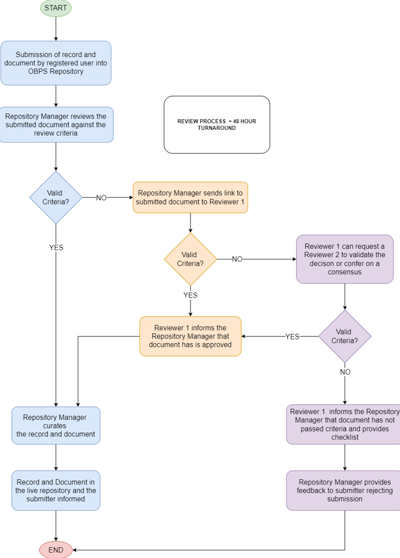

**Decision Tree - Retrospective**

**To be added**

1. Mention of a commercial company or product within this repository content does not constitute an endorsement by UNESCO/IOC-IODE. Use of information from this repository for publicity or advertising purposes concerning proprietary products or the tests of such products is not authorised.