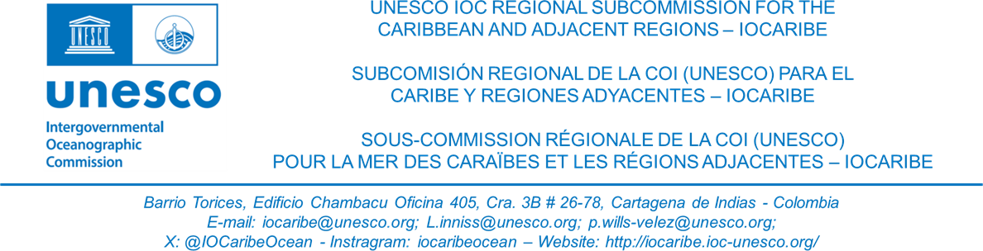

**IOCARIBE-GOOS Working Group**

**Inaugural Meeting**

**(Draft) AGENDA**

1. Welcome and introductions
2. Presentation- Global Ocean Observing System
3. Decisions of IOCARIBE Member States (IOCARIBE-GOOS Program Coordinator)
4. Existing regional initiatives
   1. CARICOOS
   2. ICG CARIBE-EWS
   3. CIMH
   4. Tropical Cyclone Exemplar
   5. Others
5. Discussion: Draft Terms of Reference
6. Work Plan
7. Any other business

**Meeting Agenda: November 8th IOCARIBE-GOOS Working Group**

**Start with a Global Presentation**

1. **Introduction:** Lorna (15 Minutes)

Opening, IOCARIBE perspective, why we’re here in the context of IOCARIBE Goals, and introduction of speakers

1. **Presentation on Global GOOS** (15 minutes)

Slides: Emily’s GOOS presentation from early Spring 2024 on GOOS (goals/priorities)

* What is GOOS?
* Global perspective > Regional bodies, how they work together
* What are Global GOOS Goals?

1. **Regional IOCARIBE GOOS Presentation -** (10 Minutes)

**Presentation:** Intro to IOCARIBE-GOOS - Regional Priorities

* + History, Goals, Priorities, Timeline for next year
  + Reports on the Scientific Meeting (day before IGM)
  + Report the decision of the meeting that went to IGM for approval

1. **Existing Regional Initiatives**

* CIMH (7 Minutes)
* ICG CARIBE-EWS (7 Minutes)
* CariCoos (7 Minutes)
* Tropical Cyclone Exemplar (7 Minutes)

1. **Discussion: (Lorna)** Goals, First Steps, introduce documents:
   * Draft TOR review and discussion
   * Decide meeting Cadence
   * Goal: Finalize and Approve updated TOR at the first meeting
   * Present draft timeline

* Discuss Additional experts that might need to be invited
* Biennium budget, talk about funding and goals
* Q&A

1. **Work Plan:**

* Coast Predict Proposals to the Adaptation Fund
* Connecting existing observing systems that we have to the
* Gather input for Roadmap with actionable steps

1. **Any Other Business: Announcements/Updates (Lorna)**

* Plan in-person WG meeting in the spring (April)

**Action:** Send out Doodle poll for In-person meeting.

* Warming Ocean Technical meeting
  + Tentative dates:
    - Technical Meeting- March 31st
    - IGM (April 1-3rd)
    - In person Ocean Decade Task Force April 4th
* Speakers from small island states, experts