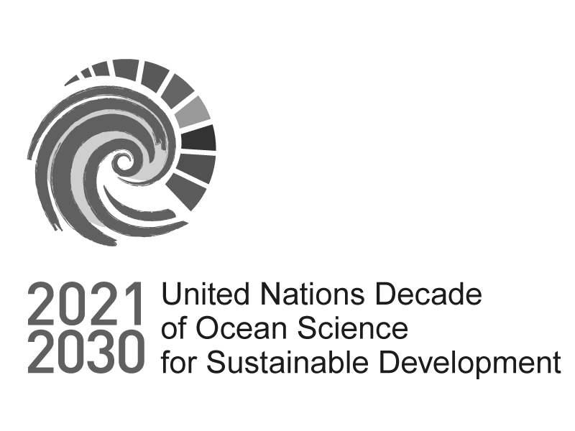

Information - Please read it entirely before proceeding with your application

Call for Decade Actions No. 08/2024 - Programme Expression of Interest

**Call for Decade Actions No. 08/2024 - Expressions of Interest for Programme proposals that aim to address any of the other Decade Challenges not addressed in Part I and that can demonstrate the urgency of the Action to address the priorities outlined in The Barcelona Statement and the broader Vision 2030 process.**

**To avoid pre-empting the results of the Vision 2030 process, applicants are first invited to submit an Expression of Interest demonstrating the urgency of the initiative and the alignment with initial priorities identified in the Vision 2030 process.**

**Please read all the supporting documentation to the Call carefully before submitting your application:**

1. [**Guidance Note**](https://oceanexpert.org/document/29169)
2. [**FAQ**](https://oceanexpert.org/document/29170)
3. **Ocean Decade Implementation Plan and Summary**

**The deadline for submission of this form is 10 November 2024 23h59 UTC.**

**The Expressions of Interest submitted via this form will be reviewed by the Decade Coordination Unit and the Decade Advisory Board. If successful, the applicant will be invited to submit a full proposal by 31 January 2025.**

**If you wish to submit another type of Decade Action during Call for Decade Actions No 08/2024, please refer to the** [**Guidance Note**](https://oceanexpert.org/document/29169) **and the** [**Call page**](https://forum.oceandecade.org/page/call-for-decade-actions-no7) **for more information.**

**Important Information:**

**Please note that all character limits include spaces.**

**You can find the PDF and Word versions of the form here:** [**https://oceanexpert.org/document/29173.**](https://oceanexpert.org/document/29173) **Please note that these are for your use only, e.g. to help prepare your submission. Only submissions sent via the online form**

**will be accepted.**

**If you need a copy of your responses please email us at** [**oceandecade@unesco.org**](mailto:oceandecade@unesco.org) **with the exact full name and contact name of your submission. Please be aware that it may take some time to provide you with the download.**

**For any questions please contact** [**oceandecade@unesco.org**](mailto:oceandecade@unesco.org) **with “Call for Decade Actions No. 08/2024” in the subject line.**



Eligibility

Call for Decade Actions No. 08/2024 - Programme Expression of Interest

* 1. Before proceeding with your submission, please ensure that you meet the requirements as a Decade Programme described in [this document](https://oceanexpert.org/document/32052). Do you wish to proceed with your submission as a Decade Programme?

 Yes No



Call for Decade Actions No. 08/2024 - Programme Expression of Interest

# Proposal scope

* 2. On which Ocean Decade Challenge will your Decade Action have a primary focus?

 Challenge 1: Understand and map land and sea-based sources of pollutants and contaminants and their potential impacts on human health and ocean ecosystems and develop solutions to remove or mitigate them.

 Challenge 2: Understand the effects of multiple stressors on ocean ecosystems, and develop solutions to monitor, protect, manage and restore ecosystems and their biodiversity under changing environmental, social and climate conditions.

 Challenge 3: Generate knowledge, support innovation, and develop solutions to optimise the role of the ocean in sustainably feeding the world’s population under changing environmental, social and climate conditions.

 Challenge 4: Generate knowledge, support innovation, and develop solutions for equitable and sustainable development of the ocean economy under changing environmental, social and climate conditions.

 Challenge 5: Enhance understanding of the ocean-climate nexus and generate knowledge and solutions to mitigate, adapt and build resilience to the effects of climate change across all geographies and at all scales, and to improve services including predictions for the ocean, climate and weather.

 Challenge 6: Enhance multi-hazard early warning services for all geophysical, ecological, biological, weather, climate and anthropogenic related ocean and coastal hazards, and mainstream community preparedness and resilience.

 Challenge 7: Ensure a sustainable ocean observing system across all ocean basins that delivers accessible, timely, and actionable data and information to all users.

 Challenge 8: Through multi-stakeholder collaboration, develop a comprehensive digital representation of the ocean, including a dynamic ocean map, which provides free and open access for exploring, discovering, and visualizing past, current, and future ocean conditions in a manner relevant to diverse stakeholders.

 Challenge 9: Ensure comprehensive capacity development and equitable access to data, information, knowledge and technology across all aspects of ocean science and for all stakeholders.

 Challenge 10: Ensure that the multiple values and services of the ocean for human wellbeing, culture, and sustainable development are widely understood, and identify and overcome barriers to behaviour change required for a step change in humanity’s relationship with the ocean.



Proponent and Partner Details

Call for Decade Actions No. 08/2024 - Programme Expression of Interest

* + 3. Lead Institution Name

The lead institution is the one responsible for the programme and where the lead contact is affiliated to.

* + - 4. Lead Institution Type



* + 5. Lead Institution Physical Address

Street Address

Town/City

Postal/Zip Code

* + - 6. Lead Institution Country



* + - 7. Is your institution based in a Least Developed Country, Small Island Developing State, or Africa

Please find a list of SIDS here: <https://www.un.org/ohrlls/content/list-sids>

[Please find a list of LDCs here: https://www.un.org/development/desa/dpad/least-developed-country-category/ldcs- at-a-glance.html](https://www.un.org/ohrlls/content/list-sids)

 Yes  No

* + 8. Lead Institution Website
  + 9. Lead Institution Primary Contact

*This is the person responsible for the proposal and who will be directly contacted in future communications throughout the review process, and will be expected to sign the letter of endorsement should your application be successful.*

First Name

Last Name

* + - 10. Lead institution primary contact gender

 Male  Female

 Prefer not to say

* + 11. Lead Institution Primary Contact Email Address
  + 12. Email contact of person completing survey

*This person might not be the same as the lead institutional contact, but will be someone we will include in future communications throughout the review process.*

* + 13. Partner Institution Names

Please provide the names of up to five partner lead institutions. Other partner details can be provided if you are invited to submit a full application.

Partner No. 1 Institution name

Partner No. 2 Institution name

Partner No. 3 Institution name

Partner No. 4 Institution name

Partner No. 5 Institution name



Decade Action Description

Call for Decade Actions No. 08/2024 - Programme Expression of Interest

* + 14. Name of Decade Action

The public facing name used to refer to your Decade Action. Your Action name must be fewer than 50 characters.

* + 15. Short name or acronym of Decade Action
    - 16. Is the project you are proposing an ongoing initiative or new?

 Ongoing Initiative New Initiative

* + 17. Please describe how your Decade programme proposal creates positive synergies with existing endorsed Decade programmes (see Annex I of [Guidance Note](https://oceanexpert.org/document/29169)).
  + 18. How does this proposal align with the priorities identified in [The Barcelona Statement](https://oceanexpert.org/document/34098)?
    - 19. Have you contacted any relevant decentralized coordination structure(s) (Decade Coordination Office or Decade Collaborative Centre) in the development of your proposal? Full list can be found [here](https://oceandecade.org/decade-collaborative-centres/).

 No

 Yes. Please inform which one and briefly summarise the results of the discussion.

* + - 20. Have you contacted any relevant National Decade Committee(s) in the development of your proposal? Full list can be found [here](https://oceandecade.org/national-ocean-decade-ecosystem/).

 No

 Yes. Please inform which one and briefly summarise the results of the discussion.

* + 21. When will your proposed Action start and end?

Please use the first of the month in which your Action will start if you do not have a specific start date.

Start Date

Date

DD/MM/YYYY

End Date

Date

DD/MM/YYYY

* + 22. Total Budget estimate for the Decade Action to the nearest whole number with no punctuation.
    - 23. Please indicate the currency of the above budget.



* + 24. Estimate of percentage of total budget secured

This can include in-kind and financial resources.



0

50

100

* + - 25. Please select all countries in which the Decade Action will be implemented.

All Countries Afghanistan Albania Algeria Andorra Angola Anguilla

Antigua and Barbuda Argentina

Armenia Australia Austria Azerbaijan Bahamas Bahrain Bangladesh Barbados Belarus Belgium Belize Benin Bhutan

Bolivia (Plurinational State of) Bosnia and Herzegovina Botswana

Brazil

British Virgin Islands Brunei Darussalam Bulgaria

Burkina Faso Burundi

Gambia (Republic of The) Georgia

Germany Ghana Greece Grenada Guatemala Guinea

Guinea-Bissau Guyana

Haiti Honduras Hungary Iceland India Indonesia

Iran (Islamic Republic of) Iraq

Ireland Israel Italy Jamaica Japan Jordan

Kazakhstan Kenya Kiribati Kuwait Kyrgyzstan

Lao People’s Democratic Republic

Palau Palestine Panama

Papua New Guinea Paraguay

Peru Philippines Poland Portugal Qatar

Republic of Korea Republic of Moldova Romania

Russian Federation Rwanda

Saint Kitts and Nevis Saint Lucia

Saint Vincent and the Grenadines

Samoa

San Marino

Sao Tome and Principe Saudi Arabia

Senegal Serbia Seychelles Sierra Leone Singapore Sint Maarten Slovakia Slovenia

Cabo Verde Cambodia Cameroon Canada

Central African Republic (CAR)

Chad Chile China Colombia Comoros Congo

Cook Islands Costa Rica Cote d'Ivoire Croatia Cuba

Cyprus

Czech Republic

Democratic People’s Republic of Korea

Democratic Republic of the Congo

Denmark Djibouti Dominica

Dominican Republic Ecuador

Egypt

El Salvador Equatorial Guinea Eritrea

Estonia Eswatini Ethiopia Fiji Finland France

Latvia Lebanon Lesotho Liberia Libya

Liechtenstein Lithuania Luxembourg Madagascar Malawi Malaysia Maldives Mali

Malta

Marshall Islands Mauritania Mauritius Mexico

Micronesia (Federated States of)

Monaco Mongolia Montenegro Morocco Mozambique Myanmar Namibia Nauru

Nepal Netherlands New Zealand Nicaragua Niger Nigeria

North Macedonia Norway

Oman

Solomon Islands Somalia

South Africa South Sudan Spain

Sri Lanka Sudan Suriname Sweden Switzerland

Syrian Arab Republic Tajikistan

Thailand Timor-Leste Togo

Tonga

Trinidad and Tobago Tunisia

Türkiye Turkmenistan Tuvalu Uganda Ukraine

United Arab Emirates (UAE)

United Kingdom of Great Britain and Northern Ireland (UK)

United Republic of Tanzania

United States of America (USA)

Uruguay Uzbekistan Vanuatu

Venezuela, Bolivarian Republic of

Viet Nam Yemen Zambia

Gabon Pakistan Zimbabwe

* + - 26. Please select all ocean basins in which the Decade Action will be implemented.

 North Atlantic Ocean  South Atlantic Ocean  North Pacific Ocean  South Pacific Ocean  Indian Ocean

 Arctic Ocean  Southern Ocean

 Mediterranean Sea

Other (including regional seas)

* + 27. Please succinctly describe your proposed Decade Action (max. 3000 characters).
  + 28. Please describe why the proposed Decade Action fills an important gap in the Ocean Decade and should be considered as part of the current Call for Decade Actions. In answering this question please consider other endorsed Decade programmes and projects, as well as the potential to contribute to global or regional policy processes and frameworks (max. 3000 characters).



Disqualification page

Call for Decade Actions No. 08/2024 - Programme Expression of Interest

**Please consider submitting your proposal as a different Decade Action. Here are the options:**

**Decade Project:** [**https://www.surveymonkey.com/r/Proj_CFDA8**](https://www.surveymonkey.com/r/Proj_CFDA8)

**Decade Contribution:** [**https://www.surveymonkey.com/r/DecadeContribution**](https://www.surveymonkey.com/r/DecadeContribution) **Decade Activity:** [**https://www.surveymonkey.com/r/DecadeActivity**](https://www.surveymonkey.com/r/DecadeActivity)

**If you have any questions, please contact us at** [**oceandecade@unesco.org**](mailto:oceandecade@unesco.org)