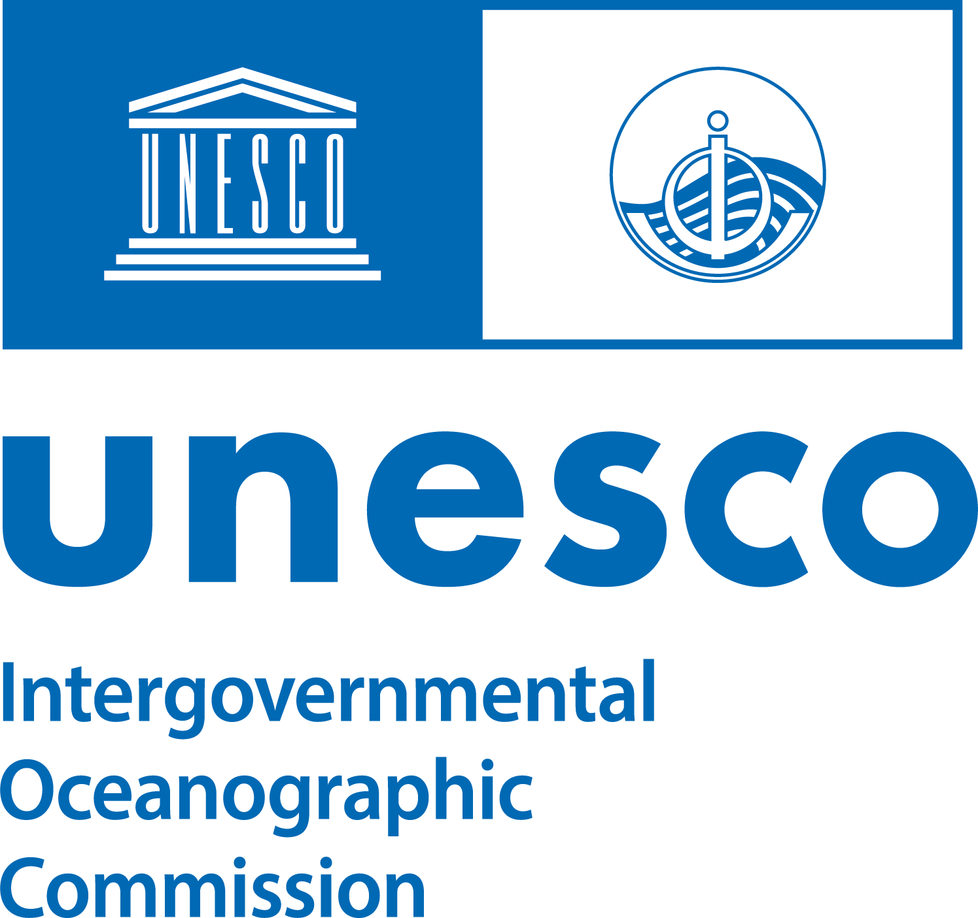 | ROGER REVELLE  MEMORIAL LECTURE  2024 | 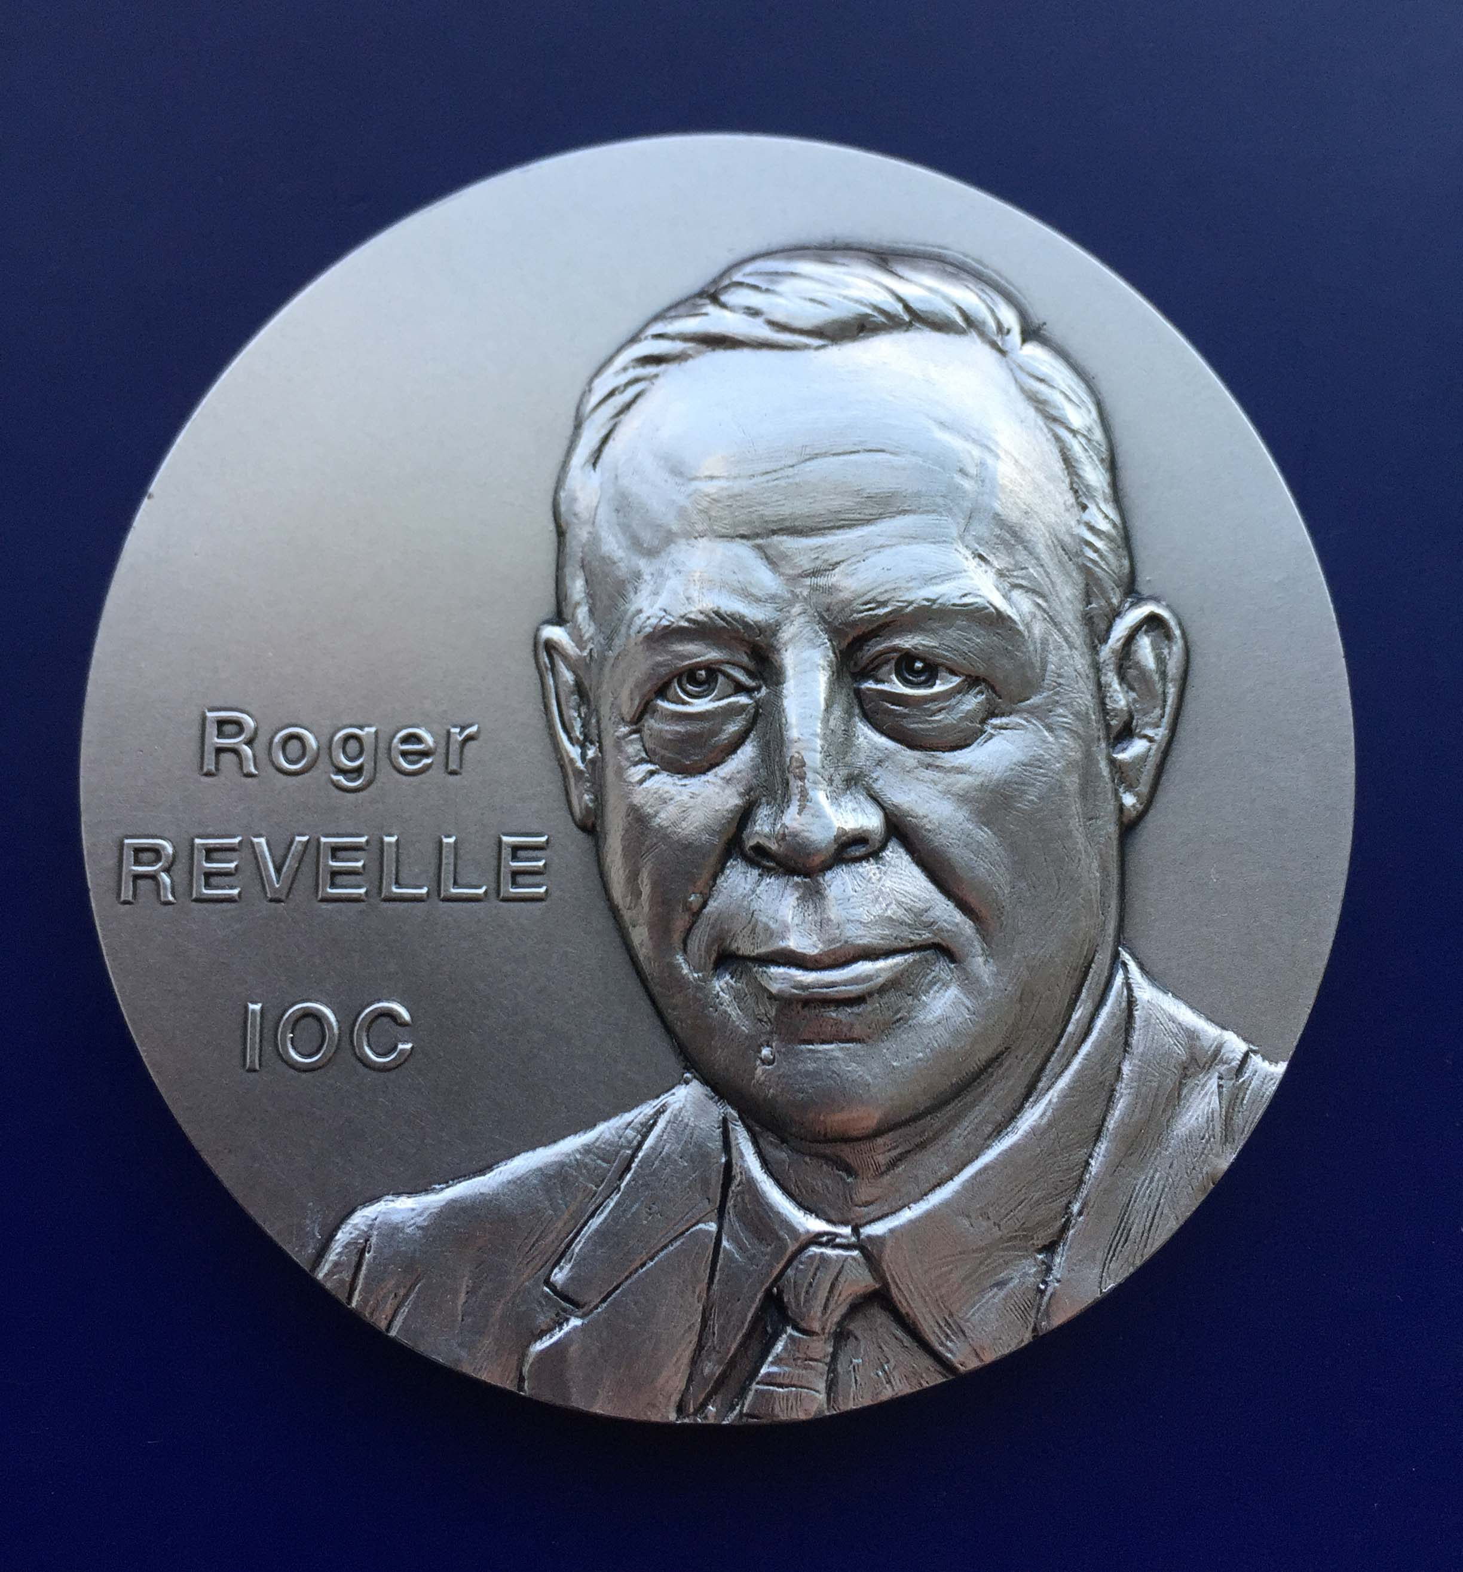
On the occasion of the 57th session of the IOC-UNESCO Executive Council
(26–28 June 2024, UNESCO, Paris)

Prof. Emile A. Okal

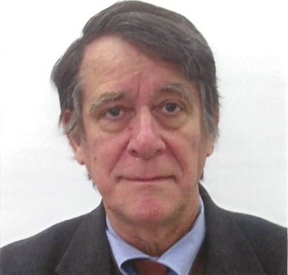 | Emile A. Okal is Professor Emeritus of Earth & Planetary Sciences at Northwestern University, and a graduate of the Ecole Normale Superieure in Paris and the California Institute of Technology. His domains of research are the investigation of tsunamis, of hydroacoustics, and the physics of earthquake sources. He has participated in more than 35 post-tsunami field surveys and authored more than 275 refereed publications. He is a member of the Seismological Society of America, and a Solovev medallist of the European Geosciences Union.

20 years since Sumatra: Advances in Tsunami Science and Mitigation

Emile A. Okal
Northwestern University
Evanston, IL 60208 USA

Abstract

It has now been close to 20 years since the 2004 Sumatra disaster, which made "tsunami" a household word, and was probably the most lethal such event in the history of mankind. As a result, a worldwide emphasis has been given to tsunami risk mitigation, and we will review our progress in several areas.
From the theoretical standpoint, the Sumatra earthquake (the 2nd or 3rd largest instrumentally recorded) caught the seismological community by surprise, since it had been generally assumed that the combination of a slow convergence rate and an old subducting plate precluded the occurrence of mega-earthquakes. Such models have been abandoned, and all subduction zones are now regarded as potential sites of large tsunamis from mega-earthquakes, a precautionary attitude confirmed by the recent occurrence of unexpected events such as the 2021 South Sandwich earthquake, or the reassessment of historical seismicity, e.g., in the Mariana Islands.
Real-time tsunami warning has benefited from the systematic detection of tsunamis on the high seas prior to their reaching coastlines, primarily through the deployment of ocean-bottom sensors, initially using the DART concept, with improvements now targeting high-density networks of sensors in critical offshore locations.
In parallel, developments in numerical simulations, made possible by the advent of supercomputers, have led to the systematic modelling of near- and far-field inundation for literally millions of plausible scenarios, which can be stored and immediately retrieved upon detection of a hazardous event, thereby providing realistic inundation estimates to civil defence authorities.
The last stretch of tsunami mitigation remains the evacuation of people at risk out of harm's way. This can be achieved only by educating them to the nature of the risk and using a resilient infrastructure. In this respect, an interesting step is the development of the international "tsunami ready" label recognizing communities which have invested in the necessary infrastructure and education.
Two statistics bear testimony to the progress made in this respect. First, ever since the 2004 event (which killed tens of thousands in countries such as India and Sri Lanka), tsunamis have caused only 5 deaths in the far field. Second, during the 2011 Tohoku tsunami, and despite the heavy local death toll (18,000), it has been estimated that about 200,000 persons were present in the zone of complete destruction by the tsunami, suggesting a success rate of about 90% for the evacuation.
A remaining challenge concerns the so-called "tsunami earthquakes" whose tsunamis are larger than their seismic size would suggest. Ongoing research has now identified more than 20 such events over the past 100 years, occurring in a wide variety of environments, either as main shocks or as aftershocks of more regular earthquakes. Promising techniques involving exclusively first-arriving seismic P waves aim at identifying their anomalous character in real time, in order to incorporate it into warning algorithms.
Tsunamis from non-seismic sources also remain a challenge, especially from submarine landslides, for which we lack adequate technologies for precursory monitoring. Significant work is also carried out in the field of meteo-tsunamis which derive their energy from the weather cycle.
Finally, a growing number of studies consider tsunamis as part of a global Solid Earth-Ocean-Atmosphere system, allowing their detection by technologies as diverse as seismology, hydroacoustics or even space geodesy, even though such approaches cannot, for the time being, be used for real-time warning.
In this context, the 2022 Tonga volcanic explosion provided a wealth of new understanding in the complex problem of the coupling of atmospheric air waves to the water column, even if the far-field amplitudes of sea surface oscillation remained at most decimetric, and as such relatively benign.

