Summary
Through IOC Circular Letter 2981, the Working Group on User Requirements and Contributions to GEBCO Products was re-constituted to undertake the regular GEBCO assessment of user requirements in accordance with Decision EC-XLIX/Dec.4.4 (2016) and Decision A-31/3.5.1 (2021).
The main task of the Working Group is to: (i) collect, integrate and assess user requirements to inform the development of present and future GEBCO products; and (ii) address ways for strengthening the contributions of IOC programmes and Member States activities to GEBCO data and products. A survey was designed to collect information, the results of which are synthesised in this document.
After due consideration by the governing bodies of IHO and IOC, the findings of this report will be shared with the IHO and GEBCO Guiding Committee for their follow up actions.
The proposed decision is referenced as EC-57/Dec.4.4 in the Revised Action Paper for the session (document IOC/EC-57/AP Prov. Rev.).

Introduction
- The IHO-IOC General Bathymetric Chart of the Oceans (GEBCO) project is a joint project of the International Hydrographic Organization (IHO) and the IOC of UNESCO. Its aim is to provide the most authoritative public domain global reference bathymetric dataset, based on all available information provided through the interest, participation, support and effort of scientists, institutes, research centres, individuals, industry and national Hydrographic Services who provide data and expertise to the programme at no cost in the interest of science, safety and the environment. More information on the GEBCO governance and activities can be found at https://www.gebco.net/.
- GEBCO provides global bathymetric data, which is crucial for understanding the topography of the ocean floor. This information is essential for various oceanographic studies, including marine geology, ocean circulation patterns, and habitat mapping, amongst a few. The IOC relies on accurate bathymetric data to support its scientific and research activities. In return, many ocean observation and research activities conducted under the IOC have the benefit to increase bathymetric data collection and enrich the GEBCO products and services. This collaboration helps advance scientific understanding, promote sustainable ocean management, and address challenges related to the marine environment.
- In 2014, IOC Member States decided that IOC should increase its engagement in GEBCO and later in 2016 it was decided to have a regular mechanism established to assess user requirements needs as it relates to GEBCO products, from the IOC perspective, and identify ways to strengthen potential IOC contributions to GEBCO data and products from the oceanographic community, and broader maritime end-users’ perspective (Executive Council Decision EC-XLIX/Dec.4.4).
- An initial assessment was conducted in 2017 (IOC/EC-LI/2 Annex 7), then in 2021 (IOC/A-31/3.5.1.Doc) and now in 2024. In this year assessment (Annex I), particular efforts have been made to capture the user requirements of Member States and governmental organizations that have interest in GEBCO products, as well as those from industry/civil society organizations. Through IOC Circular Letter 2981, a Working Group was constituted to undertake the GEBCO assessment of user requirements on a triennial basis. The Working Group was chaired by IOC Vice Chair Juan Camilo Forero Hauzeur. The membership of the Working Group is presented in Annex II of this document.
- To support the collection of information, a questionnaire was developed and deployed through IOC Circular Letter 2989. The recipients of the questionnaire targeted were Member State representatives and institutions working with ocean mapping products as well as Officers and experts of relevant IOC technical and regional subsidiary bodies and GOOS Regional Alliances. Furthermore, the questionnaire was circulated throughout the extensive network of the Nippon Foundation/GEBCO/Seabed 2030 project in order to reach out to non-governmental institutions and industry. The results of the survey presented in this document were synthesized by Nippon Foundation/GEBCO/Seabed 2030 project team who provided support throughout the process and presented to the Working Group though an online meeting that took place on 16 May 2024. The findings of this report will be shared with the IHO and GEBCO Guiding Committee for their follow up actions.

Summary of the main findings
- A total of 59 responses from 39 countries were received, to the questionnaire closing on 19 April 2024, representing the views of a broad international community of government agencies, academics, industry and individuals. The list of responding institutions is presented in Annex III of this document.
- In terms of the diversity (type of organisation and regions of origin), the following data is available:

Type of organisations | Geographical origin (IOC Groups)
Government other (24)  Government hydrographic agencies (10)  University (12)  Industry (8)  NGO (4)  Other (1) | Group 1 (North America & Western Europe) 23  Group 2 (Eastern Europe / Russian Federation) 1  Group 3 (Central & South America, Caribbean) 8  Group 4 (Asia & Oceania) 12  Group 5 (Africa & Middle East) 13

- Broadly the respondents are highly supportive of GEBCO, with over 90% valuing the GEBCO gridded bathymetry datasets, over 70% valuing the GEBCO web services, and over 60% valuing the undersea feature names and capacity development aspects of GEBCO’s work.
- There was much less interest in availability of hard copy products or in the History of GEBCO.
- A high proportion of respondents wanted to see higher resolution products, with considerable interest in expanding the scope of GECO data products to include a larger number of parameters and data layers, notwithstanding that some of these lies outside GEBCO’s current remit.
- Respondents wanted to see a greater choice of file formats and improved compatibility with state-of-the-art software products used in the geospatial sector, including better visualisation tools. Most respondents were concerned about security within coastal zones and EEZs, with a greater awareness of risks to subsea infrastructure from malevolent actors.
- The creation of an international seabed data users group is a commonly requested feature, that would help transfer skills and promote knowledge exchange and capacity development. In addition, the provision of specialist training sessions and workshops would be welcomed.
- The idea of rewards and incentives for sharing data emerged from several respondents, particularly where this might encourage industry to share data more widely.
- During the meeting of the Working Group, further recommendations were made to integrate the GEBCO capacity development needs and priorities within the IOC Capacity Development Strategy and delivery mechanism such as the Ocean Teacher Global Academy. Connecting the GEBCO data infrastructure with the IOC Ocean Data Information System was also highlighted.
- For future assessments of GEBCO user needs, the Working Group recommended that the results should be more granular in order to identify needs by type of users or by regional groups.
- The Working Group welcomed the increased diversity of respondents compared to the 2021 previous exercise but highlighted the lack of responses from specific IOC programmes.

ANNEX I – Detailed Analysis (English only)
- GEBCO User Requirements. Ranking of products/services of the GEBCO project that offers particular value to end-users.
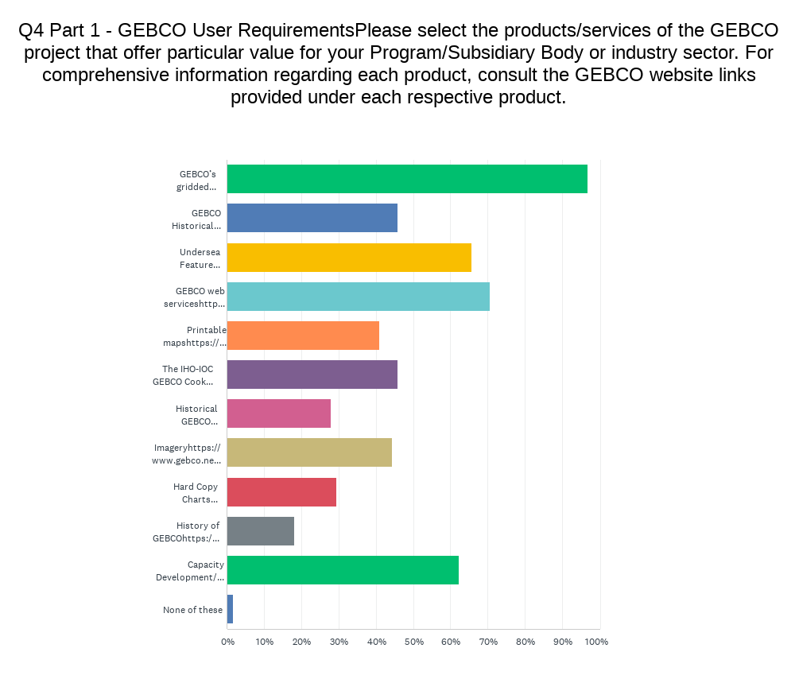

The survey responses were plotted, the graph above indicates the most used GEBCO product are:
1. GEBCO’s gridded bathymetric data sets
https://www.gebco.net/data_and_products/gridded_bathymetry_data/
2. Followed by GEBCO web services
https://www.gebco.net/data_and_products/gebco_web_services/ and
3. Undersea Feature Names
https://www.gebco.net/data_and_products/undersea_feature_names/

Order of priority for existing products of the GEBCO project that your Program/IOC Subsidiary Body/Organization/Industry Sector is most inclined to utilize, and least inclined to utilize

The respondents listed their preference in order of utilization. The table below summarises the findings
Most 1 | GEBCO’s gridded bathymetric data sets
Most 2 | Undersea Feature Names
Most 3 | GEBCO Web Services
Most 4 | IHO-IOC GEBCO 'Cook Book'
Least 1 | History of GEBCO
Least 2 | Historical datasets
Least 3 | Historical charts
Least 4 | Hard copy charts

- Improvement of GEBCO products – Areas where specific GEBCO products might warrant enhancement from a technical standpoint. This could pertain to aspects such as accessibility, format, coverage, spatial resolutions, and supplementary services, among others.

GEBCO’s gridded bathymetric data sets | - Improve the spatial resolution and accuracy of the gridded datasets  - Additional effort is needed in improving data quality and resolution in shallow areas  - Enhance accessibility by providing more user-friendly interfaces for data download and visualization  - The gridded bathymetric datasets could be made available in other commonly used file formats.  - Where higher quality aggregated surfaces are available (e.g. from national or continental programs), they should be included.  - More data validation is required by directly measure depths  - Provide more metadata e.g. (number of soundings per grid node, standard deviation, number or data sources per grid node)  - Areas of data gaps needs to be clearly identified  - Other supplementary services to be considered to add value bathymetric dataset
GEBCO Historical Datasets | - Standardize historical data formats to ensure compatibility with modern data processing tools and systems.  - Provide comprehensive documentation and metadata for historical datasets to facilitate proper utilization and interpretation
Undersea Feature Names | - Ensure consistency and accuracy in undersea feature names across different datasets and versions.  - Include polygon vector layer for larger areas  - Implement standardized naming conventions and guidelines for undersea features to enhance clarity and interoperability
GEBCO web services | - Web Services could be improved my offering more services such as (masked WMS of source data to determine coverage, and higher resolution display)
Printable maps | - Recommended to improve the quality and resolution of printable maps to support high-quality printouts.  - Enable customization options for printable maps, allowing users to select specific regions, layers, and information to be included
The IHO-IOC GEBCO Cook Book | - The Cook book is to be updated more frequently  - Update the Cook Book with the latest methodologies and best practices for bathymetric data processing and analysis.  - Provide tutorials and training materials to help users effectively utilize the 'Cook Book' resources
Historical GEBCO Charts | - Digitizing and geo-referencing historical charts to facilitate their integration with modern GIS software and analysis workflows.  - Improving metadata to meticulously document the origin and precision of historical chart data, and creating tools for comparative analysis between historical charts and contemporary datasets.  - Access to historical datasets in easy to use formats
Imagery | - Improve the spatial resolution and accuracy  - Integrate high-resolution satellite imagery with bathymetric data to provide a comprehensive view of the seafloor  - Imagery to be made available in other commonly used file formats  - Provide more metadata on imagery
Hard Copy Charts | - Ensuring consistency and accuracy between digital and hard copy chart versions  - Include relevant metadata and information on chart sources and data quality.  - Provide guidelines for chart interpretation
History of GEBCO | - Incorporate multimedia elements such as archival photos and videos to enrich the narrative, and highlighting key milestones and achievements in GEBCO's history.

- Among areas of enhancement suggested above, which ones do you think that IOC needs to provide additional resources or capacity?
- Expanding coverage and improving accessibility of bathymetric data sets, especially in remote and less explored regions,
- Expanding web services and developing interactive tools for data visualization and analysis
- Standardizing naming conventions and maintaining a comprehensive feature names database

- Details on the users of GEBCO products within your Program/IOC Subsidiary Body/national authorities/Organization/Industry Sector. Please describe for which activities users currently use GEBCO products? Describe your requisites and specifications regarding GEBCO products. This may include delineating mapping needs in specific maritime areas, specifying desired product types, resolution criteria, preferences for web services, and any additional datasets deemed pertinent.
- GEBCO grid is used as an input for various kinds of modelling e.g. tsunami and hydrodynamic. The grid is also useful in survey planning and environmental management activities.
- Another application involves incorporating both the GEBCO grid and undersea feature names into the cartographic production process.

6. Perception of how users would like to use GEBCO products in future. [Are there new, emerging activities where GEBCO products can be used in innovative ways?]
- Having a more interactive web service with more data layers with the ability to easily extract various datasets in different formats
- High-resolution bathymetric data sets can be helpful in identifying suitable locations for marine protected areas, offshore infrastructure projects, and aquaculture zones while minimizing environmental impacts
- Ability to utilise GEBCO grid as inputs to machine learning (AI) systems for event predictions

- GEBCO is now providing data products for waters of less than 200m depth, as well as the long-established deep-water data. For data shallower than 200m, who are the key users of GEBCO products, and for what activities do they use GEBCO products in your Program/Subsidiary Body/Organization/Industry Sector?
- The data shallower than 200m are critical for tsunami assessment, hazard maps and numerical modelling of coastal processes
- GEBCO products for various activities such as navigation during research cruises, environmental monitoring, identification of Undersea features, and identification of trawl able areas.
- Data products are also used by hydrographic offices, offshore windfarms, cables and pipeline companies for survey planning.

- How do the users intend to utilize shallow water GEBCO products? What specific types of products related to shallow waters would you envision the GEBCO project generating? Please add detail on the requisites, specifications, and impediments concerning GEBCO products. This may include delineating mapping needs in particular maritime regions, desired product types, product resolution requirements, web services preferences, among others.
- Data products utilised in coastline definition and maritime boundaries, S-130 connection to web services will be very beneficial
- Data is utilized for pre-survey studies where enhanced resolution of the bathymetric data holds significance
- With shallower and more precise data, tsunami and coastal models will be more accurate
- Perhaps GEBCO would consider incorporating mechanisms to integrate higher-resolution national products into the GEBCO product suite, such as multi-resolution products or tiled
zoom features.

- Does your country and / or organization have any concerns over accessing or sharing data that was collected from inside the Exclusive Economic Zone?

Most of the respondents had concerns about data collected in EEZ due to national security issues.

- Are there any products of ocean mapping activities from which your Program/Subsidiary Body/Organization/Industry Sector would benefit other than those already currently developed under GEBCO data and products? Is there a desire for access to processed point data sets beyond those that GEBCO currently provide?

Respondents have either answered YES, NO and some have skipped this question.

- If Yes to above, please describe what kind of new products you would like to see.
- It would be highly beneficial to have the capability to effortlessly download processed, cleaned point data at the maximum available resolution for user-defined areas of interest
- Would be helpful to have seafloor classification maps that provide information about the composition and characteristics of the seafloor substrate
- Interactive maps and virtual reality environments offer immersive experiences for users to explore underwater landscapes and features in three dimensions (3D). These visualization products play a crucial role in enhancing public outreach and education and facilitating marine science communication

- Apart from the IOC consultation process, kindly propose any mechanisms for discerning user needs and requirements regarding GEBCO data and products, and subsequently conveying them to GEBCO, from the perspective of your Program/Subsidiary Body/Industry Sector? This may encompass mechanisms for enhancing collaboration with GEBCO as well.
- Creating a specialized User Advisory Group consisting of representatives from your Program/Subsidiary Body/Industry Sector, along with other pertinent stakeholders such as scientists, researchers, government agencies, and industry partners. This group will provide a forum for stakeholders to express their needs, requirements, and feedback regarding GEBCO data and products. Regular meetings, workshops, and surveys will be organized to collect input and insights from members of the advisory group.
- Formalizing partnership and collaboration agreements between your Program/Subsidiary Body/Industry Sector and GEBCO to promote enhanced collaboration and communication. These agreements will delineate mutual objectives, roles, responsibilities, and commitments for both parties, including frameworks for sharing data, resources, and expertise, as well as coordinating joint initiatives and projects.

- Contributions to GEBCO Products. Has your Program/IOC Subsidiary Body/Country/Organization/Industry Sector contributed towards GEBCO data and products?

Respondents have either answered YES, NO and some have skipped this question.

- If Yes to above, please describe in more detail what has been contributed.
- Crowd Source Bathymetry
- Bathymetric data (indirectly in EEZ in European and Caribbean Seas) through EMODnet contribution
- Private sector data sharing through Seabed 2030
- Printable maps are created by GEBCO folks with financial support of Korean Government
- Each country of the OCEATLAN Regional Alliance is contributing in different ways to GEBCO
- SHOA nautical charts (2010) Basin delimitation polygons (2018) SHOA nautical charts for Magallanes (2019) Track of navigation 2014 and 2015 years (2020) High resolution bathymetry, Piloto Pardo Mount (2022) High resolution bathymetry, Guyot and Mount O'Higgins (2024)
- Most of the deep-water survey data from NOAA scientific field programs are shared back to IHO to be included in GEBCO products
- Some entities/individuals conduct annual quality control checks and offer feedback on the Undersea Feature Names product, while also actively engaging in various working groups dedicated to advancing SCUFN's initiatives.

- If you contributed data to GEBCO, which options did you choose for data sharing?

Most common selections were:
- Data for public access - Data sent direct to the IHO Data Centre for Digital Bathymetry hosted by NOAA
- Data for public access - Data sent via Seabed 2030 centres
- Followed by Data for GEBCO use only - data provided via GEBCO's data holding centre at the British Oceanographic Data Centre (BODC)

- If 'other'- please describe
- Seabed 2030 routinely download data from the AusSeabed data portal.
- EMODnet contribution
- UN Entities and Intergovernmental Organisations

- If you do not currently contribute data, is there any potential for you to contribute in the future? If no, please explain why. Please also provide suggestions/requirements to facilitate future contributions
- Enhanced future contributions could be facilitated by ensuring that data providers perceive the process as rewarding, with clear identification of their contribution
- Possibility to share some data collected during transit during hydrographic surveys in order to improve GEBCO data quality (Royal Moroccan Navy)
- This topic is predominately under review as hydrographic office or navy in certain countries have the authority to permit data release and sharing

- Please suggest any potential new approaches that could be tried to facilitate and augment the contribution of bathymetric data collected by scientific or other endeavours to GEBCO.
- Promote collaboration among scientific communities, industry partners, and government agencies to undertake collaborative bathymetric mapping initiatives in underexplored or remote marine areas. Combine resources, expertise, and equipment to gather high-resolution bathymetric data through ship-based surveys, autonomous underwater vehicles (AUVs), unmanned surface vessels (USVs), or airborne LiDAR systems. Coordinate data collection endeavours to achieve comprehensive coverage and avoid redundant efforts.
- Establish incentives and rewards for organizations and individuals to contribute bathymetric data to GEBCO. Recognize and acknowledge data contributors through citation, co-authorship, or awards. Provide financial support, research grants, or access to GEBCO resources and services as incentives for sharing high-quality bathymetric data. Foster a culture of collaboration and knowledge sharing within the bathymetric mapping community to promote data exchange and cooperation.
- Allocate resources to capacity building initiatives aimed at strengthening the skills, knowledge, and capabilities of scientists, researchers, and marine professionals engaged in bathymetric data collection and processing. Deliver training workshops, seminars, and online courses covering bathymetric mapping techniques, data management practices, and quality assurance protocols. Facilitate access to cutting-edge bathymetric surveying equipment, software tools, and analytical resources to bolster capacity development endeavours.
- Please suggest any potential requirements and type of capacity development regarding GEBCO products from the perspective of your Program/Subsidiary Body/Industry Sector.

Though most of the respondents have skipped this question, the following were identified by some respondents:
- Provide training programs and workshops to enhance the technical skills and knowledge of professionals involved in bathymetric data collection, processing, and analysis.
- These programs could encompass workshops or courses focusing on GIS (Geographic Information Systems) software utilization, data processing techniques, and spatial analysis methods pertinent to GEBCO datasets. Facilitating collaborative research and knowledge-sharing initiatives cantered around GEBCO products would further enhance value. This could entail fostering partnerships and collaborations among stakeholders to undertake joint research projects or exchange experiences and best practices in leveraging GEBCO datasets.

- Please suggest any supplementary factors for the assessment of contributions to GEBCO's data and products from the standpoint of your Program/Subsidiary Body/Organization/Industry Sector

Though most of the respondents have skipped this question, the following were identified by some respondents:
- In the past, TSCOM provided reports indicating the annual number of scientific articles citing GEBCO grid data and maps. It would be prudent to maintain these statistics for future reference.
- Implementing a more effective mechanism for crediting data contributors when utilizing GEBCO products.

- Key recommendation for enhancing the GEBCO efficacy of its dissemination of seabed data to relevant stakeholders
- Continuously enhance accuracy and coverage while advocating for data sharing and open access.
- Utilize all communication channels and engage a broad range of stakeholders by leveraging GEBCO members or points of contact (POCs) in each region/country. This could involve organizing workshops or meetings across different countries to showcase improvements and products. In-person meetings are particularly effective for this purpose
- GEBCO could introduce online workshops or short-term courses, removing geographical barriers and enabling broader dissemination to individuals.

ANNEX I – List of Members of the IOC Working Group on User Requirements and Contributions to GEBCO Products

Country | Name | Institution
Australia | Ms Philippa Bricher | National Seabed Mapping. Geoscience Australia
Bangladesh | Captain Habib-Ul-Alam, (HI), NUP, PCGM, psc, BN | Bangladesh Navy Hydrographic and Oceanographic Centre (BNHOC)
China | Ms Fan Miao | National Marine Data and Information Service (NMDIS)
Colombia | Ms Yerynelys Santos Barrera | Caribbean Oceanographic and Hydrographic Research Centre. General Maritime Directorate
Colombia | Mr Juan Camilo Forero Hauzeur | Comisión Colombiana del Océano (Working Group Chair)
Ecuador | Mr Freddy Guzmán | Dirección de Hidrografía y Cartografía. Instituto Oceanográfico y Antártico de la Armada
Egypt | Ms Suxan Mohamed El Gharabawy | National Institute of Oceanography & Fisheries
Mexico | Ms Amaia Ruiz de Alegría Arzaburu | Grupo de Procesos Litorales del Instituto de Investigaciones Oceanológicas de la Universidad Autónoma de Baja California
Mexico | Mr Isaac Rodríguez Padilla | Grupo de Procesos Litorales del Instituto de Investigaciones Oceanológicas de la Universidad Autónoma de Baja California
Morocco | Captain Ayoub BELATTMANIA | Inspection de la Marine Royale
Morocco | Lieutenant de Vaisseau El Mehdi LATNI | Inspection de la Marine Royale
Norway | Mr Helge Sagen | Norwegian Marine Data Centre. Institute of Marine Research
Norway | Mr Cristian Muñoz Mas | Institute of Marine Research
Qatar | Mr. Moahemd Ahmed Al Khenji | Ministry of environment and climate change
Republic of Korea | Ms Jinju Im | Korea Hydrographic and Oceanographic Agency
Russian Federation | Ms Anastasia Abramova | Geological Institute of the Russian Academy of Sciences
Senegal | Mr Abdoul Tanor Diaw | Agence nationale des Affaires maritimes
USA | Ms Shannon Hoy | NOAA Ocean Exploration

Annex II – List of Responding institutions

