15th Observation Coordination Group (OCG-15)
13-17 May 2024, Victoria, BC, Canada

The Argo Float Program
Breck Owens, Director
Susan Wijffels, Co-chair
Brian King, Co-chair

- Highlight the key network successes

We have solved many technical challenges - Fast salty drift, pH sensor production, piloting on-board dynamic corrections on a CTD, new pressure sensors, etc. Continued close collaboration between Argo and its suppliers will continue this progress.Ten companies had 22 representatives attending the Argo AST meeting in March, 2024.

COVID supply chain issues appear to be largely overcome. Sadly the large price increase of parts, and thus floats and sensors, is still with us.

The new mission teams for BGC, Deep and Polar Argo are working well and taking on the technical and logistical challenges these present. The Argo community as a whole is operating as a collaborative effort across missions and with our commercial partners. The new missions are growing the Argo user community, as are new applications for core data such as storm forecasting.

We are developing a healthy working relationship with several global analysis centers so that we can improve the utility of Argo data and its associated quality control information.

- How has the network advanced across the OCG Network Attribute areas
In general Argo meets the OCG Network Attributes. Nevertheless, there are a few attributes that should be discussed:
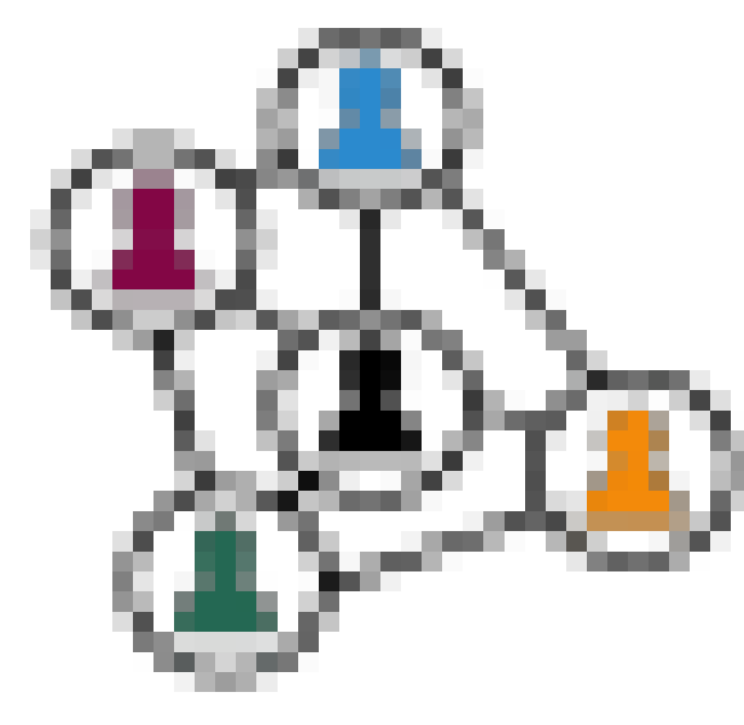Community of Practice | Argo has created mission teams to oversee (1) Argo Bio-Geochemical measurements, (2) Deep Argo and (3) Polar floats and consolidated the AST and its meetings, encompassing all aspects of Argo.  A Technical Community of Practice is meeting regularly by Zoom. An in-person workshop will be held in September 20124 in Seattle, WA. The Delayed-Mode Working Group meets monthly to share experiences and best practices.
Maintain network mission | The effective Argo array coverage continues to slowly decrease from its peak in 2018. The decrease is largest in the Indian Ocean, where more floats are needed in the northern and western region, and in the Southern Ocean south of 60S. The Arctic and most marginal seas also have very low coverage. There is a vigorous community that sustains Argo in the Mediterranean Sea.  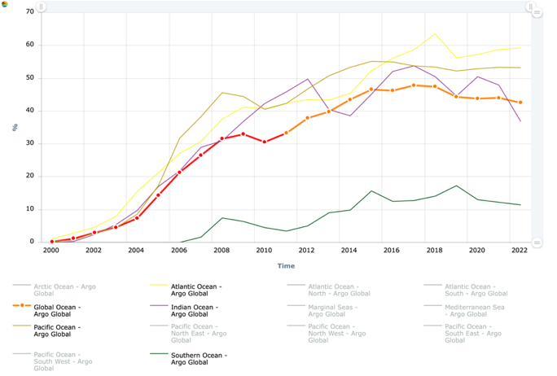  Despite broad community support, including from the G7, The goal of implementing OneArgo by 2030 is unlikely without a rapid and significant increase in financial resources.
Delivers data in a timely manner | 96% of Argo profiles are reported on the GTS within 12 hours. In response to prior issues with “Fast-Salinity Drift” sensor failures, Argo DACs receive the results of Min/Max tests from IFREMER daily to flag failing sensors by the next cycle. Work is underway to implement this test on the real-time data stream.
  Ensure metadata quality | Argo is working with our float and sensor providers to provide Argo clients with JSON meta-data files, based on the Argo metadata schema and NERC Vocabulary Server (NVS) controlled terms, to provide machine-to-machine transfer of metadata. Several providers are now providing these files.
  Standards and Best Practices | Two articles have been recently published in Frontiers in Marine Science documenting Argo best practices (Morris, et al, 2024a,b).  Documentation of the Argo Data Management system is routinely updated and can be accessed through the Argo Documentation website: https://www.argodatamanagement.org/Documentation  Software for accessing and using Argo data can be accessed through the Argo website: https://argo.ucsd.edu/data/argo-software-tools/  To insure that oceanographers understand the responsibilities necessary to declare floats used for their research as part of the Argo Program, Argo has develop a website and encourages float manufactures to share it with their customers:  (https://argo.ucsd.edu/about/what-makes-a-float-part-of-argo/)

- Future Plans and Opportunities - at network and/or cross-network OCG level

Argo regional basin deployment planning meetings continue to be very successful and helpful. It would be useful to expand to include other networks. We hope to work across networks to improve data interoperability. We are also working on developing simple vertically-gridded data products of our high quality data operationally to assist users that are challenged by the complexities of our native netCDF format.

Over the next 1-2 years Argo will be planning a next generation data system aiming to use cloud-based services to serve a cloud optimized data format that would operate in the short term in parallel with the present system based on GDAC http servers and netCDF files. The responsibility and management of this system would continue to be broadly based within the Argo community using GitHub to maintain the code and documentation. Argo invites other networks to join us in this activity.

- Challenges and Concerns - at network and/or cross-network OCG level

The ongoing outage at OceanOPS is a major issue for Argo and makes it difficult to meet our responsibilities under IOC resolutions with respect to measurements in EEZs.

Although Argo has actively encouraged and collaborated to develop a diverse set of suppliers of platforms and sensors, Seabird System has just announced that they will not be providing either Core or BGC NAVIS floats beyond their existing orders. We hope that other manufacturers will either take over the manufacturing of these floats or provide equivalent high quality floats.

After 10 years of data system development, technical development and testing, Argo is in a position to implement the OneArgo design at a global scale. We have a window of time to secure the required resources and establish a sustainable market for our suppliers. If we fail, the capability will be almost impossible to sustain within our suppliers.

- Asks from OCG (Exec, networks, OceanOPS, and/or GOOS), perhaps related to the responses to parts 3 and 4 and how OCG can support your network

When the Argo Float program was first developed, there was a close coordination with both the oceanographic research community and the operational organizations to take advantage of the capabilities of this new observational network. The development of the BGC mission for Argo has been well received with the research community, but the links to operational usage has not been as strong. We ask that OCG and GOOS help in developing the links that are required for operational products, for example for fisheries and for the monitoring and evaluation of potential carbon sequestration efforts.

References

Morris, Tamaryn, et al. "Best practices for Core Argo floats-part 1: getting started and data considerations." Frontiers in Marine Science 11 (2024): 1358042.

Morris, Tamaryn, et al. "Best practices for Core Argo floats-Part 2: physical handling, deployment and metadata considerations." Frontiers in Marine Science 11 (2024): 1358048

Future plans on implementation, instrumentation, data management, test, new sensors, plan for new EOV/ECV observations, capacity development, etc.

