Summary

This document presents an overview of the financial situation of the IOC Special Account at year-end 2023 and the forecast for the biennium 2024–2025, as well as the proposed adjustments to the budgetary allocations for 2024–2025 approved by the IOC Assembly at its 32nd session. The Financial Report for the period 1 January 2022 to 31 December 2023 is provided in Annex I,
Decision proposed: After a brief introduction and discussion in plenary under item 3.1, the Executive Council is invited to take note of this report and consider the draft decision referenced as Dec. IOC/EC-57/3.1 in the Provisional Action Paper (document IOC/EC-57/AP). The document will then be subject to an in-depth review by the sessional statutory open-ended Financial Committee and the decision reflected in the Draft Resolution that the Financial Committee will be submitting to the Executive Council for adoption under item 5.4 in accordance with paragraph 15 of the Draft Revised Guidelines for the Preparation and Consideration of Draft Resolutions (IOC/INF-1315).

overview of the financial situation of the ioc special account

as at year end 2023 (in US dollars)

- In accordance with the Financial Report for the period 1 January 2022 to 31 December 2023 presented in the annex to this document, the total income in period amounted to $6,064,291.76 (comparative 31.12.2021 – $6,093,445.76), while total expenditure for the same period amounted to $5,668,552.07 (comparative 31.12.2021 – $3,365,010.89).
- At the end of year 2023, $378,398.41 were firmly committed by donors, of which $155,451.93 payable in 2026.
- At the end of year 2023, the Fund balance amounted to $6,669,956.19 (comparative 31.12.2021 – $6,282,617.86), with the following breakdown:
- General reserves: $ 4,337,604.49 (comparative 31.12.2021 – $ 4,042,690.37)
- OceanOPS : $ 146,611.57 (comparative 31.12.2021 – $ 190,381.05)
- IOTWMS ICG Secretariat: $ 285,499.00 (comparative 31.12.2021 – $ 654,379.08)
- UN Decade of Ocean
Science for Sustainable
Development: $ 1,900,241.13 (comparative 31.12.2021 - $ 1,395,167.36)
- In accordance with Articles 8.2 and 8.3 of the Financial Regulations for the IOC Special Account, the above-mentioned balance is carried over to year 2024 for the implementation of the budget approved by the IOC Governing Bodies. In this context, the proposal for a revision of budgetary allocations adopted by the IOC Assembly through IOC Resolution A-32/4 is submitted for the approval by the Executive Council in Table 1.
- Table 2 provides the forecast for 2024–2025 as at year end 2023.

Table 1. proposed revised budgetary allocations for 2024–2025

TABLE 2. FORECAST 2024–2025

ANNEX I
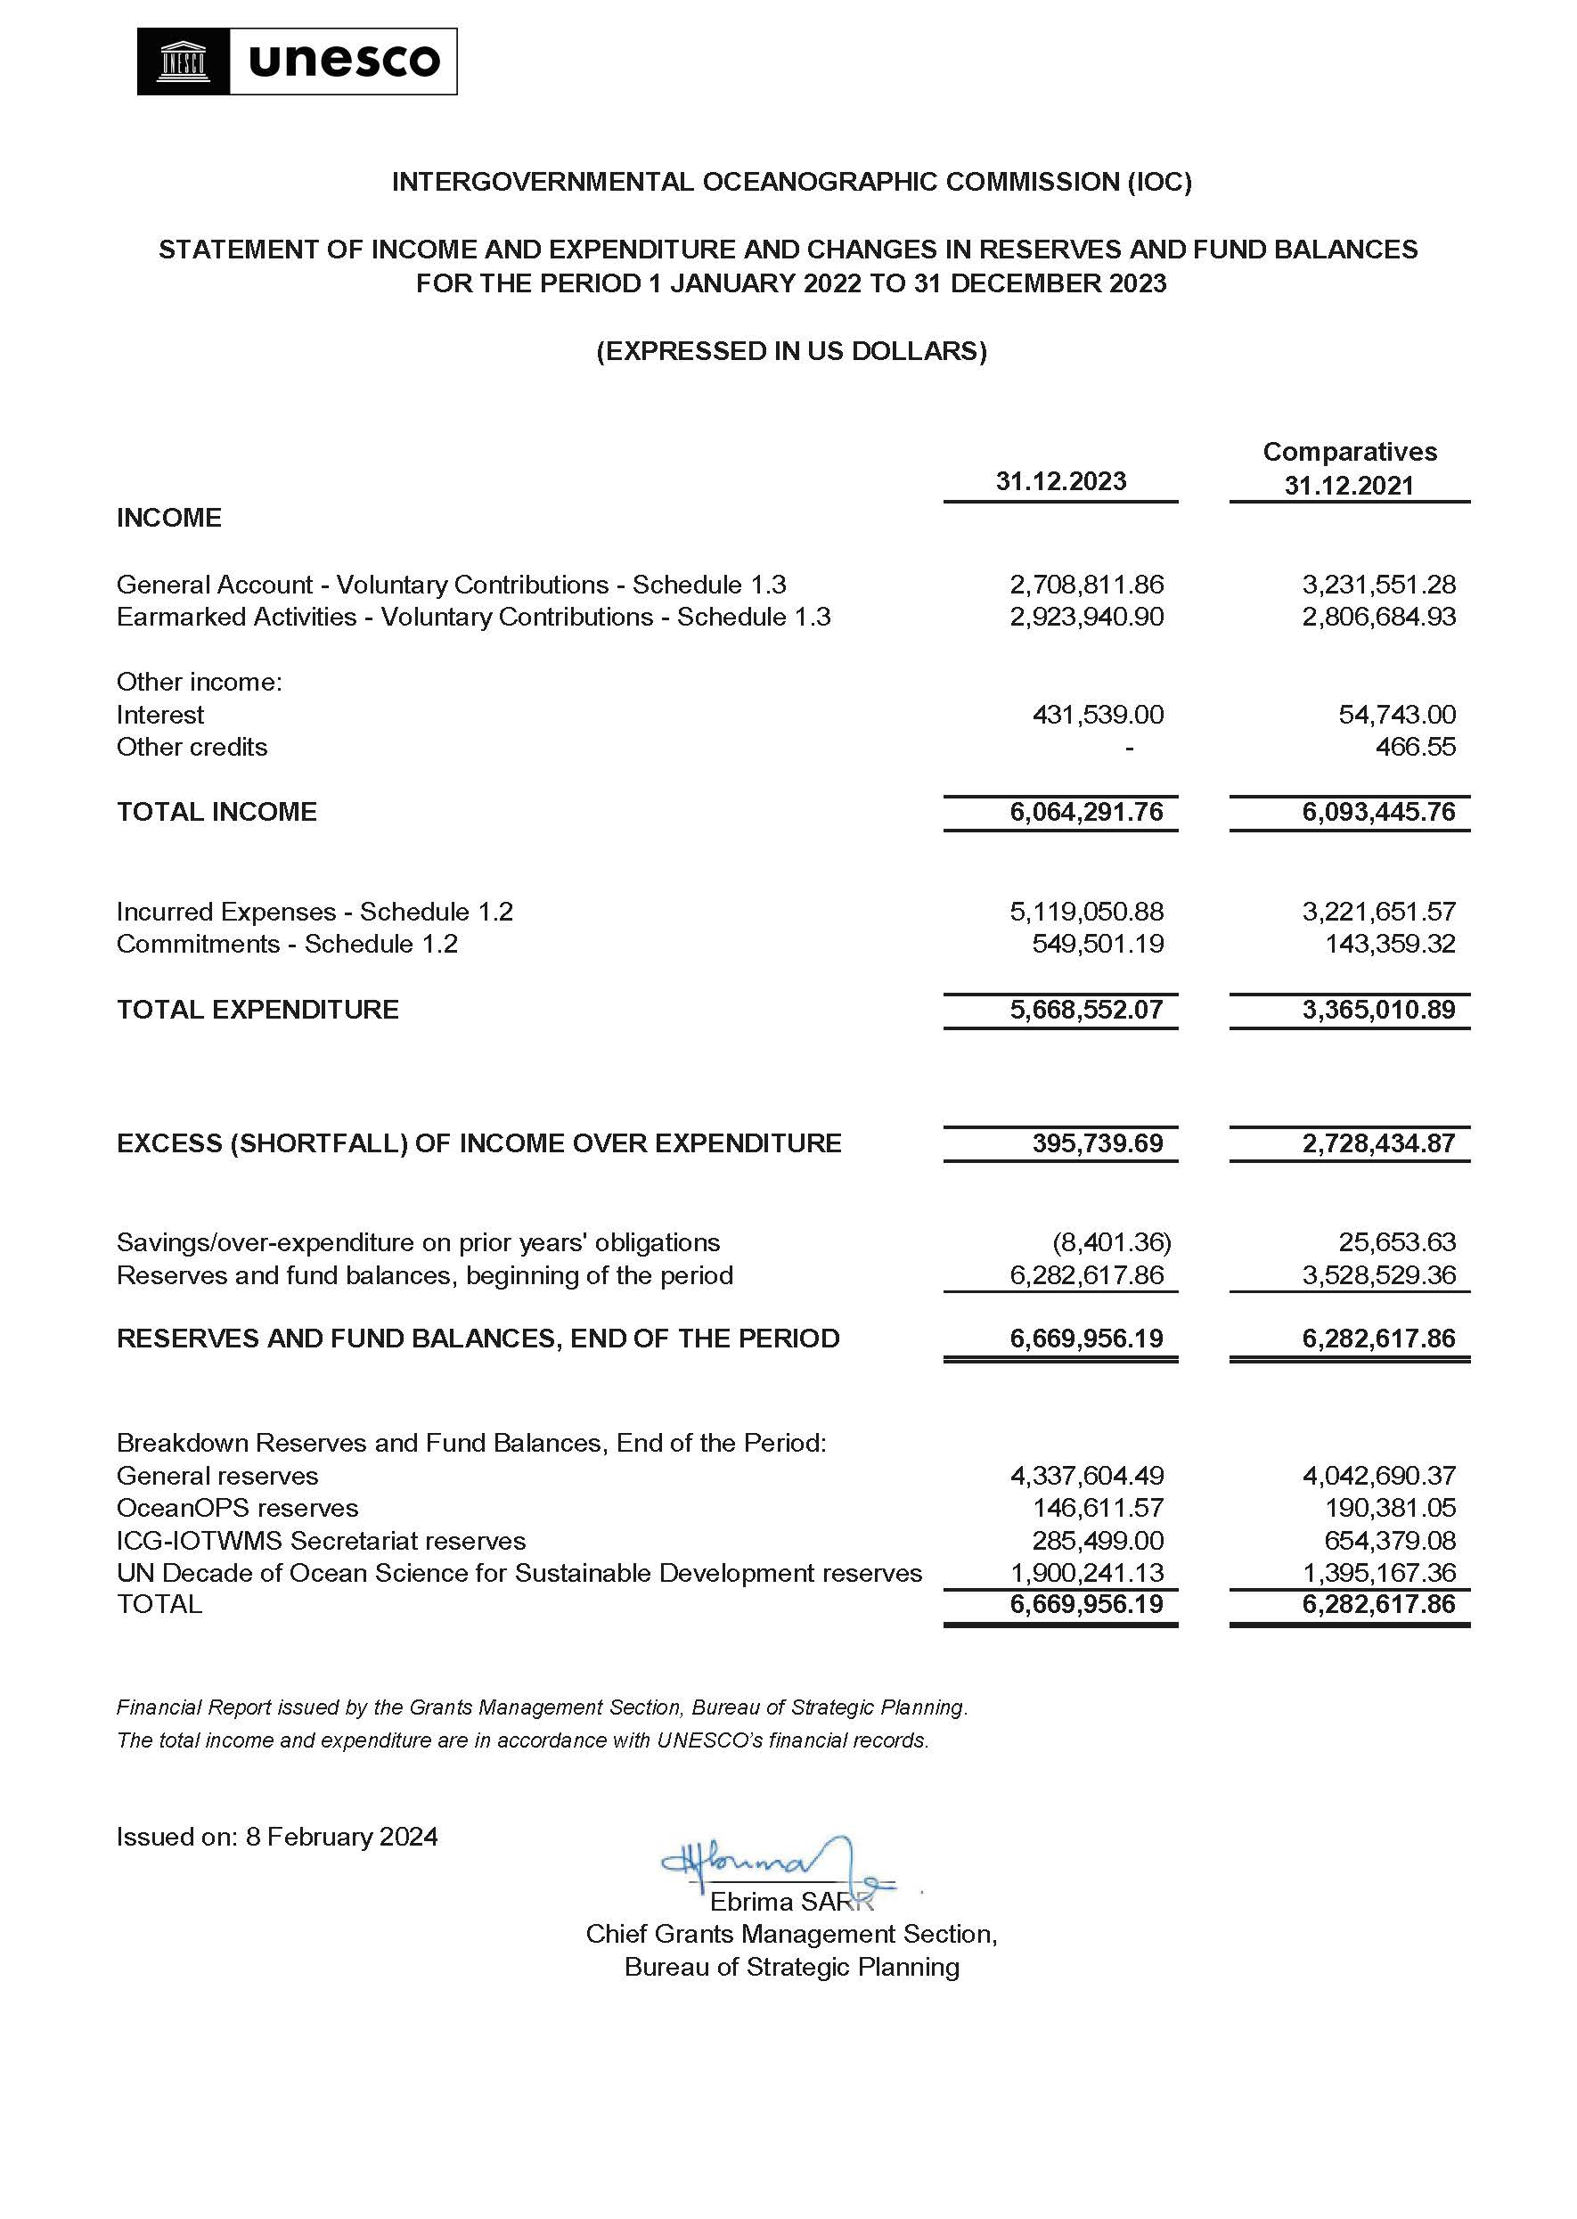

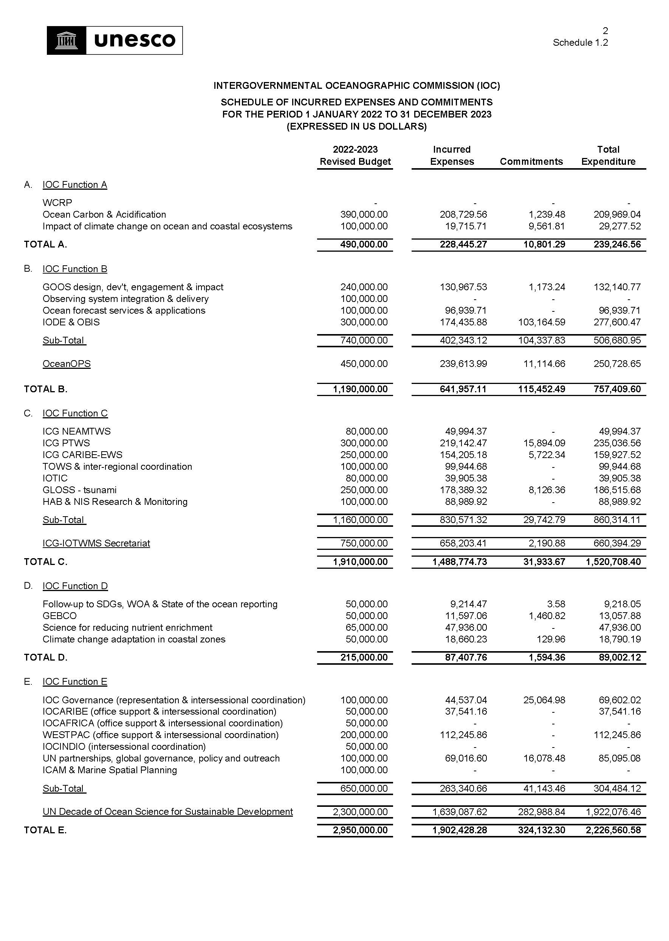
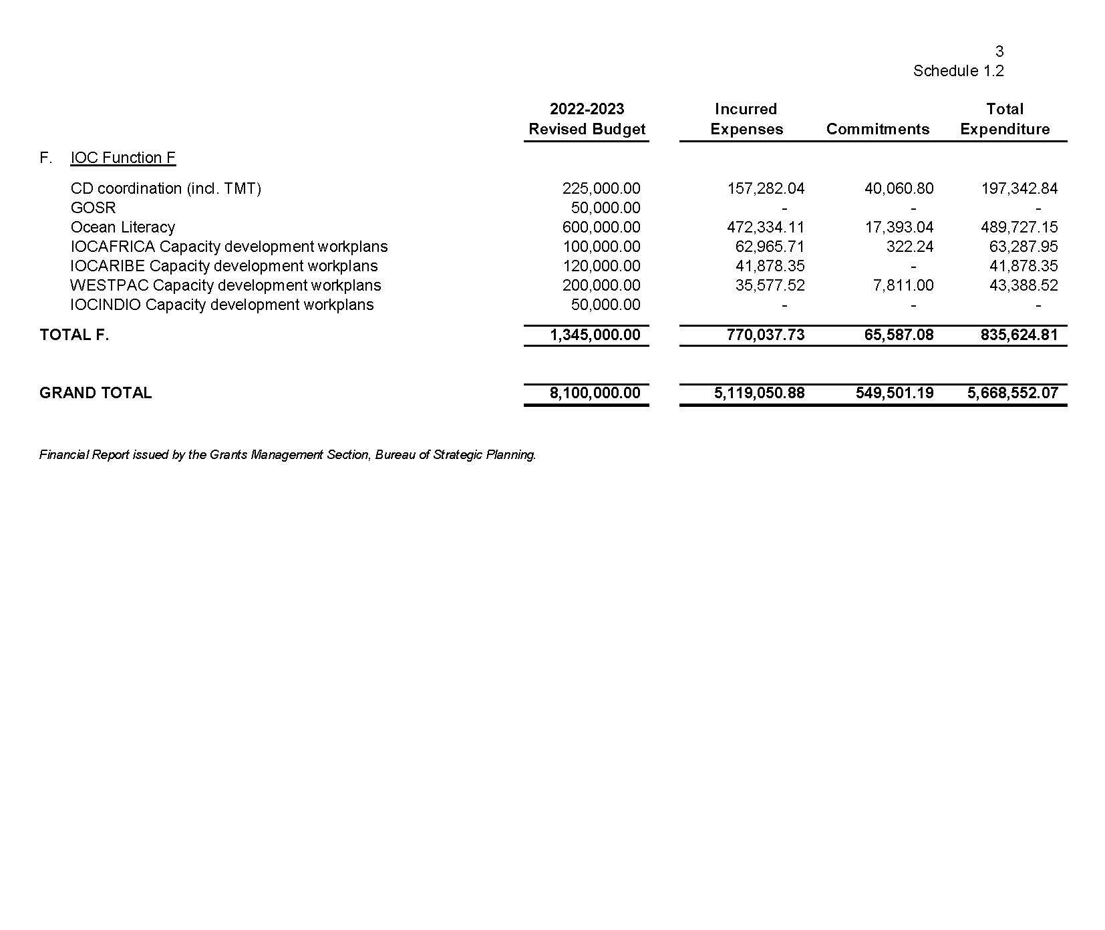

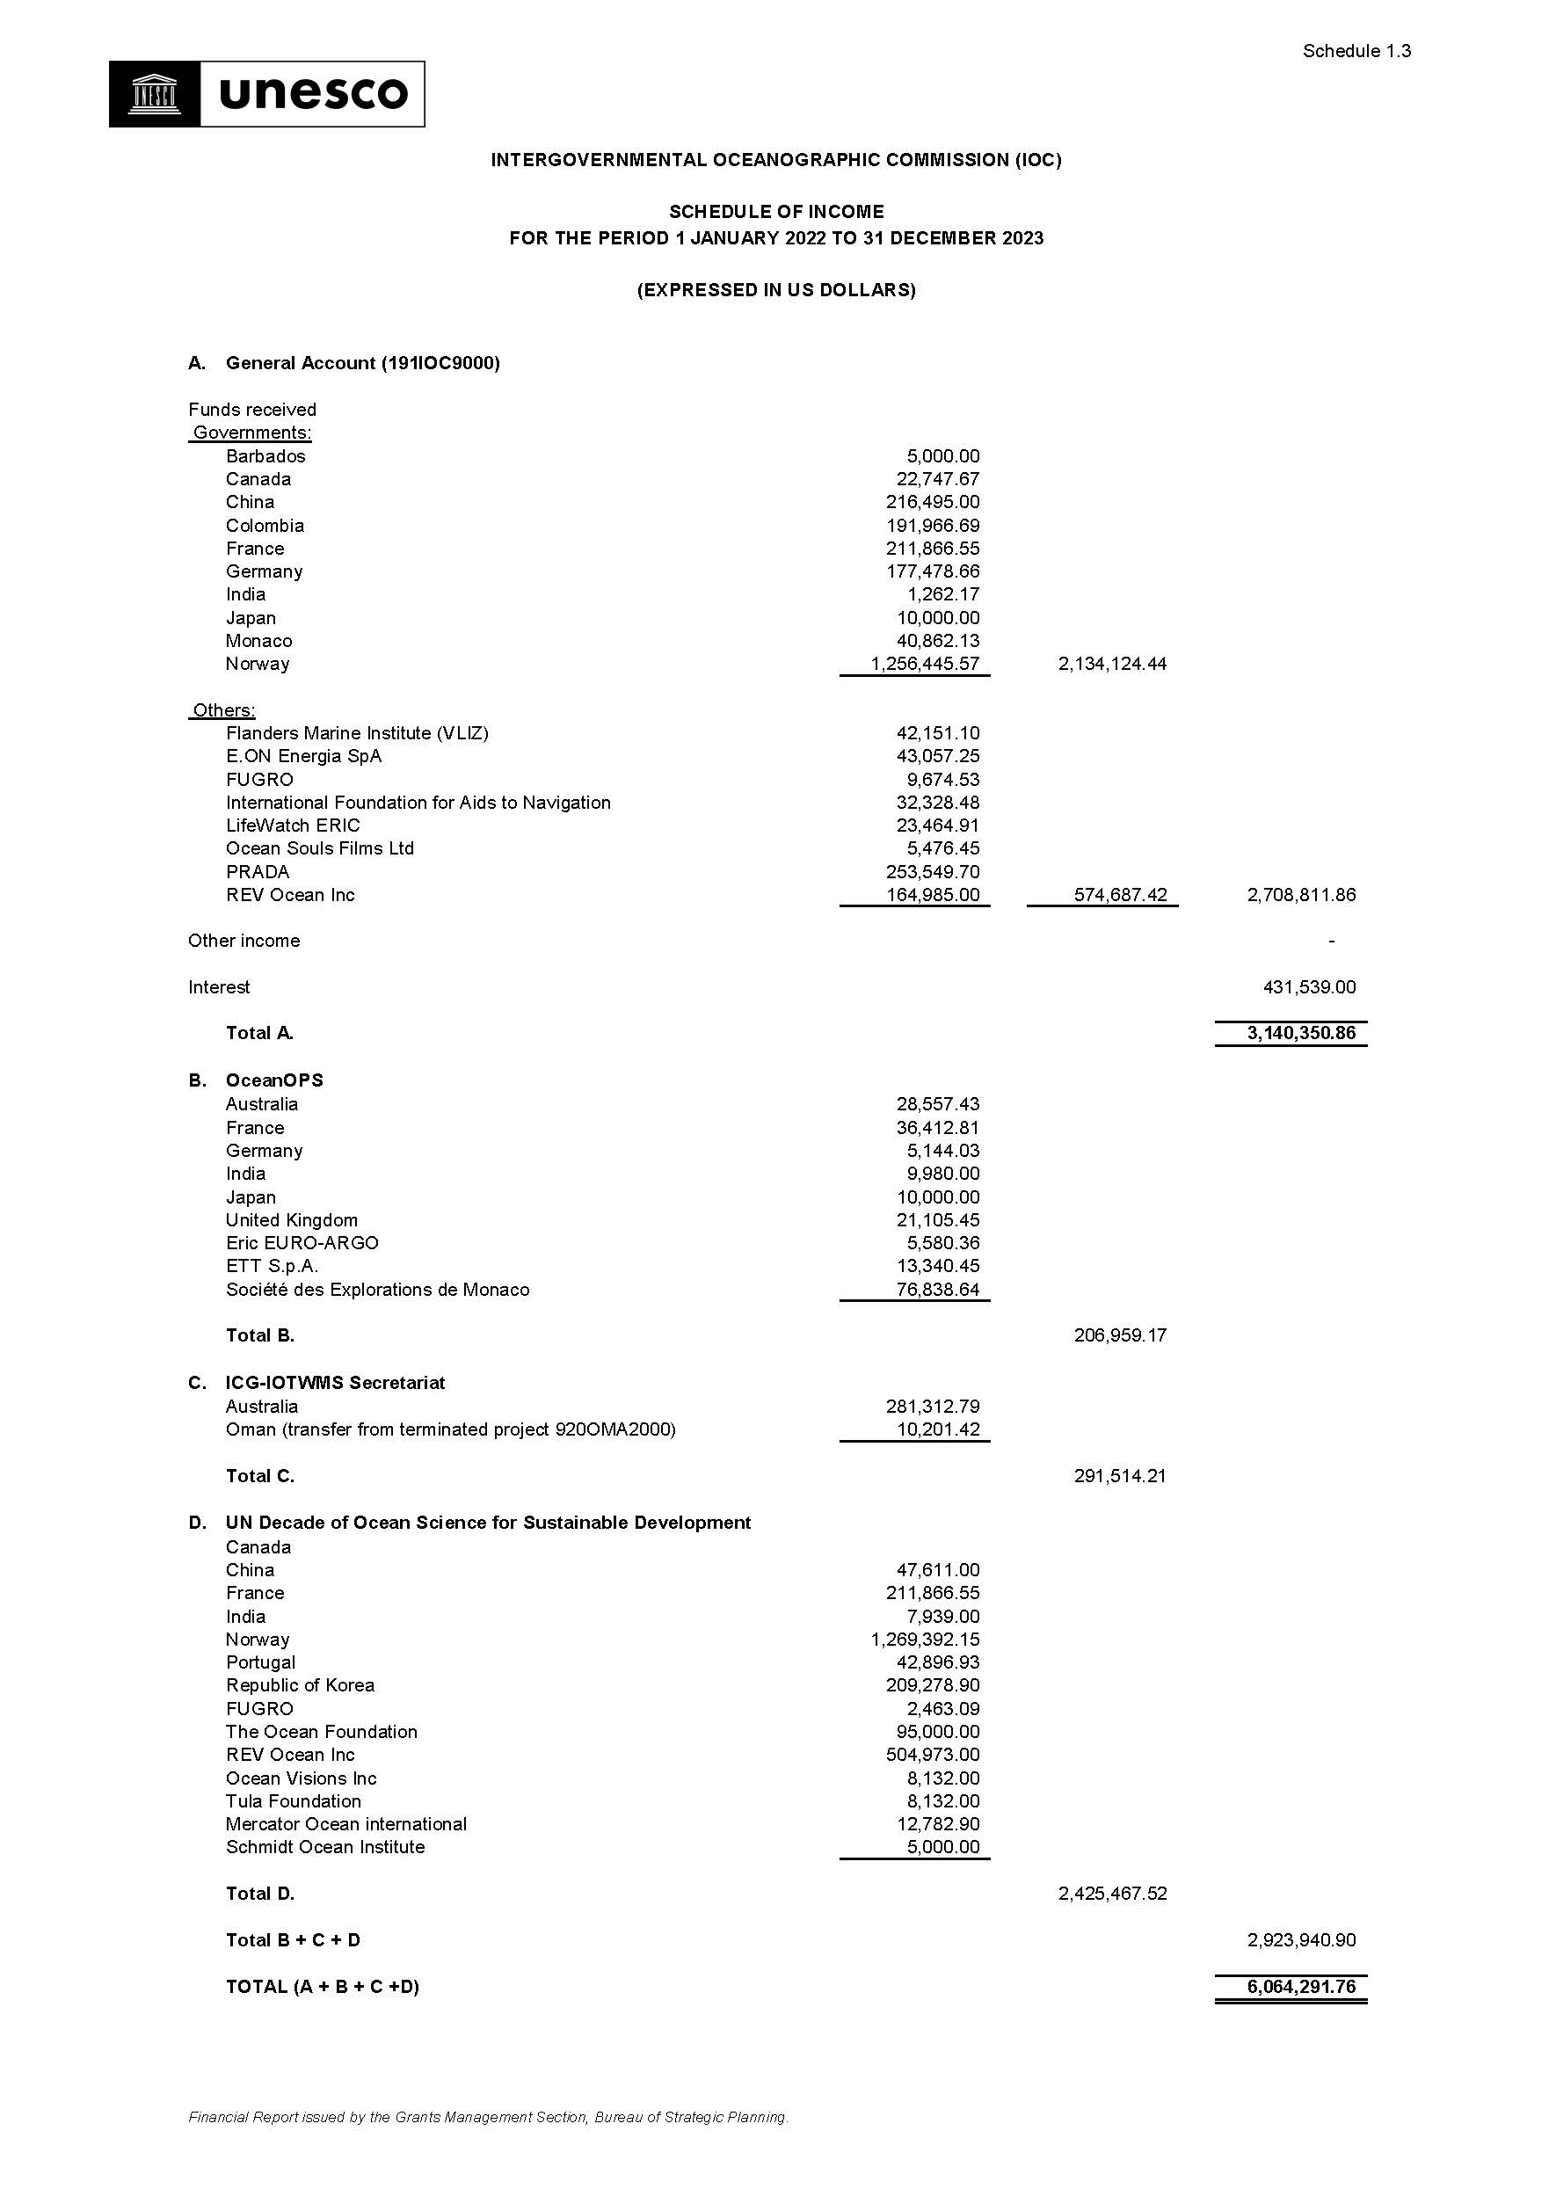
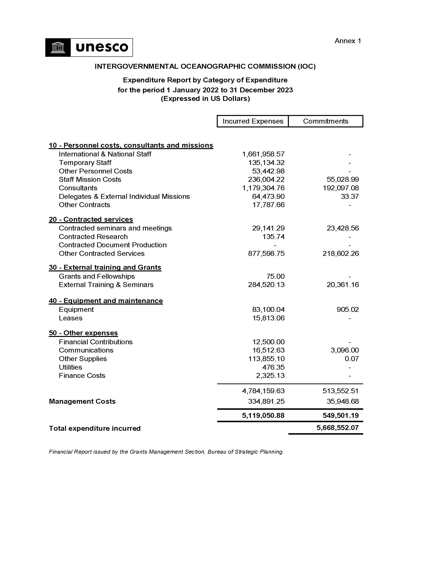
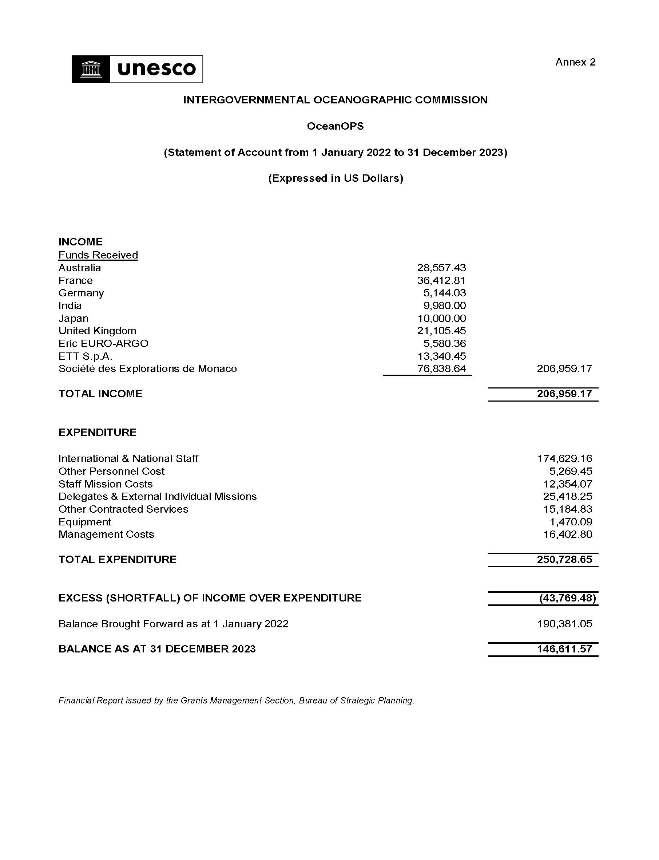

Includes contribution from NORAD in the amount of $457,295.92 received on 12.12.2023
Includes contribution from NORAD in the amount of $457,295.92 received on 12.12.2023
Proposed adjustments are based on observed capacity to mobilize the funds and expenditure trends.

