Restricted distribution IOC/IODE-MG-2024/7.5
2 January 2024
Original: English

INTERGOVERNMENTAL OCEANOGRAPHIC COMMISSION
(of UNESCO)

2024 Meeting of the IODE Management Group
IOC Project Office for IODE, Oostende, Belgium, 5-7 February 2024

REPORT ON THE USER FEEDBACK FOR IODE PROGRAMME COMPONENTS, ACTIVITIES AND PROJECTS

INTRODUCTION

During the past 6 decades the IODE programme network of over 100 data centres has created a wide variety of global databases, hosted by the IODE Secretariat and partners, providing ocean data and information, freely accessible to all. IODE has also established the OceanTeacher Global Academy providing free online and hybrid technical training in various areas of the IOC’s mandate. More recently IODE has embarked on the development of the Ocean Data and Information System (ODIS), creating a global federation of data systems, many of which are partners in the IODE network.

The need for reliable ocean data and information will be important more than ever during the UN Decade of Ocean Science for Sustainable Development and not only for the ocean research community: our products and services must address needs to users of the entire value chain from observation & science, through data & information management to decision making support.

It is for this reason that we embarked on an online survey of various IOC and Decade stakeholder communities to investigate their awareness, use, appreciation but also criticism of the IODE products and services.

The survey was opened on 10 October 2023 and closed on 15 November 2023.
The results are also available from https://www.surveymonkey.com/results/SM-I8qFyjyGj6L3jqEv3RVQnw_3D_3D/

TARGET AUDIENCES

Target audiences for the survey were as follows:
- IODE NODC
- IODE ADU
- IODE AIU
- Ocean Decade Programme
- Ocean Decade Project
- Ocean Decade Contributions (i.e. Decade Collaborative Centres, Decade Coordination Offices, Other Decade contributions)
- Scientist
- Private sector
- Government employee involved in coastal/marine management
- Civil society (NGO, ...)
- General public
- Student (university)
- Student (other)
- Other (please specify)

Emails were sent out to the OceanExpert mailing lists for IODE National Coordinators for Data Management, IODE National Coordinators for Marine Information Management, NODC contacts, ADU contacts, AIU contacts as well as to the larger IODE contacts (approx. 1800 addresses). In addition, the Decade Coordination Unit (DCU) sent the invitation to fill the survey to their contact lists. The IODE invitation emails included English, French and Spanish versions of the invitation text.

SURVEY QUESTIONS

The number of survey questions was kept small with only 9 questions:

- Q1: Are you working in an NODC, ADU, AIU, as a scientist, in the private sector, as decision maker, or other (you can tick more than one)
- Q2: In what country are you located? (enter in text box)
- Q3: Do you know our products/services and how would you rate them?
- Q4: Have you used our products/services?
- Q5: Have you contributed data/information to the product or service?
- Q6: How would you rate the user friendliness of the product/service?
- Q7: How easy/difficult was it to find what you were looking for?
- Q8: How would you rate the quality of the data/information in the service?
- Q9: Do you have any suggestions to improve the service?

RESULTS

responses BY RESPONDENT TYPE

A total of 286 individuals responded to the survey (2 did not respond to Q1).

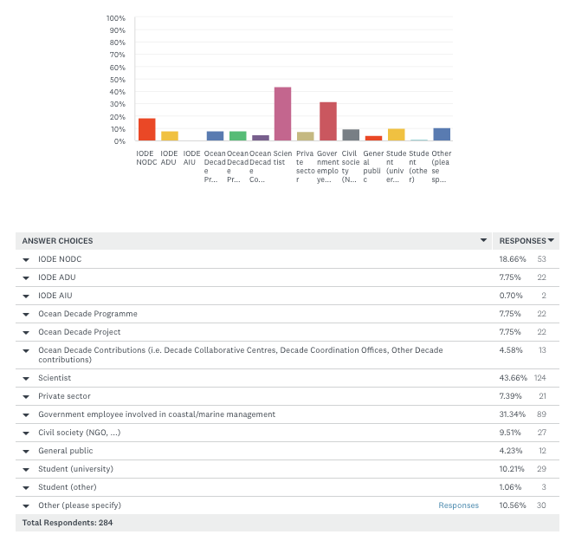
Figure 1: responses by respondent type

Figure 2 shows that scientists represented the largest group of respondents, followed by government employees involved in coastal/marine management. Respondents involved in the Ocean Decade (the 3 groups combined) represented only 20%. It is noted that many respondents identified with more than one respondent type (e.g. scientist and NODC and government employee involved in coastal/marine management).

Scientist | 43.7
Government employee involved in coastal/marine management | 31.3
IODE NODC | 18.7
Other (please specify) | 10.6
Student (university) | 10.2
Civil society (NGO, ...) | 9.5
IODE ADU | 7.7
Ocean Decade Programme | 7.7
Ocean Decade Project | 7.7
Private sector | 7.4
Ocean Decade Contributions (i.e. Decade Collaborative Centres, Decade Coordination Offices, Other Decade contributions) | 4.6
General public | 4.2
Student (other) | 1.1
IODE AIU | 0.7
Figure 2:distribution of respondents by type in %

IODE community respondents

For the IODE community respondents this corresponds with 76% of the NODCs and 52.4% of the ADUs. Only 2 out of the 6 AIUs responded.

Geographic distribution of responses

Responses were received from respondents in 90 countries. Figure 3 shows the geographic distribution and numbers by country. The number of responses by country varied from 1 to 16. The top 10 countries in terms of responses were Mexico, Argentina, Colombia, Spain, United States, Australia, Indonesia, Germany, India and Peru. Response from Africa was very poor as was the response from Eastern Europe. The full list of countries and number of respondents is included as Annex 2.

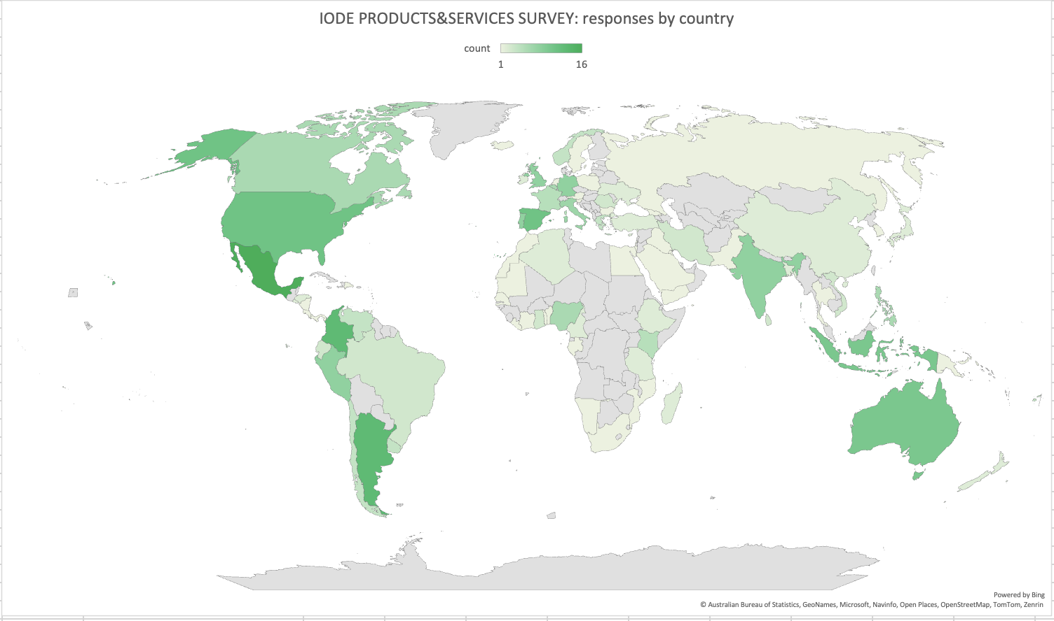
Figure 3: geographic distribution of survey responses

Results by Question

Q3: Do you know our products/services and how would you rate them?
286 responses
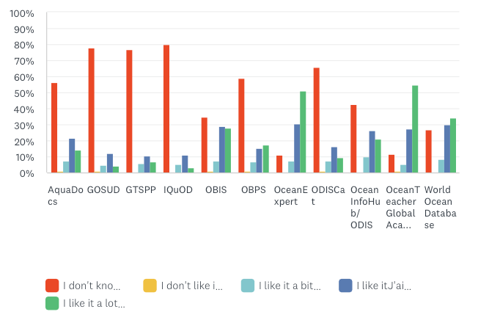
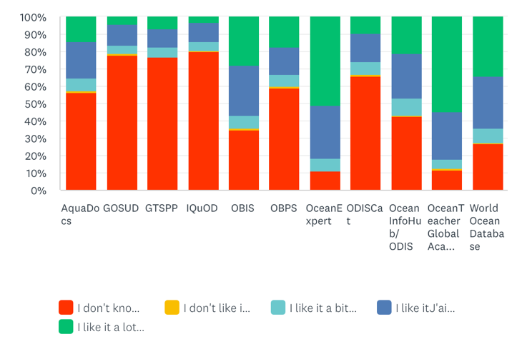
The results show that of the 10 products/services 3 are extremely poorly known (GOSUD, GTSPP, IQuOD) with close to 80% of the respondents indicating they do not know the produst/services. Only OceanExpert and OceanTeacher Global Academy have less than 20% unknown ratings.
In terms of user satisfaction OceanTeacher Global Academy, OceanExpert, World Ocean Database and OBIS score the highest.

Q4: Have you used our products/services?
285 responses

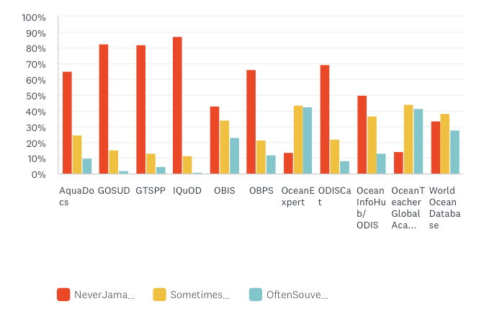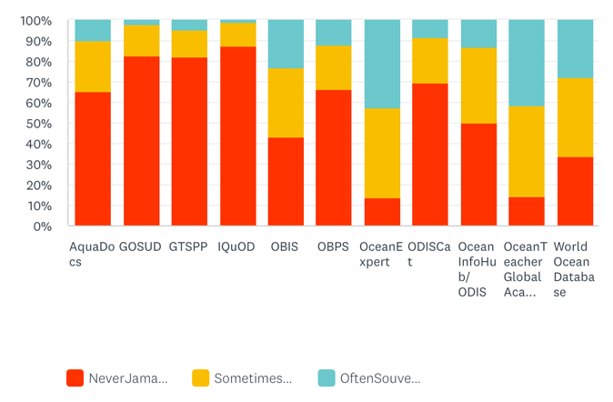

We see the same response ratios as for Question 3.

Q5: Have you contributed data/information to the product or service?
280 responses
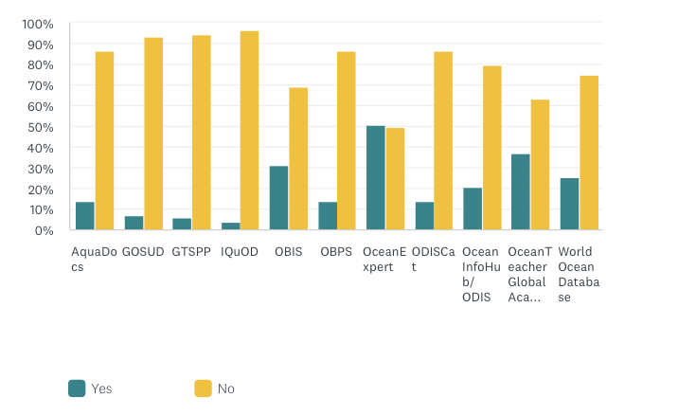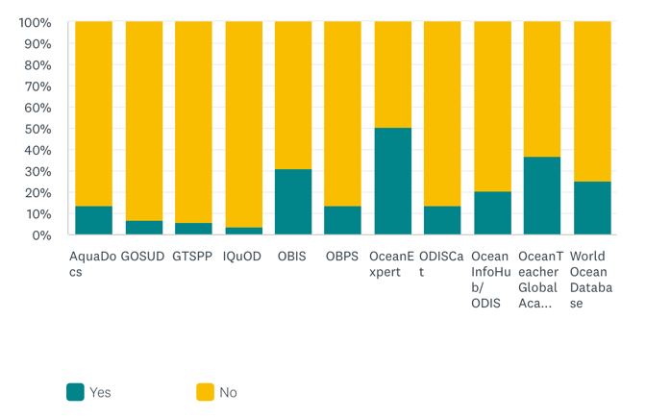

Very few respondents reported any contributions to the products and services except for OceanExpert (50%) OTGA (37) and OBIS (31%).

Q6: How would you rate the user friendliness of the product/service?
268 responses
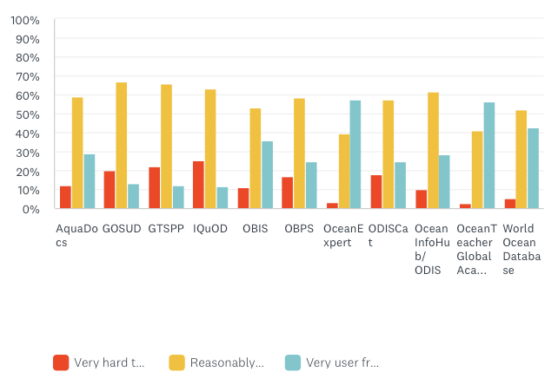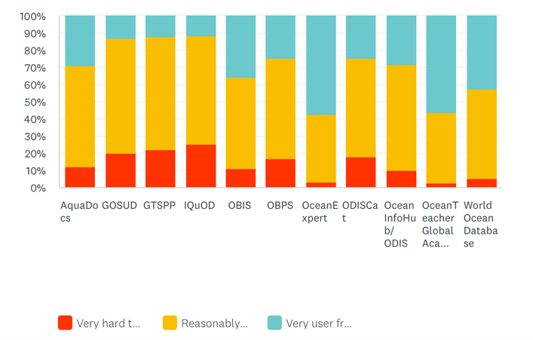

OceanExpert (57%), OTGA (56%) and WOD (42%) are considered as the most user friendly.

Q7: How easy/difficult was it to find what you were looking for?
258 responses
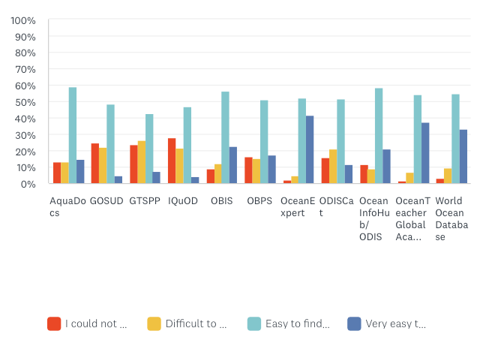
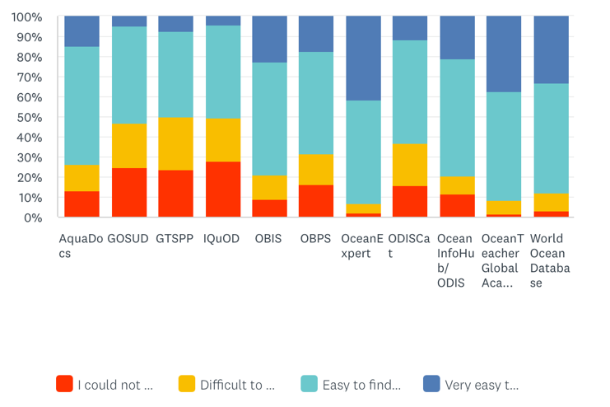

Nearly all score similarly around 50% “easy to find” with OceanExpert, OTGA and WOD getting “very easy to find”.

Q8: How would you rate the quality of the data/information in the service?
255 responses
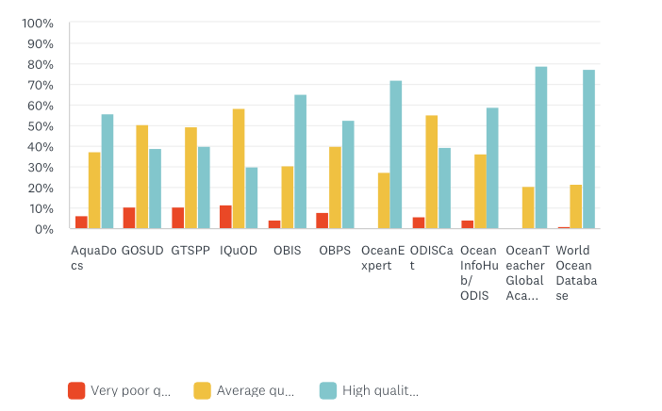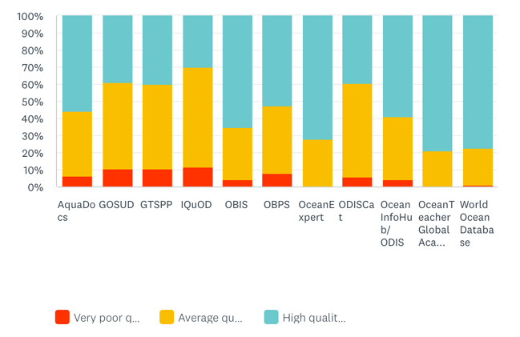
OceanTeacher Global Academy, World Ocean Database, OceanExpert and OBIS receive the highest ratings for quality of the data/information in the service.

Q9: Do you have any suggestions to improve the service?

Note: it should be noted that the below comments are comments by individuals and the number of individual responses for this question were very small: between 4 and 9 per product/service. The comments should therefore not be considered as the opinion of the full set of respondents.

Aquadocs

no particular suggestion (we prefer to go to OBPS)

awareness of what this product/service is and the benefits to use made clearer

would be better if ocean experts like young ECOPs are given opportunities to contribute.

improve socialisation - as I never heard this acronym before

make platform more user friendly

extending interoperability to receive existing library catalogues

support activities that promote AquaDocs

this need to be popularized at bit more.

implement OAI interoperability

implement advanced search features with various filters to allow users to find documents based on author, publication year, topic, species, etc

desires for training

improve the dissemination service, I suggest social networks

inform more about how to contribute

improving the platform

IODE should continue to fund its part of AquaDocs. Donations from librarians kept it going this year, but it will fail if it does not have future support.

GOSUD

- qwareness of what this product/service is and the benefits to use made clearer
- improved UI is needed
- add regional ocean data
- modernize the interface and Web Search
- Offer visualization tools for users to understand and interpret the data easily
- improve socialisation - as I never heard this acronym before
- improve the quality of your database
- make platform more user friendly
- improve dissemination. Publicise what it is and how to use it
- support activities that promote GOSUD
- community needs to learn more about such IODE services
- divulgation
- offer visualization tools for users to understand and interpret the data easily.
- improve the dissemination service, I suggest social networks
- promote its utility
- improve quality

GTSPP

- as the data are available in WOD we go to WOD
- awareness of what this product/service is and the benefits to use made clearer
- improved UI is needed
- add regional ocean data
- modernize the interface and Web Search
- improve socialisation - as I never heard this acronym before
- make plataform more user friendly
- improve dissemination. Publicise what it is and how to use it
- support activities that promote GTSPP
- needs to evolve in line with WIS2.0
- community needs to learn more about such IODE services
- divulgation
- improve the dissemination service, I suggest social networks
- inform about it and its capabilities

IQuOD

- give more visibility to it and enlarge it to other important parameters in WOD such as salinity in particular
- awareness of what this product/service is and the benefits to use made clearer
- intelligent data search interface is needed
- add regional ocean data
- modernize the interface and Web Search
- improve socialisation - as I never heard this acronym before
- It's very important to me
- make plataform more user friendly
- improve dissemination. Publicise what it is and how to use it
- support activities that promote IQuOD
- community needs to learn more about such IODE services
- divulgation
- improve the dissemination service, I suggest social networks
- inform more about it and contributions
- improve platform

OBIS

- keep going - but still improve socialisation as few colleagues know about it
- improve dissemination. Publicise what it is and how to use it
- support activities that promote OBIS
- facilitate the process to mobilize data into OBIS (community sees this as a difficult process). Coordinate better with or merge with GBIF by becoming the aquatic branch of GBIF and still keep under IODE (GBIF and OBIS would benefit; the entire community would benefit)
- countries should mandate data publication into obis
- I love OBIS, but it is very very hard to figure out how to run a search and download the records, versus just see a map. I have given up using it in education/training work because the UI is so unintuitive
- more training and more funding for data stewardship
- search bar mechanism is not very intuitive
- develop educational materials and resources on marine biodiversity, targeting both academic and general audiences
- desires for training
- improve the dissemination service, I suggest social networks
- allow for API get and Push services
- improve the platform
- OBIS is a critical platform for marine biodiversity data. It is fantastic - please reverse your decision to dramatically reduce funding for OBIS.
- promote further by investing in Communications and Outreach

OBPS

- use cases and unique selling points for this service should be communicated better for a scientific audience
- multilanguage support is needed
- the metadata available for BPs is not sufficient in narrowing search results to determine fitness for purpose
- improve socialisation - as I never heard this acronym before
- improve dissemination. Publicise what it is and how to use it
- support activities that promote OBPS
- better search interface now volume of documentation is high
- community needs to learn more about such IODE services
- there are a lot of good guides in OBPS, but also a lot of less authoritative things. It can be hard to find what you really want
- link better and more automatically with other relevant repositories
- improve the dissemination service, I suggest social networks

OceanExpert

- use cases and unique selling points for this service should be communicated better for a scientific audience
- information is not always up-to-date
- could be more professional. Networking possibilities should be increased.
- keep going - but still improve socialisation as few colleagues know about it
- excellent help
- you could add more images
- very satisfied
- initiate a drive that pulls people of influence to talk on the issue
- the service is very well delivered
- training
- improve portal
- that it could connect to LinkedIn
- there is something about self enrollment that is seems isn't work efficiently. I think you can improve
- using social media to publicise events
- improve dissemination. Publicise what it is and how to use it
- support activities that promote ocenxpert
- community needs to learn more about such IODE services
- enhance networking features, such as forums or groups, to encourage collaboration and communication among professionals
- improve the dissemination service, I suggest social networks
- Promote further by investing in Communications and Outreach

ODISCat

- enable easy access to national entries as national IODE IODE coordinator and enable submission of needed updates (specially when the coordinator changes)
- use cases and unique selling points for this service should be communicated better for a scientific audience
- improve socialisation - as I never heard the ODIS acronym before
- make plataform more user friendly
- improve dissemination. Publicise what it is and how to use it
- support activities that promote ODISCat
- this need to be popularized at bit more.
- content improvements (already underway)
- community needs to learn more about such IODE services
- not complete, but a promising effort
- desires for training
- improve the dissemination service, I suggest social networks
- more information about it and accesibility

Ocean InfoHub

- to have more teaching/training ssessions via televideoconference for the novice/future users.
- use cases and unique selling points for this service should be communicated better for a scientific audience
- add regional ocean data
- improve socialisation - as I never heard the ODIS acronym before
- regional or local datasets linked
- very nice
- more sources
- make platform more user friendly
- that blue carbon issues be touched upon
- improve dissemination. Publicise what it is and how to use it
- support activities that promote ocean infohut/ODIS
- community needs to learn more about such IODE services
- establish a helpdesk or support system for users who need assistance navigating or using the resources
- desire training
- improve the dissemination service, I suggest social networks

OceanTeacher

- provide more material in Spanish
- the platform offers a service which is useful, however the administration of access to the content is difficult and not user friendly.
- multilanguage support is needed (all UNESCO languages)
- more face-to-face training course, please.
- diversify training
- a more detailed user guide would be helpful.
- better if Trainings are alerted through emails. Registration process can be made easier. Online option for attending trainings, recordings and materials for self paced learning would make it better.
- improve socialisation - as I had not heard of this service
- make it more fluid in access and notify changes in advance
- on-site courses
- the provided material (eg presentations) to stay open for ever
- a wonderful training tool
- important
- allow participants to attend to the seminar
- that blue carbon issues be touched upon
- streamline the communication of private messages with those responsible for the courses. That all the information presented is downloadable, including the videos
- expand the course offering without the need for a recommendation or directive from the entity where you work.To improve the online platform which have access troubles sometimes
- WEB with a more intuitive design, which includes a simpler search for courses by RTCs, for example
- when the modality is online, there are no limits on the number of participants. Do not discriminate against students based on age.
- give more formation with certificate
- have more training course with full scholarship in a year
- support activities that promote Ocean Teacher Gaobal Academy
- community needs to learn more about such IODE services
- provide interactive learning opportunities, such as webinars, live Q&A sessions, and virtual labs.
- Big Blue Button is extremely unreliable and problematic to deploy. In my opinion it undermines OTGA, as everything else is great.
- improve the dissemination service, I suggest social networks
- offer more programs for information professionals
- promote further by investing in Communications and Outreach

World Ocean Database

- how to contribute data when one is not clear about data policy in one's country ?
- can't find an API for requesting different data/ metadata by script
- enable a more interactive feedback and improve the QC of data from oceanographic cruises
- awareness of what this product/service is and the benefits to use made clearer
- add regional ocean data
- would benefit from an API solution
- modernize the interface and Web Search
- could be improved with more recent data and data of higher resolutions could be made available.
- improve socialisation - as I had not heard of this service
- allow for everyone to access to it
- make plataform more user friendly
- Implement a more interactive geographic application, have more information about the data at hand before downloading it, to know if it is useful
- improve dissemination. Publicise what it is and how to use it
- support activities that promote world ocean datebase
- augment historical biodiversity and biological observations
- very nice
- update UI and UX, it is very outdated
- ensure the database interface is user-friendly and supports advanced queries for diverse user needs
- the WOD should harverst data in order to have the most QC:ed data. European data repositories are more accurate.
- improve the dissemination service, I suggest social networks

Results by Question and Respondent types

IODE community (NODC, ADU, AIU) (75 responses) vs all respondents

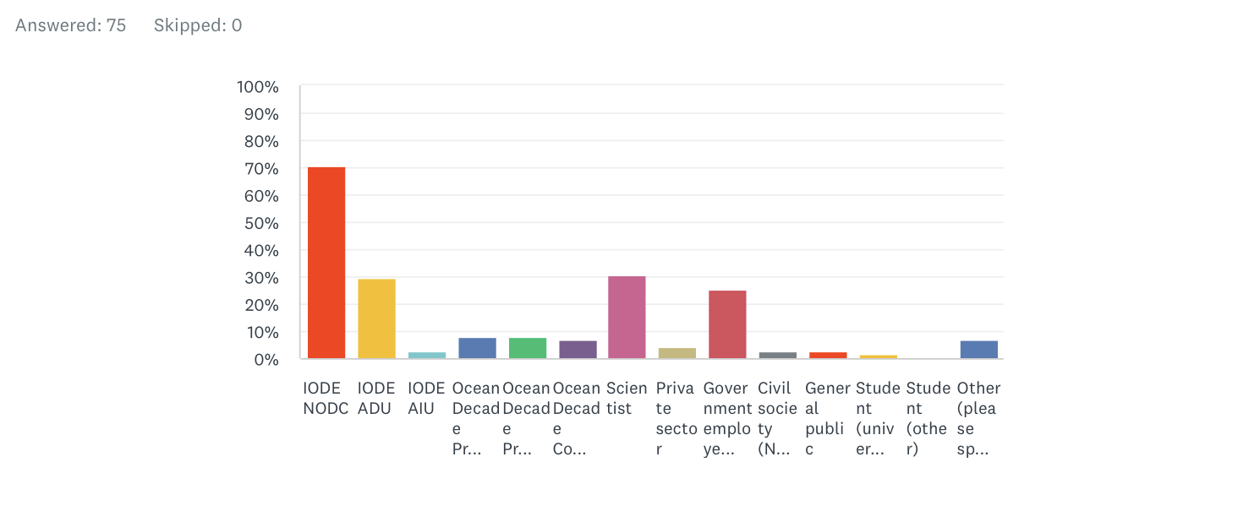
As mentioned previousy respondents from NODCs, ADUs and AIUs also described themselves often as part of other respondent types.

Q3: Do you know our products/services and how would you rate them?
75 responses

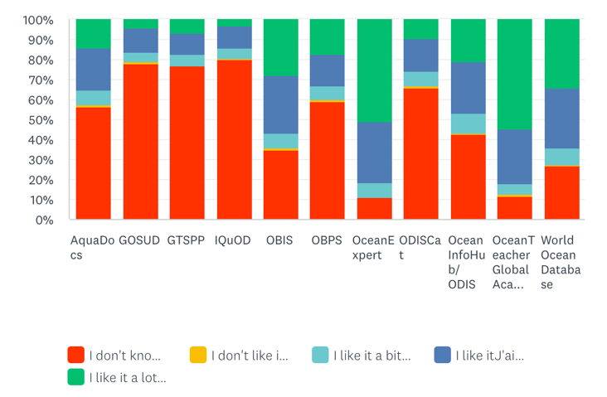
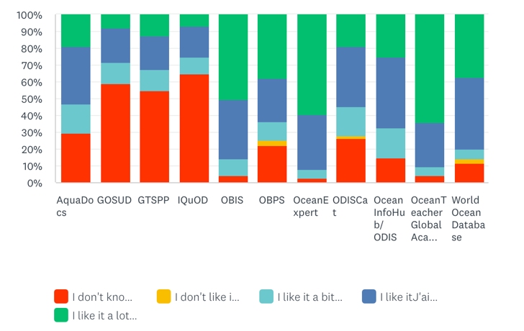

All respondent types NODC, ADU, AIU

The results show that within the IODE community knowledge of AquaDocs, OBIS, OBPS, ODISCat, OIH is substantially better that for the entire set of respondents. Awareness of GOSUD, GTSPP and IQuOD remain low with approx. 60% of the respondents having no knowledge of these activities (80% for all respondent types).

Q4: Have you used our products/services?
75 responses
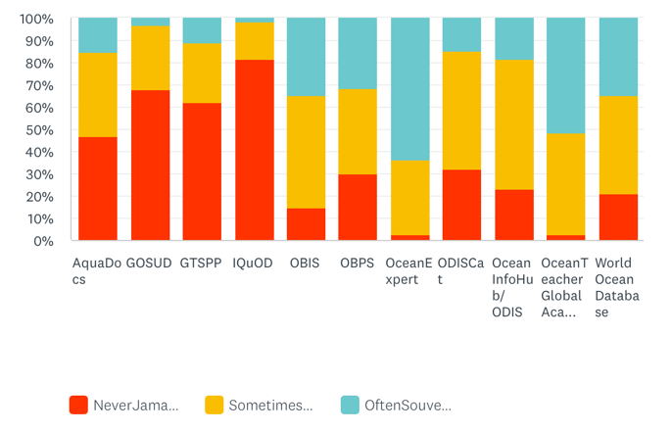

All respondent types NODC, ADU, AIU

We see similar changes as for Q3.

Q5: Have you contributed data/information to the product or service?

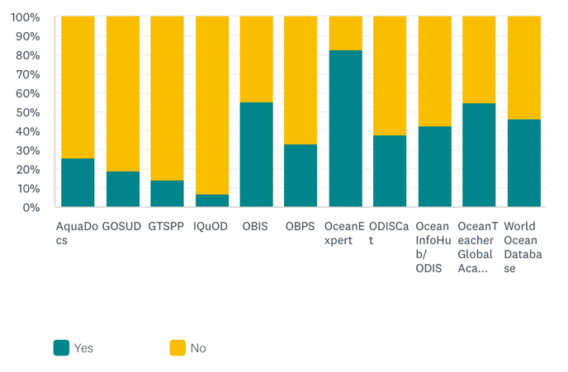
All respondent types NODC, ADU, AIU

Very few respondents reported any contributions to the products and services except for OceanExpert (83%), OBIS (55%), OIH (42%), OTGA(54%) and WOD (46%). The relatively high percentage for WOD should have been expected as data centres are supposed to provide their data to the WOD for long-term and secure archival. The relatively high percentage for OBIS should also have been expected but is lower than expected due to the small number of ADUs who responded (52%). GOSUD, GTSPP and IQuOD score the lowest.

Q6: How would you rate the user friendliness of the product/service?
74 responses
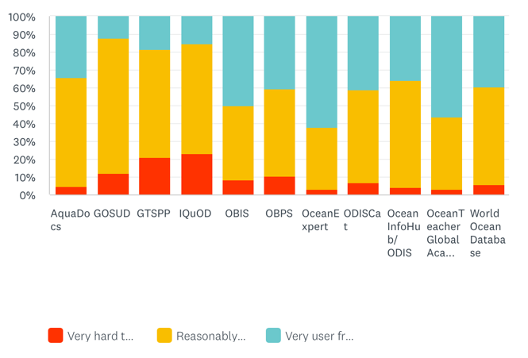
All respondent types NODC, ADU, AIU

User friendliness is assessed the highest for OceanExpert (62%), OTGA (56%), OBIS (50%). GOSUD, GTSPP and IQuOD score the lowest.

Q7: How easy/difficult was it to find what you were looking for?
69 responses
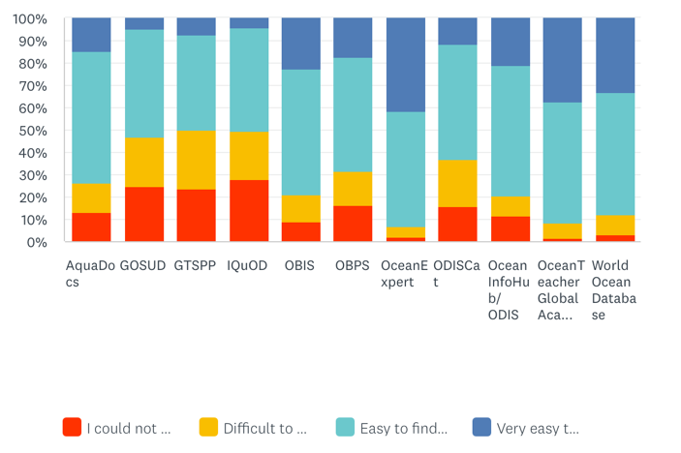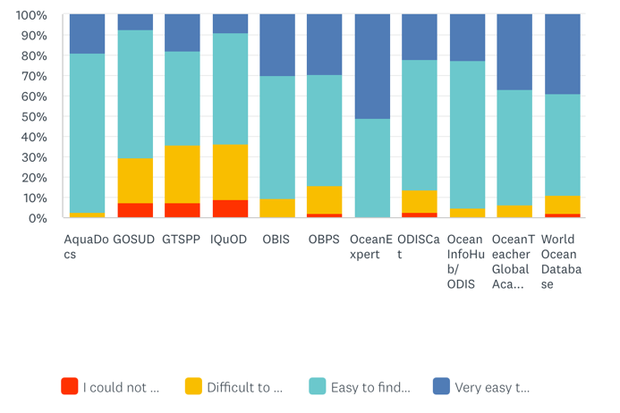
All respondent types NODC, ADU, AIU

Nearly all score similarly around 50% “easy to find” with OceanExpert, OTGA and WOD getting the highest scores for “very easy to find”. GOSUD, GTSPP and IQuOD score the lowest.

Q8: How would you rate the quality of the data/information in the service?
73 responses
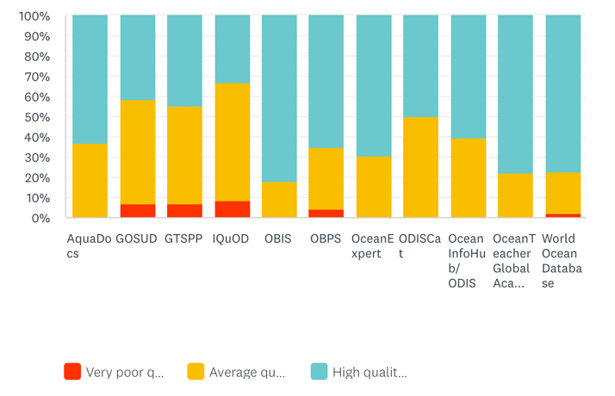
All respondent types NODC, ADU, AIU

OBIS (82%) gets the highest rating for quality followed by OTGA (78%),WOD (77%), OceanExpert (70%). GOSUD, GTSPP and IQuOD score the lowest.

Q9: Do you have any suggestions to improve the service?

Note: it should be noted that the below comments are comments by individuals and the number of individual responses for this question were very small. The comments should therefore not be considered as the opinion of the full set of respondents.

Aquadocs

no particular suggestion (we prefer to go to OBPS)

awareness of what this product/service is and the benefits to use made clearer

extending interoperability to receive existing library catalogues

support activities that promote AquaDocs

this need to be popularized at bit more.

implement OAI interoperability

implement advanced search features with various filters to allow users to find documents based on author, publication year, topic, species, etc

desires for training

improve the dissemination service, I suggest social networks

GOSUD

- awareness of what this product/service is and the benefits to use made clearer
- improved UI is needed
- Offer visualization tools for users to understand and interpret the data easily
- improve socialisation - as I never heard this acronym before

GTSPP

- as the data are available in WOD we go to WOD
- awareness of what this product/service is and the benefits to use made clearer
- improved UI is needed
- modernize the interface and Web Search
- needs to evolve in line with WIS2.0
- divulgation
- improve the dissemination service, I suggest social networks

IQuOD

- give more visibility to it and enlarge it to other important parameters in WOD such as salinity in particular
- awareness of what this product/service is and the benefits to use made clearer
- intelligent data search interface is needed
- modernize the interface and Web Search
- divulgation
- improve the dissemination service, I suggest social networks

OBIS

- link between GBIF and OBIS is unclear - this could be clarified
- more training and more funding for data stewardship
- develop educational materials and resources on marine biodiversity, targeting both academic and general audiences
- desires for training
- improve the dissemination service, I suggest social networks

OBPS

- use cases and unique selling points for this service should be communicated better for a scientific audience
- multilanguage support is needed

OceanExpert

- use cases and unique selling points for this service should be communicated better for a scientific audience
- information is not always up-to-date
- that it could connect to LinkedIn
- enhance networking features, such as forums or groups, to encourage collaboration and communication among professionals

ODISCat

- enable easy access to national entries as national IODE IODE coordinator and enable submission of needed updates (specially when the coordinator changes)
- use cases and unique selling points for this service should be communicated better for a scientific audience
- this need to be popularized at bit more.
- content improvements (already underway)
- desires for training
- improve the dissemination service, I suggest social networks

Ocean InfoHub

- to have more teaching/training ssessions via televideoconference for the novice/future users.
- use cases and unique selling points for this service should be communicated better for a scientific audience
- regional or local datasets linked
- establish a helpdesk or support system for users who need assistance navigating or using the resources
- desire training
- improve the dissemination service, I suggest social networks

OceanTeacher

- the platform offers a service which is useful, however the administration of access to the content is difficult and not user friendly.
- multilanguage support is needed (all UNESCO languages)
- a more detailed user guide would be helpful.
- on-site courses
- the provided material (eg presentations) to stay open for ever
- a wonderful training tool

World Ocean Database

- how to contribute data when one is not clear about data policy in one's country ?
- can't find an API for requesting different data/ metadata by script
- enable a more interactive feedback and improve the QC of data from oceanographic cruises
- awareness of what this product/service is and the benefits to use made clearer
- would benefit from an API solution
- modernize the interface and Web Search
- Implement a more interactive geographic application, have more information about the data at hand before downloading it, to know if it is useful
- ensure the database interface is user-friendly and supports advanced queries for diverse user needs
- the WOD should harverst data in order to have the most QC:ed data. European data repositories are more accurate.
- improve the dissemination service, I suggest social networks

UN Ocean Decade community (Ocean Decade Programme, Ocean Decade Project, Ocean Decade Contributions) (44 responses) vs all respondents

Q3: Do you know our products/services and how would you rate them?
44 responses

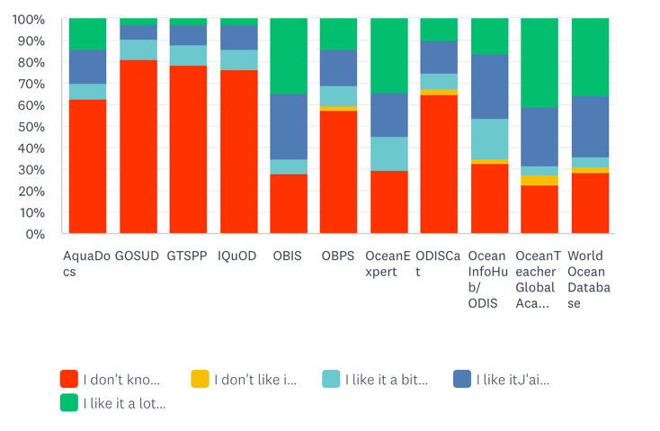

All respondent types UN Ocean Decade community

The results show that within the UN Ocean Decade community knowledge of IODE products and services is similar to the results for all respondents.

Q4: Have you used our products/services?
43 responses
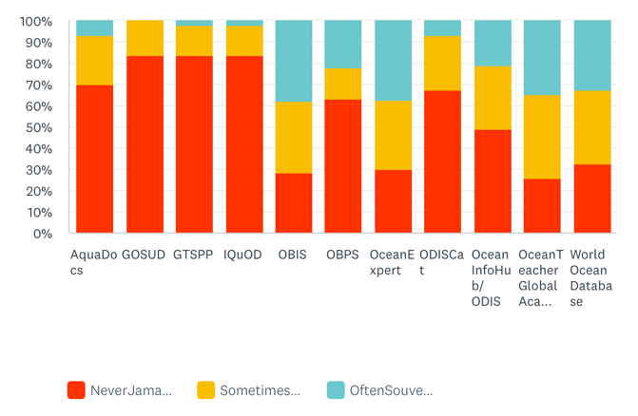

All respondent types UN Ocean Decade community

We see similar changes as for Q3 but with higher use rate for OBIS but lower rate for OTGA. GOSUD, GTSPP and IQuOD score the lowest.

Q5: Have you contributed data/information to the product or service?
54 responses
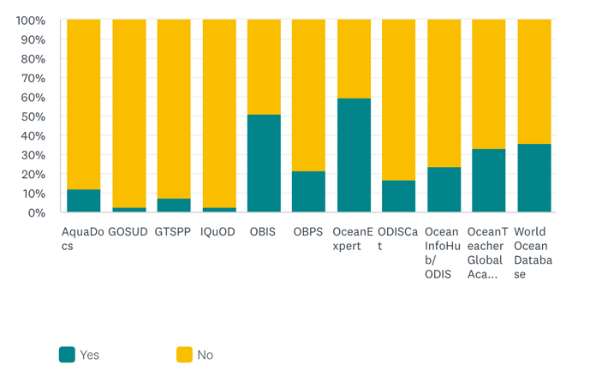
All respondent types UN Ocean Decade community

Very few respondents reported any contributions to the products and services except for OceanExpert (60%), OBIS (51%), WOD (36%). OTGA (33%). GOSUD, GTSPP and IQuOD score the lowest.

Q6: How would you rate the user friendliness of the product/service?
37 responses
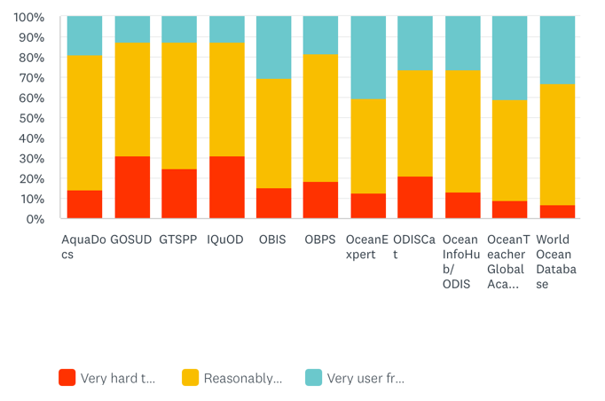
All respondent types UN Ocean Decade community

User friendliness is assessed the highest for OceanExpert (41%), OTGA (41%), OBIS (30%). GOSUD, GTSPP and IQuOD score the lowest.

Q7: How easy/difficult was it to find what you were looking for?
34 responses
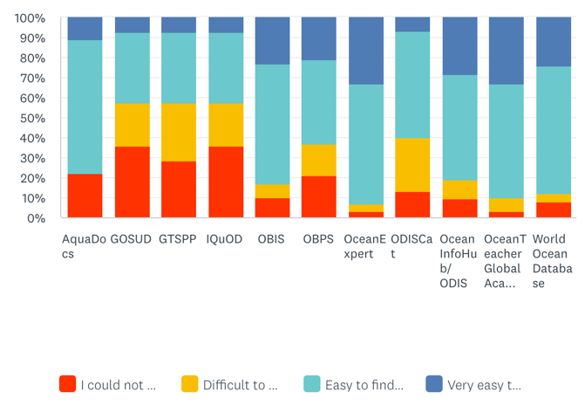
All respondent types UN Ocean Decade community

No significant differences with the overall respondent pool.

Q8: How would you rate the quality of the data/information in the service?
36 responses
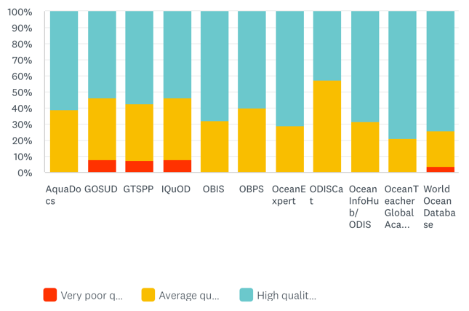
All respondent types UN Ocean Decade community

No significant differences with the overall respondent pool.

Q9: Do you have any suggestions to improve the service?
Note: it should be noted that the below comments are comments by individuals and the number of individual responses for this question were very small. The comments should therefore not be considered as the opinion of the full set of respondents.

Aquadocs

this need to be popularized at bit more.

GOSUD

None

GTSPP

None

IQuOD

None

OBIS

- Bringing in absence data, connecting with more databases, and making data exchanges more transparent
- Facilitate the process to mobilize data into OBIS (community sees this as a difficult process). Coordinate better with or merge with GBIF by becoming the aquatic branch of GBIF and still keep under IODE (GBIF and OBIS would benefit; the entire community would benefit)
- countries should mandate data publication into obis
- I love OBIS, but it is very very hard to figure out how to run a search and download the records, versus just see a map. I have given up using it in education/training work because the UI is so unintuitive
- More training and more funding for data stewardship

OBPS

- There are a lot of good guides in OBPS, but also a lot of less authoritative things. It can be hard to find what you really want

OceanExpert

None

ODISCat

- this need to be popularized at bit more.
- Not complete but a promising effort

Ocean InfoHub

None

OceanTeacher

- on-site courses

World Ocean Database

- augment historical biodiversity and biological observations

Conclusions and Recommendations

Conclusions

The survey results have revealed the following:

- Response from IODE NODCs in Africa was poor (10 out of 19 NODCs).
- Response from LAC and Caribbean was good (9 out of 11 NODCs)
- Response from WESTPAC was poor (4 out of 8 NODC)
- Response from IOCINDIO region was good (5 out of 7 NODC)

- The response rate of 76% from NODC was excellent
- The response rate of 52.4% from ADUs was low
- The response rate of 33% fom AIUs was very low

- Even with the IODE network (NODC, ADUs, AIUs) awareness of some of the IODE products and services is very low: approximately 60% of the IODE group respondents is not familiar with the GOSUD, GTSPP and IQuOD projects, followed by 30% for AquaDocs. OBPS and ODISCat is unknown to approx. 20% of the IODE group
- Across all respondent groups 80% of the respondents do not know GOSUD, GTSPP and IQuOD, followed by ODISCat and OBPS and AquaDocs
- Following from the lack of awareness of products and services the numbers for usage and contribution are equally low
- Across all respondent groups the best ratings in terms of awareness go to OTGA, OceanExpert, WOD and OBIS
- Within the IODE group the best ratings go to OTGA, OceanExpert, OBIS and OBPS showing more successful outreach of OBIS and OBPS within the IODE community
- Awareness for Ocean InfoHub is quite low both across all groups but even within the IODE group. This could be the result of OIH focusing on three regions (LAC, AFR, P-SIDS)
- User friendliness of products and services was rated reasonable to good across all products except for GOSUD, GTSPP and IQuOD and, to a lesser extent, OBPS and ODISCat. Within the IODE Group only GTSPP and IQuOD received 20% poor ratings for user friendliness

Recommendations

- IODE needs to make special efforts to rebuild the IODE network of data and information centres in Africa. The network declined after the ending of the ODINAFRICA projects but also in the WESTPAC region response was poor which needs to be remedied.

- Across all groups, both outside and within IODE there is a need for a substantive outreach campaign to promote the IODE products and services: when respondent knew about the products and services, they were well appreciated but the lack of awareness is a serious issue that needs to be addressed.

- GTSPP, GOSUD and IQuOD have very low awareness ratings even within the IODE community. This needs to be investigated and remedied. In Q9 it was recommended to improve and modernize the UI. This should be considered.

- ODISCat also has very low awareness ratings even within the IODE community. This needs to be addressed.

- AquaDocs has a very low awareness rating across all groups (almost 60%) but a better rating within the IODE community (30% unaware). AquaDocs needs to undertake a promotional campaign/communication strategy stressing the usefulness of its product for various stakeholders.

- OBPS, despite its outreach work package, has poor awareness ratings across all groups combined. (55%) . Numbers are better within the IODE community. As OBPS wishes to reach multiple stakeholder communities to attract (best)practices it needs to improve its promotional activities.

- OBIS, while doing very well in awareness within the IODE community, needs to address its visibility outside IODE. Some attention is needed to Q9.

- Ocean InfoHub is somewhat poorly known outside the IODE community. After its transition into ODIS it is recommended to undertake an extensive poromotional campaign.

- World Ocean Database has good visibility both within and outside the IODE community but needs to take into account the feedback of Q9.

- Both OceanExpert and OceanTeacher Global Academy received excellent awareness ratings. Some attention is needed for feedback in Q9

- In Q9 feedback the suggestion to use social media to promote products and services was often repeated. This should be taken into account.

- Annex 1: IODE community responses
(1 indicates response received)

Argentina | Troisi Ariel  Servício de Hídrografia Naval  added 21/10/2022 | 1
Australia | Rehbein Mark  Australian Institute of Marine Science, Townsville  added 16/10/2023 | 1
Belgium | Lagring Ruth  Royal Belgian Institute of Natural Sciences, Operational Directorate Natural Environment, Belgian Marine Data Centre  added 21/10/2022
Belgium |  | 1
Belgium | Tyberghein Lennert  Vlaams Instituut voor de Zee  added 21/10/2022 | 1
Benin | DEGBE Cossi Georges Epiphane  Centre de Recherches Halieutiques et Océanologiques du Bénin  added 21/10/2022 | 1
Brazil | MALUF VLADIMIR  Brazilian Navy Hydrographic Center, Directorate of Hydrography and Navigation  added 15/3/2023 | 1
Bulgaria | Palazov Atanas  Bulgarian Academy of Sciences, Institute of Oceanology  added 21/10/2022 | 1
Cameroon | Ondo Ntyam Sylvie  Ministère des Sciences et Innovation, Institut de Recherche Agricole pour le Développement. Centre de Recherche pour Ecosystèmes Marin (CERECOMA).  added 21/10/2022
Canada | Alcinov Trajce  Marine Environmental Data Section (MEDS), Oceans Science Branch (DFO - OSB), Fisheries and Oceans Canada  added 11/4/2023 | 1
Chile | Calvete Teresa  added 21/10/2022 | 1
China | SHI Suixiang  National Marine Data and Information Service  added 21/10/2022
Colombia | Ortiz Martínez Ruby  Dirección General Marítima Colombia  added 21/10/2022 | 1
Comoros | Abdoulkarim Ahmed  Centre National de Documentation et de Recherches Scientifiques  added 21/10/2022
Côte d'Ivoire | N'GUESSAN Benjamin  Centre National de Recherches Océanologiques Abidjan  added 21/10/2022 | 1
Croatia | Dadic Vlado  Institute of Oceanography and Fisheries Croatia  added 21/10/2022
Cyprus | ZODIATIS GEORGE  Oceanography Centre, University of Cyprus  added 21/10/2022 | 1
Denmark | no contact
Ecuador | Alcívar Jose  Instituto Oceanográfico y Antártico de la Armada del Ecuador  added 21/10/2022
France | Harscoat Valerie | 1
Germany | Tamm Susanne  Bundesamt fuer Seeschifffahrt und Hydrographie (Federal Maritime and Hydrographic Agency)  added 21/10/2022 | 1
Ghana | Ofoli-Anum (Née: Tette) Eunice  Marine Fisheries Research Division , Ghana Oceanographic Data Centre†  added 21/10/2022 | 1
Greece | Iona Athanasia  Hellenic Centre for Marine Research (HCMR), Hellenic National Oceanographic Data Centre (HNODC)  added 21/10/2022 | 1
Guinea | Bangoura Kandè  Centre de Recherche Scientifique de Conakry Rogbanè  added 21/10/2022
India | VS Udaya Bhaskar Tata  Indian National Centre for Ocean Information Services  added 21/10/2022 | 1
Indonesia | RIZA Hammam  Badan Pengkajian dan Penerapan Teknologi, Agency for the Assessment & Application of Technology  added 21/10/2022
Iran (Islamic Republic of) | Tavakoli Mortaza  Iranian National Institute for Oceanography and Atmospheric Science  added 21/10/2022
Iran (Islamic Republic of) |  | 1
Ireland | O'Grady Eoin  Marine Institute Headquarters, Galway  added 21/10/2022 | 1
Israel | Gertman Isaac  Israel Oceanographic & Limnological Research  added 21/10/2022 | 1
Italy | Giorgetti Alessandra  Istituto Nazionale di Oceanografia e di Geofisica Sperimentale, Trieste  added 21/10/2022 | 1
Japan | Komori Tatsuo  Japan Oceanographic Data Center  added 21/10/2022
Kazakhstan | Ivkina Natalya  РГП "Казгидромет"  added 21/10/2022
Kenya | ONGANDA Harrison  Kenya Marine and Fisheries Research Institute, Headquarter & Mombasa Station | 1
Republic of Korea | Lee Joon-Soo  Ministry of Oceans and Fisheries (MOF), National Institute of Fisheries Science (NIFS)  added 21/10/2022 | 1
Madagascar | NOMENISOA Aina Le Don  Institut Halieutique et de Sciences Marines  added 21/10/2022 | 1
Malaysia | M Muslim Aidy  Institute of Oceanography and Environment  added 21/10/2022
Mauritania | Ould Hamady Bambaye  Institut Mauritanien de Recherche Océanographique et des Pêches  added 21/10/2022 | 1
Mauritius | Bucha Krisna  Mauritius Meteorological Services  added 21/10/2022
Mexico | Hernandez Ayon Martin  Universidad Autonoma de Baja California Sur  added 21/10/2022
Mozambique | Maueua Clousa  Insituto Nacional de Hidrografia e Navegaco  added 21/10/2022 | 1
Netherlands | De Bruin Taco  Koninklijk Nederlands Instituut voor Onderzoek der Zee  added 21/10/2022 | 1
Nigeria | FOLORUNSHO REGINA  Nigerian Institute for Oceanography and Marine Research  added 21/10/2022 | 2
Norway | Sagen Helge  Institute of Marine Research (IMR), Bergen  added 21/10/2022 | 1
Pakistan | Lodhi Uzair  National Institute of Oceanography, Karachi  added 21/10/2022
Panama | López Yolanda  Universidad de Panama - Instituto de Geociencias  added 21/10/2022 | 1
Peru | Morote Somontes Giacomo  Marina de Guerra del Perú, Dirección de Hidrografía y Navegación  added 21/10/2022 | 1
Portugal | Silveira Tanya  Instituto Português do Mar e da Atmosfera, I. P.  est 26/10/2022 | 1
Portugal | Nunes Paulo  Instituto Hidrográfico Lisboa | 1
Romania | Buga Luminita  National Institute for Marine Research and Development “Grigore Antipa”  added 21/10/2022 | 1
Russian Federation | n/a response by Sergey Belov)  All-Russian Research Institute Hydrometeorological Information - World Data Center, Obninsk | 1
Senegal | Faye Saliou  Centre de Recherche Océanographique de Dakar Thiaroye (CRODT-ISRA)/ LPAOSF-ESP-UCAD  added 21/10/2022
Seychelles | no contact
Slovenia | Cermelj Branko  National Institute of Biology, Marine Biology Station, Piran  added 21/10/2022 | 1
Spain | Tel Elena  Instituto Español de Oceanografía  added 21/10/2022 | 1
Sweden | Fyrberg Katarina Lotta  Sveriges meteorologiska och hydrologiska institut  added 21/10/2022 | 1
Togo | ADJOUSSI Pessièzoum  Université de Lomé, Centre De Gestion Integrée du Littoral et de Environnement  added 21/10/2022
Tunisia | no contact
Türkiye | Tukenmez Emre  Turkish Naval Forces, Office of Navigation, Hydrography and Oceanography  added 21/10/2022 | 1
Ukraine | Komorin Viktor  Ukrainian Scientific Centre of Ecology of the Sea  added 21/10/2022 | 2
United Kingdom of Great Britain and Northern Ireland | Hebden Mark  British Oceanographic Data Centre  added 12/12/2022 | 1
United Republic of Tanzania | MASALU Desiderius  University of Dar es Salaam, Institute of Marine Sciences  added 21/10/2022 | 1
United States of America | Garcia Hernan  NOAA NESDIS National Centers for Environmental Information (NCEI)  added 21/10/2022 | 1

Annex 2: geographic distribution of responses by country

country | count
Algeria | 2
Argentina | 13
Australia | 10
Austria | 1
Bahrain | 1
Bangladesh | 2
Belgium | 6
Benin | 1
Brazil | 3
Bulgaria | 1
Cameroon | 2
Canada | 6
Cape Verde | 3
Chile | 4
China | 2
Colombia | 13
Costa Rica | 1
Cyprus | 2
Dominican Republic | 1
Ecuador | 3
Egypt | 1
El Salvador | 2
Ethiopia | 2
Fiji | 4
France | 5
Gabon | 1
Georgia | 1
Germany | 8
Ghana | 3
Greece | 4
Honduras | 2
Iceland | 1
India | 8
Indonesia | 10
Iran | 3
Iraq | 1
Ireland | 2
Israel | 1
Italy | 7
Ivory Coast | 1
Japan | 2
Kenya | 5
Kuwait | 1
Liberia | 1
Madagascar | 2
Marshall Islands | 1
Mauritania | 1
Mauritius | 2
Mexico | 16
Morocco | 1
Mozambique | 1
Namibia | 1
Netherlands | 1
New Caledonia | 1
New Zealand | 2
Nicaragua | 1
Nigeria | 6
Norway | 4
Pakistan | 1
Panama | 1
Papua New Guinea | 1
Peru | 8
Philippines | 6
Poland | 1
Portugal | 8
Republic of Korea | 1
Romania | 3
Russia | 1
Samoa | 1
Saudi Arabia | 1
Senegal | 1
Slovenia | 1
South Africa | 1
Spain | 11
Sri Lanka | 3
Sweden | 1
Tanzania | 2
Thailand | 1
Togo | 1
Tonga | 1
Trinidad and Tobago | 1
Turkey | 2
Tuvalu | 1
Ukraine | 2
United Kingdom | 8
United States | 11
Uruguay | 4
Venezuela | 4
Vietnam | 3
Yemen | 1

[end of document]

