**Logistics document V2.0**

**INFORMATION NOTE FOR IN-PERSON PARTICIPANTS**

**LOCAL ORGANISING COMMITTEE**

Tricy Aquino, [tricyaquino@oceannetworks.ca](mailto:tricyaquino@oceannetworks.ca)

Ella Minicola, [ellaminicola@oceannetworks.ca](mailto:ellaminicola@oceannetworks.ca)

**VENUE OF THE MEETING**

[OCG-15](https://oceanexpert.org/event/3981) will be held from 13-17 May 2024 Ocean Networks Canada (2474 Arbutus Rd) in Victoria, British Columbia, Canada.

The meeting will include additional workshops throughout the week. These include:

* CIOOS workshop [Tuesday, 14 May 2024, POC: TBD]
* Requirements implementation workshop + Co-Design [Tuesday, 14 May 2024, POC: Ann-Christine Zinkann, David Legler]
* WIS 2.0 workshop [Wednesday, 15 May 2024, POC: Champika Gallage]

**ARRIVAL AT MEETING**

Check in for the OCG-15 session will take place at the registration desk in the venue on May 13, 2024 from 8.30 to 9.00 a.m. Participants are encouraged to bring a name tag at the time of registration [you are encouraged to use a prior name tag to reuse and recycle].

**WORKING LANGUAGE**

The working language will be English**.**

**ENTRY VISA REQUIREMENTS**

Please ensure to check what the entry requirements are for your country in advance of the meeting. See the list for travellers needing an [Electronic Travel Authorization (eTA)](https://www.canada.ca/en/immigration-refugees-citizenship/services/visit-canada/entry-requirements-country.html) to board their flight to Canada. However, these travellers do not need an eTA if entering by land or sea – for instance driving from the U.S. or coming by bus, train, or boat, including cruise ship.

For Visa assistance, including invitation letter issued by local host, please contact: [ue-officer@oceannetworks.ca](mailto:ue-officer@oceannetworks.ca) and provide your CV.

**LIFE AND HEALTH INSURANCE**

Life/major health insurance for each participant is necessary and is the responsibility of the participant's institution or Government. The Local Organizing Committee will not assume any responsibility for life and major health insurance, nor for expenses related to medical treatment or accidents.

**HOTEL RESERVATION**

Participants are advised to make their own accommodation bookings. A hold has been placed for 20 rooms at the [Inn at Laurel Point](https://www.laurelpoint.com/rooms/?nst=0&ds_rl=1287774&gad_source=1&gclid=CjwKCAiArLyuBhA7EiwA-qo80NpW1gd3ebAr1TLX2suYCPAE46Yhlnu3t-8Tgj_adzaMIJlzfKThkxoC0MAQAvD_BwE&gclsrc=aw.ds) hotel for 270.00 CAD + tax per night **until March 18 only**. Please choose from the options below to reserve:

* Call 1-800-663-7667 (toll free) use code “OCG 15 Conference”
* Email to [reservations@laurelpoint.ca](mailto:reservations@laurelpoint.ca) with the subject “OCG 15 Conference”
* Use this link - <https://reservations.travelclick.com/12209?groupID=4270952>

Additional Hotel recommendations can be found [here](https://docs.google.com/spreadsheets/d/1pin5lMYTY8T5LZJZTt0UMO_x8coQMWBbRydRg6l2xMw/edit?usp=sharing).

**LOCAL TRANSPORTATION**

Participants shall arrange their local transportation between the airport and the hotel and between the hotel and the venue.

Most hotels recommended are located in Downtown Victoria so there will be local buses and taxis available. Please see the other information below:

* Taxi:
  + Bluebird Cabs- (250) 382-2222
  + Yellow Cab - (250) 381-2222
* Local Buses - One-way ticket costs CAD 2.50 and only cash is accepted. Transit and Google Maps apps are reliable sources to check the departure and arrival of buses.
* Shuttle Buses - organising a shuttle from hotel to the venue is available, but the local organising committee will need the number of people and their hotel information ahead of time to make the bookings.

**MAPS**

***Ocean Networks Canada***

***Victoria International Airport to Ocean Networks Canada***

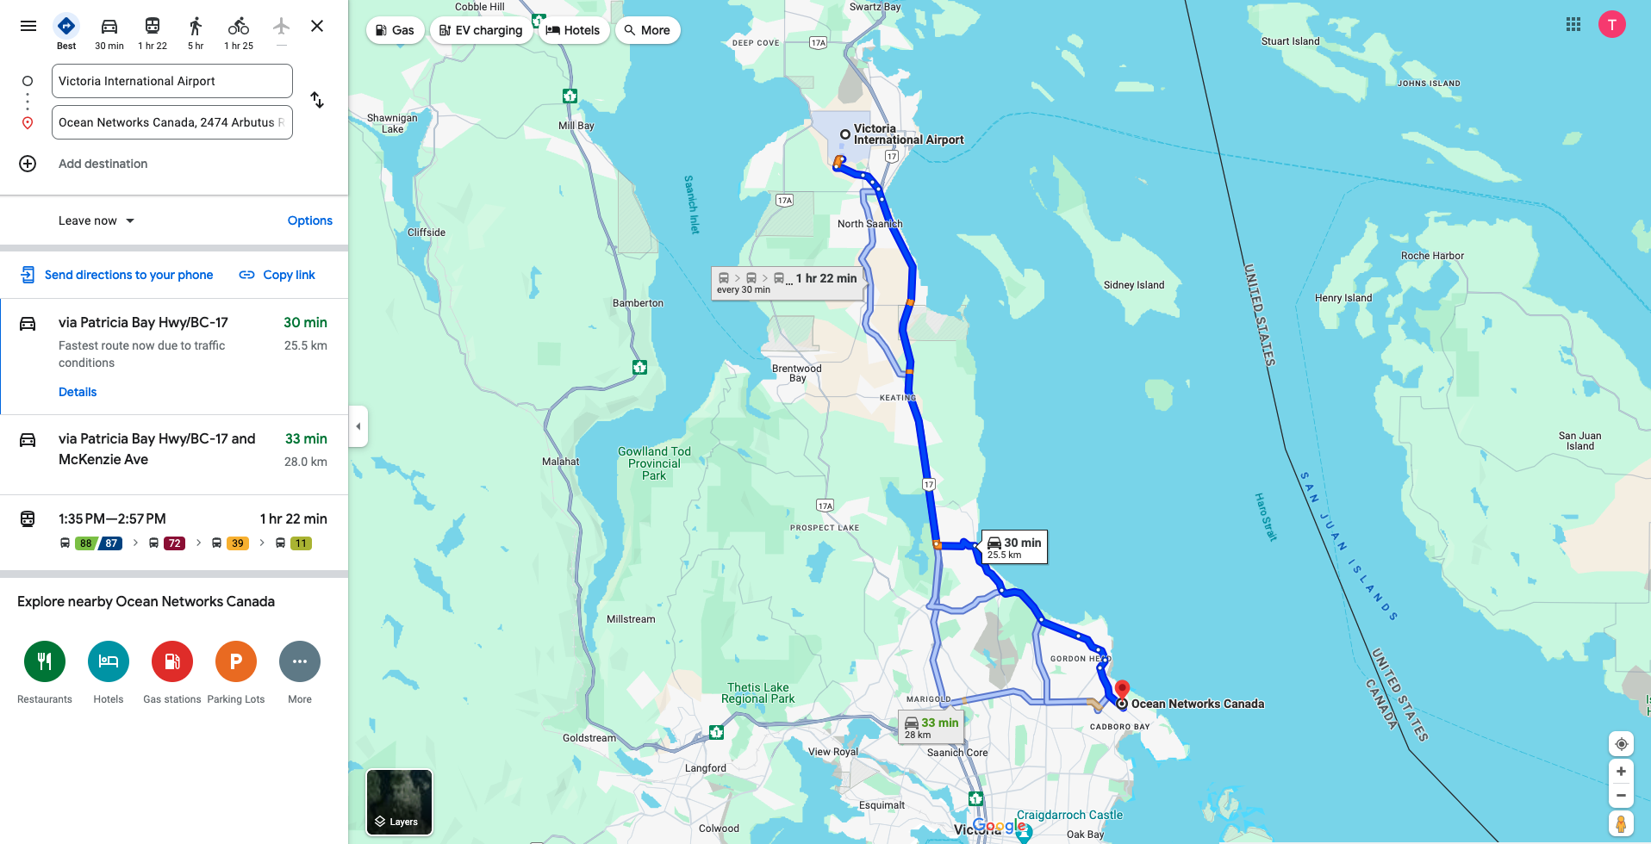

***Inn at Laurel Point to Ocean Networks Canada***

**ELECTRICITY VOLTAGE**

For Canada there are two associated plug types, types A and B. Plug type A is the plug which has two flat parallel pins and plug type B is the plug which has two flat parallel pins and a grounding pin. Canada operates on a 120V supply voltage and 60Hz.



**LUNCH**

Coffee and lunch will be provided by ONC through catering.

* Food allergies need to be reported through the [registration form](https://forms.office.com/e/93Jv5wt3p6)

**CURRENCY EXCHANGE**

The local currency is the Canadian Dollar (CAD). There are currency exchange offices at the Airport as well as most banks.

**INTERNET ACCESS AND COMMUNICATIONS**

Wireless internet connectivity will be freely available to the participants, at the meeting’s venue.

The Local Organizing Committee can facilitate participants to purchase local SIM cards for mobile phones, if required.

**LOCAL CLIMATE**

The mean weather conditions in Victoria in May are as follows:

Average max temperature: 57°F

Average min temperature: 44°F

Average rainfall for May: 26% to 22%.

**POSTER SESSION**

Please bring your posters to the registration desk on Monday, May 13th.

* Poster location and space.
  + *Posters will be displayed in the reception area.*
  + *Displayed using the ONC whiteboards*
* Poster size
  + *Portrait*
  + *No larger than 55” X 45” (ONC whiteboards dimension)*

**GROUP DINNER**

A Group dinner is planned for Wednesday, 15 May 2024 after the OCG session.

Additional ad hoc dinner on Thursday, 16 May

**RESTAURANT RECOMMENDATIONS**

Here is a list of restaurant recommendations.

* [Pagliacci’s](https://www.pagliaccis.ca/)
* [Yua](https://www.yuabistro.com/)
* [Finn’s Seafood Restaurant](https://www.finnsvictoria.com/?utm_source=google&utm_medium=gmb&utm_campaign=gmb-main)
* [Ramen Arashi](https://www.ramenarashi.ca/locations/view/6-victoria)
* [Ox King Noodles](https://www.oxkingnoodles.ca/)

**GROUP WALK (*TBC*)**

Possibly and route for a group walk:

* + Walk through [Mystic vale](https://uviccgm.geog.uvic.ca/location/mystic-vale-2) (45min)
  + Finnerty Cove Beach Access (30min)