Tsunami Glossary 2019 Proposed Comments
from

IUGG Joint Tsunami Commission Working Group on Terminology

International Tsunami Information Centre (ITIC)
TOWS Inter-Agency Task Team on Tsunami Watch Operations (TT-TWO)
and Task Team on Disaster Management and Preparedness (TT-DMP)

1 March 2023

IUGG JTC Working Group on Terminology

Chair: William Power, New Zealand
Members:
Kelly Stroker
Alexander Rabinovich
Fumihiro imamura
Lori Dengler
Diana Greenslade
Laura Kong

International Tsunami Information Centre
Laura Kong. Director
Carlos Zuniga, Associate Director
Christa von Hillebrandt-Andrade, Deputy Director

PROPOSED EDITS (in red and pink)

Preface (2nd to last paragraph)
The 2023 edition of Tsunami Glossary includes the definition of technical terms, and information on the expert and governance groups for tsunami warning and mitigation.

Acknowledgements
right paragraph update to include IUGG JTC Terminology WG
Many distinguished scientists and experts have since collaborated to improve the content of the Tsunami Glossary through the subsequent versions ITIC and IOC have developed, including Fumihiko Imamura, Modesto Ortiz, Kenji Satake, François Schindelé, Fred Stephenson, Costas Synolakis, Masahiro Yamamoto and Gerassimos Papadopoulos. More recently, the IUGG Joint Tsunami Commission Working Group on Terminology chaired by William Power has organized and contributed many of the technical improvements. Laura Kong (ITIC) is gratefully acknowledged for coordinating these recent versions of the Glossary.

1.Tsunami Classification
Local tsunami
A tsunami from a nearby source for which its destructive effects are confined to coasts less than 1 hour tsunami travel time, or typically within about 200 km from its source. A local tsunami is usually generated by an earthquake, but can also be caused by a landslide or a volcanic eruption (pyroclastic/debris flow, Lamb wave, underwater explosions). Over history, 90% of tsunami casualties have been caused by local tsunamis

Meteorological tsunami (meteotsunami)
Tsunami-like phenomena generated by meteorological disturbances. These waves can be produced by weather-induced atmospheric gravity waves, pressure jumps, frontal passages, squall lines, gales, tropical cyclones, and other tropospheric weather sources. Meteotsunamis have approximately the same temporal and spatial scales as ordinary tsunami waves and can similarly devastate coastal areas, especially in bays and inlets with strong amplification and well-defined resonant properties (e.g. Ciutadella Inlet, Balearic Islands; Nagasaki Bay, Japan; Longkou Harbour, China; Vela Luka, Stari Grad and Mali Ston Bays, Croatia). They are also quite common and dangerous in the Great Lakes. In various places around the world, they have specific local names: rissaga in Spain, abiki in Japan, marrobbio in Sicily (Italy), šćiga in Croatia, milghuba in Malta and Seebär in the Baltic Sea.

New figure:

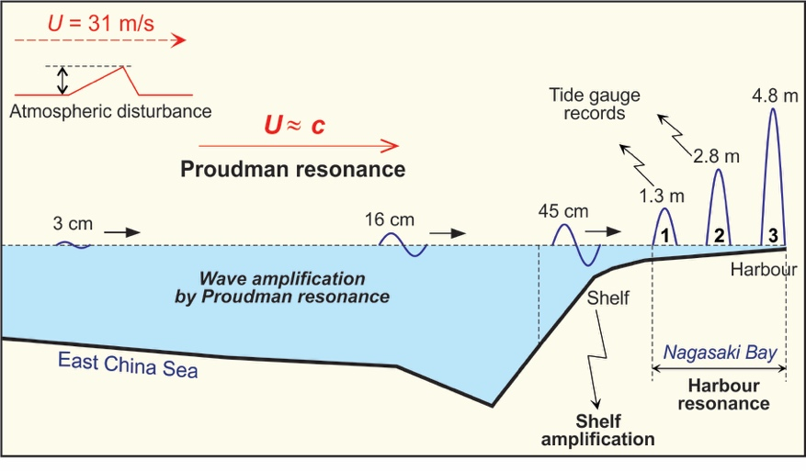
Caption:
A sketch illustrating the physical mechanisms responsible for formation of the meteotsunami of 31 March 1979. The initial pressure jump over the western part of the East China Sea was about 3 hPa. The long waves generated by this event successively amplified from 3 cm to 16 cm as the result of several resonant effects, then to 45 cm and finally to 478 cm at the head of the bay. (Modified from Monserrat et al., 2006).

ORIGINAL (with some edits, final is above):
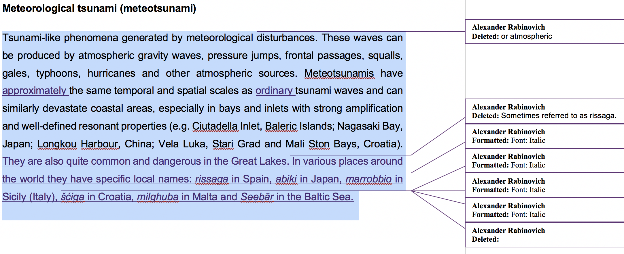

Update of Maps and Tables (ITIC to provide high-res/adobe illustrator for updating)
- images (and captions) on
page 8 (confirmed tsunamis by region - Pacific, Indian, Mediterranean, Caribbean)

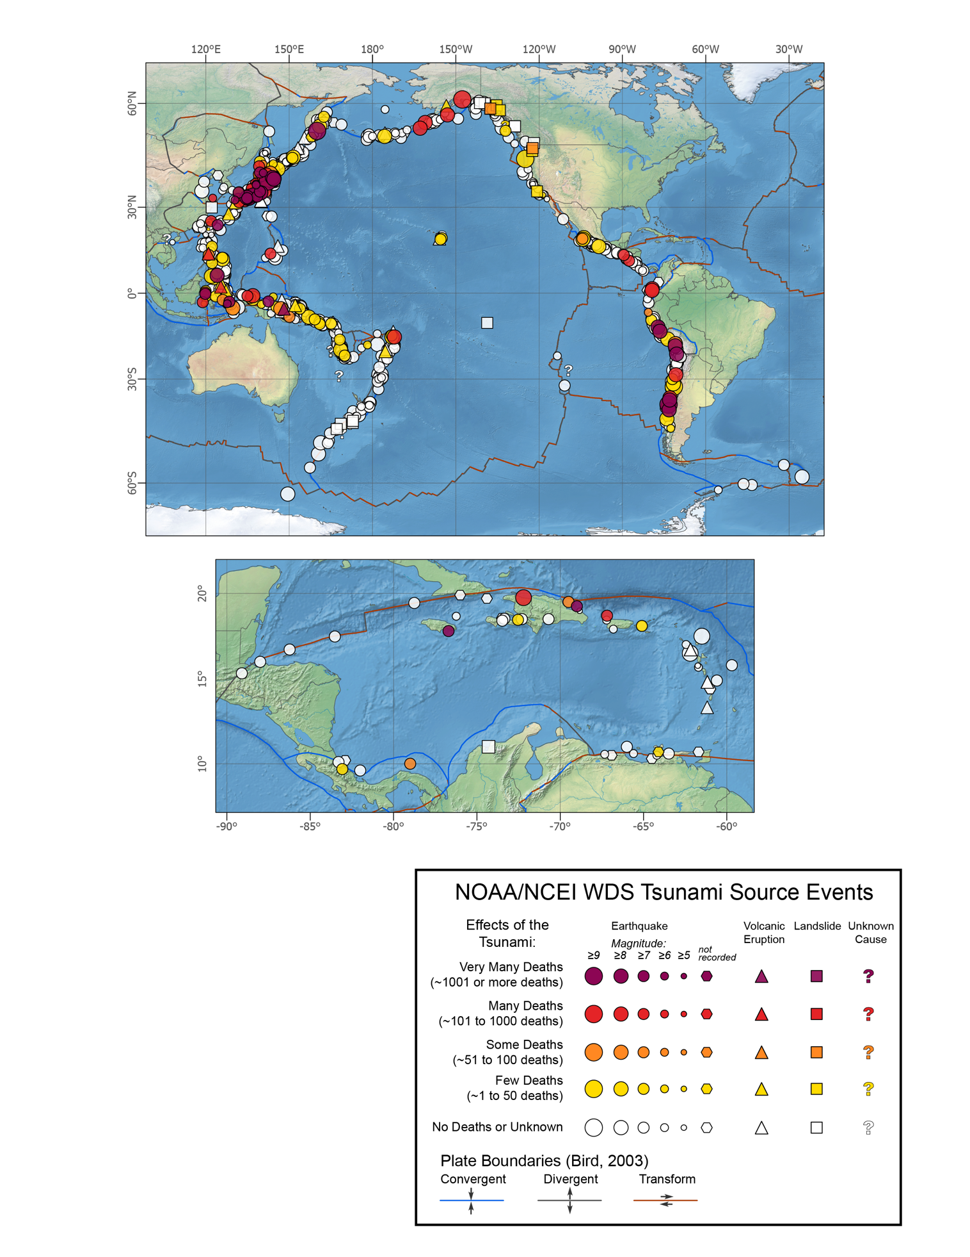

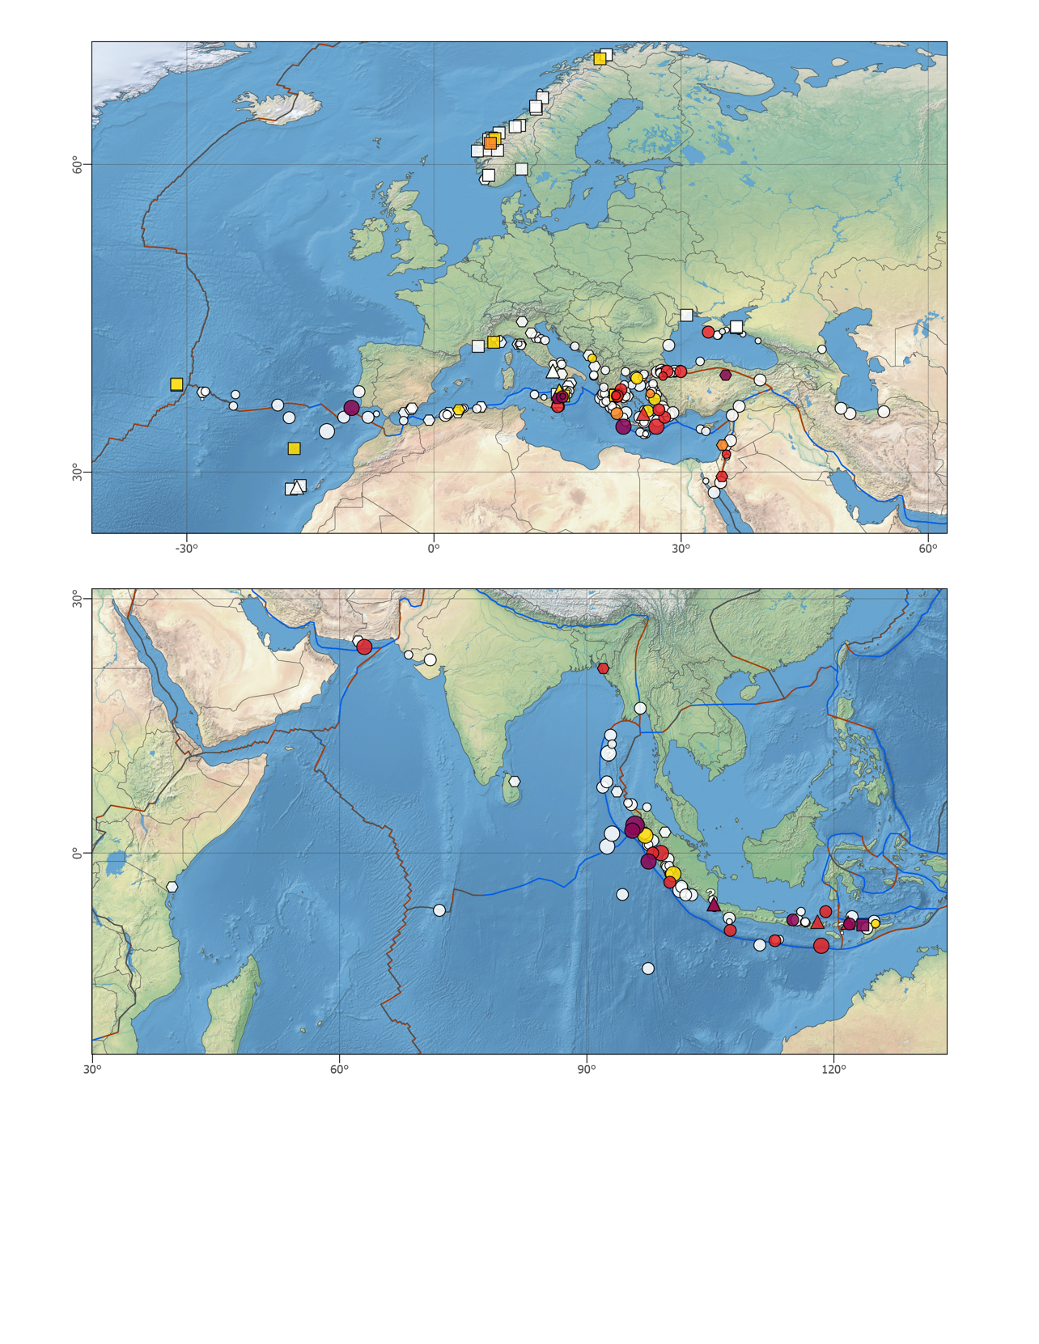
caption (replacing text above): The four images show confirmed tsunami source locations in the Pacific Ocean, Indian Ocean, North-Eastern Atlantic Ocean and Mediterranean Sea, and Caribbean Sea. Source: NCEI / WDS-Geophysics.

page 10 (All tsunamis causing damage/deaths, those Local, those Tele)

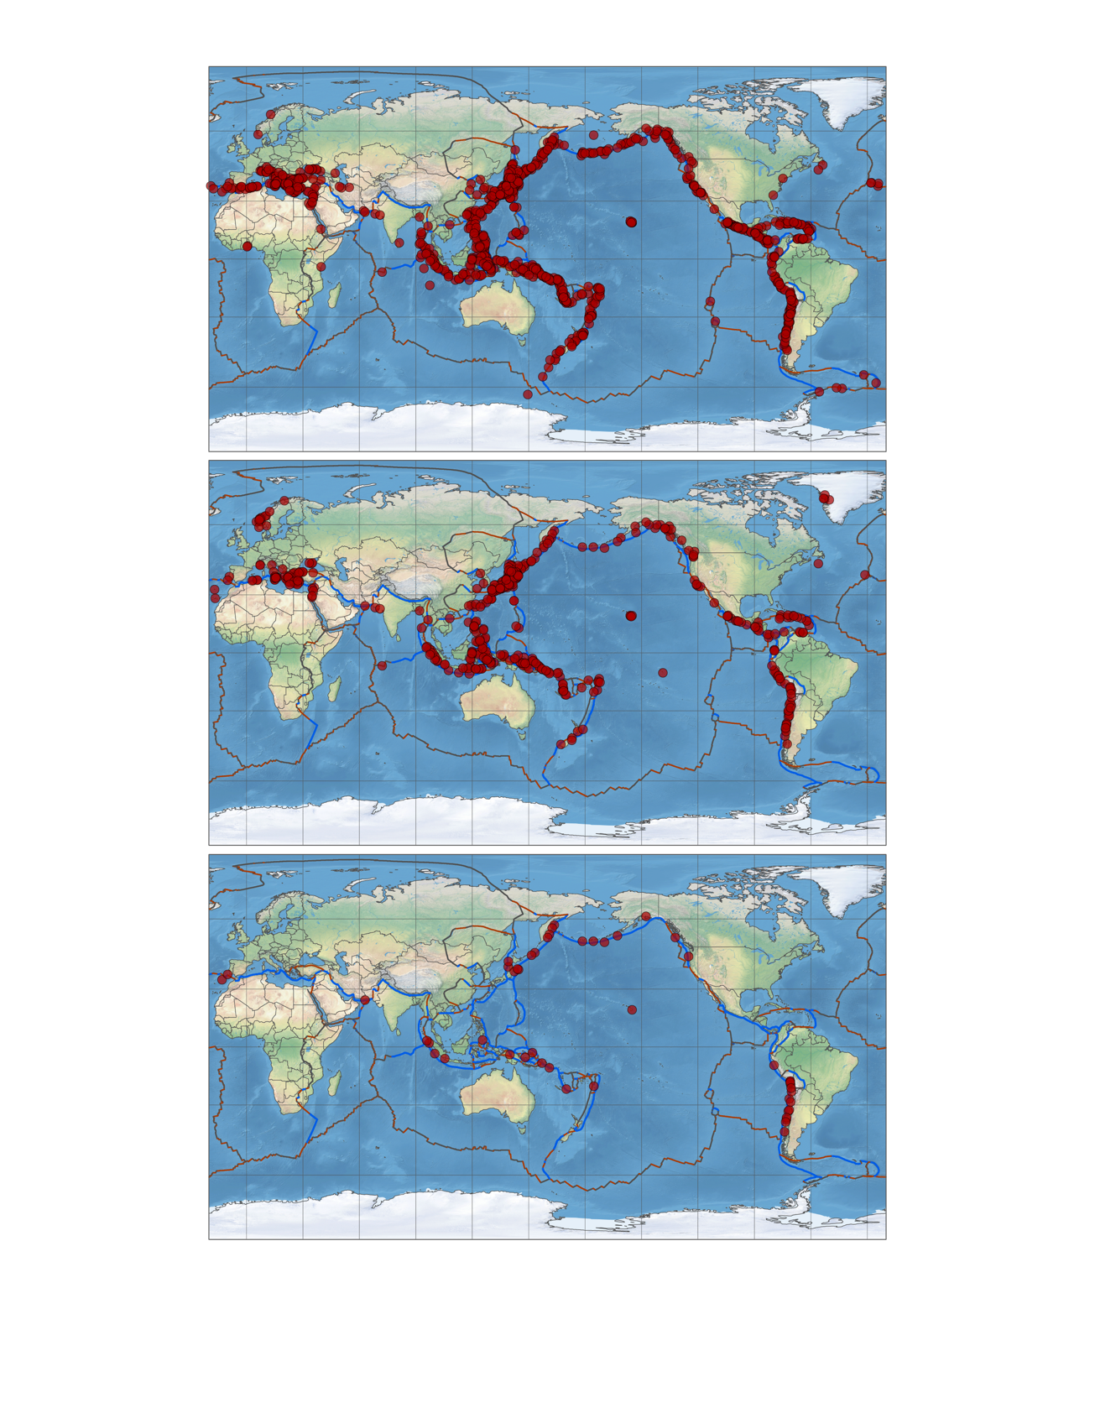

Caption: More than 80% of the world’s tsunamis were caused by earthquakes and over 70% of these were observed in the Pacific where large earthquakes occur as tectonic plates are subducted along the Pacific Ring of Fire. Top: Epicentre of all tsunamigenic earthquakes tsunamis in all ocean basins. Middle: Locations of earthquakes, volcanic eruptions, and landslides generating tsunamis that caused damage or casualties locally. Although the majority of tsunamis that were observed more than 1,000 km away (teletsunamis) were generated by earthquakes in the Pacific, teletsunamis have also caused damage and casualties in the Indian and Atlantic oceans. Bottom: Source locations of teletsunamis generated by earthquakes or volcanic eruptions causing damage or casualties. These data are based on historical records. Source: NCEI / WDS-Geophysics

- tables (ITIC will provide Excel files of tables for updating)
page 9 left (regional/local deaths since 1980)
Regional and local tsunamis
causing deaths since 1980
Date |  |  |  |  | Estimated Dead or Missing
Year | Mon | Day |  | Source Location
1981 | 9 | 1 |  | Samoa Islands | Few
1983 | 5 | 26 |  | Noshiro, Japan | 100
1988 | 8 | 10 |  | Solomon Islands | 1
1991 | 4 | 22 |  | Limon, Costa Rica | 3
1992 | 9 | 2 |  | Off coast Nicaragua | 170
1992 | 12 | 12 |  | Flores Sea, Indonesia | 1,169
1993 | 7 | 12 |  | Sea of Japan | 208
1994 | 6 | 2 |  | Java, Indonesia | 238
1994 | 10 | 8 |  | Halmahera, Indonesia | 1
1994 | 11 | 4 |  | Skagway Alaska, USA** | 1
1994 | 11 | 14 |  | Philippine Islands | *81
1995 | 5 | 14 |  | Timor, Indonesia | 11
1995 | 10 | 9 |  | Manzanillo, Mexico | 1
1996 | 1 | 1 |  | Sulawesi, Indonesia | 9
1996 | 2 | 17 |  | Irian Jaya, Indonesia | 110
1996 | 2 | 21 |  | Northern Peru | 12
1998 | 7 | 17 |  | Papua New Guinea | 1,636
1999 | 8 | 17 |  | Izmit Bay, Turkey | 155
1999 | 11 | 26 |  | Vanuatu Islands | 5
2000 | 5 | 4 |  | Sulawesi, Indonesia | *54
2001 | 6 | 23 |  | Southern Peru | 26
2003 | 9 | 25 |  | Hokkaido, Japan | 2
2004 | 12 | 26 |  | Banda Aceh, Indonesia | *^227,899
2006 | 3 | 14 |  | Seram Island, Indonesia | 4
2006 | 7 | 17 |  | Java, Indonesia | 802
2007 | 4 | 1 |  | Solomon Islands | 50
2007 | 4 | 21 |  | Southern Chile | 8
2007 | 8 | 15 |  | Southern Peru | 3
2009 | 9 | 29 |  | Samoa Islands | 192
2010 | 1 | 12 |  | Haiti | 7
2010 | 2 | 27 |  | Southern Chile | 156
2010 | 10 | 25 |  | Mentawai, Indonesia | 431
2011 | 3 | 11 |  | Tohoku, Japan | *^18,428
2013 | 2 | 6 |  | Solomon Islands | 10
2015 | 9 | 16 |  | Central Chile | 8
2017 | 6 | 17 |  | Greenland** | 4
2018 | 9 | 28 |  | Sulawesi, Indonesia | *4,340
2018 | 12 | 22 |  | Anak Krakatau, Indonesia*** | 437
2020 | 10 | 30 |  | Aegean Sea | 1
2022 | 1 | 15 |  | Tonga Islands*** | 4
 |  |  |  | Total | 256,777
*May include earthquake deaths
**Tsunami generated by landslide
*** Tsunami generated by volcanic eruption
^Includes dead/missing near and outside source region

page 9 right (regional/local causing more than 2000 deaths)
Regional and local tsunamis

causing 2,000 or more deaths
Date |  |  |  |  | Estimated Dead or Missing
Year | Mon | Day |  | Source Location
365 | 7 | 21 |  | Crete, Greece | 5,000
887 | 8 | 2 |  | Niigata, Japan | 2,000
1341 | 10 | 31 |  | Aomori Prefecture, Japan | 2,600
1498 | 9 | 20 |  | Enshunada Sea, Japan | 5,000
1570 | 2 | 8 |  | Central Chile | 2,000
1605 | 2 | 3 |  | Nankaido, Japan | 5,000
1611 | 12 | 2 |  | Sanriku, Japan | 5,000
1674 | 2 | 17 |  | Banda Sea, Indonesia | 2,244
1687 | 10 | 20 |  | Southern Peru | *5,000
1692 | 6 | 7 |  | Port Royal, Jamaica | 2,000
1703 | 12 | 30 |  | Boso Peninsula, Japan | *5,233
1707 | 10 | 28 |  | Enshunada Sea, Japan | 2,000
1707 | 10 | 28 |  | Nankaido, Japan | *5,000
1741 | 8 | 29 |  | Hokkaido, Japan** | 2,000
1746 | 10 | 29 |  | Central Peru | 4,800
1751 | 5 | 20 |  | Northwest Honshu, Japan | 2,100
1755 | 11 | 1 |  | SW Iberian Margin, Portugal | *50,000
1771 | 4 | 24 |  | Ryukyu Islands, Japan | 13,486
1792 | 5 | 21 |  | Kyushu Island, Japan** | 15,000
1854 | 12 | 24 |  | Nankaido, Japan | *3,000
1868 | 8 | 13 |  | Northern Chile | *25,000
1877 | 5 | 10 |  | Northern Chile | 2,282
1883 | 8 | 27 |  | Krakatau, Indonesia** | 34,417
1896 | 6 | 15 |  | Sanriku, Japan | *27,122
1899 | 9 | 29 |  | Banda Sea, Indonesia | *2,460
1907 | 1 | 4 |  | Sumatra, Indonesia | 2,188
1908 | 12 | 28 |  | Messina Strait, Italy | 2,000
1923 | 9 | 1 |  | Sagami Bay, Japan | 2,144
1933 | 3 | 2 |  | Sanriku, Japan | 3,022
1952 | 11 | 4 |  | Kamchatka, Russia | 10,000
1960 | 5 | 22 |  | Southern Chile | 2,000
1976 | 8 | 16 |  | Moro Gulf, Philippines | 6,800
2004 | 12 | 26 |  | Banda Aceh, Indonesia | *^227,899
2011 | 3 | 11 |  | Tohoku, Japan | *^18,428
2018 | 9 | 28 |  | Sulawesi, Indonesia | *4,340
 |  |  |  | Total | 508,565
*May include earthquake deaths
**Tsunami generated by volcanic eruption
^Includes dead/mising near and outside source region

page 11 (tele deaths)

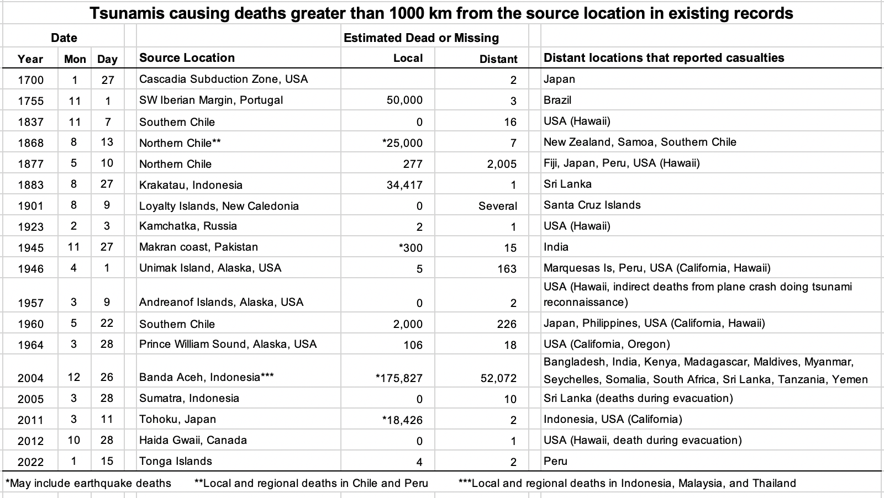

2. General tsunami terms
Eddy
By analogy with a molecule, a “glob” of fluid within the fluid mass that has a certain integrity and life history of its own; the activities of the bulk fluid being the net result of the motion of the eddies.
A persistent swirling motion in a body of water.

Historical tsunami data.
Data collected on past tsunamis that has been recorded in historical records. Historical data are available in many forms and at many locations. These forms include published and unpublished catalogs of tsunami occurrences, personal narratives, marigraphs, tsunami amplitude, runup and inundation zone measurements, field investigation reports, newspaper accounts, film, or video records.

Lamb wave
An atmospheric pressure wave that travels horizontally relative to the Earth’s surface. The 2022 eruption of Hunga Tonga-Hunga Ha’apai produced a Lamb wave that circulated the Earth and generated tsunami waves. The Lamb wave is sometimes referred to as an ‘air wave’, ‘blast wave’ or ‘shock wave’.

Seiche
A seiche is a standing wave oscillation A seiche may be initiated by a standing wave oscillating in a partially or fully enclosed body of water. It may be initiated by long period seismic waves (an earthquake), wind and water waves, or a tsunami.

Tsunami generation
The process in which a tsunami is initially generated. Tsunamis are most frequently caused by earthquakes, but can also result from landslides, volcanic eruptions, and very infrequently by meteorites or other impacts upon the ocean surface. Earthquake-induced tsunamis are generated primarily by tectonic dislocations under the sea which are caused by shallow focus earthquakes along areas of subduction. The upthrusted and downthrusted crustal blocks impart potential energy into the overlying water mass with drastic changes in the sea level over the affected region. The energy imparted into the water mass results in tsunami generation, i.e. energy radiating away from the source region in the form of long period waves. In the case of a landslide, the tsunami is generated by the transfer of energy from the sliding mass to the water mass.

New Figure
Source mechanisms of volcanic tsunamis (modified after Paris et al., 2014).
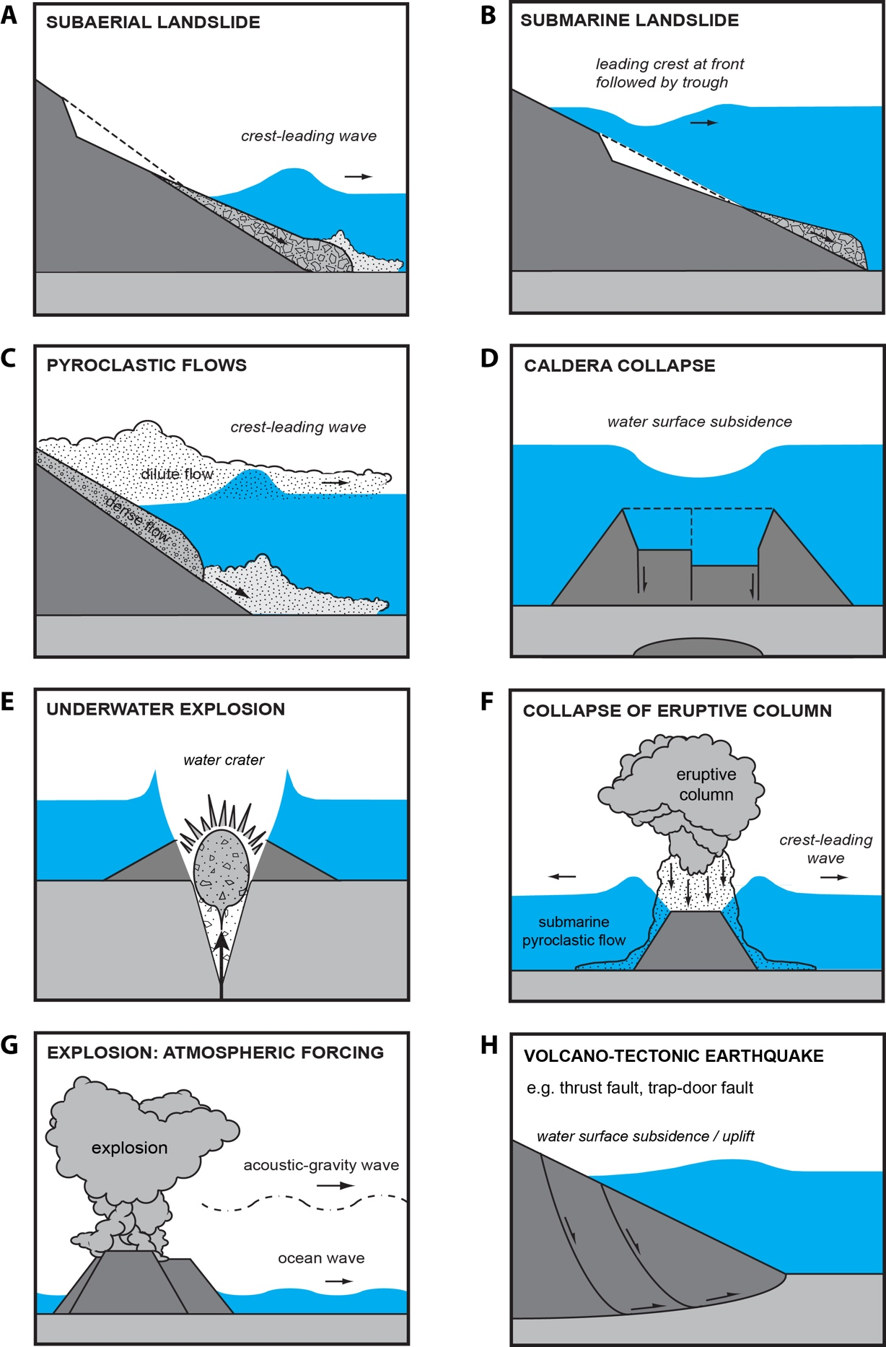
Caption: Source mechanisms of volcanic tsunamis (modified after Paris et al., 2014). In the case of a volcanic eruption, tsunamis might be generated by landslides (A and B), pyroclastic flows (C), caldera collapse (D), underwater explosions (E), blast (F) or volcano-tectonic earthquakes (G).

Tsunami generation
Add 2nd paragraph
. For earthquakes the fault rupture is described as a dislocation in an elastic half-space, using the theory of elastic dislocations an estimate is made of the consequent displacement of the seabed (which is represented by the free surface of the half-space). The distribution of seabed displacement can then form the input to a tsunami model, or it can be used to estimate the potential energy of the tsunami according to the change in potential energy of the water displaced vertically by the seabed movement. Where the seabed has steep slopes, sudden horizontal motion caused by an earthquake can also contribute to the vertical displacement of water, and hence to the generation of a tsunami.

Tsunami generation theory
A theory to explain the generation of tsunamis by a particular physical mechanism. The theoretical problem of generation of the gravity wave (tsunami) in the layer of elastic liquid (an ocean) occurring on the surface of elastic solid half-space (the crust) in the gravity field can be studied with methods developed in the dynamic theory of elasticity. The source representing an earthquake focus is a discontinuity in the tangent component of the displacement on some element of area within the crust. For conditions representative of the Earth’s oceans, the solution of the problem differs very little from the joint solution of two more simple problems: The problem of generation of the displacement field by the given source in the solid elastic half-space with the free boundary (the bottom) considered quasi-static; and the problem of the propagation of gravity wave in the layer of heavy incompressible liquid generated by the known (from the solution of the previous problem) motion of the solid bottom. There is the theoretical dependence of the gravity wave parameters on the source parameters (depth and orientation). One can roughly estimate the quantity of energy transferred to the gravity wave by the source. In general, it corresponds to the estimates obtained with empirical data. Also, tsunamis can be generated by other mechanisms such as landslides (both subaerial and submarine), volcanic eruptions, asteroids, or nuclear explosions, thus implying different wave generation mechanisms.

Tsunami hazard assessment
An assessment, typically in the form of a report, identifying and documenting the level of tsunami threat to which a population or set of assets is exposed. Documentation of tsunami hazards for a coastal community is needed to identify populations and assets at risk, and the level of that risk. This assessment requires knowledge of probable tsunami sources (such as earthquakes, landslides, and volcanic eruptions), their likelihood of occurrence, and the characteristics of tsunamis from those sources at different places along the coast. For those communities, data of earlier (historical and paleotsunamis) tsunamis may help quantify these factors. For most communities, however, only very limited or no past data exist. For these coasts, numerical models of tsunami inundation can provide estimates of areas that will be flooded in the event of a local or distant tsunamigenic earthquake or a local landslide.

Tsunami impact
The actual or potential consequences of a tsunami. Although infrequent, tsunamis are among the most terrifying and complex physical phenomena and have been responsible for great loss of life and extensive damage. Because of their destructiveness, tsunamis have important impacts on the human, social, and economic sectors of societies. Over the last 3600 years, there have been 252 fatal tsunamis and more than 540,000 deaths. The worst catastrophe in history was the 26 December 2004 Sumatra, Indonesia tsunami that killed 228,000 people in 14 Indian Ocean countries and caused $10 billion in damage. The Pacific Ocean, however, is where 70% of the world’s tsunamis occur. 99% of the deaths were caused by local tsunamis, which are those hit in less than 1 hour tsunami travel time. Since 81% of the tsunamis are Generated by shallow great earthquakes, shaking and damage from the earthquake is the 1st hazard to address before the tsunami arrives.

In Japan, which has one of the most populated coastal regions in the world and a long history of earthquake activity, tsunamis have destroyed entire coastal populations. There is also a history of severe tsunami destruction in Alaska, the Hawaiian Islands, Indonesia, and South 18 Tsunami Glossary 2019 America.The last major Pacific-wide tsunami was the 11 March 2011 Japan tsunami which killed more than 18,000 in Japan and 2 persons in the far field.
Tsunami numerical modelling
Mathematical descriptions that seek to describe the observed tsunami and its effects.

Often the only way to determine the potential runups and inundation from a local or distant tsunami is to use numerical modelling since data from past tsunamis is usually insufficient. Models can be initialized with potential worst case scenarios for the tsunami sources or for the
waves just offshore to determine corresponding worst case scenarios for runup and inundation. Models can also be initialized with smaller sources to understand the severity of the hazard for the less extreme but more frequent events. This information is then the basis for creating tsunami evacuation maps and procedures. At present, such modelling has only been carried out for a small fraction of the coastal areas at risk. Sufficiently accurate modelling techniques have only been available in recent years, and these models require training to understand and use correctly, as well as input of detailed bathymetric and topographic data in the area being modelled.

Numerical models have been used in recent years to simulate tsunami propagation and interaction with land masses. Such models usually solve similar equations but often employ different numerical techniques and are applied to different segments of the total problem of
tsunami propagation from generation regions to distant areas of runup. For example, several numerical models have been used to simulate the interaction of tsunamis with islands. These models have used finite difference, finite element, and boundary integral methods to solve the linear long wave equations. These models solve these relatively simple equations and provide reasonable simulations of tsunamis for engineering purposes.

Tsunami warning centres use numerical models to forecast expected wave arrival times, directions of maximum tsunami energy, strength of near-shore water currents, and coastal wave height. This important information helps emergency response officials to plan and focus relief on where the impact is expected to be the greatest.

The choice of the model depends on the geometry and duration of the source, the quality of the available grid used for calculation, and the computing capacities. Sophisticated models such as dispersive, coupled flow/water models may have a very high computational cost. The modelling strategy is thus mostly guided by the objectives to be fulfilled: understanding the physics or evaluating hazards are unlikely to require the same approach.

Considering that landslide and volcanic tsunamis are usually characterized by intermediate to deep-water waves (shorter wave-lengths compared to tectonic tsunamis), it is highly recommended to use weakly dispersive, depth-averaged models (models based on the Boussinesq approximation) or fully dispersive three-dimensional models (e.g. Reynolds-averaged, Navier-Stokes models).

Tsunami propagation
The spreading and travel of a tsunami from its source. Tsunamis travel outward in all directions from the generating area, with the direction of the main energy propagation generally being orthogonal to the direction of the earthquake fracture zone. Their speed depends on the depth of water, so that the waves undergo accelerations and decelerations in passing over an ocean bottom of varying depth. In the deep and open ocean, they travel at speeds of 500 to 1,000 km per hour (300 to 600 miles per hour). The distance between successive crests can be as much as 500 to 650 km (300 to 400 miles). However, in the open ocean, the height of the waves is generally less than a meter (3 feet) even for the most destructive teletsunamis, and the waves pass unnoticed. Variations in tsunami propagation result when the propagation impulse is stronger in one direction than in others because of the orientation or dimensions of the generating area and where regional bathymetric and topographic features modify both the waveform and rate of advance. Specifically, tsunami waves undergo a process of wave refraction and reflection throughout their travel. Tsunamis are unique in that the energy extends through the entire water column from sea surface to the ocean bottom. It is this characteristic that accounts for the great amount of energy propagated by a tsunami.

3. Surveys and Measurements
Arrival time
Time of the first maximum or minimum of the tsunami waves, specifically the observed time of arrival of first tsunami wave with positive or negative amplitude.

Initial rise time Changed the name of the definition..
Time of the first minimum of the tsunami waves.
Time of the first rise in water level relative to the background tidal level.

MOVE TO '2. General Tsunami Terms' section’ with new definition
Inundation
The process of overland flooding caused by a tsunami.

Inundation-distance
The horizontal distance inland that a tsunami penetrates, generally measured perpendicularly to the shoreline.

Modified Sieberg sea-wave intensity scale
Address for 2025 Tsunami Glossary - Comment by W. Power: There are other intensity scales, why is the focus on this particular one?
Post-tsunami survey
A field survey to collect data in the immediate aftermath of a tsunami. Tsunamis are relatively rare events and most of their evidence is perishable. Therefore, it is very important that reconnaissance surveys be organized and carried out quickly and thoroughly after each tsunami occurs, to collect detailed data valuable for hazard assessment, model validation, and other aspects of tsunami mitigation. Since the early 1990s, post-tsunami reconnaissance surveys have been organized following each major destructive tsunami to make measurements of runups and inundation limits, to collect associated data from eyewitnesses such as the number of waves, arrival time of waves, and which wave was the largest, and to assess human response to tsunami danger. The surveys have been organized on an ad-hoc basis, facilitated and coordinated by the IOC and ITIC working with the affected country, and conducted by international academic tsunami researchers (International Tsunami Survey Team, ITST). The IOC-ITST Post-tsunami Survey Field Guide (Manuals and Guides 37, 1998, 2nd Edition 2014, IOC/2014/MG/37) provides a flexible framework for undertaking surveys, their guiding principles and protocols data types, and observations to be taken to standardize data collection.

Wave trough
1. The lowest part of a wave.
2. That part of the wave below still water level.

4. Tide, Mareograph, Sea Level
Refraction diagrams
Models using water depths, direction of wave, separation angle, and ray separation between two adjacent rays as input, to produce the path of wave orthogonals, refraction coefficients, wave heights, and travel times.

Sea surface height
Height of the Sea Surface relative to a reference level. Satellite altimeters monitor Sea Surface Height (SSH), and can record a snapshot of the propagating tsunami if the satellite orbit is located above the tsunami. During the 2004 Indian Ocean tsunami and 2011 Tohoku tsunami, several satellites captured the tsunami as it propagated across the Indian and Pacific Ocean, respectively.

5. Tsunami Warning System Acronyms & Organizations
TSP - update to add
PTWS
South China Sea Tsunami Advisory Centre (SCSTAC) of China State Oceanic Administration
NEAMTWS
Institute of Geodynamics, National Observatory of Athens (NOA) of Greece
Instituto Português do Mar e da Atmosfera (IPMA) of Portugal
Kandilli Observatory and Earthquake Research Institute (KOERI) of Boğaziçi University of Türkiye
Tsunami Ready Recognition Programme
The UNESCO/IOC Tsunami Ready Recognition Programme, established in 2022, is an international voluntary, performance-based community recognition programme that aims to build resilient communities through awareness and preparedness strategies that will protect life, livelihoods and property from tsunamis in different regions. This is achieved through a collaborative effort among national and local warning and emergency management agencies, and government authorities, scientists, community leaders and the public to meet a standard level of readiness. Communities that meet all 12 readiness indicators, which cover Assessment, Preparedness, and Response, are recognized as ‘Tsunami Ready’ by the UNESCO/IOC. Although communities can be recognized as being ‘Tsunami Ready’, this recognition does not mean that a community is tsunami proof; rather, it is an acknowledgement and recognition that a community has adopted mitigation measures to cope with their tsunami risk. The recognition is renewable every four years. The IOC Tsunami Information Centres in each region (CTIC, IOTIC, ITIC, NEAMTIC) have the role of facilitating and assisting Member States in the implementation of Tsunami Ready in their countries. The Programme is modelled after the US TsunamiReady® Program.

6. Bibliography
<<Add the following reference under the ‘Technical’ category>>

Paris, R., Switzer, A.D., Belousova, M., Belousov, A., Ontowirjo, B., Whelley, P.L., Ulvrová, M., 2014. Volcanic tsunami: a review of source mechanisms, past events and hazards in Southeast Asia (Indonesia, Philippines, Papua New Guinea). Natural Hazards 70 (1), 447-470.

