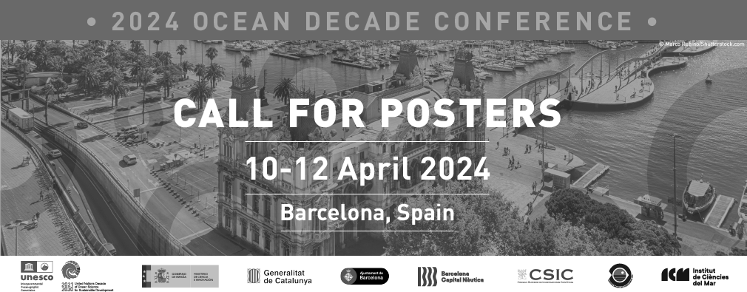

Call for Posters - 2024 Ocean Decade Conference

**As part of the 2024 Ocean Decade Conference, we are inviting submissions of Posters focused on initiatives, projects, organizations, or groups that work to contribute to the fulfillment of the Ocean Decade Challenges and enhance cooperation and collaboration within the Ocean Decade. Of particular interest are posters that showcase efforts that aim to bridge across disciplines, sectors, and thematic areas while also promoting equity, diversity, and inclusion.**

**Posters will be exhibited in the Banquet Hall of the main conference venue, the Barcelona International Convention Centre (CCIB). Posters will be exhibited throughout the duration of the Conference from 10 to 12 April 2024. Oral poster sessions will be organised during lunchbreaks of the Conference.**

[**If you are interested in submitting a Poster proposal, please first read the Poster Guidance Note and then fill in this form before 23.59h CET on 1 December 2023**](https://oceanexpert.org/document/33356)**.**

**To help you in the process, PDF and Word versions of the application form can be downloaded** [**here.**](https://oceanexpert.org/document/33354)

**For any questions please contact** [**oceandecade@unesco.org.**](mailto:oceandecade@unesco.org)



Call for Posters - 2024 Ocean Decade Conference

* 1. First name of lead author:
* 2. Last name of lead author:
* 3. Email adress of lead author:

4. Institutional affiliation (if relevant) of lead author:

* 5. Is the lead author:

 An [Early Career Ocean Professional](https://www.ecopdecade.org/#%3A~%3Atext%3DFor%20the%20purpose%20of%20the%2Conly%20employed%2Fpaid%20positions)) (ECOP)

Based in or from a [Small Island Developing State](https://www.unesco.org/en/sids/about) or [Least Developed Country](https://www.un.org/ohrlls/content/list-ldcs)

None of the above

* 6. How are you or your organization involved with the Ocean Decade?

 Decade Action (programme, project, contribution, activity)

 Decade Collaborative Centre (DCC) or Decade Coordination Office (DCO)  Decade Implementing Partner (DIP)

 National Decade Committee (NDC)  Informal Working Group

 Not currently connected to the Decade Other (please specify)

* 7. Name of Poster:

1. Co-Authors of Poster:

(If relevant, please list the name of the co-authors. If there are more than 5 Co-authors, please include the details of the remaining participants in question no. 10).

Co-Author No. 1:

Co-Author No. 2:

Co-Author No. 3:

Co-Author No. 4:

Co-Author No. 5:

1. Institutional Affiliation of Co-Authors of Presentation:

Co-Author No. 1:

Co-Author No. 2:

Co-Author No. 3:

Co-Author No. 4:

Co-Author No. 5:

1. Please indicate if any of the Co-Authors are Early Career Ocean Professionals (ECOP) or based in or from a Small Island Developing State (SIDS) or Least Developed Country (LDC).

ECOP SIDS / LDC



Co-Author No. 01

Co-Author No. 02



Co-Author No. 03

Co-Author No. 04



Co-Author No. 05

1. If your Poster has more than 5 Co-Authors, please provide the information of the remaining participants in bullet points:

(Name, institutional affiliation, and if the co-authors are Early Career Ocean Professionals (ECOP) or based in or from a Small Island Developing State or Least Developed Country)



* 12. Brief Description of Poster content (max. 3000 characters per question).

Brief description of the contribution of the Poster to the Conference objectives

Brief description of the innovative nature of the substance of the Poster

Description of the link of the Poster author(s) to the Ocean Decade