14th Observation Coordination Group (OCG-14)
6-8 June 2023, Cape Town, South Africa

The Argo Float Program
Breck Owens, Director
Susan Wijffels, Co-chair
Brian King, Co-chair

The effective Argo array coverage continues to slowly decrease from its peak in 2018. The decrease is largest in the Indian Ocean, where more floats are needed in the northern and western region, and in the Southern Ocean south of 60S. The Arctic and most marginal seas also have very low coverage.

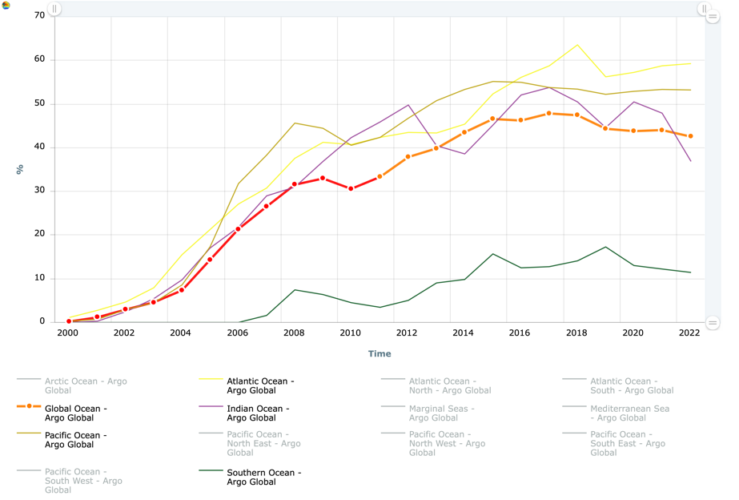

There are presently 3877 active floats listed at Ocean-Obs. 682 of these floats are grey-listed due to fast salinity drift and 140 floats profile to less than 1200 dbar, leaving approximately 3000 “healthy” floats (64% of new OneArgo target). There are 240 Deep floats (25% of target), profiling to 6000 or 4000 dbar and 296 multiple sensor BGC floats (~29% of target).
- Enhanced coverage in equatorial and western boundary regions is decreasing.
- Deep Argo is essentially stalled with no significant increase in coverage beyond the initial pilot demonstration deployments.
- BGC Argo deployments are increasing due to a one-time grant from the US National Science Foundation. Sustained support for BGC Argo is uncertain.

A best practices document for participating in the Argo Program has been completed and will be submitted for publication shortly. A short document describing the requirements necessary to be an Argo float, including issues with measurements within EEZs, is now available for float manufacturers to help scientific float users outside of Argo to properly follow IOC directions and respect Coastal States jurisdiction rights.

Collaborations with Seabird have led to improvements in the SBE 61 CTD pressure accuracy and are ongoing to improve calibration procedures for the conductivity sensor that will produce the requisite accuracies for Deep Argo. Modeling and flow and pressure tank tests have led to significant improvements in RBRargo³ CTD calibration procedures, moving towards Argo accuracy requirements. RBRargo³ on-board dynamic correction is about to be tested at sea, which would leap-frog Seabird approaches to this bias error. Work on the dynamic errors for oxygen and pH sensors is underway, with the aim of having a rigorous basis for dynamic error bias correction in DMQC. Other OCG networks might be interested in these results, as the interoperability of data across networks is predicated on removing these dynamic bias errors.

Early failures of the pH sensor used on BGC floats have led to a mechanical redesign and ongoing changes to manufacturing processes. Work on sourcing and testing alternative sources of ISFET chips (used in Seabird pH sensors) and alternative optical pH sensors is underway. Issues with MCOM reference calibrations are still being address by SeaBird. Quality control procedures continue to evolve for the BGC parameters, which require adjustments in real-time. Few floats can carry radiometers along with the other BGC payload, yet the demand from both the physics (for upper ocean heating) and biogeochemical community for these data continues to grow. New prototype floats able to carry radiometers include a new version of the BGC NAVIS as well as a BGC SOLO float.

Data from all Argo parameters are transmitted in near real-time. Sensors and procedures for Argo measurements continue to be improved to meet the necessary timeliness and accuracies needed for scientific and operational analyses. The speed of delivery of data enabled by use of Iridium communications has resulted in a shift in latency targets down from 24 hours. Now 93% of data are delivered within 12 hours, 82% in 6 hours and 50%in 3 hours. The data team will continue to improve the speed of data delivery for coupled weather forecasting applications.

The recent erroneous estimates by climate analysis centers of an increase in global averaged salinity derived from Argo data demonstrated that quality-control flags and delay-mode profile data were not being used for these analyses. This was a source of great dismay to the Argo community. A paper and various presentations at international meetings have shown how to properly use Argo data for climate studies. Further presentations (including a possible AGU Ocean Sciences Town Hall) and detailed meetings with data aggregation and analysis centers are continuing.

Argo will be considering expanded oxygen measurements in the array. Oxygen sensors are more mature than other BGC sensors and are relatively inexpensive and low power, which reduces the cost and risk for their broadscale use. A small task team will examine the cost/benefits of possibly expanding oxygen to more core floats or to all deep floats, hopefully with the involvement of some data assimilating modelling groups. Members of the Argo community are actively seeking funding for these activities. Other OCG groups might be interested in this activity.

Argo engineers and technicians have formed a Community of Practice, whereby they organize regular international zoom discussions on float testing, deployment and performance issues. A face-to-face workshop is being organized for 2024 (likely in Seattle). The last workshop was in 2017. Suppliers are invited to contribute.

Argo regional basin deployment planning meetings continue to be very successful and helpful. Whether these should be cross network or involve subsets of the networks should be discussed.

There continues to be strong community support (research and operational) for the expanded OneArgo program, and indeed an expectation that this expansion is ‘in the pipeline’. However, while capacity building within national Argo teams to carry out the new missions has been very successful, progress towards securing the required larger, sustained funding for expanded Core, Deep and BGC missions has stalled. We believe we have a window of a few years to maintain momentum and keep our suppliers interested but may have to fall back to the core only design if we fail to secure the required major increase in sustained support.

