IOC Manuals and Guides 92

IOC Strategic Plan
for Ocean Data
and Information Management
(2023–2029)

(Draft)

UNESCO
IOC Manuals and Guides 92

IOC Strategic Plan
for Ocean Data
and Information Management
(2023–2029)

UNESCO 2022

IOC Manuals and Guides, 92
September 2022
English only

Edited and organized by: Lesley Rickards and Peter Pissierssens
with contributions from:
Greg Reed
Lucy Scott
Pauline Simpson
For bibliographic purposes this document should be cited as follows:
Intergovernmental Oceanographic Commission of UNESCO. 2022. IOC Strategic Plan for Ocean Data and Information Management (2023–2029). Paris, UNESCO, 18 pp. (IOC Manuals and Guides, 92) (English)
The preceding version of the IOC Strategic Plan for Data and Information Management (2017–2021) was published in 2017 as IOC Manuals and Guides N° 77.
© UNESCO 2022

(IOC/2022/MG/92)

Table of Contents
1 INTRODUCTION 1
2 DATA AND INFORMATION MANAGEMENT AND SHARING IN THE IOC 2
3 VISION AND OBJECTIVES OF THE STRATEGIC PLAN 6
4 EXPECTED OUTCOME AND OUTPUTS 8
4.1 EXPECTED OUTCOME 8
4.2 EXPECTED OUTPUTS 9
5 IMPLEMENTING THE STRATEGY: THE IMPLEMENTATION PLAN 9

Acknowledgement
The authors wish to thank the large community of data and information providers who collaborate through the IODE programme and make huge amounts of ocean data and information available free of charge to millions of users.

Introduction
The purpose of the Intergovernmental Oceanographic Commission of UNESCO is to promote international cooperation and to coordinate programmes in research, services and capacity-building, in order to learn more about the nature and resources of the ocean and coastal areas and to apply that knowledge for the improvement of management, sustainable development, the protection of the marine environment, and the decision-making processes of its Member States. (IOC Statutes, Article 2.1).
The IOC strategy for Ocean Data and Information Management has been regularly developed and published in the IOC Manuals and Guides series since 2008. In 2017, the IOC Strategic Plan 2017–2021 provided a vision and concept for delivering an ocean data and information service for the “global ocean commons”.
In 2021, the IODE Committee, at its 26th Session, called for the revision of the IOC Strategic Plan for Oceanographic Data and Information Management taking into account important developments within and outside IOC such as the IOC Medium-Term Strategy (2022–2029), and the UN Decade of Ocean Science for Sustainable Development (2021–2030) as well as the developments in data technology that offers new opportunities.
Through international cooperation, IOC aspires to build and apply scientific knowledge to achieve the following five High-Level Objectives (HLOs), with particular attention to ensuring that all Member States have the capacity to meet them:
- Healthy ocean and sustained ocean ecosystem services;
- Effective warning systems and preparedness for tsunamis and other ocean-related hazards;
- Resilience to climate change and contribution to its mitigation;
- Scientifically-founded services for the sustainable ocean economy; and
- Foresight on emerging ocean science issues.
An additional “driver” is the United Nations Decade of Ocean Science for Sustainable Development (2021–2030):
The UN Decade of Ocean Science for Sustainable Development (the “Decade”) will run from 2021 to 2030. The aim of this unique long-term high-level campaign is to bring ocean science to the new level of readiness to deliver what is required to inform decisions and to catalyse efficient actions and policies for sustainable use and protection of the ocean.
During the years 2022–2029 (time frame of the IOC Medium-Term Strategy), a major responsibility of IOC will be to support and facilitate the Ocean Decade implementation and to regularly report progress to the United Nations Secretary General and General Assembly.
The Ocean Decade will be guided by a vision of “the Ocean we need for the future we want”, as described by seven outcomes of which item 6 forms the framework of the present Strategic Plan:
- a clean ocean where sources of pollution are identified, reduced or removed;
- a healthy and resilient ocean where marine ecosystems are understood and managed;
- a productive ocean supporting sustainable food supply and a sustainable ocean economy;
- a predicted ocean where society understands and can respond to changing ocean conditions;
- a safe ocean where life and livelihoods are protected from ocean-related hazards;
- an accessible ocean with open and equitable access to data, information and technology, and innovation; and
- an inspiring and engaging ocean where society understands and values the ocean in relation to human wellbeing and sustainable development.
The main transformation to be achieved in the course of the Ocean Decade is to allow science to deliver not only diagnostics of existing or emerging problems but to offer effective solutions and to motivate the society and elevate its readiness to implement them. The Ocean Decade will aim therefore to build science capacity, mobilize scientists, facilitate an enabling environment for engagement of practitioners, decision-makers and the private sector in the co-development and use of science-based solutions to start managing the ocean sustainably.
The IOC Strategic Plan for Ocean Data and Information Management will describe the implementation of functional and interoperable data and information management practices and frameworks to ensure data and information availability.
The IOC Strategic Plan for Ocean Data and Information Management will guide IOC programmes to effectively share and manage their data and information in a coordinated way and based on widely agreed practices so as to assist in fulfilling not only IOC’s objectives but also those of the Ocean Decade.

DATA AND INFORMATION MANAGEMENT AND SHARING IN THE IOC
Within the context of IOC and this Strategic Plan the following definitions for data and information are used:
- Data: Data is a set of values, symbols or signs (recorded on any type of medium) that represent one or more properties of an entity. (source: Implementation Plan Ocean Decade)
- Information: Information is the results obtained after processing, interpreting, and organizing facts/data (recorded on any type of medium). Examples are publications, videos, graphs, maps, databases (directory of scientists or organizations), etc.
The IOC Strategic Plan for Ocean Data and Information Management takes into account the IOC Medium-Term Strategy 2022–2029, and its high-level objectives (detailed above). The Strategy should also take into account the IOC Data Policy and Terms of Use (2023) and the IOC Capacity Development Strategy (2023).
The IOC Medium-Term Strategy is organized as a framework of six functions (as illustrated in Figure 1), distinct types of relatively uniform sets of processes, actions or tasks, that help the Commission to fulfil its purpose and achieve its High-Level Objectives. The ‘IOC Functions’ are to:
- A Foster research to strengthen knowledge of ocean and coastal processes and human impacts upon them [Ocean research]
- B Maintain, strengthen and integrate global ocean observing, data, prediction and information systems [Observing system / data management];
- C Develop early warning systems, services, and preparedness for risks of tsunamis and ocean-related hazards [Early warning and services];
- D Support assessment and provision of information through the science-policy interface [Assessment and Information for policy];
- E Enhance ocean governance through a shared knowledge base and improved regional cooperation [Sustainable management and governance]; and
- F Develop the institutional capacity in all of the functions above, as a cross-cutting function [Capacity Development].
These functions are realized through existing IOC and co-sponsored programmes, work of IOC regional subsidiary bodies and various mechanisms of cooperation.
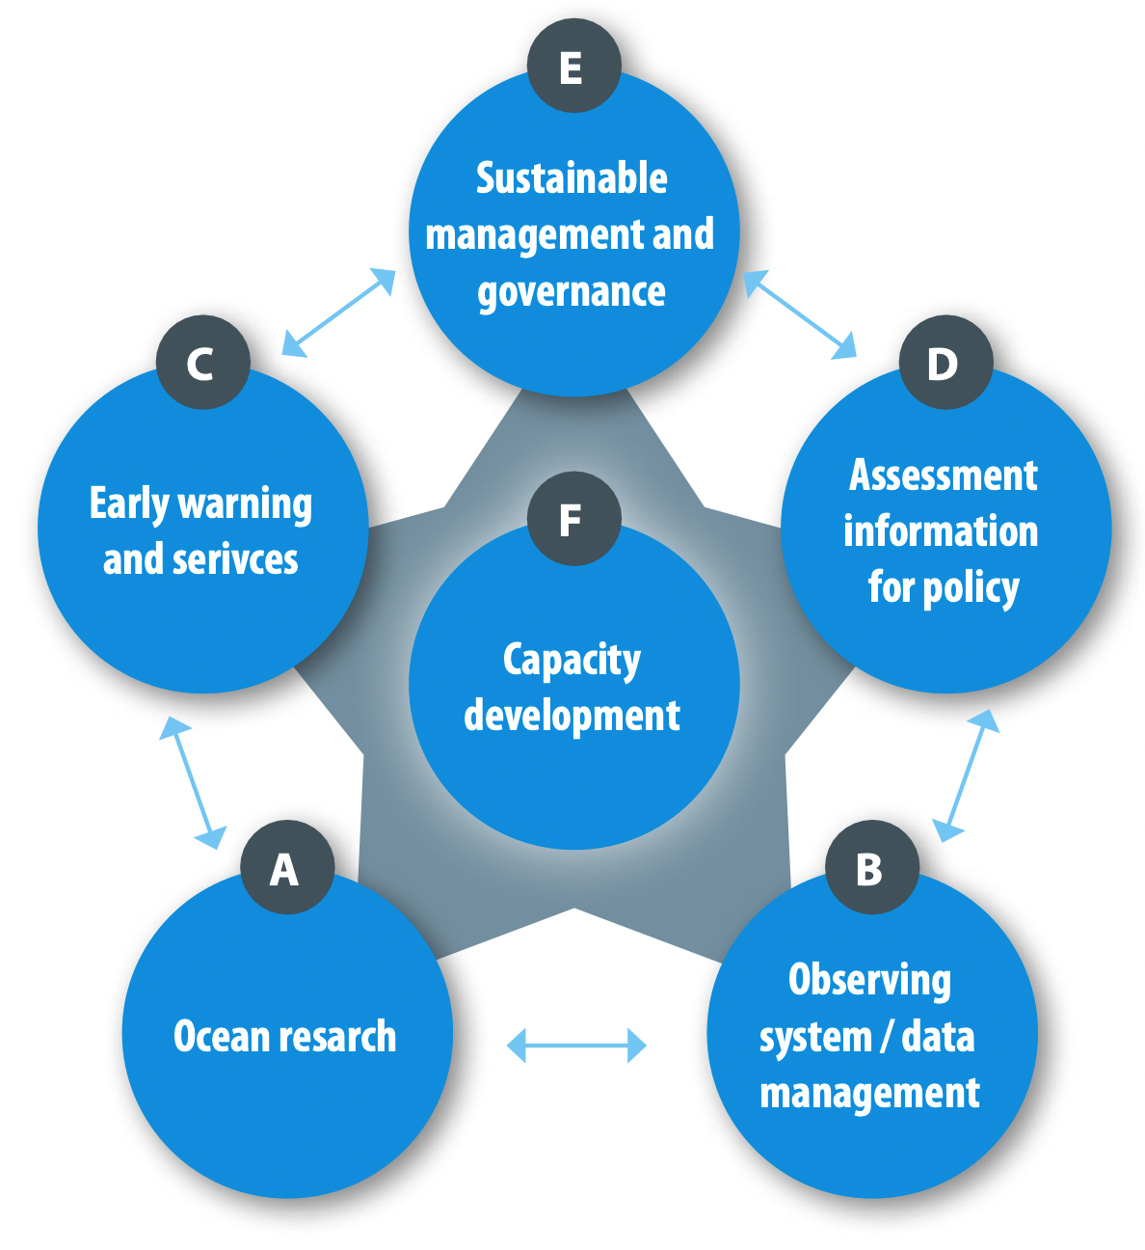
As shown in Figure 1 data and information management is covered by Function B (Observing System/Data Management).
The value chain of IOC: “IOC generates value through interaction of all its functions. In order to maximize the value, the IOC should work as an end-to-end system, in which observations and research enable various services and assessments, leading to informed management decisions and guidance to policy and culminating in multiple societal and economic uses. Feedback from various functions in the system should lead to evolving and, generally, increasingly more specific and more demanding requirements for observations, science and services. Capacity development will act as the catalyst for the whole system, working both at the cutting edge and leaving no one behind.”.
Figure 1: the IOC value chain
The IOC functions and their interaction in the value chain are illustrated in Figure 1.
The importance of professional and high quality data and information management can be illustrated as follows (Figure 2) (example)
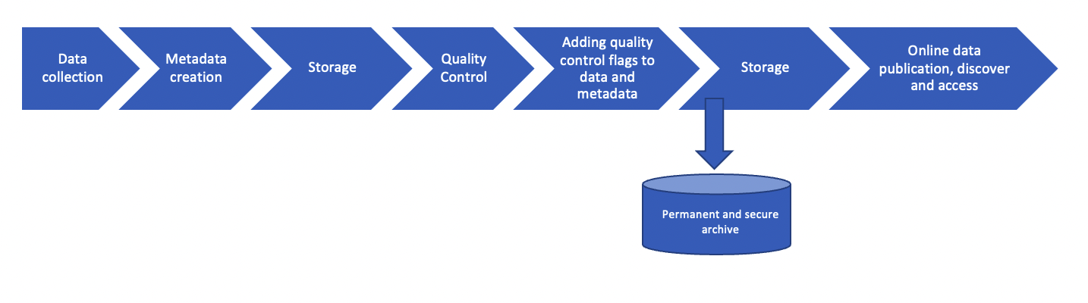Figure 2: Data flow diagram for delayed-mode data
It is worth mentioning that specific IOC programmes or projects may have specific data flow arrangements as well, including specific outputs (data/information products and services).
All programmes within IOC need a data and information management component, developed within the programme and implemented in close collaboration and consultation with the IOC/IODE Programme through its IODE Secretariat, IODE projects/activities and its network of data and information centres, so the considerable expertise available in-house and in these national/regional/thematic structures can be fully utilised.
All programmes within IOC and the activities they implement should have a Data Management Plan that documents the data flow, used methodologies for the management of its data and information, how the data and information will be made available and use permissions, and long-term secure repository arrangements for the data and information. The Data Management Plan should be a “living document” and updated as necessary during the relevant programme or project.
In 1961, the IOC established the IODE Programme. The IODE Programme, and especially its network of National Oceanographic Data Centres (NODCs), Associate Data Units (ADUs) and Associate Information Units (AIUs) as well as the IODE Secretariat, has assumed responsibility for the data and information management and sharing tasks of many national and international ocean science and observation programmes and projects. The IODE data centres all coordinate with each other through a number of IODE projects, and emphasis is placed on the development of standards and best practices for all aspects of data and information management, across the wide range of data types.
At the end of this chain, data should also be made available for machine-to-machine interaction (e.g. through APIs and online web services) which will be a core component of the “digital ocean ecosystem”, the key output of the Strategic Plan (see section 4).
- A “digital ocean ecosystem” is defined here as a system that interlinks distributed, independent systems through a decentralized interoperability architecture to form a digital ecosystem. As with natural ecosystems, it should be resilient to the gain or loss of parts, and accommodate high diversity of products and services, while maintaining its core functions.
Key requirements are: (i) quality control – data collected are subject to errors due to malfunction of the instrument, human error or other unforeseen factors that result in erroneous values. Quality control, using standard methods is therefore essential to ensure the reliability of the data; and (ii) permanent and secure archival of the data – contrary to data generated by laboratory experiments (ex situ), ocean data often result from in situ observations and are unique in time and place and as such are not reproducible.
A wide variety of quality control procedures for oceanographic data already exist. Many of these can be found in the Ocean Best Practices System (OBPS) repository at: https://search.oceanbestpractices.org.
Similarly, the following large and secure IOC ocean data repositories have been developed:
- The World Ocean Database (WOD): WOD is the world's largest collection of uniformly formatted, quality controlled, publicly available ocean profile data. It is a powerful tool for oceanographic, climatic, and environmental research, and the end result of more than 20 years of coordinated efforts to incorporate data from institutions, agencies, individual researchers, and data recovery initiatives into a single database. WOD data spans from Captain Cook's 1772 voyage to the contemporary Argo period, making it a valuable resource for long term and historical ocean climate analysis. WOD is an IODE project (established 2000) and hosted and maintained by the USA National Centers for Environmental Information (NCEI) – https://www.ncei.noaa.gov/products/world-ocean-database;
- The Ocean Biodiversity Information System (OBIS): OBIS is a global open-access data and information clearing-house on marine biodiversity for science, conservation and sustainable development. Its vision is to be the most comprehensive gateway to the world’s ocean biodiversity and biogeographic data and information required to address pressing coastal and world ocean concerns. OBIS contributes to a large number of international programmes, activities and conventions. OBIS started in 2000 by the Census of Marine Life and became a project of IODE in 2009 (Resolution IOC-XXV-4) – https://obis.org.
In terms of IOC ocean information repositories we can mention:
- AquaDocs: the joint open access repository of the UNESCO/IOC InternationaI Oceanographic Data and Information Exchange (IODE) and the International Association of Aquatic and Marine Science Libraries and Information Centers (IAMSLIC) with support from the FAO Aquatic Sciences and Fisheries Abstracts. It is a thematic repository covering the natural marine, coastal, estuarine/brackish and fresh water environments and includes all aspects of the science, technology, management and conservation of these environments, their organisms and resources, and the economic, sociological and legal aspects – https://aquadocs.org
- Ocean Best Practices System (OBPS): has a vision to have the same agreed and broadly adopted methods in use across ocean research, operations, data/information management and applications communities, used by practitioners and for capacity development training. It invites these communities to contribute their own methodologies (documents, training videos, etc.) (also known as “Best Practices”) to the OBPS open-access, permanent global repository to share with their colleagues. The repository offers sophisticated search capabilities underpinned by advanced semantic technologies built on rich metadata profiles and automated vocabulary indexing to significantly improve discovery and access to ocean methods. It is hosted and maintained by the International Oceanographic Data and Information Exchange (IODE) of the UNESCO-IOC as an IOC (IODE, GOOS) coordinated activity – https://www.oceanbestpractices.org/
- OceanExpert: The OceanExpert system is a database containing information on individuals active on issues related to the marine (and freshwater) environment. It is intended to be a tool for scientists, policy makers and anyone who needs to contact a marine (or freshwater) professional – https://oceanexpert.org/

VISION AND OBJECTIVES OF THE STRATEGIC PLAN
The vision of the IOC Strategic Plan for Data and Information Management (2023–2029) is to achieve:
“A comprehensive and integrated ocean data and information system, serving the broad and diverse needs of IOC Member States, for management, policy-making and scientific use”.
This will contribute both to the mission and vision of the IOC. The latter is:
“To bring together governments and the science community in achieving the ‘Ocean We Need for the Future We Want.”
The IOC Strategic Plan for Ocean Data and Information Management describes the implementation of functional and interoperable data and information management practices and frameworks to ensure data and information availability.
It guides IOC Programmes to effectively share and manage their data and information in a coordinated way and based on widely agreed practices so as to assist in fulfilling not only IOC’s objectives but also those of the Ocean Decade.
The scope of the IOC Strategic Plan for Ocean Data and Information Management is therefore intended to be comprehensive and cover all disciplines within the mandate of IOC. All types of data and all time scales for data delivery (e.g. real-time versus delayed mode) as well as synthesis products and model output are included. Different strategies might be employed to satisfy global, regional and local requirements, and to meet timeliness needs. We must move towards a coherent ocean data and information management communications strategy to enable us to integrate the wide variety of complex marine environmental measurements and observations across disciplines, institutions, and temporal and spatial scales.
The aim is to ensure the establishment of a comprehensive and integrated ocean data and information ecosystem for all ocean activities. It is essential that the existing and operational national, regional, and international systems can connect to the integrated global system.
The objectives of the Strategic Plan are to deliver:
- interoperable, quality-controlled data on a diverse range of variables: (i) generated according to scientifically and operationally sound methods; and (ii) persistently archived in well-documented, globally applicable standards and formats;
- timely dissemination of data on a diverse range of variables (generated from observations and model outputs) both in real-time and delayed modes depending on the needs of user groups and their technical capabilities (“on demand” as well as automatically scheduled); and
- easy discovery and access to data and information about a diverse range of variables and derived products (including forecasts, alerts and warnings) in a way that is user friendly for a wide variety of users.
The implementation of the Strategic Plan should take into account:
- Developments within the IOC/IODE Ocean Data and Information System (ODIS) and the ODIScat catalogue of online data and information services as an interoperability framework to interlink international, regional and national digital resources (see also 4.1);
- Developments within the IOC/GOOS Observations Coordination Group (OCG) to map the data flows of the global in situ networks and develop a data implementation plan;
- Developments within the IODE/GOOS Ocean Best Practices System (OBPS), noting that currently not all methods and best practices relevant to the IOC Strategic Plan for Ocean Data and Information Management are included;
- The IOC Capacity Development Strategy (2023) and IOC Data Policy and Terms of Use (2023);
- The need to support the data and information requirements for marine services, transportation, ocean forecasts, climate change and variability studies and scientific research;
- The need to support IOC’s efforts related to its custodian responsibility for indicators for SDG target 14.3 on ocean acidification and SDG target 14.a on marine scientific research;
- The recognition and inclusion of Indigenous and Local Knowledge (ILK) to ensure this knowledge is appropriately integrated;
- The support of community data principles such as FAIR (Findable, Accessible, Interoperable and Reusable), CARE (Collective benefit, Authority to control, Responsibility, Ethics), and TRUST (Transparency, Responsibility, User Focus, Sustainability, Technology); and ‘Trusted Repository’ protocols;
- The need to undertake marine assessments and routinely provide indices on the “health” of the marine environment, such as assessments under the UN Regular Process (World Ocean Assessment) and the Intergovernmental Platform on Biodiversity and Ecosystem Services (IPBES);
- The call from the Convention on Biological Diversity (CBD) to IOC and its OBIS to provide data and information for the identification of Ecologically or Biologically Significant Areas (EBSAs), and to support the CBD’s post-2020 Global Biodiversity Framework through GOOS and OBIS.

EXPECTED OUTCOME AND OUTPUTS

Expected outcome
The expected outcome of the IOC Strategic Plan for Data and Information Management is to achieve significant enhancement of infrastructure, common approaches in ocean data and information management that enable interoperable data sharing and stewardship, and enhanced collaboration between data providers and users.
It will implement a “digital ocean ecosystem” as a dynamic and continuous process, incorporating established approaches and technologies as well as those that are only just emerging. In close cooperation with the UN Decade of Ocean Science for Sustainable Development it will aim at representing the socio-ecological dimensions of the ocean through digital means.
In the context of IOC it will provide a comprehensive and global “e-environment where users can discover data, data products, data services, information, information products and services provided by Member States, projects and other partners associated with IOC.”
The “digital ocean ecosystem” will enable the understanding of the ocean from a socio-ecological perspective using historical, contemporary (including real-time) and modelled data to describe past and current ocean conditions while supporting forecasts and prediction of their future states. It will also contribute to the identification of knowledge gaps, helping to prioritize the use of existing data or the generation of new data, information and knowledge.
The IOC Assembly, at its 31st Session established the IOC Ocean Data and Information System Project (ODIS) through Decision A-31/3.4.2. The objectives of this project are to:
(i) develop the IOC Ocean Data and Information System (ODIS) as an e-environment where users can discover data, data products, data services, information, information products and services provided by Member States, projects and other partners associated with IOC;
(ii) work with partners, linked and not linked to the IOC, to improve the accessibility and interoperability of existing data and information. It will contribute to the development of a global ocean data and information system, to be referred to as the IOC Ocean Data and Information System, leveraging established solutions where possible;
(iii) start its development using existing “ecosystem components” such as, inter alia, the ODIS Catalogue of Sources (ODISCat), the Ocean InfoHub Project, and all IODE data and information products and services, and to add components within and outside the IODE programme as these become available to and interoperable with the ODIS ecosystem.
To support and promote the equitable participation of all IOC Member States as well as Ocean data and information providers in Member States and other organizations, the Ocean InfoHub Project facilitates the implementation of the ODIS digital ocean ecosystem.
As the Ocean Decade advances, the range of digital sources will expand to industry and citizen-science data, as well as sources of less-quantifiable insights, such as indigenous and local knowledge. Components that contribute to the digital ecosystem will include approaches to overcome a number of digital divides caused by different ways of knowing, differing levels of capacity (e.g. access to technology and computing power), data fragmentation, siloed activities, impediments to data sharing and the undervaluing/underuse of data, information and knowledge.

Expected outputs
Accordingly the IOC Strategic Plan for Ocean Data and Information Management will have the following outputs:
- An IOC Ocean Data and Information System, “digital ecosystem” built around already existing and operational national, regional, and international systems which will be the system of choice for all ocean activities, particularly those of research programmes;
- An IOC Ocean Data and Information System that will contribute to and be fully interoperable with, and part of, the “digital ecosystem” to be built during the Ocean Decade;
- Guidelines and best practices on all aspects of the ocean data and information management process chain;
- Long-term and reliable data preservation, archiving and accessibility of ocean data and information;
- Deliver timely access to assembled, quality controlled and archived data on a diverse range of variables according to scientifically sound and well-documented standards and formats;
- Enhanced collaboration with other organizations and the private sector to ensure greater flexibility in timely and cost-effective access to ocean data and information;
- Facilitate publishing of research findings by scientists (with special attention to scientists in developing countries); and
- More effective and enhanced communication and outreach to better serve user communities.
Factors that impact on the outputs:
- The IOC Data Policy and Terms of Use (2023) that will provide guidelines to data providers towards the best possible “free and open” access to ocean data and information, as well as recommendations on “terms of use” for the users of the ocean data and information;
- The IOC Capacity Development Strategy (2023) that will provide a framework of capacity development actions and activities that will assist with the development of sustainable capacity in ocean data and information management in developing countries.
These outputs will be achieved through a number of targeted activities and related actions that will constitute the implementation plan.

IMPLEMENTING THE STRATEGY: THE IMPLEMENTATION PLAN
The IOC Strategic Plan for Data and Information Management is co-designed and will be implemented jointly by all IOC programmes, in close collaboration with the IODE Programme. As the Strategic Plan seeks to cover all data and information collected by IOC programmes it is crucial that there is input on the progress towards delivery of the strategic objectives from IOC Member States and IOC programmes.
An IOC Strategic Plan for Ocean Data and Information Management Advisory Group will have responsibility for overseeing the implementation of this Strategy. The Advisory Group will review and endorse the activities of data and information management components of all IOC programmes and will be responsible for both the development and execution of the Strategy. To help with the implementation of this strategy, an implementation plan will be developed and updated on a regular basis to best adapt to the evolution of tools and international scientific frameworks.
In order to be efficient, the Advisory Group will be a small representative group able to draw on additional expertise as required. Membership of the Group will comprise representatives nominated by the governing bodies of each IOC programme and chaired by one of the IODE Co-chairs. Experts from the regional sub-commissions and regional committees are also encouraged to participate.
The Advisory Group will operate as an electronic discussion group and meet regularly by email or web conferencing, thus avoiding costly meetings. It is recommended the Advisory Group meets every six months to discuss specific programme issues related to data and information management.

[end of document]

Intergovernmental Oceanographic Commission  of UNESCO  7 Place de Fontenoy  75352 Paris Cedex 07 SP, France  http://ioc.unesco.org |  | UNESCO/IOC Project Office for IODE  InnovOcean Campus  Jacobsenstraat 1  8400 Oostende, Belgium  Email: info@iode.org  http://www.iode.org

https://oceanexpert.org/downloadFile/50394 : IOC/INF-1412 (IOC Medium-Term Strategy, 2022–2029. UNESCO, 2022)
https://oceanexpert.org/downloadFile/50394: IOC/INF-1412 (IOC Medium-Term Strategy, 2022–2029. UNESCO, 2022)
International Oceanographic Data and Information Exchange programme (IOC)
From: “Proposal for the Establishment of the IOC Ocean Data and Information System (ODIS)”. Document IOC/IODE-XXVI/6.1.1 - https://oceanexpert.org/document/27884
A best practice is a methodology that has repeatedly produced superior results relative to other methodologies with the same objective; to be fully elevated to a best practice, a promising method will have been adopted and employed by multiple organizations.

