Summary

This document presents the proposal for the IOC Draft Programme and Budget for 2024–2025 (42 C/5), as submitted to the 216th session of the UNESCO Executive Board.
Decision proposed: After introduction and discussion in plenary under item 6.1, the Assembly is invited to take note of this report and consider the draft decision referenced as Dec. IOC-32/6.1 in the Provisional Action Paper (document IOC-32/AP). The document will then be subject of an in-depth review by the sessional statutory open-ended Financial Committee and the decision reflected in the Draft Resolution that the Financial Committee will be submitting to the Assembly for adoption under item 6.4 in accordance with paragraph 15 of the Draft Revised Guidelines for the Preparation and Consideration of Draft Resolutions (IOC/INF-1315).

CONTEXT AND BACKGROUND

An integral part of the UNESCO Draft Programme and Budget for 2024–2025 (42 C/5), submitted by the Director-General to the 216th session of the UNESCO Executive Board, this document presents the strategic focus for the final two years of the Approved Programme and Budget for the 2022–2025 quadrennium (41 C/5), endorsed by IOC Resolution A-31/2 as presented in document IOC/A-31/4.2.Doc. As such, it represents IOC’s ambition, focus and continuity, building on achievements made during the first biennium towards delivering on the Commission’s mandate.
In accordance with the decision of the UNESCO Executive Board at its 215th session, two budget scenarios are presented with respect to the regular budget:
- Base Case scenario – a total UNESCO programme budget of $564.6 million, which represents an increase of $30 million in assessed contributions compared to $534.6 mission for the 41 C/5 Approved regular budget (2022–2023). This scenario responds to strategic priorities set by Member States, as well as projected increases in staff costs and the impact of inflation on non-staff costs. It foresees a significant reinforcement of the IOC with the allocation of $13,5 million, which represents a budget increase of $2.2 million (+19.7% variation compared to 41 C/5), including $0.4 million to strengthen IOC’s contribution to Intersectoral Programme 2 in environmental and climate change education
- Zero Nominal Growth (ZNG) scenario – a total UNESCO programme budget of $534.6 million, requiring programmatic and budget adjustments to absorb programme and staff statutory increases in inflation, significantly impacting UNESCO’s capacity to deliver on the approved Programme for 2022–2025. It foresees the allocation of $11.7 million to the IOC (+0.4 million or +3.1% compared to 41 C/5).
The chart below shows the comparison between integrated budgetary frameworks of the 41 C/5 and the two scenarios of the Draft 42 C/5.

The following section of this document presents the narratives and the tables with the detailed presentation of the IOC’s Draft 42 C/5 budget proposal in an Integrated Budget Framework (IBF), setting out the resources required for implementation for all sources of funds. It includes the proposed IBF budget based on the Base Case scenario, as well as the impact of the ZNG scenario with respect to all figures (programmes, global priorities, priority groups), as well as performance targets.
DRAFT 42 C/5 AS SUBMITTED TO THE 216TH SESSION OF UNESCO EXECUTIVE BOARD
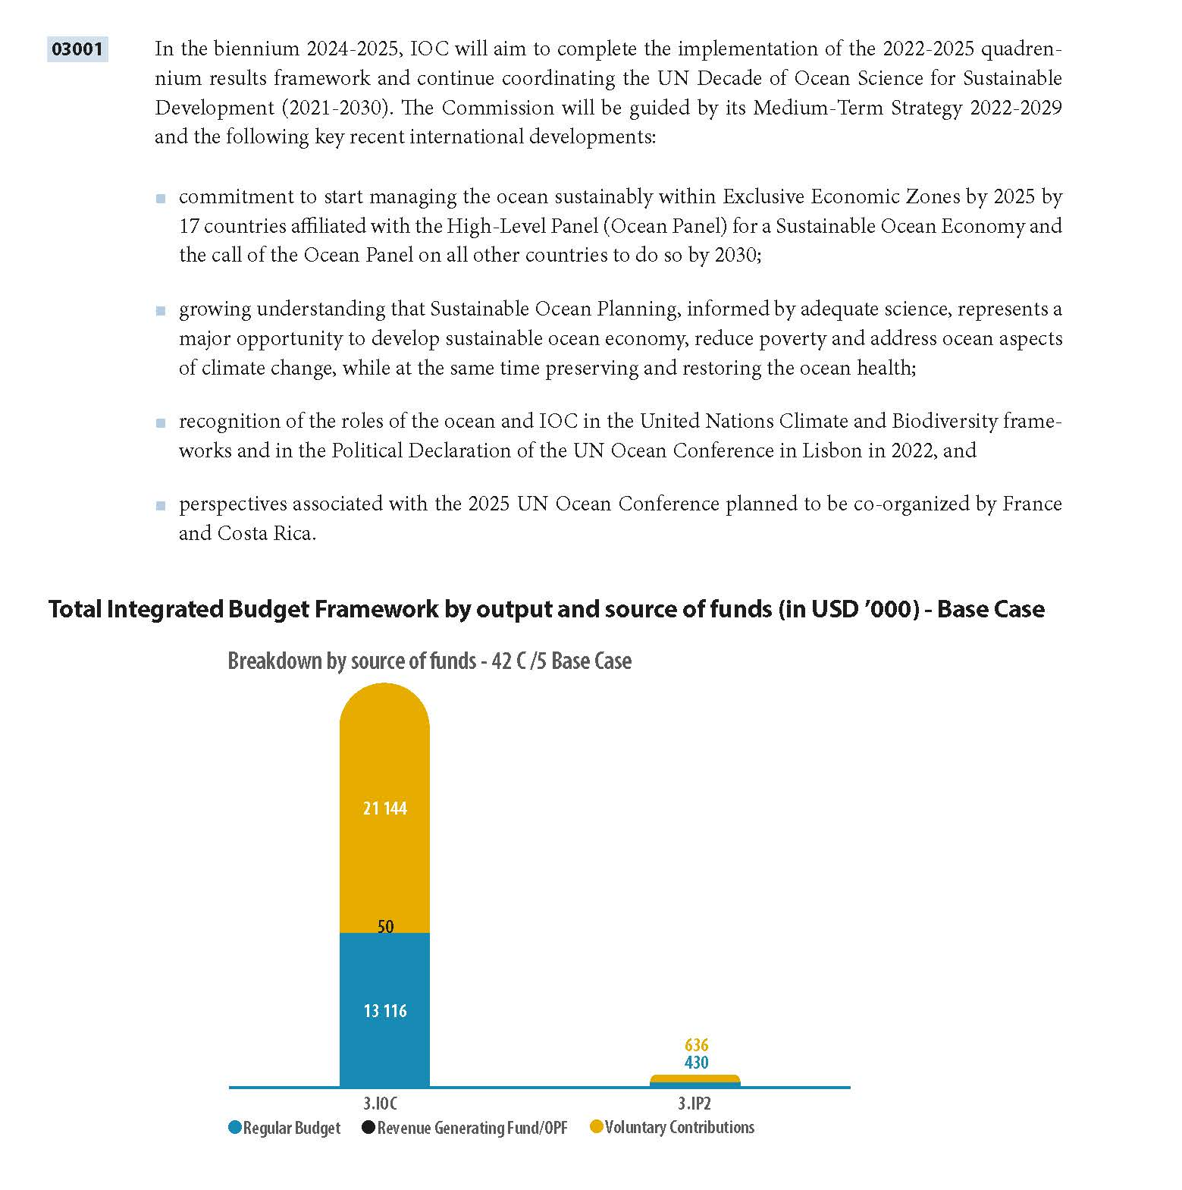

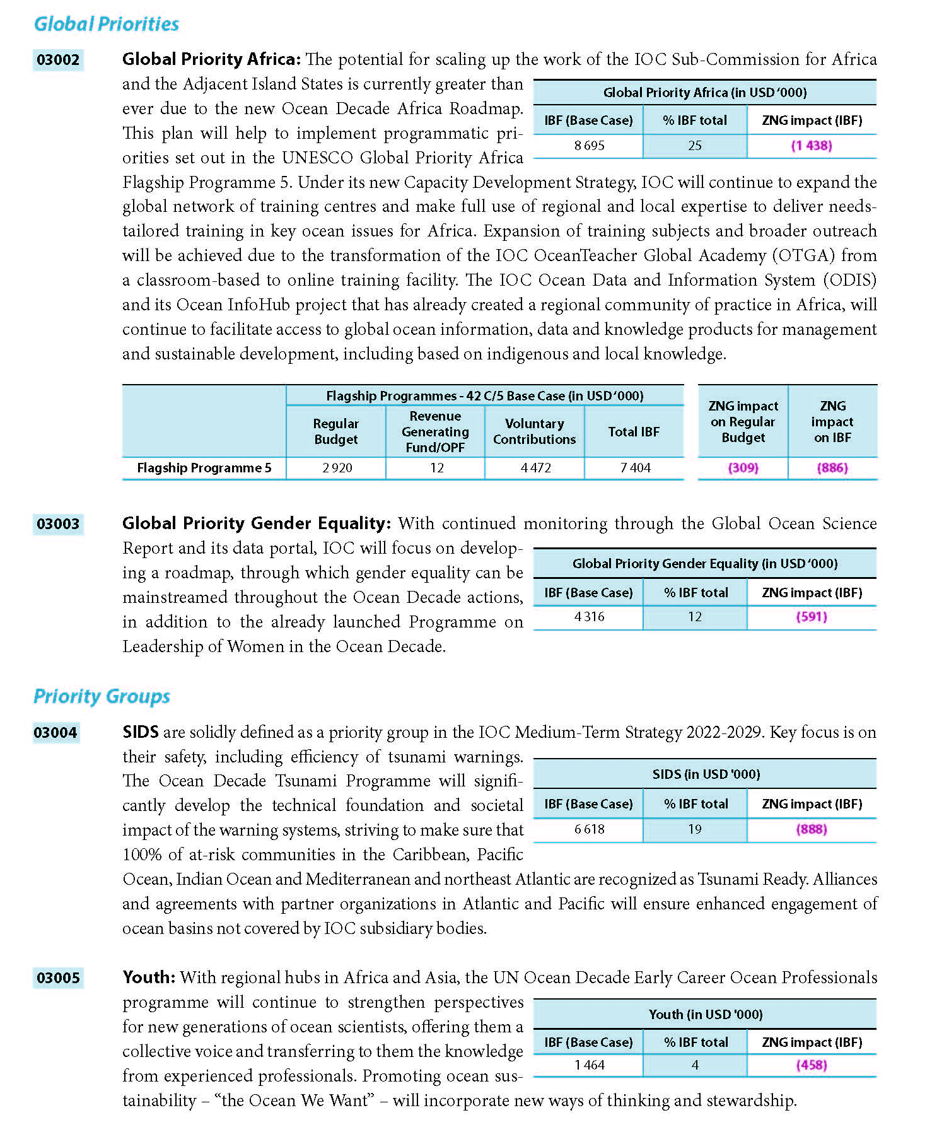
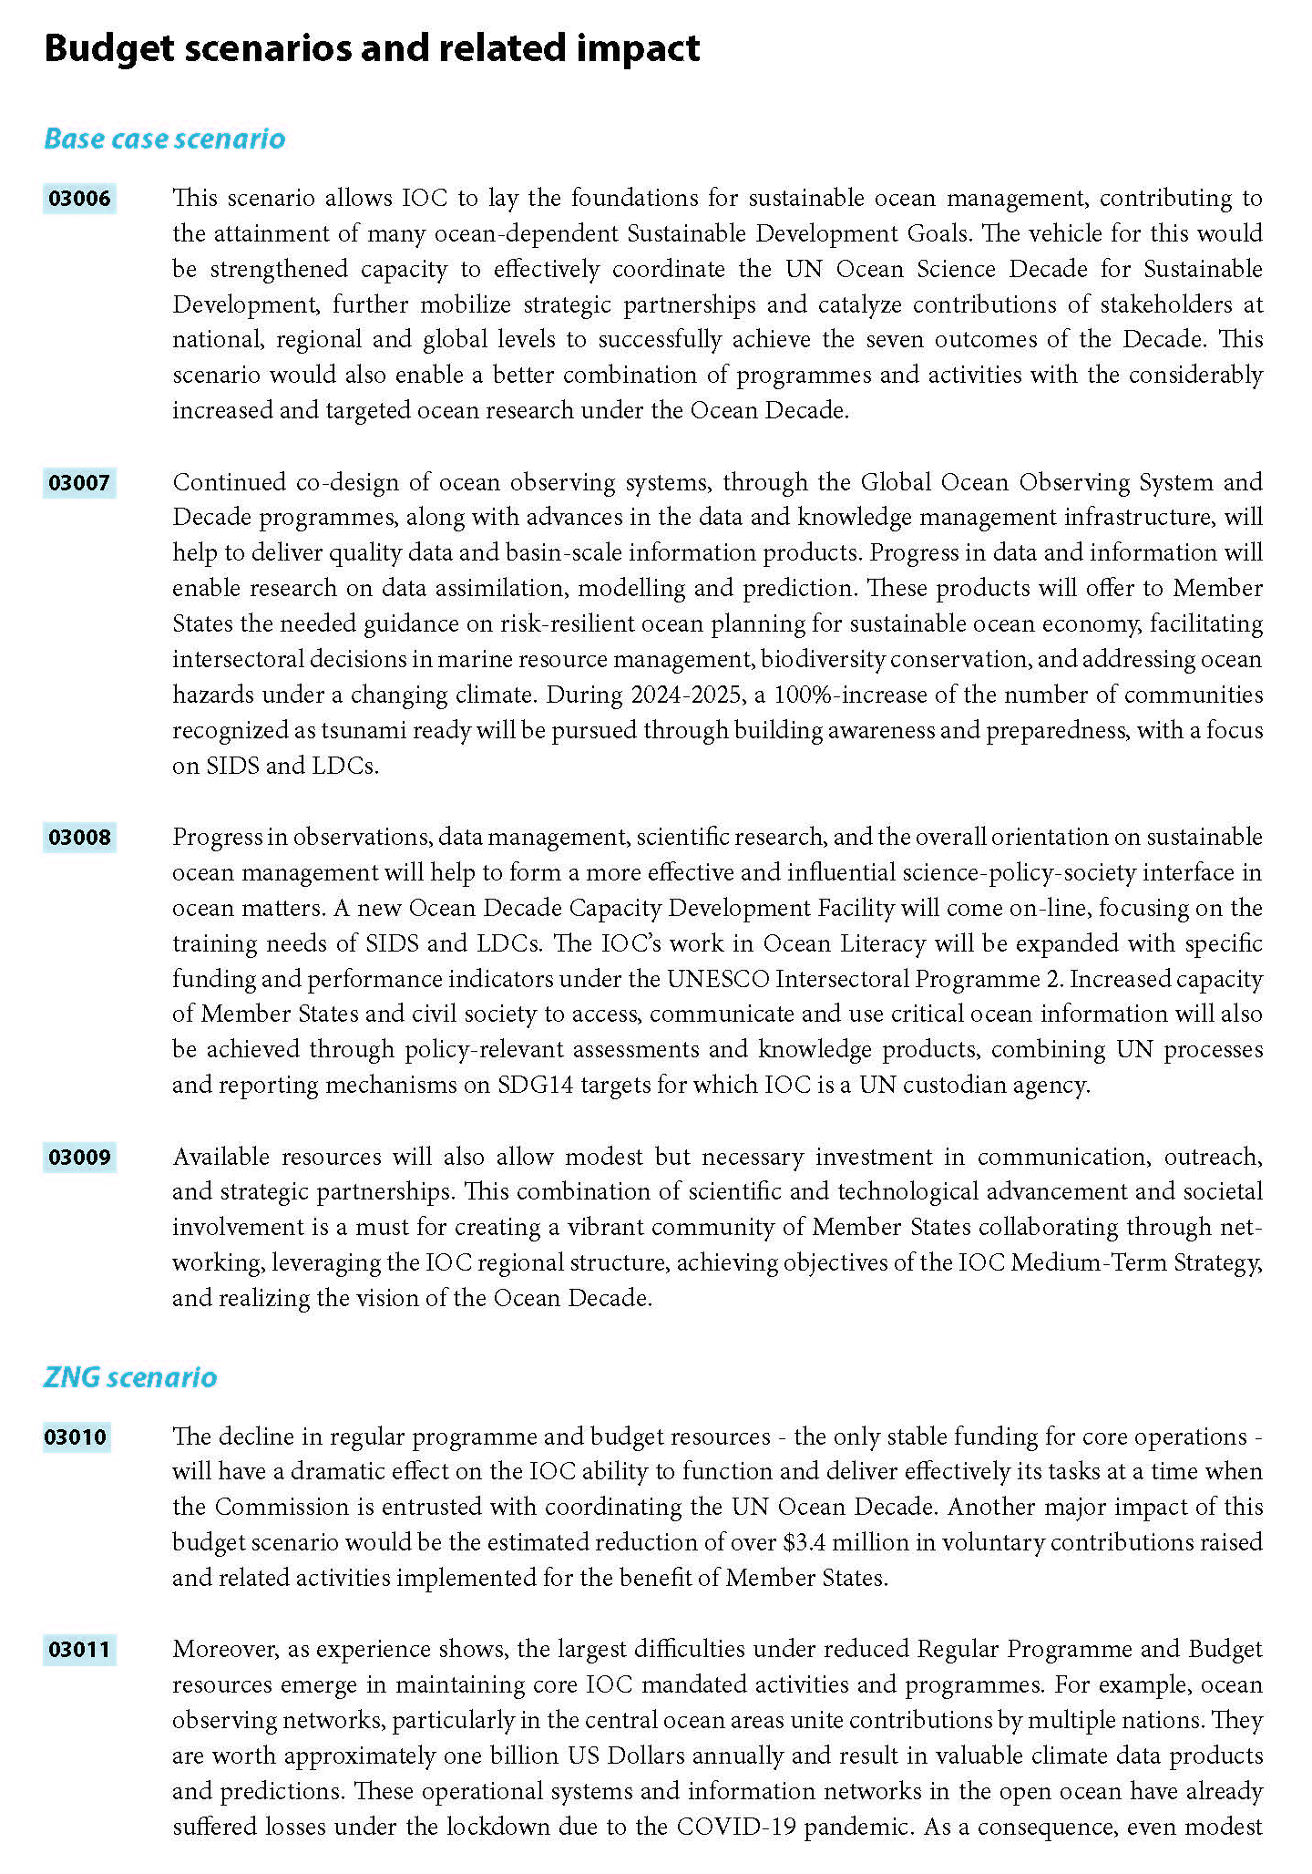
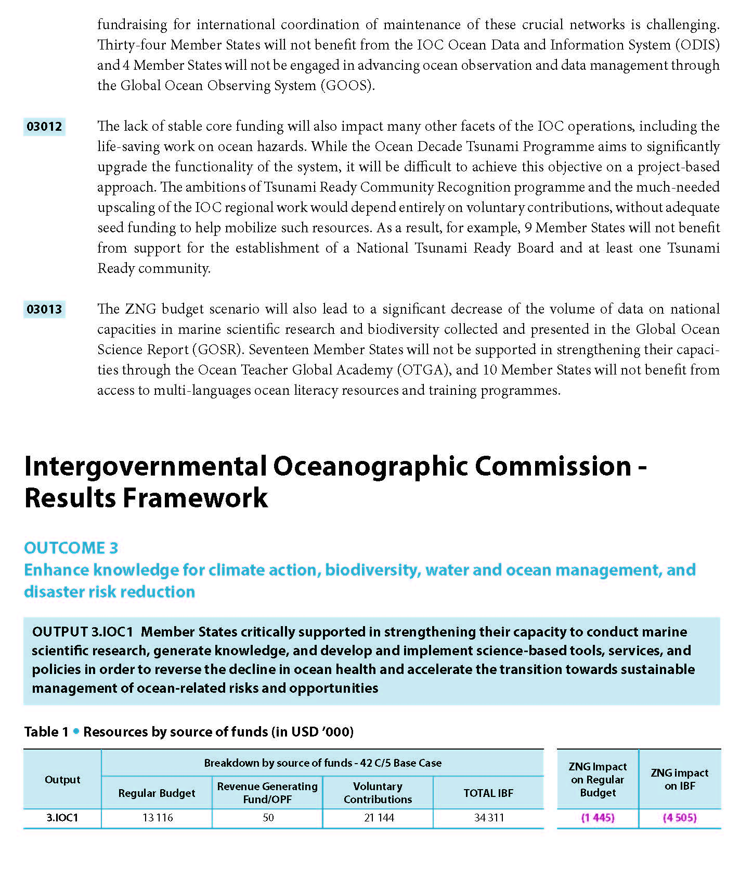
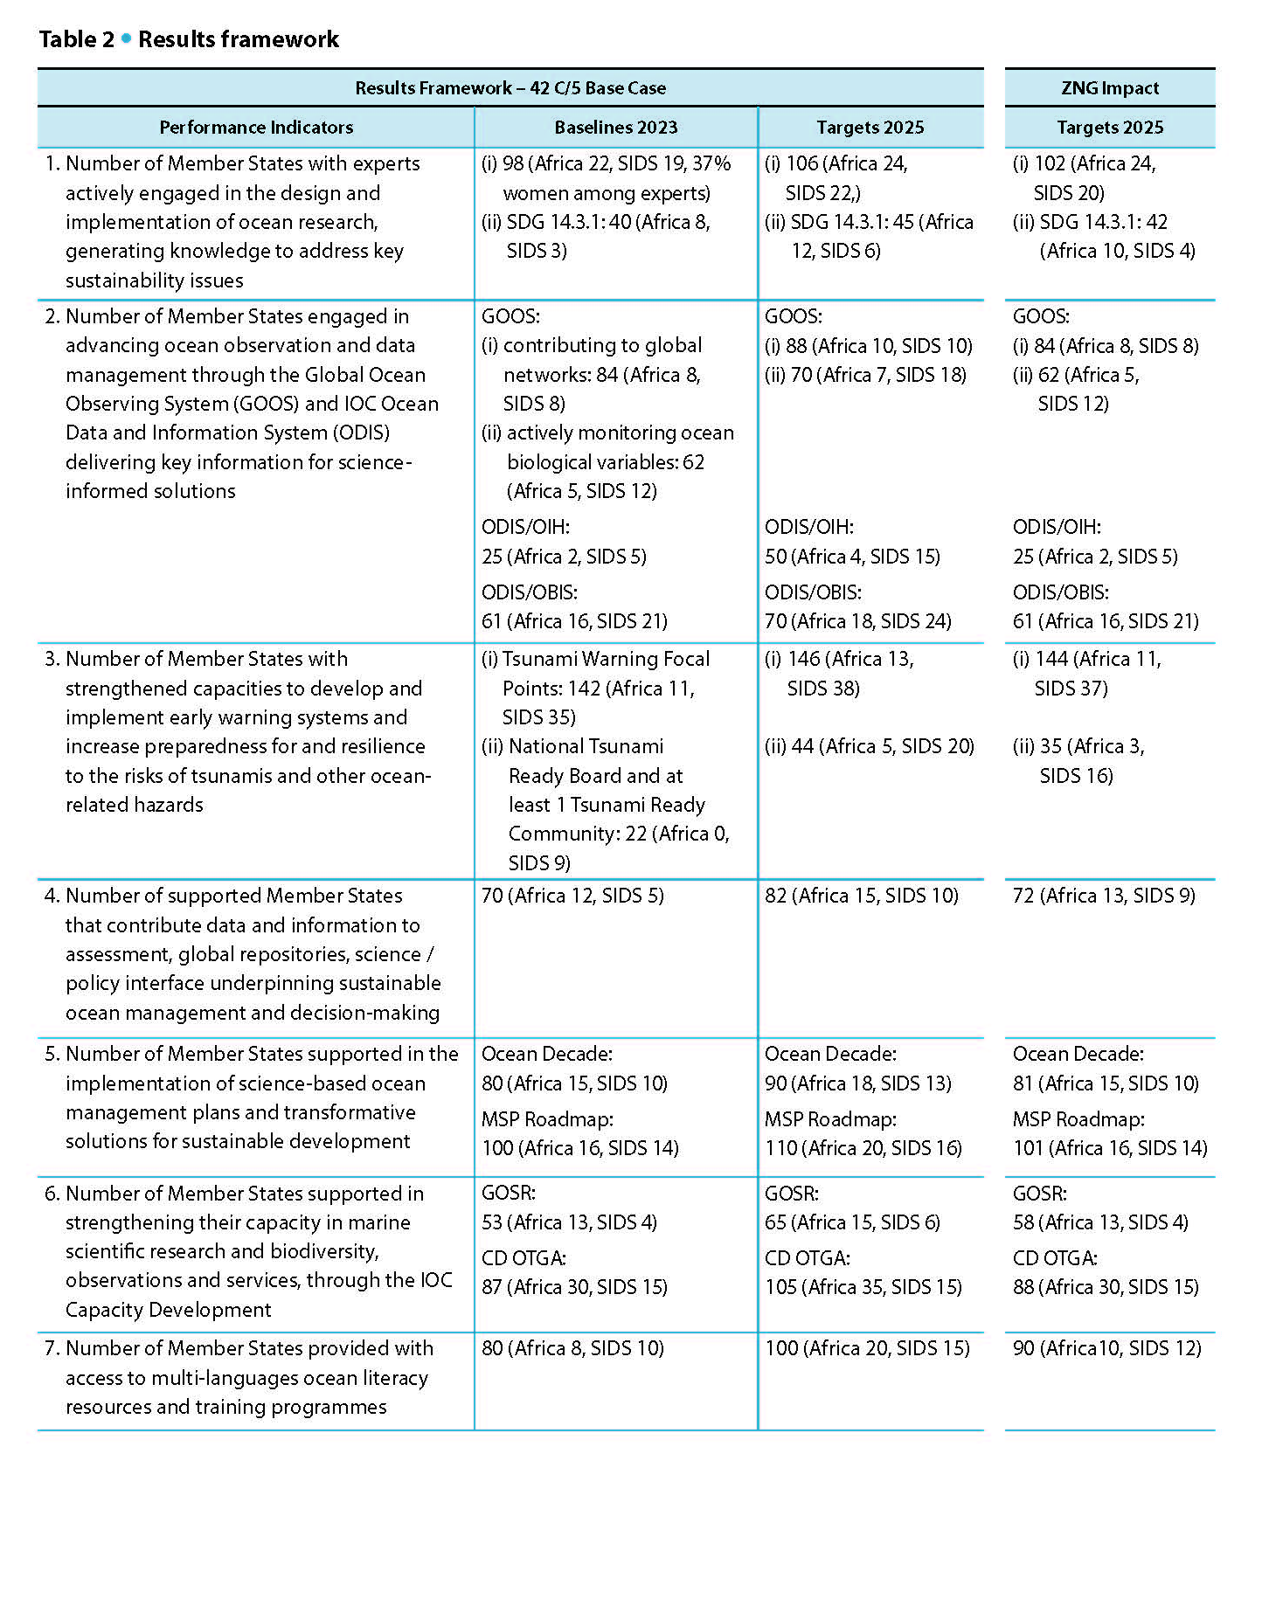
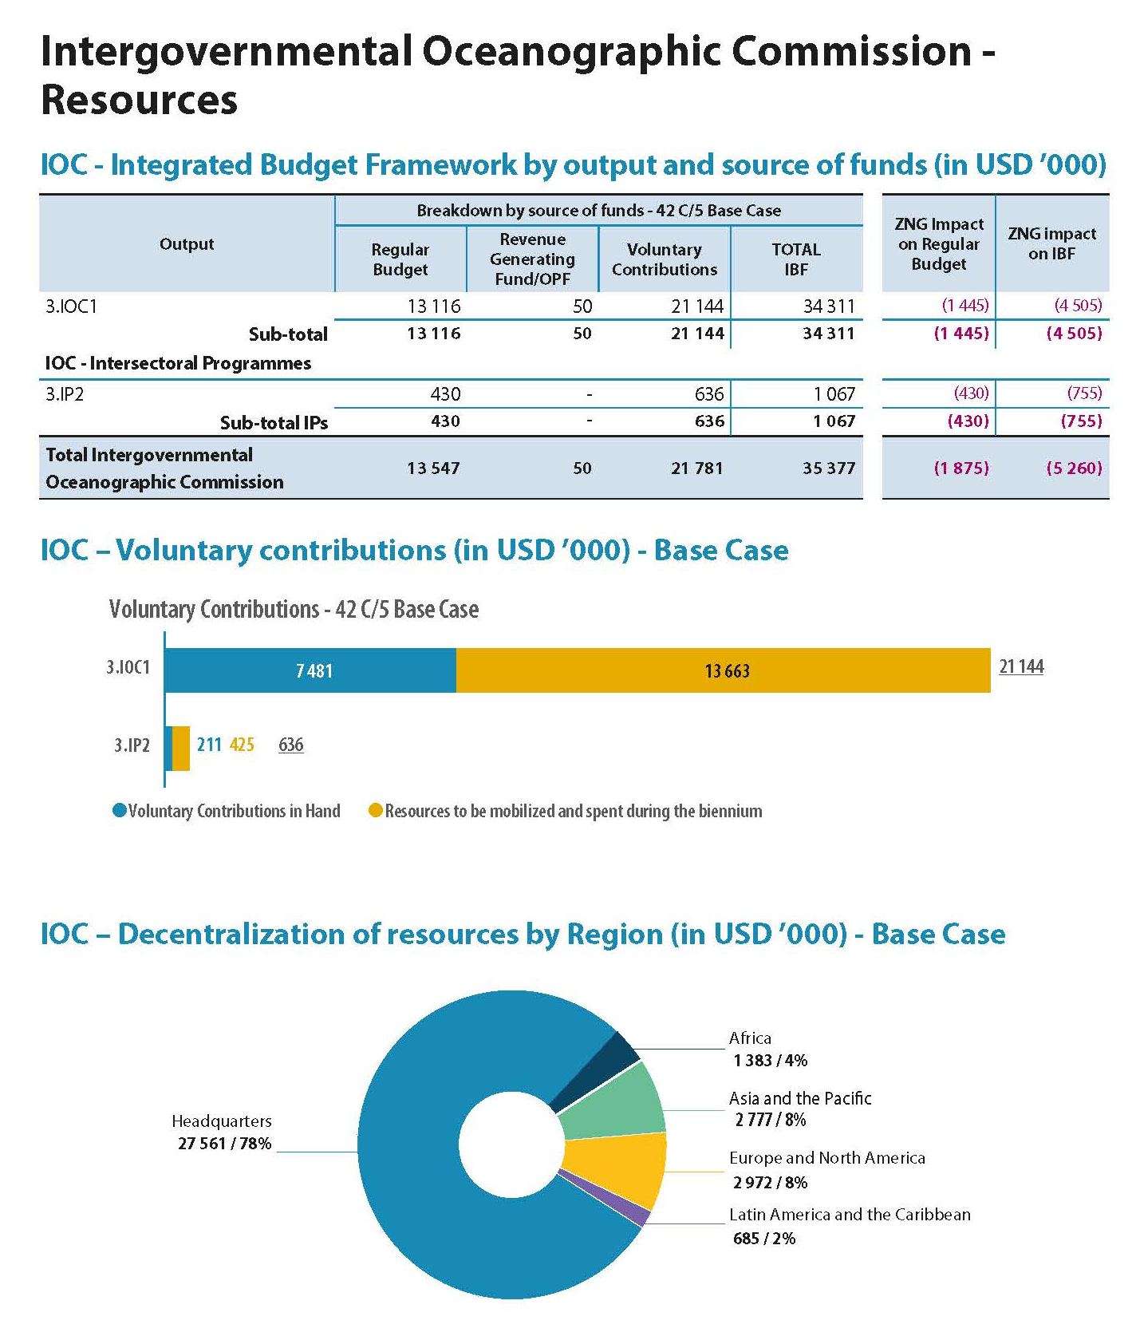

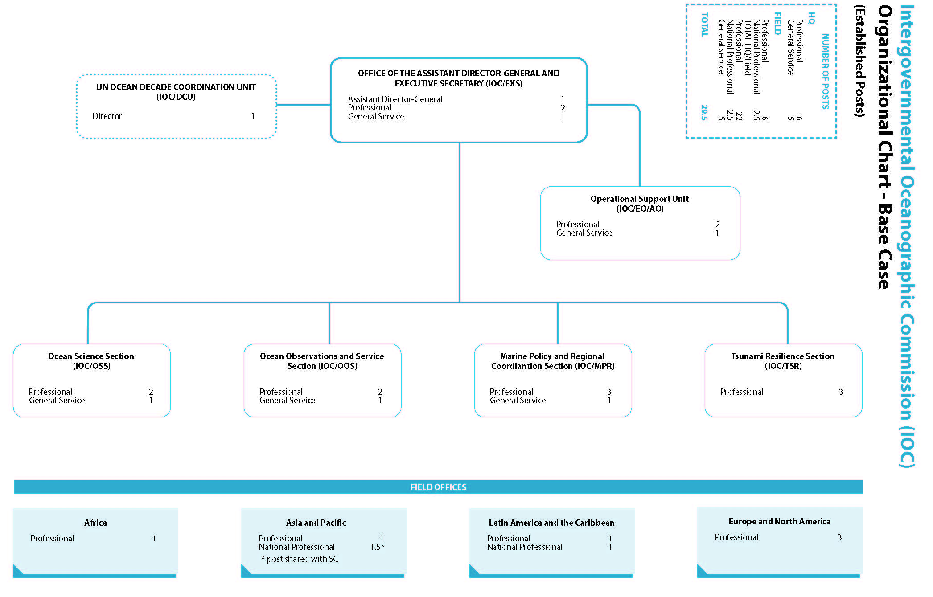
IOC-32/6.1.Doc(1)
page 9

PROPOSED DISTRIBUTION OF RESOURCES TO IOC FUNCTIONS & ACTIVITIES

Function/Activity title | Scope |  | Impl.unit |  | Regular Budget Allocations (in US$)
 |  |  |  |  | 41 C/5* |  | Draft 42 C/5
 |  |  |  |  |  |  | Base Case scenario |  | ZNG scenario
FUNCTION A - Ocean Research |  |  |  |  |  | 135,745 |  | 264,500 |  | 162,280
WCRP |  | GLO |  | IOC |  | 33,000 |  | 50,000 |  | 30,000
Ocean Carbon Sources & Sinks |  | GLO |  | IOC |  | 49,745 |  | 107,250 |  | 66,140
CC impact on ocean & coastal ecosystems |  | GLO |  | IOC |  | 53,000 |  | 107,250 |  | 66,140
FUNCTION B - Observing Systems & Data Management |  |  |  |  |  | 503,205 |  | 933,715 |  | 591,220
GOOS design, development, engagement & impact |  | GLO |  | IOC |  | 192,025 |  | 270,525 |  | 243,790
GOOS Projects through IOCAFRICA |  | AFR |  | NAI |  | 33,715 |  | 33,715 |  | 20,000
GOOS Regional Alliances |  | GLO |  | IOC |  | 26,500 |  | 66,500 |  | 33,640
Observing system integration & delivery |  | GLO |  | IOC |  | 52,975 |  | 117,975 |  | 59,000
Ocean forecast systems & applications |  | GLO |  | IOC |  | 43,040 |  | 45,000 |  | 46,270
IODE & OBIS core systems |  | GLO |  | IOC |  | 54,300 |  | 133,270 |  | 62,840
IODE & OBIS products & services |  | GLO |  | IOC |  | 44,365 |  | 133,270 |  | 62,840
IODE & OBIS training & education |  | GLO |  | IOC |  | 56,285 |  | 133,460 |  | 62,840
FUNCTION C - Early Warning & Services |  |  |  |  |  | 261,045 |  | 541,146 |  | 320,220
Promote integrated & sustained warning systems |  | GLO |  | IOC |  | 79,885 |  | 167,455 |  | 104,300
Tsunami-Ready - Educating communities at risk |  | GLO |  | IOC |  | 38,345 |  | 65,505 |  | 40,800
Tsunami-Ready - Caribbean |  | LAC |  | IOC |  | 22,655 |  | 41,925 |  | 26,110
Tsunami-Ready - Pacific |  | APA |  | API |  | 26,480 |  | 43,676 |  | 26,480
Building capacities for assessment |  | GLO |  | IOC |  | 39,730 |  | 83,280 |  | 51,870
Building capacities for assessment Indian Ocean |  | INT |  | JAK |  | 26,980 |  | 56,555 |  | 35,230
HAB & NIS Research & Monitoring |  | GLO |  | IOC |  | 26,970 |  | 82,750 |  | 35,430
FUNCTION D - Assessment & Information for Policy |  |  |  | IOC |  | 136,235 |  | 282,750 |  | 158,300
Follow-up to SDGs, WOA & StOR |  | GLO |  | IOC |  | 49,265 |  | 75,000 |  | 57,130
GEBCO |  | GLO |  | IOC |  | 20,000 |  | 40,000 |  | 25,400
Reducing nutrient enrichment |  | GLO |  | IOC |  | 26,970 |  | 82,750 |  | 33,070
CC adaptation in coastal zones Africa |  | AFR |  | NAI |  | 20,000 |  | 30,000 |  | 20,000
CC adaptation in coastal zones |  | GLO |  | IOC |  | 20,000 |  | 55,000 |  | 22,700
FUNCTION E - Sustainable Management & Governance |  |  |  |  |  | 448,760 |  | 760,000 |  | 458,238
IOC Governing bodies |  | GLO |  | IOC |  | 240,000 |  | 240,000 |  | 240,000
IOCARIBE |  | LAC |  | IOC |  | 26,970 |  | 30,000 |  | 22,000
IOCAFRICA |  | AFR |  | NAI |  | 26,970 |  | 30,000 |  | 22,000
WESTPAC |  | APA |  | BGK |  | 26,970 |  | 30,000 |  | 22,000
IOCINDIO |  | APA |  | IOC |  | 20,000 |  | 30,000 |  | 22,000
IOC Communication & Outreach |  | GLO |  | IOC |  |  |  | 85,000 |  | 20,238
UN partnerships |  | GLO |  | IOC |  | 47,400 |  | 75,000 |  | 50,000
UN Decade preparation/coordination |  | GLO |  | IOC |  | 20,000 |  | 155,000
ICAM & MSP |  | GLO |  | IOC |  | 40,450 |  | 85,000 |  | 60,000

Function/Activity title | Scope | Impl.unit | Regular Budget Allocations (in US$)
 |  |  | 41 C/5* | Draft 42 C/5
 |  |  |  | Base Case scenario | ZNG scenario
FUNCTION F - Capacity Developm+A47:F62ent |  |  | 228,418 | 600,180 | 383,720
CD & TMT&GOSR & Ocean Literacy | GLO | IOC | 49,963 | 180,000 | 60,800
Ocean Literacy contribution to IP2 | GLO | VNI |  | 20,000
CD IOCAFRICA | AFR | NAI | 57,315 | 145,180 | 105,900
CD IOCARIBE | LAC | IOC | 50,570 | 85,000 | 72,340
CD WESTPAC | APA | BGK | 50,570 | 85,000 | 72,340
CD INCINDIO | APA | IOC | 20,000 | 85,000 | 72,340
IOC PROGRAMS NET OPERATIONAL BUDGET |  |  | 1,713,408 | 3,382,291 | 2,073,978
Common country programming 1% |  |  | 17,848 | 33,823 | 20,740
Evaluations 3% |  |  | 53,544 | 101,469 | 62,219
IOC Training & Development |  |  |  | 20,000
IOC Operating costs |  |  | 50,000 | 50,000 | 50,000
TOTAL NON STAFF |  |  | 1,834,800 | 3,587,583 | 2,206,937
TOTAL STAFF COSTS |  |  | 9,401,200 | 9,959,017 | 9,464,463
TOTAL |  |  | 11,236,000 | 13,546,600 | 11,671,400
*as approved by the IOC Assembly through IOC Resolution A-31/2 - ref. document IOC/A-31/4.2.Doc

PROPOSED BUDGETARY ALLOCATION FOR THE IOC SPECIAL ACCOUNT – 2024-2025

FUNCTION/ACTIVITY TITLE | Budget code | Approved budget
IOC Function A - Ocean Research |  | 450,000
 | 191ORS2042 | 450,000
WCRP | 191ORS2042.1 | 50,000
Ocean Carbon & Acidification | 191ORS2042.2 | 250,000
Impact of climate change on ocean and coastal ecosystems | 191ORS2042.3 | 150,000
IOC Function B - Observing Systems & Data Management |  | 1,550,000
 | 191OSD2042 | 1,100,000
GOOS design, development, engagement & impact | 191OSD2042.1 | 300,000
Observing system integration & delivery | 191OSD2042.2 | 300,000
Ocean forecast services & applications | 191OSD2042.3 | 200,000
IODE & OBIS | 191OSD2042.4 | 300,000
OceanOPS | 193OPS2042 | 450,000
IOC Function C - Early Warning & Services |  | 2,030,000
 | 191EWS2042 | 1,180,000
ICG NEAMTWS | 191EWS2042.1 | 100,000
ICG PTWS | 191EWS2042.2 | 250,000
ICG CARIBE-EWS | 191EWS2042.3 | 250,000
TOWs & inter-regional coordination | 191EWS2042.4 | 100,000
IOTIC | 191EWS2042.5 | 80,000
GLOSS - tsunami | 191EWS2042.6 | 300,000
HAB & NIS Research & Monitoring | 191EWS2042.7 | 100,000
ICG-IOTWMS Secretariat | 193EWS2042 | 850,000
IOC Function D - Assessment & Information for Policy |  | 450,000
 | 191AIP2042 | 450,000
Follow-up to SDGs, WOA & State of the ocean reporting | 191AIP2042.1 | 150,000
GEBCO | 191AIP2042.2 | 50,000
Science for reducing nutrient enrichment | 191AIP2042.3 | 100,000
Climate change adaptation in coastal zones | 191AIP2042.4 | 150,000
IOC Function E - Sustainable Management & Governance |  | 4,000,000
 | 191RCG2042 | 1,000,000
IOC Governance (representation & intersessional coordination) | 191RCG2042.1 | 100,000
IOCARIBE (office support & intersessional coordination) | 191RCG2042.2 | 100,000
IOCAFRICA (office support & intersessional coordination) | 191RCG2042.3 | 100,000
WESTPAC (office support & intersessional coordination) | 191RCG2042.4 | 250,000
IOCINDIO (intersessional coordination) | 191RCG2042.5 | 100,000
UN partnerships, global governance, policy and outreach | 191RCG2042.6 | 150,000
ICAM & Marine Spatial Planning | 191RCG2042.7 | 200,000
Un Decade of Ocean Science for Sustainable Development |  | 3,000,000
IOC Function F - Capacity Development |  | 1,440,000
 | 191ICD2042 | 1,440,000
CD coordination (incl. TMT) | 191ICD2042.1 | 350,000
GOSR | 191ICD2042.2 | 100,000
Ocean Literacy | 191ICD2042.3 | 300,000
IOCAFRICA Capacity development workplans | 191ICD2042.4 | 200,000
IOCARIBE Capacity development workplans | 191ICD2042.5 | 120,000
WESTPAC Capacity development workplans | 191ICD2042.6 | 250,000
IOCINDIO Capacity development workplans | 191ICD2042.7 | 120,000
TOTAL |  | 9,920,000

41 C/5 as approved by the IOC Assembly through IOC Resolution A-31/2 – ref. document IOC/A-31/4.2.Doc

