Department of Geology

University of Puerto Rico, Mayagüez and

NOAA’s National Weather Service

CARIBE WAVE 2023

Supplement Report

Jelis J. Sostre Cortés

Stephanie Soto

Christa von Hillebrandt-Andrade

International Tsunami Information Center Caribbean Office

Elizabeth A. Vanacore

UPRM, Dept of Geology, Puerto Rico Seismic Network

April 2023

# Summary of CARIBE WAVE

The CARIBE WAVE exercise is conducted within the framework of the UNESCO Intergovernmental Coordination Group for Tsunamis and other Coastal Hazards for the Caribbean and Adjacent Regions (CARIBE-EWS). The 2023 annual tsunami exercise took place on March 23rd to test Tsunami Warning Systems and promote tsunami preparedness in the Caribbean and adjacent regions. The exercise was coordinated by the CARIBE WAVE task team, the NOAA International Tsunami Information Center Caribbean Office, and supported by the Caribbean Tsunami Information Center and Pacific Tsunami Warning Center. It was left up for Member States and Territories to choose between the Gulf of Honduras and Mount Pelée scenarios and to decide the level of participation and activity to be held in their country.

CARIBE WAVE exercises focus on communications and evaluating procedures and programs within Member States and Territories. The Pacific Tsunami Warning Center (PTWC), the Regional Tsunami Service Provider, issued a “Dummy” message through the different warning systems at 1400 UTC to test communications with Tsunami Warning Focal Points (TWFP) and National Tsunami Warning Centers (NTWC). Different methods of communications were used to test and disseminate the message: The World Meteorological Organization (WMO), Advanced Weather Interactive Processing System (AWIPS), Aeronautical Information Replacement System (AIRS), NOAA Weather Wire, GEONETCast Americas, Fax, Email, and social media. According to feedback as well as social media and web posts, the dummy message was successfully received. The Central America Tsunami Advisory Center also disseminated simulated products for the Gulf of Honduras scenario to its stakeholders.

When PTWC issued its simulated “end of threat” messages for the exercise, over 420,000 people from across the entire Caribbean basin had registered on the Tsunami Zone website (tsunamizone.org). The majority of the participants were from K-12 Schools. State governments, universities and preparedness organizations also had a high level of participation. Social media platforms, which has become the primary source for communicating tsunami awareness, reached over 1.8 million people worldwide during the exercise.

Sea level data availability is important to forecast and confirm a real tsunami event. If a tsunami had occurred during the day of the exercise, data of 44 of the 65 sea-level stations in the region would have been available for event analysis. Only two of the Deep Ocean Assessment and Reporting on Tsunamis (DARTs) were operational during the exercise. CARIBE WAVE has been improving and validating tsunami preparedness since 2011, which is why tsunami exercises are crucial to maintain readiness in case of a real tsunami event.

## **Supplement Survey Results**

**Caribe Wave 2023 Survey Report from TWFP/TNC**

CARIBE WAVE 23 exercise was conducted at various levels and sophistications taking into consideration the implications due to the COVID-19 pandemic. The survey was available through the Survey Monkey services from the start of the exercise on March 23 and extended through April 14. The following Member States and Territories participated in the post-exercise evaluation:

* Aruba
* Bahamas
* Barbados
* Belize
* Brazil
* Colombia
* Costa Rica
* Cuba
* Dominica
* Dominican Republic
* France (Martinique, Guadeloupe, Guyane, St. Barthelemy, St. Martin)[1]
* Grenada
* Guatemala
* Guyana
* Haiti
* Honduras
* Mexico
* Netherlands (Bonaire, Saba and Sint Eustatius)[2]
* Nicaragua
* Panama
* Saint Kitts and Nevis
* Saint Lucia
* Saint Vincent and the Grenadines
* Sint Maarten
* Trinidad and Tobago
* United Kingdom (Anguilla, Bermuda, British Virgin Islands, Cayman Islands, Montserrat)
* United States (Puerto Rico, US Virgin Islands)
* Venezuela (Bolivarian Republic of Venezuela)

## **Contact Information – Agency**

**Comments:**

**Dominican Republic:** The dummy message was received at 1402 UTC.

**France:** First message was received at 1415 UTC.

**Sint Maarten:** Did not receive the dummy message.

**US - US Virgin Islands**: Received via email to director of VITEMA.

**Comments:**

**Grenada:** They also received an email and call from National Focal Point in addition to the email from PTWC.

**Sint Maarten:** The TNC did not receive any of the messages, although they signed up.

**Comments:**

**Cuba:** The messages arrived on time although at some initial moment we could not see them due to our own technical problems, but everything could be done

**France:** The message was received 12 minutes after.

**Grenada:** The Disaster office receives communication and alerts from the Met office.

**Sint Maarten:** The TNC did not receive any of the messages, although we signed up.

**Comments:**

**Dominican Republic:** Puerto Rico Seismic Network.

**Guatemala:** Centro de Asesoramiento de Tsunami para América Central (CATAC).

**Nicaragua:** Centro de Asesoramiento de Tsunami para América Central (CATAC).

**UK - British Virgin Islands:** Both the TWFP & TWC had issues with the faxes that delayed the receipt of the messages via fax.

**USA - Puerto Rico:** Using PREMB Ham Radio to the Municipal Emergency Management Offices. NOAA Radio and EAS-PR in coordination with NWS.

**USA - US Virgin Islands:** Puerto Rico Seismic Network - Emergency Management SMS

**Comments:**

**Aruba:** Fire Department; Police; Health Department; Social Affairs; Public Work; Department of Civil Aviation; Utilities; Commerce and Tourism.

**Brazil:** There is an initial and ongoing collaborative work between CEMADEN (TWFP/NTWC) and CENAD - the Tsunami National Contact - to work on establishing communication protocol.

**Colombia:** Servicio Geológico Colombiano DMO - Unidad Nacional para la Gestion del Riesgo de Desastres.

**Costa Rica:** To National Management Emergency (CNE).

**Dominican Republic:** Operation Emergencies Center (COE).

**France:** All the towns in Guadeloupe.

**Haiti:** Civil Protection of Haiti, Haitian Red Cross, Bureau of Seismology in Haiti, GOAL-HAITI

**Mexico:** Federal, State and Municipal Civil Protection Units, Port Captaincies, National Port System Administrations.

**Nicaragua:** National System for Disaster Attention and Prevention (SINAPRED) Civil Defense (DC).

**Netherlands - Bonaire, Saba, Sint Eustatius:** Local governments Saba, St. Eustatius, Bonaire, DCC, Rijksvertegenwoordiger, communication department.

**Panama:** The Institute of Geosciences, as the National Tsunami Warning Center for Panama, translated the PTWC messages, and sent messages to the National Emergency Operations Center of the National Civil Protection System throughout the exercise.

**Saint Kitts and Nevis:** Telecommunications Unit of the Royal St. Christopher Nevis Police Force provided notification by telephone to the Disaster Management offices. All service provider and Public Offices were notified.

**Saint Lucia:** Used telephone to inform relevant authorities according to established protocols.

**Trinidad and Tobago:** The National Emergency Operations Center was activated virtually and all ESF's including the Police, Fire Service, all arms of the military, the Meteorological Service, The Disaster Management Units of the Municipal Corporations, the Ambulance Service, the Maritime Services Division, the Electricity Commission, the Telecommunication Services, the Airports Authority and more were sent the message via WhatsApp, SMS, voicemail and email. The local coast station, North Post Radio was engaged and provided information to the Maritime Community.

**UK - Anguila:** Fire service and the Department of Disaster Management.

**UK - Cayman Islands:** Schools.

**UK - Bermuda:** This year a communications test took place.

**USA - US Virgin Islands:** Virgin Islands Territorial Emergency Management Agency.

**Venezuela:** The seismological service of Venezuela in Funvisis issued messages to the focal points and the Ven-911 communication center and the Vice Ministry of Risk Management and Civil Protection.

**Comments:**

**Barbados:** The first message which was expected at 1407 UTC was not received until 1416 UTC.

**Brazil:** The UTC times of arrival were: Dummy: 14:05; message#1: 14:16; #2: 14:32; #3: 15:05; #4: 15:30; #5: 16:01; #6: 16:31.

**Colombia:** First bulletin from PTWC was received at 14:16 UTC.

**Nicaragua:** CaribeWave23 Exercise - CARIBE-EWS Message 2 - Honduras Scenario- Graphical Forecast Products. This message was received twice, at 14:30 and 14:36 UTC.

**Panama:** Messages from the Gulf of Honduras scenario were received at the specified time.

**Saint Lucia:** I am not certain.

**Trinidad and Tobago:** Exception: Correlating arrival time of email and Message #5, Message #5 seems to have been delivered approximately 25 minutes late.

**UK - Cayman Islands:** We were expecting the message scheduled for 14:25 UTC to come in on time but it came through to some focal points and 14:31 UTC.

**USA - Puerto Rico:** Emails received in a timely manner at PRSN for each PTWC Message.

**Comments:**

**Guatemala:** There were some problems with the order of messages.

**Comments:**

**Guatemala:** The order of the messages was not in order and not in time.

**Comments:**

**Guyana:** The volcano scenario did not contain the products that are usually available with earthquake scenarios. The current protocol was developed based on these products.

**Netherlands - Bonaire, Saba, Sint Eustatius:** Wave heights were missing but would be next to impossible to provide those in this scenario.

**Saint Vincent and the Grenadines:** However, the information is loaded I suggest we highlight the salient sections of the messages for quick dissemination.

**Trinidad and Tobago:** Nothing further to add.

**USA - US Virgin Islands:** Wave Height sent in Feet. Some previous message testing has had the wave height in meters. Is there a standardization being recommended.

**Venezuela:** The absence of information allows us to think and develop important and real products to carry out the exercise in the event of a volcano.

**Comments:**

**Brazil:** We have sea level information but no action on going to check the value was done. There are no operational procedures implemented yet.

**Saint Kitts and Nevis:** All interests within the Tsunami Hazard Zone were alerted of the Tsunami Exercise.

**Trinidad and Tobago:** Referral was made to current marine forecasts for the area. Referral was also made to the IOC Sea Level Station Facility.

**USA - Puerto Rico:** PRSN used Tide Tool and monitor the Martinique Volcano Observatory Webpage for information.

**Venezuela:** Due to the gasses emitted by the volcano, air pollution was involved, which generated an alert in the air, maritime and health sector authorities.

**Comments:**

**Brazil:** We have in-country expert at situation room, where the emails from TPWC arrive, but there is no operational procedures implemented yet.

**Venezuela:** Yes, several health and environmental specialist scientists discussed the effects of a volcano and the messages of the exercise.

**Comments:**

**Barbados:** Some residents were not aware of the exercise despite numerous public announcements on radio and social media.

**Brazil:** The authorities/media and public do not know about the exercises.

**Netherlands - Bonaire, Saba, Sint Eustatius:** Communication department asked more details and about the consequences for the volcano, possibility of an eruption.

**Trinidad and Tobago:** The media was interested in learning more about the exercise and sought out ODPM staff to participate in interviews to better inform the public. The members of the public were generally interested and supportive; however, requests to verify the authenticity of the exercise were received, despite the news reports and social media posts by relevant agencies.

**UK - Bermuda:** This was not a public event this year.

**USA - Puerto Rico:** A tsunami generated by a volcanic eruption is a subject that is not commonly addressed.

**Venezuela:** Everyone adapted to the proposed scenario, helped educate and create the culture of how to act in the event of a volcanic eruption.

**Comments:**

**Barbados:** The national SOPs will have to be updated to include volcanic events in the near future.

**Colombia:** The Tsunami Detection and Warning National Protocol.

**France:** In progress.

**Guyana:** There is a Volcanic Ash and a Tsunami plan but not a plan specific for tsunamis caused by volcanic activity.

**Netherlands - Bonaire, Saba, Sint Eustatius:** Same as for other tsunamis.

**Saint Kitts and Nevis:** There is a multi-Hazard plan. The entire island of Nevis will have to be evacuated in the event of an eruption on Nevis Peak.

**Saint Vincent and the Grenadines:** The plan is still in draft.

**Trinidad and Tobago:** The ODPM has a draft tsunami response plan that includes volcanic events.

**USA - Puerto Rico:** The tsunami response plan is more specific for the response during a tsunami generated by an earthquake because we have less time to evacuate.

**USA - US Virgin Islands:** VITEMA plan only addresses Local, Regional, Distant origins of the Tsunami. Does not include source.

**Venezuela:** In Venezuela there aren't volcanoes, but it is important to remember that our Caribbean neighbors do have volcanoes that can affect us.

**Comments:**

**Dominica:** Multi hazard public awareness community and schools engagements for the week of March 20th.

**Grenada:** A community school that caters to young (teen age) women were evacuated.

**Mexico:** Some communities carried out a tabletop exercise, others carried out evacuation of civilian and military population and drill exercises in their areas.

**Netherlands - Bonaire, Saba, Sint Eustatius:** Tabletop and emergency response plan tests by local governments.

**Panama:** The Institute of Geosciences and COEN-SINAPROC carried out the communication tests, another group with Arnulfo Sanchez from the AMP carried out evacuations (in the communities Almirante e Isla Colon, povincia de Biocas del Toro).

**Saint Kitts and Nevis:** Hybrid approach was taken for maximum participation and awareness.

**Sint Maarten:** We intended to use this as a communication test, but since no messages were received this was not possible.

**UK - Anguila:** This year we did not participate; however, the selected components would have been considered.

**UK - Bermuda:** Review of SOPs as well as tools used but no test messages issued.

**US - Puerto Rico:** EAS live code activation. NOAA Radio activation, Coastal Sirens activated at TsunamiReady Municipalities.

**USA - US Virgin Islands:** Exercised mass messaging notification, conduct evacuation drills, and sound Tsunami Warning Sirens.

**Venezuela:** Much enthusiasm in the coastal areas by the municipal PCs.

**Comments:**

**Grenada:** One school situated on a beach within the evacuation zone located on the south of the island.

**Mexico:** Matamoros, Tamaulipas y Solidaridad, Quintana Roo.

**Panama:** Areas were evacuated on a Caribbean island of Panama.

**Saint Kitts and Nevis:** All Areas located within the Tsunami Hazard Zones were evacuated. Downtown Basseterre, major commercial center.

**Saint Vincent and the Grenadines:** Schools and government agencies located in main town on bequia participated in a tsunami evacuation drill.

**Trinidad and Tobago:** Communities, schools, public and private agencies, TsunamiReady Supporters and others.

**UK - Cayman Islands:** Various Schools had their student bodies move from classrooms etc. to safer areas.

**USA - Puerto Rico:** Communities, schools, public and private agencies, TsunamiReady Supporters and others.

**USA - US Virgin Islands:** Select Schools, Businesses, and Government Agencies located in the evacuation zone (below 82 feet).

**Comments:**

**Dominican Republic:** https://onamet.gob.do/index.php/noticias/item/542-onametrealizara-ejercicio-de-simulacion-de-tsunamis-por-colapsovolcan.

**Trinidad and Tobago:** Video and photos supplied to christa.vonh@noaa.gov.

**USA - US Virgin Islands:** Being sent via separate email.

**Comments:**

**Aruba:** Facebook Bureau Rampenbestrijding Aruba

**Colombia:** https://www.linkedin.com/posts/dimarcolombia_destacado-colombia-caribewave23-activity-7045456590476300288-uCxh? utm_source=share&utm_medium=member_ios https://www.facebook.com/100064632821871/posts/pfbid021saRPBc1oNbPuXvMP149P5ism7SCPtStivPagungFvBJeRoHyuWBnsuVB U27e8Tql/?mibextid=Nif5oz

**Costa Rica:** Video: https://we.tl/t-d2dCsDKIJT Foto: https://we.tl/t-U4mrxKP7jN https://www.facebook.com/sinamot.cr/posts/pfbid02vyy3n3NThh5iX6gCC8PgnETVG6PVEEw5LqBqsHuMPej2Pbu4S9FGQrtzCj2762enl

**Dominican Republic:** https://onamet.gob.do/index.php/noticias/item/542-onamet-realizara-ejercicio-de-simulacion-de-tsunamis-por-colapso-volcan

**Grenada:** NaDMA Facebook page.

**Panama:** IOCARIBE page.

**Saint Kitts and Nevis:** The link will be shared at a later date. https://www.facebook.com/profile.php?id=100064553717283 ; sknis.com

**Saint Vincent and the Grenadines:** Not shared but the activity was covered by the state media agency.

**Trinidad and Tobago:** Photos of the exercise were shared via the social media pages of the ODPM (T&T's NDO), as well as via the ODPM's website: https://odpm.gov.tt/node/1518.

**UK - British Virgin Islands:** bviddm facebook

**UK - Cayman Islands:** https://www.facebook.com/caymanprepared/

**USA - Puerto Rico:** NMEAD facebook.

**USA - US Virgin Islands:** Shared via VITEMA FB as a Thank You. No videos posted to FB.

**Venezuela:** https://twitter.com/FUNVISIS/status/1638198341384253444 https://www.diarioeltigrense.com/2023/03/23/mas-de-18-mil-personasfueron-movilizadas-en-anzoategui-durante-el-caribe-wave-2023/ https://twitter.com/FUNVISIS/status/1638903437071884288 https://diarioelvistazo.com/proteccion-civil-guanipa-lidero-desalojo-de-3-300-estudiantes-en-simulacro-caribe-wave-2023/caribe-wave23/ https://www.vtv.gob.ve/venezuela-ejercicio-tsunamis-caribe-wave-2023/ https://www.pcivil.gob.ve/2023/03/sngr-en-preparativospara-el-caribe-wave-2023/ http://www.pdvsa.com/index.php?option=com_content&view=article&id=9835:pdvsa-fortalece-protocolos-decontrol-de-emergencia-durante-ejercicio-anual-de-tsunami-caribe-wave-2023&catid=10:noticias&Itemid=589&lang=es https://portuguesa.gob.ve/index.php/2023/03/23/equipo-del-sistema-nacional-de-riesgo-realiza-simulacro-caribe-wave-2023/ https://twitter.com/MijpVzla/status/1638925474242895872? ref_src=twsrc%5Etfw%7Ctwcamp%5Etweetembed%7Ctwterm%5E1638925474242895872%7Ctwgr%5E95daf48ed605f264a7d29e813a 1aa96372e973a3%7Ctwcon%5Es1_&ref_url=https%3A%2F%2Fportuguesa.gob.ve%2Findex.php%2F2023%2F03%2F23%2Fequipodel-sistema-nacional-de-riesgo-realiza-simulacro-caribe-wave-2023%2F http://www.correodelorinoco.gob.ve/venezuela-simulacrointernacional-caribe-wave-2023/ https://proteccioncivil.maracaibo.gob.ve/pcad-participara-en-el-ejercicio-caribe-wave-2023/ https://www.elinformadorve.com/23/03/2023/venezuela/simulacro-de-tsunami-caribe-wave-2023-se-realizara-este-23-mar https://elcomercio.pe/respuestas/venezuela/caribe-wave-2023-en-venezuela-cuando-sera-y-que-pasara-con-las-alertas-deemergencias-monte-pelee-tdex-noticia/

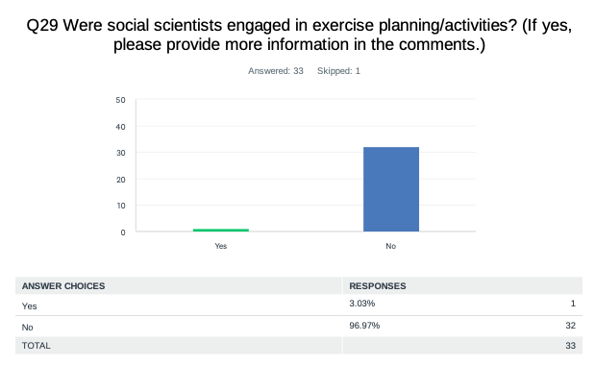

**Comments:**

**Brazil:** Not yet. There is a workshop ongoing now that takes into account an Early Warning System based on people, being conducted by social scientists.

**Venezuela:** Important question, since the domain exercised by natural and basic sciences on the problem of disasters in the Latin American subcontinent is almost total. The study of seismic and climatological patterns, terrestrial dynamics, etc., places a notorious emphasis on prediction problems and on the adaptation of structures to the physical parameters of natural events that threaten society. But society does not appear in the formula, neither as an object of study, nor as an object of action and change in terms of its patterns of behavior and incidence in the realization of disaster situations. We have two social scientists who have participated as observers in the exercise and have made important reflections that indicate the importance of incorporating the social issue into the Caribe Wave exercise.

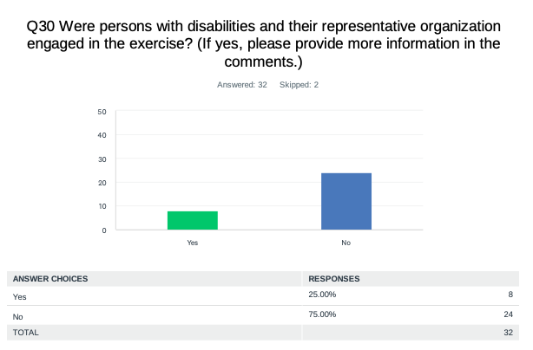

**Comments:**

**Aruba:** Mental disabilities.

**Costa Rica:** They were moved by police vehicle.

**Saint Kitts and Nevis:** Their knowledge of disasters, plans, and responses were tested.

**USA - Puerto Rico:** School Segundo Ruiz Belvis at Mayaguez PR with around 50 students with disabilities. Community in Bayamón PR with some deaf families.

**Venezuela:** We have people with disabilities working in earthquake and tsunami risk education, also the PC directorates work and are trained to work with people with disabilities.

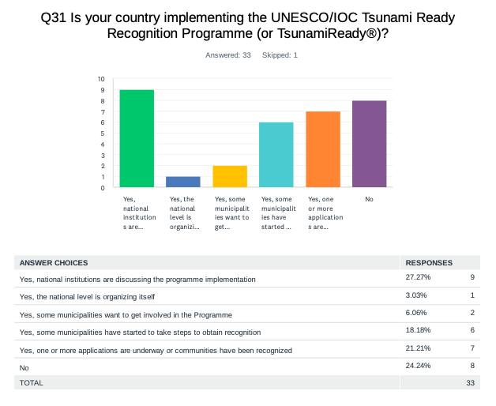

**Comments:**

**Netherlands - Bonaire, Saba, Sint Eustatius:** Maybe local governments are working on this?

**Saint Kitts and Nevis:** St Kitts and Nevis is Recognized as Tsunami Ready.

**Saint Lucia:** The programme is being implemented in one community.

**Sint Maarten:** But we will do so as soon as our tsunami modeling has been completed.

**USA - Puerto Rico:** At the moment we have 46 Municipalities TsunamiReady and 16 TsunamiReady Supporter.

**USA - US Virgin Islands:** US Virgin Islands has received Tsunami Ready Recognition since 2014.

**Venezuela:** Yes, community activities are started in favor of the tsunami ready program, there are still a lack of resources for the respective visits and observations.

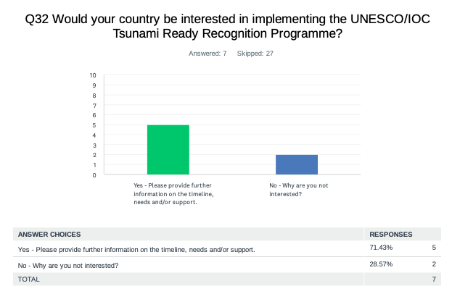

**Comments:**

**Brazil:** At the moment the Tsunami topic is still on a very beginning, and it is necessary to work on mapping the risk areas and potential risk before starting working on becoming tsunami ready.

**Colombia:** Needs: Economical resources to establish the programme requirements.

**Netherlands - Bonaire, Saba, Sint Eustatius:** Depends on local governments.

**Sint Maarten:** We have all the relevant information already.

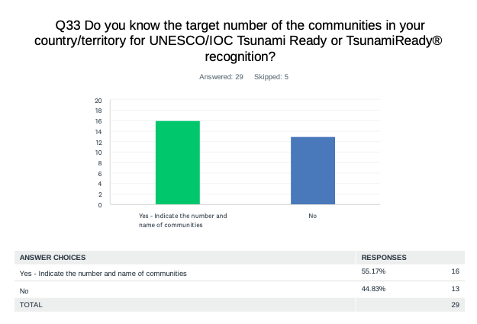

**Comments:**

**Aruba:** 8 territories Noord ; Sta. Cruz; Savaneta; San Nicolas Zuid; San Nicolas Noord; Oranjestad West; Oranjestad Oost; Paradera.

**Barbados:** Shermans St. Lucy to Mullins, St. Peter.

**Costa Rica:** We are trying to have the first one in Caribe this year.

**Cuba:** Baracoa City and Caibarien City.

**Dominica:** Discussion and planning is underway.

**Dominican Republic:** We have Puerto Plata (San Felipe), San Cristobal (Haina,Nigua y Palenque).

**Grenada:** 3 communities 2 completed and 1 ongoing Carriacou and St.Patrick's completed St. George's ongoing.

**Haiti:** 2 communities Jeremie and Cap-haitien.

**Mexico:** In relation to the UNESCO IOC Tsunami Ready program, we prepared the documents integration act of the National Council of the Tsunami Ready program in Mexico and the operation rules of the National Council of the Tsunami Ready program in Mexico.

**Nicaragua:** Two communities: Bluefields and Corn Island.

**Panama:** Puerto Armuelles, provincia de Chiriquí.

**Saint Kitts and Nevis:** The entire country.

**Saint Lucia:** 1, Laborie.

**Saint Vincent and the Grenadines:** Ultimately all coastal communities across St.Vincent and the Grenadines. The next phase of the National Tsunami Ready programme will focus Tsunami ready plans actions and activities on the island of Bequia.

**Sint Maarten:** It will be implemented country wide.

**Trinidad and Tobago:** 12 of the 13 municipalities in Trinidad, along with the entirety of Tobago have significant sea frontage and would be targeted for tsunami-ready recognition.

**UK - Anguila:** Four. The Valley, Long Bay, Shoal Bay & Island Harbour.

**UK - British Virgin Islands:** Entire Territory 4 islands (Jost Van Dyke, Tortola, Virgin Gorda & Anegada).

**USA - Puerto Rico:** 46 communities.

**Venezuela:** Not yet.

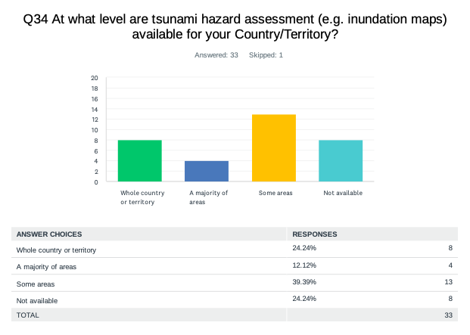

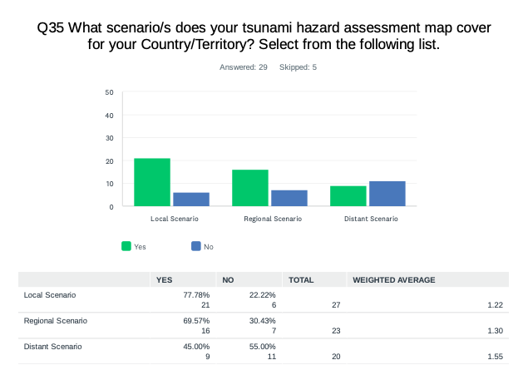

**Comments:**

**Dominican Republic:** The maps are of inundation by tsunamis. apply for the described scenarios.

**Panama:** Maps have been made of only two small coastal communities in the Caribbean of Panama that meet criteria recognized by JMA-JICA experts.

**Saint Lucia:** I am not sure yet.

**Venezuela:** Local capacities are being generated so that the municipal Civil Protection and communities prepare their own maps.

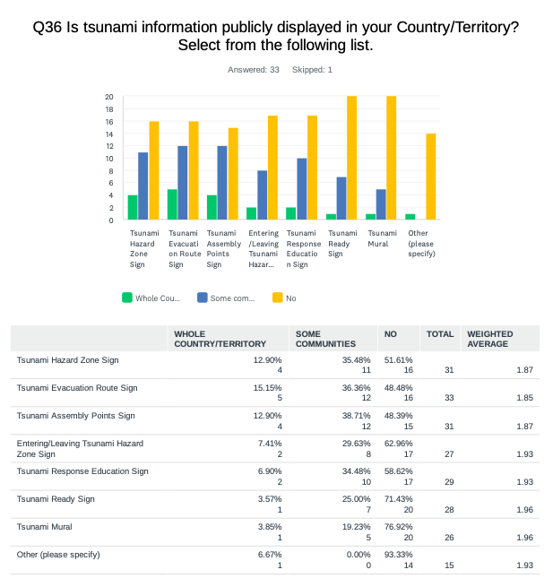

**Comments:**

**Dominica:** Only one community has done work to have evacuation route maps and assembly points marked.

**Panama:** 20-25.

**Saint Kitts and Nevis:** 50.

**UK - Cayman Islands:** None at this point - our most population is generally flat and low lying so we are really looking forward to improved run up modeling so we can design our preparedness, mitigation and response processes and procedures.

**USA - Puerto Rico:** Signs painted on streets. There are around 2,000 Tsunami Signs installed around the island plus 2 educational murals and some signs on the streets.

**Venezuela:** I don’t know the number of signals on the coasts, we will be investigating and documenting in this regard.

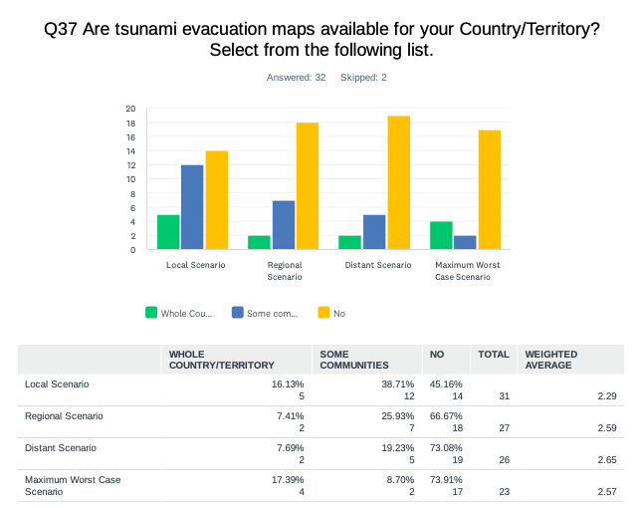

**Comments:**

**Brazil:** None at the moment.

**Mexico:** Low resolution modeling of 35 scenarios of possible tsunamis. The physical and population vulnerability of the place, and it is adapted to the altimetry level heights.

**Nicaragua:** Numerical modeling.

**Saint Kitts and Nevis:** 30 meter wave impact.

**Saint Vincent and the Grenadines:** Not sure.

**UK - British Virgin Islands:** Fixed height/distance.

**USA - US Virgin Islands:** Bathtub model.

**Venezuela:** Numerical models using data provided in the CW23 manual and the estimated wave heights in the model from 1.5 to 3 meters snm.

**Comments:**

**Brazil:** In phase of implementation.

**Dominica:** These are being developed currently.

**Nicaragua:** All institutions have their own standard operating procedures.

**Panama:** We use the Pacific Tsunami Warning Center's Enhanced Products User's Guide. COI Technical Collection 105. UNESCO 2014.

**Venezuela:** Yes, the seismological service of Venezuela has developed an action protocol in case of earthquake and tsunami, it is currently in execution and the Vice Ministry of Risk Management and Civil Protection has generated the official Operational Plan for action in case of tsunami.

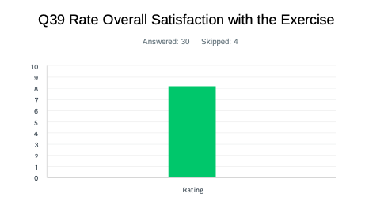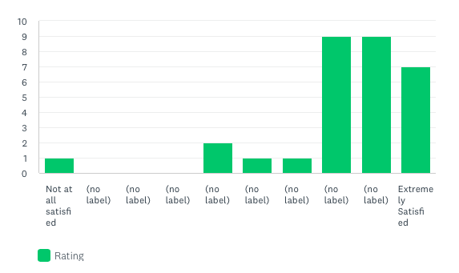

**Comments:**

**France:** Little effects in Guadeloupe.

**Netherlands - Bonaire,Saba, Sint Eustatius:** More needs to be done to raise awareness /preparedness.

**Trinidad and Tobago:** Number of stakeholders could have been larger.

**USA - Puerto Rico:** This exercise is an amazing opportunity to take under consideration different tsunami scenarios and how our response plans can deal with the challenges. Also provide the opportunity to conduct the PRSN Annual Tsunami Communication Exercise with all the emergency agencies in Puerto Rico and Virgin Islands.

**Venezuela:** We are reborn again after the pandemic, we lacked having different observers on the coasts to support the response entities.

|  |  |
| --- | --- |
| **Country** | **Exercise Caribe Wave 23** |
| **Aruba** | Yes, It contributed to awareness, test plans, and evacuation exercises. |
| **Barbados** | It was a true test of the emergency national telecommunications system. |
| **Brazil** | It is important to at least be able to receive the warnings from PTWC. It was possible to test it. |
| **Colombia** | The exercise allowed the National Tsunami Detection and Warning System to apply the updates in the tsunami procedure for volcanic source. |
| **Costa Rica** | Yes, but in this case we use a local scenario because Honduras has a really small flooded all of this by community consideration. |
| **Cuba** | The opportunity to train young specialists in the exercise who had trained in tsunami modeling for the last two years. |
| **Dominica** | Information from the exercise provided specific information for the local area. |
| **Dominican  Republic** | Yes. |
| **Grenada** | The exercise was very useful. It brought much awareness for participants on the issues of Tsunami. It was very useful. It allowed for the provision of information to participants of the exercise. |
| **Guatemala** | We test our dissemination system of our bulletins of tsunami hazard to our population and our emergency agency. |
| **Guyana** | It showed the deficiency in the current tsunami protocol. |
| **Haiti** | This exercise lets us make decisions in case of a real event. |
| **Mexico** | The drill was very useful for the evaluation of the procedures, the participation of the authorities and their relationship with the civilian population, also to approve communication systems. |
| **Nicaragua** | Very useful. |
| **NL-Bonaire, Saba, and Sint Eustatius** | Good to find the weak chains in the communication chain. |
| **Panama** | The exercise made it possible to update the contacts with the COEN-SINAPROC, and verify the times of issuance of alerts. |
| **Saint Kitts and Nevis** | The exercise is very useful, majority of the residents aware of what the exercise and what to do if there is an actual event. The exercise was very useful the mass evacuation exercise included Schools, Business Community, Faith-based Organisations and Communities. |
| **Saint Lucia** | It gave an estimate of the people's knowledge about and their interest in tsunamis. |
| **Saint Vincent and the Grenadines** | Provided an opportunity to test our emergency communication network To assess the local tsunami call tree To assess NEOC and remote EOC management dynamics ( communications and tasks assignments) To practice the use of tsunami evacuation routes. |
| **Sint Maarten** | Unfortunately we could not participate due to not receiving the exercise messages. |
| **Trinidad and Tobago** | It enabled us to test our tsunami response capabilities at the national emergency response level. |
| **UK - Anguilla** | Was very useful in the past. |
| **UK- Bermuda** | It is always good to discuss with our national partners our tsunami plans and at least test our communications. |
| **UK - British Virgin Islands** | This allowed us an opportunity to test all systems with the involvement of stakeholders and staff. |
| **UK- Cayman Islands** | This was an excellent opportunity to review, update and familiarize school administrators, parents and students with tsunami response plans and procedures. The engagement improved Ministry level engagement and an annual tsunami exercise drill has been mandated in Government Schools. |
| **USA- Puerto Rico** | This exercise provides all that is needed to test our communications and tsunami response plans. |
| **USA-US Virgin Islands** | Good Regional Scenario (Pelee). Good Exercise Playbook. Great Email notification with appropriate details. |
| **Venezuela** | It was very good, because we had to think about a tsunami product of a volcanic eruption, imagine a landslide having the potential to producing a tsunami, and educate our authorities and staff about the possibility of a volcanic eruption that affects us, Venezuela not being a volcanic country. |

|  |  |  |
| --- | --- | --- |
| **Country** | | **Number of Participants according to Member States** |
| **Aruba** | | 3,700 |
| **Barbados** | | 200 |
| **Brazil** | | 15 |
| **Colombia** | | 97 |
| **Costa Rica** | | 70 |
| **Cuba** | | 150 |
| **Dominica** | | 300 |
| **Dominican Republic** | | 350 |
| **Grenada** | | 4,000 |
| **Guatemala** | | 25 |
| **Guyana** | | 6 |
| **Haiti** | | 150 |
| **Mexico** | | 14,500 |
| **Netherlands**  Bonaire, Saba, Sint Eustatius | | 34 |
|
|
| **Nicaragua** | | 90 |
| **Panama** | | 2,500 |
| **Sint Maarten** | | 1 |
| **Saint Kitts and Nevis** | | 2,500 |
| **Saint Lucia** | | 300 |
| **Saint Vincent and the Grenadines** | | 200 |
| **Trinidad and Tobago** | | 500 |
| **United Kingdom** | **Bermuda** | 233 |
| **British Virgin Islands** | 3,000 |
| **Cayman Islands** | 7,225 |
| **U.S.** | **Puerto Rico** | 129,189 |
| **US Virgin Islands** | 17,904 |
| **Venezuela** | | 54,999 |

|  |  |
| --- | --- |
| **Country** | **Exercise Caribe Wave 23** |
| **Aruba** | From Aruba there is no need for adaptation of the manual. |
| **Barbados** | More ways of getting materials and knowledge for doing inundation maps and ways of contributing for the education of people living near the coasts. |
| **Brazil** | If scenarios affect our territory, it would impact more the involved personnel and authorities. |
| **Colombia** | We consider the TT has done a good job. Increasing the community participation is the responsibility of each Member State. |
| **Cuba** | Promote and develop audiovisual products to disseminate through fully accessible social networks the activities carried out by the different countries and the organization as a whole in different languages in a language accessible to all audiences in a sense of awareness and understanding of the event tsunami. |
| **Dominican  Republic** | Some procedures should be created to handle volcanoes. It is true that they will not produce great increases in the sea, in the case of the Dominican Republic, but it can generate confusion. |
| **Grenada** | Continued education using various methods eg. Social media, videos etc. |
| **Haiti** | Having an exercise document in different languages ( English, Spanish, French). |
| **Mexico** | Expose the CARIBE WAVE 23 exercise on social networks for a greater impact on the population. |
| **Nicaragua** | Taking into account that there is already a greater possibility of doing exercises with the communities, post COVID 19, it would be advisable for the member countries to organize exercises on the day of the CW exercise. |
| **Panama** | Hold a meeting with the Ministry of Foreign Affairs, the Ministry of Government and the Ministry of Security. |
| **Saint Kitts and Nevis** | Continued education and exercises. Continuous Public Education and Awareness in all areas soliciting a participatory approach in the outreach. |
| **Saint Lucia** | Conduct tsunami drills. |
| **Saint Vincent and the Grenadines** | Work with NTWC to promote the activity and support with organizations to enhance plans, knowledge and awareness. |
| **UK- Bermuda** | Continue with info-graphics and short videos that are easily shared to stakeholders and social media. |
| **USA - Puerto Rico** | Maybe send some information about next year's exercise once in a while during the year so people keep the expectations up. |
| **USA - US Virgin Islands** | Continue with realistic scenarios with good modeling. Continue outreach with the US Virgin Islands. |
| **Venezuela** | It would be interesting to incorporate social science practitioners into the Caribe Wave regarding the options and needs of their contributions to research and action. Where the disaster is an occasion of crisis or social stress, observable in time and space, in which societies or their components (communities, regions, etc.) suffer physical damage or loss and alterations in their routine functioning. |

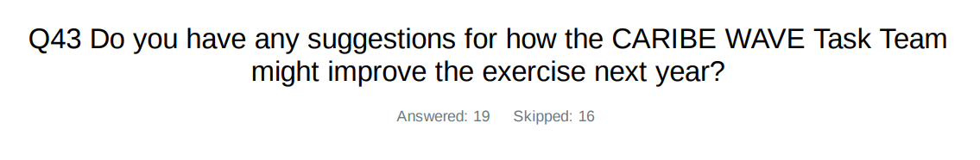

|  |  |
| --- | --- |
| **Country** | **Exercise Caribe Wave 23** |
| **Aruba** | Keep up the good job! |
| **Brazil** | I would like to have exercises every six months. |
| **Colombia** | Maybe you could suggest integrating a failure during the exercise or not containing information in the handbook, to evaluate the level of preparedness of each NTWC. |
| **Costa Rica** | Select scenarios with considerable significant flooding for each country to carry out the evacuation and test the emergency plans. |
| **Cuba** | Not for now. |
| **Dominican  Republic** | It would be good to create some brochures, and awareness information for the population. Even provide a digital instruction so that people can register. It would be good to replicate the strategy of November 5, creating editable information so that the member countries can edit it. |
| **Haiti** | Not yet. |
| **Nicaragua** | This should be a consensus of the member countries at the next meeting. |
| **Panama** | Send exercise documents in Spanish. |
| **Saint Kitts and Nevis** | Let's look at various demographic groups and target accordingly. The exercise can look at the impact of a large Meteorite falling from Space impacting the Caribbean Sea and triggering a Tsunami. |
| **Saint Lucia** | Begin preparing earlier. |
| **Saint Vincent and the Grenadines** | Increase training on product. Simplify warning messages. |
| **Trinidad and Tobago** | Not at this time. |
| **UK - British Virgin Islands** | Modeling specific to countries participating. |
| **UK- Cayman Islands** | I can't think of anything right now. |
| **USA - US Virgin Islands** | None. |
| **Venezuela** | I would like to improve communication between countries, so that emergency management offices operating communications can be seen in real time. |

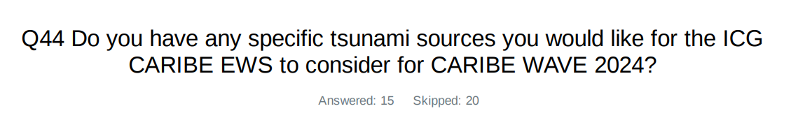

|  |  |
| --- | --- |
| **Country** | **Exercise Caribe Wave 23** |
| **Aruba** | Arashi / Aruba. |
| **Brazil** | Cumbre Vieja, South Sandwich Islands, Portugal 1755 event. |
| **Cuba** | Include, together with tsunamis of seismic origin, tsunamis due to landslides. |
| **Haiti** | No. Is it possible to have a landslide source? |
| **Trinidad and Tobago** | A distant tsunami scenario. La Palma volcano eruption. |
| **UK- Cayman Islands** | June 7, 1692 known as the Port Royal Earthquake but First hand accounts (in books such as Oldmixon, British Empire in America), make it clear it was all of Jamaica event - mountains collided, rivers dried up or changed course, and there was widespread liquefaction in addition to a tsunami wave...Happy to provide original first hand accounts :-) |
| **USA - Puerto Rico** | Puerto Rico Trench or a Tsunami triggered by a landslide scenario. |
| **Venezuela** | I would like October 11, 1918 in Puerto Rico or Volcano Kick 'em Jenny in Grenada. |

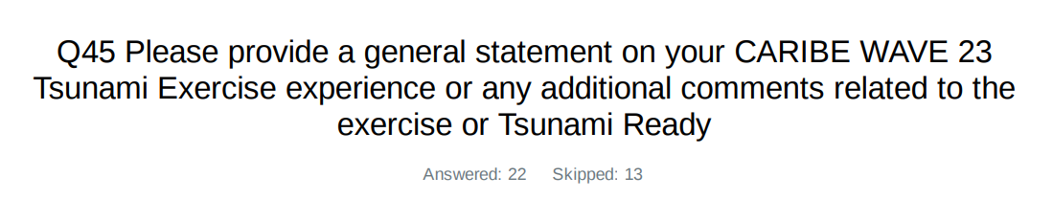

|  |  |
| --- | --- |
| **Country** | **Exercise Caribe Wave 23**  **General Statements** |
| **Aruba** | Evaluating adapt and adjust for Caribe Wave 2024. |
| **Barbados** | From the communications end, the Barbados Meteorological Services (BMS) did a good job in sending out the appropriate warning and discontinuation messages. The only issues that occurred was the delay in the distribution of the CAP messages which was beyond the scope of the BMS. |
| **Brazil** | After a sequence of participation, I could note more willingness from the Operations Chief in the Situation room, even with lots of warnings being sent due to the rainy season in our country. I hope to keep increasing the participation on the operational 24/7 sector of our institute. |
| **Colombia** | It was an interesting exercise which allowed the National Detection and Warning System to apply the protocol update and to identify improvement actions. |
| **Cuba** | CARIBE WAVE Tsunami Exercises are perhaps, without fear of being mistaken, one of the best examples of a systematic effort and activity in order to continuously improve a warning system for the common well-being of all the inhabitants of the Caribbean region, taking into account that it is a relatively small basin where a tsunami could put its precious coastal settlements in great danger. |
| **Dominica** | The public interaction was very informative and interactive. Schools are always very receptive to the public outreach activities. |
| **Dominican  Republic** | In general, the exercise is fine. It is important to continue raising awareness about these issues among the population, especially the rulers of the countries that make decisions. |
| **Guatemala** | This kind of exercise is very good for testing our preparedness in case of a real event. As INSIVUMEH, whe are in charge of processing the information from PTWC emails and translating to more convenient bulletins for national agencies and people in general. So in this exercise we test the system doing this kind of processing, our system of dissemination of messages (telegram and email). |
| **Haiti** | It's very difficult to provide a general statement about the caribe wave 23 tsunami exercise because of the bad socio-political situation in Haiti. We couldn't organize a very good exercise because communication and moving across the country are very difficult. We couldn't use EMWIN because its installation is not in a safe area. I wish that the political situation will be improved in order to realize a better exercise next year. |
| **Mexico** | The exercise was communicated one month in advance, for a greater participation of the coastal population. the PTWC products were received at the times scheduled for the exercise. However, there was a delay in the distribution of a monitoring bulletin, due to inconsistencies in the email system. The participation of the civilian population was obtained, carrying out evaluations and response activities by the emergency managers. |
| **Nicaragua** | Excellent work. |
| **Panama** | In the case of Panama, greater coordination is required between the responsible agencies to advance in the development of the alert system. The training prior to the exercise is very good, many students are trained, we must internally improve the participation of all levels that have to do with Risk Management, a fund must be designated to meet all the logistics and preparation needs in time for the exercise, related to the making of signs, tubes for its installation in PVC, stickers, making maps and their printing on durable material, talk with the Authorities so that they allow their officials involved in this issue to be able to attend and participate, this means designating them their per diem to cover their mobilization, food and lodging, allow those in charge of Tsunami to be able to provide statements, participate in televised programs to speak and educate on the subject. |
| **Saint Kitts and Nevis** | The exercise has proven to be instrumental for the response to any real event. The NEMA and the other government agencies, private sector, and NGOs are more informed of their responsibilities and roles. The majority of residents have shown that they are knowledgeable of the tsunamis and know what to do in the event of a tsunami. The country has been certified as Tsunami Ready, and this exercise will continue to provide the necessary incentives to improve. The Nevis Disaster Management highlighted the Tsunami Hazard as part of its Public Awareness and Education Multi Hazards Campaign for the Month of March. As part of the campaign the Department executed a Mass Evacuation Exercise with over 2500 persons on Thursday 23rd March 2023 @ 10 a.m. as part of the 12th annual Regional Caribe Wave Tsunami Exercise. The CARIBE WAVE Tsunami exercise was important to validate and advance end-to-end tsunami preparedness. It provided an opportunity to test International, Regional and Local operational lines of communications, tsunami response and evacuation procedures and evaluate our readiness in communities at risk on the island of Nevis. The hybrid approach lends to greater participation that will being more interest from the private sector. I encourage us to look at this moving forward. |
| **Saint Vincent and the Grenadines** | The SVG CARIBE WAVE 23 was a resounding success. We were able to mobilize plan action in the community of Port Elizabeth and successfully evacuate 200 people for several institutions in less than 15 to 20 minutes. The communication process requires some additional training and work. |
| **Sint Maarten** | See my comments above. |
| **Trinidad and Tobago** | No comments at this time. |
| **UK - Anguilla** | Being Tsunami ready is and will continue to be an important element within our annual planning. |
| **UK - British Virgin Islands** | Overall, the exercise went very well with the activation of the National Early Warning Multi-hazard Alert System, which includes public notifications via emergency siren, radio, the DDM app, social media and other tools. We had support from local broadcasters airing messages to make sure that persons were aware of the exercise and what to do in case of a real threat. There was great support from the public and private sec-tor took especially the primary schools and early childhood education centres, doing full drop, cover and hold drills in addition to evacuation inland or to high ground as well as participation from the BVI Autism Centre and BVI Services. |
| **UK - Cayman Islands** | This was a really positive exercise experience for the Cayman Islands. The involvement of all schools has resulted in improvement in the school hazard plans for tsunami threats. It has built awareness and familiarization in the education system as well as more generally in the community. The exercise also provided an opportunity for us to test the emergency notification system and as a result of the publicity surrounding the exercise an additional 800 persons signed up for the Emergency App bringing the total to nearly 7,000 (so more than 10 percent growth from a single event - Caribe WAVE 23). We feel grateful. This exercise improved our overall preparedness and level of readiness for a tsunami. |
| **USA - Puerto Rico** | Caribe Wave 23 was an excellent opportunity to practice tsunami response plans at state, municipalities, public and private agencies, schools, families and TsunamiReady Supporter agencies. The scenario was ideal to activate our critical thinking about how to react if a tsunami is generated by a volcanic eruption and not an earthquake as we are used to. It was also an opportunity to foment the participation in exercise and foment the preparedness after all these years that we had to deal with the pandemic and people avoided contact. This interaction is ideal for communities, so their plans are more solid and realistic in case they have to confront a real tsunami. |
| **USA - US Virgin Islands** | Adequate time for the agency (VITEMA) to prepare and conduct outreach. Ability to conduct evacuation drills and sound Tsunami Warning Sirens. Anticipate including VITEMA EOC Tabletop Exercise in 2024. |
| **Venezuela** | This Caribe Wave 23 was more active than the previous two years in the face of the health emergency, contacts with the highest authorities were resumed and the new authorities were convinced of the importance of the Caribe Wave 23 exercise, coordination with scientists and communities was very important. With great enthusiasm, the state and municipal civil protections, given their experience in previous exercises, assumed the participation with their own methodologies and adapted their participation taking into account the security against Covid19, they informed the situation room and a lot of work was done with the documents prepared by the Vice Ministry of Risk Management and Civil Protection and its team called "Operations Order for the Caribbean Wave", with the participation of radio amateurs, in this exercise communications were strengthened. We must rescue international communications with the other alert centers in the region , to obtain confirmation and data exchange, among others. An evaluation will be made to the coastal zones that can be prepared for the tsunami ready program in the near future. |

1.  One survey submitted by the Member States for all constituents.
2.