Restricted distribution IOC-FAO/IPHAB-XVI/Inf.14
Paris, 22 March 2023
English only

Sixteenth Session of the IOC-FAO Intergovernmental Panel

on Harmful Algal Blooms

Rome, 27-29 March 2023

Item 4.7.5 of the Provisional Agenda

REPORT OF THE IPHAB TASK TEAM ON BIOTOXIN MONITORING, MANAGEMENT AND REGULATIONS

The report is structured according to the decision IPHAB-XIV.6 taken in 2021, reproduced below:
The IOC Intergovernmental Panel on Harmful Algal Blooms, decides to continue with the Task Team on Biotoxin Monitoring Management and Regulation with the following terms of reference (in bold those addressed during the intersessional period):
- Establish and maintain regular contact with FAO, IAEA, WHO, and other regulatory or advisory bodies; follow-up on finalization of methodological annex of Codex standard 292-2008, in particular with reference to toxicity equivalency factors (TEF) to clarify regulatory status of individual toxin analogs,
- Establish and maintain regular contact with leading scientists and scientific organizations to ensure that the latest and most robust science is available to the Task Team in discharging its responsibilities,
- Establish contact with national, regional and global risk evaluation agencies to evaluate the risk of freshwater cyanobacterial toxins in seafood,
- Advise other IPHAB Task Teams on aspects of toxinology, including emerging toxins,
- Communicate and disseminate information on training workshops and participate (as requested) in the organization of training workshops for toxin detection, monitoring and management,
- Continue development on the IOC/IODE database of algal toxins which will also serve other Task Teams as a web-based tool for crosslinking knowledge on HAB organisms and toxins;
- Develop a concerted (inter-agency) effort and seek opportunities to get this effort funded on drafting guidance on mitigation (EWS, safeguarding shellfish during HAB-events, HAB-destruction and shellfish detoxification),
- Report to IPHAB-XVI on international activities in marine biotoxin monitoring, management and regulation during the inter-sessional period,
- Recommend to IPHAB-XVI on revised priorities for research, capacity development and engagement with regulatory bodies to address the most pressing issues and threats posed by HAB toxins in the marine environment;
- In 6 months develop a succinct list of challenges, objectives and actions with respect to the Task Team topic that will address the UN Decade of Ocean Science for Sustainable Development objectives and challenges and to present these at an IPHAB intersessional on-line consultation September 2021 with a view to formulate an IPHAB strategic framework for UN Decade initiatives;
Encourages relevant organizations to invite the IPHAB Task Team to participate as observer at the principal meetings of their respective groups to facilitate international compatibility of applied methodology and legislation with respect to HAB toxins,
Decides that the Task Team will be chaired by P. Hess (FR) and comprising Beatriz Reguera (ES); M. Broadwater (USA) and T. Suzuki, (Japan). The Task Team is supplemented by international advisors and experts J. Ramsdell (USA); M. Burford (Australia); A. Gago, (EURL/ES); M. João Botelho (Portugal); E. Hamelin (USA), W. Huang (USA), R. Kudela (USA); H. Mazur (Poland); C. O. Miles, (CA); Gonzalo Alvarez Vergara (CL) and may be expanded as required to fulfill its Terms of Reference,
Invites FAO, IAEA and WHO to be members of the Task Team,
Notes that the Task Team is established until otherwise decided by the Panel and that it will work by correspondence and/or meet on an opportunistic basis, and provide a progress report for the inter-sessional period to the Chair of IPHAB prior to IPHAB-XVI.

Activities during the intersessional period:
The task team has been enlarged from the initial team mentioned above to a larger group to facilitate editing of the toxins database, see ppint 3 of the below activity report (Aifeng Li, Ana Gago, Arjen Gerssen, Beatriz Reguera, Bernd Krock, Beth Mudge, Chris Miles, Elizabeth Hamelin, Fabienne Hervé, Gonzalo Alvarez, John Ramsdell, Manoëlla Sibat, Maria Botelho, Michele Burford, Naomasa Oshiro, Philipp Hess, Tim Harwood, Toshiyuki Suzuki, Wade Huang, Zhihong Wang).

- Establish and maintain regular contact with leading scientists and scientific organizations to ensure that the latest and most robust science is available to the Task Team in discharging its responsibilities
Task team members contributed to the review of abstracts on algal and cyanobacterial toxins at the ICHA 2021 virtual conference in Mexico.
The task team chair participated in the kick-off meeting of EuroCigua 2 – project (26-27/10/2022).

- Advise other IPHAB Task Teams on aspects of toxinology, including emerging toxins
The task team chair referred to a French expert on fish killing toxins for activities on these during the intersessional period.
The task team chair gave a webinar on emerging toxins of Vulcanodinium rugosum and their effects in bathing communities and fishermen as part of the Dinophyte seminar series (available on request, P. Hess, 8/6/2022).
The chair of the task team participated in the EU-Working Group on Emerging Toxins held in Vigo, 19/10/2022 at which WG members presented findings on emerging toxins in Belgium, Croatia, France, Germany, Greece, Portugal and Spain (presentations available on request from WG members).

- Continue development on the IOC/IODE database of algal toxins which will also serve other Task Teams as a web-based tool for crosslinking knowledge on HAB organisms and toxins;
Several meetings were organized by John Ramsdell/Philipp Hess since the XIVth IPHAB meeting to progress the design of the database of algal toxins, in particular as a web-based tool for cross-linking knowledge on HAB organisms and toxins. The initial meetings were aimed at defining the requirements of the database. Subsequently, the fields were defined with the subcontractor and several team members. Several meetings followed for testing and refining the design. Finally, several meetings were held with all available task team members to distribute toxin groups to populate the database. Currently, a guide on how to enter data into the database is being developed (first input by Chris Miles to ensure data quality of entries). Currently 28 groups of toxins are listed to be included, Codex alimentarius-regulated groups in bold (amphidinol, anatoxin, azaspiracid, beta-N-methylamino-l-alanin, brevetoxin, ciguatoxin, cylindrospermopsin, domoic acid, goniodomin, gymnocin, gymnodimine, Karenia brevisulcata toxin, karlotoxin, lyngbyatoxin, maitotoxin, microcystin, nodularin, okadaic acid, palytoxin, pectenotoxin, pinnatoxin, polycavernosides, portimine, prymnesin, saxitoxin, spirolide, tetrodotoxins, yessotoxin). The toxin database may be viewed here but is not currently populated (aside from a couple of examples to view toxin – species relationship).
Each toxin is presented in 10 sections, including naming (recommended name, synonyms, acronym, abbreviation), progenitor and vector species, chemical information and information on reference materials, detection methods, regulatory status, bioactivity, notes, references and contributors.
The editorial team of the database comprises 20 volunteers. Several volunteers offered to edit several groups also allowing for having a primary editor and a verifying editor (denoted by a ‘P’ and a ‘V’ in the distribution-of-tasks spreadsheet).

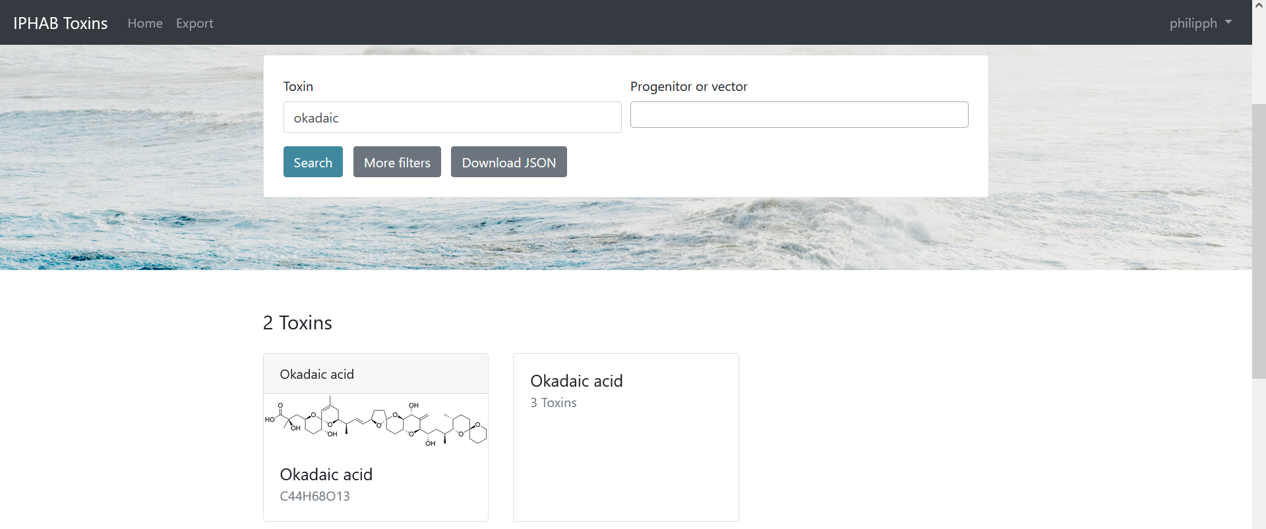

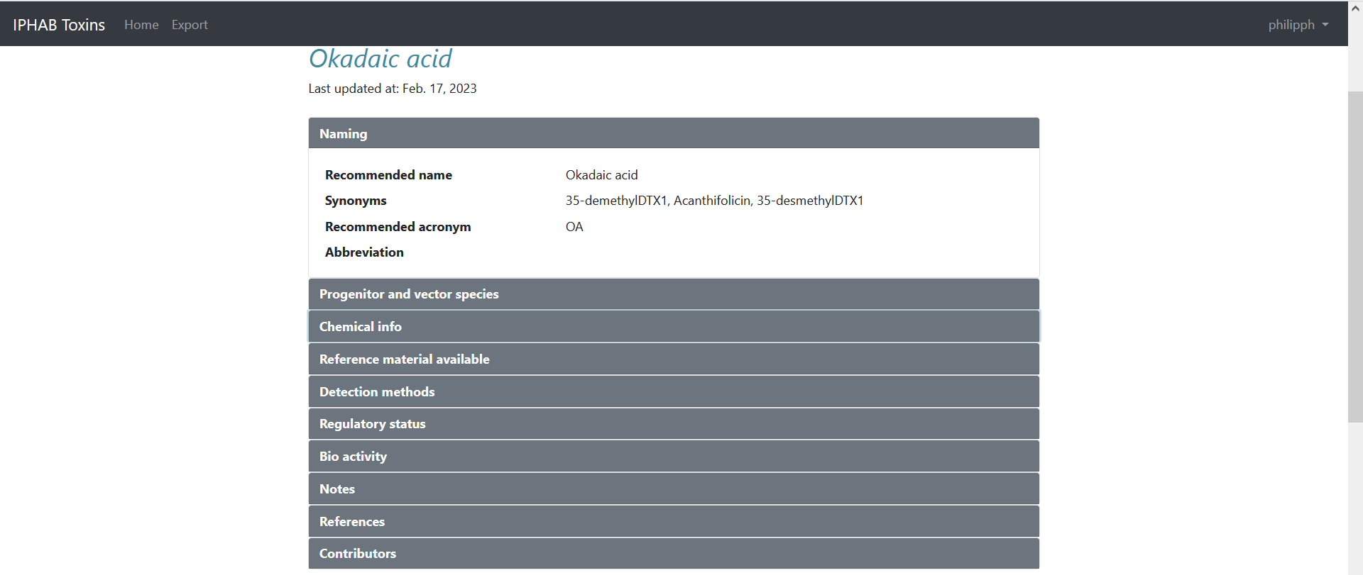

- Develop a concerted (inter-agency) effort and seek opportunities to get this effort funded on drafting guidance on mitigation (EWS, safeguarding shellfish during HAB-events, HAB-destruction and shellfish detoxification)
See report on EWS-WG, FAO report published March 2023. Task team chair and several task team members contributed to this FAO-report (Maggie Broadwater, Philipp Hess, Ana Gago-Martínez, Maria João Botelho).

- Report to IPHAB-XVI on international activities in marine biotoxin monitoring, management and regulation during the inter-sessional period
The present report.

- Recommend to IPHAB-XVI on revised priorities for research, capacity development and engagement with regulatory bodies to address the most pressing issues and threats posed by HAB toxins in the marine environment
See point below.
Ostreopsis cf. ovata blooms have emerged in France and Senegal impacting surfers heavily since 2021 and repeated in 2022. This had been an ongoing problem in the Mediterranean Sea but now appears to also affect areas in the Eastern Atlantic. Guidance on Early Warning Systems (EWS) for bHABs is given in the FAO-report on EWS.
Domoic acid (DA) almost had not been reported in marine biological samples before 2020 in Chinese waters. However, it was frequently detected in net-collected phytoplankton samples in the Coast of Guangdong Province, South China Sea, China, in recent years. A total of nine toxigenic species of Pseudo-nitzschia diatoms were identified in the coast of China, including Pseudo-nitzschia simulans, P. fukuyoi, P. lundholmiae, P. multiseries, P. pseudodelicatissima, P. bipertita, P. caciantha, P. cuspidata and P. fraudulenta, in which the P. cuspidata was the dominant toxigenic species as the source of DA.
The presence of diydro-DTX1 produced by D. norvegica on the US Est coast is outlined as a significant finding that may necessitate changes in regulation and monitoring programs and require further efforts on reference standards.

- In 6 months develop a succinct list of challenges, objectives and actions with respect to the Task Team topic that will address the UN Decade of Ocean Science for Sustainable Development objectives and challenges and to present these at an IPHAB intersessional on-line consultation September 2021 with a view to formulate an IPHAB strategic framework for UN Decade initiatives
A task team meeting was held with several team members on 13 April 2022 in preparation for the Helsingor (DK) - meeting on the UN OCEAN Decade action.
During this meeting, several recent methodological approaches were discussed as disruptive technologies in the field of biotoxin detection:
• Environmental RNA (eRNA) for the detection of harmful algae in toxin-producing mode (e.g. kit developed by Australian group for detection of cyanobacteria and dinoflagellates in STX-production mode). Currently limited to STX-producing species, could also potentially be developed for DA-producing Pseudo-nitzschia species as biosynthesis has recently been clarified by Californians. Still limited for all other toxin groups as toxin-related genes remain unknown;
• Passive sampling combined with metabolomics (high resolution mass spectrometry) for the detection of emerging toxins – an approach that probably fails due to the need for heavy equipment. Could also be complemented by multiplex toxin-probes on environmental samplers, again not cheap technology at this stage.
Following this meeting, the main priorities presented at the Helsingor-meeting were:
- Improve detection, management & regulation of ciguatera
- Improve detection, management & regulation of fish-killing microalgae
- Improve mitigation for all other toxin groups in the face of climate change:
  - Early warning
  - Desalination
  - HAB removal
  - Detoxification
The task team chair participated in the Helsingor-meeting of task team chairs (25-27/4/2022) as well as in the virtual follow-up meeting (16/3/2023).

