INFORMATION NOTE

The Sixteenth Session of the IOC-FAO Intergovernmental Panel on Harmful Algal Blooms (IPHAB-XVI)

Rome, Italy, 27-29 March 2023

Meeting Venue: Viale delle Terme di Caracalla, 00153 Roma RM, Italy
Meeting Room: King Faisal Room

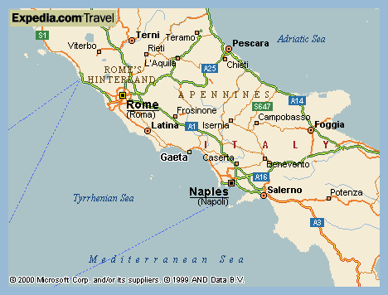

Accommodation
Hotels close to FAO:

Hotel Santa Prisca
https://www.hotelsantaprisca.it/
Euro95/night (single) Euro150/night (double/classic)

Mercure Roma Delta Colosseo
https://mercureromacentrocolosseo.com-hotel.com/
Euro110/night

Celio
https://www.hotel-romacentro.it/247201/rome/hotel-celio.html
Euro105/night

Hotel Lancelot
https://www.lancelothotel.com/it/
Euro98/night

Circus Maximus
https://www.bbcircusmaximus.it/
Euro83.5/night

The Aventino Guest House
https://www.aventinoguesthouse.it/
Euro80/night

The Aventino Hotel
http://hotel-aventino.italyromehotels.net/it/#main
Euro94/night

Villa San Pio
https://hotel-villa-san-pio-rome.hotelmix.it/
Euro89/night

Aventino San Anselmo Hotel
http://www.aventinohotels.com/sananselmo/en/
Euro105/night

BePlace Aventino
https://www.beplace.eu/
Euro 86.5/night

GASOMETER URBAN SUITES
https://www.gasometerurbansuites.com/it/index?adblast=4330062458&vbadw=4330062458&gclid=EAIaIQobChMIn8jRv7vv_AIVgo9oCR1qwwsiEAAYASAAEgL37vD_BwE
Euro 101.5/night

Airport Transfer
No airport transfer service will be arranged. Please make your own arrangements to travel to and from the airport.

1）From Fiumicino Airport:
You can get the Leonardo express train from Fiumicino airport to Termini train station which is Rome's central railway station or take one of the many buses that run to Termini station.

- Taxi: fares to central Rome cost around EUR 50 (one way). Taxi services are available at the airport.
- Train: (Trenitalia - Leonardo Express/a non-stop service to/from Rome Termini railway station): the ticket costs EUR 14 and it takes 30 minutes to arrive in Termini. https://www.trenitalia.com/it.html
- Bus: Shuttle Bus from Fiumicino Airport to Termini Railway station. There are several options, at a fee of around EUR 6. You can look at www.romeairportbus.com and http://www.terravision.eu/rome_fiumicino.html

From TERMINI you can take the Subway: (Metro B: ticket cost EUR 1.50) towards Laurentina and exit at Piramide Station (it would be 5min walk to Hotel Santa Prisca which is close to FAO).

2）From Ciampino Airport:
- Taxi: fares to central Rome cost around EUR 40.
- Train: the station is not exactly outside the airport, so you'll need to take ATRAL/SCHIAFFINI buses from the airport to the train station. They depart every 30-40 minutes and cost EUR 1.20; the drive to the train station takes 5 minutes. From there, the train to Rome’s Termini train station takes 15 minutes and costs just EUR 1.50. More information on trains: http://www.trenitalia.com/tcom-en
- Bus: Terravision Shuttle Bus from Ciampino Airport to Termini Railway station, just in front of the arrival hall. Fare EUR 4. Special offers on http://www.terravision.eu/.
There are also other options: https://www.rometoolkit.com/airport/ciampino_airport_bus.htm

From TERMINI you can take the subway (Metro B: ticket cost EUR 1.50) towards Laurentina and exit at Circo Massimo Station (it would be 5min walk to Hotel Santa Prisca which is close to FAO).

Plug type in Italy
Electricity in Italy conforms to the European standard of 220V to 230V, with a frequency of 50Hz. The power plugs and sockets are of type F and L.

Type F: also known as "Schuko". | 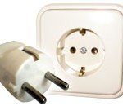
Type L: This type is of Italian origin. | 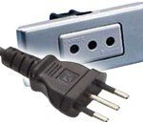
For further information, you can contact:

Florence Faivre
Email: Florence.Faivre@fao.org
Tel: +39 331 915 24 99

Covid-19 measures and precautions
The Italian Ministry of Health has defined updated procedures for dealing with confirmed COVID-19 cases and close contacts:
Confirmed cases:
- Completely asymptomatic cases or persons who have been asymptomatic for two consecutive days may conclude isolation either:
  - 5 days from the first positive test/ symptoms without needing a negative COVID-19 test BUT must wear an FFP2 mask until the 10th day from the first positive test/ symptoms AND it is recommended that they avoid contact with high-risk individuals and crowds. Mask wearing may cease prior to the 10th day only with a negative COVID-19 test (antigen or molecular).
  - prior to the 5th day with a negative COVID-19 test (antigen or molecular) taken at a healthcare facility or a pharmacy;
- Vulnerable persons: may conclude isolation 5 days from first positive test ONLY with a negative COVID-19 test (antigen or molecular);
- Health workers: if asymptomatic for at least two days, may conclude isolation with a negative COVID-19 test (antigen or molecular);
- Persons who were in China at some point in the 7 days prior to the first positive test: may conclude isolation after a minimum of 5 days from the first positive test ONLY if asymptomatic for at least two days AND with a negative test (antigen or molecular).
Close contacts with COVID-19 positive cases:
- Must observe a period of self-surveillance until the 5th day from close contact, during which FFP2 mask must be worn indoors and in crowded areas
- Those who exhibit potential COVID-19 symptoms during the self-surveillance period are recommended to immediately take a COVID-19 test;
- Health workers must take a COVID-19 test (antigen or molecular) DAILY during the self-surveillance period.
- FFP2 masks are not mandatory but recommended on the following means of transport:
  - Interregional boats and ferries
  - Interregional, Intercity, and high speed trains
  - Interregional bus services
  - Local public transit
- Face masks must be worn at all times by workers, service users, and visitors in any healthcare or social care facilities, including care homes, senior housing facilities, and hospices.
All other COVID-19 restrictions have ceased.
- Inside the conference room: social distancing is required (1 meter), voluntary wearing of masks (masks and hand sanitizers will be available in the meeting room).
**

