DATA BUOY COOPERATION PANEL (DBCP)

NATIONAL REPORT CHINA

Country | China
Year | 2020.08 - 2021.08

- CURRENT PROGRAMME:

Please Identify your Programme’s Major Opportunities and Challenges/Risks during the upcoming year and how DBCP may assist your Programme.
(1) Deployment and operational security issues
The frequent marine fishery activities in China makes the buoys are extremely vulnerable to man-made damage or entangled by fishing nets, causing loss of underwater sensors and damage to the chain swivel group, which seriously endangers the safety of buoys in operation.
(2) Observations in the polar region are difficult
Observations in the polar region are affected by environmental, technological, and equipment issues, and it is difficult to carry out stable and long-term observations. Research and development of related technologies and equipment upgrades are needed.
Agency or programme | Ministry of Natural Resources
Number and type of buoys | (a) deployed during the year | 12 moored buoys, including 3m, 6m, 10m diameter moored buoys and, 29 Argo floats, 3 drifting buoys, and 3 other type of buoys
Number and type of buoys | (b) operational as of 31 August | 42 moored buoys  80 Argo floats  3 drifting buoys  4 environmental buoys  3 other type of buoys
Number and type of buoys | (c) reporting on GTS as of 31 August | 83
Purpose of programme  (check/uncheck boxes using [_] or [x] as appropriate) | (a) operational | [-]
 | (b) met / ocean research | [-]
 | (c) developmental | [-]
Main deployment areas | China Seas and adjacent waters, Tropical Western Pacific，Tropical Indian Ocean, the Arctic Ocean
Vandalism incidents | 21

Agency or programme | China Meteorological Administration
Number and type of buoys | (a) deployed during the year | 0
Number and type of buoys | (b) operational as of 31 August | 17 moored buoys, including 3m,6m,10m diameter moored buoys
Number and type of buoys | (c) reporting on GTS as of 31 August | 0
Purpose of programme  (check/uncheck boxes using [_] or [x] as appropriate) | (a) operational | [-]
 | (b) met / ocean research | [x]
 | (c) developmental | [x]
Main deployment areas | China Seas and adjacent waters
Vandalism incidents | 0

Agency or programme | Ministry of Ecology and Environment
Number and type of buoys | (a) deployed during the year | 0
Number and type of buoys | (b) operational as of 31 August | 1 environmental buoy
Number and type of buoys | (c) reporting on GTS as of 31 August | 0
Purpose of programme  (check/uncheck boxes using [_] or [x] as appropriate) | (a) operational | [-]
 | (b) met / ocean research | [x]
 | (c) developmental | [x]
Main deployment areas | China Seas and adjacent waters
Vandalism incidents | 0

Agency or programme | Chinese Academy of Sciences
Number and type of buoys | (a) deployed during the year | 1
Number and type of buoys | (b) operational as of 31 August | 5 moored buoys, including 3m,6m,10m diameter moored buoys and, and 19 other type of buoys
Number and type of buoys | (c) reporting on GTS as of 31 August | 0
Purpose of programme  (check/uncheck boxes using [_] or [x] as appropriate) | (a) operational | [-]
 | (b) met / ocean research | [-]
 | (c) developmental | [-]
Main deployment areas | China Seas and adjacent waters, The Indian Ocean
Vandalism incidents | 0

2. PLANNED PROGRAMMES:

Agency or programme | Ministry of Natural Resources
Number and type of buoys | planned for deployment in the next 12 months | 6 moored buoys
Purpose of programme  (check/uncheck boxes using [_] or [x] as appropriate) | (a) operational | [-]
 | (b) met / ocean research | [-]
 | (c) developmental | [-]
Main deployment areas | China Seas and adjacent waters, Tropical Western Pacific, the Arctic Ocean

3. TECHNICAL DEVELOPMENTS:

(a) Buoy design | - After 30 years of development, the large-scale buoys in China has been continuously improved. At present, China is developing the second generation of Bailong buoy to meet the requirement of marine observation development, it will have multi-function such as intelligent, networking and information transformation.  - The HM2000 Argo float independently developed by China has been widely used. In addition, the HM2000-02 Argo float (which has been put into use) and the H4000 Argo float (which has been successfully tested in the sea) have been designed and developed based on the HM2000 Argo float.  - In recent years, the buoy has adopted modern sensor technology, automatic control technology, special data analysis software and communication network. It can carry a variety of sensors involving water quality, hydrology, meteorology and other elements, and has excellent observation and monitoring capabilities to deal with complex marine environments. It is possible to collect high-quality ocean observation and monitoring data all day.
(b) Instrumentation | - Beidou satellite communication technology is becoming more and more mature, CDMA and dual Beidou transmission mode are gradually implemented in Chinese operational buoy, which has effectively reduced communication costs.

4. PUBLICATIONS (on programme plans, technical developments, QC reports, etc.):

Ref | Title | Type
1 | The data collection and operation system for deep ocean buoy. | Technical developments

5. ADDITIONAL COMMENTS:

(a) Quality of buoy data
(b) Communications
(c) Buoy lifetimes
(d) Data Accessibility
(e) New Observations
(f) GFCS and WIGOS
(g) Additional Requirements
(h) DBCP Linkages
(i) Contribution to UN Decade and UN SDGs | ●
(j) Other (i.e. Impact of COVID19 on observing systems and mitigation efforts) | - At present, the COVID-19 outbreak is under control in China, and the buoy observation network is less affected by the pandemic. Various tasks are progressing steadily, and offshore buoys are operating normally.  - The international cooperation is stagnated due to COVID-19, and the maintenance of oversea buoys is difficult.
Note: It is recommended that this form is filled in electronically and returned also electronically to the Secretariat. A template of the form can be downloaded from the following SharePoint site:

https://wmoomm.sharepoint.com/:w:/s/wmocpdb/EQetWM6WBqdBuQLz3FET6aABCNttxnMVv3yU_wpSbRlxgA

Annex - Form for reporting incidents of vandalism on data buoys
Country |  |  | China
Contact person e-mail |  |  | Yue Xinyang, National Marine Data and Information Service, email: yue_xin_yang@outlook.com
Year | Buoy Location |  | Type of Buoy  (e.g. Tsunami / Met -Ocean Buoy/Drifter/ARGO floats/ Other) | Type of damage to buoy | Buoy id/WMO id | Number of days of transmission lost | Cost of replacement | Remarks  (e.g. whether photos have been taken)
Year | Latitude | Longitude
2020.10 | / | / | Met-ocean buoy | Ageing | / | 0 | 7.69 | No
2020.10 | / | / | Met-ocean buoy | Ageing | / | 0 | 9.23 | No
2021.1 | / | / | Met-ocean buoy | Destroy | / | 0 | 7.69 | No
2021.2 | / | / | Met-ocean buoy | Destroy | / | 0 | 7.69 | No
2021.3 | / | / | Met-ocean buoy | Destroy | / | 0 | 7.69 | No
2021.3 | / | / | Met-ocean buoy | Destroy | / | 0 | 7.69 | Yes(Fig.1)
2021.3 | / | / | Met-ocean buoy | Destroy | / | 6 | 26.15 | Yes(Fig.2)
2021.4 | 0° | 85.5°E | Met-ocean buoy | Solar panel and battery damage | / | / | / | No
2021.1 | 0° | 147°E | Met-ocean buoy | Drifting | / | / | / | No
2020.10 | 85.8°N | 134.5°W | Other | Drifting | / | / | / | No
2021.8 | / | / | Met-ocean buoy | Beidou satellite lost | / | 14 | 1.23 | No
2021.3 | / | / | Met-ocean buoy | Buoy damage | / | / | / | No
2020.8 | / | / | Met-ocean buoy | Low voltage | / | 9 | / | No
2020.12 | / | / | Met-ocean buoy | Wind sensor damage | / | 5 | 0.82 | No
2021.3 | / | / | Met-ocean buoy | Broken down | / | 61 | 1.94 | No
2020.8 | / | / | Met-ocean buoy | Inflow and signal lost | / | 71 | / | No
2021.7 | / | / | Wave buoy | Typhoon damage | / | 10 | / | Yes(Fig.3)
2020.11 | / | / | Wave buoy | Malfunction | / | 48 | / | No
2021.2 | / | / | Wave buoy | Malfunction | / | 6 | / | No
2021.3 | / | / | Wave buoy | Malfunction | / | 13 | / | No
2021.1 | 8°S | 100°E | Met-ocean buoy | No transmit | 5300041 | 270 | 30.77 | No
Efforts taken against vandalism |  |  | - A new buoy monitoring system is installed.  - Improve the remote monitoring of buoy, such as install video camera and alarm system, AIS system installed to prevent collision, etc.  - To strengthen the security capabilities of fasteners, such as increasing anti-theft bolts.  - To strengthen the running state monitoring and control of the buoy.  - Paste water proof warning notice, program label and multiple languages introduction of buoy and contact information on buoys. |  |  |  |  |  |  |  |  | /
Awareness meeting Organized |  |  | - At 3 August 2020, SOA invited primary school students to visit the buoy management base in Guangzhou, and carried out popularization of science activities to introduce the buoys operation  - At 12 May 2021, SOA organized a publicity activity to publicize the importance of buoys for public services, disaster prevention and mitigation. Meanwhile SOA used its WeChat account to publish articles to publicize the destruction of the buoy and call for protection of the buoy.
Suggestions (if any) |  |  | - To establish the monitoring system of buoy operation.  - To establish a coordination operation with the China Coast Guard to establish and improve the regular inspections and maintenance of buoys  - To strengthen buoy management after deployed.  - To establish maintenance system of buoy operation.  - To strengthen the education, improve the senses of people in protecting scientific equipment.
Photos on Vandalism

Note: It is recommended that this form is filled in electronically and returned electronically also to JCOMMOPS (cgallage@wmo.int; support@jcommops.org). A template of the form can be downloaded from the following ftp site: ftp://ftp.wmo.int/Documents/PublicWeb/amp/mmop/documents/dbcp/templates/Format-DBCP-Buoy-Vandalism-Reports.doc

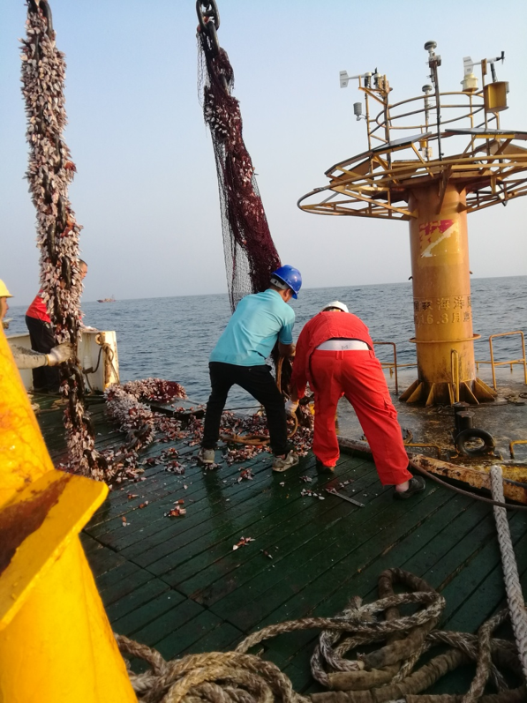
Fig.1 entangled by fishing nets

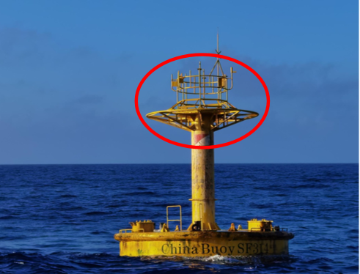
Fig.2 Equipment Stolen

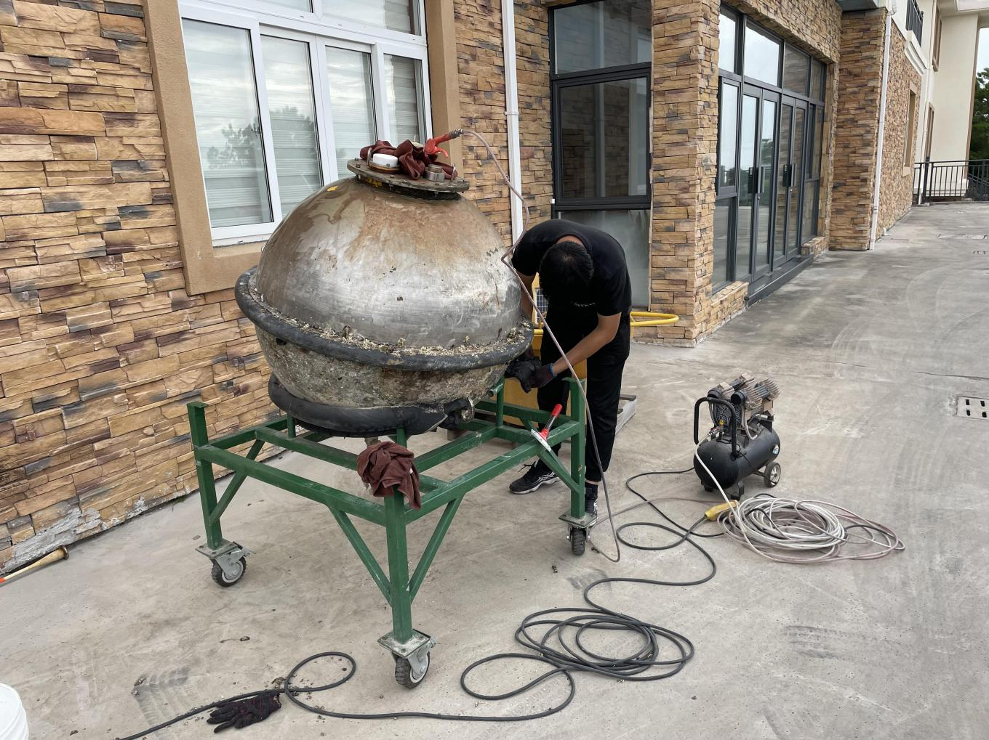
Fig.3 Typhoon damage

Inputs to ITP report
China

National Marine Environmental Forecasting Center (NMEFC) of State Oceanic Administration (SOA) of China is responsible for operating the tsunami warning and mitigation system in China.
In South China sea, two tsunami buoys and coastal seismic stations have been deployed by SOA to detect earthquakes that may trigger local tsunamis. These buoys have been damaged many times since they were deployed, and have stopped data transmission. At present, SOA has completed the repair of one tsunami buoy by cooperating with the Shandong Technological Center of Oceanographic Instrument by integrating the existing tsunami buoy hardware and cooperate with relative departments to carry out the site selection work for new stations.
In East China sea, the deployment of tsunami buoy is finished, their operations are normal, the met-ocean observations are reliable, and the tsunami warning and mitigation system are efficient.

: Types of publications: (1) Implementation, (2) Operations, (3) Instrumentation, (4) Quality Management, (5) Data Management, (6) Data collection and/or location, (7) Data use, (8) Other
¹: Types of publications: (1) Implementation, (2) Operations, (3) Instrumentation, (4) Quality Management, (5) Data Management, (6) Data collection and/or location, (7) Data use, (8) Other ?How does the international community access the ocean observing data provided by your Organization
What new ocean observations does your Organization plan to make in the upcoming year (i.e. new parameters, expanding geographic scope, filling spatial or latency gaps)?
How do your Organization’s observations contribute to the WMO’s Integrated Global Observing System (WIGOS) and/or Global Framework for Climate Services (GFCS)?
What additional requirements (other than climate) does your organization have that are currently not adequately addressed by the DBCP?
How would your organization benefit from DBCP’s closer linkages to the Global Ocean Observing System(GOOS), Data Management and Modelling Communities?
How do your ocean observing networks contributing to the UN decade on Ocean Science and UN Sustainable Development Gloats .

