Summary
This Information document provides an overview of the activities implemented by the Marine Policy and Regional Coordination Section of IOC (IOC/MPR) during the last biennium, in support of the ICAM programme strategic objectives, including technical advice and support to Member states on marine spatial planning, sustainable blue economy and large marine ecosystems.

Introduction
Following the endorsement of the ICAM Strategy (Document IOC-XXVI/2 Annex 11), the Assembly at its 29th Session endorsed the objectives for the IOC/ICAM Programme to support the implementation of SDG14 (Conserve and sustainably use the oceans, seas and marine resources for sustainable development) of the Agenda 2030 in line with the key objectives of the Ocean Decade. The activities described below cover the period in between June 2019 and June 2021.

THEME 1:

COASTAL AND MARINE ECOSYSTEM-BASED MANAGEMENT AND PLANNING
OBJECTIVE 1: Build collective capacities to respond to emerging ocean issues through ecosystem and area-based management tools such as Integrated Coastal Area Management, Marine Spatial Planning and Sustainable Blue Economy initiatives, including transboundary and large-marine ecosystem approaches for the sustainable use of marine resources and with a view to achieve a healthy and a productive ocean.

The Marine Policy and Regional Coordination Section of IOC-UNESCO (IOC/MPR) organized and participated in more than 300 events during this biennium in relation to our institutional activities on integrated coastal area management, marine spatial planning, large marine ecosystems and sustainable blue economy.
Together with other project initiatives, Member States and international institutions, IOC/MPR has increased awareness among governmental authorities and stakeholders about the importance of marine spatial planning (MSP). This awareness was accompanied in the majority of the cases with capacity development activities jointly organised to strengthen regional networks and common understanding on the importance of transboundary aspects in both planning and the development of sustainable blue economy strategies.
In other cases, the activities had the format of a specific thematic session in the context of global and regional workshops dedicated to the United Nations Decade of Ocean Science for Sustainable Development (2021-2030), ecosystem-based management or the interaction amongst policy-science-society.
The Government of the Netherlands continues to support IOC Secretariat in the implementation of the institutional capacity development strategy in support of the Joint Roadmap to accelerate Marine Spatial Planning worldwide and the MSPglobal Initiative. The Netherlands donated three MSP Challenge board games in English, Spanish and French. IOC/MPR staff translated the MSP Challenge manual, game documentation and tokens into Spanish, Russian, Chinese, Arabic and Portuguese as part of the institutional agreement in between IOC, the European Commission and the Government of the Netherlands in support of the Joint Roadmap and priority actions related to capacity development.
The Government Offices of Sweden is the main national donor to the activities led by IOC/MPR in the context of the institutional ICAM Strategy. The Government of Sweden provided in 2019 and 2020 support to IOC Secretariat to assist the regional implementation of the Joint Roadmap to accelerate Marine Spatial Planning worldwide, in collaboration with the IOC Regional Offices in Africa and the Caribbean and national institutions of the beneficiary countries.
The MSPglobal Initiative under implementation reinforced during this biennium the institutional coordinated dialogue with governmental authorities at regional, national and local levels. The IOC Secretariat strengthened its collaboration with Regional Sea Conventions in the context of the UN Ocean Decade with positive impacts for the MSPglobal Initiative in terms of visibility and networking beyond the partnerships in large marine ecosystems. This is the case of the Abidjan and Nairobi Conventions in Africa, the Regional Organization for the Conservation of the Environment of the Red Sea and Gulf of Aden, the Permanent Commission for the South Pacific and HELCOM. Future efforts will strengthen collaboration with the Bucharest Convention, Oslo and Paris Conventions and the Cartagena Convention.
MSPglobal was presented at the plenary and sessional meetings during the 1st Caspian Economic Forum on Sustainable Blue Economy that took place in Awaza - Türkmenbaşy (Turkmenistan) on 11 and 12 August 2019. Together with Xiamen University, IOC staff presented the work done in the context of MSPglobal to 40 students attending the Summer School GO2NE-SS2019 organised in Xiamen (P.R. of China) from 2 to 8 September 2019 and the Blue Partnership Forum for the Oceans that took place in Brussels (Belgium) on 5 September 2019, the session dedicated to cross-butting tools to implement the Ocean Partnership was also an opportunity to report the progress on the implementation of the Joint Roadmap in support to the implementation of the EU-China Ocean Partnership.
IOC-UNESCO and the MSPglobal Project Team strengthened the collaboration with FAO, OECD, UNDP and UNEP, in line with the project objectives to support sustainable blue economy actions in the context of the Blue Fisheries Ports Initiative, as well as with the organisation of specific events in large marine ecosystems at regional scale to promote the co-design of the science we need for the future we want.
Marine and maritime policy inventories
A catalogue-inventory of national and regional policies related to the management of coastal zones, marine spatial planning and blue economy was developed for the Western Mediterranean and the Southeast Pacific. The information was structured by: Policy Name; Theme; Online Source; Date; Policy Level; Geographical Scale; Type of Legal Instrument; Responsible Authority; and a summary of the policy content.
This policy catalogue lists policies and legislations as well as the main initiatives and projects on the subject matter. The data comes mainly from governmental sources, other institutional or regional websites and academic sources.
This catalogue was a relevant input to the technical reports on current and future conditions in the context of the MSPglobal pilot projects in the Mediterranean and the Pacific. A documented way to consider the status of marine policies and legal frameworks aspiring to preserve and sustainably use the marine resources.
Some recommendations were formulated on the need to adopt sub-regional targets and to seek more technology transfer and capacity building. Cross-border cooperation could be enhanced by taking into account development gaps while ensuring that final objectives align with the shared vision of the region.
The Regional UNESCO Office in San José (Costa Rica) organised on 3 and 4 October 2019 the Latin America and Caribbean Regional Partners Forum in Panama City. IOC Executive Secretary and Chair actively participated in the workshop dedicated to “Opportunities for Building a Sustainable Blue Economy in the Region” highlighting the implementation of the Joint Roadmap on MSP and the work progress of MSPglobal in the region. Representatives from governments, private sector, development agencies, philanthropic foundations, development banks, regional and international organizations, academia and civil society got together to discuss cooperation opportunities around specific themes of importance to the region: Culture & Creativity for Sustainable Development; Climate Action and Promoting Socio-Environmental Resilience; Partnering for More Inclusive, Equitable and Quality Education; Empowering Youth and Building Opportunities to Drive Change for Sustainable Development; Addressing Regional Challenges around Migration; and Opportunities for Building a ‘Sustainable Blue Economy’.
Capacity development activities were organised at the national and the regional scale in collaboration with regional partners and project initiatives. Together with CPPS in the context of the finalisation of the SPINCAM project, IOC/MPR organised trainings on marine spatial planning and sustainable blue economy in Lima (Peru), Panama City (Panama), Cartagena de Indias (Colombia) and Guayaquil (Ecuador). IOC staff and consultants also met local stakeholders in Tumbes (Peru), Balboa (Panama), Cartagena de Indias (Colombia) and the Gulf of Guayaquil (Ecuador) to advance with the preparation of the national and regional stakeholders activities in support of the Joint roadmap.
Together with the Permanent Commission for the South Pacific (CPPS), IOC Secretariat organised a regional workshop to prepare the contributions in support of the UN Ocean Decade 2021-2030, the workshop took place in Guayaquil (Ecuador) from 24 to 26 September 2019. Member States highlighted the importance of project initiatives such as MSPglobal and SPINCAM towards a sustainable use of marine resources in the region.
In the Mediterranean, IOC-UNESCO strengthened the collaboration with the Priority Action Programme/Regional Activity Centre (PAP/RAC) to support regional trainings and align objectives for the activities to be jointly implemented in 2020 and 2021, including the potential celebration of the Mediterranean Coast Day in 2021 in the WestMED on the theme of transboundary Marine Spatial Planning. The institutional collaboration in between IOC Secretariat and the Union for the Mediterranean was strengthened thanks to the close collaboration established in between both institutions in the context of MSPglobal.
Union for the Mediterranean (UfM) Ministerial declaration on Sustainable Blue Economy
2 February 2021
The Ministers, gathered at the Conference for the promotion of sustainable blue economy in the Mediterranean region, on 2 February 2021, under the Union for the Mediterranean (UfM) Co-Presidency of H.E. Mr. Marwan Alkhitan, Minister of Transport, for the Hashemite Kingdom of Jordan, and of H.E. Mr. Virginijus Sinkevičius, Commissioner in charge of Environment, Oceans and Fisheries for the European Union (EU), and in the presence of H.E. Mr. Nasser Kamel, Secretary General of the UfM Secretariat,
As regards Maritime Spatial Planning and Integrated Coastal Zone Management:
58. Highlighting the increasing competition for the use of marine and coastal space and resources in the Mediterranean and the need for increased effort to control and minimize the impacts associated with the expansion of activities in coastal areas and at sea while increasing the coverage of Marine Protected Areas;
59. Ministers recognise that tools such as ecosystem-based Integrated Coastal Zone Management (ICZM) and Maritime Spatial Planning (MSP) are important to enable the development of sustainable blue economy sectors and activities, attract investment, and reduce impacts on the environment;
- Ministers underline the importance of preserving and enhancing ecosystems, including vulnerable marine ecosystems notably through well-connected and effectively managed marine and coastal protected areas and highlight the importance of preserving the connection with inland wetlands in line with the recommendations adopted under the RAMSAR convention;
- Ministers take note of the progressive use as governance tool of ICZM and MSP since the adoption of the 2015 UFM Ministerial Declaration on Blue Economy, welcome the work of the Intergovernmental Oceanographic Commission of UNESCO on Maritime Spatial Planning in the western Mediterranean and invite all UfM member countries to further use Maritime Spatial Planning in support of the development of the sustainable blue economy in the Mediterranean, including by addressing Land-Sea Interactions, as appropriate;
- Ministers commend UfM Member Countries that developed ICZM national strategies and call for their further development and update, when necessary, through the provision of adequate financial and technical support;
- Ministers welcome the adoption by the Contracting Parties of the Barcelona Convention, in last December 2019, of the Common Regional Framework for ICZM, as a guiding document to facilitate the implementation, in the Mediterranean, of the ICZM Protocol;
- Ministers recognise the crucial role played by national and local authorities, in MSP and ICZM and call for their further involvement and coordination as appropriate.

Face-to-face events with local stakeholders were organised in 2019 and 2020 in the Gulf of Guayaquil (Ecuador and Peru), the Mediterranean (France, Italy, Morocco and Spain) and the Baltic Sea (Latvia).
Several regional and national consultations with representatives of maritime sectors were organised in collaboration with the National Focal Points in the Pacific, the Mediterranean, the Caribbean, the Macaronesia, the Gulf of Guinea, the Indian Ocean and Small Island Developing States to review, together with sector representatives, the spatial dimension of maritime activities such as fisheries and aquaculture; oil and gas; tourism and cultural heritage; maritime transport and defence; and environment. At national and local scale, IOC staff and consultants established effective dialogues with national authorities to increase cooperation between national stakeholders and experts from the national institutions involved in MSP and blue economy processes.
National trainings were also organised in close collaboration with the MSPglobal and IOC National Focal Points. These trainings allowed participants to experience and discuss the meaning and implications of different maritime strategic objectives such as sustainable blue growth and blue economy, and how to align and apply them in practice. It was an opportunity to discuss at national level the next steps necessary to deliver the national plans.

Africa | America | Asia | Europe | SIDS
Rabat, MA  Alger, DZ  Dakar, SN  Accra, GH  Libreville, GA  Yaoundé, CM  Luanda, AG  Maputo, MZ  Antananarivo, MG  Nairobi, KE  Mombasa, KE  Dodoma, TZ | Guayaquil, EC  Machala, EC  Tumbes, PE  Lima, PE  Cartagena, CO  Panama, PA  San José, CR  Mexico City, MX  San Salvador, SV  Guatemala, GT  Sao Paulo, BR | Beirut, LB  Jeddah, SA  Hanoi, VN  Jakarta, ID  Quingdao, CN | Rome, IT  Madrid, ES  Toulon, FR  Paris, FR | Mindelo, CV  Port-of-Spain, TT  Port Louis, MU
 |  |  | LMEs and Regional Seas
Gulf of Guinea; Gulf of Mexico;
Caribbean; Pacific Central American; Red Sea and Gulf of Aden; Arabian Sea; Mediterranean; Black Sea; Caspian Sea; Humboldt, Patagonian – South Brazil Shelfs, Canary Current – Macaronesia; Indian Ocean - Agulhas-Somali; Bay of Bengal; South China Sea; Yellow Sea; Northeast Atlantic and Arctic.

In the context of the Italian-Moroccan Presidency of the WestMED Initiative, IOC-UNESCO continued the discussion with the Italian authorities to organise the regional event on ocean economy and innovation to link economic potential and marine ecosystem health for an ecologically sustainable development of the ocean through Marine Spatial Planning. Other partners are the OECD, the Italian Blue Growth Cluster, the European Commission amongst others. At this stage, the proposed dates are 29 and 30 September 2020.
During this biennium, IOC-UNESCO and the MSPglobal Initiative have productively continued the work with the French-Moroccan; Italian-Moroccan and Italian-Libyan Co-Presidencies of the Western Mediterranean Initiative. IOC joined the Steering Committee Meeting assuming the role of observer and advisor for aspects related to marine spatial planning. Both parts have agreed to strengthen collaboration with the WestMED National Hubs under contract with the European Commission to join efforts implementing both institutional initiatives in the Western Mediterranean.
At national and local scale, IOC staff and consultants continued a productive dialogue with national authorities to increase cooperation between national stakeholders and experts from those national institutions involved in MSP and blue economy processes.
Binational and regional roadmaps to implement marine spatial planning in cross-border and transboundary regions:
Most of our Member States from the Western Mediterranean and the Southeast Pacific committed to actively contributing to the elaboration of regional and binational roadmap for their respective region in the context and in support of existing mechanism under implementation.
MSPglobal and IOC National Focal Points support the Secretariat organising national and regional consultations online to analyse the options to prioritise and validate or adopt a joint roadmap on transboundary MSP for these regions as an example of good practices to be replicated elsewhere.
The agreed recommendations will be presented into five different priority actions:
- Inter-institutional and cross-border articulation.
- Blue economy
- Ecosystem approach
- Research, development, innovation, and training
- Participation and communication

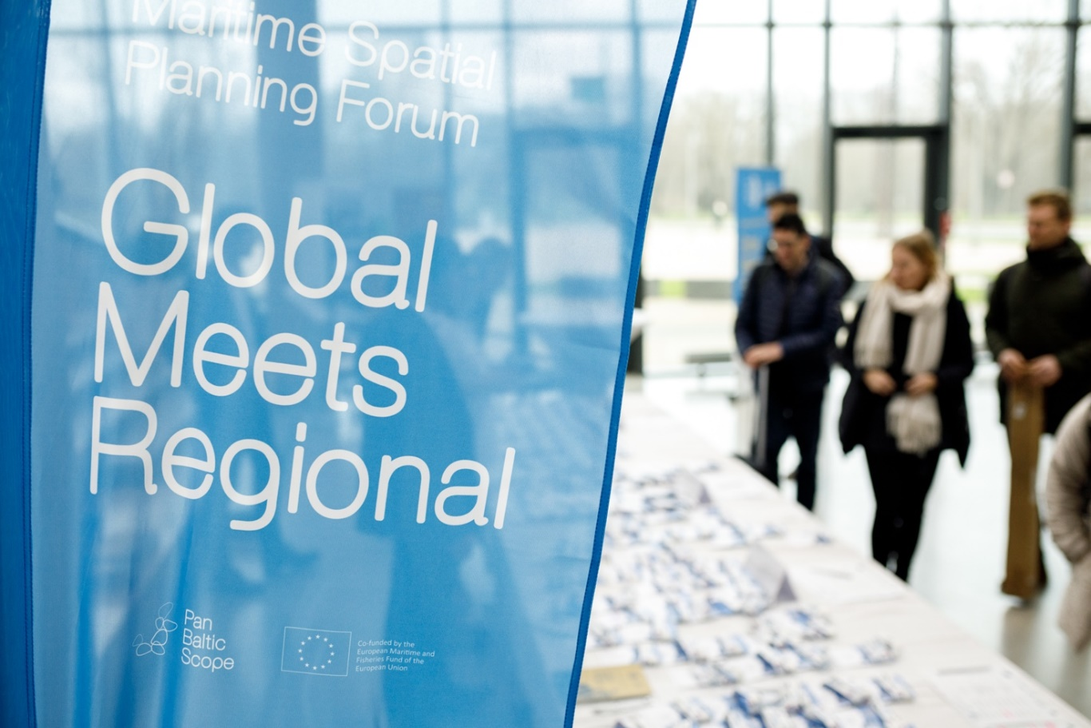
During this reporting period, the MSPglobal Initiative participated in 4th MSPforum jointly organised by IOC-UNESCO, the European Commission, VASAB and the Government of Latvia in Riga. The report, presentations and videos are available at MSPglobal website: https://www.mspglobal2030.org/msp-forum/riga/

The 5th and the 6th MSPforums planned in April 2020 in Athens (Greece) and in November 2020 in Scheveningen (The Netherlands) were cancelled, together with the agreement to postpone the organization of the 3rd International MSP Conference in 2022 if the sanitary conditions allow it. The MSPglobal network is increasing and expanding across our ocean despite the limitations of the past months. The network is providing valuable inputs to share with the members of the MSPglobal International Expert Group in charge of developing the guidance on transboundary MSP that is currently in the final phase of development and will be launched in September 2021 in English, Spanish, French and Arabic. The P.R. of China offered the Secretariat to translate the guidelines into Chinese too.
Extending networks worldwide
The organisation of these activities in the current pandemic situation represented different challenges but also multiple opportunities, starting with the increase of exchanges and interactions with competent authorities in Member States, UNESCO’s field offices and regional partners of MSPglobal and the Joint Roadmap.
In the absence of face-to-face events, and with the postponement of the MSPforums to 2021 limitations that the pandemic imposed on interaction with local stakeholders aimed, the MSPglobal team put all efforts in improving direct communication with national experts, partners, national authorities and stakeholders. UNESCO services also found the best solutions to organise events with interpretation services to facilitate multilingual interactions and ensuring multilateral discussions.
In this context, the MSPglobal team prioritised activities dedicated to the exchange of good practices and transfer of maritime knowledge globally and also with regional partners in the Western Mediterranean and with maritime sectors in the Southeast Pacific.
Thanks to the valuable support of our Member States and the UNESCO Field Offices in Africa, Asia, Latin America and the Caribbean, IOC/MPR organized more than 80 events during the pandemic dedicated to coastal vulnerability, marine spatial planning, sustainable blue economy including training courses, technical seminars, institutional exchanges, dialogues, expert and public consultations.
Technical discussions and trainings online were an opportunity to deepening discussions on specific topics affecting the development and implementation of MSP, from climate change to participative mapping, public/private participation or the relevant role of maritime clusters. These events were organized in six different languages (English, Spanish, French, Portuguese, Arabic and Chinese) and were attended by more than 5.000 participants from more than 120 countries. A video repository of most of presentations is available in our Youtube channel: https://www.youtube.com/channel/UCBnh3YmsgbQ2MszWnwBpVnw/videos
In 20211, IOC/MPR together with National Authorities of Indonesia, Germany, Finland, China, the Netherlands and Mozambique jointly organised dedicated online seminars to share national practices designing, approving and implementing marine spatial planning in their respective countries. Videos are available at the MSPglobal video gallery section: https://www.mspglobal2030.org/resources/msp-global-video-gallery/

The MSPglobal website (www.mspglobal2030.org) is now fully operative, contents are updated progressively and the multilingual sections are available in English, Spanish, French and Arabic.
Publications on the role of maritime sectors in planning and sustainable blue economy strategies, as well as the technical reporting for the pilot case studies on current and future conditions for planning, the elaboration of policy briefs on crosscutting issues, blue economy, capacity development and climate change complements the intensive work agenda implemented during this biennium by IOC/MPR, partners and Member States. All products are available at: https://www.mspglobal2030.org/resources/

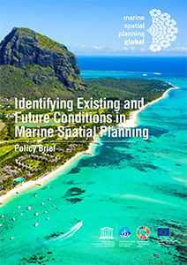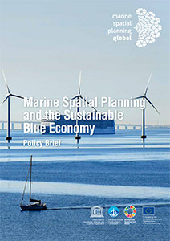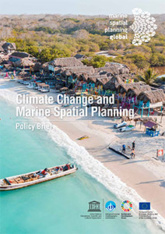

Identifying Existing and Future Conditions in Marine Spatial Planning | Marine Spatial Planning and the Sustainable Blue Economy | Climate Change and Marine Spatial Planning

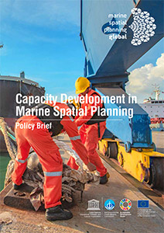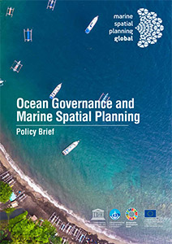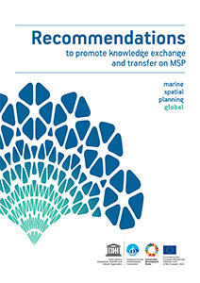

Capacity Development in Marine Spatial Planning | Ocean Governance and Marine Spatial Planning | Recommendations to promote knowledge  exchange and transfer on MSP
New MSPglobal brochures were launched in 2020 in the seven most spoken languages in our ocean: Chinese, Spanish, English, French, Portuguese, Arabic and Russian was possible thanks to the multilingual diversity and origins of the MSPglobal Project team at IOC and the valuable support of the First Institute of Oceanography of the P.R. of China.

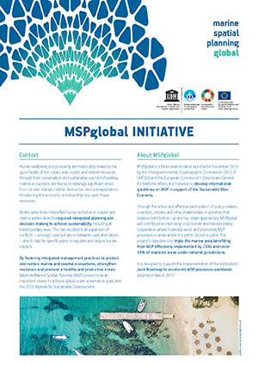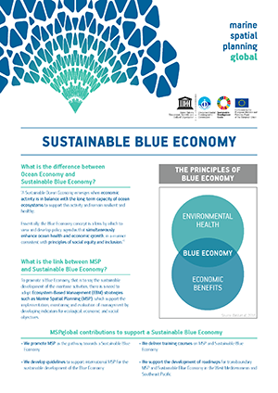
AR | CN | EN | ES | FR | PT | RU | AR | CN | EN | ES | FR | PT | RU

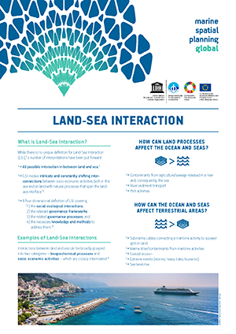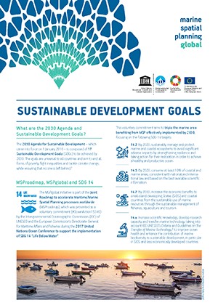
AR | CN | EN | ES | FR | PT | RU | AR | CN | EN | ES | FR | PT | RU

The UNESCO Action Plan for Small Island Developing States adopted in 2016 embraces the “Samoa Pathway” and integrates its priorities across all the Organization's programmes, especially those related to the mandate of IOC-UNESCO.
In the context of MSPglobal and with the support of Sweden, IOC/MPR enhanced island capacities to achieve sustainable development through education, ocean literacy for all and the reinforcement of human and institutional capacities on integrated coastal area management, marine spatial planning and sustainable blue economy. The activities implemented in Trinidad and Tobago and Cabo Verde complemented the national efforts to enhance national resilience and the sustainability of human interactions with ecological, freshwater and ocean systems as well as it favoured the interaction amongst institutions and stakeholders increasing information management and knowledge-sharing by ensuring the fullest participation of youth and social inclusion.
These activities jointly organized by IOC with the Ministry of Maritime Economy and Institute for the Sea of Cabo Verde and the Institute of Marine Affairs of Trinidad and Tobago provided responses to combatting climate change through the strengthening of capacities in SIDS. It also facilitated the discussion with country authorities on how to deal with emergencies triggered by natural disasters through consistent and effective ecosystem-based management practices.
The Portuguese Navy and its Hydrographic Institute provided support to IOC Secretariat to disseminate these practices in the context of the Ocean Decade during their campaign in Africa in 2021.
Promotional videos describing national efforts in support of marine spatial planning and sustainable blue economy in Cabo Verde and Trinidad and Tobago were used in national broadcasting corporations, schools and universities to disseminate national best practices. The videos are available at the MSPglobal video gallery: https://www.mspglobal2030.org/resources/msp-roadmap-video-gallery/
National consultants and authorities prepared dedicated national technical reports as part of the IOC series of publications dedicated to sustainable blue economy. reports that will support the institutional efforts to create awareness.
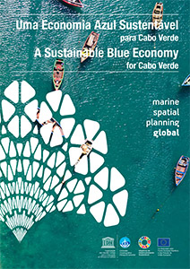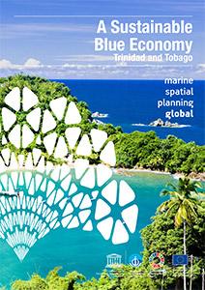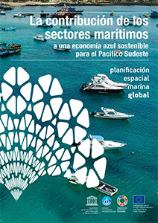

A Sustainable Blue Economy  for Cabo Verde | A Sustainable Blue Economy  for Trinidad and Tobago | La contribución de los sectores marítimos a una economía azul sostenible para el Pacífico Sudeste
In accordance with the request of IOC Member States to avoid duplications or inconsistencies amongst existing MSP country profiles at regional and international level, it was decided that the available content published in English, French and Spanish on the institutional IOC MSP website under the section “World Applications” (http://msp.ioc-unesco.org/) are now migrated to the MSPglobal website (http://www.mspglobal2030.org/).
Furthermore, on 27 February 2020, the IOC-UNESCO sent out Circular Letter n°2794 to its Member States requesting them to fill in a survey on the implementation process of MSP at national level. The results of this survey will be used to update the online country profiles and the capacity development activities to be organised jointly with National Authorities, regional and international partners in the Southeast Pacific and the Latin American region.
National practices implementing marine spatial planning worldwide are now for all Member States who responded the abovementioned survey. The MSPglobal website launched a new section dedicated to “MSP around the world” with all national profiles available in different languages and also includes a compendium of existing and emerging cross-border and transboundary initiatives on marine spatial planning. (IOC/INF-1395)
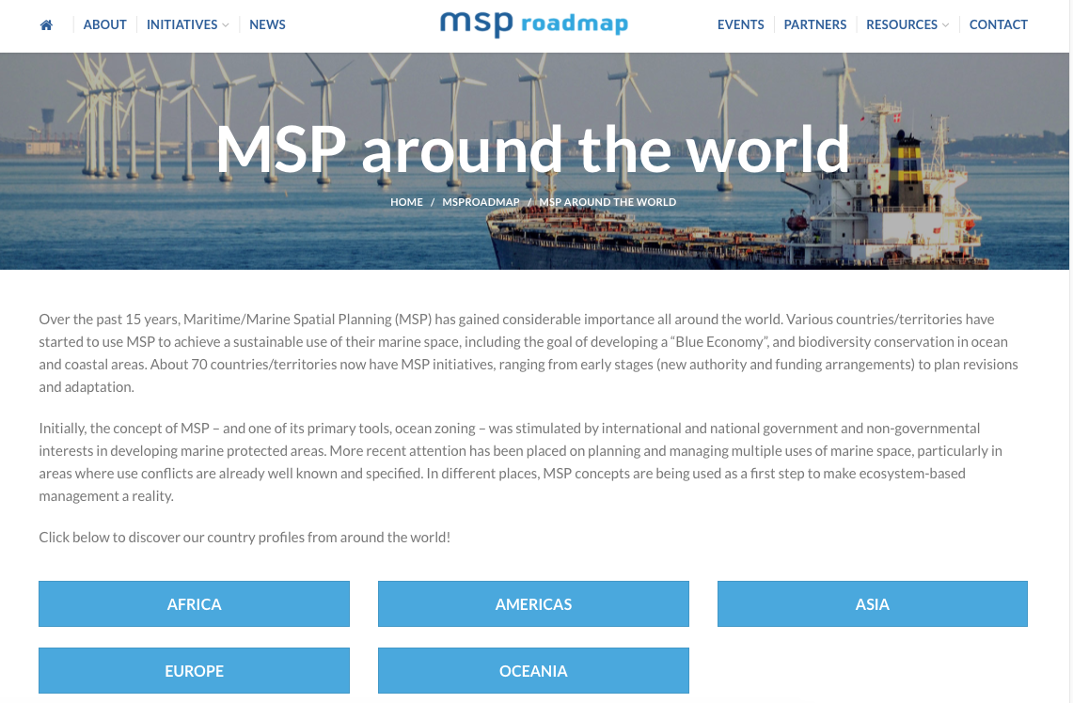

IOC continue supporting the alumni from the Erasmus Mundus Master Course on Marine Spatial Planning led by the Universities of Venezia (Italy), Sevilla (Spain) and Açores (Portugal) providing them the opportunities to grow in science and marine policy development.
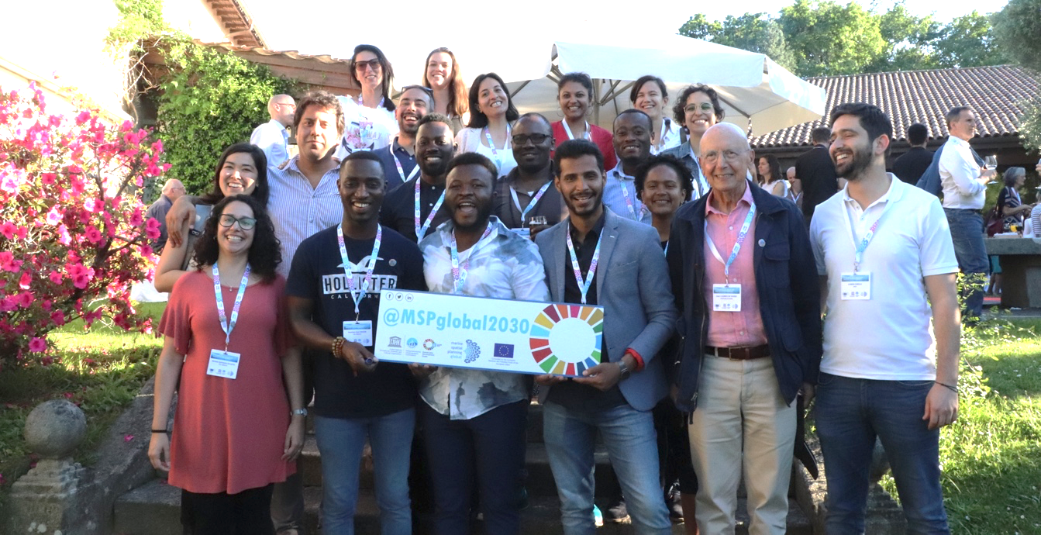
©MSPglobal, Alumni of Erasmus Mundus Mater Course on MSP, Vigo (Spain), 2019
During the last biennium more than 30 former students and interns from Latin America, Africa, Asia and Europe were selected as best candidates to support the Secretariat implementing national and regional activities in support to their country needs and in line with the objectives of this ICAM Strategy. Some of them as international experts in our institutional working groups, other through consultant contracts or selected as Youth Ambassadors to promote the MSPglobal Initiative.

THEME 2:

COASTAL AND MARINE HAZARDS ADAPTATION AND PREPAREDNESS
THROUGH EBM/AREA-BASED MANAGEMENT TOOLS
OBJECTIVE 2: Promote the integration of ocean-related hazards and climate change adaptation within coastal and marine management and planning tools in order to improve preparedness and resilience of coastal communities

IOC/MPR continues the implementation of multiscale activities on coastal and marine hazards, adaptation and preparedness through ecosystem-based approaches at the local scale, in collaboration with IOCAFRICA and Member States. These activities aim at improving the understanding on how IOC Member States will be impacted by climate change.
Amongst other activities related to ocean literacy and the co-design of the UN Ocean Decade, Sweden has provided valuable support to build collective capacities to respond to emerging ocean issues through ecosystem and area-based management tools such as integrated coastal area management, marine spatial planning and sustainable blue economy initiatives, including transboundary and large-marine ecosystem approaches for the sustainable use of marine resources and with a view to achieve a healthy and productive ocean.
In line with the specific actions implemented last year in Africa on integrated coastal area management and coastal vulnerability. Experts’ consultations on coastal and marine environmental pressures, including transboundary pressures, were organized by national experts hired by IOC Secretariat in 2020 in Ghana, Cameroon, Gabon, Angola, Mozambique and Kenya with the support and active participation of national authorities, representatives of the academia, the private sector and society.

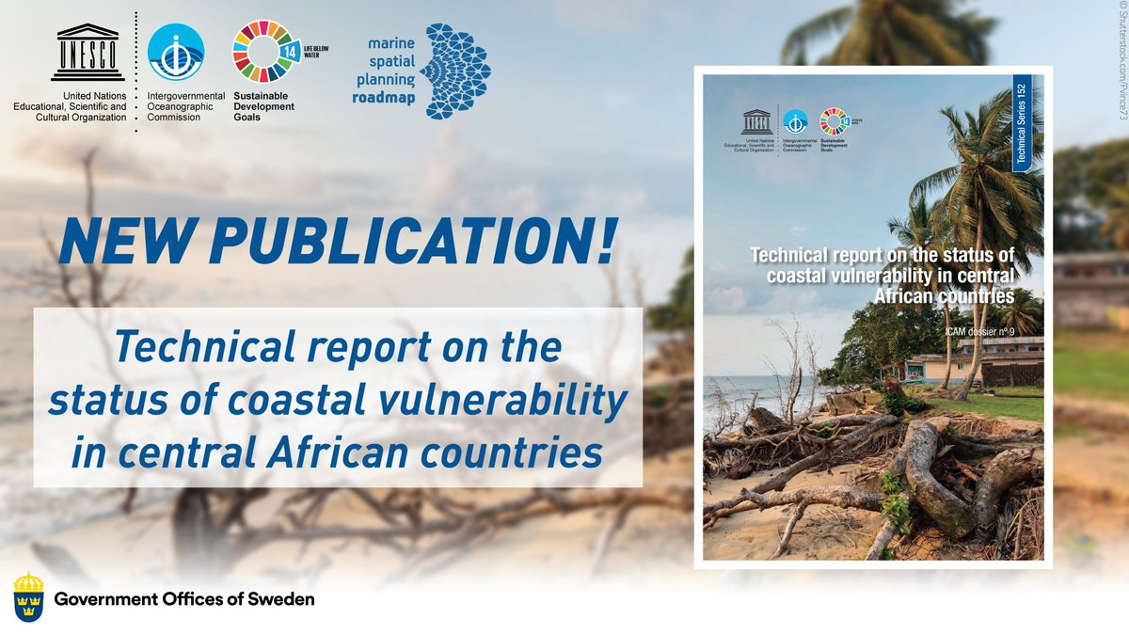
https://unesdoc.unesco.org/ark:/48223/pf0000373623

Additional lessons learnt and best practices of managing coastal risk from local community perspectives were also compiled in national experts from Costa Rica, Venezuela, Uruguay, Senegal, Ghana, Gabon, Lebanon, Bangladesh and Myanmar.
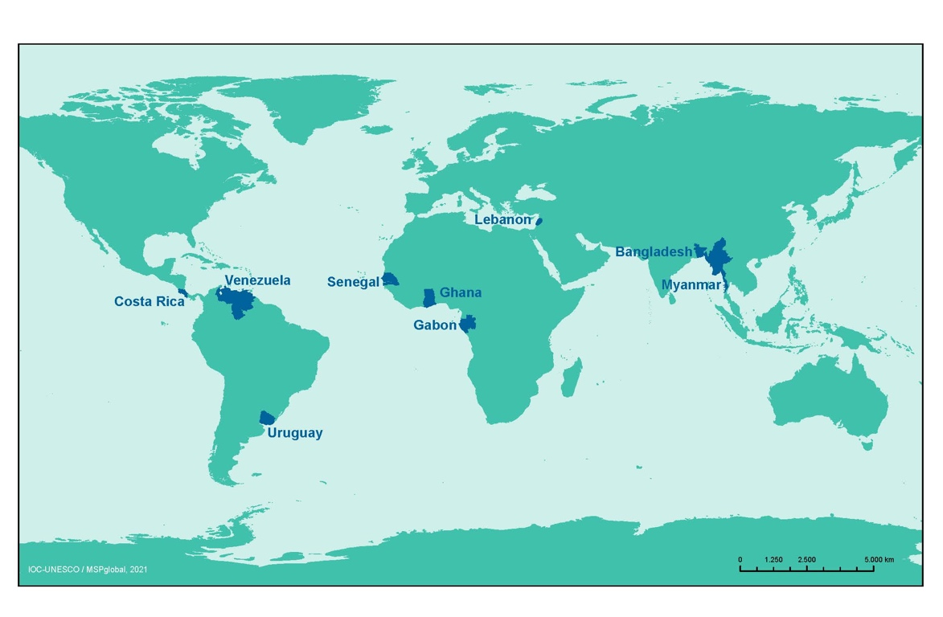

IOC promoted both Africa and Gender equality global priorities by selecting a wide diverse panel of experts, young professionals, to implement the work in their own countries. National practices compiled and summarised will be disseminated in a publication that will also include policy recommendations for adaptation and options for the development of mitigation strategies.
The Secretariat provided support to Member States to make informed decisions on practical adaptation actions and measures in response to climate change to be considered in the context of integrated coastal management and marine spatial planning processes. A workbook to understand the options to address these challenges will be published in 2021. A multilingual community guide for community members interested in risk reduction efforts and how to reduce coastal hazard risk at community level following a step-by-step approach is already available in English, Spanish, French, Arabic, Russian and Portuguese.

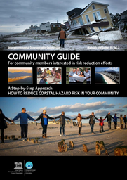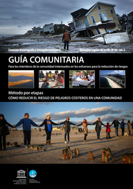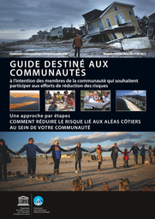
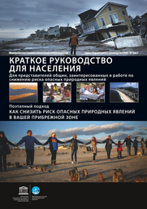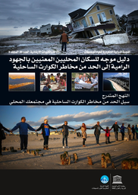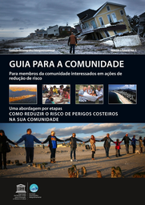
https://unesdoc.unesco.org/ark:/48223/pf0000375768
Working with national experts facilitated the interaction and active contribution of national authorities and stakeholders to all events and products. The COVID-19 pandemic transformed all expected events into online seminars, workshops or dialogues increasing the number of participants and beneficiaries. Challenges to report are only those related to internet access and stability, especially in LDCs and SIDS. All activities planned in Cuba in 2020 were cancelled, in consultation with La Habana Office and national authorities, due to the impossibility to implement them virtually.
IOC/MPR, the Tsunami Unit and the Ocean Observation Section continue building synergies to promote the integration of ocean-related hazards and climate change adaptation within coastal and marine management and planning tools to improve preparedness and resilience of coastal communities: 1) Coastal cities adaptation and preparedness in collaboration with Member States; 2) Coastal and Marine Risks; 3) Resilience of coastal communities in collaboration with PADDLE and GEF LME:Learn and 4) Scenarios for MSP and Blue Economy in the context of MSPglobal and the support of the European Commission and the Kingdom of Sweden.
Together with the Man and Biosphere Programme of UNESCO (MaB), IOC/MPR launched the small-scale activity Ecosystem-based solutions for coastal and marine sustainability in the Southeast Pacific in consultation with beneficiary countries and UNESCO Regional Offices.
This joint initiative by IOC and MaB is co-financed by the Government of Flanders and aims at exchanging knowledge on ecosystem-based solutions for coastal and marine sustainable development at the national and the regional level, in order to develop a harmonized coastal and marine environmental management framework for the beneficiary countries in the Southeast Pacific.
The project facilitates the discussion on the right data and tools needed by national and local authorities (e.g. Coastal and Marine Biosphere Reserves) to apply the ecosystem approach in their coasts, while also providing a foundation for planning sustainable economic development through inter-institutional and stakeholders’ interaction, which will translate into concrete recommendations and strategies.
The project is mobilizing the SPINCAM and BRESEP networks to facilitate:
- the development of a collaboration framework for coastal and marine management and planning in favour of sustainable national development, strengthening regional consensus, public participation.
- the use of the previous technical and institutional capacity activities to reduce disparities between countries and extend it to stakeholders representing the most relevant maritime sector in the region;
- the use of tools developed to support decision-making with the aim of increasing synergies to apply methodological concepts, for both integrated coastal management and marine spatial planning;
- the development of regional and national strategies for coastal and marine management and planning in the context of the Lima Convention.

By improving the coordination amongst regional experts dedicated to coastal and marine issues as an instrument for exchanging knowledge and experiences, the project aims to achieve synergies and effective coordination in support of current and future processes of formulation, consolidation, implementation and monitoring of national and regional coastal and marine sustainable initiatives;
The project will contribute to the institutional efforts of IOC-UNESCO in the Southeast Pacific, it will also support the implementation of other programmes, strategies and initiatives of UNESCO in the region by:
- Strengthening the collaboration with the Man and Biosphere Programme of UNESCO and the strategic support to BRESEP Network;
- Exchanging good practices and common interests with other project initiatives in the region in line with the ICAM Strategy and the mandate of the Marine Policy and Regional Coordination Section of IOC-UNESCO;
- Keeping informed the rest of UNESCO Sectors and the Field Offices located in the Southeast Pacific.
IOC/MPR is currently assessing ecosystem-based solutions in the coastal and marine environments of three selected coastal and marine Biosphere Reserves in the Southeast Pacific: Archipelago Juan Fernández (Chile), Archipelago of Colon – Galápagos (Ecuador) and Noreste - Amotapes-Manglares, (Peru).
IOC/MPR is developing a technical report, in close coordination with the managers of the Biosphere Reserves and local stakeholders, on the analysis of three potential nature-based solutions to be implemented in coastal and marine areas of the Reserve aiming at reducing vulnerability. A comprehensive description of the data needs, information and sources / references that are necessary and essential for the execution of the proposed nature-based solutions and recommendations on the conditions conducive to applying nature-based solutions will also be included.
In addition, IOC will identify and report on the users’ cases, the specific questions to be answered and the technical solutions that can help to solve the users’ needs using the work to be implemented in 2021 at the three selected coastal and marine Biosphere Reserves in the Southeast Pacific.
The report will identify potential solutions and enabling conditions involving capacity needs, in line with the IOC Capacity Development Strategy, the ICAM Strategy and the institutional functions and capacity development activities led by the Marine Policy and Regional Coordination Section of IOC and the Man and Biosphere Programme of UNESCO.

THEME 3:

COASTAL AND MARINE DATA, INFORMATION AND DECISION SUPPORT TOOLS
OBJECTIVE 3: Increase collective knowledge supporting management actions on the status and change of coastal and marine ecosystems and sustained services through use and dissemination of data, information and decision support tools.

The organization of regional technical events contributed to highlight the need of data, information and decision support tools to accomplish the objectives of the MSProadmap and the targets of Agenda 2030, the Green Deal and the Ocean Decade.
A Marine Spatial Data Infrastructure (SDI) was developed with the available information in the Western Mediterranean and the Southeast Pacific, in order to reuse and update available data from previous projects funded by the European Commission and those led by IOC/MPR.
This information served IOC/MPR to implement mapping exercises in both regions allowing the spatial analysis following the recommendation of the IOC-UNESCO’s step-by-step that recognises that the marine management area is typically affected by human activities that are upstream and downstream this area, i.e., boundaries for analysis must be broader than the boundaries for management, allowing the identification of sources of influence.
Data needs were defined based on IOC-UNESCO’s step-by-step approach and the Article 8 of the Directive 2014/89/EU; as well as grouped as Ecological, Physical or Human / Socio-economic Data.
An analysis of spatial data quality and availability was undertaken. First, regional sources of data were accessed and assessed followed by national sources. A preliminary gap analysis was conducted in order to assess which data had to be requested from national authorities. It is to be noted that data for beneficiary countries were accessible in Europe and Latin America. The MSPglobal team found difficulties accessing public data and information in African countries and worked closely with national authorities to solve the situation and access some datasets that were already reported to international organisations and were not restricted.
Data quality analysis was done in all cases based on criteria developed by the Project team, taking into account: A. Relevance and Updates; B. Relevance of the Source; C. Geographical Projection; D. Attributes; E. Metadata. When possible, data was accessed through Open Geospatial Consortium (OGC) compliant web services, among which, Web Feature Services (WFS). A log file was created in order to do an inventory of the original data specifying source, year, quality and spatial extent. IDs were created to identify each dataset in different tables. Layer processing was documented. Metadata was collected with the original datasets when available.
In the Southeast Pacific, a review and systematic analysis of global, regional and national Spatial Data Infrastructures (SDIs) was carried out to identify the functional status and relevance to MSP process in the Southeast Pacific according to the EU document “MSP Data Study”. In total, 24 SDIs were reviewed. Different data sources have been consulted from worldwide providers (e.g., USGS, GEBCO), regional cooperation (e.g., SPINCAM) and national agencies (e.g., MAE for Ecuador and MINAM for Peru), giving priority to the use of official sources of information.
The spatial data collected is mostly socio-economic and organised in more than 100 thematic layers, each one with its respective metadata.
A set of maps was created for important biological and ecological areas and current human activities. The next phase will analyse conflicts and compatibilities amongst human uses and in between human uses and the environment.

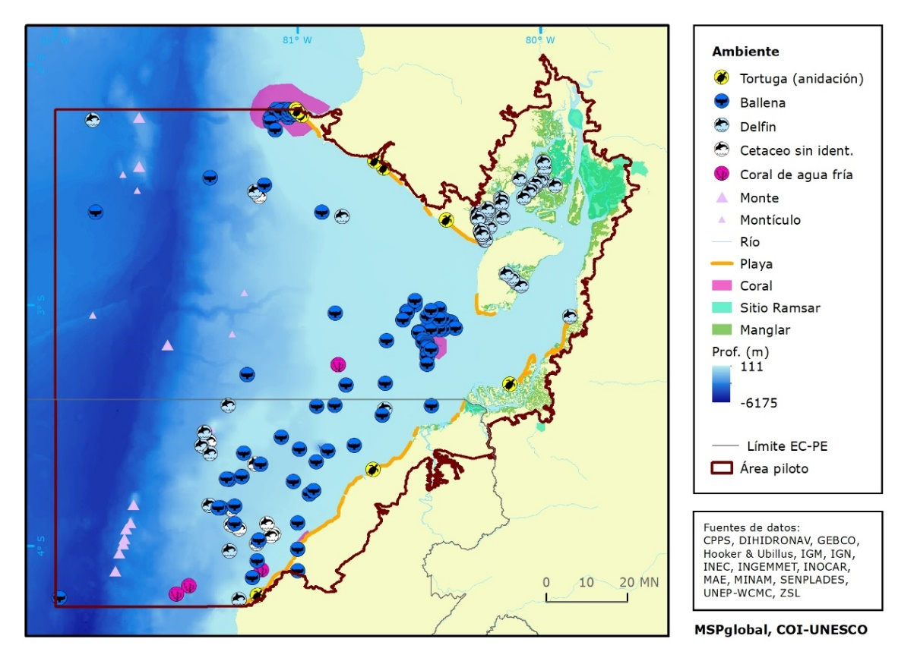

Based on the created maps and the mapping analysis of the potential conflicts, the recently published technical report focuses on the conflicts between human uses and the environment and the conflicts amongst human uses. The analysis was complemented by the identification of conflicts at the local scale whenever data and literature were available.
With regard to the compatibilities amongst human uses and in between human uses and the environment, the report analyses the existing and potential multi-use of marine activities while complementing it from analysis done locally (by country) whenever data and literature was available.
In addition to the conflicts and compatibilities analysis, the reports carried an analysis of the governing national policies, regional initiatives and projects in relation to integrated coastal area management, marine spatial planning and sustainable blue economy, as well as an analysis of the status of the marine environment and its conservation and the maritime activities.

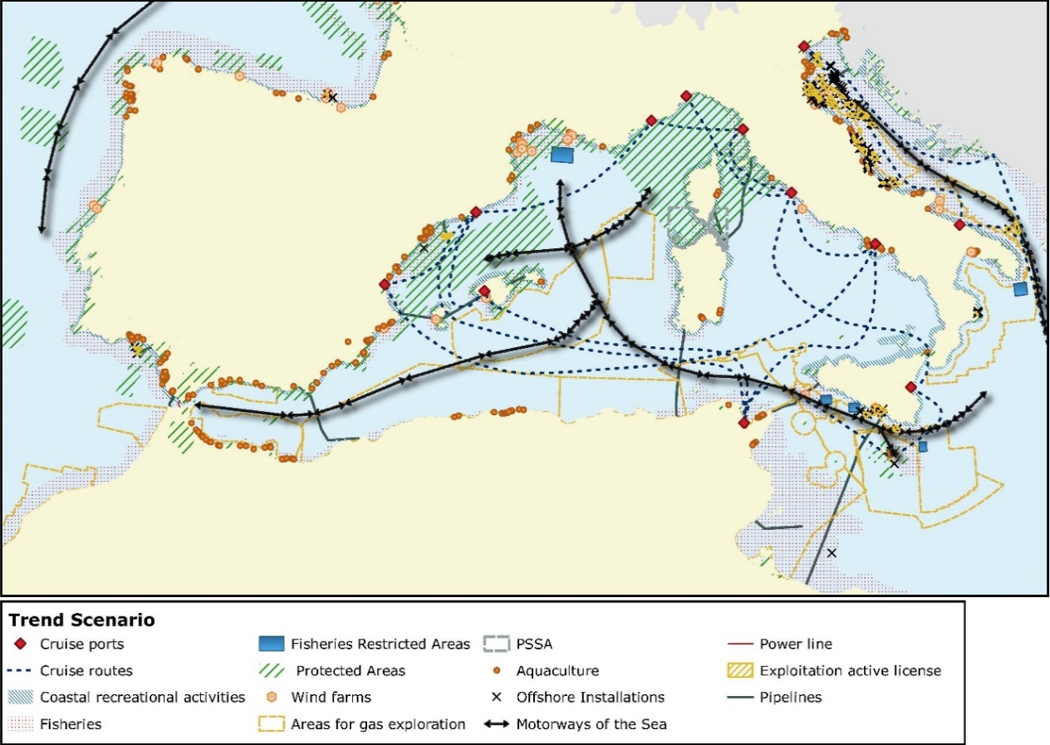
©MSPglobal, IOC-UNESCO, 2021

The technical reports on future conditions and scenarios for marine spatial planning and sustainable blue economy in both the Western Mediterranean and the countries in the Southeast Pacific propose three scenarios for 2030. The first with a focus on conservation (Conservationist scenario), a second projecting current trends of activities to the future (Trend scenario) and a final integrated scenario where conflicts are minimised and blue economy strategies are followed (Integrated scenario).
The reports are available to download for the Western Mediterranean in English and French and for the Southeast Pacific in English and Spanish.

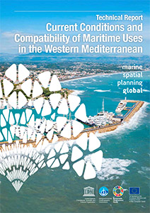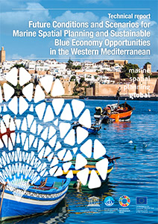

EN | FR  (IOC Technical Series, 160, 2021) | EN | FR  (IOC Technical Series, 162, 2021)

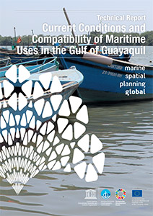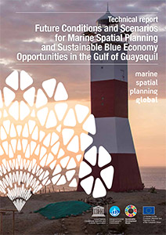

EN | ES  (IOC Technical Series, 161, 2021)) | EN | ES  (IOC Technical Series, 163, 2021)

Resources considerations
In the context of the MSPglobal Initiative and the Joint Roadmap to accelerate Marine/Maritime Spatial Planning Worldwide and in support to the Agenda 2030, IOC/MPR has strengthened the collaboration with the European Commission for the development of International MSP Guidelines, including transboundary aspects for the development of the sustainable ocean economy (blue economy) enabling ecosystem-based MSP and pursuing capacity building for mutual understanding and for communicating MSP. Through direct funding provided by the European Commission to the MSP Global project, IOC has been able to achieve these goals as set up in the MSP roadmap. Annual contributions provided by the Government of Sweden has also enabled IOC to expand technical training on MSP in several regions such as Africa and the Caribbean.
In order to respond to the needs of IOC Member States, the IOC/ICAM programme will continue to seek extra-budgetary resources to facilitate training on marine spatial planning, sustainable blue economy and decision support tools in the context of the MSPglobal Initiative and its follow up, particularly in Africa, Central and East Asia, Latin America and Caribbean and the Pacific Islands. Beyond 2021, the Secretariat is working toward the development of a new MSP roadmap to guide cooperation over the next four years (2022–2025).
The GEF funded projects, in particular the next phase of the IW:Learn project executed by IOC/MPR and aimed at strengthening global governance of large marine ecosystems through enhanced knowledge and information sharing will continue providing an essential platform for implementing transboundary marine spatial planning and sustainable blue economy activities and join trainings with sister UN organisations and regional partners worldwide at the level of LME Projects.
In terms of human resources, there are currently no core regular programme position to support the work of IOC in MSP or LME areas. This raises the question of sustaining this important function in the long term, beyond the implementation of extra-budgetary projects. IOC Member States are therefore invited to consider the provision of in-kind and/or financial support to build internal capacity within the Secretariat.

Intergovernmental Oceanographic Commission (IOC)
United Nations Educational, Scientific and Cultural Organization
7 Place de Fontenoy
75 732 Paris Cedex 07, France
Tel.: +33 1 45 68 10 10
http://ioc.unesco.org

(1) 14.2 By 2020, sustainably manage and protect marine and coastal ecosystems to avoid significant adverse impacts, including by strengthening their resilience, and take action for their restoration in order to achieve healthy and productive oceans; 14.7 By 2030, increase the economic benefits to Small Island developing States and least developed countries from the sustainable use of marine resources, including through sustainable management of fisheries, aquaculture and tourism; 14.a Increase scientific knowledge, develop research capacity and transfer marine technology, taking into account the Intergovernmental Oceanographic Commission Criteria and Guidelines on the Transfer of Marine Technology, in order to improve ocean health and to enhance the contribution of marine biodiversity to the development of developing countries, in particular small island developing States and least developed countries.

