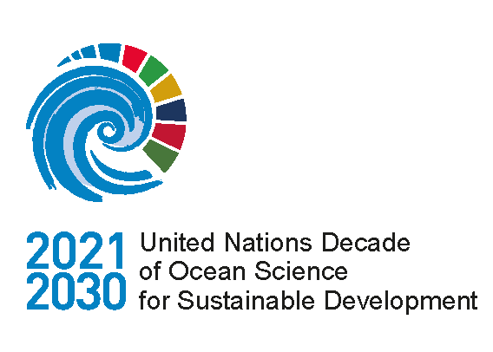

UN Decade of Ocean Science for Sustainable Development

Advisory Report on Communications Strategy

2021–23 (v2.0)

(DRAFT)

Written by Reelmedia Film Ltd.

Executive summary

The Ocean Decade represents a unique opportunity to bring together world-leading experts from across the globe to tackle some of the most urgent needs and challenges today. The scope to transform our future through collaboration across sectors, geographies, generations and academic disciplines is an exciting moment in our history and requires a global coalescing and togetherness in order to create solutions which will make a real-world difference.
Over the past four years, experts from science, industry, government, NGOs, foundations, UN agencies and early career professionals have come together in workshops, events, conferences, meetings and consultations to create an Implementation Plan and vision for a truly transformative Decade, setting out 10 challenges to establish the science we need, for the ocean we want.
During this time, the upsurge of interest has prompted the creation of numerous communications about the Decade worldwide by multiple stakeholders within and outside the IOC– from social media plans, to reports, events, website development and press outreach, alongside the appointment of a communications advisory group, and communications approaches by professionals in partner institutions.
This Advisory Report on the Communications Strategy provides an overview of the proposed approach to communications throughout the Ocean Decade. It is being presented to the 31st Assembly of the Intergovernmental Oceanographic Commission of UNESCO to facilitate feedback by IOC Member States that will be integrated into the development of the final Communications Strategy.
Communications is fundamental to the Decade’s success
As we set foot on the 10-year path of the Decade, it is crucial we now harness the excitement and potential of this global network by producing impactful communications which amplify the Ocean Decade as a collective voice and capture the appetite and eagerness of stakeholders to create real change. As a scientist in a focus group remarked, ‘Communications is fundamental – if we cannot get this right, we will not be able to deliver the enormous scope of the Decade’.
With consultation at the heart of the Decade, the creation of this report has been entirely led by this mandate, including numerous focus group interviews with stakeholders across the private sector, trusts and foundations, the ocean science community, early career professionals, NGOs and UN agencies to ensure the needs of these groups are realised through tangible recommendations and plans.
Global yet local
The report also considers the critical need to remain specific to geographies, regions and demographics whilst telling a collective narrative in order to ensure the Decade is relevant to everyone – from fishermen, to lab-based scientists, and policymakers. From countries in the Western Pacific to the Indian Ocean, to the North Atlantic. We cannot create the solutions we need in isolation.
The report looks at the initial three-year period of the Decade, in order to be as granular and specific as possible and sets a basis for strong communications for the remainder of the Decade.
Key findings include:
- Significant interest across global media and social media in ocean issues and sustainable solutions presents an untapped opportunity to further the Decade’s voice. There is a need for collective coalescing around global moments, such as the UNFCCC and Biodiversity COPs and World Oceans Day but also organic regional and sector-specific communications
- There is a clear call from all sectors for messaging which demonstrates the value and diversity of the Decade to individual groups with decisive entry points. Example messaging and dissemination form a key part of this strategy.
- Reviewed mechanics of communications – clearer brand guidelines, a more accessible website and clearer modes of communications delivery will enable easier access to the Decade.
- The Decade, and in particular the Global Stakeholder Forum should act as a network of networks which brings together diverse groups who are already active and keen to engage on a more global level. The strategy outlines how to capture these existing networks and work in tandem with network leaders.
- Storytelling and visual assets are an integral part of the Decade’s success – despite the focus on institutional-level engagement, the humanity of ocean challenges needs to be told through communications. A clear framework for story collection and creation demonstrates the journey to achieve this.
- Building capacity internationally is key – the strategy discusses how training and working with communications focal points, rolling out specific toolkits and creating shared messaging is essential to ensure the Decade is self-sustaining, grows organically and is co-owned by everyone who participates.
Action Plan
As part of the report the Communications Action Plan presents a three-year framework of action in order to grow the Decade’s presence and encourage increased participation. The monitoring and evaluation framework works together with this to help map progress as the Decade continues.
Realising the potential
Through collaboration, capacity building and the creation of a shared voice, strong communications will enable the Ocean Decade to realise the full potential of this extraordinary opportunity, to transform our futures, and create the science we need for the ocean we want.

Contents

Section Title Page
Acronyms and Authors 5
1.0 Introduction 6

1.1 Integration with Generation Ocean communications strategy 6

2.0 Key audiences 7
2.1 Scientific community 7
2.2 Governments 7
2.3 Non-Governmental Organisations (NGOs) and civil society 8
2.4 Funders 8
2.5 Private Sector 8
2.6 Early Career Ocean Professionals (ECOPS) 9
2.7 United Nation (UN) agencies 9

3.0 Situational analysis: global and social media 10
3.1 Global and social media: Ocean Science 10
3.2 Global and social media: Ocean Decade 13
3.3 Summary and analysis 14

4.0 Analysis of Decade communications for Decade audiences 16
4.1 Audience feedback and analysis 21
4.2 Specific comments from individual stakeholder groups 25
5.0 Objectives 28
5.1 Communication KPIs: 2021-23 29

6.0 Communications recommendations 31
6.1 Recommendations rationale 35
6.2 Messaging 35
6.21 Messaging – additional notes 40
6.3 Website 41
6.4 Storytelling assets 42
6.5 Communication toolkit 42
6.6 Training 42
6.7 Communications Advisory Group 42
6.8 Stakeholder networks 43
6.9 Global and social media 44
6.91 Global media 44
6.92 Social media 46

List of acronyms
ECOPS Early Career Ocean Professionals
IGO Inter-governmental Organisation
INGO International, Non-Governmental Organisation
NGO Non-Governmental Organisation
IOC Intergovernmental Oceanographic Commission
UN United Nations
UNESCO United Nations Educational, Scientific and Cultural Organization
CAG Communications Advisory Group

Prepared by Reelmedia Film
Tim Webster | Creative Director
Sarah Baldwin | Campaign Strategist
Aiyana Gane | Communications Officer

Introduction
This strategy will enable implementors to roll out communication activities that will enable stakeholders from a variety of networks and disciplines to become engaged and take part in the Decade. It has become clear from focus group research that there is a lack of clarity about the Decade, with a recurring theme being lack of understanding on how to become involved and the relevance to different stakeholders. It has also been made clear that although the audiences are institutional, storytelling is paramount to effective communications, in order to make the Decade more relatable, emotive, and inspiring for funders, scientists and other key audiences. A member of the Executive Planning Group expressed that, “communications is fundamental to the Decade – without good communications we will not be able to deliver this ambitious and inspiring programme”.
Good communications will ensure the Decade is a truly global effort which “creates the science we need for the ocean we want”, in order to “catalyse transformative ocean science solutions for sustainable development, connecting people and our ocean”.
Essential to the success of the Decade is the collaboration between key sectors, in order to form initiatives that grow and flourish across the globe on a local, regional, national and international level throughout the course of the Decade.
The strategy will suggest a clear pathway and messaging in order to:
- Demonstrate the value of the Decade to different sectors.
- Encourage participation, dialogue and collaboration from key stakeholder groups across the world, including leading ocean scientists, governments, philanthropic and corporate foundations, UN agencies, early career professionals, NGOs, and the private sector.
- Recommend how to clearly communicate so that each audience group can become involved.
As a document, the Ocean Decade Communications Strategy will:
- Outline key audiences, map existing communications, feedback from stakeholder groups and engagement.
- Provide a context analysis of existing media and social media analysis.
- Establish practices and mechanics to disseminate messaging, build capacity and effectively communicate the Decade.
- Present a Communications Action Plan to achieve sustainable communications which create real impact, on a global scale.

1.1 Integration with Generation Ocean Communications Strategy
The strategy will sit alongside and complement the public Generation Ocean Communications Strategy, with more detail outlined later in the document.
2.0 Key audiences
The communications activities of the Decade will help to convene a number of stakeholder groups by developing messaging and actions that can contribute to the development of communities of practice around ten Ocean Decade Challenges. The following section draws on the database of partners associated with the Ocean Decade website, as well as additional information provided by members of the IOC Secretariat in relation to engagement activities. This database contains all partners that self-registered on the website during the Decade preparation phase and relies on information provided by those partners.

2.1 Scientific Community
Scientists, research institutions and universities are key to the success of the Decade, creating ground- breaking scientific solutions to key issues which benefit cross-sector. Scientists benefit from opportunities provided by the Decade for increased collaboration with a diverse range of partners to co-design new technologies tackling key ocean issues.
Currently, there are 200 member organisations/institutions under the category of ‘Ocean Science & Technology’ signed up to the community on the Ocean Decade website. It is important to note that while some sit within labs and industry, many scientists also sit within government federal bureaus, agencies and NGOs. Scientific communities are a principal audience of the Ocean Decade, however, feedback from this group has indicated that they struggle to understand the ‘value proposition’ of the Decade, how they can engage particularly at the individual level, and how the Decade will generate added value to their work. The aim of the strategy is to increase numbers of scientists involved and collaboration between scientists and other stakeholder groups engaged in the Decade.

2.2 Governments
National Governments will continue to be essential funders and coordinators of ocean science – both as Member States of UN entities and via national funding agencies. Several governments are represented as partners of the Decade, including Sweden, Norway, Canada, the US and UK.
The Decade will rely on governments across the world to be fully on board in order to lead the development of Decade Actions, provide resources for ocean science, and use the results of ocean science in policy or management. As the Decade has transitioned into the implementation phase, several governments are proposing to host decentralised coordination structures (Decade Coordination Offices or Decade Collaborative Centres) and numerous National Decade Committees are emerging. These Committees will have an essential convening and coordination role at the national level. All of these structures will provide support to communications activities at the regional and national levels. Interaction with governments is both via official interactions between the IOC Secretariat and Member States, as well as engagement of government staff and groups via broader Decade engagement mechanisms. It is therefore essential that the strategy displays a clear and consistent narrative for how the Decade is relevant to all governments who are involved.

2.3 NGOs and civil society
NGOs and civil society are a diverse group that can play a multitude of roles in the Decade ranging from generation of science, to advocacy with governments and policy makers, and education and outreach with local communities.
Currently, there are 201 members signed up to the community under the ‘Civil Society & NGOs’ category on the Ocean Decade website, with thousands of national and INGOs playing a unique role in advocacy, operational roll-out of ocean technologies and informing policy. Through the Decade NGOs will be essential in bridging the gap between scientists and governments, using influence to inform policy and engage the wider public. To date, there has been limited targeted engagement with NGOs, however, this group appears well aware of the Decade and was one of the major groups to submit proposed Decade Actions to the recent Call for Decade Actions.

2.4 Funders
The Ocean Decade will require the commitment and engagement of a wide range of funding partners – both traditional and new funding partners. Currently, there are 39 donors and foundations signed up to the Ocean Decade community. Philanthropic foundations and science funding agencies will play a crucial role in the Decade through provision of resources, as well as outreach, advocacy and development of an enabling environment to catalyse broad support for Decade priorities. To date, engagement with funders has focused on philanthropic and corporate Foundations, as well as national science funding agencies. Targeted engagement with other funder types – including international or regional development banks, international financing instruments or private sector – has been limited but will need to be a strong focus of future efforts. Funding organisations will require clear messaging on both the value proposition for engaging in the Decade as well as information on mechanisms to allow their engagement.

2.5 Private sector
Business and private sector stakeholders, including emerging maritime industries and ocean information service providers are primary commercial users of the ocean and can contribute significantly to the Decade in terms of resources and partnerships, as a driver of technological innovation to enhance ocean science, and as an employer of the next generation of ocean science professionals. Currently there are 107 partners signed up on the website.
Benefits to the private sector include enhanced scientific knowledge that can contribute to reducing business risks and creating opportunities for sustainable economic development. To date the Ocean Decade has focused its private sector engagement primarily through platforms or networks of industry partners such as the United Nations Global Compact and the World Ocean Council. This strategy will look at how to continue engagement with these important platforms as well as increasingly target individual companies or businesses, including those with indirect relationship to the ocean, such as land-based industries.

2.6 Early Career Ocean Professionals (ECOPS) and Communications Advisory Group
ECOPs can make crucial contributions to the Decade by actively participating in Decade Actions and governance and coordination structures, acting as Decade advocates, and continuing the post-2030 legacy of the Decade. ECOPs will benefit from professional development and networking opportunities catalysed through the Decade, and opportunities to join and lead scientific collaborations and partnerships. An Informal Working Group of ECOPs has been created and has been actively engaged with the preparation phase of the Decade. This Group has also submitted a programme for endorsement as part of the Decade that will structure a programme of ECOP engagement over the next ten years. The strategy will outline how best to engage with and support ECOPs, who provide a vast network and enthusiasm for ocean issues.
The Communications Advisory Group (CAG) consists of established and recognised experts of high standing in one or more key areas of expertise relevant to the Ocean Decade and with due respect to geographic, gender and generational balance. Formed in September 2020, they meet on a quarterly basis to plan Ocean Decade communications and activities, as volunteers. Many members are also ECOPS and sit within major institutions around the world. They were interviewed as part of a joint discussion with ECOPs and during this strategy we will look at how to best work with the CAG, to empower them and utilise their extensive networks and experience.

2.7 UN agencies
UN entities and Intergovernmental Organisations (IGOs) are essential actors at numerous points throughout the ocean science value-chain from co-design to co-delivery, to use of generated knowledge, and the provision of resources. Engagement in the Decade will support these partners to fill their respective mandates. Major contributions in the form of Decade Actions and provision of resources are expected and will be welcomed from UN entities and IGOs throughout the Decade. Currently, there are 45 UN agencies/affiliated groups under the ‘United Nations’ category on the Ocean Decade website. The main platform for interaction is the contact group of UN-Oceans that has provided substantial input to the preparation of the Decade and will continue to be a platform for discussion and engagement throughout the implementation phase. The strategy will outline how to work in collaboration with key UN agencies and themes running throughout the Decade and engage them as partners to multiply the communications and outreach of the Decade.
3.0 Analysis: global and social media
February 2020 – February 2021

3.1 Global and social media engagement: Ocean Science
With the COVID-19 pandemic hitting in 2020, the world’s media naturally focused on the global pandemic, with ocean science and other environmental issues suffering in terms of media coverage and global engagement. However, in this period, 3,253 news articles were still published online about ocean science with a total engagement of 3,5485,991 across social media channels between February 2020 – February 2021. Facebook remained the most popular platform for sharing ocean science stories.

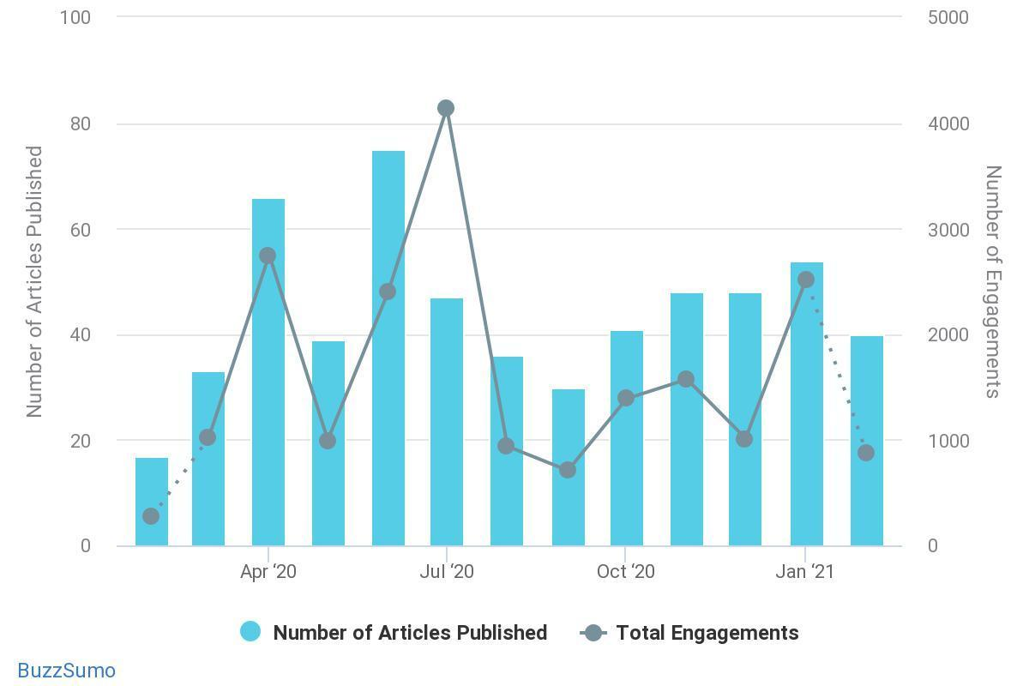
Fig 1. Articles and Engagement in Ocean Science Feb 2020 – Feb 2021. Source: Buzzsumo

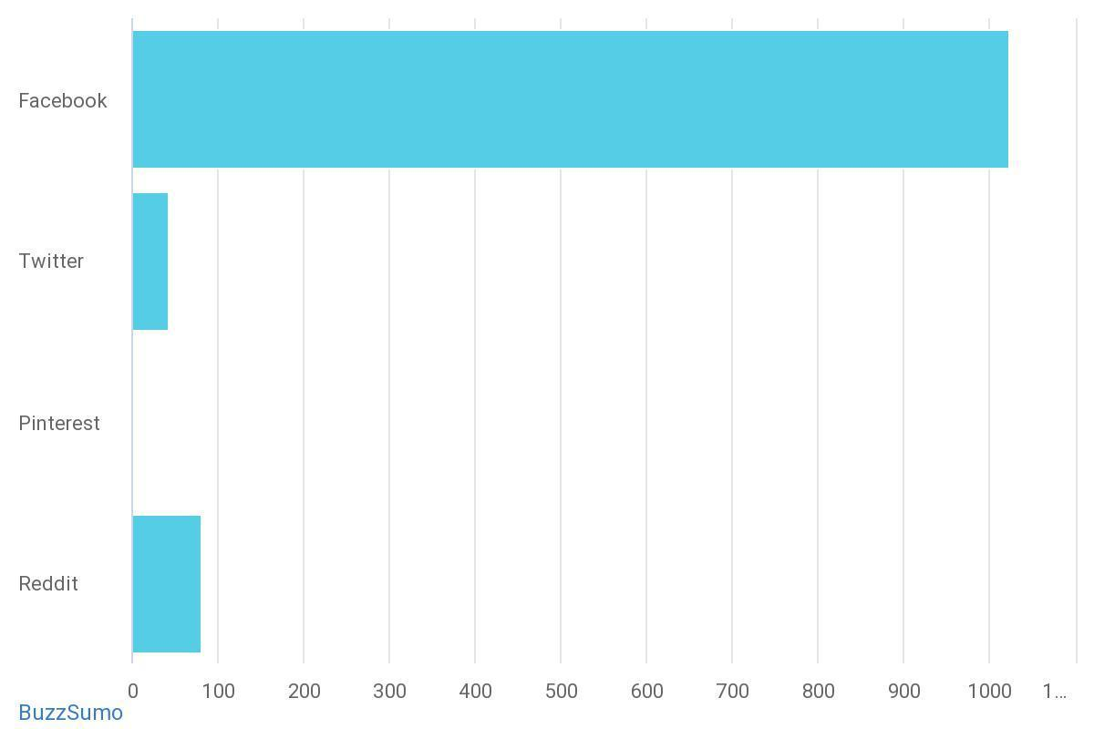
Fig 2: Breakdown of channels with social media reach for ocean stories, Feb 2020 – Feb 2021.
Source: Buzzsumo.

The Guardian represented the majority of stories on ocean topics, including science, with a score of 888.88k in total engagement. This was followed by scientific journals and then other global news agencies, generating up to 200k in reach.

Fig 3. Guardian article in June 2020 with a social media reach of 888k

Engagement peaked in June, when over 1000 articles were produced on ocean science. This all-year high was driven by the 8 June “World Oceans Day” celebrations, which traditionally attract substantive media attention to ocean and ocean science stories.

Key stories included:
- Coronavirus waste ending up in oceans (Guardian)

One fifth of the Earth’s ocean floor was now mapped, a project by the Nippon Foundation-GEBCO Seabed 2030 Project (BBC coverage), part of the global race to map the Ocean Floor by 2030 (Guardian)

“Pluto likely to have an ocean buried beneath its frozen exterior” (Space coverage)
- NGOs continue to grab news headlines on ocean issues with headers such as “one million tonnes of fishing gear left in the oceans” each year (WWF).

Fig 4. BBC News, 20 June 2020

3.2 Global and social media engagement: Ocean Decade
In contrast, the number of news articles which referenced the “Ocean Decade” was considerably less, at 214, with a reach of 5,177. News articles specifically mentioning “UN Decade of Ocean Science for Sustainable Development” or “UN Decade of Ocean Science” amounted to just 77. Media peaked in February 2021, when the Decade officially launched with the first major event of the Ocean Decade, the virtual broadcast A Brave New World.
A Brave New World drew additional media attention and provided a boost to the Ocean Decade, providing 24 media articles, including nationals Xinhua, France 24, and regional outlet the North Africa Post. Industry also covered the launch, including IBM in a blog about why ocean science needs more data. This generated a peak in active social media engagement close to 5k as recorded below, with approximately 30,000 people, (including 15,000 in the first 24hrs) watching the video. Several high-level stakeholders were involved, which also fuelled social media interest.

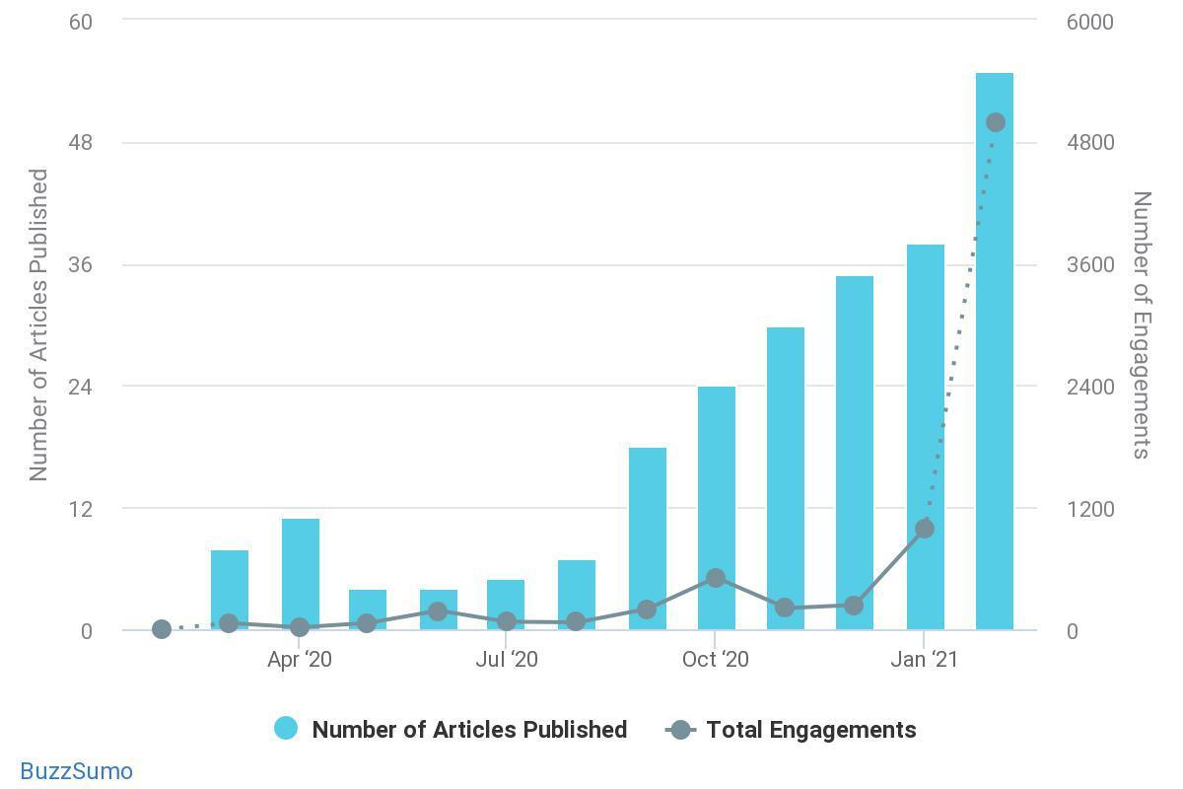
Fig 5: Number of articles and social media engagement related to ‘Ocean Decade’
Feb 2020- Feb 2021. Source: Buzz Sumo.

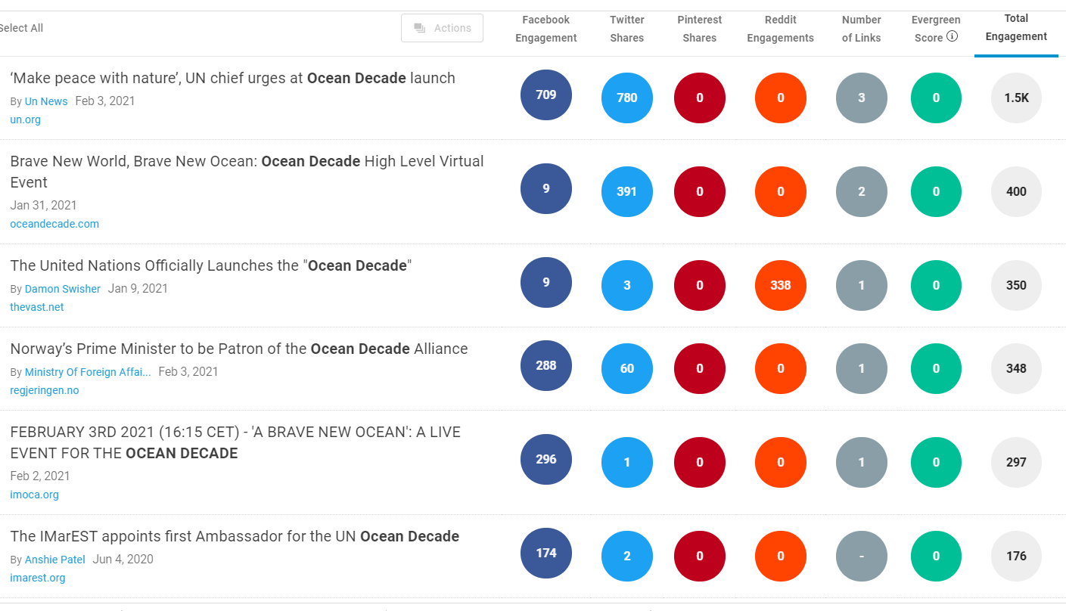

Fig 6: Engagement of top articles mentioning Ocean Decade February 2020 – February 2021.
Source: BuzzSumo

Since 15 January the Ocean Decade has a Twitter, Facebook, Instagram and LinkedIn account and is beginning to see a substantial increase in followers and engagement. There is additionally an Ocean Decade ECOPs Twitter account with 237 followers, which is updated regularly with Decade news, including 5 video profiles of different young ocean professionals.

Aside from the event in February and the activities with ECOPs, general social media engagement throughout the year came from relating ocean science and stories to upcoming events, natural disasters, innovations in science. However, there is room to grow the social media footprint in order to capitalise on interest in ocean issues.

3.3 Summary
Overall, the statistics above indicate the appetite for stories related to ocean issues and the environment in the media, and a lack of public awareness of the Ocean Decade amongst key global media outlets or on social media platforms. While broadcast data is unavailable, it has been made clear by UNESCO that no substantial broadcast media interviews on the Ocean Decade were conducted over 2020. This presents a clear opportunity to enhance the UN Decade’s presence through targeted, rich and truly global media coverage over the coming months and years.

Given the context of COVID-19 and the disaster agenda dominating the media consciousness, it is essential that Decade media communications are interlinked with social media actions, and are newsworthy, authentic and in collaboration with high-level institutions worldwide.

As expected, the data also illustrates the importance of remaining relevant in order to secure a global foothold, telling stories rather than simply presenting data, and remaining cognizant of current issues and affairs (e.g., environmental impact of COVID-19). The charts also demonstrate the power of collaboration on communications with key networks and stakeholder groups who are presenting ground-breaking technologies, in order to coalesce around set points in the ocean agenda, and obtain maximum impact (e.g. GEBCO Seabed mapping).

Speaking to focus groups (refer below for more detailed analysis) it became clear that there is great appetite to become involved and help communicate, therefore it will be essential to equip these groups with agile content, clear guidelines and messaging which can be used effectively.

The strategy will suggest ways to create rich content, plan strategically and harness the existing power of existing stakeholder groups to increase the Decade’s media and social footprint.

4.0 Analysis of Decade communications for Decade audiences

Throughout the Decade, key audiences listed above will be targeted in order to generate new linkages between policymakers and scientists, governments, NGOs and the private sector, early career professionals, UN agencies, funders and philanthropists. By doing so, the Decade will foster a spirit of collaboration and commitment to fundamentally advance ocean science in order to achieve the Decade’s ambition of an ocean which is clean, healthy and resilient, productive, predictive, safe, accessible and inspiring to society as a whole.

Currently stakeholders have been receiving a number of communications as detailed below:

Communication Type | Decade Communications
Events and Conferences | During the preparatory phase, 11 regional consultation workshops were held between June 2019 and April 2020. The results of the workshops were integrated into the Ocean Decade Implementation Plan.  The regions covered and hosting countries were as follows: Arctic Ocean (Norway), North Atlantic (Canada), Mediterranean Sea (Italy), North Pacific (Japan), Western Tropical Atlantic Ocean (Mexico), Northern/Central Indian Ocean and Marginal Seas (India), Africa and Adjacent Island States (Kenya), South Atlantic (Brazil), Pacific Community (New Caledonia), Southeast Pacific (Ecuador) and Southern Ocean (USA).
The Ocean Decade Virtual Series | Beginning in September 2020, this series features a number of sessions of high-level and scientific interactive virtual dialogues, organised around the Decade Challenges and relevant cross-cutting issues, which represent common priorities that can be translated into Decade Actions. The sessions are ongoing, accessible through the Decade website and on UNESCO’s YouTube channel. Examples of sessions include:  Empowering Women in the Ocean Decade.  Co-designing the science we need for the North Atlantic.  Fostering innovative ocean science partnerships for Small Island Developing States in the Ocean Decade.
Newsletters | The latest Decade news is shared directly with the community via a newsletter. So far, 4 x newsletters have been released so far between December 2019 – October 2020, sharing the latest Decade highlights and community news. Newsletters are currently being sent out to everyone signed up on the website and thousands more, amounting to over 8,000 recipients.
Official Decade documentation | The Decade Implementation Plan remains the bedrock of communication, and in addition, the IOC has produced audience specific PDFs for:  - Private Sector: Advancing Science for Sustainable Ocean Business.  - Foundations: The transformative role of Foundations in the Ocean Decade.  - Wider public: The Science We Need for the Ocean We Want (Official Decade brochure).  - Partners: Brand Guidelines.  The PDFs speak directly to their respective audiences, providing information such as:  Background on the Decade.  - Rationale for engaging with that particular audience.  - How they can get involved and contribute to the Decade.  - What benefits they can hope to experience by joining the Decade community.
Website | The Ocean Decade website currently serves as the central hub for the Decade and functions as a place for individuals, organisations and institutions to sign up and join the Decade.  Website news section  Decade news and updates are posted regularly under within the activities/news section of the site, updates include:  - Press releases  Example: UNESCO calls for recognition of the central role the ocean for the 2030 sustainable development agenda, 23/12/20.  - Call for Decade Actions  Example: Call for Decade Actions No. 01/2020, 01/20/2020.  - Announcements of new partnerships/funding  Example: New partnership between Schmidt Ocean Institute and IOC to support Ocean Decade, 09/12/20.  - Announcement of upcoming events  Example: regional conferences etc.  Website resources  The resources section of the site makes available all official Decade documentation and reports as well as video content that includes:  - Interviews with Decade partners and stakeholders.  - Sharing videos from the Decade community.  - Explainer videos produced by UNESCO.  - Testimonials from high profile individuals affiliated with the Decade.  - Sessions from the Ocean Decade Virtual Series.
Social media | Social media is a key focus for the Decade, which since 15 January 2021 has had dedicated accounts on Facebook, Twitter, LinkedIn and Instagram. During its preparatory phase, social media was also critical as a means of communication, though Decade information was released via IOC social media channels. Twitter is the main platform for engagement, though Instagram is growing at a fast pace. Facebook remains the best platform for putting content out to the greatest number of people.  Breakdown of accounts and recent activity as follows:  Twitter  IOC account @iocunesco, 14,000 followers  - 15/02/2021 job offer re: consultant for Decade Coordination Unit.  - 14/02/20201 Ocean courier article - links to #saveourocean.  @UNOceanDecade 1,118 followers  Recent activity:  - 15/02/2021 #SaveOur Ocean – stories from UNESCO courier on making an ocean commission.  - 11/02/2021 Women in Science story - 44 likes, 24 retweets.  Facebook  IOC account - @Iocunesco, 16,223 followers  Ocean Decade recent activity:  - 05/01/21 - Call for Decade Actions, video from Ocean Agency CEO, 28 likes, 18 shares.  - 02/01/21 – Start of the Ocean Decade, animation, 86 likes, 101 shares.  UN Ocean Decade account @unoceandecade, 785 followers, 691 likes  - 15/02/2021 UNESCO courier latest pictures of whale shark, 4 likes.  - 15/02/2021 Ocean Decade Video, 7 likes, 6 shares.  Instagram  IOC account - @ioc_unesco, 5,459 followers.  Ocean Decade recent activity:  - 06/01/21 – Announcement of the acceptance of the Ocean Decade Implementation Plan, 278 likes.  - 02/01/21 – Start of the Ocean Decade, 216 likes.  UN Ocean Decade account (@unoceandecade), 411 followers, 13 posts, approx. 40 likes / post. Started on 25 January 2021.  - 14/02/21 Ocean acidification stories, pictures from a Brave New Ocean.  YouTube (UNESCO account) 307K followers.  Ocean Decade recent activity:  - 06/01/21– Start of the Ocean Decade animation, 105 views.  06/01/21– Discover the outcomes of the Ocean Decade preparatory phase, 64 views.  LinkedIn  @UN Ocean Decade, 498 followers  - Posts and videos including launch video, youth-summit video.  - Engagement approx. 6 – 12 likes / post.

4.1 Audience feedback and analysis
In order to review the existing communications of the Ocean Decade by key audiences, a series of interviews and workshops were conducted for 2.5 hours each, to discuss stakeholders’ current understanding of the Decade, their experience of communications and their hopes for the coming 10 years of Decade communications.
The groups included:
- Members of the Executive Planning Group, representing Australia, Sweden and the Middle East
- Individual interviews with colleagues from the IOC representing Africa and Western Pacific
- A mixed group of early career professionals, and delegates from the Communications Advisory Group
- A group of delegates from governmental institutions, from France, US and the UK.
Participants were selected by the IOC at UNESCO and each interview was delivered by Reelmedia without UNESCO colleagues present. Each group and set of interviewees were asked the same questions, including:
- Their current involvement in the Decade.
- Difficulties or challenges they have experienced communicating the Decade with their stakeholders.
- Their views on Decade communications so far (website, newsletters, emails, social media).
- Existing stakeholder networks they are a part of, and their level of integration with other sectors or groups.
- Key media and social media accounts they follow and consume.
- General feedback on strategy mission, vision and messaging concepts.
- Recommendations for communications tools which would help them better with the Decade and encourage others to participate on a local, national, regional or international scale.
Across all groups, a number of themes developed, which are discussed below.

General
- Lack of understanding about what Ocean Decade is and how to get involved
Across all parties there was a clear lack of understanding about what the Ocean Decade actually entails, what simple steps need to be taken and how they would convince partners or other stakeholders to get involved. While there was a broad understanding of the concept, scientists, policymakers and ECOPs all expressed the same concerns that the actionable elements of the Decade were still too complex.
- Confusion around terminology and “concept of transformative science”
There was a wide disparity amongst all groups around the fundamental difference of the Decade to existing science, research and policy. While some described it as ‘transformative science,’ there was disagreement within and between groups of what this meant, whether it was accurate and of the unique proposition the Decade held.
- Value proposition for different groups is not clear
All groups felt that a simple ‘why’ they should get involved in the Decade was not something they could answer or relay to partners. They expressed confusion on the exact purpose of, for example, private sector, working with NGOs or scientists.
- Role of IOC vs UN
It was expressed by some groups that the role of the IOC vs that of the UN, with the EPG also involved, was confusing, and they would appreciate a clear breakdown or chart explaining the different roles, as this would enable groups to easily understand the mechanics of the Decade with other stakeholders.

Website, newsletters and content
- Website is unclear and hard to navigate
All parties fed back that the website, while full of beautiful imagery, was a barrier due to complex amounts of information, no natural user journey, and a disparity between what was relevant to different audiences. One commented that they just wanted to tell their colleagues how to submit a Decade action but did not know how to do it. There were several recommendations and easy fixes to make the website more user friendly and engaging.
- Newsletters are useful but need to be translated
The newsletters were universally found in their length and brevity, yet not shareable or appealing to those not currently engaged. There was an appetite for the newsletters to continue alongside other forms of content.
- Call for rich, shareable, simple content
The ECOPs, Comms Group and scientists called for simpler content that could be shared across channels, with more story-led imagery, excitement and a more diverse use of content.
- Multi-lingual documentation
Currently documents are not translated which is a barrier and perceived negatively by non-native English speakers. It’s essential that a number of languages from the Global South are translated into, as well as the main UN languages. More information on the specific languages is in the recommendations and the appendix attached, containing transcripts of the interviews.

Tone of messaging
- Tone of communications lacks empathy or storytelling
An interesting insight across all stakeholder groups was that the communications felt stiff and uninviting, with a lack of emotive connection or storytelling. It was felt strongly by all groups that even within organisations at an institutional level, it was essential to demonstrate the work through people’s stories, faces, and more compelling examples.
- Communication on funding opportunities and general value proposition is a barrier
It’s important that the clear value proposition is represented in communications, clearly and simply. One example of this which was echoed in a number of conversations, was a misunderstanding around the mechanics of funding, especially in this time of COVID, when funding is at a premium. Therefore, it is essential that key messaging reflects the true value of the Decade, alongside funding.

Geographical split and messaging for Global South audiences
Several colleagues felt the messaging and roll-out needed to include geographical messaging, because of hugely differing contexts, and also commented on the importance of regional rather than national outreach.
- “My context is not reflected in the Decade”
Conversations with colleagues in Africa and Western Pacific expressed the entirely different contexts they were working in, where messaging does not reflect their region’s circumstances or needs. One point in particular was made around much of the messaging relating to conservation and protection, rather than the economy. It was therefore essential that messaging which was appropriate to their context was seen on the website and in other communications. This was currently a huge barrier to involvement.
- Western-centric
Leading on from the comment above, there was a sense that the Decade remained Western-centric, with more explanation being needed as to why governments and scientists from the Global South should become involved.

Stakeholder engagement and capacity to roll-out
Focus groups also indicated issues and suggestions relating to stakeholder engagement and roll-out:
- Many stakeholders doing similar things – but no cohesion
A common theme amongst the groups was the immense excitement and anticipation amongst labs, universities, government departments, museums and others worldwide, many creating similar strategies and campaigns, but with no cohesion between them. Participants expressed eagerness to link together, welcomed the stakeholder forum but wanted to ensure it was going to be a ‘network’ of ‘networks’ rather than a duplication of existing efforts.

- Regional, not national
There was strong response to the idea that the rollout should be regional rather than national, in order to create more networks and opportunities. Whilst national decade committees would play a role, it was key that the importance of collaboration should remain central to the strategy.

Capacity-building and rollout
- Lack of understanding about the role of individual National Decade Committees and groups for communications
While there was great excitement about being involved in the Decade, there were broad concerns about expectations of the IOC for National Decade Committees to roll-out the communications element without guidance, and equally concerns about ensuring messaging was tailored to their audience. Toolkits and training were welcomed by participants.
- Call for training and toolkits on communications
All participants expressed great interest at having a toolkit and training which they could draw from. Although several organisations had a dedicated press officer or experienced communications teams, they were aware that these press offices would still benefit from clarify on messaging and expectations for involvement, and indeed many smaller organisations and individuals were managing communications themselves with no press capacity. They requested for the toolkits to include simple ‘how-to’s on, how to get involved, how to work with media, key messaging, imagery and simple digital assets, value propositions for different groups, brand guidelines, developing a social media plan.

4.2 Specific comments from individual stakeholder groups
These reflect some of the comments from individual groups, but are by no means exhaustive:

Group | Specific comments
Governmental representatives (from National Decade Committees) | “Scientists want stories too.”  Governmental representatives were keen to point out that storytelling was still key to driving media coverage and keeping Oceans at the top of the agenda.  “Help us give oceans top billing – link oceans to other Government departments and initiatives.”  Governmental representatives also spoke of years of campaigning to bring oceans to the top of the agenda, and the need now to maintain this, capitalise on key climate events, such as COP, G7 and others, by linking Oceans to key departments such as trade, foreign affairs and development.
Interim Decade Advisory Board /  Formerly Executive Planning Group | “We need a simple narrative and clearer messaging. Communications is the most important part of the Decade – if we don’t get this right, we don’t stand a chance.”  There was a strong sense from the EPG that communications are fundamental to the success of the Decade, with a clear call for a streamlined approach.  “This is the time to use the intermediaries – those who bridge the gaps, to get people working together.”  EPG were keen to ensure the Decade communicated to those in ‘the gaps’ not those purely in scientific institutions or governments, but those leveraging contracts in finance, working in research and policy, think tanks and business incubators.
Early Career Ocean Professionals | “There are some great networks already doing amazing stuff – use them.”  ECOPS especially were a mine of information for existing stakeholder groups, keen to use these connections.  “Upskill us – we are often not comms professionals, so we need your help.”  “We already have a comms plan but want to be part of centralised comms.”  Often in lab roles, ECOPs had a great enthusiasm but lack of professional skills in the area and were keen to be integrated into the main plan.
Communications Advisory Group | “Use us to roll out the Decade.”  The Group were keen to help with the Development and roll-out of the Decade as it evolved.  “Keep things simple with rich, shareable content.”  A call for shareable simple content, and guidance on what could be used when, and by whom.  “Recognise communications professionals as their own audience.”  An interesting insight and call for comms professionals to be targeted especially rather than put into other groups they did not naturally sit in.
West-Pacific Representative | “We need high-level media coverage. To target governmental leaders first, we need a top-down approach.”  The representative was keen to express that a ‘bottom-up’ or self-organising method would not work in this region, the priority must be buy-in from the governments. He was also clear that oceans played a central role in everyone’s lives in the Western Pacific and as such the messaging could become overly complex.  “There is a geographical split – which means Oceans means something entirely different to the North and South.”  The representative was also keen to explain that messaging would need to differ widely across the region – the North with more interest concentrating on conservation issues and the South, in lower income areas, would react better to understanding how the Ocean benefited local economies.
Africa Representative | “It’s all about the economy. Conservation messages won’t work here.”  The African representative was clear that on every level, the impact on the economy must be the driving force behind all communications, rather than concentrating on conservation or environmental messaging as this was the primary target for most African governments and high-level stakeholders.  “Landlocked countries present a challenge – yet are critically affected by Oceans.”  The representative explained that monsoons and cyclones were a regular threat and as such oceans played a crucial role in landlocked African nations, yet there was often little understanding of the interplay.

5.0 Objectives
In light of the feedback from the focus groups, and the media analysis above, the strategy now sets out an initial proposal for communications objectives in order to engage these groups, as measured by a suggested set of Key Performance Indicators (KPIs) which directly impact on core Decade Activities. These KPIs will be finalised as part of the development of the Ocean Decade Monitoring and Evaluation Framework. Once finalised they will be regularly measured to monitor the success of the implementation of the communications strategy. The indicators related to the impact on Decade activities will be monitored via the Ocean Decade monitoring and evaluation framework.

Objectives | Resulting Expected Impact on Decade Activities
- To demonstrate the importance of ocean science on a global and regional stage and promote the Ocean Decade to high-level institutions worldwide.  - To increase engagement in the Ocean Decade within the first three years of the Decade.  - To communicate a clear value proposition to each group which demonstrates why it is essential to get involved in the Decade.  - To demonstrate to stakeholders clearly how they get involved in the Decade.  - To increase cross-working and collaboration between stakeholder groups and across regions.  - To build capacity locally, regionally, and internationally, contributing to the Decade through offline toolkits and marketing. | Decade Actions  - Increase in number of Decade Actions submitted.  Private Sector  - Increase in number of private sector entities involved in Decade Actions.  - Number of private sector partners in Ocean Decade Alliance.  - Increased number of technological patents being submitted which reference ocean science.  Governments / Policymakers  - Increase of number of Governments committed to Ocean Decade Alliance.  - New legislation or policy includes reference to ocean science.  - Increase number of governments involved in Decade Actions.  Funding  - Significant increase in funding to ocean science from key philanthropists, private sector and funders.  - Significant increase in number of resource partners being brought in and corresponding upswing in level of funding.  Scientists  - Increase in number of, and diversity of, scientists, taking part in Ocean Decade Actions.  Early Career Professionals  - Increase in number of early career professionals involved in Decade Actions.  UN agencies  - Increased number of UN agencies as members of the Ocean Decade Alliance.  - Increased number of UN agencies engaged in Decade Actions.

5.1 Communications KPIs: 2021 – 2023

Global Stakeholder Forum | Ocean Decade KPIs | GenO KPIs | Evaluation
 | 80 % increase in sign up to the Global Stakeholder Forum. | n/a | HiveBrite to produce reporting structure for 3-year period.
 | Increased diversity across sign ups, across generations, sector and discipline.
 | 80% of signs up remaining engaged within Stakeholder Forum over 3 years.
Web and Social Media | 70 % increase in traffic to Ocean Decade website in year 1. | 5 x macro influencers  Instagram: 50,000 followers. | Utilising social listening tools/platforms, e.g., Hootsuite or Pulsar, Talkwalker, Google Analytics.  Monthly reports from IOC.
 | Increase in social media engagement - 80% upswing in engagement figures. | 50,000 pledges/ sign-ups on the GenO website.
 | Cross-sectoral representation across website and social media. | 10,000 pledged actions evidenced by the hashtags on social media.
Events and Conferences | 150 events and conferences over a 3 year period that receive Decade endorsement. |  | Quarterly reporting from regional structures on planned events.  Quarterly centralised calendar shared with M&E officer.
Media and PR | 20 articles in scientific journals and key oceanographic trade titles. | Up to 10 x pieces of global media coverage in key territories globally. | Daily media alerts using Google alerts or cuttings service (budget permitting).  Monthly media monitoring reports via Schmidt Institute or other cuttings service.
 | 50 pieces of global media in first 3 years (broadcast, print and online).
 | 25 regional media hits / year in key titles. | 2 x global media partnerships.
 | Decentralised coordination structures sending coverage reports.

6.0 Communications recommendations
The four pillars of our recommendations are:
- Clear and actionable. Simple messaging.
- Human and diverse. Storytelling and diversity within Decade communications
- Empowering and supportive. Building capacity and enabling networks.
- Collaborative. Uses the power of our wide partnerships to multiply communications.
Drawing on the feedback from focus groups, the objectives above and the media analysis, we make the following recommendations:
Section | Link to Objectives / Communications issues | Recommendations
- Messaging | Links to Objectives:  1, 2, 3 and 4.  - Lack of understanding about what Ocean Decade is and how to get involved.  - Confusion about what “transformative science is.  - Concerns the Decade is too Western- Centric.  - Lack of understanding on funding and non-funding benefits of the Decade.  - Concerns the communications lacks empathy or storytelling. | - Focus on the WHAT, WHY and HOW of the Ocean Decade and revise key messages which can be used across all communications.  - Include specific stakeholder messages, including a clear value proposition for each.  - Clearly explain why the Decade is different and what ‘transformative science’ means.  - Formulate regionally specific messaging and prioritise communications to be translated and into which languages.  - Ensure all communications reflect regional diversity.  - Set out a clear pathway on benefits of the Decade.  - Stronger use of people and storytelling throughout.  - Update all communications with revised messaging, visuals and storytelling approach.  - Update brand guidelines with visual guidelines, tone of voice, messaging, use of photography.  - Integrate with Generation Ocean’s Ocean stories across all Ocean Decade communications.  - Integrate with Generation Ocean’s image library.  - Formulate a communications component for every Decade action.  - Clear messaging on who is who in the Decade e.g., IOC, Decade team, Board, UN.
- Website | Links to Objectives 1, 2,3 and 4  - Website is unclear and hard to navigate.  - No user journey / UX design.  - “I don’t see myself in the Decade.”  - “We need stories” | - UX update to incorporate user journey from the homepage e.g., by entering into geographical region then viewing examples per sector.  - Messaging and visual refresh.  - Provide people-led short explainer videos for each target area alongside animated videos of Ocean Challenges.  - Incorporate case studies / storytelling throughout which reflects diversity of the Decade.  - Calendar of events.  - Clear entry points for engagement.
3. Storytelling assets | Links to Objectives 1,2,3,4  - “I don’t see myself in the Decade.”  - Concerns the communications lacks empathy or storytelling. | - Stories of people from each sector and each region describing their role within the Decade, integration with GenO.  - Additional explainer animations and infographic where needed.
- Communications Toolkit | Links to Objectives 1, 2, 3 and 6.  - Content is not rich, or shareable. | - Create a toolkit, accessible by everyone which contains:  - Branding  - Messaging  - Social media templates and best practices  - Images and video.  Work with regional and national partners to adapt kit to specific contexts.
- Training | Concern about lack of capacity. | - Conduct monthly or quarterly training sessions with regional staff. (spark news) - (interact with media rather than the other way round).  - Appoint diverse spokespeople from a range of backgrounds.
- Communications Advisory Group | Links to Objectives 2,3, 4 and 6.  - “Use us in the comms group”  - Comms is its own audience. | - Assign roles for Comms Advisory Group – inc. regional ambassadors.  - Start a comms group, with CAG at its core, driving comms on Stakeholder forum.  - Develop comms professionals with accreditation, references, work experience, links etc, reviews on LinkedIn.
- Stakeholder networks | Links to Objective 5.  - Lack of cohesion in stakeholder networks.  - We need to work with intermediaries. | • Map key stakeholder networks in order to create a ‘network of networks’ and communicate with top 5 across all sectors in first quarter of 2021.  • Create key stakeholder groups / communities of practice on Global Stakeholder Forum which networks can be invited into.  • Review engagement with stakeholder networks via NDCs and decentralised structures on a quarterly basis.  • Create link from website to Global Stakeholder Forum with video explainers as entry point.  • NDCs and decentralised structures to reach out to local networks, invite them to join the Stakeholder Forum and organise regional events and workshops.  • Equip stakeholders with toolkit, regular newsletter updates and propagate messaging over social media workshops.
- Media plan, inc. social media. | Links to Objectives 1,2,3,4, 5 and 6.  - We need simple shareable content  - Lack of high-level footprint for Ocean Decade makes it harder to influence governments | - Encourage global push from all stakeholders around 3 main news events; World Oceans Day and G7 (June), COP (November).  - Target trade and other journalists on a national regional scale, as advised in the toolkit.  - Target national journalists with exciting news stories.  - Create a consistent, planned  - Create social media plan.

6.1 Recommendations rationale
The actions associated directly with these sections can be found in the separate ‘Action Plan’ document.

6.2 Messaging
Primary campaign messaging will quickly convey the role of the Decade and the part each stakeholder group plays within it. Primary messaging should be clearly communicated on the website, in press releases, speech notes, conferences, posters and all other appropriate assets.
It is essential that alongside primary messaging, how each targeted group can get involved is clearly sign-posted, to enable tangible next-steps.
Due to the differences in communicating ocean issues across the world and across sectors, audience-specific messaging should also be used in communications which involve that particular sector. This should be initially rolled out across webpages.
A communications component should be built into each Decade Action application and proposal, in order to meet communications deliverables. This would ensure there was a constant flow of information throughout the Decade, regular feedback and stories. These should be reviewed on a bi-monthly basis.
The table below contains the initial suggestions for the primary and secondary messaging for the Ocean Decade.

Main tagline

The science we need for the ocean we want.

Ocean Decade story

By working together, with the best knowledge available, we can develop innovative ocean-based solutions to the biggest challenges facing society and the planet. The Decade offers a once in a lifetime opportunity to ensure a sustainable future.

Key Overall Messaging (all stakeholder groups)

- The Decade will harness the power of knowledge to restore, protect and sustainably manage the ocean at a crucial time in our history.

- Through the Decade you can connect with a global community to co-create innovative, concrete solutions to the most urgent challenges in the world today.

- You have a role to play in this knowledge revolution. Join the Global Stakeholder Forum to start the journey towards the ocean we want.

Secondary messaging - NGOs

- Access ground-breaking scientific research and work with governments to raise awareness and campaign at the international, levels on the role of the ocean in sustainable development.

- Transform the future of our ocean and sustainable development and grow your impact by collaborating with world scientists and policy makers.
- Be equipped to influence and lobby local level administrators, and make a real change in your area, country or region.

- Build your network and act as connectors between scientists, governments and industry to translate complex science into real-world solutions.

- Access funding opportunities through the Decade’s matchmaking function, linking you to institutions globally.

- Join the Global Stakeholder Forum.

Secondary messaging - Private sector

- Be at the cutting edge of innovation, accessing ground-breaking science from the world's leading and most engaged ocean experts.

- Work with governments, science, civil society, philanthropies, and other engaged business leaders to co-design the future of sustainable development.

- Harness the Decade’s global presence and network with colleagues on a global scale.

- Connect with the next generation of ocean professionals and reduce your risk by accessing the latest developments in ocean science.
- Contribute to a global collective effort to transform our ocean, through resources, mentoring and partnership-building.

- Join the Global Stakeholder Forum.

Secondary messaging - Scientists

- Answer the biggest challenges facing the ocean today through transformative science that leads to real-world action.

- Network with funders and easily collaborate with experts from different sectors and regions across the world.

- Help drive a true knowledge revolution through this 10-year mission to transform science into concrete sustainable long-term solutions to key global issues.

- Join the Global Stakeholder Forum.

Secondary messaging - Funders

- Support programmes with a proven impact on sustainability on a local, national, regional and global scale.

- Collaborate with key governments, experts, communities and leading NGOs.

- Join the Global Stakeholder Forum.

Secondary messaging - Governments

- Take the lead in developing sustainable solutions which will transform our planet and economy.

- Join the UN and world leaders in a 10-year endeavour build a sustainable, equitable blue economy and create opportunities worldwide.

- Foster knowledge-based new policy and solutions to global challenges through through cutting-edge scientific research (from the global pandemic to climate change).

- Access experts to craft new policies which will make a difference to the future of sustainable development.

- Join the Global Stakeholder Forum.

Secondary messaging - Early Career Professionals

- Be part of a world-leading initiative to develop sustainable solutions which will transform our planet and economy.

- Connect with your peers, future employers in your field and be mentored by world-class professionals.

- Create a legacy and mentor aspiring future leaders.

- Join the Global Stakeholder Forum.

Secondary messaging - UN Agencies

- Collaborate with UNESCO in a 10-year endeavour build a sustainable, equitable blue economy and create opportunities worldwide.

- Be at the cutting edge of innovation, accessing ground-breaking science from the world's leading and most engaged ocean experts to meet sustainable development goals.

- Network with fellow UN agencies funders, media partners, and NGOs to create meaningful change.

- Join us as we launch and deliver the UN Ocean Decade.

6.2.1 Messaging – additional notes
Transformative science
The concept of transformative science has been included in the messaging above but re-worded to use words in terms of ‘change’, ‘impact’, ‘novel’ and ‘future-led’. This is because focus groups demonstrated a range of opinions and misunderstandings of the concept of transformative science, hence unpacking the concept in more detail.
IOC / UN Decade
To mitigate confusion regarding the relationship between the IOC and UN it is recommended a simple infographic or explainer image / video is created for the website. Simple, powerful branding for the UN Decade will also alleviate misunderstandings regarding who the Decade involves and the roles of IOC and other institutional stakeholders.
Funding messaging
The interplay between funders, scientists and policymakers is crucial and it is recommended some time is allocated to create messaging which sets out a clear pathway on how funding works, across website and printed comms.
Region-specific messaging
Feedback in stakeholder workshops indicated that regions may require specific messaging. This should be developed in conjunction with the Communications Advisory Group.
6.3 Website
Most people access Ocean Decade through the website in the first instance. The website requires re-designing to improve the user-experience. This should include options to explore by region or sector. Updated messaging and brand guidelines should be incorporated throughout. Resources need to be easily accessible, and content needs to be refreshed often.
Short people-led videos for each sector will feature, clearly demonstrating how to get involved. Moving forwards, additional, films should be produced which tell stories of exciting new technologies, innovations and collaborations. Some content can be incorporated from Generation Ocean.
6.4 Storytelling assets
Alongside messaging, people-led storytelling should be used in all communications. Communications should seek stories from stakeholders representing a diversity of regions. Stories should be human, empathic, individual and emotive, in order to maximise impact. Where relevant, content can be drawn from the Generation Ocean campaign, but storytelling specific to Ocean Decade should also be sourced, produced and published.
A single communications toolkit should be produced, accessed on the Ocean Decade website, that allows all stakeholders, including the media and other interested groups, to autonomously communicate about the decade.
Signposting to the toolkit should be included throughout Ocean Decade communications, including on social media.

6.5 Communication Toolkit
A single communications toolkit should be produced, accessed on the Ocean Decade website, that allows all stakeholders, including the media and other interested groups, to autonomously communicate about the decade. Signposting to the toolkit should be included throughout Ocean Decade communications, including on social media.
It is understood that The Ocean Agency have submitted a proposal to create a number of bespoke toolkits for sectors, therefore we suggest close collaboration to ensure they are in line with the communications strategy.
6.6 Training
IOC and UNESCO should deliver a number of Zoom trainings in order to fulfil the needs of the Decade by regional staff. Regional staff should be given the opportunity to participate in media training workshops, case study gathering workshops and other storytelling training.
Due to the global nature of the Decade, it is crucial that spokespeople represent the diversity of the Decade in its entirety both sectorally and regionally. To that end, spokespeople from major world cultural events such as those listed above should represent where possible the Global South as well as Western European or North American contexts.
Spokespeople should be equipped with full media training and pro-actively put forward for global broadcast, print and online interviews, rather than just on a regional basis. This will ensure that the brand and the voice of the Decade is suitably diverse and reflects the nature and values of the UN. In particular, spokespeople/agencies who are based in SIDS and LLDC should be prioritised where possible as they represent the more marginalised groups of the Decade.
A communications component should be built into each application and proposal, in order to meet communications deliverables. This would ensure there was a constant flow of information throughout the Decade, regular feedback and stories. It is recommended these are reviewed on a bi-monthly basis.

6.7 Communications Advisory Group
The Communications Advisory Group consists of professionals in communications from across the world. Conversations with them indicated that there was an appetite and willingness to continue to promote the Decade to their stakeholder networks. We believe that this is an excellent opportunity raise their profile and to fully utilise their networks and influence. See action plan for concrete actions.
It is completely understood that the participation in this group is entirely voluntary, so to that end, it is strongly advised that members are compensated and valued for their work and input into the Ocean Decade. This could include:
- Providing the opportunity to deliver a key speech at major conferences
- Accreditation given to members of that group, which can be used on a professional basis
- Featuring in newsletters, printed communications, or as media spokespeople
- Opportunities to work with UNESCO and meet other members from key departments
- Access to training on media, crisis management, branding or design, through online webinars or virtual training sessions
It is also recommended that a formal infrastructure within the Decade is established, through IOC representatives, who can liaise directly with the Group and to whom communications can be handed over should the group cease to exist, or members no longer be involved.

6.8 Stakeholder networks
Numerous stakeholder networks across the world currently exist which gather together thousands of scientists, policymakers, private sector individuals, businesses and early career professionals.
Members of the EPG, ECOPs, Governments, the Communications Advisory Group, NGOs and the private sector delegates we spoke to provided information about key networks which could be targeted. Some of the most prolific global stakeholder networks can be provided.
We would strongly advise that in the early part of 2021, UNESCO reaches out to these networks through existing contacts, on a regional or sectoral basis, in order to encourage participation and leverage existing influence. There was a strong sense that the UN Decade should create a ‘network’ of ‘networks’ rather than establish something from scratch.
It is advised that the Global Stakeholder Forum is easy to use and coalesces these networks within the platform via regional, sectoral and thematic groupings, and is linked to from the website, with easy entry points for different groups.
NDCs should be equipped to reach out to local networks, invite them to join the Stakeholder Forum and organise regional events and workshops. This will allow the engagement of stakeholder groups around key international moments (COP, G7 and World Oceans Day).
A number of key stakeholder opportunities should be included in a list of key events for 2021-2023 to maximise exposure to the UN Decade:
- Regional workshops and conferences held by UNESCO.
- Trade shows and industry tech events.
- NGO conferences e.g. Bond conference, World Economic Forum .
- UNGA.
These groups should be equipped with the toolkit, regular newsletter updates and communicated with across social media.

  - Global media and social media plan
The media plan below will work in a tandem and complementary fashion with the social media plan, ensuring content and stories work for both platforms. All media outlets now have a social media presence, so it is essential they are provided with multimedia content that will deliver results cross-platform.
As a global 10-year campaign, the UN Decade presents a unique opportunity to galvanise interest across the world, excite high-level media and forge lasting relationships which change the course of ocean science.
9.9.1 Global media
Media Targets
In general terms, the media strategy will involve high level global media such as BBC, Sky, Al Jazeera, CNN, CNBC and New York Times as well as leading national and international press:
Print and online
UK | Telegraph, Times, Daily Mail, Mirror, Sun, Financial Times, Independent, Metro, BBC
US | New York Times, Washington Post, Bloomberg News
Global | BBC World News Online, CNN, Sky Online AFP, AP, Reuters

Broadcast
UK | BBC Radio 4, Global Radio, Guardian, ITV, Channel 4, Channel 5
US | CNN, Today, CBS, NBC
Global | BBC World News, Sky, Al Jazeera

- Trade titles and magazines which are specifically read by stakeholder groups; and
- National press in specific developing contexts e.g., Western Pacific, specifically requested by IOC representatives from Western Pacific due to media organisations in that region.
To this end, it is recommended that the entire network is mobilised to coalesce around a number of key global media moment per year, specifically, for 2021:
- G7, COP, World Oceans Day
- Call for Decade Actions
- the release of hard-hitting research from the oceanographic community.
Key moments should be driven by:
- The publication of exclusive new scientific data to create news-grabbing headlines
- Press release including a specific, relevant call to action to stakeholder groups and the general public, which is linked to the findings
- Internationally translated press kits as part of toolkits sent to territories with examples of institutional and individual supporters
- Exclusive content and stories, gathered from around the world or networks
- Global network pledge involvement in the Decade to alleviate primary ocean concerns.

World Oceans Day
This event is usually celebrated by the UN with a conference or gathering. Due to Covid 19 restrictions it is looking unlikely that this will take place, however there will still be a significant amount of media interest and we recommend that this is seen as a key moment to re-capitalise on the enthusiasm around the Ocean Decade, asking stakeholders across the globe to engage and to sign up to joining in a specific call to action, e.g., pledging their involvement in the Decade or pledging their participation in tackling specific ocean issues. This will galvanise the entire stakeholder network around a specific event.
Achieving thought-leadership articles in long-lead key press on ocean science, young ECOPs, in collaboration with key stakeholders will inspire action and generate credibility.
The IOC are also creating a new web portal for World Oceans Day together with other UN colleagues), and the Ocean Decade will have a dedicated space in that portal for showcasing the work of the Decade and Gen O stories, assets and news. http://unworldoceansday.org

G7 Summit
Later in June 2021 is the G7 Summit in Cornwall. Hosted in a coastal location, that is known to be one of the most pristine and much-loved surfing paradises in the world, this represents a rare opportunity for ocean activism around the time of the conference.

COP 27
Since President Biden has now re-joined the Paris Agreement, media interest in COP this year will be expected to dominate national and international media, with much build up and anticipation across social media channels. For this reason, we recommend that this is seen as the third moment to raise the profile of the Decade, advocate at the highest level, gather case studies and stories from around the world about the everyday impact of the ocean and encourage stakeholders following COP to join up to the Ocean Decade, pledging their support to tackle some of the most crucial issues which are facing our climate and our world today.

Regional media
It is essential that regional nuances and messages are reflected during the Decade. Whereas conservation messages resonate well in Western contexts, the economy remains the most crucial part of any messaging in the Global South particularly in developing contexts.
In order to galvanise interest in regional contexts, the role of decentralised coordination structures (Decade Coordination Offices, Decade Collaborative Centres, and Decade Implementing Partners) and, according to their resources and capacity – NDCs, will be fundamental in engaging regional and national media. The toolkit will provide ideas on how to engage locally with journalists, provide Q&As, imagery and guidance on branding and messaging. Regional news hubs and news agencies can be used to disseminate Ocean Decade messaging, generate authentic people-led stories which are relevant to the audiences in these regions.
Media partnership with the Guardian or Reuters
The Guardian continues to top the news lists as most committed to international development, environment and climate issues. They have a global reach and are widely respected. Their online presence reaches across the world and is highly regarded within and outside of the UK.
A media partnership with them could involve a media visit to an ocean site, using a London-based journalist or stringer, with the development of a series of editorial features, online rich content as well as potentially benefiting from direct marketing to their reader database, positioning at conferences and events and endorsement. It would maintain campaign momentum, generate interest and guarantee high-level thought leadership coverage of our work.
Reuters is the main newswire worldwide, with a reach of over 7million across North America and worldwide, and was recently named as the number one digital media brand in Europe. With a strong digital presence, Reuters would feed all major news sites and be a gold standard for communicating our message to the widest audience possible. With the Thomson Reuters arm, their commitment to serving international issues is unparalleled and through features, Op-eds, blogs, news pieces and digital content.

6.9.2 Social Media
Note: these actions run in tandem with Generation Ocean social media plans and actions.
As reflected earlier in the plan, the social media presence has grown since February with UN Decade specific social media accounts. While creating unique content, the accounts can also act an echo chamber for propagating content from social media users who are posting about ocean issues and the Ocean Decade This will ensure that there is a continuous flow of information and it is not too resource-heavy for the IOC.
Voice and Tone
The Ocean Decade social media content will use affirmative language to convey a message of positivity and action, and to develop a direct relationship with the community targeted / followers (eg. Let’s take action! Join the Decade!). According to the brand personality, the Decade voice should be inspirational and educational.
The tone of the Ocean Decade is enthusiastic to generate hope and positivity, as well as serious (factual - scientific) considering that science-based solutions are promoted. A direct address to the audience is required to engage people in knowing more about the Decade.
Example of a social media message (tone): On average only 1.7% of national research are dedicated to ocean science… As the ocean is the source of all life on Earth, supporting ocean sciences means allowing its understanding. Learn more, take action and join the Ocean Decade!
Content
Throughout the course of the Decade, social media will be instrumental for the promotion of key Decade actions, events, workshops, gatherings and new technologies which are emerging. We recommend that a social media plan is developed alongside a calendar of events which will allow there to be continuous engagement across the platforms.
Key examples of engaging social media content include:
- Captivating stories of ocean scientists developing new technologies from countries around the world
- Data -driven content (images and videos) outlining key ocean issues e.g.
  - Ocean acidification
  - Algal blooms across the Pacific
  - Levels of plastic in the ocean.
Hashtags
Ten main hashtags have been defined to promote the Decade online and enhance a virtual dialogue about its outcomes and objectives. These hashtags directly connect the Decade to its main pillar, ocean science, as well as the components and key words related to the 2030 Agenda for Sustainable Development. Beyond the #OceanDecade hashtag, all hashtags are part of different conversations and not “owned” by the Ocean Decade team. This can ensure the Ocean Decade taps into wider dialogues to broaden its visibility and reach.
#OceanDecade
#OceanScience
#SDG14
#GlobalGoals
#TakeAction
#Agenda2030
#SaveTheOcean
#GenO
#OceanConservation
#SustainableDevelopment
Generation Ocean
The Generation Ocean Campaign will be running alongside the Ocean Decade strategy which will allow the public to become involved in the Ocean Decade through a number of calls to action, with photo competitions, ocean guardians, different ambassadors and exciting informative content. We strongly advise these stories are used across the Ocean Decade platforms in order to ensure that the content engages the audience fully. Conversely, the audience of Generation Ocean needs to grow quickly in order to be successful – to this end Ocean Decade should heavily promote the Generation Ocean campaign in the first 6 months.

Influencer networks – integration with Generation Ocean
We suggest working together with Generation Ocean content to generate a buzz around the Decade ensuring the campaign is circulated within multiple networks. Whereas the audiences are somewhat different, the influencers present the softer, more translatable side of ocean science. Below are examples of potential influencers engaged through GenO. The influencers are be a combination of ‘micro’ and ‘macro’ influencers, with follower counts in the ranges of 30k-2m. To supplement this, we suggest a number of specific science influencers, with suggestions from the ECOPs and CAG.

Written by Reelmedia Film Ltd.

Indicators and targets for the resulting expected impact will be developed as part of the Ocean Decade Monitoring and Evaluation Framework.
KPIs to be reviewed and updated as part of the development of the Ocean Decade Monitoring and Evaluation Framework.

