|  |
| --- |
| Summary  In Decision XXIX/9.1, the IOC Assembly at its 29th session in 2017 took note of the assignment of IOC as a custodian agency for specific SDG 14 indicators, particularly under Targets 14.3 and 14.a. This means that the IOC is responsible for the methodological development and measurement of these SDG indicators at the global scale. In [Decision EC-LI/4.3](https://unesdoc.unesco.org/ark:/48223/pf0000372521.page=89), the IOC Executive Council at its 51st session in 2018 endorsed the implementation of the second edition of the *Global Ocean Science Report* and its role as the main mechanism for reporting towards the SDG Target 14.a. At the same session, the IOC Executive Council, in [Decision EC-LI/4.4](https://unesdoc.unesco.org/ark:/48223/pf0000372521.page=89), welcomed the methodology for Indicator 14.3.1 as presented in document [IOC/EC-LI/2 Annex 6](http://www.unesco.org/ulis/cgi-bin/ulis.pl?catno=265127&set=005B72999C_2_273&gp=1&lin=1&ll=1).  This information document provides an overview of the progress regarding the indicators for Targets 14.3 (ocean acidification) and 14.a (marine scientific research) for which the IOC is identified as custodian agency, as well as for the SDG 14 indicators 14.1.1 and 14.2.1 for which the IOC is providing technical support to UNEP. This document update similar reports for 2019 ([IOC/INF-1368](http://legacy.ioc-unesco.org/index.php?option=com_oe&task=viewDocumentRecord&docID=24776)), 2018 ([IOC/EC-LI/2 Annex 6 rev.](http://legacy.ioc-unesco.org/index.php?option=com_oe&task=viewDocumentRecord&docID=21938)), and 2017 ([IOC-XXIX/2 Annex 14](http://legacy.ioc-unesco.org/index.php?option=com_oe&task=viewDocumentRecord&docID=19589)). |

**Introduction**

In 2015, the Member States of the United Nations adopted the 2030 Agenda and a set of Sustainable Development Goals (SDGs), including a dedicated goal on the ocean, SDG 14, which calls to *‘conserve and sustainably use the oceans, seas and marine resources for sustainable development’*. This Goal reinforces the policy enabling framework for ocean science, constitutes an essential point of reference for IOC’s engagement with its Member States, national institutions dealing with ocean matters, as well as with individual scientists contributing to the Commission’s programmes and activities at the global, regional and national levels.

The IOC Executive Council at its 49th session, through decision [EC-XLIX, Dec.4.1](http://www.ioc-unesco.org/index.php?option=com_oe&task=viewDocumentRecord&docID=17443), decided that IOC should *‘provide normative support to countries to establish, implement, monitor and report on implementation of the Ocean SDG 14 and its related targets’*.

On 6 March 2015, the United Nations Statistical Commission (UNStats), at its 46th session, created the Inter-agency and Expert Group on SDG Indicators (IAEG-SDGs) composed of Member States with the task to: (i) develop an indicator framework for the follow-up and review of the goals and targets of the 2030 Agenda at the global level; (ii) provide technical support for the implementation of the approved indicator and monitoring framework over the 15-year period towards 2030; and (iii) regularly review methodological developments and issues related to the indicators and their metadata.

In 2016, the IAEG-SDG agreed on a list of indicators for all SDGs, which was approved by the UN Statistical Commission. IOC was identified as the custodian agency for two SDG 14 targets and related indicators, i.e. ocean acidification ([Target 14.3](https://sustainabledevelopment.un.org/sdg14)) and marine scientific research ([Target 14.a](https://sustainabledevelopment.un.org/sdg14)). A [tier Classification](https://unstats.un.org/sdgs/iaeg-sdgs/tier-classification/) for Global SDG Indicators was also put in place in order to assess the degree of operationality for each indicator of the SDGs, ranging from Tier III (no internationally established methodology), Tier II (whereby the Indicator is conceptually clear, has an internationally established methodology and standards are available, but data are not regularly produced by countries) to Tier I (indicator conceptually clear, with internationally agreed methodology and data regularly collected for at least 50% of countries). The two indicators under IOC custodianship are:

* Indicator 14.a.1: Proportion of total research budget allocated to research in the field of marine technology.
* Indicator 14.3.1: Average marine acidity (pH) measured at agreed suite of representative sampling stations.

IOC is also identified as a technical support agency for two additional SDG targets indicators, namely Target 14.1 on marine pollution and Target 14.2 on marine and coastal ecosystems, both under UN Environment custodianship. The indicators for these two targets are:

* Indicator 14.1.1: Index of coastal eutrophication and floating plastic debris density.
* Indicator 14.2.1: Proportion of national exclusive economic zones managed using ecosystem-based approaches.

### Progress with the development of methodologies under IOC custodianship (Indicators 14.a.1 and 14.3.1)

The technical support provided by IOC includes the development of agreed methodology to populate respective SDG indicators as well as underpinning data standards to collect data from Member States and report these globally to the UN Statistical Division. For each indicator the methodology is addressing the following: definitions, sampling approach, guidelines for measurement, data quality control, data analysis, data visualization, and reporting aspects.

***Indicator 14.a.1****: Proportion of total research budget allocated to research in the field of marine technology*

In 2017, based on the methodology tested through the [*Global Ocean Science Report*](https://unesdoc.unesco.org/ark:/48223/pf0000250428.locale=en)and following [Decision XXIX/9.1](https://unesdoc.unesco.org/ark:/48223/pf0000367678.page=121), the IOC Assembly welcomed the proposed methodology for Indicator 14.a.1 (Annex 3 of [IOC-XXIX/2 Annex 14](http://www.ioc-unesco.org/index.php?option=com_oe&task=viewDocumentRecord&docID=19589)). Subsequently, IOC requested the IAEG-SDGs to move up this indicator to Tier II (whereby the Indicator is conceptually clear, has an internationally established methodology and standards are available, but data are not regularly produced by countries). The IAEG-SDG agreed to the reclassification of this indicator at its 6th meeting in November 2017.

The IOC Executive Council in July 2018 in its Decision [IOC/EC-LI/4.3](https://unesdoc.unesco.org/ark:/48223/pf0000372521.page=89) reaffirmed the importance of the *Global Ocean Science Report (GOSR)* as the main mechanism to measure progress towards the achievement of Sustainable Development Goal (SDG) 14, Target 14.a (SDG Indicator 14.a.1) and recognized that investments in ocean science are key to developing sustainable ocean economies.

The IOC Secretariat, in close cooperation with the [Editorial Board](http://www.unesco.org/new/en/natural-sciences/ioc-oceans/single-view-oceans/news/experts_kick_off_production_of_the_second_global_ocean_scien/) of GOSR, developed a new online questionnaire for the second edition of the *Global Ocean Science Report* (GOSR 2020), to which Member States were invited to report on the current status report of ocean science ([Circular letters, 2729](https://oceanexpert.org/document/22577) and [2744](https://oceanexpert.org/document/23135)).

The IOC-UNESCO Secretariat received 45 national replies to the GOSR 2020 questionnaire (30% of the IOC-UNESCO Member States): Australia, Belgium, Brazil, Bulgaria, Canada, Chile, China, Colombia, Comoros, Democratic Republic of the Congo, Denmark, Ecuador, El Salvador, Finland, France, Germany, Guinea, Islamic Republic of Iran, Ireland, Italy, Japan, Kenya, Kuwait, Madagascar, Mauritania, Mauritius, Mexico, Morocco, Mozambique, Myanmar, Netherlands, Norway, Oman, Peru, Poland, Portugal, Republic of Korea, Russian Federation, Somalia, South Africa, Spain, Sweden, Turkey, United Kingdom of Great Britain and Northern Ireland, and the United States of America. The countries that submitted information to the GOSR2020 questionnaire produced about 82% of the global ocean science publications during the period 2012–2017.

The GOSR2020 was published on the occasion of the 60th anniversary of IOC on 14th December 2020. The report and all the information and data used in the report can be accessed via the GOSR portal <http://ioc-unesco.gosr.org>.

Based on data collected from around the world via the [questionnaire](https://gosr.ioc-unesco.org/en/survey), the *Global Ocean Science Report* 2020 (GOSR2020) offers a global record of how, where and by whom ocean science is conducted. By analyzing the workforce, infrastructures, equipment, funding, investments, publications, data flow and exchange policies, as well as national strategies, the GOSR monitors our capacity to understand the ocean and seize new opportunities. In its second edition, the GOSR2020 addresses four additional topics: contribution of ocean science to sustainable development; blue patent applications; extended gender analysis; and capacity development in ocean science.

The GOSR2020 is a resource for policymakers, academics and other stakeholders seeking to assess progress towards the sustainable development goals of the UN 2030 Agenda, in particular SDG Target 14.a on scientific knowledge, research capacity and transfer of marine technology. The GOSR provides the information for the indicator for Target 14.a as the proportion of total research budget allocated to research in the field of ocean science. GOSR2020 not only provides consistent reference information at the start of UN Decade for Ocean Science for Sustainable Development 2021–2030, but it also evolves as a living product. The global community is given the online facility to submit and update data on the GOSR portal and consult data to regularly assess progress on the efficiency and impact of policies to develop ocean science capacity.

Figure 1 illustrates the information regarding [Indicator 14.a.1](https://sdgs.un.org/goals/goal14) on the proportion of total research budget allocated to research in the field of marine technology. This information was transmitted for submission to the office of the UN Secretary-General in February 2021 and is expected to be published in July 2021.



Figure 1. Estimates of ocean science funding as a share of GERD. Sources: Data adapted from GOSR2020 questionnaire and UNESCO Institute for Statistics database. Note that ocean science funding is not explicitly as such in GERD data, and can often be found under the category of natural sciences or other science categories.

By providing information on the gender of research personnel, the GOSR 2020 links [SDG Target 14.a](https://sdgs.un.org/goals/goal14) with [SDG Target 5.5](https://sdgs.un.org/goals/goal5) (‘Ensure women’s full and effective participation and equal opportunities for leadership at all levels of decision-making in political, economic and public life’) and supports IOC’s commitment to gender equality.

Financial as well as in kind support provided by the Republic of Korea for the development of the GOSR 2020 data portal and the bibliometric analysis, and financial support provided by the United Kingdom for bibliometric research have been instrumental to the production of the GOSR 2020. Further support to GOSR 2020 was received from: Belgium, Kenya, Ireland, Norway and Sweden.

It is expected that the data and findings in the GOSR 2020 as well as newly established features to facilitate the submission of data related to SDG indicator 14.a.1 between the current and the next edition of the GOSR will corroborate the upgrade of [SDG Indicator 14.a.1](https://sdgs.un.org/goals/goal14) to Tier I, as formally requested by IOC in its role as custodian agency for the Indicator, to the IAEG-SDGs.

***Indicator 14.3.1****:* *Average marine acidity (pH) measured at agreed suite of representative sampling stations*

As the custodian agency for SDG 14 Targets 14.3 and 14.a, IOC developed the methodology for the SDG Indicator 14.3.1 and is now collecting relevant data from Member States and sending annual reports to the United Nations.

In 2018, a dedicated expert meeting held in January at IOC resulted in the preparation of a draft methodology. Further expert reviews took place between March and May 2018, with the Global Ocean Acidification Observing Network ([GOA-ON](http://goa-on.org/)).

The [methodology for SDG Indicator 14.3.1](http://legacy.ioc-unesco.org/index.php?option=com_oe&task=viewDocumentRecord&docID=21938) provides the necessary guidance on how to conduct ocean acidification observations, using different types of technology and measuring different variables, including pH, carbon dioxide partial pressure [*p*CO2], total dissolved inorganic carbon [CT/DIC], and total alkalinity [AT/TA], as well as salinity and temperature. It further provides support on how to and what kind of data sets to submit to IOC, to ensure the production of quality controlled global and possibly regional products, as requested by the Inter-agency Expert Group on SDG indicators (<https://unstats.un.org/sdgs/iaeg-sdgs/>). The methodology was developed in collaboration with IOC’s International Oceanographic Data and Information Exchange Programme (IODE), international ocean acidification experts (including data managers) and the Global Ocean Acidification Observing Network (GOA-ON).

In July 2018, the IOC Executive Council at its 51st session endorsed the methodology ([IOC/EC-LI/2 Annex 6 rev.](http://legacy.ioc-unesco.org/index.php?option=com_oe&task=viewDocumentRecord&docID=21938)), and with the upgrade to Tier II granted by the IAEG-SDG in November 2018, the Indicator is now recognized as ‘conceptually clear, has an internationally established methodology and standards are available, but data are not regularly produced by countries.’

IOC Members States are strongly encouraged to submit the relevant data for the SDG Indicator 14.3.1. The data submitted should be validated as ‘national data submissions from the Member States of IOC’. All data submissions should follow the instructions and guidelines laid out in the methodology and follow the format of the associated data and metadata files.

To facilitate data submission, IOC has developed an online portal (<https://oa.iode.org/>) based on the methodology for SDG Indicator 14.3.1 and the associated data and metadata files, in cooperation with the International Oceanographic Data and Information Exchange (IODE). The online data submission interface allows for the uploading of the completed data and metadata files, with some additional information. All received submissions are attributed a Digital Object Identifier (DOI), allowing for the tracing and correct citation of the data in derived products. Open data access is encouraged. It is expected that data and metadata contributions will be shared and used under one Creative Common license. The data submission process through the portal includes and explains all the steps outlined above.

Alternative submissions using appropriate data formats (e.g. .csv or .xls) are also accepted. For that purpose, templates for the data and metadata files for the required information can be found at the online portal (<https://oa.iode.org/>). These data files, once completed, can be sent directly to the IOC Secretariat at the following email addresses: Ms Kirsten Isensee ([k.isensee@unesco.org](mailto:k.isensee@unesco.org)) and Ms Katherina Schoo ([k.schoo@unesco.org](mailto:k.schoo@unesco.org)).

IOC Member States and experts in the respective countries, as well as National Oceanographic Data Centres were invited in 2019 and 2020 to contribute to the data collection for the SDG 14.3.1 through IOC Circular Letter [2792](https://oceanexpert.org/document/26312) in 2019 and Circular Letter [2815](https://oceanexpert.org/document/27502) in 2020.

Information provided to the SDG [14.3.1 data portal](https://oa.iode.org/) in late 2019 and early 2020 was used for the annual submission to the office of the UN Secretary-General in February 2020 and was published in July 2020. Following the second call for 14.3.1 data submission the IOC Secretariat received data from 30 Member States, which is an increase of more than 300% compared to 2020. This success is based on the capacity development activities described below, as well as an improved SDG [14.3.1 data portal](https://oa.iode.org/). Figures 2, 3, 4 illustrate the submission by the Commission to the office of the UN Secretary-General in 2021.



Figure 2. Calculated surface pH values based on ocean acidification data submitted to the 14.3.1 data portal (<http://oa.iode.org>). Top panel: Black dots – number of stations represented per year. Bottom panel: Blue crosses – average annual pH reported from quality assured measurements; orange diamonds – annual minimum pH values reported for each station; green circles – annual maximum pH values reported for each station.

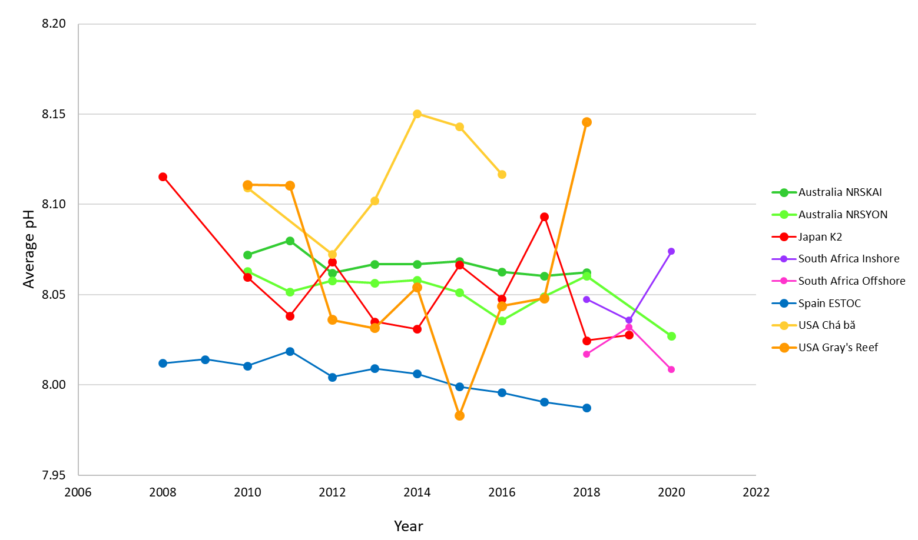

Figure 3. Variations in the annual average pH values from a suite of representative global sampling stations. Australia NRSKAI – Kangaroo Island National Reference Station (data from 2010–2020); Australia NRSYON – Yongala National Reference Station (data from 2010–2020); Japan K2 – subarctic western North Pacific Station K2 (data from 2008–2019); South Africa Inshore – Eastern Cape coastal station (data from 2018–2020); South Africa Offshore – Eastern Cape ocean station (data from 2018–2020); Spain ESTOC – European Station for Time-series in the Ocean, Canary Islands (data from 2008–2019); USA Chá bă – Pacific West Coast station (data from 2010–2016); USA Gray’s Reef – Atlantic East Coast station (data from 2010–2018).

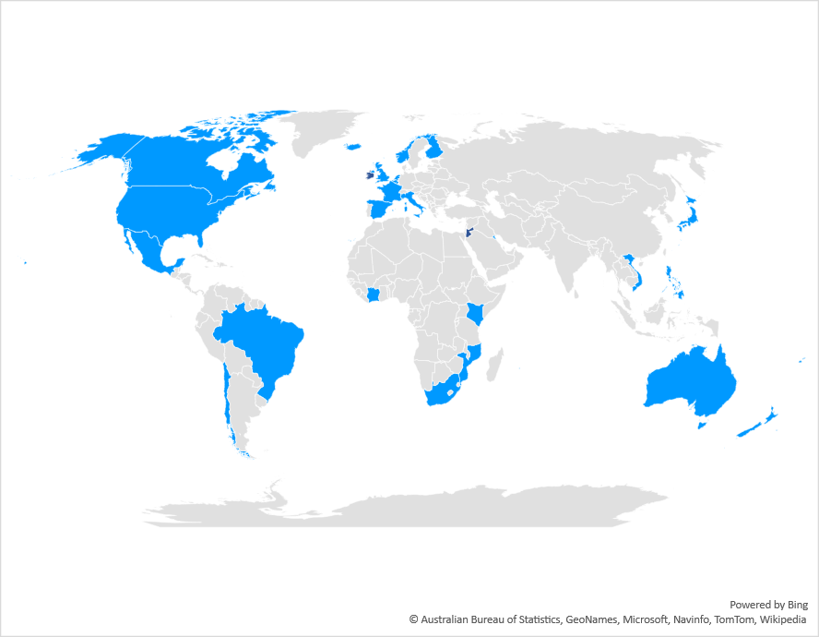

Figure 4. Map illustration surface ocean carbonate chemistry measurement locations received for the 14.3.1 ocean acidification reporting. Blue – countries whose data was reported in accordance with the SDG 14.3.1 Indicator Methodology; dark grey – countries reporting ocean acidification observation data not collected in accordance with the SDG 14.3.1 Indicator Methodology.

The methodology for SDG Indicator 14.3.1 and the associated data and metadata files for data collection are being disseminated and introduced to researchers and data managers during workshops and capacity building trainings. Several in-person or virtual capacity workshops were conducted, e.g. with the North East Atlantic Hub in November 2020, in-person workshops at the IAEA in March 2020, at the Regional Education and Research Center on Oceanography for West Asia (RCOWA) in Teheran, Islamic Republic of Iran, in June 2019 and at INVEMAR, Colombia, in October 2019. In an effort to increase capacity development efforts, the IOC Secretariat is developing an online course on ocean acidification for the Ocean Teacher Global Academy (OTGA) platform, which will include a module on the SDG 14.3.1 Indicator Methodology and how to apply it.

The IOC Secretariat, although acknowledging continued financial support by Germany, will require additional funds to further develop, improve and maintain the 14.3.1 data portal, to build the capacity of Member States to successfully implement the methodology for SDG 14.3.1 Indicator and to ensure IOC’s leadership in the field of ocean acidification research and observation. The expected portal improvements and increased capacity development by experts and Member States will allow the IOC Secretariat to request that the SDG 14.3.1 indicator be classified as Tier I (indicator conceptually clear, with internationally agreed methodology and data regularly collected for at least 50% of countries) in 2022.

**Progress with the development of methodologies benefiting from IOC technical support**(Indicators 14.1.1 and 14.2.1)

***Indicator 14.1.1****: Index of coastal eutrophication and floating plastic debris density*

The IOC is identified as a technical advisory agency to support the work to develop the Index for Coastal Eutrophication Potential (ICEP) as the indicator for [Target 14.1](https://sdgs.un.org/goals/goal14) on nutrient pollution of coastal marine ecosystems.

The development of the ICEP to the next tier is carried out under the coordination of the IOC for UNEP, which is the custodian agency for Indicator 14.1.1. Without this work, it will not be possible to develop ICEP for global application for national reporting on SDG 14. A workshop was held in December 2017 to define the work required to fully develop ICEP. However, the substantial work is not possible to fund within the exiting IOC budget but has to be funded extra-budgetary.

An Expert Workshop on Marine Pollution Indicators for [SDG Target 14.1](https://unstats.un.org/sdgs/tierIII-indicators/files/Tier3-14-01-01.pdf), held on 12–13 September 2018 at UNESCO Headquarters, Paris, brought together the task force charged to work on the science of marine pollution indicators, data capture and dissemination and to advance the global methodology on eutrophication and plastic debris assessment. A review of existing indicators and methodologies currently used highlighted three main approaches for monitoring coastal eutrophication and marine litter, and four main types of indicators for coastal eutrophication: (i) indicators for the cause of eutrophication (nutrient input and concentrations); (ii) indicators for the direct effects of eutrophication (e.g. Chlorophyll-a concentrations, biomass growth, water clarity/turbidity); (iii) indicators for the indirect effects of eutrophication (e.g. dissolved oxygen levels) and; (iv) modelled indicators of the potential for coastal eutrophication (the Index of Coastal Eutrophication Potential (ICEP)).

Combining information about land-based nutrient loading with information about the ratio of land-derived nutrients (ICEP) would make it possible to assess the risk of problems such as coastal hypoxia/anoxia, toxic blooms etc. Using ICEP as an indicator of coastal eutrophication would also make it possible to use nutrient loading models to fill gaps in data spatially (e.g. by estimating ICEP for LMEs where no nutrient data has been collected) and to explore future scenarios and potential nutrient mitigation measures. This would allow for better and more complete regional and global overviews than are currently possible and thus better and more informative reporting under Indicator 14.1.1.

IOC UNESCO and its N-CIRP Group of Experts have in 2020 produced a video available at YouTube (<https://www.youtube.com/watch?v=qW2nV2bsyCs&feature=youtu.be>) to communicate about ICEP and what it can deliver as an SDG indicator 14.1.1.

The development of the ICEP is on hold as funding has not been identified to support the implementation of the index. Unless funding is identified, IOC-UNESCO will not be in a position to develop ICEP for global application for national reporting on SDG 14.

***Indicator 14.2.1****: Proportion of national exclusive economic zones managed using ecosystem-based approaches*

Annual refinements of indicators are included in the indicator framework as they occur. In line with the mandate of the group, the IAEG-SDGs proposed 36 major changes to the framework in the form of replacements, revisions, additions and deletions as part of the 2020 Comprehensive Review, which were approved by the [Statistical Commission at its 51st session](https://unstats.un.org/unsd/statcom/51st-session/) held in March 2020.

With regards to Indicator 14.2.1, the indicator was changed to: *Number of countries using ecosystem-based approaches to managing marine areas.*

UNEP is the custodian agency of this indicator and works in close collaboration with its Regional Seas Conventions and IOC-UNESCO, the technical support agency for this Indicator.

The development of the methodology for the SDG 14.2.1 Indicator started with a review of existing indicators and methodologies currently used by Regional Seas Programmes and other key intergovernmental, international and regional bodies that provide for a number of existing indicators for integrated management and planning strategies for socio-ecological systems. The methodology also includes indicators based on the implementation status of marine-area based, integrated planning and management approaches, such as marine spatial planning or integrated coastal zone management. This indicator is currently in Tier II status.

Contributing to these methodological developments, IOC-UNESCO and the European Commission launched in 2017 a "[Joint Roadmap to accelerate Maritime/Marine Spatial Planning (MSP) processes worldwide](http://www.unesco.org/new/fileadmin/MULTIMEDIA/HQ/SC/pdf/Joint_Roadmap_MSP_v5.pdf)". This initiative contributes to sketching out a vision and a role for ecosystem-based MSP in implementing 2030 Agenda for Sustainable Development and, in particular, the dedicated SDG 14, in a comprehensive, consistent and holistic way, both within the European Union and beyond at the international level with the objective to triple the area of territorial waters benefiting from marine spatial planning by 2030. In 2020, IOC conducted a survey with its Member States to document progress in the national implementation of MSP. The results are available at <http://www.mspglobal2030.org/msp-roadmap/msp-around-the-world/>.

**Intergovernmental Oceanographic Commission (IOC)**

United Nations Educational, Scientific and Cultural Organization

7 Place de Fontenoy

75 732 Paris Cedex 07, France

Tel.: +33 1 45 68 10 10

<http://ioc.unesco.org>