Summary

This document presents an overview of the financial situation of the IOC Special Account at year-end 2020, including the proposed adjustments to 2020–2021 budgetary allocations and the updated forecast for year 2021. Financial Report for the period 1 January 2020 to 31 December 2020 is provided in Appendix I (in English only).
Decision proposed: After a brief introduction and discussion in plenary under item 3.2, the Assembly is invited to take note of this report and consider the draft decision referenced as Dec. IOC-31/3.2 in the Provisional Action Paper (document IOC-31/AP Rev.). The document will then be subject to an in-depth review by the sessional statutory open-ended Financial Committee and the decision reflected in the Draft Resolution that the Financial Committee will be submitting to the Assembly for adoption under item 4.4 in accordance with paragraph 15 of the Draft Revised Guidelines for the Preparation and Consideration of Draft Resolutions (IOC/INF-1315).

OVERVIEW OF THE FINANCIAL SITUATION OF THE IOC SPECIAL ACCOUNT
as at year-end 2020

- In accordance with the Financial Report for the period 1 January 2020 to 31 December 2020 presented in appendix to this document, the total income amounted to US$ 3,049,509.33 (comparative 31.12.2018 – $ 1,528,151.20), while total expenditure for the same period amounted to $ 1,652,925.42 (comparative 31.12.2018 – $ 1,633,158.78).
- At the end of year 2019, only $ 25,279.00 were firmly committed by donors.
- Contributions from the three historically largest donors to the Special Account – Australia, China and Norway – are traditionally paid in the second half of the year (approximatively 66% of total contributions). As a result, those contributions are mostly planned to be used in the following year.
- The outlook for 2021 is considerably more positive due to a new 2-year commitment by the Norwegian Agency for Development Cooperation (NORAD) in the amount of NOK 5 million per year to the General Account (191IOC9000) and NOK 5 million per year to the sub-account dedicated to the UN Decade of Ocean Science for Sustainable Development (193UND2040).
- At year-end 2020, the Fund balance amounted to $ 4,950,766.90 (comparative 31.12.2018 – $ 3,540,044.10), with the following breakdown:
General reserves: | $ 3,645,899.98 | comparative 31.12.2018: | $ 2,736,089.59
JCOMMOPS: | $ 159,473.54 | comparative 31.12.2018: | $ 219,685.27
IOTWMS ICG Secretariat: | $ 542,971.25 | comparative 31.12.2018: | $ 584,269.24
UN Decade of Ocean Science for Sustainable Development: | $ 602,422.13 | -- | --

- In accordance with Articles 8.2 and 8.3 of the Financial Regulations for the IOC Special Account, the above-mentioned balance is carried over to year 2021 for the implementation of the budget approved by the Assembly. In this context, the proposal for a revision of budgetary allocations is submitted for the Assembly approval in Table 1.
- Table 2 provides an updated forecast (the initial forecast for the period was presented to the Executive Council at its 53rd session in document IOC/EC-53/3.1(2)).

Table 1. Proposed revision of budgetary appropriations for the IOC Special Account 2020-2021

2020-2021 budget
Function/Activity title | Budget code | Approved | Proposed adjustment | Revised
 |  | $ | $ | $
IOC Function A: Foster ocean research to strengthen knowledge of ocean and coastal processes and human impacts upon them
 | 191ORS2040 | 500,000 | -109,000 | 391,000
WCRP | 191ORS2040.1 | 100,000 | -75,000 | 25,000
Ocean Carbon & Acidification | 191ORS2040.2 | 250,000 |  | 250,000
Impact of climate change on ocean and coastal ecosystems | 191ORS2040.3 | 150,000 | -34,000 | 116,000
IOC Function B: Maintain, strengthen and integrate global ocean observing, data and information systems
 | 191OSD2040 | 1,500,000 | -687,000 | 813,000
GOOS Work Plan - GOOS design, dev't & support | 191OSD2040.1 | 550,000 | -300,000 | 250,000
Perth Programme Office | 191OSD2040.2 | 400,000 | -37,000 | 363,000
IIOE-2 (developing capacities for sustained observations) | 191OSD2040.3 | 250,000 | -200,000 | 50,000
JCOMM Observations - Obs. systems intergration & delivery | 191OSD2040.4 | 200,000 | -150,000 | 50,000
IODE & OBIS core systems | 191OSD2040.5 | 100,000 |  | 100,000
JCOMMOPS - OceanOPS | 193JCS2040 | 450,000 | -100,000 | 350,000
IOC Function C: Develop early warning systems and preparedness to mitigate the risks of tsunamis and ocean-related hazards
 | 191EWS2040 | 1,250,000 | -530,800 | 719,200
ICG NEAMTWS | 191EWS2040.1 | 100,000 | -50,000 | 50,000
ICG PTWS | 191EWS2040.2 | 150,000 |  | 150,000
ICG CARIBE-EWS | 191EWS2040.3 | 250,000 | -100,000 | 150,000
TOWs & inter-regional coordination | 191EWS2040.4 | 100,000 | -50,000 | 50,000
JTIC - IOTIC | 191EWS2040.5 | 100,000 | -75,000 | 25,000
GLOSS - tsunami | 191EWS2040.6 | 250,000 | -100,000 | 150,000
JCOMM Services - Ocean forecast systms & applications | 191EWS2040.7 | 200,000 | -150,000 | 50,000
HAB Research and Monitoring | 191EWS2040.8 | 100,000 | -5,800 | 94,200
IOTWS ICG Secretariat | 193EWS2040 | 850,000 | -100,000 | 750,000
IOC Function D: Support assessment and information to improve the science-policy interface
 | 191AIP2040 | 550,000 | -254,500 | 295,500
SDG Follow up & WOA | 191AIP2040.1 | 150,000 | -59,500 | 90,500
GEBCO | 191AIP2040.2 | 50,000 | -20,000 | 30,000
Science for reducing nutrient enrichment | 191AIP2040.3 | 100,000 | -75,000 | 25,000
IODE & OBIS products & services | 191AIP2040.4 | 100,000 |  | 100,000
Climate change adaptation in coastal zones | 191AIP2040.5 | 150,000 | -100,000 | 50,000
IOC Function E: Enhance ocean governance through a shared knowledge base and improved regional cooperation
 | 191RCG2040 | 1,300,000 | -467,800 | 832,200
IOC Governance (representation & intersessional coordination) | 191RCG2040.1 | 150,000 | -20,000 | 130,000
IOCARIBE (office support & intersessional coordination) | 191RCG2040.2 | 100,000 | -42,400 | 57,600
IOCAFRICA (office support & intersessional coordination) | 191RCG2040.3 | 100,000 | -42,400 | 57,600
WESTPAC (office support & intersessional coordination) | 191RCG2040.4 | 250,000 | -100,000 | 150,000
IOCINDIO (intersessional coordination) | 191RCG2040.5 | 50,000 | -38,000 | 12,000
UN partnerships, global governance, policy and outreach | 191RCG2040.6 | 400,000 | -85,000 | 315,000
ICAM & Marine Spatial Planning | 191RCG2040.7 | 250,000 | -140,000 | 110,000
UN Decade of Ocean Science for Sustainable Development | 193UND2040 | 500,000 | 250,000 | 750,000

Function/Activity title | Budget code | Approved | Proposed adjustment | Revised
 |  | $ | $ | $
IOC Function F: Develop the institutional capacity in all of the functions above, as a cross-cutting function
 | 191ICD2040 | 1,065,000 | -50,900 | 1,014,100
IOC Capacity development & transfer of marine technology & GOSR & Ocean Literacy | 191ICD2040.1 | 400,000 |  | 400,000
IOCAFRICA Capacity development workplans | 191ICD2040.2 | 150,000 |  | 150,000
IOCARIBE Capacity development workplans | 191ICD2040.3 | 100,000 |  | 100,000
WESTPAC Capacity development workplans | 191ICD2040.4 | 250,000 | -35,900 | 214,100
IOCINDIO Capacity development workplans | 191ICD2040.5 | 65,000 | -15,000 | 50,000
IODE & OBIS Training and Education | 191ICD2040.6 | 100,000 |  | 100,000
TOTAL |  | 7,965,000 | -2,050,000 | 5,915,000

Table 2. Forecast 2021, updated as at 31 December 2020

IOC Special Account
Forecast 2021
(expressed in US Dollars)
2021
Opening balance: | 4,950,767
Working Capital Fund | 1,000,000
Opening balance available: | 3,950,767
Signed commitments: | 1,540,155
Norway | 1,164,551
Australia | 22,848
United Kingdom | 12,270
VLIZ | 24,540
RevOcean | 165,000
EthicOcean | 3,706
Societe des Explorations de Monaco | 85,890
ETT Spa | 61,350
Sub-total Funds available: | 5,490,922
Planned Expenditure | 4,262,000
Closing balance /Funding gap: | 1,228,922

Appendix I: Financial Report for the Intergovernmental Oceanographic Commission

for the period 1 January 2020 to 31 December 2020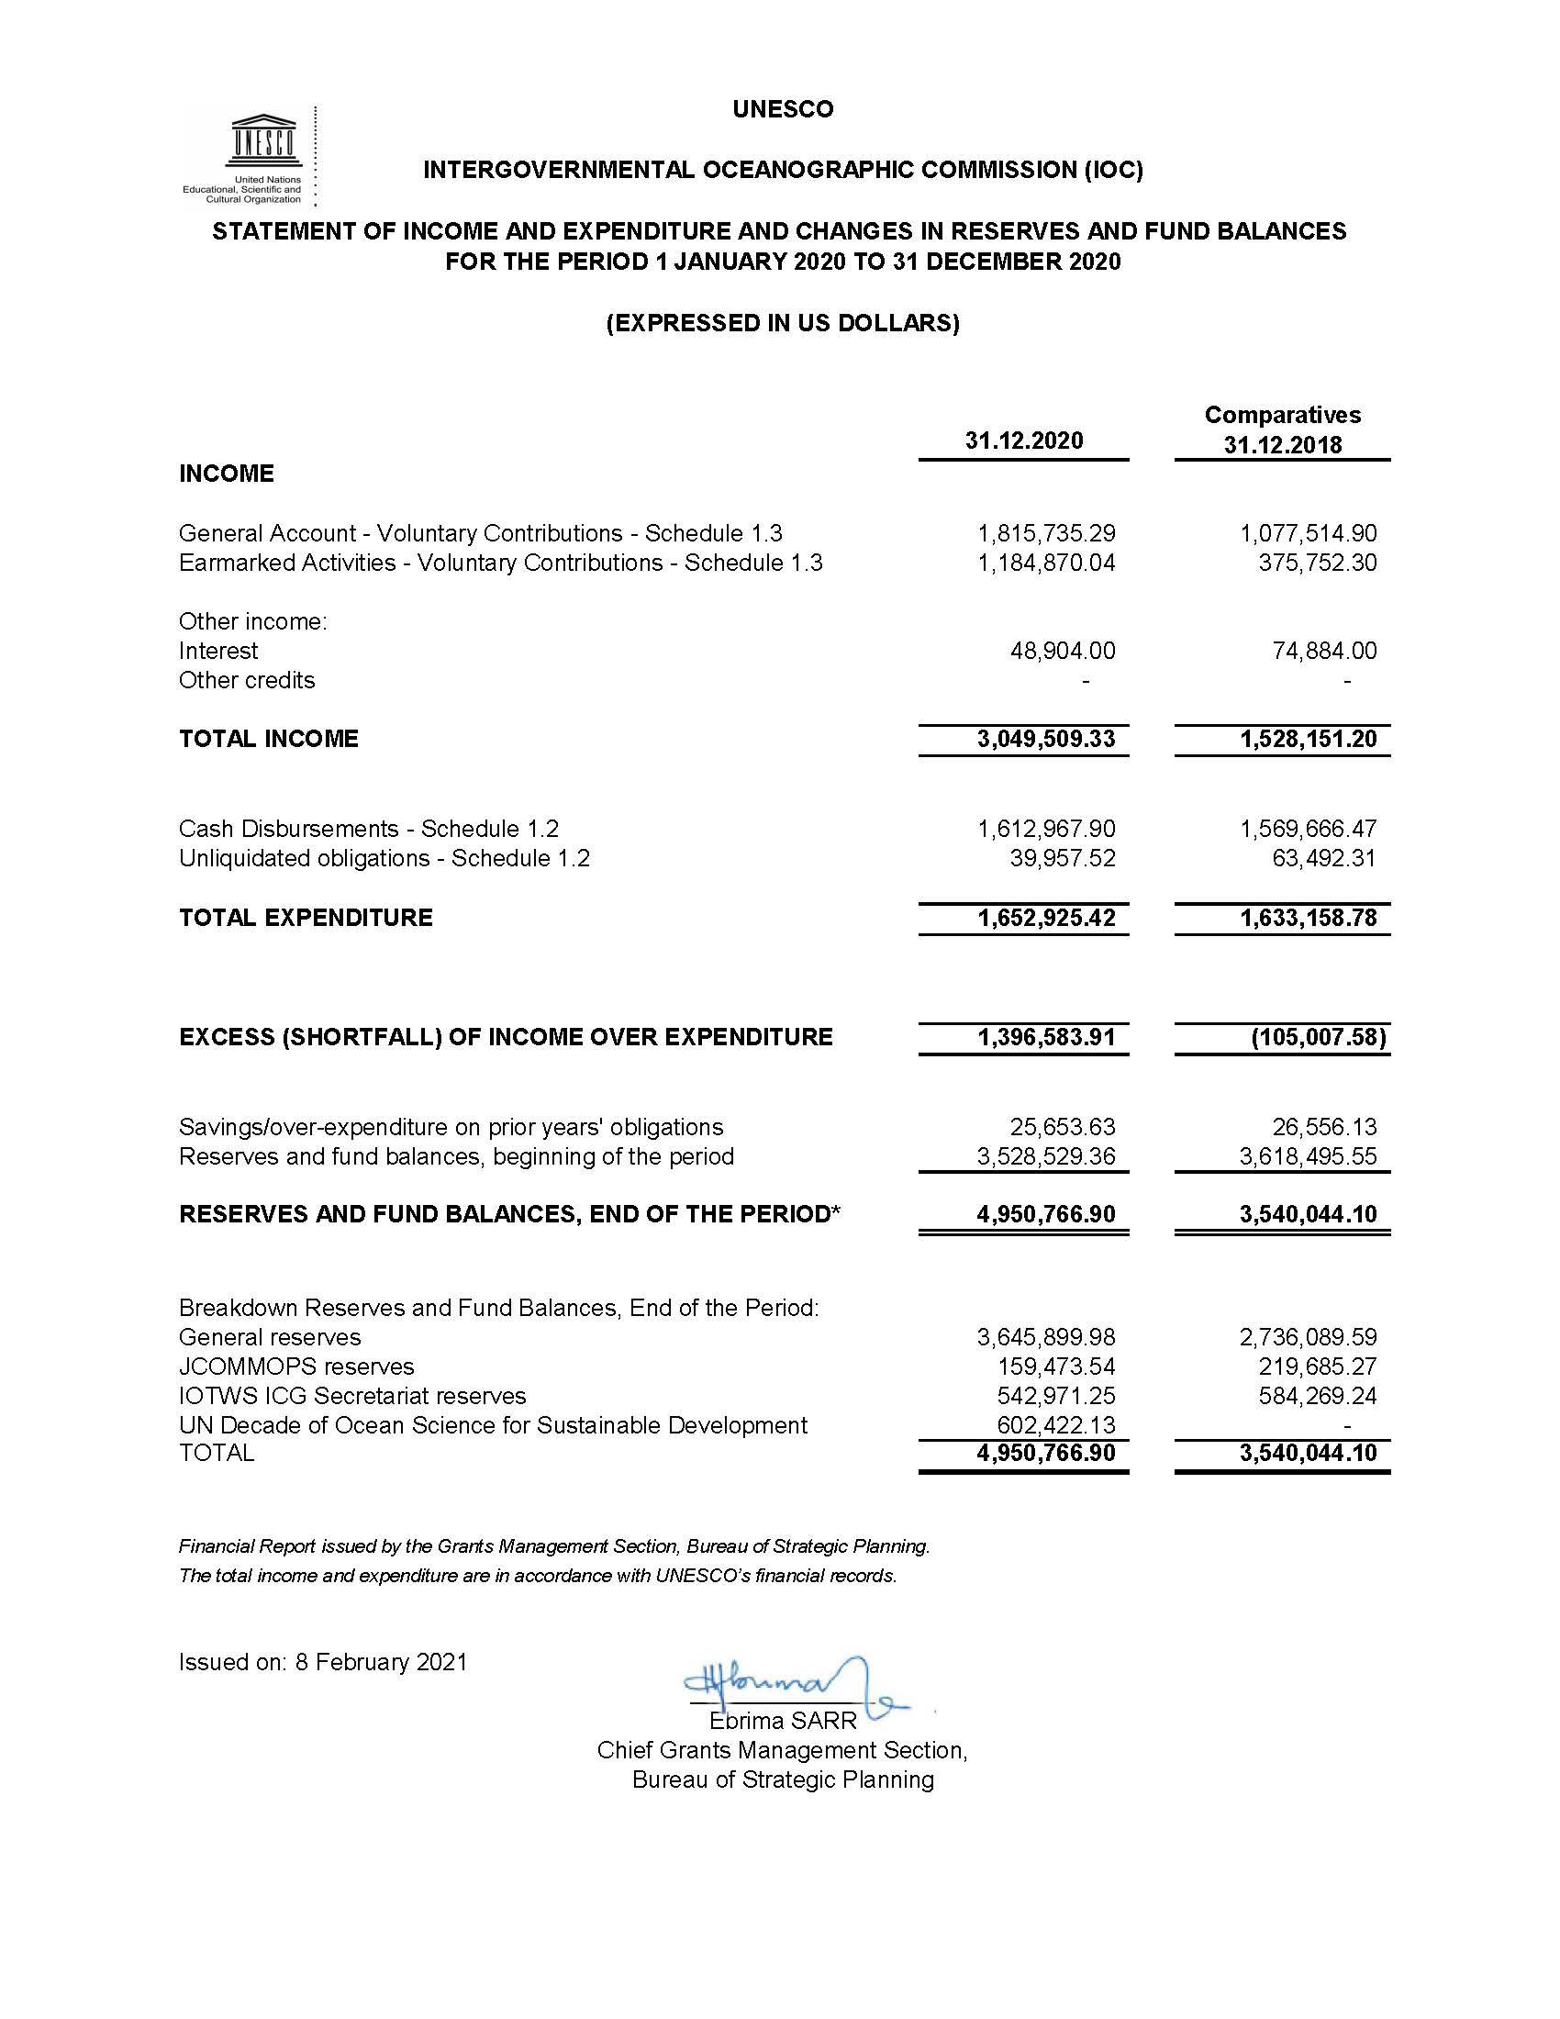

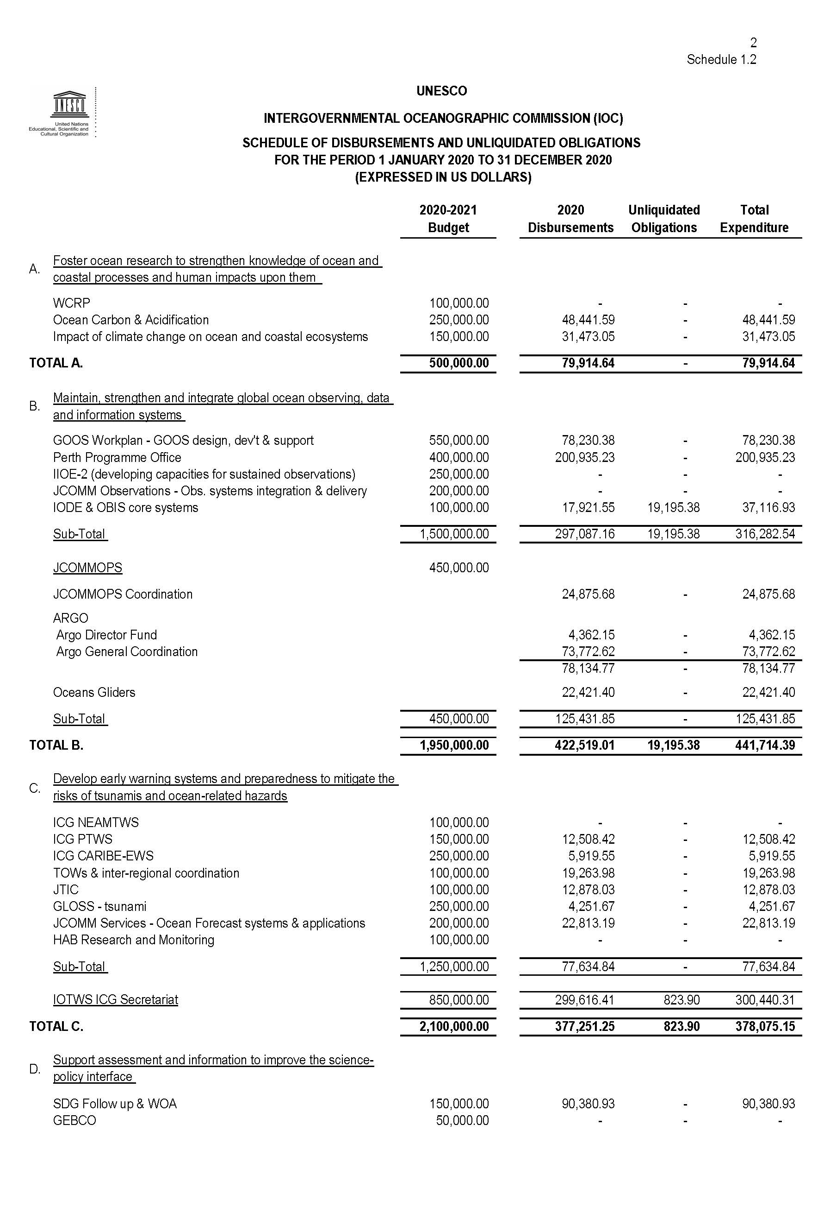

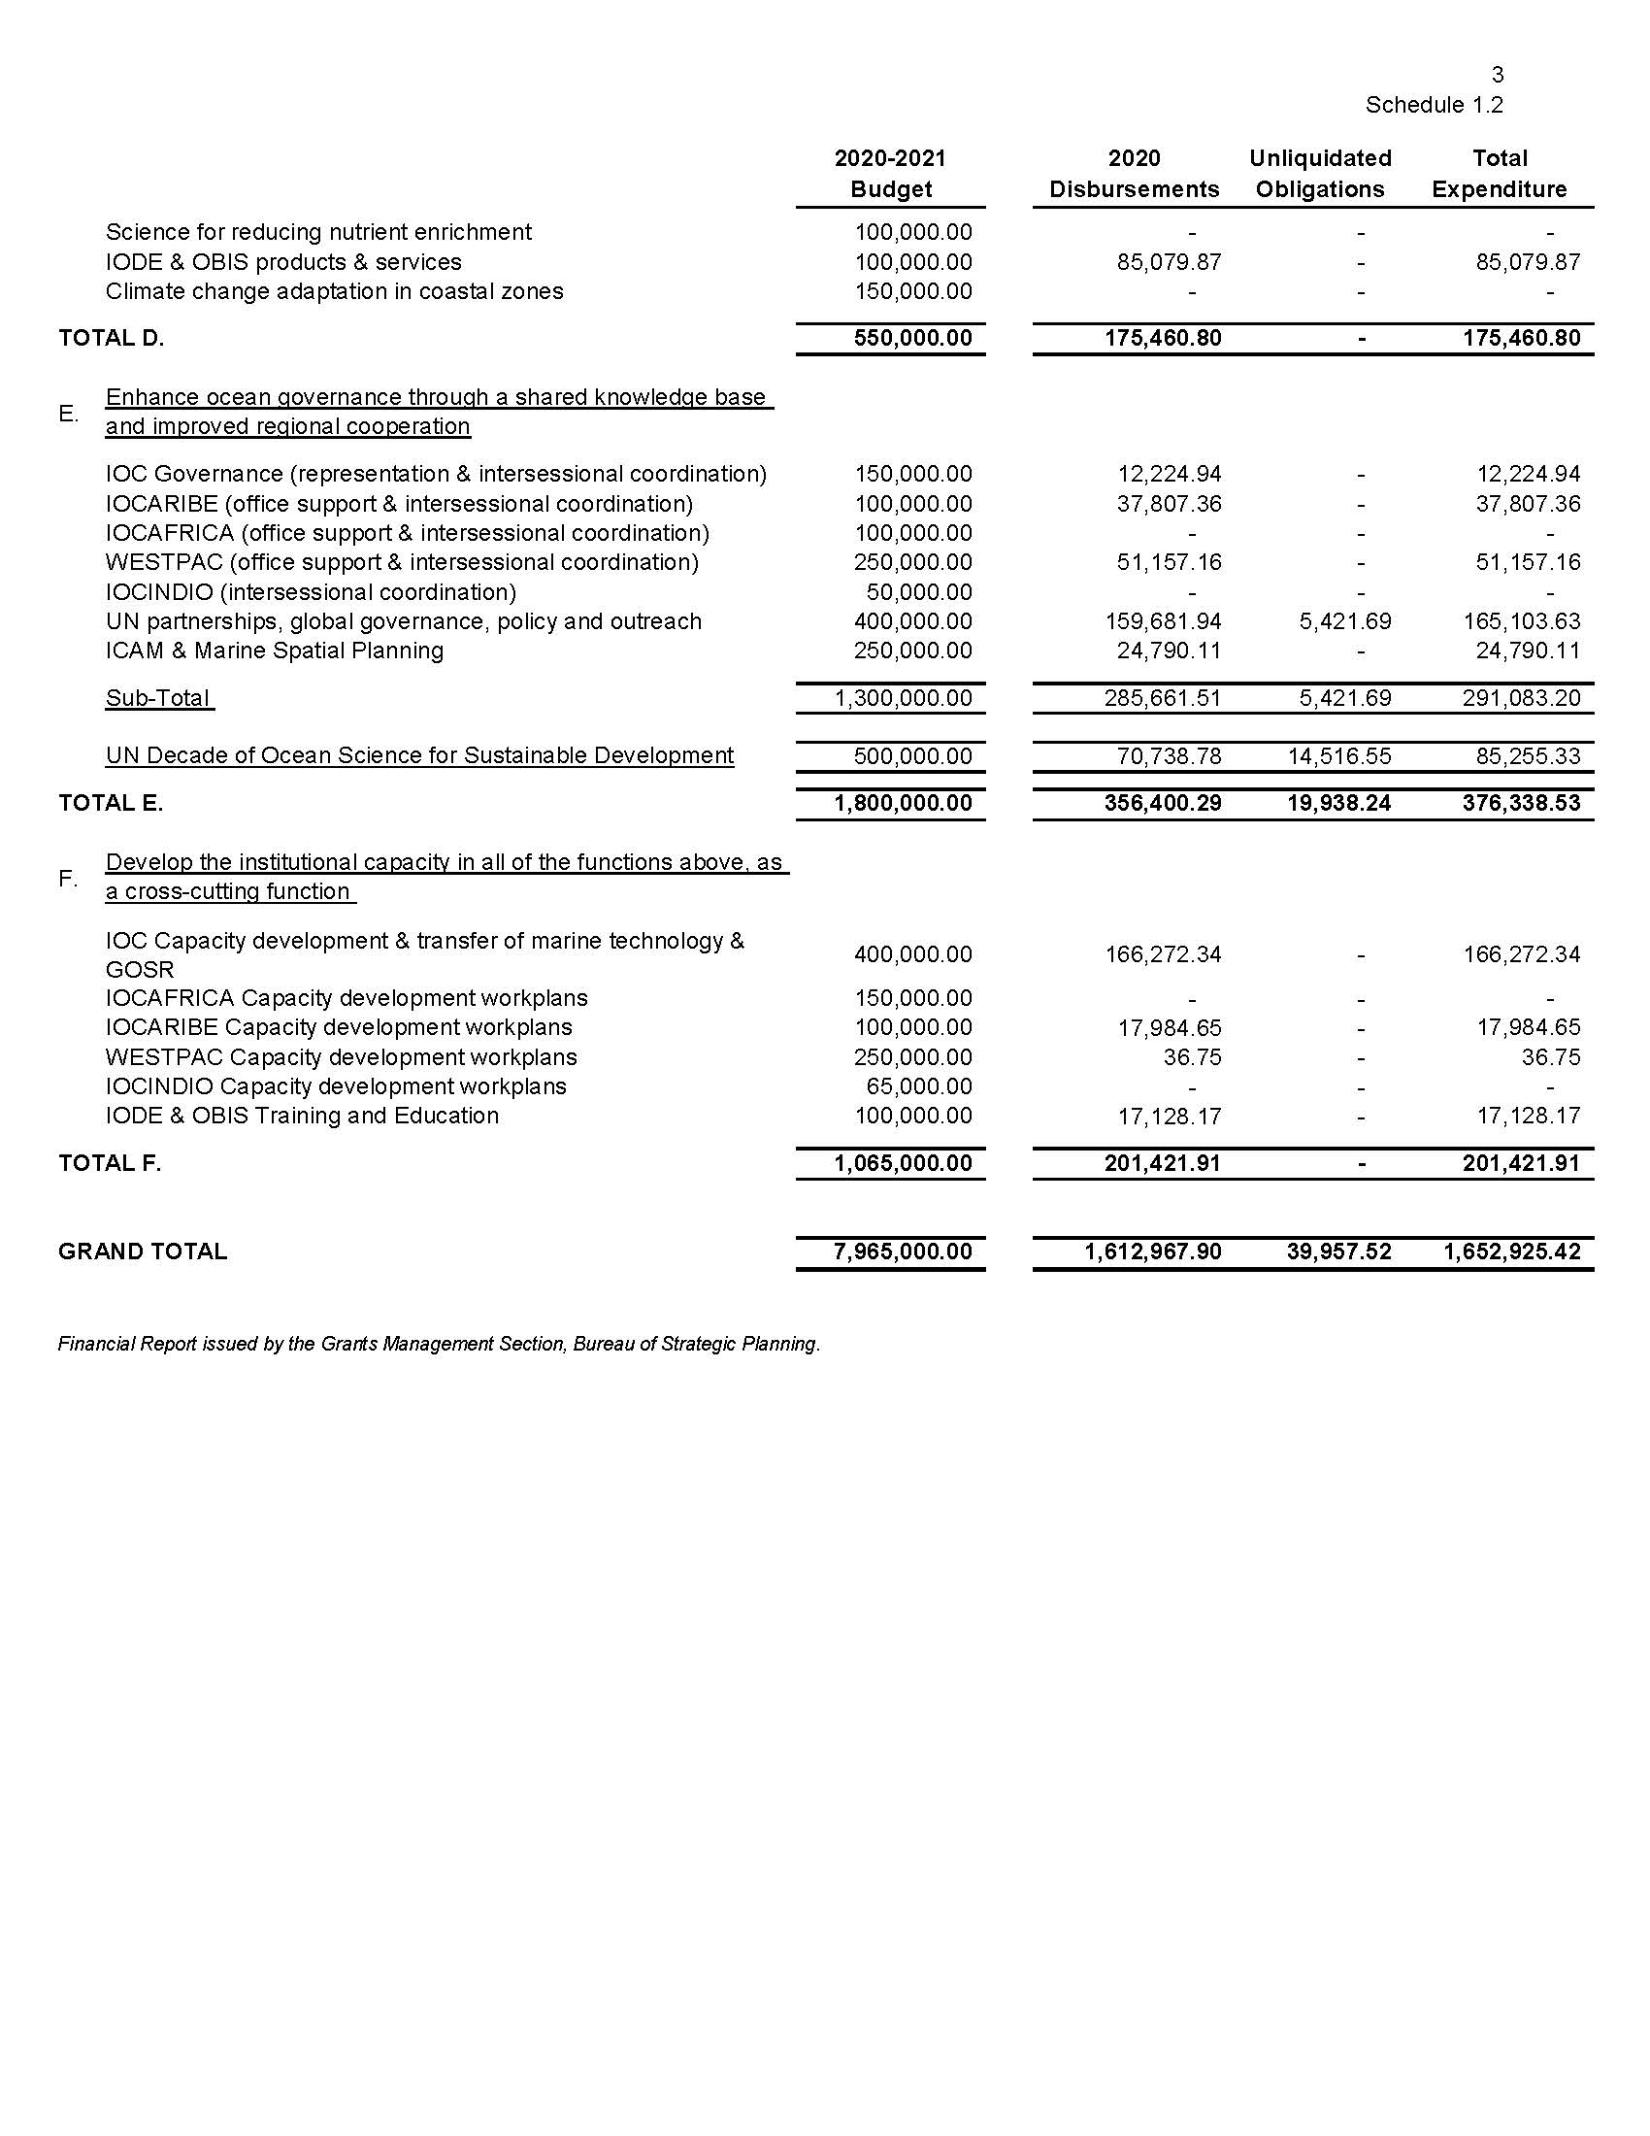

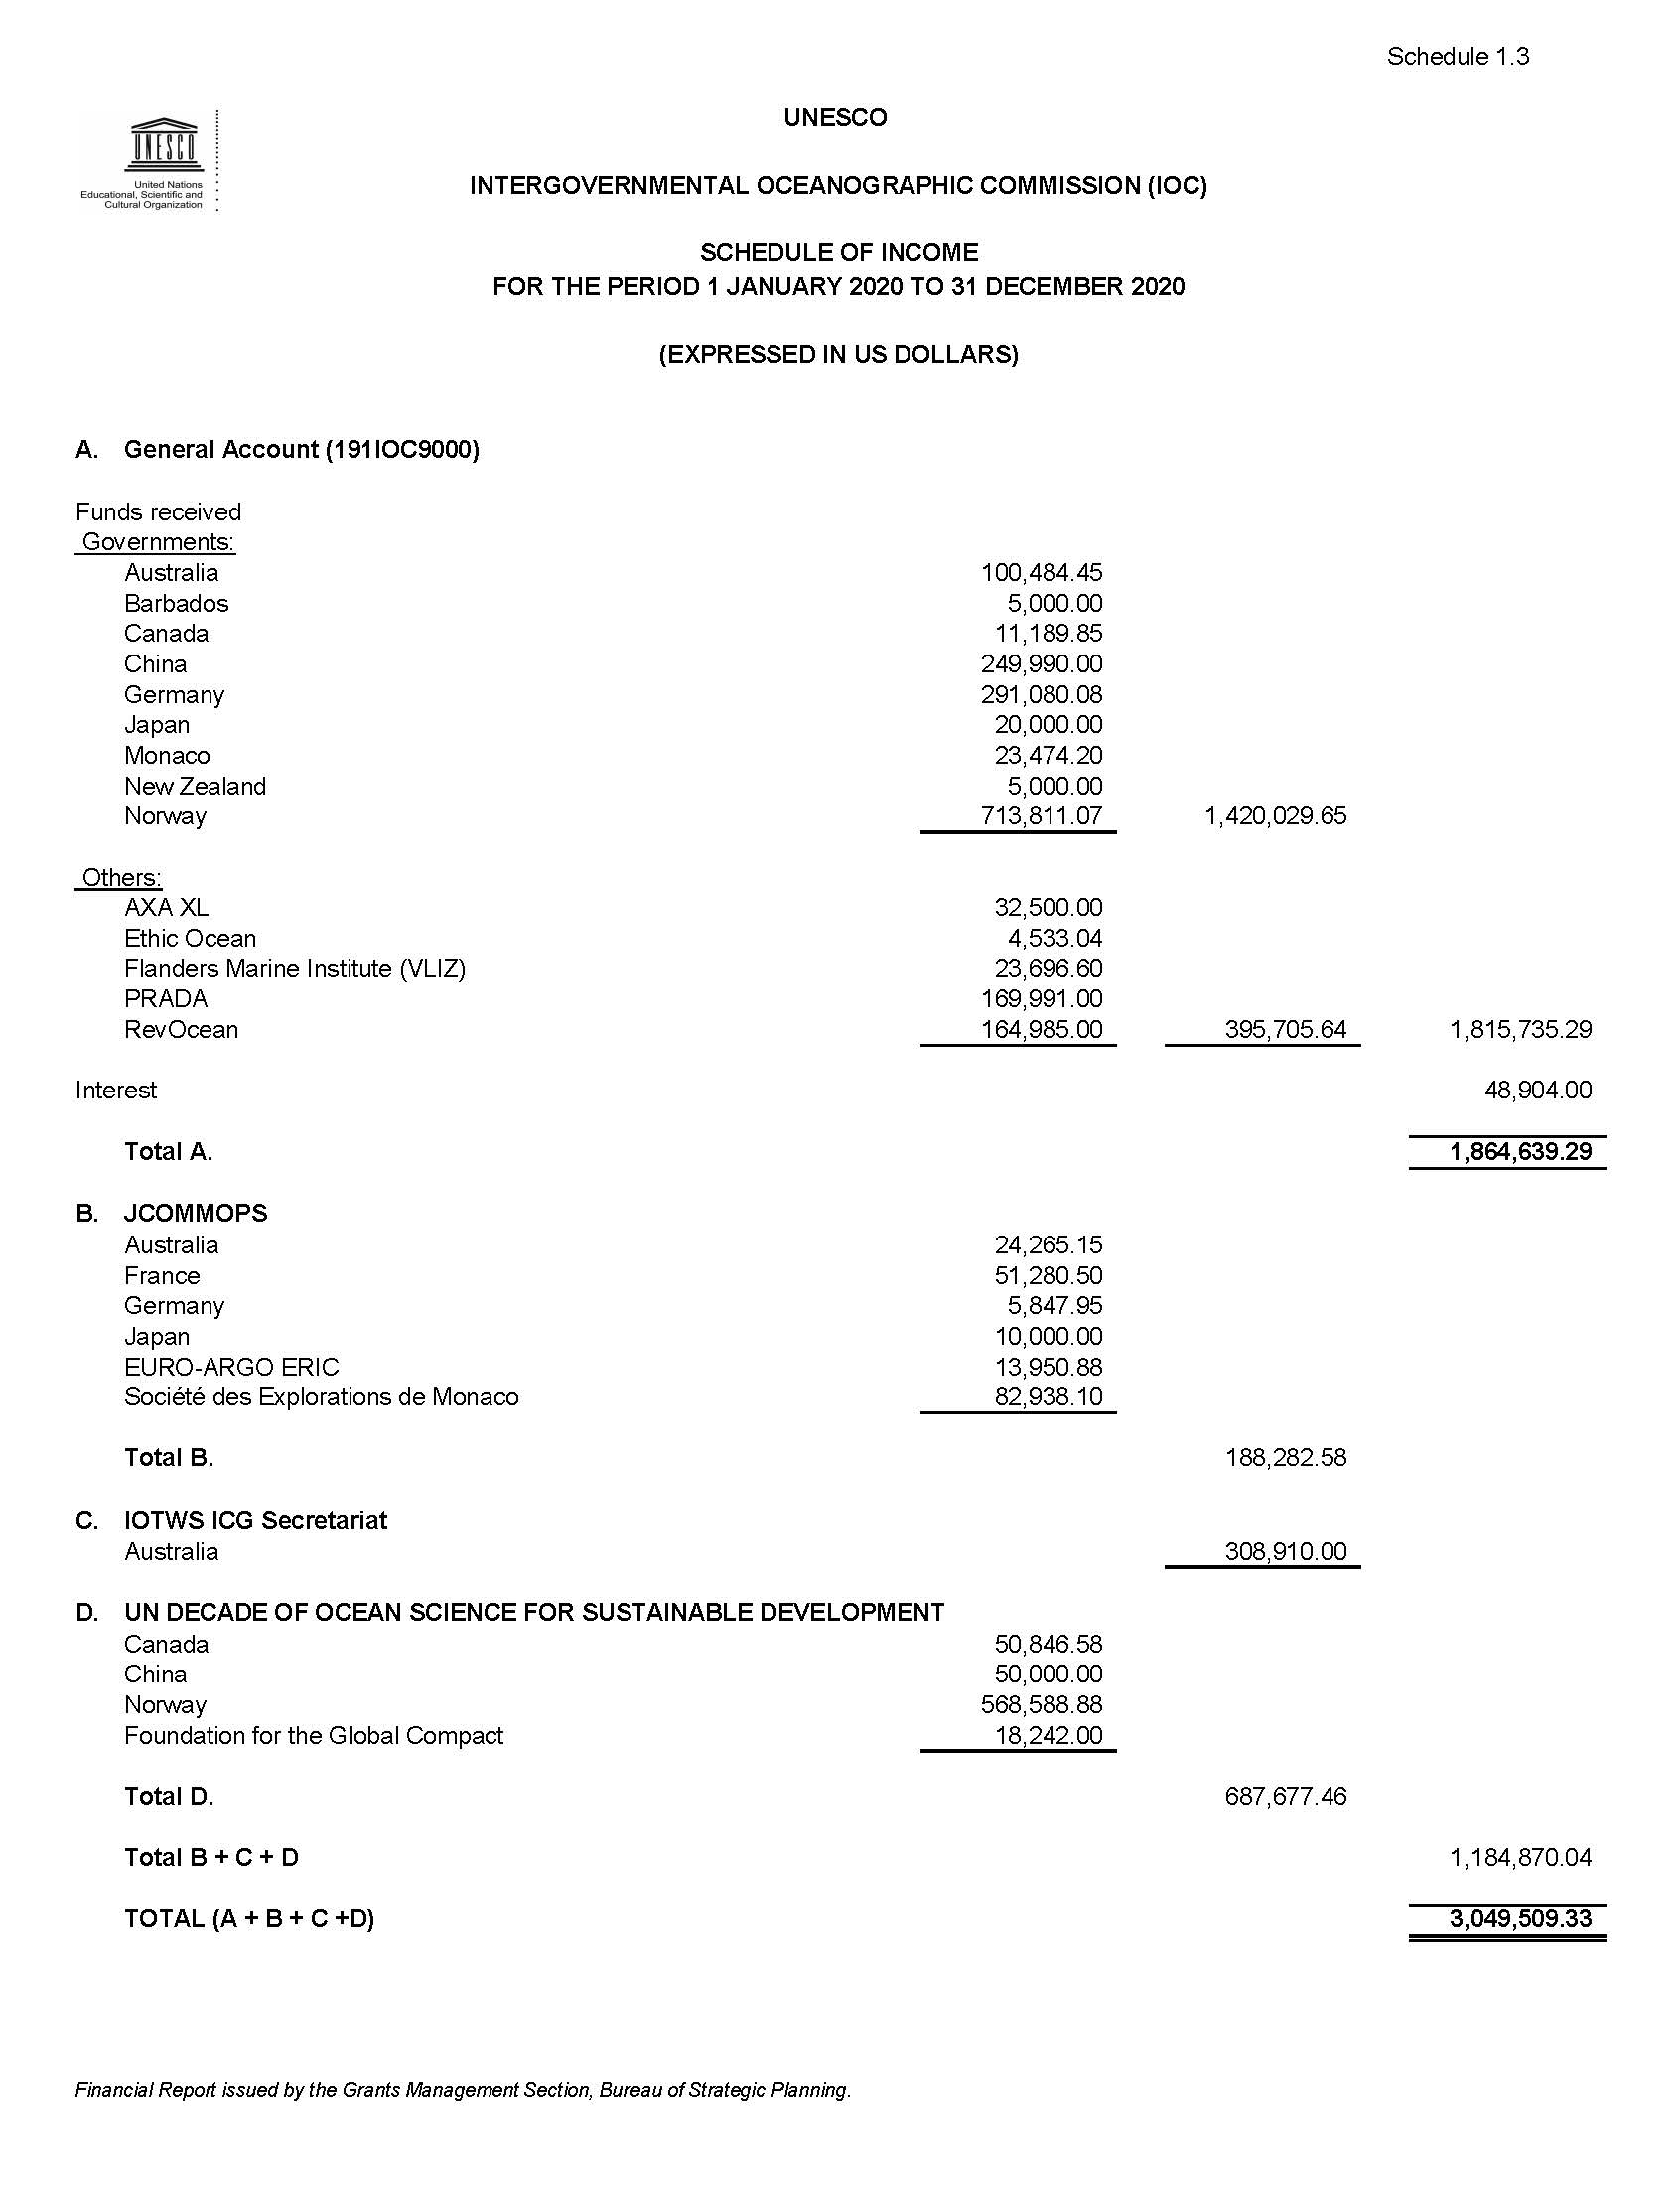

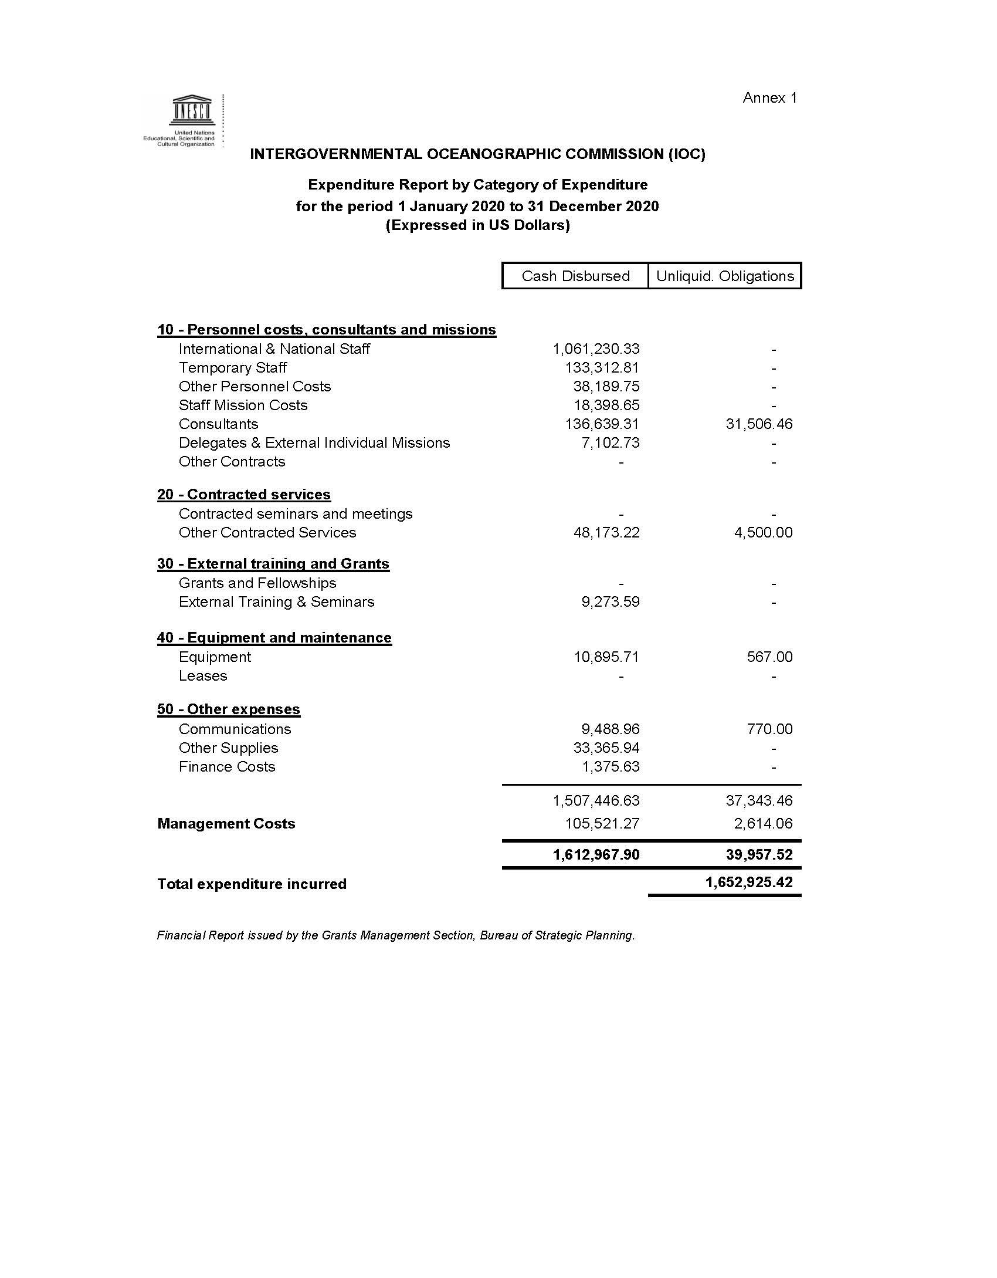

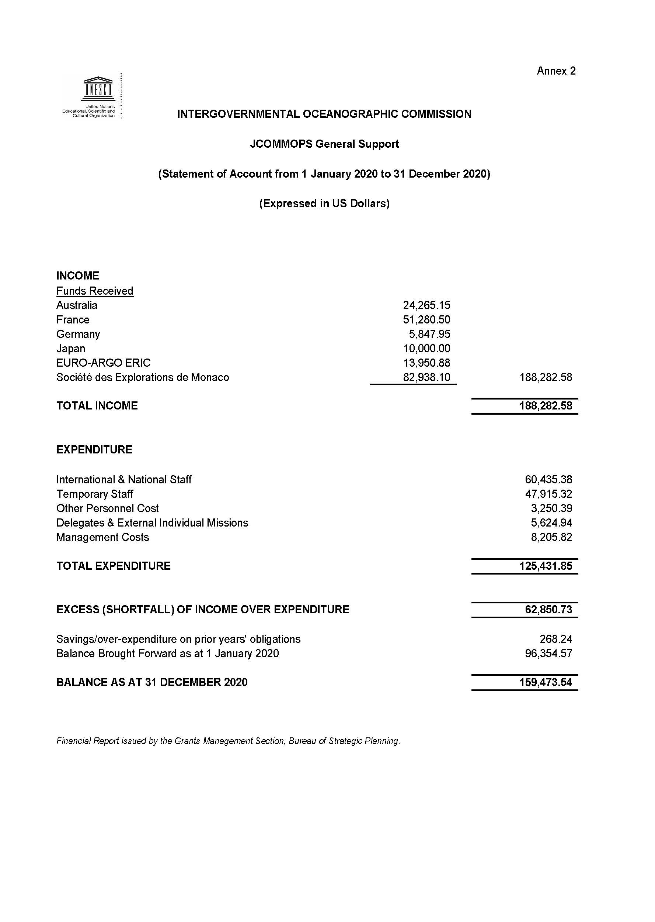

Proposed adjustments are based on observed capacity to mobilise the funds and expenditure trends. Please note changes to activity titles in italics.

