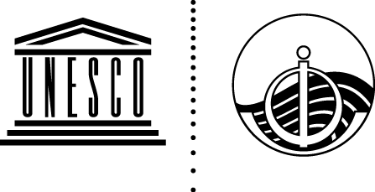
INTERGOVERNMENTAL OCEANOGRAPHIC COMMISSION
(of UNESCO)

Fifty-third Session of the Executive Council
UNESCO, Paris, 3–9 February 2021 (online)

Template for Submission of Written Records
to the IOC Executive Council Summary Report
Member States and partner organizations that wish to provide a succinct written record of a particularly important aspect of their plenary intervention may do so in one of the four working languages of the Commission. Such statements will be annexed to the EC report in their original language. Statements should be sent using this template by email to the IOC Secretariat (iocgovbody@unesco.org).
We recommend that statements are sent as early as possible in advance of the discussion to help interpreters in their work.

Name of Delegation :
Agenda Item :
Date and Time of Intervention :
Name of Delegation Point of contact for this statement:
Title Agenda Item :
Statement:

