Information

This document was prepared by the IOC Secretariat. It aims to provide guidance to institutional partners wishing to play a role in supporting the Decade Coordination Unit, to be hosted by IOC starting in 2021, by assuming decentralized coordination functions to facilitate the implementation of the Decade. The document aims to further clarify relevant parts of the Decade Implementation Plan related to decentralized coordination, specifically the role of Decade Collaborative Centres and Decade Implementing Partners. The Decade Implementation Plan was reviewed by the 75th Session of the UNGA and welcomed through resolution A/75/239. These guidelines will be reviewed by UN-Oceans, ensuring a UN-wide common approach in formalizing partnership with institutions in the framework of the Decade. This document will be presented to the 53rd session of the IOC Council (February 2021) as an information document.

**Decade Collaborative Centres and Decade Implementing Partners**

**OPERATIONAL GUIDANCE NOTE**

**December 2020**

**TABLE OF CONTENTS**

page

1. INTRODUCTION 3

A. PURPOSE OF OPERATIONAL GUIDANCE NOTE 3

B. THE OCEAN DECADE 3

[C. OVERVIEW OF OCEAN DECADE GOVERNANCE  
AND COORDINATION STRUCTURES 4](#_Toc62204724)

[2. DETAILED OPERATIONAL GUIDANCE   
FOR DECADE COLLABORATIVE CENTRES 7](#_Toc62204725)

A. ROLE OF DECADE COLLABORATIVE CENTRES 7

[B. ESTABLISHMENT AND OPERATION   
OF DECADE COLLABORATIVE CENTRES 9](#_Toc62204727)

[C. USE OF OCEAN DECADE LOGO BY DECADE  
COLLABORATIVE CENTRE 10](#_Toc62204728)

[3. DETAILED OPERATIONAL GUIDANCE   
FOR DECADE IMPLEMENTING PARTNERS 10](#_Toc62204729)

A. ROLE OF DECADE IMPLEMENTING PARTNERS 10

[B. ESTABLISHMENT AND OPERATION   
OF DECADE IMPLEMENTING PARTNERS 12](#_Toc62204731)

[C. USE OF OCEAN DECADE LOGO   
BY DECADE IMPLEMENTING PARTNERS 13](#_Toc62204732)

# INTRODUCTION

# PURPOSE OF OPERATIONAL GUIDANCE NOTE

This Operational Guidance Note has been developed to build on information contained in the Implementation Plan for the United Nations Decade of Ocean Science for Sustainable Development (‘the Ocean Decade’) that was adopted on the 31 December 2020 by the United Nations General Assembly as part of Resolution A/75/239.

It contains detailed information and guidance in relation to the establishment and operation of two forms of decentralized coordination support that could be provided by non-United Nations entities to the implementation of the Decade i.e. Decade Collaborative Centres and Decade Implementing Partners. It provides contextual information on a third form of coordination support that could be provided by United Nations entities or Member States i.e. Decade Coordination Offices, but further guidance on those structures will be provided in a separate document.

This note will form part of a series of documents that are being developed as part of the overall comprehensive partnership strategy to be developed for the Decade.

# THE OCEAN DECADE

The [Ocean Decade Implementation Plan](https://www.oceandecade.org/resource/108/Version-20-of-the-Ocean-Decade-Implementation-Plan-) will guide the operationalisation of the Ocean Decade over the next 10 years. The Plan describes the desired characteristics of the ‘ocean we want’ via a series of seven Decade Outcomes. The Plan provides a non-prescriptive framework for diverse stakeholders to collaborate in the design of Decade Actions and delivery of results that will be organised around a series of Decade Objectives, and implemented to address a series of ten Ocean Decade Challenges, which represent the most pressing and immediate priorities for the Decade (refer Figure 1).

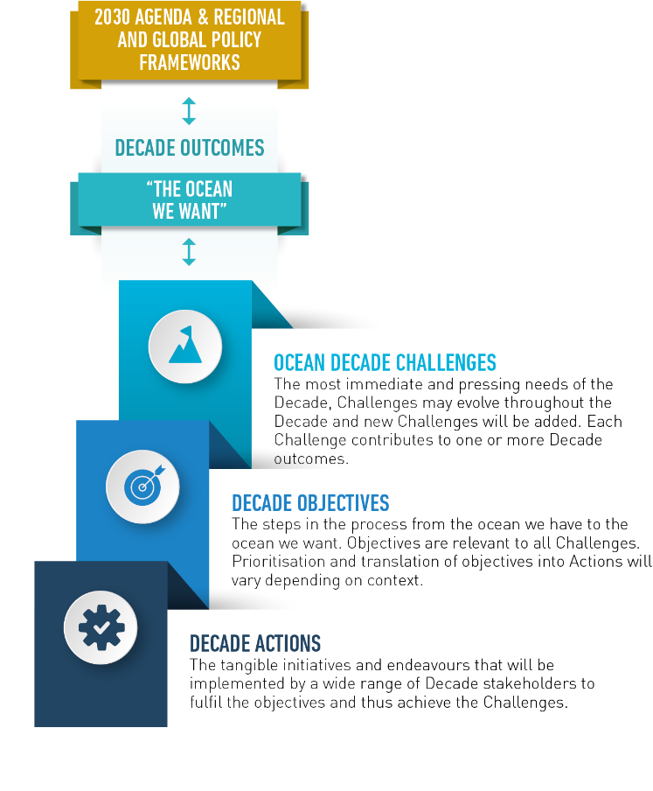

Figure 1: Ocean Decade Action Framework

The Implementation Plan describes the governance and coordination structures of the Decade, including the roles of the Decade Advisory Board, Decade Coordination Unit and decentralized coordination structures (which include Decade Coordination Offices and Decade Collaborative Centres), as well as the way in which stakeholder entities and engagement networks can provide support to specific aspects of the Ocean Decade, i.e. through acting as Decade Implementing Partners.

# OVERVIEW OF OCEAN DECADE GOVERNANCE AND COORDINATION STRUCTURES

The key elements of the formal Ocean Decade governance and coordination structures are shown in Figure 2 below and briefly described in the text underneath.

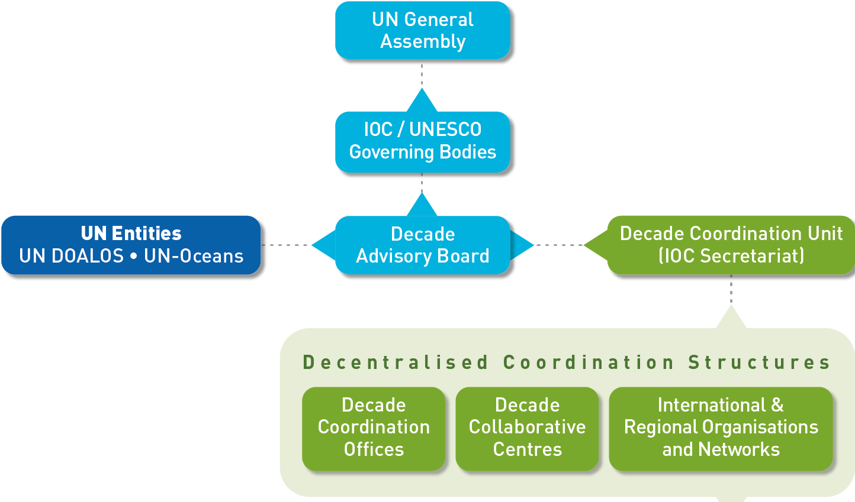

**Decade Collaborative Centres**

**Decade Coordination Offices**

**Decade Implementing Partners**

Figure 2: Ocean Decade Governance and Coordination Structures

The **Decade Advisory Board is a** multi-stakeholder advisory body to the IOC Governing Bodies that will provide strategic advice on Decade implementation.

The **Decade Coordination Unit** is the central coordination unit for the implementation of the Decade that will be housed within the IOC Secretariat. The Decade Coordination Unit will work in close collaboration with the Secretariats of other UN entities and may include seconded staff from UN entities and programmes to ensure a well-coordinated inter-agency approach. In addition, a more decentralized approach may be explored by appointing personnel within UN entity Secretariats to support the coordinating functions of the Decade.

The Decade Coordination Unit will be supported by Decade Coordination Offices which will collaborate closely with the Decade Coordination Unit and play an important role in coordination of the Decade at a decentralized level and with a focus on a specific region or theme (i.e. linked to one or more Ocean Decade Challenge). Initial guidance for the establishment of IOC/UNESCO-based Decade Coordination Offices is provided through [IOC-CL 2785](http://ioc-unesco.org/components/com_oe/oe.php?task=download&id=44336&version=1.0&lang=1&format=1) of 2019. These offices will be located in existing UN or Member State structures or in newly established structures, and staffed with UN employees. Decade Coordination Offices will act as regional or thematic sub-units of the central Decade Coordination Unit and may coordinate Decade Collaborative Centres and Decade Implementing Partners, depending on the geographical and thematic mix of these structures. Specific tasks of these structures will include:

* 1. Coordinate, monitor and report on specific Decade programmes or regional portfolios of actions.
  2. Review requests for endorsement of Decade Actions falling under their mandate and provide recommendations to the Decade Coordination Unit.
  3. Organize and participate in Decade implementation review meetings and other relevant meetings and discussions linked to the Decade implementation.
  4. Promote cooperation with relevant IOC programmes, related projects, other relevant UN entities and stakeholder groups in order to advance the implementation of the Decade.
  5. Raise awareness and visibility of the Decade amongst diverse stakeholder groups and coordinate targeted communications activities in line with branding and messaging guidelines provided by the Decade Coordination Unit.
  6. Seek partnerships and potential voluntary commitments to strengthen implementation and impact of the Decade.

*N.B. the above information on Decade Coordination Offices is provided here for contextual purposes. Decade Coordination Offices are not addressed in detail in this operational guidance note but will be addressed in the overall partnership strategy being developed for the Decade.*

*In addition,*

1. Decade Collaborative Centres, will be proposed by Member States, international or major regional non-UN organizations. They will provide support to the Decade Coordination Unit and to Decade Coordination Offices by catalysing and coordinating Decade Actions at the regional or thematic level.

*N.B. These structures, along with Decade Implementing Partners, are the main focus of this operational guidance note and details of their mandate and role are provided in Section 2.*

1. Decade Implementing Partners will be non-UN regional or international stakeholder organisations that sit outside the formal governance and coordination structures, but that provide targeted support to the Decade Coordination Unit and decentralized coordination structures – including both Decade Coordination Offices and Decade Collaborative Centres - in relation to different facets of Decade implementation.

*N.B. These structures, along with Decade Implementing Partners, are the main focus of this operational guidance note and details of their mandate and role are provided in Section 3.*

Table 1 summarises the key features of these three types of structures.

|  |  |  |  |
| --- | --- | --- | --- |
|  | **Decade Coordination Offices** | **Decade Collaborative Centres** | **Decade Implementing Partners** |
| **Type of institution eligible to play this role** | UN entity and/or UN Member State acting as host of a UN Secretariat | International or major regional organization working in relevant area of marine science e.g. research institutes or centres, NGOs, philanthropic Foundations, private sector entities or universities. | International or regional organization working in relevant area of marine science e.g. research institutes or centres, NGOs, universities, existing networks or platforms, or informal or formal working groups. |
| **Main roles** | Acts as sub-unit of the central Decade Coordination Unit. Catalysis and coordination of Decade Actions including of Calls for Decade Actions, organise and coordinate Decade review processes, promote cooperation amongst UN and Member State partners, communications, monitoring, and resource mobilisation. | Catalysis and coordination of Decade Actions and partners, communications, monitoring and resource mobilisation. | Selected, specific support tasks to activities of central or decentralized coordination offices |
| **Geographic or thematic scope** | Ocean basin or thematic priority related to one or more Ocean Decade Challenge | Ocean basin or thematic priority related to one or more Ocean Decade Challenge | Regional or thematic focus (e.g. sub-basin, land based region or one or more elements of an Ocean Decade Challenge) |
| **Expected resource commitment** | Small team of dedicated UN staff, premises and office operational costs | Small team of dedicated staff, premises and operational costs | Part-time staff time allocated to specific tasks, operational costs |

Table 1: Key features of Decade coordination and support structures

Decade Collaborative Centres and Decade Implementing Partners will have mandates that are focused either thematically (i.e. the Ocean Decade Challenges) or geographically (i.e. ocean basins or land-based regions). The ultimate aim of the Ocean Decade is to have a full and coordinated matrix of partners covering all major themes and geographies, and operating in a way that enhances collaboration and avoids overlap. Each Decade Action will have designated primary and secondary point of contact within this matrix (e.g. a Decade Implementing Partner or Collaborative Centre). If there is overlap between thematic and geographical coverage for a specific Decade Action, a secondary point of contact may be nominated.

Figure 3 outlines the proposed reporting lines for the Decade Collaborative Centres and Decade Implementing Partners.

Decade Coordination Unit

Decade Coordination Offices

Decade Collaborative Centres

Decade Implementing Partners

Decade Programmes

Decade Projects & Activities outside of Decade Programmes

Figure 3: Reporting lines for Decade Collaborative Centres and Decade Implementing Partners

Decade Collaborative Centres and Decade Implementing Partners may be established under the framework of the IOC, or by another UN entity engaged in the Decade. In this latter case, the UN partner would use its own procedures to establish the centre and discussions would be held with the IOC Secretariat to ensure coherence and coordination in activities and reporting lines of the structure.

# DETAILED OPERATIONAL GUIDANCE FOR DECADE COLLABORATIVE CENTRES

# ROLE OF DECADE COLLABORATIVE CENTRES

**Decade Collaborative Centres** would play a coordination and catalysis role for Decade Actions at the regional or thematic level by providing technical, logistical, and financial support for: (i) scientific coordination and planning; (ii) the identification of collaboration opportunities; (iii) awareness raising and stakeholder engagement; and (iv) technical and scientific capacities to support Decade Actions. They will provide advice to the Decade Coordination Unit (via the Decade Coordination Offices where they exist for that theme or region) on requests for endorsement of Decade Actions that fall within their purview. Decade Collaborative Centres will be legally separate from the IOC or the UN agency under which they are established, and operate under the complete responsibility of the establishing entity (ies).

Decade Collaborative Centres will have a central role to play as part of the Decade governance and coordination framework that is described in the Ocean Decade Implementation Plan. The scope and mandate of Decade Collaborative Centres is expected to address one or more Ocean Decade Challenges (i.e. thematically focused Centres) or one or more ocean basins (i.e. geographically focused Centres).

Each Centre’s mandate will eventually cover multiple Decade Actions. They will be the main interface between Decade Actions - in the form of programmes, as well as any relevant projects and activities that fall outside Decade programmes but that fall within the Centre’s mandate - and the Decade Coordination Unit.

In some cases, they will also be the main interface between Decade Implementing Partners

Decade Collaborative Centres will play a diverse range of roles as described below.

*Stakeholder Coordination, Facilitation and Engagement*

Centres will facilitate the structuring and engagement of communities of practice within their scope and mandate and will play an important role in the coordination of Decade Actions being proposed and implemented by stakeholders. A Global Stakeholder Forum will be operationalised in 2021 and will provide a convening and exchange mechanism for all stakeholder engagement networks. Decade Collaborative Centres will use this Forum to play an active and leading role in facilitating dialogue and exchange between other Decade stakeholders via this Forum.

*Calls for Action*

Centres will assist the Decade Coordination Unit to develop, launch and process Calls for Decade Actions for programmes and projects. They will contribute to the scoping of Calls for Decade Actions including gap analyses on the basis of monitoring data to propose areas for focused Calls for Actions. They will aid in the identification of potential financial partners to sponsor relevant Calls for Decade Actions. In the lead up to the Calls and during the submission period, Centres will play a strong coordination and convening role to facilitate collaboration and synergies between initiatives under development. Once submissions are received, they will aid in collating, synthesizing, soliciting input from programmes on project level endorsement decisions, and providing comments to the Decade Coordination Unit on endorsement decisions. They will also provide advice on applications for endorsement of Decade Activities received on a rolling basis.

*Monitoring*

Centres will provide advice to the Decade Coordination Unit on the most appropriate means of collecting monitoring and evaluation data. Centres will collect annual monitoring data from programs, projects and activities under their responsibility, as well as Decade Implementing Partners where relevant, and will provide this data to the Decade Coordination Unit. Centres will contribute to Decade annual reporting, including the preparation of programmatic / geographic summaries of Decade Actions under their responsibility. Centres will also provide specific inputs to the triennial State of the Decade Report such as case studies, or more in depth thematic or geographic analyses.

*Communications*

Centres will play an important role in communications both by diffusing content and assets created by the Decade Coordination Unit and by creating content tailored to the interests of their constituencies. All communications activities will be carried out in accordance with the Ocean Decade Branding Guidelines and in close collaboration with the Decade Coordination Unit communications team. Centres will be encouraged to develop communications plans that align with the overall Decade Communications Strategy.

*Mobilisation of Resources*

Centres will contribute to the identification of potential partners, including resource providers, for the Decade and support the Decade Coordination Unit to foster partnerships with these individuals, institutions or groups.

*Coordination*

Through virtual and in-person meetings, Centres will regularly interact with the Decade Coordination Unit, other Collaborative Centres and Decade Implementing Partners, as well as relevant National Decade Committees.

# ESTABLISHMENT AND OPERATION OF DECADE COLLABORATIVE CENTRES

*Eligibility Criteria*

Existing or newly established institutions, groups, or networks (or partnerships thereof) that are working internationally or regionally in relevant aspects of ocean science; who can demonstrate that their vision, mission or mandate align with the priorities of the Ocean Decade; and who can demonstrate that they have the experience, resources and capacity to fulfill the roles identified above can apply to be a Decade Collaborative Centre. The types of institutions or groups that could be eligible include, but are not limited to, research institutes or centres, NGOs, philanthropic Foundations, private sector entities or universities.

*Process and decision making for establishment*

Interested parties should contact the Decade Coordination Unit to discuss their interest and their proposed role as a Decade Collaborative Centres. Interested parties can then submit applications to become a Collaborative Centre via an online application form on [www.oceandecade.org](http://www.oceandecade.org).

The Decade Coordination Unit will undertake an initial assessment of the application. Based on the results of the initial assessment, the Decade Coordination Unit will liaise with the applicant to conduct a more detailed Feasibility Study of their capacity and skills to fulfill the envisaged role[1].

The results of the Feasibility Study will be submitted to the Decade Advisory Board for recommendations before being reported to the IOC Governing Bodies. Information on Decade Collaborative Centres to be established will also be shared amongst UN-Oceans members.

When approval is received, an agreement will be signed between the applicant and the IOC Secretariat.

Should other UN entities establish Decade Collaborative Centres under their own procedures, discussions would be held with the IOC Secretariat to ensure coherence and coordination in activities and reporting.

*Expected Resource Requirements*

It is expected that the Centre will put in place a dedicated team of qualified personnel to carry out the tasks identified above. The composition of each team will be discussed with the Decade Coordination Unit during formalization of the Agreement but it may include personnel dedicated to scientific advice, partnerships and stakeholder engagement, monitoring and evaluation, and communications.

Collaborative Centres are expected to be able to commit the required human, infrastructure, technical and other resources for a period of at least five years. After the first five year period a joint review of the Centre’s operation would be carried out and based on the results of that review a second period of five years operation could be envisaged, if desired by both the Centre and the Decade Coordination Unit.

# USE OF OCEAN DECADE LOGO BY DECADE COLLABORATIVE CENTRE

The Decade Collaborative Centre will be able to use the logo of the Ocean Decade in accordance with the terms of the Agreement signed with the IOC Secretariat (or the relevant UN entity in the case the Decade Implementing Partner is established under the auspices of a UN partner) and the provisions of the Ocean Decade Branding Guidelines. The use of the logo will be allowed uniquely in the context of its agreed mandate as a Decade Collaborative Centre (e.g. to communicate or raise awareness about its role as part of the Ocean Decade). The Centre cannot approve or delegate use of the logo to other parties for any purpose. Any other use of the logo, for example for specific Decade Actions that the Partner may wish to develop, would be subject to the relevant operational procedures of the Decade.

# DETAILED OPERATIONAL GUIDANCE FOR DECADE IMPLEMENTING PARTNERS

# ROLE OF DECADE IMPLEMENTING PARTNERS

**Decade Implementing Partners** are described as stakeholder institutions, networks or groups that are committed to the vision and mission of the Decade, and that are making significant and sustained efforts to support the Decade through the implementation of specific tasks. This can be either through alignment of partners’ strategic priorities and work programs, to Decade priorities and/or through the provision of support to implementation of various elements of the Decade.

Decade Implementing Partners will make significant and sustained efforts to support the Decade by: (i) implementing a coordinated and long-term series of Decade Actions; and/or (ii) support to the implementation of various aspects of the Decade.

Registration as a Decade Implementing Partner is not an obligatory step for institutions wishing to engage in the Decade or to submit a Decade Action for endorsement. There are numerous other avenues and mechanisms for partners to engage in the Decade. Registration as a Decade Implementing Partner is a specific role for those institutions that wish to make a significant and sustained effort to support Decade implementation.

Each of the potential roles of Decade Implementing Partners are described in more detail below.

*Commitment to contribute to the achievement of Decade objectives*

Decade Implementing Partners would need to demonstrate their sustained commitment to the Ocean Decade by aligning key elements of their strategic planning and programming with Ocean Decade priorities in the form of one of more Ocean Decade Challenges. This could be via: (i) the integration and recognition of Ocean Decade priorities in existing planning and work programs, or (ii) through the development of a standalone strategy, roadmap or work program for support to the Decade, as long as a multi-year and significant commitment is envisaged.

The Decade Implementing Partner would need to seek endorsement of each proposed Decade Action via the processes outlined in the Decade Implementation Plan.

*Support to the implementation of various aspects of the Decade*

In addition to the above, Decade Implementing Partners may also choose to make a sustained and significant commitment to the implementation of the Decade through one or more tailored support, communication and/or monitoring tasks. Such tasks could be focused on a particular geography (e.g. an ocean basin or land based region), or theme (e.g. one of more the Ocean Decade Challenges). The specific support tasks that could be carried out would depend on the mandate, location and resources of the Decade Implementing Partner and the needs of the Ocean Decade coordination structures, but could include one or more of the following:

* **Convening of Ocean Decade partners** via existing networks and the Global Stakeholder Forum (once operational), including raising awareness about the Decade and facilitating new partnerships and collaborations for co-design of Decade Actions.
* **Incubating Decade Action co-design processes** through support to working groups or meetings of diverse groups of actors.
* **Communications and outreach** via the Partner’s existing communications networks including sharing of Ocean Decade communications, translation and adaptation of communications assets to local languages and contexts, and providing local or thematic content for use in global communications.
* **Support to meetings / conferences** including support to regional or national workshops or events or convening of Decade events on the sidelines of other major conferences or meetings.
* **Tracking and reporting of Decade Actions** by carrying out mapping of planned and ongoing Decade Actions and assisting the Decade Coordination Unit and decentralized coordination structures with identification of gaps and areas where further action is required (e.g. to inform Calls for Decade Actions) and/or collection and aggregation of monitoring data from proponents of Decade Actions.

Through these activities, the Decade Implementing Partner will support and complement the roles played by formal governance and coordination structures, including the Decade Coordination Unit (and DCOs) and decentralized coordination centres. While they will play a fundamental role in supporting Decade implementation and will form an essential element of the stakeholder engagement network for the Decade, Decade Implementing Partners will not form part of the governance and coordination structures for the Ocean Decade. Their scope and mandate, and thus the required resource investments, are expected to be significantly less than those required for a Decade Collaborative Centre or Coordination Office. Partners may register their interest to be a Decade Implementing Partner for a minimum of three years. Over time, the status of the Decade Implementing Partner could evolve to become a Decade Collaborative Centre if they meet the requirements described above.

*Reporting to Ocean Decade Coordination Structures*

A main liaison structure for each registered Decade Implementing Partner will be identified. Depending on the location and mandate of the partner, this could be either the Decade Coordination Unit or a decentralized coordination structure. A secondary liaison structure may also be identified (e.g. a second relevant geographic or programmatic decentralized coordination structure). The Decade Implementing Partner will work closely with its primary liaison structure during the implementation of its mandate and will collaborate with any secondary liaison structure as required. It will provide a simple annual monitoring report on its activities and progress to the primary liaison structure that will be aggregated into overall Decade reporting.

*Links to Global Stakeholder Forum*

A Global Stakeholder Forum will be operationalised in 2021 and will provide a convening and exchange mechanism for all stakeholder engagement networks. Registered Decade Implementing Partners will be members of the Global Stakeholder Forum and will use this Forum to maintain close and regular contact with key stakeholder groups including National Decade Committees or thematic and sectoral platforms relevant to their mandate. They will also be encouraged to play an active and leading role in facilitating dialogue and exchange with and between other Decade stakeholders via this Forum.

*Scope and Mandate*

As noted, Decade Implementing Partners can be focused thematically or geographically. The scope and mandate of Decade Implementing Partners is expected to address one, or part of one, of the Ocean Decade Challenges (thematically focused partners) or a well-defined region, group of countries or part of an ocean basin (geographically focused partners).

# ESTABLISHMENT AND OPERATION OF DECADE IMPLEMENTING PARTNERS

*Eligibility as a Decade Implementing Partner*

Existing or newly established institutions, groups, or networks (or partnerships thereof) that are working in relevant aspects of ocean science; who can demonstrate that their vision, mission or mandate align with the priorities of the Ocean Decade; who can demonstrate their experience and capacity to fulfill one or both of the roles identified above; and who have available resources and expertise to contribute in a sustained and significant manner to the implementation of the Decade can apply to be a Decade Implementing Partner. The types of institutions or groups that could be eligible as a Decade Implementing Partner include, but are not limited to, research institutes or centres, NGOs, universities, existing networks or platforms, or informal or formal working groups. Decade Implementing Partners will work predominantly at the international or regional scale, but proposals for national Decade Implementing Partners will also be considered.

*Registration Process*

Institutions or groups with an interest in becoming a Decade Implementing Partner will need to request registration with the Decade Coordination Unit. Before sending registration requests, interested parties should contact the Decade Coordination Unit to discuss their interest and their proposed role. In advance of the establishment on an online system, registration requests can be made via written correspondence that should be accompanied by:

1. A brief overview of the vision and/or strategy of the institution or group including alignment with the Ocean Decade vision and mission.
2. A brief description of the role and specific tasks that the institution or group proposes to undertake during the Ocean Decade (cf. Section 2 above), and the alignment with the Decade Action Framework, including the endorsement criteria contained in the Implementation Plan.
3. A brief description of the institution or the group including (as relevant) information on experience in global, regional and national initiatives, the legal status, governance and management structure, available funding and resources, and membership.

For interested parties that wish to play a role that includes specific tasks to support Decade implementation, the request for registration should also include:

1. A draft Terms of Reference for the tasks that they propose to undertake, and an indication of the proposed duration of their support.
2. A description of the human, technical, infrastructure, financial or other resources that the institution or group will dedicate to the performance of the proposed tasks. If resources are not yet secured this should be indicated.

Registration requests can be sent at any time from 1 January 2021 onwards.

*Decision Making and Formalisation of Agreement*

Once the request has been received it will be reviewed by the Decade Coordination Unit and discussions will be held with the institution / group to clarify any outstanding issues or request additional information. In accordance with existing policies, due diligence procedures will be followed and where relevant, the advice of the IOC National Focal Point and/or UNESCO National Commission will be sought before a decision is made.

The Decade Coordination Unit will work with the partner to finalise the Terms of Reference, and where it is necessary (i.e. in the case that the Partner provides support to the implementation of the Decade) establish an Agreement in line with UNESCO procedures governing partnerships[2].

Should other UN entities establish Decade Implementing Partners under their own procedures, discussions would be held with the IOC Secretariat to ensure coordination of activities and reporting.

*Resource Requirements*

Decade Implementing Partners will be expected to allocate the necessary staff on a part-time or full-time basis to fulfill the agreed mandate. Typically, registration will be for an initial period of three years (renewable).

# USE OF OCEAN DECADE LOGO BY DECADE IMPLEMENTING PARTNERS

The registered Partner will be able to use the logo of the Ocean Decade in accordance with the Partnership Agreement signed with the IOC Secretariat (or the relevant UN entity in the case the Decade Implementing Partner is established under the auspices of a UN partner) and the provisions of the Ocean Decade Branding Guidelines. The use of the logo will be allowed uniquely in the context of its agreed mandate as a Decade Implementing Partner (e.g. to communicate or raise awareness about its role as part of the Ocean Decade). The Decade Implementing Partner cannot approve or delegate use of the logo to other parties for any purpose. Any other use of the logo, for example for specific Decade Actions that the Partner may wish to develop, would be subject to the relevant operational procedures of the Decade.

1. Note that any costs associated with the Feasibility Study will be covered by the applicant.
2. Partnership Agreements are envisaged for Decade Implementing Partners playing a major support role under the Decade.