Summary
This brief update complements the Executive Secretary Report to the 53rd Session of IOC Executive Council published as document IOC/EC-53/3.1.Doc(1). It covers the work accomplished in the extended intersessional period due to the postponement of the 53rd session and includes the Executive Secretary’s considerations of the Commission’s current challenges and perspectives, as well as an update on the reports provided to UNESCO Governing Bodies in annexes to this document for ease of reference.

Brief update on the accomplished work
- A key focus of the Commission in the last six months was on the preparation of the Implementation Plan for the United Nations Decade of Ocean Science for Sustainable Development 2021–2030 and on creation of enabling environment for successful start of the Decade. Since March–April two major peer-reviews turned the Implementation Plan from a zero draft to Version 1.0 and then to 2.0, and the latter version was submitted to the 75th Session of UN General Assembly. The Implementation Plan sets the outcomes, goals, and challenges for the Decade. It also outlines its coordinating and monitoring mechanisms. The task now is two-fold: to support the Plan with concrete scientific inputs and initiatives and move forward the Decade activities engaging nations, organizations and people, simultaneously seeking a finding, increasing commitment and broadening engagement. This is how the Decade will unroll, eventually leading the world towards creating the science we need for the ocean we want. The Executive Secretary deeply thanks the Decade team at IOC, the Executive Planning Group and many supporters among Member States for their most professional, dedicated and truly tireless work and for the very good results of it.
- IOC will not only need to coordinate the Decade but is also expected to make a strong contribution to its programme of work. The contributions may come from various IOC programmes and constituencies, and, hopefully, they will be numerous and diverse. One such potential contribution, on the proposal of which the Secretariat is now working, could be a State of the Ocean Report (StOR, IOC/INF-1393). Coordinated by IOC, it would present to the world on the annual basis a summary of key changes in the ocean state, in terms of its physical, biogeochemical, biological and ecological variables, supplemented by a strategic summary of developments with regard to integrated ocean management, such as percentage of area covered by area management tools, observations, etc. It would facilitate general public’s understanding of ocean-related issues and serve as a monitoring mechanism for the Decade’s contribution towards its sustainable management. A brief preliminary outline of the potential StOR will be presented to the Council. However, the fully developed proposal of StOR will be prepared, discussed with the expert community and Member States, and presented for consideration by the IOC Assembly at its 31st session.
- Intensive work on the planning of the scientific content of the Decade is going on in WESTPAC, IOCARIBE, and IOCAFRICA. In this context, the success of the Decade kick-off conference for Africa to be hosted by Egypt in 2021 could be an important milestone, with the political commitment of all involved Member States. IOC participated in a UNESCO consultation with the African Union, which allowed to further align objectives and set the context for intensified cooperation.
- Consultations continued between the IOC Chair, Executive Secretary, the IOC Vice-chair for electoral group IV with the IOCINDIO Chair and Officers regarding the upgrade of IOCINDIO into an IOC sub-commission, in line with the corresponding decision of the IOC Assembly at its 30th session in 2019. A very important consultation with IOC Member States interested in the Indian Ocean is being planned for the beginning of 2021 to discuss the proposal and seek their engagement, support and commitments. To be truly effective and efficient, the new sub-commission should offer Member States a wider scope for their participation in regional activities according to their priorities and needs. Its work would also be of interest and have implications for some countries of IOCAFRICA and WESTPAC. The 8th session of IOCINDIO in the first quarter 2021 represents an opportunity to rally Member States of the entire Indian Ocean rim and beyond, solidify the plans, see how the new body could contribute to the Decade and add value to the multiple activities in the region. Based on the results of this consultation and the regional committee session, the fully developed proposal will be presented to the IOC Assembly at its 31st session in June 2021, for consideration and decision.
- In the domain of observations, the community is brainstorming on the implementation of the GOOS 2030 Strategy (IOC/BRO/2019/5 rev.2) and designing a Decade programme. Expert consultations were held on potential concerns, value, impact and solution spaces for sustained ocean observations in Exclusive Economic Zones. Progress can be reported in the planning of data and information management through the Ocean Data and Information System “Catalogue of Sources” (ODISCat) and the OceanInfoHub Project. The Ocean Biodiversity Information System (OBIS) continues to expand. There are major advances in research coordination with regard to ocean carbon. The Global Ocean Science Report 2020 will be launched on 14 December 2020. Active work continues on ocean acidification, deoxygenation, harmful algal blooms, long-time series. The IOC-cosponsored World Climate Research Programme (WCRP) is moving towards a very ambitious programme of work, including research on ocean and climate. The IOC tsunami programme expands the work on tsunami preparedness and develops new service providers. The World Tsunami Awareness Day of 5 November 2020 was truly global and the participation of the Director-General of UNESCO helped raise the Organization’s visibility on this occasion. There is a continuous progress in the development and application of the methodology to support Member States’ implementation of and reporting on the two SDG target indicators 14.3.1 and 14.a, for which the IOC has the custodianship role in the UN system. Very active and productive work goes on in the expansion of the maritime spatial planning, preparations for the new phase of the Ocean Teacher Global Academy and in the domain of ocean literacy. The IOC Regular Working Group on User Requirements and Contributions to GEBCO Products has been formed.
- The impact of Covid-19 on the work of IOC was significant but it did not discourage the team. Due to the cancellation or postponement of many important events – including the “2020 UN Ocean Conference” – the Secretariat explored alternative approaches to the launch of the Draft Implementation Plan for the Decade and the 2nd edition of the Global Ocean Science Report (GOSR) on the occasion of the Commission’s 60th anniversary celebrations on 14 December 2020. Implementation of the Commission’s programme in 2020 experienced some difficulties and delays, similar to all sectors of UNESCO, but the Secretariat actively assessed the influence of the pandemic on IOC’s areas of competence and looked for solutions. Surveys and assessments of impact on ocean observation and tsunami warning and evacuation procedures were conducted. The longer-term effect on investment in ocean sciences and Member States capacities to achieve the SDG target 14.a will be measured through the GOSR process. Overall, the Secretariat implemented 2018–2019 workplans in accordance with the budgetary allocations and resource mobilization targets approved by the IOC Executive Council’s Resolution EC-LI.2 and developed 2020–2021 workplans in accordance with Resolution XXX-3, as presented in document IOC/EC-53/3.1(2).

Challenges and perspectives
- Ocean management, ocean and climate, marine biodiversity and sustainable ocean economy are among the main avenues in the current thinking about the future of the ocean.
- IOC-affiliated experts contributed to the IPCC Special Report on Ocean and Cryosphere in a Changing Climate (SROCC). IOC delegation, led by the IOC Chair, participated in the UNFCCC 25th Conference of Parties in Madrid in early December 2019. The discussions there, informed by SROCC, led to the establishment of the UNFCCC Ocean and Climate Dialogue under the Convention’s Subsidiary Body for Scientific and Technological Advice (SBSTA). IOC actively and visibly participated in the first Dialogue on 2 and 3 December 2020, offering the Decade as a platform for strengthening the scientific basis for UNFCCC deliberations on ocean and climate.
- IOC actively contributes to the negotiation process on an International Legally Binding Instrument (ILBI) on the conservation and sustainable use of marine biodiversity in areas beyond national jurisdiction (BBNJ). In October 2020, with a view to inform the negotiation process, the Secretariat published a Non-Paper on existing and potential contributions of IOC-UNESCO to the BBNJ process (IOC/INF-1387).
- Major progress in the reflection on the concept of integrated ocean management and its prototyping came from the work of the High Level Panel (HLP) for a Sustainable Ocean Economy. A vision of ocean management based on objectivity and transparency stemming from science and data is emerging. This vision involves a broad range of stakeholders, uses national accounting and economic considerations for valuing the ocean, and harmonizes human relations with the ocean through notions of equity and ethics. Consultation and joint brainstorming of the Advisory Panel for HLP will continue to steer the research under the Decade towards sustainable ocean management.
- The main challenge for the Commission’s small Secretariat continues to be the dual task to raise not only extrabudgetary resources necessary to maintain its core operational programmes but also significant additional resources to support its role in the Decade and contribute to expanding ocean agenda. However, the increased understanding of the role of the ocean in sustainable development opens new horizons. The Decade will be the main vehicle for moving IOC forward. It is symbolic that this new period in the IOC service to the world is occurring when the Commission is turning 60 years old. A consolidated forward-looking view on the role of IOC and how the Commission should optimally look into the future will be presented by the Executive Secretary to the IOC Assembly at its 31st session.
- The Executive Secretary thanks the Chair and Officers for their guidance and leadership, support, and understanding as well as the IOC Member States and partners for their ever-growing commitment and support. His appreciation also goes to the entire Secretariat team for its excellent work under challenging conditions.

Annex 1
Progress in the implementation of the programme adopted by the General Conference, during the period 1 January 2018 to 30 June 2020 – Intergovernmental Oceanographic Commission (abstract from 210 EX/4.I.INF, October 2020) – English only
This Summary Report has been consolidated based on reporting information entered in SISTER. It presents an account of progress towards the achievement of the 40 C/5 expected results assessed in terms of the performance indicators and related targets for each of the Major Programmes, the IOC and the UNESCO Institute for Statistics. In addition, it presents summary assessments for each of the two Global Priorities, Africa and gender equality.

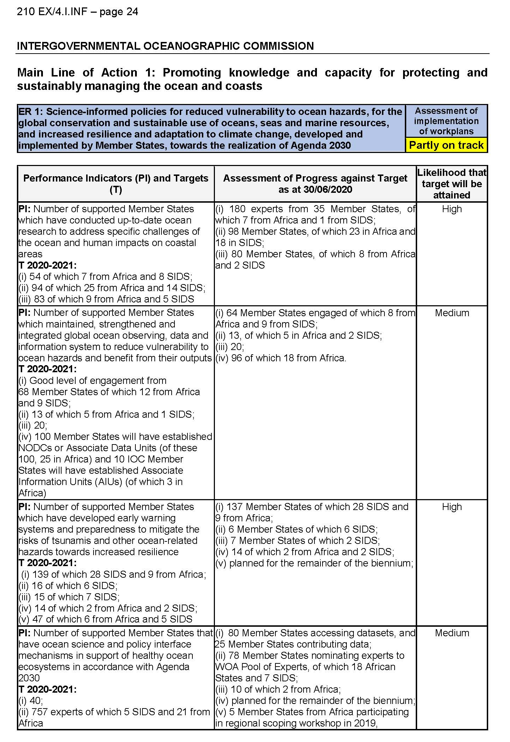
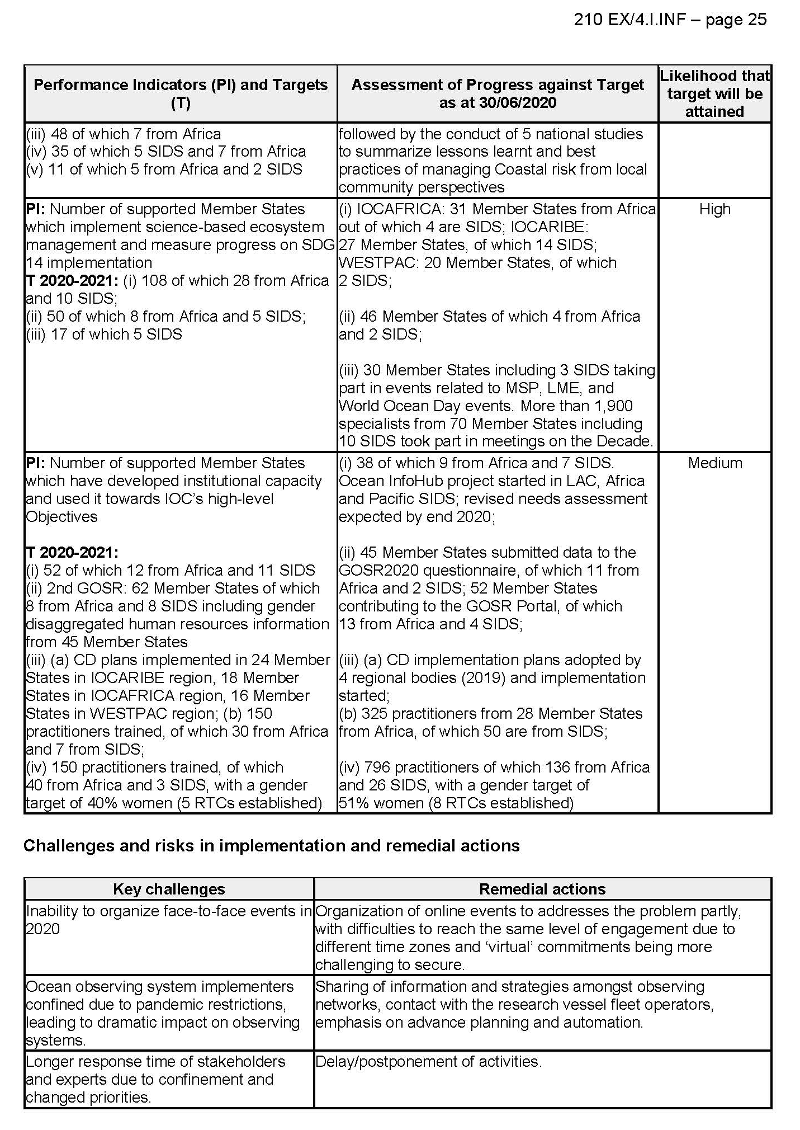

Global priority Africa
The UN Decade of Ocean Science for Sustainable Development (2021-2030) is an exceptional opportunity for the region to strengthen its capacities in ocean research in support of the Blue Economy. IOC partnered with the Western Indian Ocean Marine Science Association and the secretariat of the Nairobi Convention (UN Environment) to organize “the Regional Consultation workshop for the UN Decade of Ocean Science for Sustainable Development 2021-2030 for Africa and the Adjacent Islands States” which was hosted by the Government of Kenya from 27-29 January 2020 in Nairobi, Kenya. The workshop offered crucial opportunity to identify regional needs and priorities in terms of transforming knowledge systems, accelerating transfer of marine technology, enabling training and education, fostering science-policy dialogues and building capacities, in alignment with the African Union’s initiatives.
Capacity development in marine science and technology continues to be a key focus for the IOC’s Sub Commission for Africa and the Adjacent States, with 3 Regional Training Centres established within the framework of the Ocean Teacher Academy programme in Kenya, Mozambique and Senegal. The centres organized 12 training courses, attended by more than 250 trainees from 27 countries. IOC organized 5 workshops on Marine Spatial Planning in English, French and Portuguese, attended by more than 200 participants from 20 Member States. A regional webinar on the development of the African regional node for the Ocean Information Hub (OIH) on 10 June 2020 gathered more than 100 participants.
The Second International Indian Ocean Expedition (2015-2020) offered an excellent opportunity for the member states from the region to strengthen their ocean observations capabilities. The government of South Africa provided its oceanographic research vessel, the SA Agulhas II, for two cruises, enabling participation of more than 50 marine scientists and students from Comoros, Egypt, Kenya, Madagascar, Mozambique, Nigeria, and Tanzania.
Under the framework of the Indian Ocean Tsunami Warning and Mitigation System (IOTWMS), two initiatives deserve particular mention: (i) the capacity assessment of tsunami preparedness that provided a benchmark of the current status of tsunami warning and mitigation systems, identifying gaps, and prioritizing capacity development needs in 21 Member States and (ii) the Indian Ocean wide tsunami exercise (IOWave18). All African Member States bordering the Indian Ocean participated in IOWave18, with Tanzania, Kenya and Seychelles conducting community evacuations. Activities carried out under the Intergovernmental Coordination Group for the Tsunami Early Warning and Mitigation System in the North-eastern Atlantic, the Mediterranean and connected seas (ICG/NEAMTWS) were focused on enhancing tsunami warning capacities of African Member States bordering the Mediterranean Sea and Atlantic Ocean.
Global priority Gender equality
The IOC has been increasingly adopting a gender sensitive approach to its activities. The second edition of the Global Ocean Science Report (GOSR) to be published in 2020 provides baseline information on women and men working in the field of ocean science; globally 38% of the scientists are female, with considerable regional and national differences. Several events were organized to promote gender equality; the 2019 World Ocean Day, with its ‘Gender and the Ocean’ theme, could be cited as one example. However, the approach was still largely ad hoc rather than systematic.
The upcoming UN Decade of Ocean Science for Sustainable Development (2021-2030) with its explicit gender-related objectives presents a perfect opportunity to build synergies between SDG 5 and SDG 14 and to move from gender disaggregated assessments within the field of ocean science workforce to a more coherent framework of action. Regular assessments of gender representation in ocean science within the framework of the Global Ocean Science Report (GOSR) publications will allow changes to be tracked and the impacts of new initiatives to be observed. Together with its partners, IOC is currently planning a series of outreach and engagement activities to encourage submission of gender-sensitive programmes and projects to the upcoming Decade Calls for Action. A first virtual consultation will be organized in November 2020.

Annex 2
Report on UNESCO’s response to the Covid-19 pandemic and on the impact of the pandemic on the implementation of the programme and budget for 2020–2021 (40 C/5) – Intergovernmental Oceanographic Commission (abstract from 210 EX/17, October 2020)

Intergovernmental Oceanographic Commission (IOC)
1. Update on UNESCO’s response to the pandemic
73. Working on behalf of the UN system and in close partnership with the 24 members of UN Oceans, the IOC finalized the 10-year implementation plan of the UN Decade of Ocean Science for Sustainable Development (2021-2030) which will be discussed at the 75th session of the UN General Assembly in September 2020. The Draft Implementation Plan benefited from an international multi-stakeholder peer-review process conducted in March-April 2020 and an intergovernmental review process by IOC Member States and UN-Oceans in June-July 2020. Despite the cancellation of a number of preparatory meeting, a number of virtual participatory events during the period March-July allowed to ensure engagement of international ocean stakeholders (e.g. in cooperation with the World Economic Forum and UN Global Compact, the Ocean Science Decade Business brief was launched on 5 June 2020).
74. The second edition of the Global Ocean Science Report (GOSR2020), initially intended to be launched in June 2020 at the 2nd UN Ocean Conference (now postponed to 2021) will be launched through a dedicated series of simultaneous webinars in all regions of the world in the last quarter of 2020.
75. IOC and the European Commission continued the implementation of the Joint Roadmap to accelerate Maritime/Marine Spatial Planning (MSP) processes worldwide. Despite the cancellation of several face-to-face meetings, an engagement strategy to sustain the delivery of MSP Global activities was rapidly put in place. As a result, 11 online seminars took place, covering ecosystem-based management, gender perspectives, climate change and linkages with sustainable blue economy strategies.
2. Impact of the pandemic on the implementation of the 40 C/5 Programme and Budget
Table 4. Intergovernmental Oceanographic Commission: Staff and non-staff Expenditures for 2020-2021 (40 C/5) by source of funds, as at 30 June 2020
* Data reflected here is before offsetting.
** The breakdown by staff/non-staff is not available for the voluntary contributions.
76. The COVID-19-related confinement was of a particular concern for the Commission’s operational programmes, in particular the Global Ocean Observing System (GOOS), as observations and data collection of the global oceans were dramatically impacted. As a result, the intergovernmental coordination of the Global Tsunami Warning System activities was limited mostly to online meetings, with governance meetings postponed to a later date. Activities were quickly adapted virtual delivery modalities and the Secretariat continued to work closely with expert working groups and Member States of the four regional Intergovernmental Coordination Groups to sustain and enhance the regional systems and pursue relevant initiatives: (i) preparation of guidelines for tsunami warning services, evacuation and sheltering during COVID-19, and (ii) survey on the impact assessment of COVID-19 pandemic on Seismic Tide Gauge and Tsunameter Networks, and operations of Tsunami Service Providers.
77. The Tsunami Wave exercises were maintained (CaribeWave 20 took place in March 2020 with scope reduced to communication tests) or postponed (the IOWave20 was rescheduled for October 2020; the PacWave 20 for September-December 2020; and the NEAMWave exercise, for March 2021).
78. The availability of the Ocean Teacher Global Academy e-learning platform allowed a quick re-orientation and organization of online courses from June 2020. However, the inability to organize face-to-face meetings as planned impacted all activities. Courses in the existing training centres had to limit the number of trainees between March and July 2020. In addition, the number of new applications was limited because of lockdowns in Member States.
79. The online survey on the impact of the pandemic launched in June 2020 received 117 responses from Member States’ institutions involved in the IOC-led International Oceanographic Data and Information Exchange programme, with a majority of respondents indicating that the pandemic had an impact on data centres. While surveys will continue to assess the complete impact through 2020-2021, it is becoming increasingly clear that data gaps will be created in the global ocean data archives due to cancelled research cruises, lack of maintenance of observing equipment during the pandemic, reduction in staff during and possibly after the pandemic and possibly reductions in operational budgets.

Governments and oceanographic institutions recalled nearly all oceanographic research vessels to home ports; some commercial ships were also unable to contribute vital ocean and weather observations while ocean buoys and other systems could not be maintained. This situation to important data gaps for marine, climate, and weather forecasts and warnings.
81% of the respondents reported that the pandemic had an impact on the data centre; 77% of the respondents reported that data centre staff has been working from home; 51% of the respondents reported that the pandemic resulted in a reduced data flow to the data centre (data received) while 25% reported no data received at all; 48% of the respondents reported that there was no change in the services provided by the data centre while 36% reported reduced services; 49% of the respondents reported that they expect the impact of the pandemic continue for more than 3 months (i.e. later than August 2020); 57% of the respondents expect that the pandemic will result in data gaps in their collection, and 44% expect a loss of funding.

