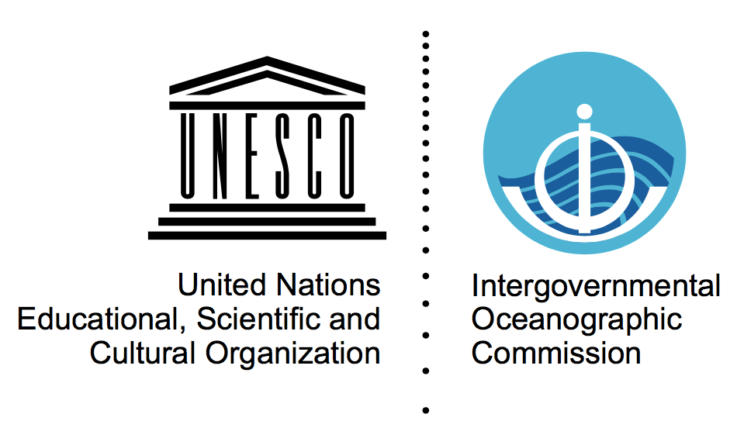

**EXPERTS WORKSHOP**

**Ocean Observations in Areas under National Jurisdiction**

*12-13 February 2020*

*IOC/UNESCO, 7 place de Fontenoy, 75007 Paris, France*

***Room 8*** *- please follow signs, on the -1 level in the Conference building*

**Provisional Agenda**

*Last updated 6 February 2020*

**Wednesday 12 February 2020**

*From 08:30, collection of badges at UNESCO main entrance (7 Place de Fontenoy)*

|  |  |
| --- | --- |
|  | *Morning session chair: A. Troisi* |
| 09:00 - 09:30 | **1. Welcome - *Ariel Hernán Troisi***   * Welcome to participants * Define the scope of the exercise, objectives, agenda *(20 min)* * Tour de table *(10 min)* |
| 09:30 - 10:00 | **2. Sustained Ocean Observing Overview - *Albert Fischer*** *(15 mins)*   * Global Ocean Observing System (GOOS) * For what purposes are the data collected? Which ocean data/parameters are collected (EOVs, sub variables)? How are they collected (which platforms/instruments used)? How are these collected data processed and made accessible? Which international institutions are organizing these efforts? * “Sustained” and “systematic” observations * Questions *(15 mins)* |
| 10:00 - 10:30 | **3. The value of observations in waters under national jurisdiction to users - *Emma Heslop*** *(15 mins)*   * Observations in waters under national jurisdiction * The value and importance of this data for key science questions * Value of the data from user perspective * Questions *(15 mins)* |
| 10:30 - 11:00 | Coffee/tea break |
| 11:00 - 12:30 | **4. Overview of the legal and administrative context**  **4.0 What challenges are currently experienced by the global observing networks ? - *Emma Heslop*** *(20 mins)*   * Questions/discussion *(20 mins)*   1. **The implementation of the UN Law of the Sea Convention’s Part XIII on marine scientific research and its scope - *Alice Hicuburundi*** *(15 mins)* * Questions/discussion *(25 min)* |
| 12:30 - 13:30 | Lunch break |
|  | *Afternoon session chair: E. Heslop* |
| 13:30 - 14:40 | * 1. **Issues of concern to Coastal States - *A. Troisi*** *(10 mins)* * How could the data collected/information produced by these data be of significance for the interests of coastal States in respect of the use of their natural resources (living/non-living) and their security? * A non-exhaustive overview of issues that the observing system and legal experts are aware of * Questions *(20 min)*   **4.3 How are certain data collecting activities currently managed with respect to areas under National Jurisdiction**   * VOS (WMO workshop and Cg-18 resolutions) - *Anthony Rea* - *WMO (10 mins)* * Argo *- Albert Fischer (10 mins)* * *Questions (10 min)* |

|  |  |
| --- | --- |
| 14:40 - 15:30 | **5. Possible ways to improve the current situation, within the framework of UNCLOS**   * Overview of the landscape and outline of some example solution spaces: expand the VOS and/or Argo approaches, either formally or in practice; use of Art. 247 UNCLOS; a separate Implementing Agreement; planning in ocean observing activities etc. - *Fred Soons - Utrecht University (20 mins)* * Plenary Discussion on the ideas and issues |
| 15:30 - 16:00 | Coffee/tea break |
| 16:00 - 17:30 | **5. Continued**   * Plenary Discussion on the ideas and issues |

|  |  |
| --- | --- |
| 19:30 | An optional non-hosted group dinner will be organized at a restaurant near UNESCO |

**Thursday 13 February 2020**

|  |  |
| --- | --- |
|  | *Morning session chair: A. Hicuburundi* |
| 9:00 - 10:30 | **6. Continuation of plenary discussion on solutions within the framework of UNCLOS, following outcomes of Day 1**   * Summary of previous day and areas for further/continued discussion - *Alice Hicuburundi DOALOS (30 mins)* * Plenary Discussion following outcomes of Day 1, with focus on areas identified and additional issues from the floor |
| 10:30 - 11:00 | Coffee/tea break |
| 11:00 - 12:30 | **6. Continued** |
| 12:30 - 13:30 | Lunch |
|  | *Afternoon session chair: A. Fischer* |
| 13:30 - 15:00 | **6. Continued and finalised**   * Outcomes summarised |

|  |  |
| --- | --- |
| 15:00 - 15:30 | **7. Define how IOC could proceed**  **7.1.** Overview of potential processes available for IOC to discuss the issues and proposals with regard to observations in waters under national jurisdiction - *Ariel Hernán Troisi (30 mins)*  For example : consultation of IOC Member States by circular, reactivate the Advisory Body of Experts on the Law of the Sea (ABE-LOS), or convene a new *ad hoc* group. |
| 15:00 - 15:30 | **Break** |
| 15:30 - 16:30 | **7.2** Plenary Discussion on how IOC could proceed and agree approaches  **7.3** Plenary discussion on other initiatives that should move forward in parallel to aid the IOC process. Identification of any assistance required |
| 16:30 - 17:00 | **8. Wrap up and close of meeting** |

***Organizing committee:*** *Albert Fischer (IOC/UNESCO), Emma Heslop (IOC/UNESCO), Alice Hicuburundi (UN Division for Ocean Affairs and the Law of the Sea), Elie Jarmache (member of the legal and technical committee of the International Seabed Authority), Alfred Soons (Utrecht University), Ariel Hernán Troisi (chair, IOC/UNESCO)*