

The Ninth GOOS Regional Alliance Forum (GRA Forum -9)
Tokyo, Japan, 5-7 August 2019

Information for Participants

1. Visa
A number of countries have a Visa Exemption Arrangement with Japan, and do not require a visa. This list is available here:
https://www.mofa.go.jp/j_info/visit/visa/short/novisa.html
All other participants will require a visa to enter Japan: if you require a visa, please inform Denis Chang Seng (d.chang-seng@unesco.org) by Friday 14 June 2019, so that JAMSTEC can issue an invitation letter to support your visa application.

2. Venue
GRA Forum-9 will be held at the JAMSPEC Tokyo Office. The Tokyo Office is conveniently located at a building directly connected to Uchisaiwaicho on the Toei-Mita Line, and near JR Shimbashi as well as Kasumigaseki on the Tokyo Metro Chiyoda Line. The Tokyo Office has 5 meeting rooms with sufficient work space.

[Address]
Fukokuseimei Bld. 23F
2-2-2 Uchisaiwaicho, Chiyoda City, Tokyo, 100-0011, Japan
Phone: +81-3-5157-3900
Fax: +81-3-5157-3903

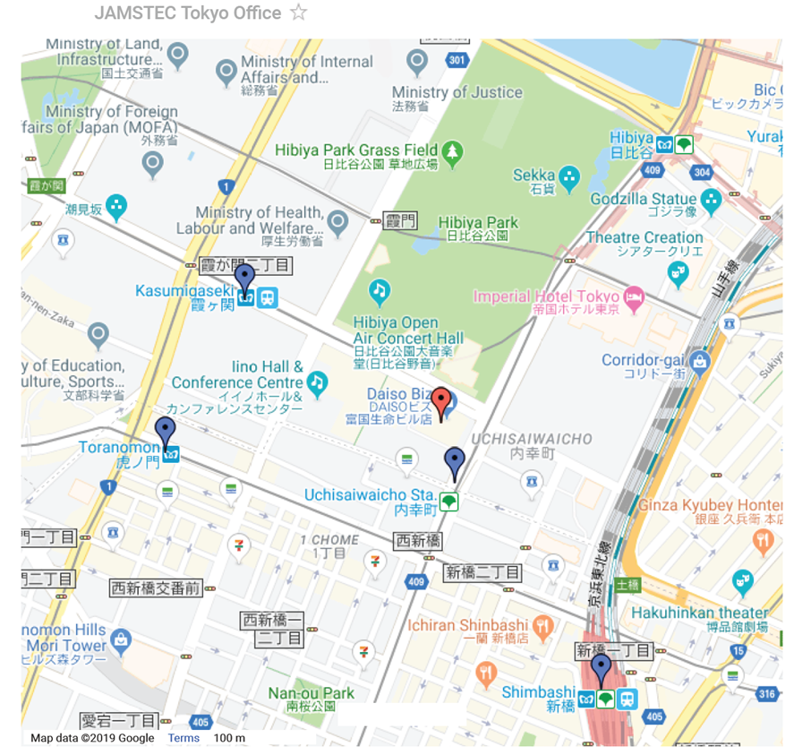
(View larger map: https://www.jamstec.go.jp/e/about/access/tokyo.html)

Tokyo Office can be reached from 4 stations. The walk to Tokyo Office is a few minutes from Exit A6 of Uchisaiwai-cho Station on Toei Mita Line, 3 minutes from Exit C4 of Kasumigaseki Station on Tokyo Metro Chiyoda Line, 6 minutes from Hibiya Exit of Shimbashi Station on JR and subway lines, and 8 minutes from Exit No. 9 of Toranomon Station on Tokyo Metro Ginza Line.

3. List of the Hotels

Hotel | Rate | Booking inclusions | Information on Google map  (The links to some hotel booking sites are shown on google map)
the b shimbashi | \16,434~ | Breakfast  Free wi-fi | Information on Google map
Dai-ichi Hotel Annex | \16,195~ | Free wi-fi | Information on Google map
remm Hibiya | \15,985~ | Breakfast  Free wi-fi | Information on Google map
Shinbashi Atagoyama Tokyu Rei Hotel | \15,008~ | Breakfast  Free wi-fi | Information on Google map
Ginza International Hotel | \14,200~ | Free wi-fi  Breakfast | Information on Google map
HOTEL UNIZO Tokyo Shimbashi | \13,238~ | Breakfast  Free wi-fi | Information on Google map
TOKYU STAY Shimbashi | \12,820~ | Breakfast  Free wi-fi | Information on Google map
APA Hotel Shimbashi Toranomon | \12,560~ | Breakfast  Free wi-fi | Information on Google map
Sotetsu Fresa Inn Shimbashi-Hibiyaguchi | \12,204~ | Breakfast  Free wi-fi | Information on Google map
Ginza Bellevue Hotel | \11,980~ | Breakfast  Free wi-fi | Information on Google map
GINZA GRAND HOTEL | \11,143~ | Free wi-fi | Information on Google map
Shimbashi Urban Hotel | \9,820~ | Free wi-fi | Information on Google map
Hotel Check In Shimbashi | \9,660~ | Free wi-fi  Breakfast | Information on Google map
*You may find the hotels at an affordable price in the areas which are 2 or 3 stations away from the meeting venue.

4. Local Climate in August

Mean temperature : 26.4°C
Mean maximum temperature : 30.8°C
Mean minimum temperature : 23.0°C
Mean precipitation : 168.2 mm/month
Humidity : 73%
Mean duration of sunshine : 169 hours/month = 5.45 hours/day

