IOC/INF-1373

REPORT OF THE CO-CHAIRS OF THE JOINT WMO-IOC CONSULTATION GROUP ON THE REFORM OF JCOMM

Summary of key outcomes
The present report is submitted to the eighteenth session of the World Meteorological Congress and the thirtieth session of the Assembly of the Intergovernmental Oceanographic Commission of UNESCO (IOC) by the co-chairs of the Joint WMO-IOC Consultation Group on the Reform of JCOMM, established in June 2018 through WMO Decision 58 (EC-70) and IOC Decision EC-LI/Dec.5.1 (June 2018).
The outcomes of the joint consultation are summarized as follows:
• Establishment of a Joint WMO-IOC Collaborative Board as a high-level coordination mechanism with broader engagement of the key relevant bodies of the WMO and IOC;
• Incorporation of current JCOMM functions and activities in marine observations, data management, forecasting systems and services in relevant WMO and IOC bodies, with closer links with co-sponsored programmes (GCOS, GOOS, WCRP).

Background

Drivers: challenges and opportunities
High-impact weather, water and climate extremes have devastating consequences for the safety of people, national economies, urban and rural environments, and food and water security. Extreme hydro-meteorological events currently account for more than 80% of the world’s natural disasters. According to the Intergovernmental Panel on Climate Change, these extreme are expected to occur with greater frequency and intensity if greenhouse gas concentrations continue to rise. Sea levels rise, also linked to climate change, will further increase the threats to more than half of the world’s population who are living in coastal regions including loss of farmlands, salt water intrusion to drinking water, and more frequent incidents of storm surge.
Society’s exposure and vulnerabilities to these hazards will be further exacerbated due to: population growth, reaching more than 9 billion by 2050; the development of human settlements, further urbanization and growth of mega cities worldwide, particularly in flood plains and coastal zones; significant expansion of built environments and critical infrastructures to service human needs that impact the natural ecosystems; and the relocation of vulnerable populations increasing density of population in fragile environments. To affect smart mitigation and adaptation policy development and decision-making by governments at all levels, international institutions, economic decision-makers and citizens, the demand for increasingly useful, accessible, and authoritative meteorological, hydrological, and oceanographic information and services is growing.
To support national agendas for disaster risk reduction and climate adaptation, WMO fosters the production and delivery of accessible and authoritative meteorological and hydrological information and services. This information is critical to strengthening resilience to the impacts of high impact weather, climate and water extremes. It provides an essential underpinning to support the development and implementation of National Adaptation Plans under the Paris Agreement and UN system needs on humanitarian and crisis management.
The work of IOC has also adapted to address a changing context, which includes Agenda 2030 and in particular Sustainable Development Goal 14 on the ocean Paris Agreement and work on climate mitigation and adaptation, the Sendai Framework for Disaster Risk Reduction, and the Samoa Pathway for Small Island Developing States.
On 6 December 2017, the UN General Assembly, as part of the Resolution on Oceans and the law of the sea (A/RES/72/73), decided to “proclaim the United Nations Decade of Ocean Science for Sustainable Development for the 10-year period beginning on 1 January 2021, and called upon the Intergovernmental Oceanographic Commission to prepare an implementation plan for the Decade in consultation with Member States, UN Bodies, and relevant stakeholder”. The IOC has begun the planning process for the Decade and has invited WMO and other UN agencies to provide contributions.
Weather, water, ocean, and climate linkages require us to foster interdisciplinary and collaborative work. In particular models for better understanding whole Earth systems are needed - specifically the ocean-land- cryosphere -atmosphere coupling that is needed to advance our science, prediction, and services.
IOC and WMO must position themselves to address these future challenges and opportunities that will require greater collaboration between them.

Guidance: WMO Strategic Plan and IOC Medium-Term Strategy
The WMO reform is driven in parallel to a new Strategic Plan 2020-2030, which puts emphasis on resilience of all nations to the socioeconomic consequences of extreme weather, climate changes, water availability, ocean changes, and other environmental events; and must underpin their sustainable development through the best possible services, whether over land, at sea or in the air. One of its major goals is to enhance Earth system observations and predictions, strengthening the technical foundation for the future.
The IOC Medium-Term Strategy 2014-2021 puts focus on ocean ecosystems, effective early warning systems and preparedness for tsunamis and other ocean-related hazards, increased resiliency to climate change and variability, and enhanced knowledge of emerging ocean science issues.
A joint meeting of the WMO Bureau and IOC Officers (Geneva and Paris, by videoconference, 17 January 2018) agreed on the usefulness of developing an overall cooperative framework agreement between the two Organizations that would cover areas of collaboration in a more coherent and effective way. The meeting further agreed that such enhanced scope of cooperation between WMO and IOC, redefined in a more holistic way based on the Earth system approach, could inform the reorganization of the interagency mechanism support it. The working group had underlined the importance of strengthening and expanding WMO collaboration with IOC, given the critical role of the ocean influencing weather and climate applications and services supported by the integration of ocean observations into predictive systems. It had also emphasized the need to preserve and enhance the collaborative work accomplished through JCOMM.

The Joint WMO-IOC Consultation Group on the Reform of JCOMM
WMO Decision 58 (EC-70) and IOC Decision EC-LI/Dec.5.1 (June 2018) recognized success of the cooperation between IOC and WMO in JCOMM and the achievements in terms of bridging oceanographic and marine meteorological observations, data management and service systems, while also recognizing the need for a restructuring of JCOMM that will increase the connection between IOC-specific groups and WMO reformed structures. It emphasized the importance of continued and enhanced cooperation between oceanography and meteorology, and between IOC and WMO, to ensure a coherent and compatible earth-systems approach to observations, data management, forecast systems and the development of appropriate services.
A Joint WMO-IOC Consultation Group on the Reform of JCOMM (JCG) was created with the following Terms of Reference (Annex I):
(i) Examine the proposal for the transition to a Joint WMO-IOC Committee for Oceanography and Meteorology (JCOM),
(ii) Consult WMO Members and IOC Member States,
(iii) Propose terms of reference for a JCOM,
(iv) Identify working arrangements and sponsorship for all bodies presently in JCOMM, the relationship between existing co-sponsored programmes (GCOS, GOOS, WCRP) and the proposed JCOM, and any other jointly undertaken work,
(v) Identify and map all technical functions from the current JCOMM to the proposed JCOM, to insure the full functioning of all operational matters.
(vi) Develop a revised proposal and a recommendation for the way forward, to be submitted to both the 18th WMO Congress and the 30th IOC Assembly for decision.
The JCG was constituted by the IOC Chairperson and WMO President, and is made up of:
For the WMO:
• Louis W. Uccellini (USA, co-chair of the JCG)
• Yaming Liu (China)
• Albert Martis (Sint Maarten and Curacao)
• Johan Stander (South Africa, JCOMM Co-president)
• Thomas Cuff (USA, JCOMM Services and Forecasting Systems chair)
• Michel Jean (Canada, CBS President)
For the IOC:
• Ariel Troisi (Argentina, co-chair of the JCG, Vice-Chairperson of IOC)
• Monika Breuch-Moritz (Germany, Vice-Chairperson of IOC)
• Margareth Kyewalyanga (Tanzania)
• Nadia Pinardi (Italy, JCOMM Co-president)
• Yutaka Michida (Japan, outgoing IODE co-chair)
• Alexander Postnov (Russian Federation, Vice-Chairperson of IOC, TOWS-WG chair)
For co-sponsored programmes:
• Stephen Briggs (UK, GCOS Steering Committee chair)
• John Gunn (Australia, GOOS Steering Committee co-chair)
• Martin Visbeck (Germany, WCRP JSC Officer)

Activities

Meetings
The JCG held five virtual meetings:
• 6 December 2018
• 22 January 2019
• 22 February 2019
• 4 March 2019
• 4 April 2019

Consultations
The JCG benefited from advice provided by the 15th Session of the JCOMM Management Committee (31 October - 3 November 2018, Paris, France).
The co-chairs and other individual members socialized the proposed reform of JCOMM and the recommendations from the JCG with WMO and IOC constituencies as follows.
For WMO:
• Constituent Bodies Reform Task Force (CBR-TF) (Geneva, 18 December 2018)
• Joint Meeting of the Presidents of Regional Associations and Presidents of Technical Commissions with CBR-TF (Geneva, 29-31 January 2019)
• CBR-TF (Geneva, 11-12 March 2019)
• EC WG/SOP (Geneva, 16–18 April 2019)
For IOC:
• 25th Session of the IOC International Oceanographic Data and Information Exchange (IODE-XXV) (Tokyo, 18–22 February 2019)
• 12th session of Working Group on Tsunamis and Other Hazards Related to Sea-Level Warning and Mitigation Systems (TOWS-WG-XII) (Paris, 21–22 February 2019)
• IOC Member States (through Circular Letter No. 2761 of 7 March 2019)
Written contributions were also received from the JCOMM Coordination Groups for Observation and Data Management, as well as from individual members of the JCG.
A presentation at the GOOS 8th Steering Committee meeting (Kiel, 1–3 May 2019) is also planned.

Overall outcome of the consultation

The Joint WMO-IOC Collaborative Board
As stated in its draft Terms of Reference, the Joint WMO-IOC Collaborative Board will maximize opportunities to co-design, co-develop and implement joint scientific and technical work, across oceanography and meteorology, which ultimately will improve the provision of information and services for societal benefit.
It will suggest initiatives to improve end-to-end links in the value chain from observations, through data management, to forecasting systems and Earth system prediction, to services and end user engagement; and enhance connections with research programmes to promote innovation.
By collaborating across both the oceanographic and meteorological communities, the Collaborative Board will provide strategic advice on programme co-design, implementation, and governance in light of relevant long-term goals and objectives. The Collaborative Board will influence how the WMO and IOC jointly enable the delivery of relevant meteorological and oceanographic information and services on the open ocean, in coastal zones and in high latitudes. In addition, while respecting governance, it will provide guidance and advice around technical and scientific issues to optimize the complementarity of activities, including through generating common projects.
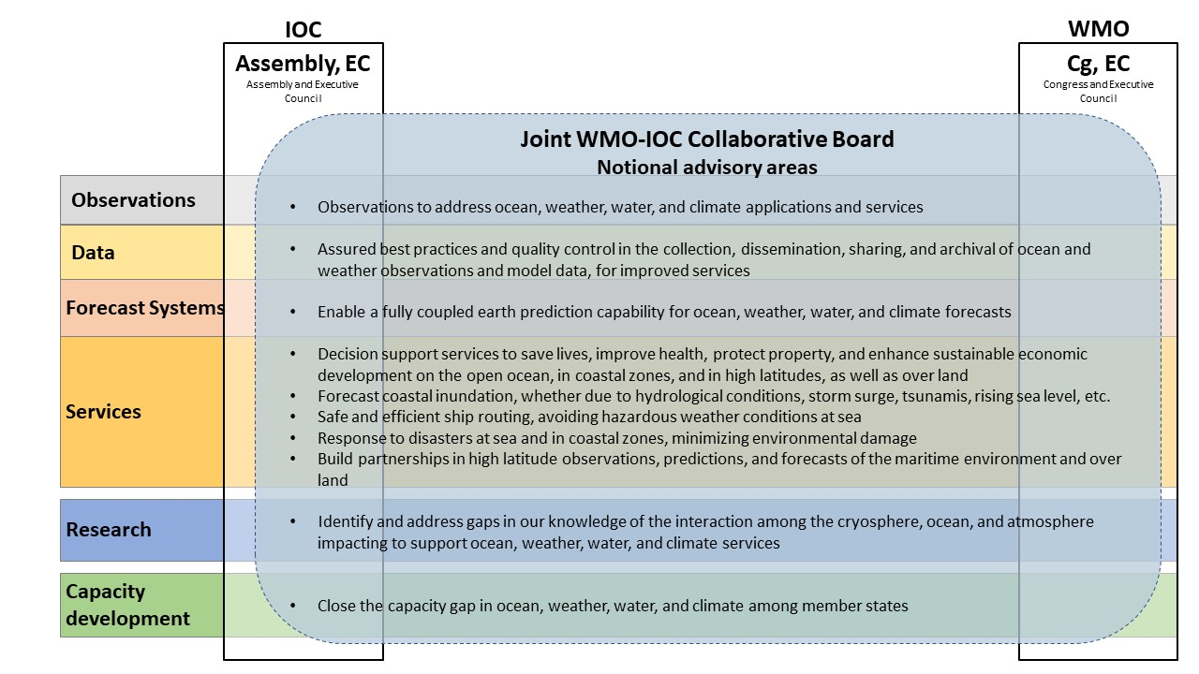
Figure 1. Some notional activities that the Joint WMO-IOC Collaborative Board will promote
The mandate of the Joint WMO-IOC Collaborative Board includes providing strategic advice to the IOC and WMO governing bodies, scientific and technical advice to the subsidiary bodies and programmes of the two organizations, including co-sponsored programmes, and liaison with stakeholders.
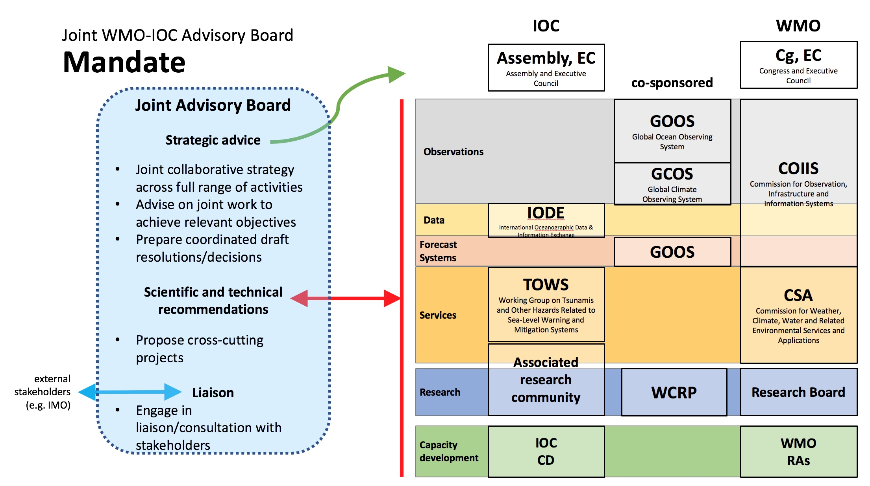
Figure 2. Mandate of the Joint WMO-IOC Collaborative Board
The proposed terms of reference of the Joint WMO-IOC Collaborative Board are provided in Annex II.

The future of JCOMM functions and activities
The JCG was charged with identify working arrangements and sponsorship for all bodies presently in JCOMM, and mapping all technical functions from the current JCOMM, to insure the full functioning of all operational matters.
The transition process, and particularly the fact that the internal structure of future WMO bodies (the two Technical Commissions for Infrastructure and Services, and the Research Board) will be decided after their creation by the World Meteorological Congress in 2019, demands that some flexibility is retained, and that the JCG cannot be fully prescriptive in this task.
However, the JCG identified notional homes for current JCOMM functions and activities of, which are noted in lines 24-35 of Annex II.
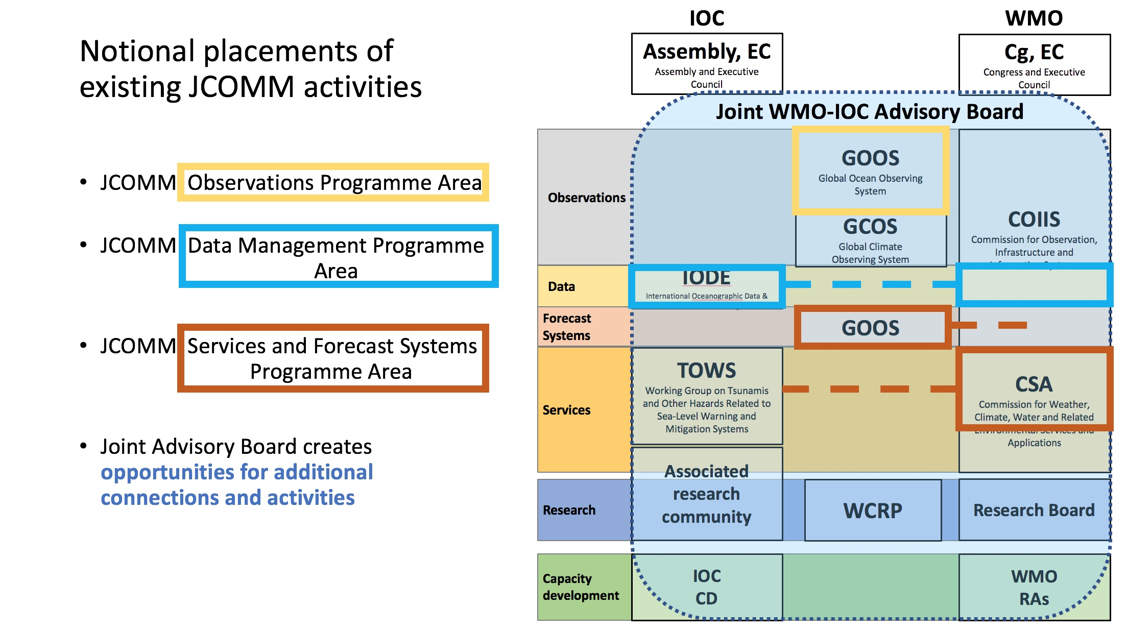
Figure 3. The notional home of JCOMM Programme Area activities, with the future internal structure of the WMO Technical Commissions subject to development during a transition process expected to last from June 2019 through April 2020
These notional sponsorship arrangements are further detailed as an initial recommendation from the JCG below.
The Joint WMO-IOC Collaborative Board, which will be in the transition period chaired by the co-chairs of the JCG and with the advice of the present JCOMM co-presidents, will be charged with managing the transition process, facilitating the continued work of all JCOMM functions and activities, by recommending connections to appropriate working structures on both sides as they develop.

Detailed recommendations of the JCG

Overall coordination
Overall coordination of JCOMM is currently ensured by the Management Committee (Resolution 5 (JCOMM-5)), whose functions will be absorbed in part by the Joint WMO-IOC Collaborative Board, and by other mechanisms detailed below. See terms of reference.

Observations
For the Observation Programme Area (OPA) (Resolution 6 (JCOMM-5)), the Observations Coordination Group (OCG) provides overall coordination and guidance to Ocean Observation Networks (SOT, DBCP, VOSP, SOOPIP, GLOSS-GE, Argo, OceanSITES) and to JCOMMOPS. The role of OCG is to look at user requirements within the value chain in support of Earth System Prediction, and advise on the best mix of technologies needed. The ocean observing networks are specific to some types of observing stations, typically ship-based, data buoys, tide gauges, profiling floats etc. The network operators meet annually to discuss implementation strategies and issues, technology, data collection, quality control and monitoring. The JCOMMOPS provides monitoring and WIGOS metadata collection functions, it provides technical support on day-to-day basis to network operators (e.g. getting WIGOS Identifiers, Satcom), and assists with regard to providing information on the quality of observations back to network operators, and recommends on potential synergies between the networks.
It is anticipated that the observation-related bodies will be sponsored primarily through GOOS, with joint support from IOC and WMO - recalling that GOOS is co-sponsored by IOC, WMO, UN Environment and ISC. This will imply stronger engagement, involvement, and contribution by WMO on the operational aspects of GOOS, and stronger links to WIGOS through the Standing Committee for Earth observing systems and measurement networks of the Commission for Observation, Infrastructure, and Information Systems (COIIS). In addition JCOMMOPS will be established as a WMO Office formally recognized by the host country, adding to the present arrangements and its co-sponsorship by IOC, and efforts will be made to ensure its sustainability.

Data management
Under the Data Management Programme Area (DMPA) (Resolution 7 (JCOMM-5)), WMO and IOC are about to approve a joint Strategy for Data Management, with following key outcomes: 1: Promoting data sharing (i.e. promoting oceanographic and marine meteorological data sharing with the research and operational communities and the private sector in compliance with WMO Resolution 40 (Cg-12), WMO Resolution 60 (Cg-17), and the IOC Oceanographic Data Exchange Policy); (2) Data collection (i.e. achieving more comprehensive, consistent, and standardized collection of oceanographic and marine meteorological data from observing platforms in real time and near real time as needed); (3) Data integration, access, rescue, and preservation (i.e. integration of oceanographic and marine meteorological data, their quality control and value adding, including structured and regulated data flow, data rescue, archival/preservation and enhanced data access for end users via WMO and IOC information systems); (4) Data Dissemination (i.e. achieving more comprehensive, consistent and standardized distribution of oceanographic and marine meteorological data to end users in real time and near real time as needed); (5) Data discovery (i.e. making oceanographic and marine meteorological data sets discoverable using WMO and IOC information systems); and (6) Capacity Development (i.e. enhanced capacities of Members/Member States with regard to oceanographic and marine meteorological data management).
It is anticipated that the data-management related bodies will be sponsored partly by WMO through WIS under the Standing Committee for Data, products and information exchange and life cycle management of COIIS and partly by the IOC Committee for International Ocean Data Exchange (IODE). The required activities to address the joint Strategy will be integrated into the relevant expert groups of both Organizations, with cross fertilization experts from both Organizations into relevant expert groups.

Services and forecasting systems
The JCOMM Services & Forecast Systems Programme Area (SFSPA) (Resolution 8 (JCOMM-5)) acts as the main delivery area for JCOMM products and services, including those for the safety of ships and persons at sea and within the coastal zone. In meeting many of its objectives, SFSPA works very closely with other agencies including other UN Agencies such as the International Maritime Organisation (IMO) and the International Hydrographic Office (IHO), in the provision of Maritime Safety Information (MSI). In addition the SFSPA also works with the International Atomic Energy Agency (IAEA) in the provision of information to support operations related to nuclear incidents that impact the oceans such as tracking the release of radioactive discharges.
The role of the SFSPA is to focus primarily on its key outputs, which are managed through several Expert Teams or Coordinator Roles, including the Worldwide Met-Ocean Information and Warning Service (WWMIWS) Committee (with responsibilities under the UN Convention on the Safety of Life at Sea (SOLAS) which obliges Members to provide forecasts at least twice daily); the Expert Team on Sea Ice (ETSI) (providing a wide and comprehensive range of information for ships operating the Polar and sub-Polar regions, which are likely to become more relevant as the waters become less ice-bound through the year); the Expert Team on Disaster Risk Reduction (which focuses on the DRR in the coastal zone, including storm surge and inundation issues, and including liaison with bodies in relation to Tsunami forecasts and warnings, such as the IOC’s Tsunami and Other Coastal Hazards Warning System (TOWS) Working Group); the Expert Team for Operational Ocean Forecasting Systems (ETOOFS) (which focuses on the development of capabilities in order to, ultimately, deliver ocean services to the marine community), and the Expert Team on Marine Environmental Emergency Response (ETMEER) (that is enhancing Member and Member State capabilities for response to emergencies such as oil spills and nuclear accidents over the ocean).
The Coordinator for Satellite Data Requirements works with experts to identify relevant satellite data requirements to support marine services and ocean applications. National Marine Service Focal Points act as communication focal points to receive marine service information from WMO, and likewise, to provide to WMO, relevant member state information related to national marine and coastal services..
It is anticipated that the proposed reform will see a ‘Standing Committee on Marine Meteorology and Oceanography Services’ in the proposed Commission for Application and Services, that will comprise of working groups reflecting the current work of the SFSPA (with the exception of Expert Team on Operational Ocean Forecast Systems, which is foreseen to continue under GOOS with a close link to the COIIS seamless forecasting and prediction activity). These activities will maintain a strong link with the IOC Working Group on Tsunamis and Other Hazards Related to Sea-Level Warning and Mitigation Systems (TOWS-WG).
A tabular representation of the notional sponsorship of JCOMM functions and activities is provided in Annex III.

Annex I
EC-LI/Decision 5.1 Rev.
IOC Recommendations regarding the proposed reform of the Joint WMO-IOC Technical Commission for Oceanography and Marine Meteorology (JCOMM)
The Executive Council,
1. Recognizing the success of the cooperation between IOC and WMO in JCOMM and the achievements in terms of bridging oceanographic and marine meteorological observations, data management and service systems,
2. Recognizing further the need to develop and implement state-of-the-art technologies and competencies in response to expanding and evolving needs of users of marine data and products,
3. Noting the importance of research and capacity development to support observations, data management and services, including information services aimed at setting global and national policy,
4. Noting the need for a restructuring of JCOMM that will increase the connection between IOC specific groups and WMO reformed structures,
5. Noting the 70th WMO EC Decision EC-70/16.3(5)/1 [final no. Decision 58 (EC-70)] titled WMO-IOC Consultation on the Reform of JCOMM,
6. Noting IOC/EC-LI/2 Annex 11 Rev. and IOC/INF-1359,
7. Noting with appreciation the intent behind the proposed reform of WMO structures, to improve efficiency and delivery,
8. Noting the involvement of IOC Officers and Executive Secretary in WMO discussions regarding reforms that touch on the co-sponsored bodies JCOMM, GCOS, GOOS, and WCRP,
9. Emphasising the importance of continued and enhanced cooperation between oceanography and meteorology, and between IOC and WMO, to ensure a coherent and compatible earth-systems approach to observations, data management, forecast systems and the development of appropriate services,
10. Decides to establish a joint IOC-WMO consultation group with the terms of reference provided in the annex to the present decision.

Annex to EC-LI/Dec.5.1
Joint WMO-IOC Consultation Group on the Reform of JCOMM
Terms of Reference
(i) Examine the proposal for the transition to a Joint WMO-IOC Committee for Oceanography and Meteorology (JCOM),
(ii) Consult WMO Members and IOC Member States,
(iii) Propose terms of reference for a JCOM,
(iv) Identify working arrangements and sponsorship for all bodies presently in JCOMM, the relationship between existing co-sponsored programmes (GCOS, GOOS, WCRP) and the proposed JCOM, and any other jointly undertaken work,
(v) Identify and map all technical functions from the current JCOMM to the proposed JCOM, to insure the full functioning of all operational matters.
(vi) Develop a revised proposal and a recommendation for the way forward, to be submitted to both the 18th WMO Congress and the 30th IOC Assembly for decision.
Membership
(a) For WMO:
(i) Representatives of Members (equal number to IOC) appointed by the President,
(ii) Representatives of JCOMM (marine meteorology) and the Commission for Basic Systems (CBS);
(b) For IOC:
(i) Representatives of Member States (equal number to WMO) consistently selected by the IOC Chairperson in consultation with vice chairs, to ensure balanced geographic representation,
(ii) Representatives of JCOMM (oceanography) selected by the JCOMM Co-presidents in consultation with the chairs of the JCOMM programme areas;
(iii) Representatives of International Oceanographic Data and Information Exchange (IODE) and the Working Group on Tsunamis and Other Hazards Related to Sea-Level Warning and Mitigation Systems (TOWS-WG);
(c) Representatives of co-sponsored programmes (GCOS, GOOS, WCRP) as proposed by the programmes.
Working procedures
The group will be expected to work primarily by electronic means.
Two co-Chairpersons representing the meteorological and oceanographic communities will be selected by the group.
The co-Chairpersons, in consultation with the group, may wish to invite other experts (as needed) to participate in the work of the group.

Annex II
Joint WMO-IOC Collaborative Board
[Note that text with green highlight is specific to WMO
and with blue highlight specific to IOC]
Draft Resolution 9.3.4/3 (Cg-18)
Draft Resolution 5.1 (IOC-XXX)

JOINT WMO-IOC COLLABORATIVE BOARD
THE WORLD METEOROLOGICAL CONGRESS,
THE ASSEMBLY,
Recalling:
(1) WMO Resolution 14 (Cg-XIII) – Joint WMO-IOC Technical Commission for Oceanography and Marine Meteorology (JCOMM),
(2) IOC Resolution XX-12 – Joint WMO-IOC Technical Commission for Oceanography and Marine Meteorology (JCOMM),
Considering the revision of the system of technical commissions as decided by Resolution 9.3.4/1 (Cg-18), which entails the disbandment of the technical commissions that have been active during the eighteenth financial period, including JCOMM, upon completion of the transition period as provided in Resolution 36 (EC-70),
Considering WMO Resolution 9.3.4/1 (Cg-18), which entails the disbandment of the Joint WMO-IOC Technical Commission for Oceanography and Marine Meteorology in the context of a reform of WMO governing structures,
Further considering the parallel WMO Resolution 9.3.4/3 (Cg-18),
Considering also the expanded collaboration between WMO and Intergovernmental Oceanographic Commission of UNESCO (IOC) in marine meteorology, oceanography and climatology, including in services, observation and information management, research and capacity building,
Considering further the evolving needs of a coordinating mechanism between WMO and IOC of UNESCO to support such collaborative activities,
Having examined the recommendations of the Joint WMO-IOC Consultation Group on the Reform of JCOMM established by Decision 58 (EC-70) and IOC Decision EC-LI/Dec.5.1,
Expresses appreciation to the Co-chairs and the members of the Joint WMO-IOC Consultation Group on the Reform of JCOMM for their work,
Decides, according to General Regulation 181 [as amended by Resolution 9.3/1 (Cg-18)] :
(1) To incorporate appropriate JCOMM functions and activities on observation and operational ocean forecasting systems into the IOC-WMO-UN Environment-ISC Global Ocean Observing System (GOOS), with functional connections to the WMO Commission for Observation, Infrastructure and Information Systems;
(2) To incorporate appropriate JCOMM functions and activities on data management and processing into the Commission for Observation, Infrastructure and Information Systems, with a close connection to the work of the IOC International Oceanographic Data and Information Exchange (IODE);
(2) To incorporate appropriate JCOMM functions and activities on data and information management into the International Oceanographic Data and Information Exchange (IODE), with a close connection to the work of the WMO Commission for Observation, Infrastructure and Information Systems;
(3) To incorporate appropriate JCOMM functions and activities on services into the WMO Commission for Services and Applications, with a close connection to relevant IOC activities in early warning and services;
(4) To establish the Joint WMO-IOC Collaborative Board, as a high-level coordination mechanism with broader engagement of the key relevant bodies of the WMO and IOC, with the terms of reference as given in the Annex to this Resolution;
Decides also that for the first intersessional period following the adoption of this Resolution, the Joint WMO-IOC Collaborative Board will be co-chaired by the current co-chairs of the Joint WMO-IOC Consultation Group on the Reform of JCOMM, with the technical advice of the current JCOMM co-presidents, noting that these co-chairs would have flexibility to adjust the length of initial appointment terms defined in the Terms of Reference, in order to stagger future rotation of members,
Decides further to review, in coordination with IOC governing bodies, in coordination with WMO governing bodies, the performance of the Joint WMO-IOC Collaborative Board, with an initial review in four years;
Requests the Joint WMO-IOC Collaborative Board:
(1) To facilitate the continued work of all JCOMM functions and activities, by recommending connections to appropriate working structures on both sides,
(2) To make recommendations on evolving the governance for the Global Ocean Observing System, in consultation with all co-sponsors, to further develop the partnership and functional connections between GOOS and WIGOS,
(3) To prepare, in consultation with WMO and IOC technical, scientific and regional bodies, a comprehensive and coordinated WMO-IOC Collaborative Strategy, based on existing sectoral strategies, and submit it in two years to the governing bodies of WMO and IOC for adoption;
Encourages WMO Members and IOC Member States to coordinate national response to the advice of the Joint WMO-IOC Collaborative Board brought to WMO and IOC governing bodies;
Instructs the Secretary-General Executive Secretary:
(1) To define, in consultation with the IOC Executive Secretary WMO Secretary-General, the working arrangements for the sponsorship of current JCOMM bodies and for the Joint WMO-IOC Collaborative Board and to report on implementation at the seventy-second fifty-third session of the Executive Council in 2020,
(2) To evaluate, in consultation with the IOC Executive Secretary WMO Secretary-General, the financial and secretariat support requirements for the Joint WMO-IOC Collaborative Board, and make adequate provisions in the budget;
Invites the IOC Assembly to reflect in its decisions the content of this Resolution.
Decides to disband the Joint WMO-IOC Technical Commission for Oceanography and Marine Meteorology upon completion of a transition period ending in April 2020, as defined in WMO Resolution 36 (EC-70).
Annex: 1
_______
Note: Article 26 of the Convention refers to relations with other organizations.
Regulations 38–45 refer to joint working groups in principle of the duration of one intersessional period.
Regulation 181 refers to joint technical commissions.
__________

Annex to draft Resolution 9.3.4/3 (Cg-18) 5.1
TERMS OF REFERENCE OF THE JOINT WMO-IOC COLLABORATIVE BOARD
Joint WMO-IOC Collaborative Board
The terms of reference of the Joint WMO-IOC Collaborative Board shall be:
Purpose statement
The Joint WMO-IOC Collaborative Board will maximize opportunities to co-design, co-develop and implement joint scientific and technical work, across oceanography and meteorology, that ultimately will improve the provision of information and services for societal benefit.
It will suggest initiatives to improve end-to-end links in the value chain from observations, through data management, to forecasting systems and Earth system prediction, to services and end user engagement; and enhance connections with research programmes to promote innovation.
By collaborating across both the oceanographic and meteorological communities, the Collaborative Board will provide strategic advice on programme co-design, implementation, and governance in light of relevant long-term goals and objectives. The Collaborative Board will influence how the WMO and IOC jointly enable the delivery of relevant meteorological and oceanographic information and services on the open ocean, in coastal zones and in high latitudes. In addition, while respecting governance, it will provide guidance and advice around technical and scientific issues to optimize the complementarity of activities, including through generating common projects.
The terms of reference of the Joint WMO-IOC Collaborative Board shall be:
Mandate
(a) To coordinate, through a quadrennial WMO-IOC collaborative strategy, the collaborative development, integration and implementation of the activities related to oceanographic and meteorological observation, data and information management, services, modeling and forecasting systems as well as research and capacity development carried out by WMO and IOC,
(b) To provide the WMO and IOC governing bodies with strategic advice on joint work between WMO and IOC to achieve relevant objectives, including proposing new actions, as required, e.g. by preparing coordinated draft resolutions and/or decisions for both the WMO and IOC governing bodies,
(c) To review work plans and provide technical and scientific recommendations for WMO and IOC subsidiary bodies and programmes, including proposing cross-cutting projects, and
(d) To engage in liaison or consultation required with relevant intergovernmental and international stakeholders.
Membership
The membership of the Collaborative Board shall be constituted by:
(a) Ten representatives of WMO and IOC scientific and technical bodies and programmes, including co-sponsored entities:
(i) Five designated by the WMO President, representing the leadership of activities in observing system, data processing and management, forecasting systems, services and applications, and research; from a meteorological perspective,
(ii) Five designated by the IOC Chairperson, representing the leadership of activities in observing system, data and information management, forecasting systems, early warning and services, and research; from an oceanographic perspective;
(b) At large members of the WMO Executive Council and representatives of IOC Member States, taking into account overall geographical balance:
(i) Three members of the WMO Executive Council designated by the WMO President,
(ii) Three representatives of IOC Member States designated by the IOC Chairperson;
(c) Two co-chairs:
(i) a WMO Vice-President, designated by the WMO President, and
(ii) an IOC Vice-Chairperson, designated by the IOC Chairperson.
Working procedures
The co-chairs shall hold their office for two years, with the possibility to be extended for a second term.
Other members shall hold their office for four years, or based on the duration of their term as leader in a WMO, IOC, or joint activity.
The co-chairs shall represent the Collaborative Board in the sessions of the WMO and IOC governing bodies.
In principle, the Collaborative Board shall meet in person every year, in order to prepare recommendations for WMO and IOC governing bodies. Intersessional work should be carried out by correspondence or virtual means.
Members of the Collaborative Board will work collaboratively across and within their respective constituent bodies and activities on WMO and IOC observations, data, forecasting systems, services, and research activities, to achieve the objectives stated in the Collaborative Board’s mandate.
The Collaborative Board may establish time-bound substructures for the discharge of specific tasks during an intersessional period. Such temporary substructures shall be discontinued at the end of every intersessional period, or may be re-established.
Chairs of other relevant WMO and IOC regional structures, working groups, panels and expert teams, as well as individual experts, may be invited by either co-chair in consultation with the other to attend meetings of the Collaborative Board as required by the agenda.
Representatives from other United Nations or international organizations may be invited as observers to the Collaborative Board as deemed appropriate by either co-chair in consultation with the other.

Annex III
Table of notional sponsorships of JCOMM bodies
X Sponsorship (primary governance and resourcing); o Important link to maintain (through tasks or cross-representation); WMO body; IOC body; GOOS (co-sponsored)
Notes: The downwards-management role of JCOMM MAN is then spread to the primary sponsors of the bodies as shown; the upwards-management and engagement role now lies with the new Joint WMO-IOC Collaborative Board. How the Joint WMO-IOC Collaborative Board would engage in CD activities of WMO and IOC and across all of its structures needs further consideration. These details are notional and subject to the development of the internal structures of the WMO Commissions.
 |  | WMO |  |  |  |  |  | Joint | IOC
 |  | WMO Commission for Weather, Climate, Water and Related Environmental Services and Applications (CSA) |  | WMO Commission for Observation, Infrastructure and Information Systems (COIIS) |  |  |  | IOC - WMO – UN Environment - ISC Global Ocean Observing System (GOOS) | IOC Committee for the International Ocean Data Exchange (IODE) | IOC Working Group on Tsunamis and Other Hazards Related to Sea-Level (TOWS-WG)
 |  | Standing Committees (proposed) |  | Standing Committees (proposed)
JCOMM  Programme areas | JCOMM  Expert teams / structure | Marine Meteorological and Oceanographic Services | Climatological and Agrometeorological Services | Earth observing systems and monitoring networks | Methods of observations, measurements and instrumentation | Data, products and information exchange and life cycle management | Data processing for applied Earth system modelling and prediction
Overall coordination – Resolution 5 (JCOMM-5) | Management Committee
Overall coordination – Resolution 5 (JCOMM-5) | Capacity Development Coordinators
Observations - Resolution 6 (JCOMM-5) | OCG - Observations Coordination Group |  |  | o |  |  |  | X
Observations - Resolution 6 (JCOMM-5) | SOT - Ship Observations Team |  |  | o | o |  |  | X
Observations - Resolution 6 (JCOMM-5) | VOSP - Voluntary Observing Ship Panel (sub-Panel of SOT) |  |  | o | o |  |  | X
Observations - Resolution 6 (JCOMM-5) | SOOPIP - Ship of Opportunity Implementation Panel (sub-Panel of SOT) |  |  | o | o |  |  | X
Observations - Resolution 6 (JCOMM-5) | DBCP - Data Buoy Cooperation Panel |  |  | o | o |  |  | X
Observations - Resolution 6 (JCOMM-5) | GLOSS-GE - Sea Level Observation Team / GLOSS Group of Experts |  |  | o |  |  |  | X
Observations - Resolution 6 (JCOMM-5) | Other observing networks represented on OCG: Argo, OceanSITES, International Ocean Carbon Coordination Project, Global Ocean Ship-based Hydrographic Investigations Programme, and ocean glider and high-frequency radar programmes |  |  |  |  |  |  | X
Observations - Resolution 6 (JCOMM-5) | JCOMMOPS - WMO-IOC Joint Technical Commission for Oceanography and Marine Meteorology in-situ Observing Programmes Support Centre |  |  | X | o |  |  | X
Observations - Resolution 6 (JCOMM-5) | Coordinator on Intercomparisons |  |  |  | o
Data Management Resolution 7 (JCOMM-5) | DMCG - Data Management Coordination Group
Data Management Resolution 7 (JCOMM-5) | ETDMP - Expert Team on Data Management Practices |  |  |  |  | o |  |  | X
Data Management Resolution 7 (JCOMM-5) | IPET-MOIS - Inter-programme Expert Team on Integrated Marine Meteorological and Oceanographic Services within WMO and IOC Information Systems |  |  |  |  | X |  |  | o
Data Management Resolution 7 (JCOMM-5) | ETMC - Expert Team on Marine Climatology | X |  |  |  | X |  |  | o
Data Management Resolution 7 (JCOMM-5) | Coordinator on table-driven codes |  |  |  |  | X
Services and Forecasting Systems - Resolution 8 (JCOMM-5) | Services and Forecasting Systems (SFSPA) Coordination Group
Services and Forecasting Systems - Resolution 8 (JCOMM-5) | WWMIWS - Committee for the Worldwide Metocean Information and Warning Service | X
Services and Forecasting Systems - Resolution 8 (JCOMM-5) | ETDRR - Expert Team on Disaster Risk Reduction | X |  |  |  |  |  |  |  | o
Services and Forecasting Systems - Resolution 8 (JCOMM-5) | ETSI - Expert Team on Sea Ice | X
Services and Forecasting Systems - Resolution 8 (JCOMM-5) | ETOOFS - Expert Team on Operational Ocean Forecasting Systems | o |  |  |  |  | o | X
Services and Forecasting Systems - Resolution 8 (JCOMM-5) | ETMEER - Expert Team on Marine Environmental Emergency Response | X
Services and Forecasting Systems - Resolution 8 (JCOMM-5) | National marine services focal points | X
Services and Forecasting Systems - Resolution 8 (JCOMM-5) | Coordinator on satellite data requirements | X
Other coordinators - Resolution 9 (JCOMM-5) | Coordinator on Satcom issues |  |  |  |  | X

Ms Monika Breuch-Moritz, Vice-Chairperson of IOC, had been invited to the first session (11–13 April 2018, Geneva, Switzerland) and second session (16–18 April 2019, Geneva, Switzerland) of the WMO Executive Council Working Group on Strategic and Operational Planning as an expert.
Johan Stander, Thomas Cuff, Monika Breuch-Moritz, Nadia Pinardi, Yutaka Michida, Alexander Postnov.
IOC EC-LI/Decision 5.1 Rev. slightly modified Decision 58 (EC-70). Through a letter dated 17 August 2018, the WMO President informed the members of the WMO EC of his concurrence with the modifications.

