*(Annex I of the JCOMM MAN-15 report)*

## 

*Final adopted version*

## Advice from the JCOMM Management Committee to the Joint WMO-IOC Consultation Group on the Future of JCOMM

### 

### Background

At its 15th meeting (31 October - 3 November 2018, IOC/UNESCO, Paris, France), the JCOMM Management Committee considered the draft WMO Strategic Plan 2020-2023, the IOC-led UN Decade of Ocean Sciences for Sustainable Development, the IOC Medium-Term Strategy, the GOOS 2030 Strategy, the JCOMM 10-year Vision, and the objectives of the WMO Constituent Body Reform including the concept for JCOM. It provides the following thoughts for the consideration of the Joint WMO-IOC Consultation Group on the Future of JCOMM in the context of the WMO Constituent Body Reform. The Consultation Group has been called to investigate the proposed JCOM as well as the broader relationship between WMO and IOC, consult with Members/Member States, with a submission of recommendations due by March 2019 for both WMO Congress (June 2019) and IOC Assembly (June 2019).

### 

### Key Opportunities

The elimination of a joint intergovernmental technical commission (JCOMM), anchoring of long-term ongoing activities in the new proposed WMO structures (Commission for Infrastructure, Commission for Services, and a Research Board) and existing IOC-led activities including GOOS (already joint with WMO) and the IODE, provide the following opportunities should be maximized in a future JCOM:

* Improving end-to-end links from observations through data management to forecasting systems (including an Earth System prediction approach), services and end user engagement, with appropriate feedback processes to improve each step.
* Enhancing connections to the research community
  + A lighter non-intergovernmental structure is less of a barrier to the research and services communities, so that ocean, climate, marine meteorological and Earth System science and services can come together in easy interactions, creating a think tank on issues, and easing research-to-operations and operations-to-research interactions
  + Many of the advances in connecting ocean observations, data, and forecast systems to improved meteorological and oceanographic services are research questions
* Simpler paths for decision making
  + Strengthen our ability to work more freely across the value chain to establish feedback loops that make observations, data management, forecast systems, services more fit for purpose for end users
* Working around a project structure
  + Form targeted joint task teams or projects - the proposed new structure will allow for the identification and definition of projects/activities that can be actively implemented by experts in both communities working together. It will be possible to achieve connections not easily made elsewhere because of hierarchical and stovepiped structures e.g. connecting across value chain from observations, through data management and modelling, to services and from IODE to WIS
  + Clear objectives and fixed timelines will enhance fundraising opportunities
  + Pilots could create testbeds for more permanent changes
* Rationalization of the governance and engagement with ocean observing networks
  + There is potential to simplify how WMO and IOC are working with groups implementing ocean observing networks. Today there are various types of networks with different governance and levels of maturity; some officially and strongly connected to JCOMM and others being independant; new networks are also emerging.
* To improve joint strategic governance across WMO and IOC
  + The proposed body will directly connect to the decision-making officers of both organizations, and broadly touch all intersection points
* The Future JCOM could be a model for inter-agency result-oriented cooperation within the framework of the UN Decade of Ocean Science for Sustainable Development
  + e.g., the cooperation between IODE and COIIS will contribute to both ODIS and WIS, potential contributions to Earth System prediction, and to multi-hazard early warning systems

### Governance principles

The Future JCOM should have three distinct purposes:

1. To develop and provide **joint** **strategic advice**, directly derived from the overall strategic plans of IOC and WMO, to achieve joint objectives, with the mandate to propose decisions directly to IOC and WMO governing bodies.
2. To provide a forum for WMO and IOC bodies, as well as external partners, to **negotiate and fast-track projects and joint work plans** that seek objectives that cut across:
   1. Meteorology and oceanography,
   2. WMO and IOC regional structures, to enhance implementation and capacity development, and
   3. the value chain connecting observations, data management, forecasting systems, services, and research.

This flatter structure would ensure more hands-on experts are involved in collaborative WMO and IOC activities.

1. To provide the external community with a **visible and single point of connection into matters that are cross-cutting** in all the spaces described in 2 above.

The Future JCOM should work in a transparent way to engage more stakeholders of the joint communities. This could include facilitating the nomination of experts in technical bodies through an improved process.

It should strive to engage the appropriate communities for joint decision-making, respecting in particular the diversity of national organizational structures for oceanography.

Given the already strong connections between JCOMM and both IMO and IHO - especially in the activities of maritime safety and bathymetric mapping - both agencies should be invited to engage in the Future JCOM with an eye to the synergistic opportunities. A representative of IMO is already foreseen as a member in the first draft of the terms of reference of JCOM. JCOMM MAN recommend that IHO is also invited as a member.

The Management Committee recommends that the Future JCOM should meet yearly.

### Future framework for collaboration

The recently-completed JCOMM Community White Paper to the OceanObs’19 conference focuses on components of JCOMM that have been successful and provides useful background.

Each Programme Area of JCOMM has a proposed solution with a specific character:

Observations

MAN recommends the OCG reports to GOOS, and that GOOS’s link to WMO (WIGOS) is strengthened.

OCG’s networks are different from the expert teams in the other areas of JCOMM, more like long-term projects/programmes. OCG is coordinating groups of people who implement networks who have plans and projects and come together to discuss implementation strategies and other issues. They essentially meet on a self funded basis, and contribute to IOC and WMO Trust Funds, mainly to support the cross-network implementation support and monitoring function - JCOMMOPS. This is proven to help support the work of the global networks. DBCP and GLOSS pre-date JCOMM, SOT created by JCOMM and other networks choose to partner with OCG. Argo, GO-SHIP and OceanSITES are formally independent of JCOMM while being members of the OCG, and new networks are emerging. The histories differ but they gain from support and focus on cross network global observing issues. The work in defining the characteristics of OPA networks was useful in engaging a broader set of networks that was reluctant to fall formally under JCOMM intergovernmental governance. A JCOMMOPS review was completed in October 2018, and made a number of recommendations to which MAN concurs, in particular with regard to its sustainability and funding model.

OCG was engaged in the GOOS 2030 Strategy’s vision of one single integrated ocean observing system serving multiple purposes.

Forecasting systems

MAN recommends that Operational Ocean Forecast System activities should have a strong link to IOC, GOOS, to the WMO’s S-GDPFS under COIIS, and to GODAE OceanView (future OceanPredict).

Data management

Activities generated through a Future JCOM in WMO and IOC data management practices and systems could to lead to improved interoperability and to enhanced global sharing of, and access to, a global data space relevant to the joint mandates of WMO and IOC. Activities will essentially be conducted through the Infrastructure Commission (WIS part) on the WMO side, and through the IODE on the IOC side. Cross fertilization and some coordination will have to be assured between the two with guidance from JCOM.

Services

The activities of the present teams apart from ETOOFS would be concentrated in CSA.

It is important that existing DRR activities in WMO and IOC be strengthened and better linked.

Capacity Development

For capacity development there will be a direct connection between WMO and IOC, combining the resources and existing systems of both organizations, maximizing the available resources, in line with the WMO and IOC CD Strategies. This joint work has a vision to improve the collaboration between relevant WMO and IOC programmes, establish institutional processes to identify capacity required at the national level, increase awareness for end users, promote downscaling of forecasts, facilitate exchanges between sea ice services, train users in the use of services and demonstrate application in local economies, facilitate uptake of data management practices, and the transition of research systems into operational monitoring and forecasting systems.

*Illustrations of some of the points above*

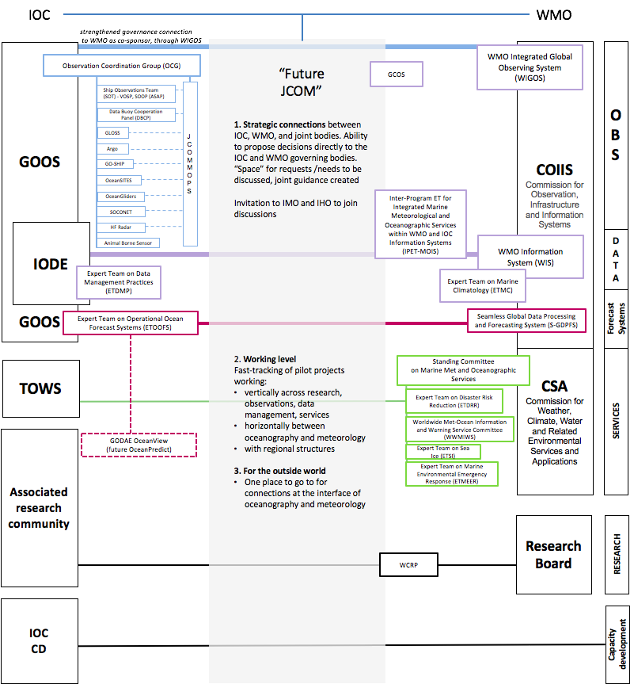

### Resourcing

The resourcing (central human and financial resources for coordinating activities) of the present JCOMM working structures could be put into the new homes of these teams and structures and, for the “direct connections” (eg IODE-COIIS(WIS part)) be shared between the two parent bodies. But the Future JCOM requirement for dialogue and meetings, engagement internally and externally, and development and launching of project ideas, would also require a human and financial resource. Some activities are likely to be implemented with existing resources as the activities will be directly relevant to both parent organizations.

MAN recommends that this resourcing requirement should be assessed by the Joint Consultation Group, and should in principle come from both WMO and IOC.

Present resources available for the SFSPA are inadequate. Keeping and strengthening the present marine meteorological and oceanographic services should be a priority.

### 

### The name of JCOM

MAN recommends that the Future JCOM name be changed, to avoid confusion in the change management so that it was seen as a body with a significantly different character than the present JCOMM, but also because according to the IOC Rules of Procedure a ‘Committee’ is an intergovernmental subsidiary body open to all Member States.

### Maintaining the present work of JCOMM and a Transition

MAN recommends that the JCOMM Observations and Data Management coordinators are consulted in the work of the Joint Consultation Group, in addition to the SFSPA coordinator (already a formal member).

JCOMM Management and its structures will continue their work as adopted at JCOMM-5 until a transition is complete.

WMO and IOC subsidiary bodies (e.g. IODE) are urged to include the future working arrangements and transition in the agenda of their governing bodies in 2019 and 2020 and to contribute to the work of the Joint Consultation Group.