**9th Session of the JCOMM Observations Coordination Group**

**14 - 17th May 2018, Brest, France**

**Report Title: Argo Float Program**

**Authors: W. Brechner Owens**

**Agenda Item Reference:**

**Date: 2 July 2018**

**Draft:**

**1. SUMMARY**

The Argo Program continues to maintain approximately 3800 active floats profiling to 2000 dbar. Argo has expanded from the Core Mission to higher latitudes and marginal seas.

Biogeochemical Argo is presently carrying out pilot deployments in the Southern Ocean, Atlantic Ocean and Mediterranean Sea. To make the Biogeochemical parameters part of the Argo Program, a proposal has been submitted to the International Oceanographic Commission Executive Council to add 6 biogeochemical parameters to the list of official Argo parameters.

Deep Argo, which includes profiling floats that profile to 6000 dbar or 4000 dbar, is carrying out pilot deployments in the South Pacific, South Indian and Atlantic Oceans. Plans are developed to continue to expand this effort towards an eventual global array.

The Argo Information Centre (AIC) continues to collect information from float providers and to facilitate the notification to member states.

Several workshops have been held in the past year to disseminate technical and delayed-mode quality control expertise to the Argo community.

The Argo community is preparing a white paper for OceanObs’19 that will cover the broad program.

**2. REPORT CONTENT**

The Argo array is presently at roughly 3800 float (figure 1). The array has been maintained through innovation and expanded participation in the presence of flat or declining funding.

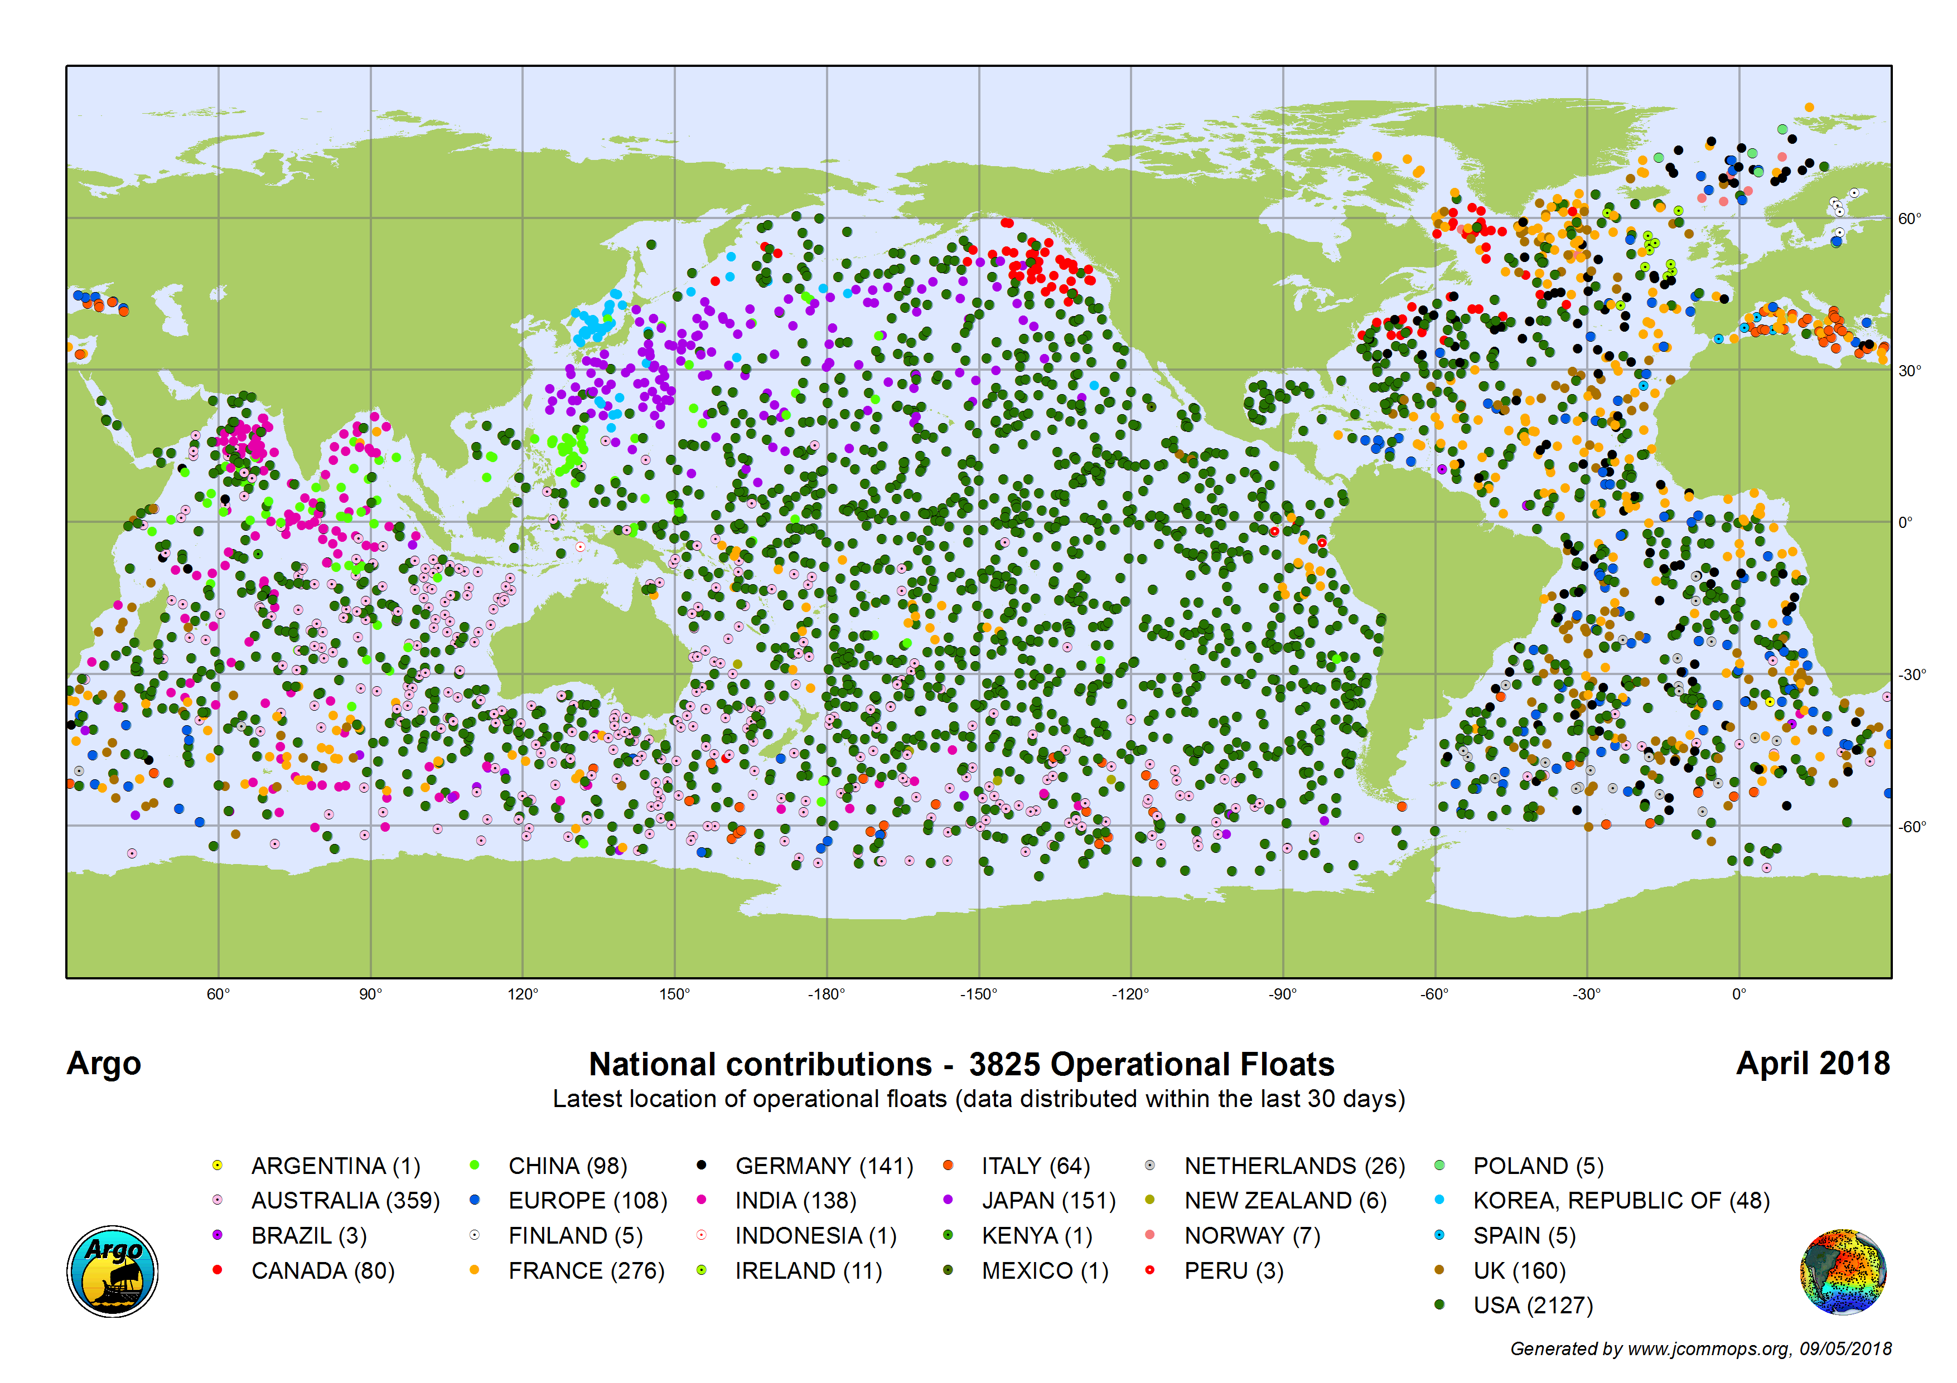

Figure 1. Argo float coverage as of April, 2018.

This coverage has expanded from the original Core Argo region to include higher latitudes and marginal seas. The most of the data is available at the Global Data Acquisition Centers within 24 hours of collection. It is also transmitted on the GTS system. The data on the GTS system will be available in only BUFR format starting in July, 2018. The AIC has expanded its support for Argo, with improved asset management tools and other web-based tools. It has also been crucial for the oversight of the array and for notification of Coastal States.

In addition to the geographic expansion, Argo has two pilot programs, BGC-Argo and Deep Argo. BGC-Argo measures biogeochemical parameters that are crucial for measuring and understanding the flux of carbon into the global ocean, ocean acidification and ocean deoxygenation that are all associated with climate change. Floats have been developed for Deep Argo that can profile to either 6000 or 4000 dbar. Deep Argo has been developed to sample the recently observed changes in the ocean heat content below 2000 dbar so that we can make better estimate the global change in ocean heat and salt content. Pilot deployments are now sampling the South Pacific, South Indian and Atlantic Oceans.

While the number of floats exceeds the original goal for Argo, the number of floats has plateaued between 3800 and 3900 floats and 15% of the core region is under-sampled. Some regions, such as the North Atlantic are over-sampled and efforts are underway to reallocate future deployments to under-sampled regions.

A technical workshop was held September, 2017 in Seattle with the goal of desimminating technical expertise from the group of “super users,” who have significantly high performing floats, to the broader Argo community. In addition, technical problems with floats were discussed with the goal of further improving the float performance. Passivation of primary lithium batteries was identified as a general problem and as a significant problem for SOLO-2 floats. It was recommended that the float battery packs be replaced with packs containing both primary lithium and secondary rechargeable batteries. This change has the potential to expand the lifetime of all types of floats. It is now possible that an Argo float can have a significantly longer lifetime, well beyond the typical 4-5 years for the average float.

Argo continues to have workshops to share expertise in carrying out delayed-mode quality control. EuroArgo held a workshop in April, 2018 for the expanded European float community. There will be a workshop on Biogeochemical Argo floats in September, 2018 at the University of Washington in Seattle, WA, USA. There will be a more general workshop help in connection with the Argo Steering Team Meeting in March, 2019 in La Jolla, CA, USA. With the help of the AIC, a GitHub site has been established to distribute Argo software. The first entry has been set up to distribute the calculation of the adjustment of salinity measurements to match climatological values.

Issues with the CTD sensors on Argo floats continue to be found. An issue with early, significant drift in the conductivity sensors have been found for recent CTDs. Argo and Seabird are working collaboratively to identify and correct this problem. The Argo Steering Team has also approved a global pilot experiment to qualify the RBR CTD for use on Argo floats.

In addition to the extension of Argo into marginal seas and high latitudes, the community has recommended that Argo coverage be significantly increased within 10 degrees of the equator and in regions near western boundary currents. No significant funding for these expansions exist.

**3. DECISIONS, ACTIONS and RECOMMENDATIONS**