**9th Session of the JCOMM Observations Coordination Group**

**14 - 17th May 2018, Brest, France**

**Report Title: Standards and Best Practices**

**Authors: Juliet Hermes, Emma Heslop, Chen Hua**

**Agenda Item Reference:**

**Date: 11th May 2018**

**Draft: 1**

**1. SUMMARY**

This report summarizes the work carried out regarding standards and best practices and issues/actions to be noted by OCG and networks. The role of the OCG S&BP Vice Chair is to promote development of standards and best practices across the marine/ocean observing networks, working with the community of networks under the JCOMM Observations Coordination Group (OCG).

**2. REPORT CONTENT**

The vision of the S&BP within OCG is: To promote development of standards and best practices across the marine meterological/ocean observing (including biogeochemistry) networks, working with the community of networks under the JCOMM Observations Coordination Group (OCG). Work with the JCOMM networks, partner networks and activities to identify and coordinate documents, catalogue and review them, identify gaps and areas where an holistic approach across variables can be taken. Create a publication and review process, encourage use and provide training.

Following on from OCG 8 discussion a number of recommendations were made:

*1) BP Spreadsheets uploaded, on JCOMM or the Oceanbestpractices website and OCG TT formed (consisting of people from JCOMM networks, partner networks and activities) to provide input, once completed gaps will be evident*

The spreadsheet was significantly reformatted based on an excellent example provided by Maciej, it is available here: <https://docs.google.com/spreadsheets/d/15iXmELSjchywD5y3qJDOmY6lGuE-SE70mcJotpjb_ZA/edit?usp=sharing>

It is still a work under progress and perhaps contains too much information. Additional information can be retrieved from specification sheets. A local repository has been set up with the documents stored

*2) It’s proposed that IODE or JCOMM (perhaps through ocean data standards and linked too WMO technical regulations.) host a repository for all relevant standards and best practices documents*

IODE has set up a repository: [www.oceanbestpractices.net](http://www.oceanbestpractices.net) has been set up and now holds over 250 BP, it is still in phase 1 and feedback is welcome.

*3) A meeting be held with the leads of RMIC/AP and RMIC/US in order to understand their capacity, skills and plans around S&BP and how they are moving forward and how we can integrate efforts and work with the platforms*

Unfortunately the RMIC/AP and US were unable to make a meeting in France, ongoing discussions have been held with RMIC/AP (see Appendix1) although main point of contact has gone on maternity leave. Improved communications should happen with RMIC/US

*4 )A meeting will be organised between JCOMM OCG, AtlantOS and a few other core groups (eg JERICO-NEXT, IMOS) working on observing platforms and S&BP to help structure a combined effort forward*

This will be the bulk of this report

*5) A number of Journals are being investigated and will be approached, some key authors should be approached and possibly editors*

Frontiers for marine science research topic on which Juliet is a topic editor- <https://www.frontiersin.org/research-topics/7173/best-practices-in-ocean-observing>

*6) Recommend GOOS follows up with GRA to discuss training in best practices, RMICs could also play a role, and it could be linked to JCOMM capacity building. An option would be to raise for discussion at the next GRA meeting, which Juliet will attend*

Reached out to GOOS RAs, attended meeting and took part in webinar and liaised with GOOS panels. Need to consider how to include BP from eg IMOS and IOOS in terms of networks. Training being considered through best practices working group

*7) Lessons learned from BCG Argo be documented and will be discussed. Maciej Telszweki will hopefully take/support the lead on this, with other advanced systems and networks considered as contributors.*

Working with Maciej, developed compatible spreadsheet, he attended meeting in Paris and is part of the extended BPWG

*8) A vice chair data management be appointed soonest, must have clear links to the JCOMM data management group, maybe this can be one person for both*

Recently filled so will begin this following OCG9

**Summary of other activities**

Juliet and Emma have been working very closely with the Best Practices Working Group (oceanbestpractices.org) to get the repository up and running and to discuss with community the processes moving forwards. This has been the focus of the work in the past year and input and time into this should reduce now: The mission of the group is to:

Create and implement a comprehensive, sustainable, easy to use Best Practices system for the ocean research and applications community. This includes:

•      A sustained, open access, and internationally recognized repository with advanced indexing and search technology, also featuring DOI- based document IDs

•     *Best Practices in Ocean Observing*Research Topic in Frontiers in Marine Science Journal

•     Community support for training and capacity building

**The BPWG team is:**

Mark Bushnell, IOOS; Pier Luigi Buttigieg, AWI; Juliet Hermes, SAEON/JCOMM; Emma Heslop, GOOS/JCOMM; Johannes Karstensen, GEOMAR; Frank Muller-; arger, Univ S. Florida; Cristian Muñoz, SOCIB; Francoise Pearlman, IEEE; Jay Pearlman, IEEE **(LEAD);** Pauline Simpson, IODE

CONTRIBUTORS/SPONSORS: IODE, GOOS, JCOMM, AWI, IEEE, IOOS, SAEON, SOCIB, AtlantOS, INTAROS, ODIP, OceanObs RCN

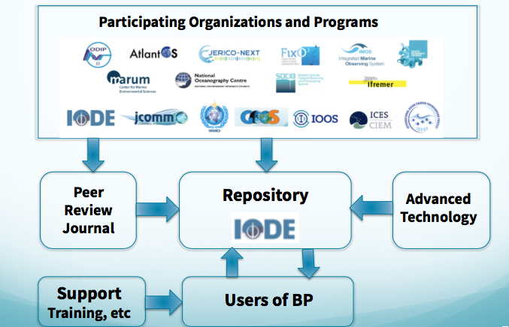

We are seeing the creation of many new best practices in the community. EMODNet, Bio-Argo, the Marine Institute, Ireland and the Applications Group in AtlantOS are all planning to document and submit their practices to the OBP-S [Repository.](http://r20.rs6.net/tn.jsp?f=001onVTCfJ9-HOsJ9YCpCDJF8AoMWyJos6NIrsy6-Ea-37Ty-t3JO41RsCwk_0udSBPUMelBwf1l4nCWnt2WOyPIxJShJzz4dcAqw4C_5_UF8oe0n7wIiGgMRs_KZNKnDMxORT-SdiEES4TQp_UZR5AXiYlO5LiaPOM&c=_-7TLrMfI9Xi0AqsIX240BDgTrmLKTa8lnR5IBCIO0-tOB5LL21XQA==&ch=64YtsU3GXFn0PZl72EZFWkMSDUqrezFnAzbZSOqHgK0r0Y_1aXSghg==" \t "_blank)

A group of OceanObs’19 abstracts in the area of best practices has been selected to collaborate in creating recommendations for next decade under the leadership of the BPWG. A white paper on “Best Practices in Ocean Observing” will be submitted to *Frontiers in Marine Science* for publication.

Presentations were given on Best Practices at AGU, Ocean Sciences Meeting (Town Hall), Oceanology International and EGU.

The BPWG has also achieved milestones in the last two months.

* The Repository has grown to 250 best practices and we are halfway to our initial goal of 500 for next year.
* A pilot for an upgraded user portal has been created. It will start beta testing soon.
* An advanced semantic-based search and document tagging capability will be enhanced using natural language techniques.
* The OBP-S Repository hosted by IODE started issuing DOIs in March to improve discoverability on the web
* Four abstracts were received last month for our Research Topic, [Best Practices in Ocean Observing](http://r20.rs6.net/tn.jsp?f=001onVTCfJ9-HOsJ9YCpCDJF8AoMWyJos6NIrsy6-Ea-37Ty-t3JO41RsCwk_0udSBPk7zSQk_QsQWyRZzIRHuwJQWif7EFEeGErRu-sgn6weh7wOuignHrMoLupU8rfACWOcpI8b41lZSUdHKrqKiTtJGbg2W4rMNJQkALRroYMjmSa-fsoCSTnvCgA841D6KqVQlcHUPcywFu4q30Bc4YjpQyFNmAVaT6&c=_-7TLrMfI9Xi0AqsIX240BDgTrmLKTa8lnR5IBCIO0-tOB5LL21XQA==&ch=64YtsU3GXFn0PZl72EZFWkMSDUqrezFnAzbZSOqHgK0r0Y_1aXSghg==" \t "_blank), in the *Frontiers in Marine Sciences* is receiving papers for peer review and publication.

Two workshops have been held:

A workshop of experts was held at IOC, Paris, in November 2017 that produced many excellent recommendations. The results are given in proceedings: <https://www.oceanbestpractices.net/handle/11329/410>

During the workshop a definition of BP was defined: A community best practice is a methodology that has repeatedly produced superior results relative to other methodologies with the same objective.

To be fully elevated to a best practice, a promising method needs to be adopted and employed by multiple organizations.

An EOS publication also came out with a summary of the workshop: <https://eos.org/meeting-reports/whats-the-best-way-to-responsibly-collect-ocean-data>

A BPWG meeting was also held in January 2018 in Majorca to finalise the project plan.

Following this, Juliet submitted a SCOR WG with members of the BPWG and other GOOS members. SCOR WG in the past have highlighted the need to produce BP but some have not made these public or known where they can be hosted. There are a few SCOR WG which feed into GOOS or the OCG networks who’s main focus is producing BP. If the WG is not successful an agreement should be sought with the SCOR WG leaders to promote the BP they are producing.

Juliet attended the GOOS RA meeting in Singapore in September and presented the work on BP. There was a good deal of interest and follow up has happened, including during a GOOS RA webinar. Some of the GOOS RA members attended the meeting in Paris. A more formal link should be considered around this relationship and this has been discussed with GOOS.

This BPWG work has taken up more time than anticipated and has drawn attention away from the more direct approach with the network leaders. However, given it was running parallel to the process here and has gained a lot of international support and interest, the JCOMM involvement has been worthwhile.

Alongside this, the OCG program leaders have been contacted (most) and have given feedback/become involved in the repository, which now hosts over 250 best practices. One on one conversations have taken place with a number of network chairs/representatives and a brief description/overview is provided here: <https://docs.google.com/document/d/1ubD-rmdTnB1QidmmAC1I7sJJn77774qzPBWaHsuIx60/edit?usp=sharing>

**3. DECISIONS, ACTIONS and RECOMMENDATIONS**

* Continue working with the chairs/designated program best practice leaders to collate and review best practices, recommend these are then uploaded to the repository and issued a DOI, where possible publication in Frontiers.
* Finalise report on network best practices and provide recommendations and next steps in conjunction with networks.
* Ensure Spec sheets have links to the best practices
* Work with GOOS and GOOS TT to facilitate method of endorsement of BP, implement some initial pilots
* Increase focus on marine meterological measurement best practices
* Work with new areas to create best practices through engaging with other networks
* Engage with new OCG data and information vice chair

APPENDIX 1 - Working Report on BP Activities

RMIC/AP

Under the guidance of OCG, RMIC-AP has searched and retrieved BPs, standards and relevant technical documents from 16 groups or communities ([https://www.oceanbestpractices.net/), and](https://www.oceanbestpractices.net/),%20and) filled the form of GAP Analysis, which can help to figure out the overlaps and vacancy. It also lays a solid foundation for the establishment of marine observation best practice framework.

|  |  |  |  |
| --- | --- | --- | --- |
| **No.** | **Organization/Group** | **Field & Content** | **Documents Number** |
| 1 | An international study of the marine biogeochemical cycles of trace elements and their isotopes (GEOTRACES) | [GEOTRACES Community Practices](https://www.oceanbestpractices.net/handle/11329/408) | 2 |
| 2 | Global Ocean Ship-Based Hydrographic Investigations Program (GO-SHIP) | [GO-SHIP Practices Collection](https://www.oceanbestpractices.net/handle/11329/372) | 14 |
| 3 | International Council for the Exploration of the Sea (ICES) | [ICES Data Guidelines](https://www.oceanbestpractices.net/handle/11329/223) | 13 |
| 4 | International Ocean Carbon Coordination Project (IOCCP) | IOCCP Best Practices Collection | 1 |
| 5 | Intergovernmental Oceanographic Commission. Except IODE (IOC) | HAB [2][IOC - EU Collaboration](https://www.oceanbestpractices.net/handle/11329/337) [5] | 7 |
| 6 | International Oceanographic Data and Information Exchange ( IODE) | [IOC Information Document (IOC-INF)](https://www.oceanbestpractices.net/handle/11329/307) [1][IOC Manuals and Guides](https://www.oceanbestpractices.net/handle/11329/139) [77][IODE Miscellaneous Best Practice Documents](https://www.oceanbestpractices.net/handle/11329/355) [11][IOC Technical Series](https://www.oceanbestpractices.net/handle/11329/256) [6] | 95 |
| 7 | The U.S. Integrated Ocean Observing System (IOOS) | [QARTOD Manuals](https://www.oceanbestpractices.net/handle/11329/336) | 12 |
| 8 | Japan Agency for Marine-Earth Science and Technology (JAMSTEC:) | [JAMSTEC SIP Protocol Series](https://www.oceanbestpractices.net/handle/11329/360) | 6 |
| 9 | Joint Tech Comm for Oceanography & Marine Meteorology (JCOMM) | [JCOMM Technical Reports](https://www.oceanbestpractices.net/handle/11329/257) [16][JCOMM Commmunity Practices Collection](https://www.oceanbestpractices.net/handle/11329/72) [24] | 40 |
| 10 | Joint European Research Infrastructure network for Coastal Observatories (JERICO) | [JERICO Best Practice Documents](https://www.oceanbestpractices.net/handle/11329/362) | 7 |
| 11 | NESP Marine Biodiversity Hub | [Marine Sampling Field Manuals](https://www.oceanbestpractices.net/handle/11329/392) [1][NESP Community Practices](https://www.oceanbestpractices.net/handle/11329/405) [1] | 2 |
| 12 | Global network of open ocean time series stations  (OceanSITES) | [OceanSITES Best Practice Documents](https://www.oceanbestpractices.net/handle/11329/389) | 1 |
| 13 | Ocean Data Interoperability Platform (ODIP) | [ODIP Publications - resources supporting ODIP objectives](https://www.oceanbestpractices.net/handle/11329/284) | 5 |
| 14 | Scientific Committee on Oceanic Research (SCOR) | [SCOR Working Groups Contributions](https://www.oceanbestpractices.net/handle/11329/260) | 2 |
| 15 | World Meteorological Organization (WMO) | [WMO Guidelines](https://www.oceanbestpractices.net/handle/11329/254) [24][WMO Technical Document (WMO/TD)](https://www.oceanbestpractices.net/handle/11329/258) [2] | 26 |
| 16 | Other Communities (RDA; CODATA ...) | Sub-communities within this community[RDA: Research Data Alliance](https://www.oceanbestpractices.net/handle/11329/271) [2][CODATA](https://www.oceanbestpractices.net/handle/11329/293) [1]Collections in this community[Miscellaneous Community Practices](https://www.oceanbestpractices.net/handle/11329/262) [10] | 12 |

1. Actively participated in the discussion and research for Evolving and Sustaining Ocean Best Practices held by OCG, and worked with other partners in the establishment of ocean best practices framework and management;
2. Participated in the activities of AtlantOS/NSF/IOC Best Practice Working Group and SCOR WG；
3. Sorted out the standards on ocean observation and ocean survey in China, if anyone one is interested in any standard, we are willing to cooperate with you to develop best practices/standards under the framework of JCOMM.

**Ocean Observation Standards in China**

|  |  |  |  |  |
| --- | --- | --- | --- | --- |
| **No.** | **Code** | **Replace** | **Title** | **实施日期** |
| **1** | GB/T 14914-2006 | GB/T 14914-1994 | The specification for offshore observations | 2006/8/1 |
| **2** | GB/T 17838-1999 |  | The specification for the ships’ auxiliary marine hydrology and meteorological observations | 2000/2/1 |
| **3** | GB/T 19721.1-2005 |  | The issue of marine forecasts and warnings- Part1: The issue of storm forecasts and warnings | 2005/11/1 |
| **4** | GB/T 19721.2-2005 |  | The issue of marine forecasts and warnings- Part3: The issue of wave forecasts and warnings | 2006/2/1 |
| **5** | GB/T 19721.3-2006 |  | The issue of marine forecasts and warnings- Part3: The issue of sea ice forecasts and warnings | 2006/12/1 |
| **6** | HY/T 023-2010 | HY/T 023-1992 | The codes of Chinese oceanic stations | 2010/10/1 |
| **7** | HY/T 037-2017 | HY/T 037.1-1994~HY/T 037.6-1994 | The specification for marine data buoy operation | 2017/6/1 |
| **8** | HY/T 134-2010 |  | Sea level observation and impact assessment | 2010/10/1 |
| **9** | HY/T 180-2015 |  | The technical guide to verify the tide level on datum | 2015/10/1 |
| **10** | HY/T 193-2015 |  | Standard system for ocean observation, forecast and hazard prevention and mitigation | 2016/6/1 |
| **11** | HY/T 195-2015 |  | Technical guide for forecast of storm surge overtopping of dike | 2016/6/1 |
| **12** | HY/T 217-2017 |  | The issue of green tide forecasts and warinings | 2017/6/1 |

**Marine Survey Standards in China**

|  |  |  |  |  |
| --- | --- | --- | --- | --- |
| **No.** | **Code** | **Replace** | **Title** | **实施日期** |
| **1** | GB/T 12460-2006 |  | Application formats for oceanographic data records | 2006/12/1 |
| **2** | GB/T 12763.1-2007 | GB/T 12763.1-1991 | Specifications for oceanographic survey-Part 1: General | 2008/2/1 |
| **3** | GB/T 12763.2-2007 | GB/T 12763.1-1991 | Specifications for oceanographic survey-Part 2: Marine hydrographic observation | 2008/2/1 |
| **4** | GB/T 12763.3-2007 | GB/T 12763.1-1991 | Specifications for oceanographic survey-Part 3: Marine meteorological observations | 2008/2/1 |
| **5** | GB/T 12763.4-2007 | GB/T 12763.4-1991 | Specifications for oceanographic survey-Part 4: Survey of chemical parameters in sea water | 2008/2/1 |
| **6** | GB/T 12763.5-2007 | GB/T 12763.5-1991 | Specifications for oceanographic survey-Part 5: Survey of acoustical and optical parameters in the sea | 2008/2/1 |
| **7** | GB/T 12763.6-2007 | GB/T 12763.6-1991 | Specifications for oceanographic survey-Part 6: Marine biological survey | 2008/2/1 |
| **8** | GB/T 12763.7-2007 | GB/T 12763.7-1991 | Specifications for oceanographic survey-Part 7: Exchange of oceanographic survey data | 2008/2/1 |
| **9** | GB/T 12763.8-2007 | GB/T 13909-1992 | Specifications for oceanographic survey-Part 8: Marine geology and geophysics survey | 2008/2/1 |
| **10** | GB/T 12763.9-2007 |  | Specifications for oceanographic survey-Part 9: Guidelines for marine ecological survey | 2008/2/1 |
| **11** | GB/T 12763.10-2007 |  | Specifications for oceanographic survey-Part 10: Submarine topography and geomorphology | 2008/2/1 |
| **12** | GB/T 12763.11-2007 |  | Specifications for oceanographic survey-Part11: Marine engineering geological investigation | 2008/2/1 |
| **13** | GB/T 18190-2000 |  | Oceanological terminology- Marine geology | 2001/5/1 |
| **14** | GB/T 30737-2014 |  | Determination of marine photosynthetic picoplankton-Flow cytometry | 2014/10/1 |
| **15** | GB/T 30740-2014 |  | Determination of total organic carbon in marine sediment-Nondispersive infrared absorption | 2014/10/1 |
| **16** | GB/T 30741-2014 |  | Determination of total sulfur in ocean atomspheric dry depositon -Nondispersive infrared absorption spectrometry | 2014/10/1 |
| **17** | GB/T 30742-2014 |  | Determination of total carbon in ocean atmospheric dry deposition-Nondispersive infrared absorption spectrometry | 2014/10/1 |
| **18** | GB/T 33543.1-2017 |  | Ocean energy terminology-Part 1:General | 2017/7/1 |
| **19** | HY/T 022-2017 | HY 022-92(ZB A24 001-90) | The codes of Chinese marine investigation institution | 2017/3/8 |
| **20** | HY/T 024-2017 | HY 024-92 (ZB A24 003-90) | Codes of Chinese offshore investigation fraction | 2017/3/8 |
| **21** | HY/T O81-2005 |  | Technical specification for eco-monitoring of mangrove ecosystem | 2005/6/1 |
| **22** | HY/T 124-2009 |  | Specifications for sea area use register investigating | 2009/5/1 |
| **23** | HY/T 125-2009 |  | Test method of ocean color spectrograph | 2009/5/1 |
| **24** | HY/T 133-2010 |  | Determination of spectral absorption coefficient of particles and dissolved material for seawater-Spectrophotometry | 2010/3/1 |
| **25** | HY/T 140-2011 |  | Specifications for the survey of marine microbenthos | 2011/6/1 |
| **26** | HY/T 150-2013 |  | Determination of organic carbon in sea water by nondispersive infrared absorption spectrometry | 2013/5/1 |
| **27** | HY/T 159-2013 |  | Method for sun photometer data calibration | 2013/5/1 |
| **28** | HY/T 178-2014 |  | Determination of alkalinity in seawater using pH potentiometric titration | 2014/12/1 |
| **29** | HY/T 183-2015 |  | Technical rules of ocean thermal energy survey | 2015/10/1 |
| **30** | HY/T 184-2015 |  | Technical rules for marine salinity gradient energy survey | 2015/10/1 |
| **31** | HY/T 196-2015 |  | Determination of dissolved inorganic carbon in sea water using non-dispersive infrared absorption | 2016/6/1 |
| **32** | HY/T 197-2015 |  | Determination of total alkalinity in seawater on potentiometric titration using an open-cell titration | 2016/6/1 |
| **33** | HY/T 206-2016 |  | Determination of iron, manganese, nickel, potassium, sodium, calcium and magnesium in the marine sediments and organisms-Atomic absorption spectrophotometry | 2017/2/1 |

**Suggestions on future activities on ocean BP framework and management**

Fully considered the visions of ocean BP framework, combined with its own expertise on standardization management, RMIC/AP would suggest as follows:

1. Set up the coordination group/mechanism to integrate and utilize the current resources of BPs/standards;
2. Encourage members/ member states and relevant groups/ communities to develop BPs/ standards desperately needed;
3. Set up a technical working group oriented to stakeholders, carry out the **training or workshop** of BPs/standards according to the real needs of stakeholders; and get regular **implementation feedback** on BPs /standards, which can help **update the technical content of BPs/standards**;
4. To enhance the quality of BPs/standards, we suggest to implement the standards development procedure of ISO as follows:

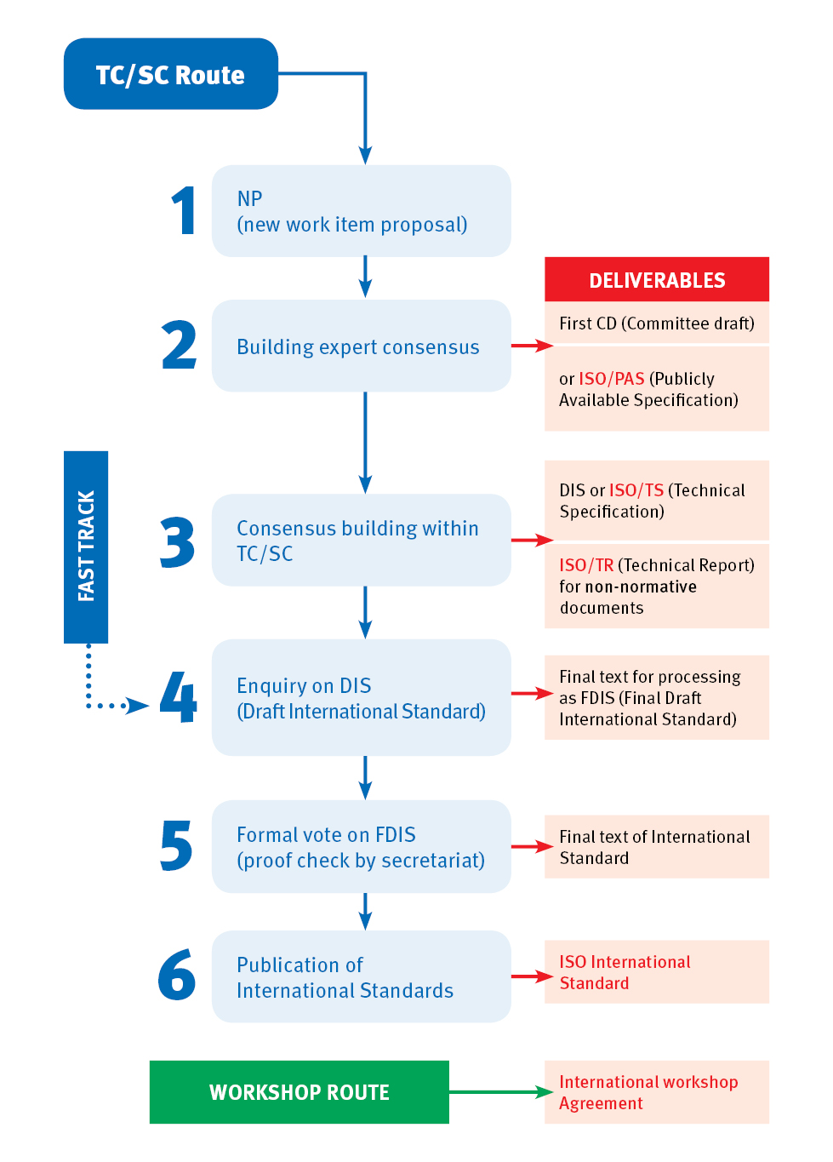

ISO standards respond to a need in the market

ISO standards are based on global expert opinion

ISO standards are developed through a multi-stakeholder process

ISO standards are based on a consensus