**Prospectus**

**A global surface ocean CO2 reference network**

by the Surface Ocean Reference CO2 network meeting organizers:

Rik Wanninkhof

Leticia Barbero

Denis Pierrot

Ute Shuster

Kathy Tedesco

Adrienne Sutton

Maciej Telszewski

**Purpose-**

The global surface ocean CO2 reference network will measure surface water and atmospheric CO2 at high-accuracy, from which global air-sea CO2 fluxes and trends surface water CO2 levels can be determined. The network partners will work collaboratively to measure the partial pressure of CO2 (pCO2) from ships and moorings[1] following agreed upon standard operating procedures, and disseminate data and, to be agreed upon, data products openly and periodically.

**Abstract-**

Over the past two decades automated surface water CO2 observations have provided data for climatologies and monthly estimates of global air-sea CO2 fluxes. They have been used to create maps of changing surface ocean pCO2 levels and its effect on ocean acidification. Moreover, the measurements have yielded numerous insights on the environmental controls on surface ocean carbon chemistry. The observations have resulted in key publications ranging in topics from aquatic chemistry, and process level understanding, to global constraints on the carbon cycle. A tremendous advance took place when data from dozens of research groups were collated and distributed as part of the Surface Ocean Carbon Atlas (SOCAT), a volunteer effort initiated by the international ocean carbon coordination project (IOCCP). SOCAT updates occur annually.

The next step is to improve coordination at the measurement level. Here we describe the formation of a surface water CO2 reference network that will facilitate interactions between participating groups, assure high quality data in uniform format, and provide an efficient means of tracking platforms. This reference network will yield quality data with rapid release for annual assessments. By working through the Observing Program Support Center of the Joint Technical Commission for Oceanography and Marine Meteorology (JCOMMOPS), the expertise and infrastructure for platform tracking will improve exposure and provide connectivity to other operational networks.

**Introduction-**

Systematic surface water CO2 observations are used to map CO2 levels in the mixed layer over time for robust estimates of air-sea CO2 fluxes and uptake of CO2 by the ocean. They contribute two key pieces of information needed to assess the global carbon cycle and impact of fossil fuel release. The first is the fraction of CO2 released by fossil fuel that is sequestered by the ocean; the second is the trends of surface water CO2 increase. The fraction of CO2 absorbed by the ocean is critical for quantifying the ocean’s role in modulating the growth of atmospheric CO2 and the resulting climate change. Trends allow determination of ocean acidification and the oceanic processes that affect, and are affected by, increasing CO2 levels in the ocean.

The observations from the network address the socio-economic needs of carbon accounting and tracking of the state of ocean ecosystems in support of the UN sustained development goals, SDGs 13, Climate Action and 14: Life Below Water (www.un.org/sustainabledevelopment/sustainable-development-goals/). The measurements feed directly into the annual Global Carbon Budget updates (Le Quéré et al., 2018), national climate and ecosystems reports (USGCRP, 2017), and authoritative assessment of the IPCC that are used to set national and international policies (IPCC(AR6), 2018) and the Paris accord (unfccc.int/paris_agreement/). A sustained effort of surface water CO2 measurements is thus warranted to provide data critical for assessments, policy and informational products.

The data are currently acquired by a variety of groups using different approaches and assembled annually in two different data products (Bakker et al, 2016, Takahashi et al, 2018). Data are provided on a volunteer basis or obtained from open access sites of individual investigators. Data undergo independent quality control prior to annual releases of combined datasets. Data in the compilations are from one to two years since acquisition. There are ≈ 20 million data points in the collated sets with most of the data acquired in the last decade. Annual releases increase the data holdings by 1 to 2 million unique data points.

To sustain the long-term effort, to facilitate uniformity and accuracy, and to increase exposure, more formal interactions amongst the groups acquiring the data are warranted. Doing so in form of a network by entraining regional networks and individual contributors who are acquiring data at highest quality provides the opportunity to create a reference dataset[2] of great value and utility. To maintain and improve reference data quality, the network will establish clear measurement objectives, best practices, organize intercomparisons, and facilitate opportunities for improving measurement quality. A formal reference network also facilitates links with other ocean networks, improving visibility and identity of surface ocean CO2 observing.

During a meeting organized by IOCCP and co-sponsored by the Ocean Observations and Monitoring Division (OOMD) of NOAA in Portland, OR on February 11, 2018, a group of major operators of surface water CO2 systems, along with select users and other interested parties discussed the formation of a network. Several investigators participated through remote access (see Appendix A for agenda and Appendix B for participant list). An overview of the rationale for a network was given along with presentations on the Ocean Thematic Center (OTC) of the European Integrated Carbon Observing Network (ICOS), and the Joint Technical Commission of Oceanography and Marine Meteorology (JCOMM) as background for network need and design. Current assets and platforms were presented. There was a very positive response to creating and participating in a surface water CO2 referencenetwork. A prospectus is offered below based on the workshop deliberations and exchanges before and after the meeting.

**Benefits -**

The establishment of an organized, international surface ocean CO2 reference network will provide the following anticipated outcomes:

* Increase the visibility and identity of participants and their efforts, reinforce the importance of sustained observations.
* Work towards a common set of standards and best practices.
* Provide training, education and capacity building efforts, encourage developing countries to start measuring pCO2.
* Build a coherent vision of the need for sustained surface ocean CO2 measurements as part of a global integrated carbon observing network.
* Common data management, QC, and data products (streamline the output of data releases, etc.).
* Connectivity to other networks (e.g. help in recruitment of ships and other platforms where our systems can be installed).
* Target data gaps and determine where gaps can be best filled.
* Improve network usability, such as atmospheric CO2 measurements from ships.

The strategies to be followed to achieve these results are detailed in the next sections.

**Goals-**

The reference network is viewed as a backbone of a surface water CO2 observing system that provides timely and accurate data for use in assessments and evaluation. In particular, providing timely and quality data addressing the global issues of quantifying the air-sea CO2 flux and the changes in surface water CO2 levels will be the focal point of the effort. These issues are of paramount societal importance for determining the fate and impact of fossil fuel produced CO2.

The reference network comprised of moorings and ships of opportunity, collectively called surface ocean observing platforms for CO2 measurements, will cover key regions of the ocean with data of specified quality. The reference network will perform measurements following documented procedures including:

* + Common protocols, instrumentation, standardization
  + Clearly defined standard operation procedures
  + Data appropriately documented with metadata
  + Clear accuracy and precision requirements

Data from the reference network will be submitted through the established SOCAT data system but will be tagged as reference network data and indicated within the SOCAT dataset as such.

The reference network is part of a global CO2 observing system, and will have its unique brand (name TBD), the surface ocean CO2 global reference observing network. It will build upon established operational groups, including regional CO2 networks, and use procedures and protocols in established global networks in oceanography marine meteorology. In particular, the development of the network will utilize practices put in place in ICOS Ocean Thematic Centre (OTC) and JCOMM Observation Program Area (OPA). In addition, the network will take advantage of proven practices by many of the prospective participants.

The reference network will not be built from the ground up but rather it will be an entity formed by consolidating current groups engaged in performing quality surface water CO2 measurements. It is recognized that this approach has its challenges and opportunities. The challenges are for the groups to agree to act as a single entity following agreed upon best practices, tracking of data, data submission, and future goals. The advantages of a surface water reference system are many. The provision of timely data to determine air-sea CO2 fluxes and surface water trends for assessments is critical for our society. It will provide proper exposure to the groups involved in the effort, particularly if efforts include branding of the network. Anticipated products and advocacy should increase the ability to sustain funding. Serving metadata and performing platform tracking through JCOMM in-situ Observing Program Support Center (JCOMMOPS) will provide important exposure and linkages to other operational efforts.

The network will be built within the Framework for Ocean Observing (FOO) of the Global Ocean Observing System (GOOS) and in accord with its mission statement

*"[to develop] a framework for moving global sustained ocean observations forward in the next decade, integrating feasible new biogeochemical, ecosystem, and physical observations while sustaining present observations, and considering how best to take advantage of existing structures. (http://www.oceanobs09.net/foo/)*

The objectives of the reference network can be summarized in bullet form as:

* To create a network of partners with proven track record of operations who will follow agreed upon procedures to obtain quality measurements.
* The CO2 measurements should be accurate to within 2 µatm for water (pCO2w) and 0.2 ppm for air (xCO2a)[3]. The partners will document how these targets are met and verified.
* There will be a designated network of lines and/or platforms that will provide quality controlled reference data within 6-months.
* Near-real-time platform tracking will be performed.
* Metrics on data quality and quantity will be provided on an annual basis.
* Quality assessment intercomparison exercises will be performed to assure that standards are met.
* An agreement will be reached concerning how often and what parts of the systems need to be checked, and when to perform calibrations for different types of platforms (before installation, during operation, after recovery of system)
* A dataset of reference network data will be created once a year.
* Mutual aid, exchange and assistance will be provided within the group dealing with technical issues in operations.
* Scientific outreach will be encouraged focusing on elevating quality and providing assistance to other groups in sustaining quality observations with a goal to entrain additional platforms into the network.
* The reference network members will provide guidance to the community on new platforms, measurements, and protocols with a vision towards implementing a biogeochemical network and support marine boundary layer atmospheric measurements.
* The network participants will provide resources towards implementing tracking platforms through JCOMMOPS and other agreed upon mutual services.

**Connections to other scientific efforts-**

The network is focused on delivering products in support of global carbon mass balances and surface ocean water CO2 trends. The reference network will be engaged in "scientific outreach" by supporting and interacting with several established and evolving programs/efforts. It is envisioned that operational JCOMM OPA efforts will be used to facilitate the interactions.

* Surface water thermosalinograph (TSG) network and data management GO SUD (http://www.gosud.org). TSGs are an integral support measurement for surface water CO2 observations and interpretation. All underway and mooring CO2 systems have TSGs but these data do not undergo quality control as part of the pCO2 data reduction. While the data are retained in the pCO2 files, it is at the lower resolution of the pCO2 measurement. Interactions with JCOMM/SOT/SOOP will be encouraged such that the TSG data on SOOP-CO2 and Mooring-CO2are quality controlled and served to the community. It is recognized that many investigators reducing and QCing pCO2 data do not have expertise or resources to take on this task.
* Validation of pCO2 estimates from BGC ARGO floats. The development of biogeochemical sensors for ARGO floats will greatly enhance our observational capabilities of the ocean, including the possibility of using the pH data from ARGO to estimate surface water pCO2. However, the pH sensors cannot be calibrated once deployed and data need to be validated, which can be done with ships in the reference network. As the reference network includes research ships that deploy the BGC ARGO floats, co-located measures are possible at site and time of deployment.
* VOS Meteorological observations. Barometric pressure is a key parameter to calculate pCO2 in air and water. These measurements are made routinely on VOS for weather applications, and barometers are calibrated by the national weather services. Wind speeds used to calculate air-sea CO2 fluxes are generally obtained from remote sensing or numerical weather models but anemometer on ships or buoys are useful for comparison or validation of wind products.
* Comparison of marine boundary layer (MBL) CO2 in support of remote sensing. Measurements of CO2 in air are routinely performed with most CO2 systems, and the data are used to determine the air-water CO2 gradient used for air-sea CO2 fluxes. They can also be used to improve the NOAA MBL atmospheric CO2 reference product (https://www.esrl.noaa.gov/gmd/ccgg/mbl/index.html), particularly for the coastal oceans; to compare with algorithms to calculate air column xCO2a from satellites; and to support atmospheric inversion modeling efforts in regions where accurate atmospheric CO2 measurements are currently lacking
* Build-out of BGC network in the essential ocean variable (EOV) framework. Inorganic carbon is an EOV and pCO2 is a key component of the inorganic carbon system. Monitoring pCO2 will provide key insights on ocean acidification. It is a core measurement that can be used in conjunction with other developing BGC observations to study biological productivity in the ocean. The reference network and its infrastructure have the potential to be the backbone of the surface water BGC observing system.

**Connections with JCOMM-**

The pCO2 reference network will function as a sustained observing system in support of climate, ocean health and sustainability. Close connection with JCOMM is viewed as imperative. JCOMM and JCOMMOPS are largely structured around platforms while the reference network is focused on key deliverables spanning different platforms. As such the reference network is aligned with the GOOS FOO. The lessons learned in the development of the CO2 reference network will be valuable for future efforts of linking the operational biogeochemistry measurements through JCOMM with the scientific objectives of GOOS. The reference network will be a cross-platform initiative with ties to the JCOMM efforts listed in Tables 1 and 2.

---------------------------------------------------------------------------------------------------------------------

Table 1. Possible connections with the JCOMM Observation Program Area (OPA). This table serves as a general concept demonstrating how the CO2 reference network could interact in the JCOMM structure. A brief overview of JCOMM is provided in Appendix C.

|  |  |
| --- | --- |
| **JCOMM OPA Program** | **pCO2 reference network connection** |
| SOT, The Ship Observations Team | Ship pCO2 observations part of SOOP-CO2 |
| DBCP, the Data Buoy Cooperation Panel | Surface Mooring pCO2 observation part of moored buoys (tropical moorings, ocean reference stations) |
| **JCOMM OPA Associated Program** |  |
| Argo, The Argo profiling float program | Data from the reference network used for validation of pCO2 estimated through pH measured on BGC ARGO |
| IOCCP, The International Ocean Carbon Coordination Project | CO2 reference network falls under auspices of IOCCP |
| OceanSITES, the OCEAN Sustained Interdisciplinary Timeseries Environment Observation System | Many of the OceanSITES platforms will have the MAP-CO2 sensors used in reference network |
| GO-SHIP, the Global Ocean Ship-Based Hydrographic Investigations Program | Surface water CO2 is a level 1 (mandatory) measurement on research ships performing GO-SHIP cruises |
| Satellite Remote Sensing programs.  ESA, NASA and NOAA  Projects/offices (e.g. OCO, Carbon observatory, GHRSST, Remote Sensing Systems (RSS), NESDIS and surface network measurement programs (e.g. ICOS-Atmosphere, NOAA ESRL, WMO GAW). | 1. Reference network air CO2 mole fraction measurements can be included into atmospheric inversion models for improved estimation of regional and global ocean and land carbon sinks.  2. Satellite SST are used for interpolation of pCO2 fields  3. Satellite SSS used for interpolation of pCO2 fields  4. Satellite winds used for air-sea CO2 fluxes |

---------------------------------------------------------------------------------------------------------------------

---------------------------------------------------------------------------------------------------------------------

Table 2. Possible connections with JCOMM Support areas. This table serves as a general concept illustrating how the CO2 reference network could interact in the JCOMM structure. A brief overview of JCOMM is provided in Appendix C

|  |  |
| --- | --- |
| **Connections to JCOMM Support areas** | **Ocean CO2 Network needs** |
| JCOMMOPS: SOT/VOS/SOOP-CO2 | 1. Real time tracking of ships using both telemetry from CO2 instruments and ship tracking though Expocodes if telemetry is not available (about 40 ships)  2. Metadata tracking  3. Linking to other measurements on ships  4. Recruitment |
| JCOMMOPS: OceanSITES | 1. Operational CO2 system tracking  2. Meta data tracking  3. Linking to other measurements on buoys  4. Recruitment |
| JCOMMOPS: GO-SHIP | 1. Tracking of research ships  2. Metadata tracking  3. Linking to other measurements and projects |
| OSMC: Observing System Monitoring Center.  The purpose of the Observing System Monitoring Center is to show the types, location and timing of in-situ observations throughout the global oceans. | Platform and metadata tracking performed by JCOMMOPS will be fed into the OSMC |

---------------------------------------------------------------------------------------------------------------------

**Implementation-**

The analytical systems under consideration as part of the reference network are those that measure the mole fraction of CO2 (xCO2) in headspace gas of an equilibrated water volume at known accurate temperature and pressure (Table 3). Analyzers should be calibrated with standard reference gases to characterize analyzer response and to correct for drift. Use of a target gas will be investigated. While most systems currently in use measure headspace gas by non-dispersive infrared analysis (ND-IR), several other spectroscopic instruments are available that are more accurate, have a linear response, and show less drift than the ND-IRs. These analyzers appear to be fully acceptable for use. While overall procedures and calibration for ND-IRs are described in Pierrot et al. (2009), the other analyzers need to have a documented protocol of checking accuracy (Wanninkhof et al., 2013). Because of the stability and linearity of spectroscopic instruments, this would likely involve using fewer gas standards. Applying current best practices accuracies for pCO2 water measurements of 2 µatm and air pCO2 to within 0.2 µatm are achievable. Mooring based systems using MAP-CO2 reach these criteria for pCO2 in water (Sutton et al. 2014) but not for air.

A gradual implementation is envisioned with a set timeline of goals and entraining partners with the following steps:

1. Invitation to join the network. This invitation would be extended to the regional networks and groups (Table 4), and apply to platforms that meet the objectives listed above. A sketch of the lines currently in operation is shown in Figure 1. All groups listed in Table 4 provide surface water data with accuracies better than 2 µatm and currently provide data and metadata to SOCAT, or other open repository. The network criteria are based on platforms and instruments. The operators could have some platforms/instruments that do not meet reference network criteria and these platforms would not be part of the network. Also, operators could choose not to include all of their platforms in the reference network. Three tiers of CO2 measurements/involvement are envisioned:

* Full- Adherence and meeting accuracy and metadata requirements
* Conditional- Currently not meeting all requirements but with intent to
* Affiliate- Investigators who wish to be involved in, and contribute to the effort but do not operate instruments meeting network requirement. Affiliate members could include data users, data managers and other interested parties.

2. Start near real-time tracking of platform and metadata through JCOMMOPS. If data are not transmitted at least daily from the platforms, the platforms will be tracked by the automatic identification system (AIS), a tracking system with hourly transmission of position data used on most ships. In this case the JCOMMOPS office would need to be notified when the particular ship is acquiring pCO2 data. There should be a plan and timeframe in place to start sending data to shore on at least a daily basis such that near real-time maps of XCO2w could be provided.

3. Provide platform and [data acquisition] metadata in prescribed format to accompany the platform tracking. This would be done with assistance from JCOMMOPS. This includes information on instrument, and specific issues compromising the quality of data. Several metadata templates are already available and can be used to create a template for the CO2 reference network metadata. This metadata would be carried forward as part of the metadata submitted alongside data to the final repository.

4. Provide information about other science operations on the ship. This would be coordinated through JCOMMOPS. Observing systems are becoming increasingly multi-disciplinary to tackle pressing environmental concerns that need to be addressed using multiple sensors. In addition to being needed to adequately reduce and interpret surface CO2 data and produce products, other sensors are critical to fully utilize the data. Operators of CO2 systems should be cognizant and assist in tracking other instruments on the platforms.

Essential parameters for interpretation of CO2 that are not always an integral part of the sensor suite, include sea surface temperature, salinity, and sea-level barometric pressure. Other sensor data of use in interpreting data and underlying processes that are often on platforms include wind speed, fluorometry, pH, nitrate, and oxygen. This activity is envisioned as support for a possible SOOP-BGC and mooring-BGC network in the future.

5. Procedure to validate quality of data through side-by-side and multiple instrument intercomparison. Periodic interlaboratory comparisons will be performed. The feasibility of a "travelling instrument comparison" effort using a custom made semi-portable, easily installable pCO2 instrument will be investigated. Such an instrument would be running side by side with the primary system. This approach is currently successfully used as part of MBL xCO2a measurements as part of the ICOS atmospheric thematic center (ATC) and in NOAA.

6. Capacity building. The group will share its expertise and protocols in order to grow the network. Two different aspects will be looked at: Instruments on platforms that are currently not widely distributing data will be assessed to determine if they are compliant (and interested in being compliant) to standard operating procedures and accuracy. In the USA, these include the systems currently installed on research vessels of the UNOLS (University-National Oceanographic Laboratory System) and systems deployed on the OOI buoys and cabled system-nodes (https://www.whoi.edu/ooi_cgsn/home). Secondly, there will be a focus on undersampled regions and use of autonomous platforms.

---------------------------------------------------------------------------------------------------------------------

Table 3. Measurements and accuracies needed for reference quality pCO2 determination

**Parameter accuracy comment**

Time 10 seconds Use UTC time (GPS Or GNSS) with local time conversion in metadata (primary/secondary*)

Location 0.01 ˚ From GPS (primary/secondary)

XCO2 0.2 ppm Mole fraction of CO2 in equilibrated headspace (primary)

Pequil 2 mb (hPa) Equilibrator pressure (primary)

Tequil  0.01 ˚C Equilibrator temperature (primary)

Patm 2 mb (hPa) Atmospheric pressure corrected sea-level (primary/secondary)

SST 0.01 ˚C Sea surface temperature from TSG or remote sensor (primary/secondary)

SSS 0.1 Sea surface salinity from TSG (primary/secondary)

*Primary: measurement captured as part of pCO2 measurement system; sensors calibrated by CO2 groups; data quality controlled by CO2 groups

*Secondary: instruments maintained by other parties; no calibration or data quality control by CO2 groups

---------------------------------------------------------------------------------------------------------------------

**Governance-**

The core of the activities and implementation will occur through interactions between the network partners, including principal investigators and technical staff operating the systems. In addition there will be an oversight committee that includes a representative of the major groups/networks and external parties developing products, managing and using the data. The oversight group will track network development and act as a venue to enhance coordination and build the network. Once established, the group will develop its terms of reference and duties, including the following:

* The oversight committee will lead the development of a 5-10 year strategic science plan for global surface ocean CO2 observations
* The oversight committee will decide on which platforms will be part of the reference network and decide on criteria of conditional and affiliated platforms using partner input.
* The oversight committee, in consultation with the network partners, will develop metrics and key performance indicators that can be used for performance tracking. This is particularly useful for integration into the GOOS-FOO framework, and provides partner and managers with a means to advocate for the reference network.
* The oversight committee will provide a strategy for implementing other sensors including accuracy assessment and validation.

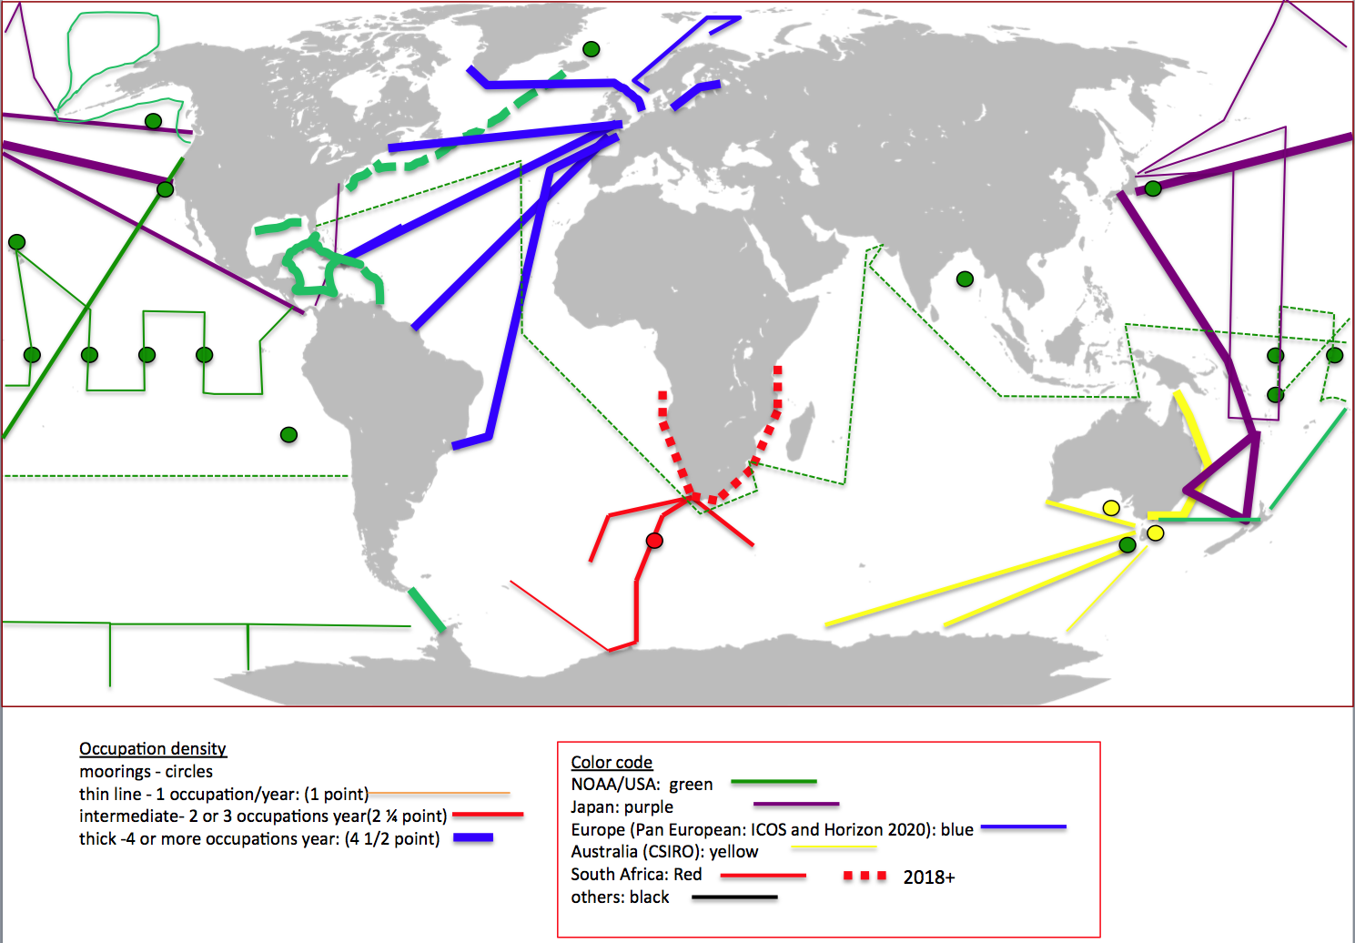

Figure 1. Sketch of lines and mooring currently in operation meeting accuracy and data submission criteria.

---------------------------------------------------------------------------------------------------------------------

Table 4. Prospective CO2 reference network participants

|  |  |  |  |  |
| --- | --- | --- | --- | --- |
| Region | Institute | Lead | Partner | Platforms |
| **Australia/New Zealand** | CSIRO  NIWA | B. Tilbrook  K. Curry | C. Neill | Mooring, Research Ships,  Cargo Ships  Research Ship |
| **Japan** | NIES  JAMSTEC  MRI/JMA | S. Nakaoka  A. Murata  M. Ishii |  | Cargo Ships  Research ships  *Floatsa*  Research ships |
| **Europe** | ICOS/OTC  AtlantOS/Horizon 2020 | T. Johannessen  T. Steinhoff  N. Lefevre | C. R. Batiste  U. Shuster  F. Perez  M. Gonzalez-Davila | Cargo ships  Research ships  Cargo Ship  *Mooring/Floats* |
| **South Africa** | CSIR/CHPC | P. Monteiro |  | Research ships  Cargo ships  *ASVb* |
| **USA** | NOAA  NSF  NSF/OOIc | R. Wanninkhof  D. Pierrot  A. Sutton  ?  ? | R. Feely  T. Takahashi  C. Sweeney  D. Munro  K. Sullivan  C. Cosca  J. Cross | Research ships  Cargo ships  Ice Breakers  Mooring  *ASV*  Research Ships  Polar Supply  *Mooring* |
| **Central/South America** | ? | ? |  |  |
|  |  |  |  |  |

a. Platforms listed in italics have sensors that have not been validated for use in the reference network.

b. ASV- autonomous surface vehicles such as wave gliders and sail drones

c. The OOI is a long-term, NSF-funded program to provide 25-30 years of sustained ocean measurements to study climate variability, ocean circulation and ecosystem dynamics, air-sea exchange, seafloor processes, and plate-scale geodynamics.

---------------------------------------------------------------------------------------------------------------------

**References cited-**

Bakker, D. C. E., and Coauthors, 2016: A multi-decade record of high-quality fCO2 data in version 3 of the Surface Ocean CO2 Atlas (SOCAT). *Earth Syst. Sci. Data* **8,** 383-413.

IPCC Sixth Assessment Report (AR6). Special Report on Climate Change and Oceans and the Cryosphere. 2018

Le Quéré, C., and Coauthors, 2018: Global Carbon Budget 2017. *Earth Syst. Sci. Data*, **10**, 405-448, https://doi.org/10.5194/essd-10-405-2018, 2018.

Pierrot, D., and Coauthors, 2009: Recommendations for autonomous underway pCO2 measuring systems and data reduction routines. *Deep -Sea Res II*, **56,** 512-522.

Rödenbeck, C., Conway, T. J., and Langenfelds, R. L. , 2006: The effect of systematic measurement errors on atmospheric CO2 inversions: a quantitative assessment, Atmos. Chem. Phys., 6, 149-161, https://doi.org/10.5194/acp-6-149-2006.

Sutton, A. J., and Coauthors, 2014: A high-frequency atmospheric and seawater pCO2 data set from 14 open-ocean sites using a moored autonomous system. *Earth Syst. Sci. Data*, **6,** 353-366.

Takahashi, T., S. C. Sutherland, and A. Kozyr, 2018: Global Ocean Surface Water Partial Pressure of CO2 Database: Measurements Performed During 1957-2017 (LDEO Database Version 2017) (NCEI Accession 0160492). Version 4.4. NOAA National Centers for Environmental Information. LDEOv2017

USGCRP, 2017: Climate Science Special Report: A Sustained Assessment Activity of the U.S. Global Change Research Program [Wuebbles, D.J., D.W. Fahey, K.A. Hibbard, D.J. Dokken, B.C. Stewart, and T.K. Maycock(eds.)]. U.S. Global Change Research Program, Washington, DC, USA, 671 pp.

Wanninkhof, R., D. Bakker, N. Bates, A. Olsen, and T. Steinhoff, 2013: Incorporation of alternative sensors in the SOCAT database and adjustments to dataset quality control flags, 25 pp.

**Appendix A. Workshop Agenda**

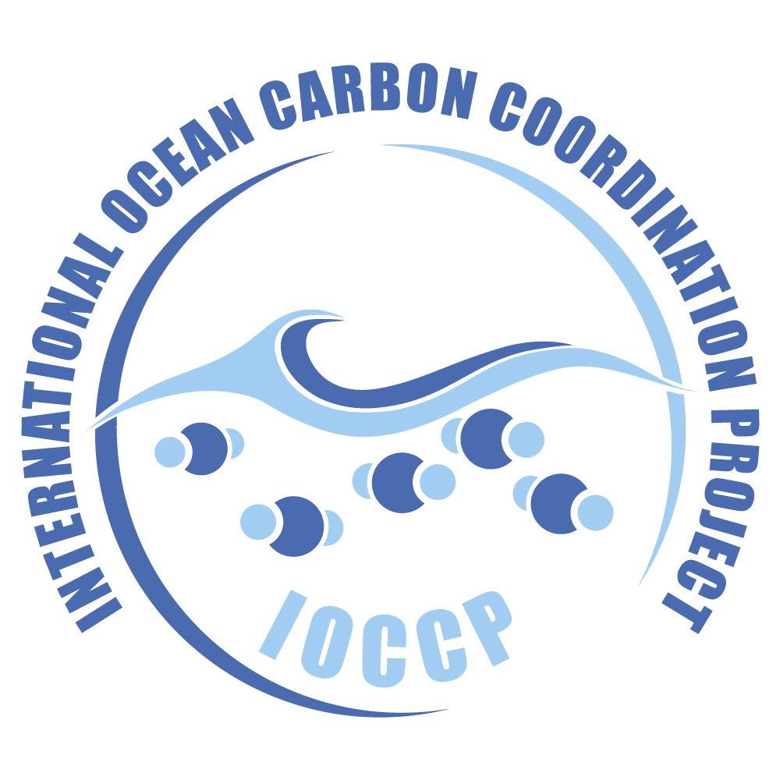

**Global Observing Network for**

**Reference Surface Water pCO2 Observations**

**Kick-off Meeting**

Time: Sunday, 11 February 2018, 8:00 – 17:30

Location: Portland, Oregon, USA

Venue: The Residence Inn Downtown Riverplace, 2115 SW River Pkwy, Portland, Oregon 97201. Phone 503-552-9500

Coordinator: Maciej Telszewski, Director, IOCCP

Meeting Lead: Rik Wanninkhof, IOCCP SSG for Surface water CO2 NOAA-AOML

Meeting Committee: Kathy Tedesco, OOMD/CPO/NOAA, Program Manager, OCO

Ute Schuster, ICOS Ocean Representative, University of Exeter

Adrienne Sutton, NOAA pCO2 Mooring Lead

Rapporteur Leticia Barbero, CIMAS/AOML, Miami

**Agenda**

**8:00-8:30 Breakfast**

**8:30-8:45** **Welcome, logistics and tour de table**

**8:45-10:30**  **Purpose of the meeting and desired results: Setting the stage**

* + - Rationale for a CO2 reference network (Rik Wanninkhof)
    - Synthesis of current assets (Adrienne Sutton)
    - ICOS - A regional model for the global network (Truls Johannessen)
    - JCOMM – OCG (David Legler)
    - JCOMM-OPS - provider of network services and other data capture issues (Kevin O’Brien)

**10:30 – 11:00 Coffee**

**11:00-12:15** **Overarching goals and current assets** (Moderators: Adrienne Sutton and Ute Schuster)

* + - Operational objectives
    - Network-wide accuracy targets and SOPs
    - Coordination and oversight
    - Platforms:
      * SOOP
      * Moorings
      * Other platforms
    - Data capture, QC & management (timeframe of delivery)
    - Product delivery*:*
    - Discussion of current operations, objectives and outlook (globally needed improvements in current operations)

**12:15 – 13:15 Lunch**

**13:15-14:30** **Conceptual design of Global network** (Moderator: Rik Wanninkhof)

* Lines (including which regions do not have coverage)
* Required Accuracies/Validation
* Deliverables: what data [T, S, xCO2ATM]?
* Metadata
* (Near)Real-time data
* Delayed mode data
* Interactions with other networks

**14:30-15:30** **Requirements** (Moderators: Maciej Telszewski and Ute Schuster)

* Milestones (including interactions with JCOMM)
* Description of what JCOMMOPS can offer (and cost thereof)
* Network design for science objectives
* Network assets: description every ship & mooring
* Benefit of visibility as a network at OCG, SOT and other
* Governance
* Resources

**15:30 – 16:00 Coffee**

**16:00- 17:30** **Pre-network deliverables and next steps** (Moderator: Rik Wanninkhof)

* Participants interested in joining network
  + Full partners
  + Associated partners (those without current capabilities)
* Inventory of current lines
* Assessment of differences in SOPs
* White paper OceansObs’19
* Future plans/meetings

**Appendix B. Participant list**

|  |  |  |  |  |  |
| --- | --- | --- | --- | --- | --- |
| First | | Last | Affiliation | Affiliation2 | Country |
| Simone | Alin | | NOAA | PMEL | USA |
| Leticia | Barbero | | NOAA | AOML | USA |
| Roman | Battisti | | Bergen |  | Norway |
| Cathy | Cosca | | NOAA | PMEL | USA |
| Amanda | Fay | | LDEO |  | USA |
| Richard | Feely | | NOAA | PMEL | USA |
| Dwight | Gledhill | | NOAA | OAP | USA |
| Melchor | Gonzalez-Davila | | ULPGC |  | Spain_Canaries |
| Masao | Ishii | | MRI | JMA | Japan |
| Truls | Johannessen | | Bergen |  | Norway |
| Siv | Lauvset | | Bergen |  | Norway |
| Galen | McKinley | | LDEO |  | USA |
| Jens | Müller | | Warnemünde | |  |
| David | Munro | | U. Colorado |  | USA |
| Akihiko | Murata | | JAMSTEC |  | Japan |
| Shin-ichiro | Nakaoka | | NIES |  | Japan |
| Kevin | O'Brien | | NOAA | PMEL | USA |
| Fiz | Perez | | IIM | Vigo, | Spain |
| Benjamin | Pfeil | | Bergen |  | Norway |
| Denis | Pierrot | | NOAA | AOML | USA |
| *Gregor | Rehder | | Warnemünde |  | Germany |
| *Gilles | Reverdin | | IPSL | L'OCEAN | France |
| Magdalena | Santana-Casiano | | ULPGC |  | Spain_Canaries |
| Ute | Schuster | | Exeter |  | UK |
| Adrienne | Sutton | | NOAA | PMEL | USA |
| Kathy | Tedesco | | NOAA | HQ | USA |
| Maciej | Telszewski | | IOCCP |  | Poland |
| Rik | Wanninkhof | | NOAA | AOML | USA |
| Andy | Watson | | Exeter |  | UK |
|  |  | |  |  |  |
| * attended | part of meeting | |  |  |  |
| **Online** | **Participants** | |  |  |  |
| Kim | Currie | | NIWA |  | New Zealand |
| Craig | Neill | | CSIRO |  | Australia |
| Bronte | Tilbrook | | CSIRO |  | Australia |
| Dorothee  Pedro | Bakker  Monteiro | | East Anglia  CSIR |  | UK  S. Africa (NA) |

**Appendix C. Overview of JCOMM.**

The function and structure of JCOMM is not well known in the oceanographic research community such that this overview could be of use when discussing the interactions of the CO2 reference network and the JCOMM. The information is culled from the web pages found under: https://www.jcomm.info/

"JCOMM, the Joint Technical Commission for Oceanography and Marine Meteorology, is an intergovernmental body of technical experts that provides a mechanism for international coordination of oceanographic and marine meteorological observing, data management and services, combining the expertise, technologies and capacity building capabilities of the meteorological and oceanographic communities. ……Worldwide improvements in coordination and efficiency may be achieved by combining the expertise and technological capabilities of World Meteorological Organization (WMO) and UNESCO's Intergovernmental Oceanographic Commission (IOC).

JCOMM is organized into three Program Areas – Observations, Services and Forecasting Systems and Data Management. [The Surface Ocean CO2 reference network would be involved in the Observations Program Area, OPA]. The OPA is primarily responsible for the development, coordination and maintenance of moored buoy, drifting buoy, ship-based and space-based observational networks. It also monitors the efficiency of the overall observing system and, as necessary, recommends and coordinates changes designed to improve it.

The JCOMM OPA Programs are:

* Data Buoy Cooperation Panel (DBCP)
* Ship Observations Team (SOT)
* Global Sea Level Observing System (GLOSS)

There are a series of related programs closely affiliated with JCOMM OPA including:

* Argo Profiling Float Program
* Ocean reference stations, OceanSITES
* International Ocean Carbon Coordination Project, IOCCP
* The Global Ocean Ship-Based Hydrographic Investigations Program, GO-SHIP
* Satellite Remote Sensing programs

The JCOMM OPA has several support function under its auspices:

* JCOMM in situ Observations Program Support Center, JCOMMOPS
* Regional Marine Instrument Centres, RMICs
* Observing System Monitoring Center, OSMC

The different components of the OPA of JCOMM are overseen by the Observations Coordination Group, JCOMM OGC. The relevant aspect of JCOMM OCG as they pertain to the Surface Ocean CO2 reference network include:

* Advise on the effectiveness, coordination and operation of the observations work program, including implementation status, performance measured against requirements, delivery of raw data, marine telecommunications, measurement standards, logistics and resources;
* Coordinate with appropriate bodies to ensure JCOMM contribution towards the development of the WMO Integrated Global Observing System;
* Coordinate the development of standardized, high quality observing practices and instrumentation
* Provide general oversight to the JCOMMOPS;
* Liaise with, and input to, Global Ocean Observing System activities regarding development, implementation, and performance of JCOMM ocean-based observing;
* Encourage and coordinate capacity development requirements   
  Identify requirements on satellite data and information in the meteorological and ocean domains

As shown in Table 1 there are several "hooks" for the surface ocean CO2 reference network to connect with JCOMM OPA. From a practical standpoint, the platform and metadata tracking of the CO2 reference network through the JCOMMOPS infrastructure is a top priority (Table 2)

1. Other platforms that can carry instruments meeting the necessary accuracy can be added in the future
2. Here, a reference dataset is a dataset of known high- quality obtained following Standard Operating procedures (See Table 3)
3. The necessary accuracy of atmospheric CO2 depends on use. For atmospheric inverse modeling 0.2 ppm would be very useful if the errors are random and not systematic (Rödenbeck et al., 2006).